Eisenhower Matrix – Reading Worksheet
Text adapted with use of AI from: Columbia University School of Professional Studies (2023) The Eisenhower Matrix. Available at: https://sps.columbia.edu/sites/default/files/2023-08/Eisenhower%20Matrix.pdf (Accessed: 20 January 2026).
Pre-reading: (discuss with your group before reading)
- Think about your own work or study: can you give an example of a task that feels urgent but isn’t important, or important but not urgent?
Vocabulary check:
Urgent: something that needs to be dealt with or happen immediately
Delegate: to give part of your work, power or authority to somebody in a lower position than you
Prioritise: to put tasks, problems, etc. in order of importance, so that you can deal with the most important first

The Eisenhower Matrix
The Eisenhower Matrix, also called the Urgent–Important Matrix, is a tool that helps you prioritise tasks and manage your time. It helps you decide what to work on first, what to plan for later, what to ask someone else to do, and what is not worth your time at all.
The matrix is based on ideas from Dwight D. Eisenhower, a former US President and military leader. He explained that tasks often feel urgent, but are not always important. Stephen Covey later used this idea to create the four-box matrix that is still used today.
How the Matrix Works
The Eisenhower Matrix sorts tasks into four boxes based on two questions:
- Is this task urgent?
and
- Is it important?
Urgent tasks need immediate attention and often have short deadlines.
Important tasks help you achieve long-term goals, even if they are not due straight away.
Urgent tasks usually cause problems if they are not done quickly, such as an assignment due tomorrow or an exam this week. Important tasks are linked to future success, such as revising regularly, planning coursework, or developing good study habits.
Understanding this difference helps you avoid spending all your time reacting to urgent tasks while neglecting important ones.

The Four Quadrants
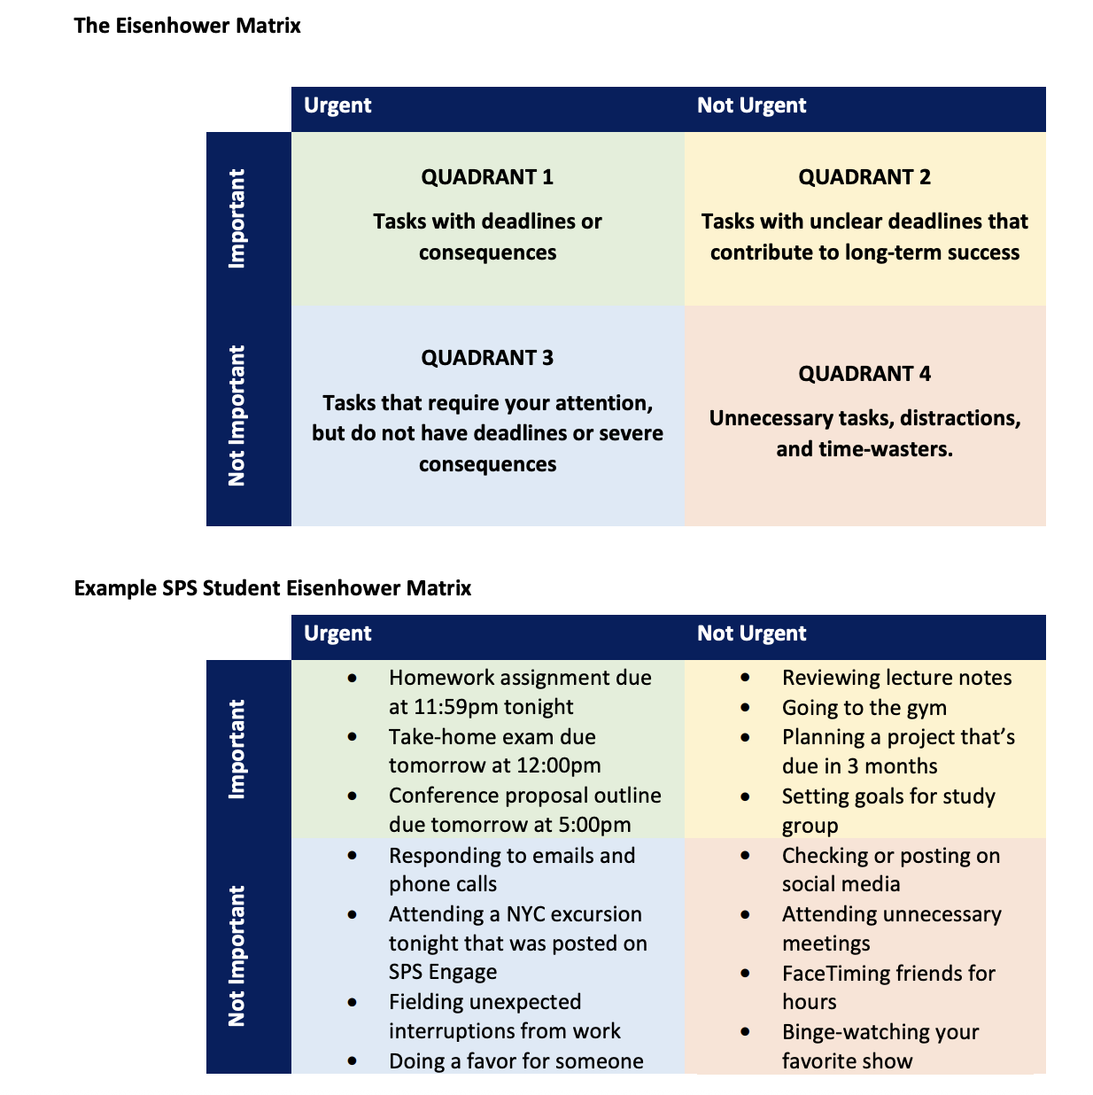
Each box in the matrix is called a quadrant and has a suggested action.
Quadrant 1: Urgent and Important – Do
These tasks must be done immediately.
Example: An assignment due tomorrow or an exam revision session the night before the exam.

Quadrant 2: Important but Not Urgent – Schedule (Plan when to do the task at another time/date)
These tasks should be planned and added to your timetable. This quadrant is especially important for students given that students often have many different deadlines.
Example: Revising weekly, planning coursework, or reviewing lecture notes.
Quadrant 3: Urgent but Not Important – Delegate
These tasks feel as though they need to be completed soon, but do not strongly support your goals. If possible, ask someone else to help or handle them.
Example: Responding to non-essential messages or completing tasks in a group project that someone else could do.
Quadrant 4: Not Urgent and Not Important – Delete
These tasks do not support your goals and waste time.
Example: Excessive social media scrolling or watching videos instead of studying.

Identifying Quadrants 3 and 4 is useful because it helps you reduce distractions and protect time for important work.
Tips for Using the Matrix
- Keep each quadrant short to avoid feeling overwhelmed.
- Use separate matrices or lists for school, work, and personal tasks if helpful.
- Use colours or symbols to clearly see priorities at a glance.
Using the Eisenhower Matrix regularly can help you make better decisions about how you spend your time and reduce last-minute stress.

Questions to answer with your Expert group about the article:
1. What is the main purpose of the Eisenhower Matrix, and how does it help with managing tasks?

2. How does the article explain the difference between 'urgent' and 'important' tasks? Give at least one example of each.

3. Describe each of the four quadrants in the Eisenhower Matrix. What kinds of actions and what kinds of tasks belong in each one? Give an example for each.

4. What examples does the article give of tasks belonging in Quadrant 3 and Quadrant 4? Why is identifying these useful?

5. What practical tips or tools does the article suggest for using the matrix effectively? How might these help someone manage time?

6. [not in article, discussion question IF time] What do you think are some advantages and disadvantages of the Eisenhower Matrix as a time management tool?

