Ballistic Modelling of 30mm APDS RARDEN Projectile in Abaqus

Ben Palmer-Drury

OME L4 Physics (ACDB4007) Year 1 UWTSD

Contents
Abstract & Introduction P3
Methodology P5
Results & Conclusion P7
Evaluation P12
References P13
List of figures and tables
Figure 1 - [2]. P3
Figure 2 - [7] P4
Figure 3 - [10] P5
Table 1 - Chosen velocities P5
Figure 4 - [16] P6
Table 2 - Johnson-Cook metallurgy details P6
Table 3 - Johnson-Cook metallurgy details P6
Figure 5 - Abaqus screengrab - plate P7
Figure 6 - Abaqus screengrab - penetrator P7
Figure 7 - Abaqus screen grab - “Camembert” P7
Figure 8 - Sheer stress screengrab - RARDEN P8
Figure 9 - Tensile stress screengrab – RARDEN P8
Figure 10 - Sheer stress screengrab – Cheetah P8
Figure 11 - Tensile stress screengrab – Cheetah P8
Figure 12 – Sheer stress screengrab – SA80 P8
Figure 13 – Tensile stress screengrab – SA80 P8
Figure 14 – Micrometeorite Abaqus failure P9
Figure 15 - Tensile stress screengrab – Challenger P9
Figure 16 – Sheer stress screengrab – Challenger P9
Graph 1 – RARDEN P10
Graph 2 – Challenger P10
Graph 3 – Cheetah P11
Graph 4 – SA80 P11
Graph 5 – Velocity comparison P12
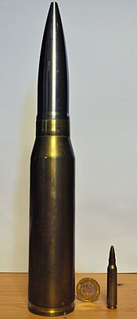
Abstract
The purpose of this finite element analysis, was to further model the effects of a projectile in motion, when it impacts a stationary object. The stress and strain values can then be plotted to show how velocity can affect a change in stress.
A particular grade of Aluminium plate was modelled for the target, due to its ease of availability of documentation. The modelled projectile was the 30mm RARDEN Armour Piercing Discarding Sabot (APDS) projectile, as used in the Warrior AFV (Armoured Fighting Vehicle).
The focus is on this particular projectile for a number of reasons. The author has used this particular weapons system in the past, and the round was developed (partly) at Fort Halstead during the 1960’s [1]. The author is currently on his 3rd stint at the facility. An example of the round with a personal infantry weapon (5.56mm) round, as reference [2].
Figure 1
Introduction
There are many points to be ascertained from studying the immediate and cumulative effects of projectiles striking a given material. Having better understanding regarding how materials react to rapid collisions, can be used to engineer reliability into products and systems. This ensures the survivability of the user and possibly the equipment. An example of this would be the modern car. In the 1980’s a car was designed to be repaired easily. Occupants of a modern vehicle are more likely to survive a typical front-end shunt at 70mph, than 40 years ago. Despite this the death rate has risen, but this is mainly due to the exponential rise in the driving population [3]. Survivability has increased, now that the crash cell is designed to collapse around the cabin. An example of this is where Formula1 improved safety, after the deaths of Ayrton Senna and Roland Ratzenberger, at the San Marino Grand Prix in 1994 [4].
Finite element analysis modelling, using software like Abaqus, enables designers to accurately predict the effect impact strikes will have on an object. It is a Lagrangian (stationary action principle) computer model, which allows parameters for each component to be set, so that differing variables can be changed to suit the engineering need [5]. In this instance, the material compositions of the plate and projectile are unchanging, simply adjusting the velocity should provide varied results.
If a designer can understand how stress forces change at different velocities, they can adjust future models for material properties. Graphical representations (graphs, charts, sim grabs) are also good supplementary tools to analyse and extrapolate data. As an example; extrapolating the minimum amount of force to breach armour. In the real world, this can be applied to Kevlar-ceramic armour, for personnel protection or reinforced-steel for Main Battle Tanks (MBT).
The Johnson-Cook model for plasticity is an analytical form of the hardening law and suitable for simulating high-strain-rate deformation of many materials. This includes most metals. Its components can be used within Abaqus to model dynamic failure, tensile failure and manage differing damage initiation criteria. Therefore, it is useful for modelling projectile impacts [6].
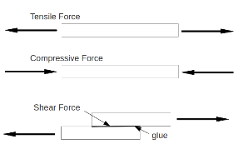
The variables that we are interested in, with relation to the point of impact, are the stress forces involved. Stress is not just an emotional response to a difficult situation, like writing this paper, but a mechanical division of an applied force to a cross-sectional area. This is defined as force per unit area. An example of the three types of stress is shown in the figure to the right [7]. This can be expressed as;
“τ = F_{p} / A
Where Figure 2
τ = shear stress (Pa (N/m²), psi (lb_{f}/in²))
F_{p} = shear force in the plane of the area (N, lb_{f})
A = area (m², in²)”
[7].
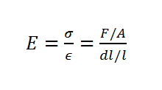
Strain, is the deformation of a solid due to stress. Normal strain is the lengthening or compression of a solid material, whilst, shear strain is a change in angle between two solid masses sliding over each other. Young’s Modulus is an important variable to consider. This can help the engineer know when an object or material is likely to bend or break. It is an indicator of how a material stretches and deforms. This can be defined as;
Where, “Since the force F = mg, we can obtain the Young’s modulus of a wire by measuring the change in length (dl) as weights of mass m are applied (assuming g = 9.81 metres per second squared).” [8]
This is highly relevant because it tells us that materials can behave in different ways. Brittle materials, normally, are strong, able to withstand stress and then break. Ductile materials have a larger elastic region, where at its limit, the material will no longer hold its form, and not be able to return to its original shape. Plastic materials tend to be weaker, but can withstand more stress [8].
As previously stated the author chose to model the 30mm RARDEN APDS projectile, as he has an affinity with it. The RARDEN auto-cannon was developed partly at Fort Halsted and the Enfield Lock Royal Small Arms Factory (shut 1988). The first prototypes entering production in 1966, and entered service in the early 1970’s. The rate of fire was restricted by design, so that the weapons system could be fitted to more mobile AFV’s. This was a tactical decision, as at the time, the British Army and its allies were embroiled in the Cold War. There was a constant, perceived, threat that the Soviet Union was about to unleash its tanks across Eastern Europe. NATO countries developed these cheaper (and more numerous than Main Battle Tanks) AFV’s to be accurate at ranges of over 1000m. The RARDEN cannon was proven to be accurate in 1m groupings at 1000m on a regular basis. The ammunition itself was developed from the Hispano-Suiza 8231-L round [1]. The APDS round was designed to defeat the 14mm-thick frontal armour, of the Soviet BTR50P Armoured Personnel Carrier. The design of this prevented the use of the cannon that originally used the H-S 823 round. Therefore the new RARDEN auto cannon was developed [9].
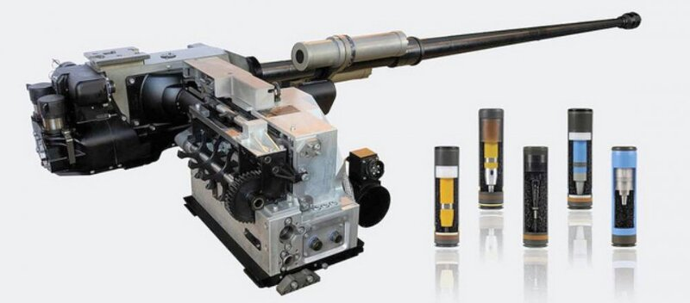
The cannon itself is of great interest to the author, but, beyond the scope of this report. So for brevity an illustration of the system is included to the right [10].

Methodology Figure 3
When creating a simulation in Abaqus, a number of variables were available for consideration;
- Velocity of projectile
- Differing material properties
- Differing techniques
It is important to test a variety of velocities as this can be affected by a number of factors. These include; weather, temperature, propellant quality and range. It is also important for the armour designer, to test their asset designs by modelling impacts with various projectiles. Sims are more cost effective than trials, especially in the initial design phase. However, there is no substitute for real world firings. These, when accurately measured gives definitive results. Initially 3 velocities were chosen, but to build a more accurate picture, as plotted on a graph, it is not unreasonable to use 5 velocities. The more data the better, however, due to the limitations with time and machine processing power, more than this (i.e. 100’s) would not be possible.
Simulation length is an important factor for this model. Time enough would be needed for impact and running for long enough to record stresses as measured. After trial and error, a baseline time of 400µs was decided upon, to give the simulation enough time to impact and detect all relevant forces. This RARDEN baseline necessitated a reduced velocity for the Cheetah and an increased velocity for the Challenger, the time limits needed to be adjusted accordingly.
The velocities chosen needed to be varied enough to give varied data patterns. They also needed to be evenly distributed to keep the spread steady and not omit any important data points, especially if results were unexpected.
Velocities chosen;
What | Why | Speed in m/s. (2dp’s) | Citation (*)
Cheetah | The fasted land animal | 31.73 | [11]
SA80 A2 L85 Assault Rifle 5.56mm | Standard British Infantry weapon | 940.00 | [12]
RARDEN muzzle velocity 30mm APDS | Chosen projectile to model | 1175.00 | [13]
Challenger Shuttle | One of the authors favourite fixed-wing aircraft | 7743.18  Mach 22 | [14]
Micrometeorite | Maybe useful to know with future applications | 71526.40  Mach 210 | [15]
*Where necessary MPH velocities were recalculated using Google. Table 1
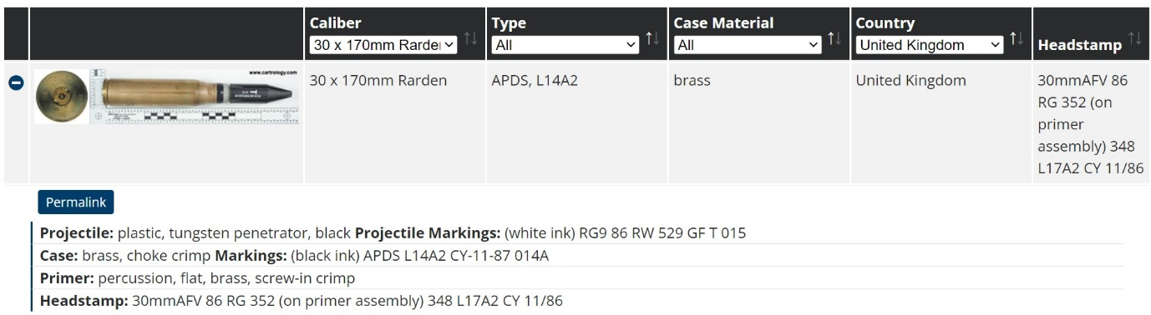
The simulation was created using instructions provided by UWTSD, with the material data changed for the RARDEN. It is a 2-part simulation consisting of projectile and a target plate. The projectile ‘part’ is simulating the tungsten core of the APDS round. The measurements or this are derived from approximations taken from physical items by the author and research. A screen grab is included below of the cartridge details;
Figure 4. [16].
The penetrator is approximately 140mm long by 20mm in diameter. As tungsten is the main element of the penetrator, and the exact metallurgy of the round is restricted (despite being obsolete and no longer being in service), the author has used commercially available data for the Johnson-Cook data points.
Metal | d1 | d2 | d3 | d4 | d5 | Melt Temp | Transition Temp | Strain Rate | Fracture Energy
Tungsten | 0 | 0.33 | -1.5 | 0 | 0 | 1723 | 134 | 1 | 0
Aluminium | -0.77 | 1.45 | -0.47 | 0 | 1.6 | 650 | 293 | 1 | 0
Table 2.

The plate is a simulation of 6061 Aluminium. Aluminium has a relative density of about 1/3rd of steel. This is useful when designing a vehicle where speed is a variable. When it is alloyed with minimal amounts of other materials, it has uses in industries such as aeronautics, vehicle production and construction. Couple alloying with heat treatment, is stronger than steel. This means aluminium alloys can be used in stress bearing beams and aircraft frames, boats and vehicle engines [17]. For relevance to this simulation, Aluminium 6061 is an alloy containing the elements Magnesium and Silicon. It has a yield strength to an equivalent of A36 steel. A36 is a weldable construction steel commonly used in bridges. 6061 is highly resistant to corrosion, so for use in vehicles it gives a go-anywhere-ability [18]. The M2 Bradley has armour components made from 7039 and 5083 aluminium alloys [19]. As does the British Warrior AFV. There is very little available information that is open source on 7039. There is some data for 5083, but 6061 is more complete. The plate ‘part’ in the simulation is 40mm thick. The required Johnson-Cook data is collated below;

Metal | Mass Density | Elastic |  | Plastic |  |  |  | Rate Dependent
Metal | Mass Density | Young’s Modulus | Poisson’s Ratio | A | B | n | m
 |  |  |  |  |  |  |  | C | E dot
Tungsten | 19.3 | 400-410 | 0.28 | 1275 | 624 | 0.12 | 1 | 0.016 | 1
Aluminium | 2.7 | 69 | 0.33 | 324.1 | 113.8 | 0.42 | 1.34 | 0.002 | 1
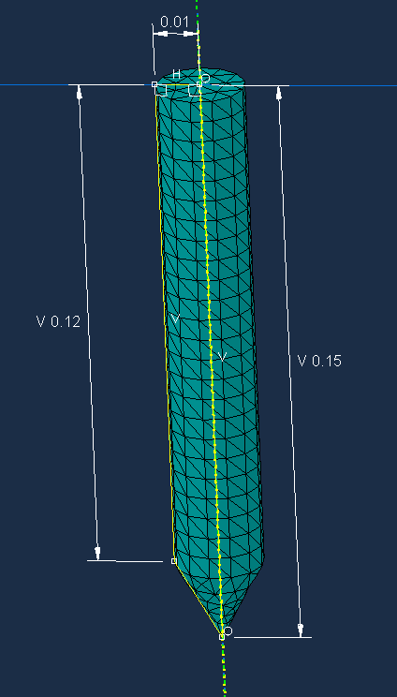
Table 3.
Sizing the components is detailed below. Measurements are in meters.
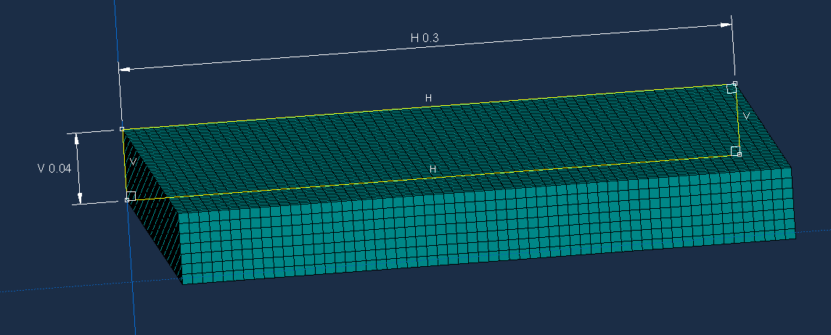
Figure 5 Figure 6

Results & Conclusion
Initially, the author was expecting the penetrator to pass through the armour with ease, after all that is what the all-up was designed to do. However, and this is probably due to the material composition of 6061, the author wasn’t anticipating the ease at which this was observed. After some drawn out teething issues, the simulation finally ran successfully. Due to the relative densities and material compositions of the plate and penetrator, the slug had very little problem in breaching the armour.
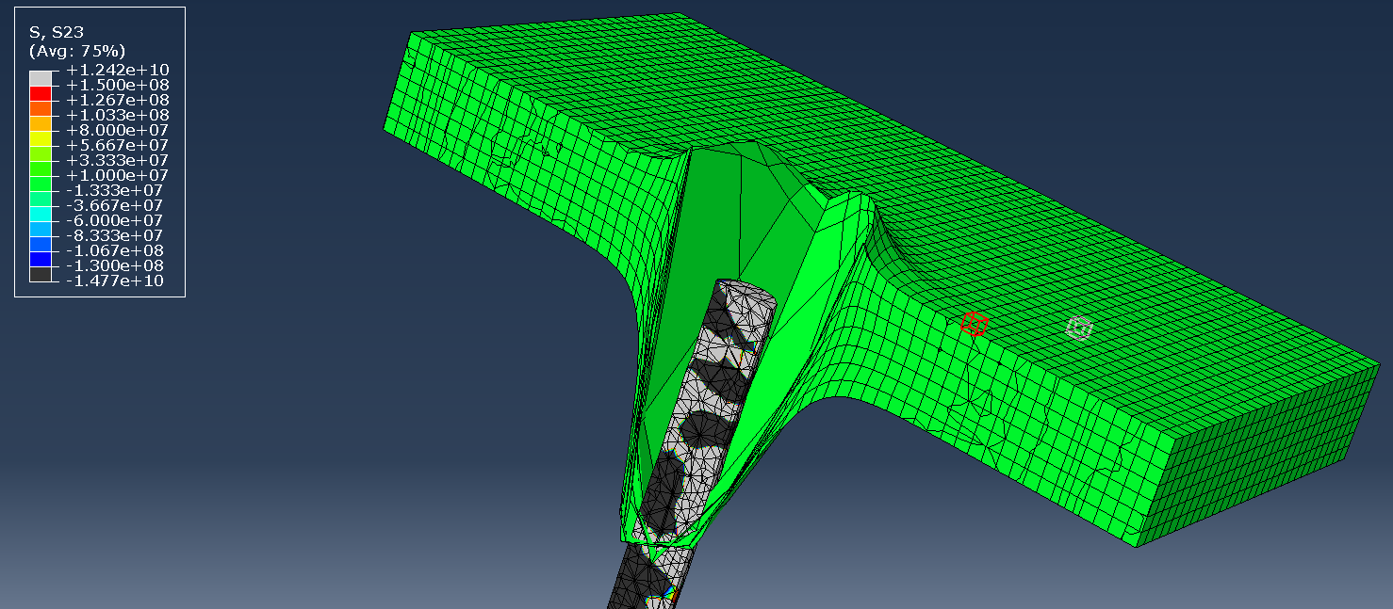
However, due to an operator error inputting the Johnson-Cook data the plate was ‘too’ ductile, practically melting like Camembert, and therefore the stress data was incorrect. This is shown below;
Figure 7
This shows the slug passing through with little to no resistance, even being able to punch a heavily cratered entrance ‘wound’.

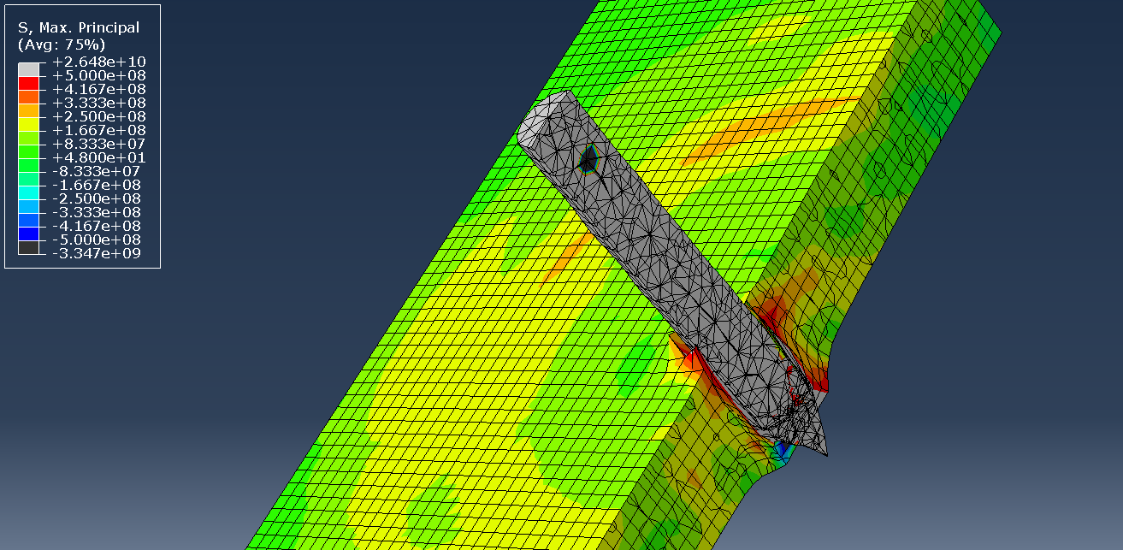
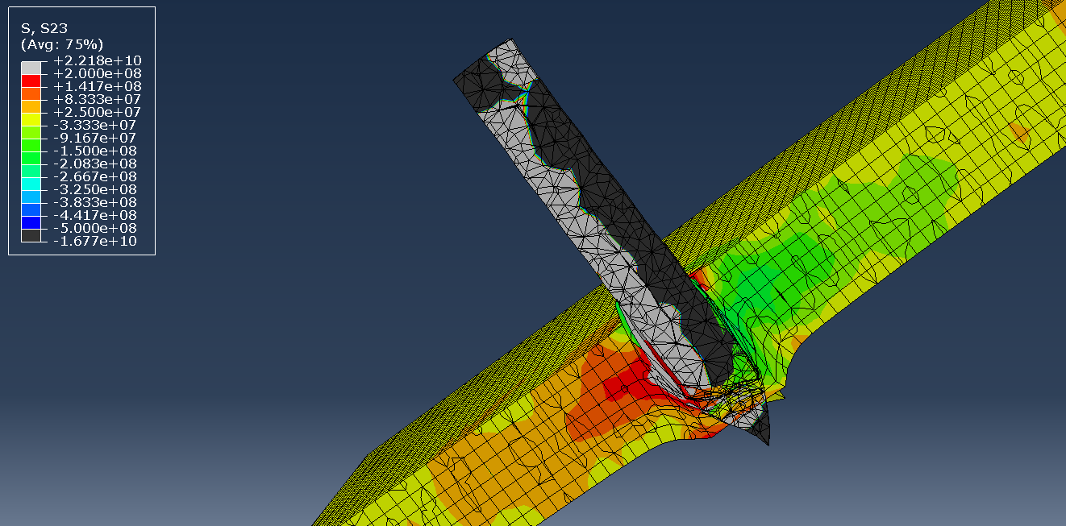
With IT issues solved, the 30mm RARDEN was very successful at breaching 40mm armour plate as shown below;
Fig 9 Tensile stress
Fig 8 Sheer stress
The projectile itself, was particularly ‘un-stressed’ as it defeats the armour, with cratering on entrance and exit. However, the leading edge of the penetrator has deformed on impact and started to move off axis in the armour. This would explain the higher stress indications to the left of the sheer stress figure.
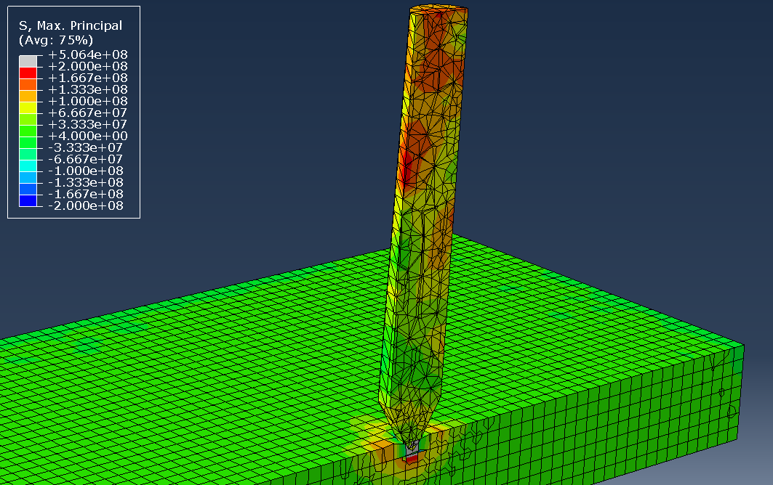
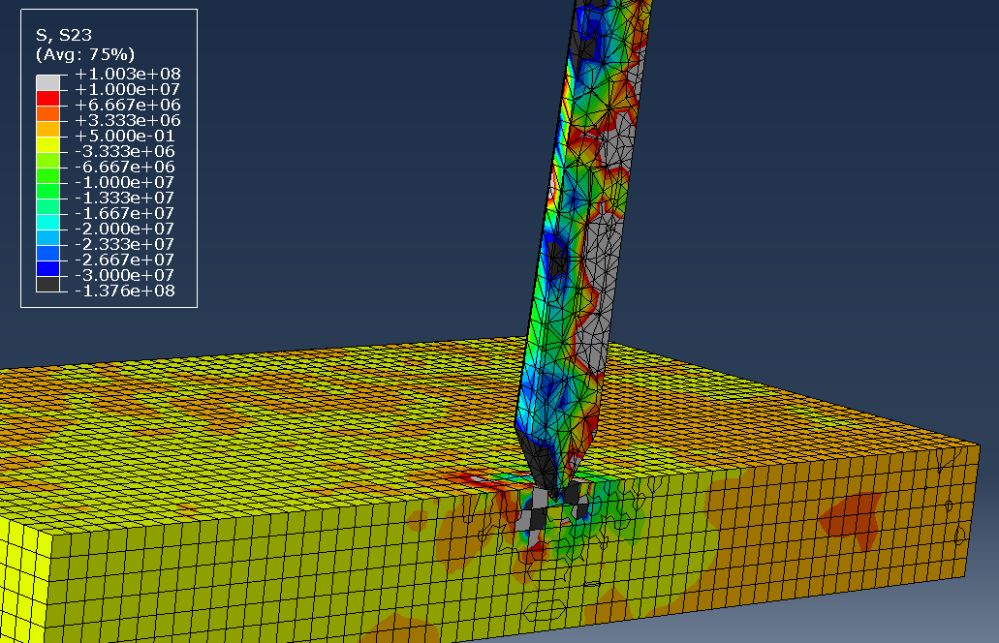
By comparison, changing the velocity variable to that of the Cheetah, the armour plate defeated the incoming projectile, even repelling it at a speed of 2ms (This is shown in the Cheetah velocity graph on page 11). Cheetah is shown below;
Fig 10 Sheer stress
Fig 11 Tensile stress

The armour was dented but remained intact. It is unlikely that any weapons system would fire such a projectile, at this velocity. The speed of the fastest land animal was included purely to explore lower velocities for comparison. This armour may be useful for lightly armoured scout vehicles, where speed and manoeuvrability are more important.
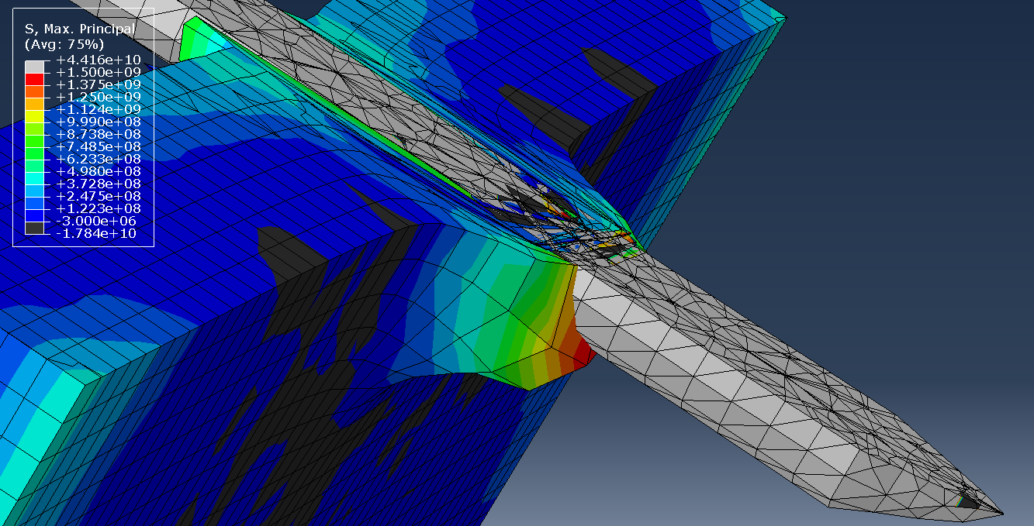
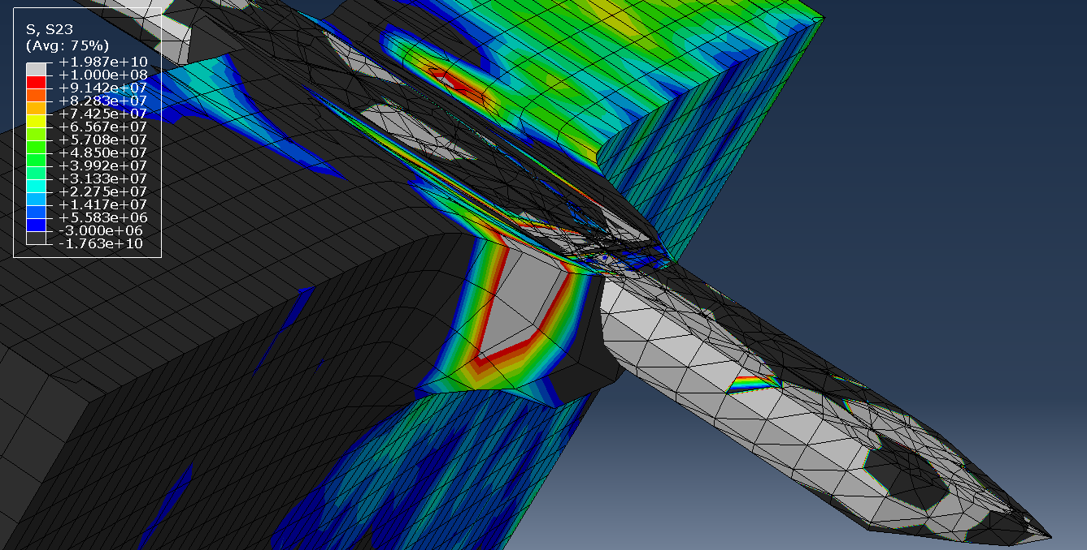
Changing the velocity to that of the SA80 Infantry weapon, which has a muzzle velocity a few hundred ms slower, the projectile is still just as effective as at RARDEN. This is shown below;
Fig 13 Tensile stress
Fig 12 Sheer stress
The defeat of the armour is as complete, compared with the RARDEN velocity. These screenshots are from later in the simulation. The armour is deforming in a viscous-looking state, at the extreme extent of its plastic region. The penetrator is still intact, with little deformation. The author concludes, that the minimum speed to total penetration would be in estimation, 850 to 900ms. Further simulations would need to be run to support this.
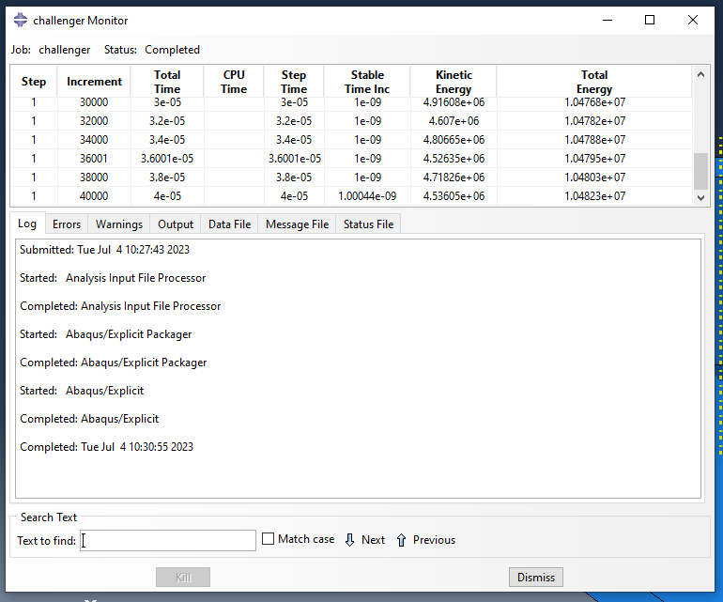

At the maximum velocity as chosen, that of the Micrometeorite, the simulation failed to run and was aborted by the software. This is due to limitations with both the software and hardware. If the software was more efficient it could have taken an hour to process on a better machine. This is evidenced to the right;

Figure 14

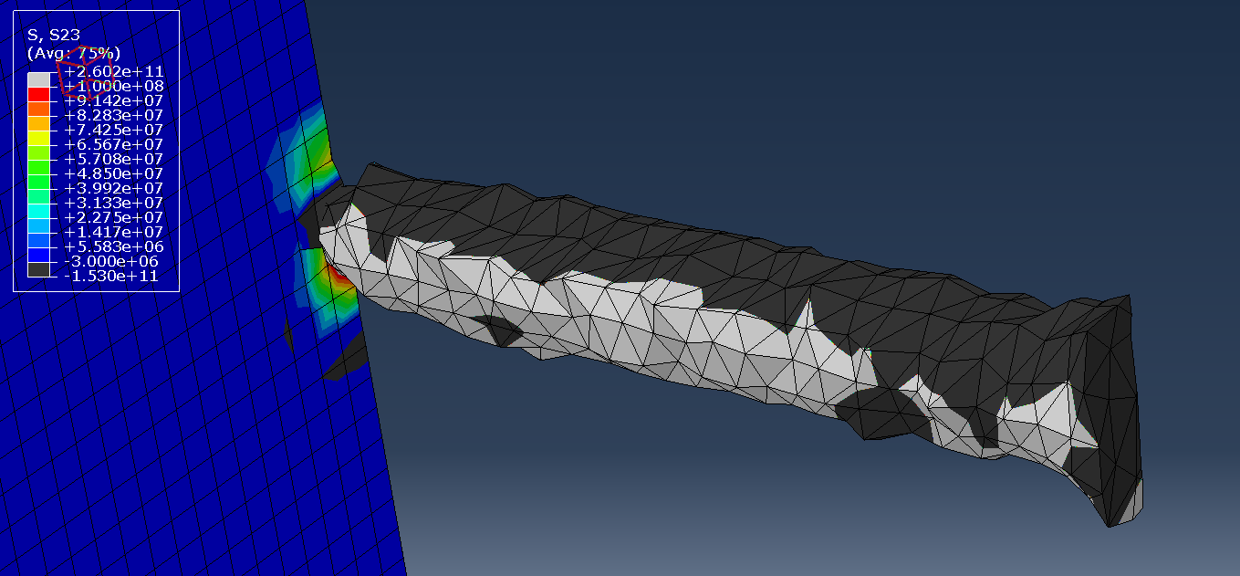
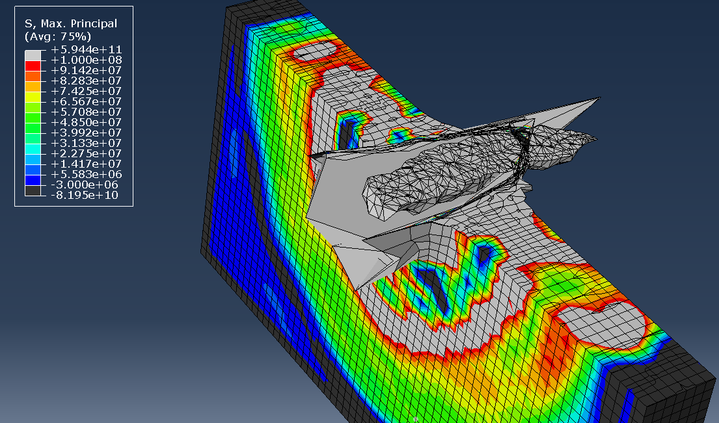
The most efficient velocity as used for penetration simulation, was the speed of the Challenger Shuttle. The screenshots below show the Tungsten APDS penetrator deforming and passing through the armour, coming close to spalling. This effect can have disastrous consequences for equipment and crew.
Figure 15 Tensile stress
Spalling is the effect of fragments breaking away from a solid body [20]. A further sim run would be required to test this. It would have been interesting to incrementally increase the thickness of the armour at this speed, to see what thickness plate, would have stopped a tungsten projectile travelling at the equivalent of Mach 22. Actually getting the projectile to travel six and a half times faster would be an interesting trial, but suspect, then, that something like the Rail Gun concept would be a far more effective method for increasing velocity. However, there are still a number of problems on this system and currently being investigated by various nations. The Rail Gun uses electromagnetism rather than chemical propellant, to propel its projectile.
Figure 16 Sheer stress
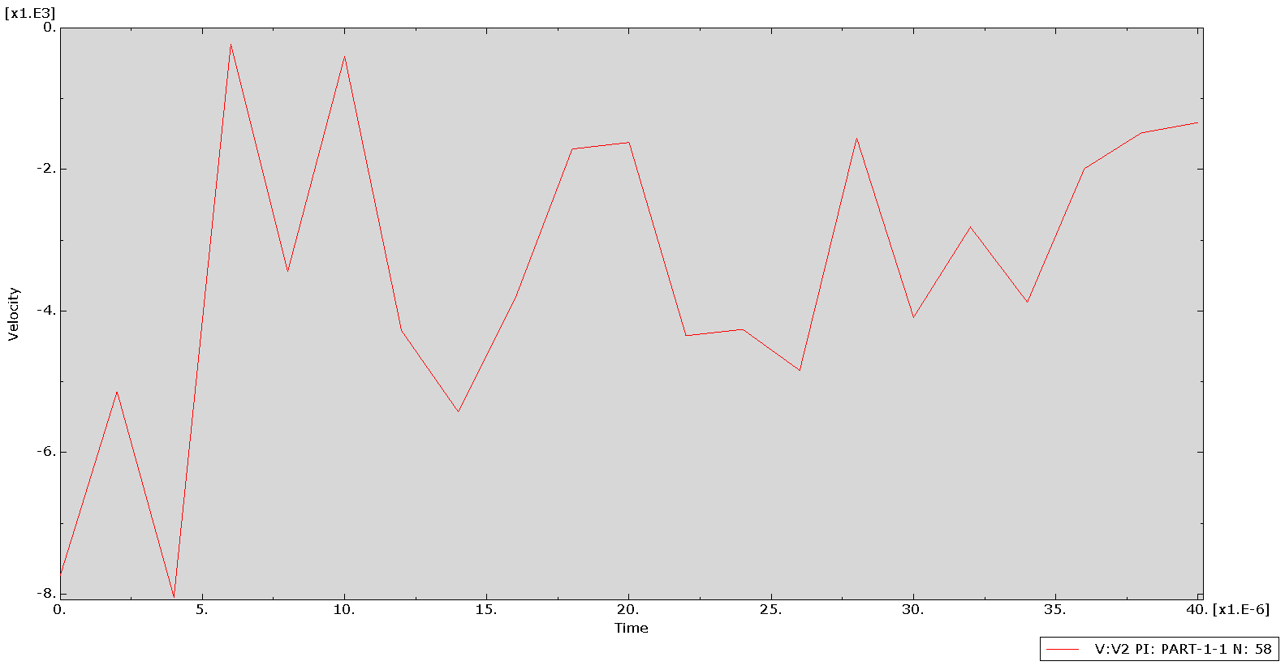
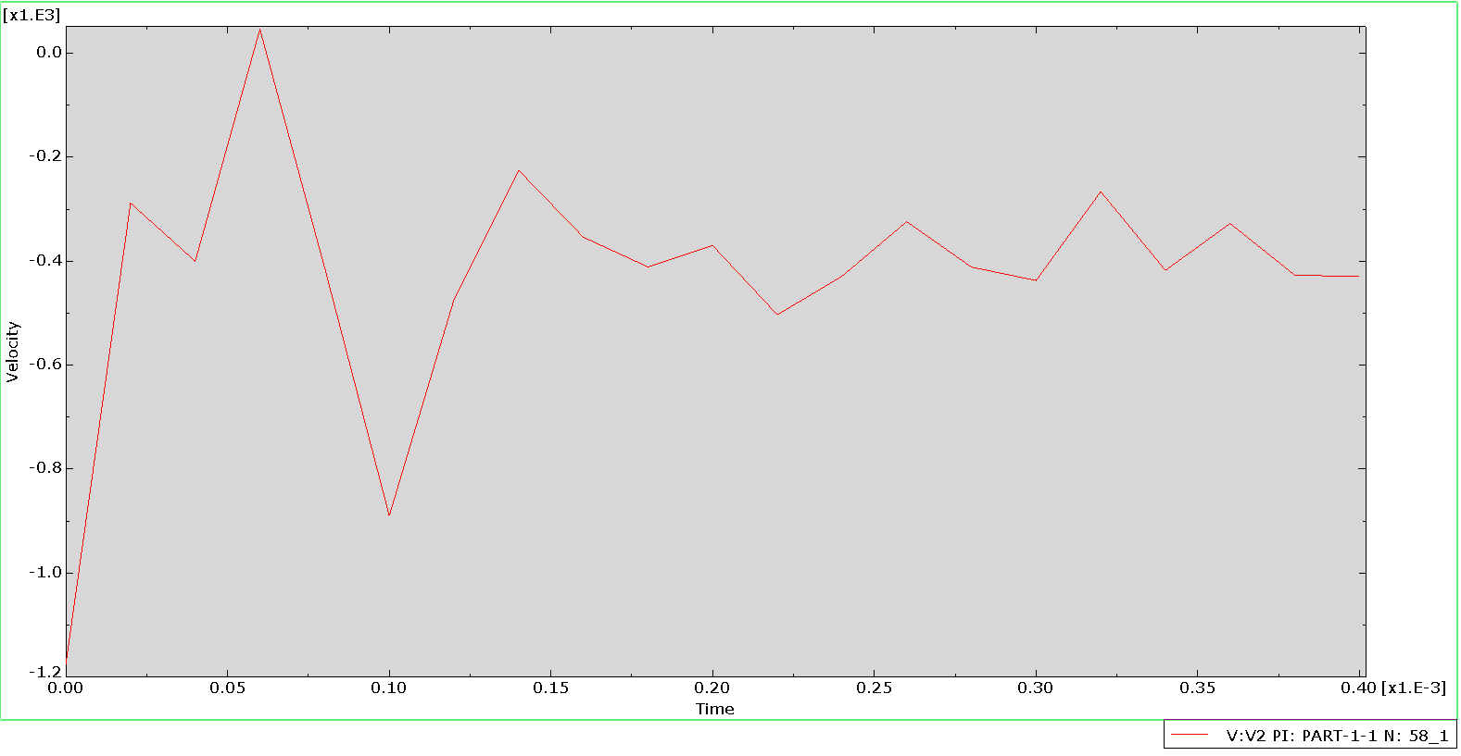
The following are the plotted projectile velocities for those given that could be run as a simulation;
Graph 2 Challenger
Graph 1 RARDEN

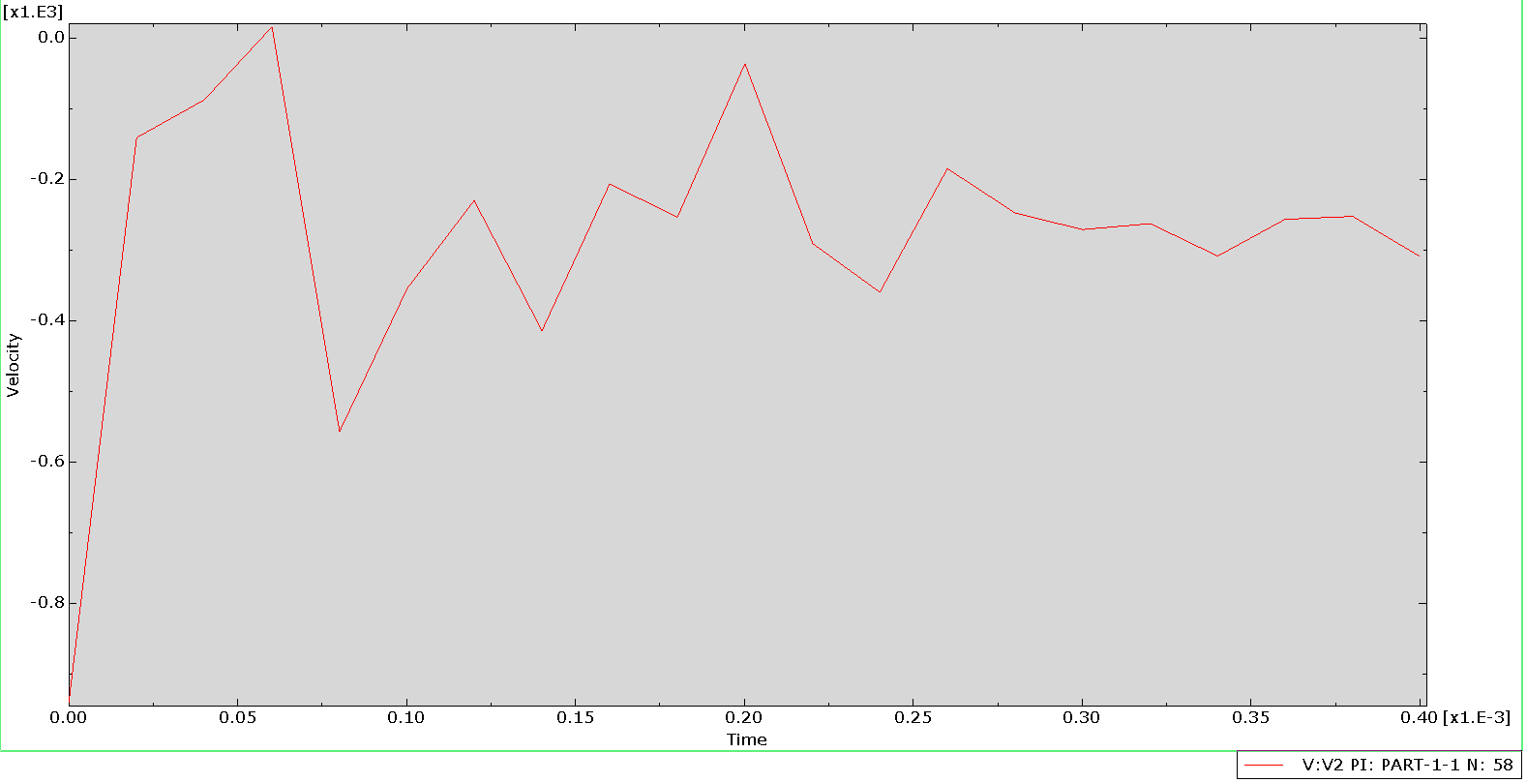
Graph 4 SA80
Graph 3 Cheetah

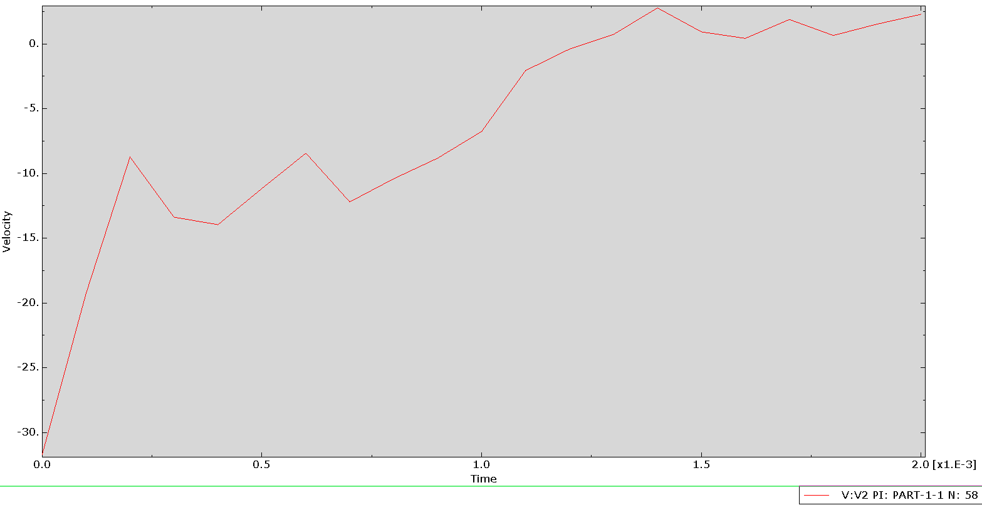

The following is a comparison of the plotted velocities, taken from the preceding graphs, at key points;
- Initial velocity
- Point of impact
- Final velocity
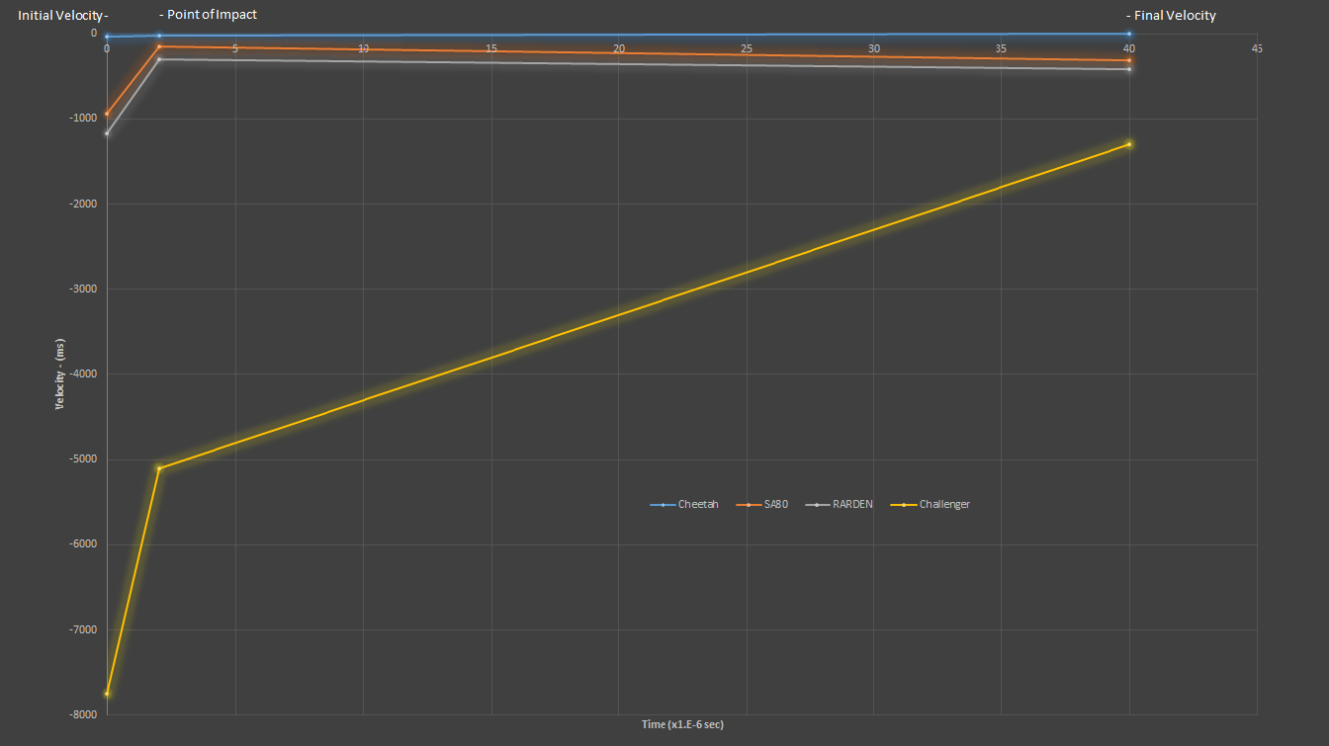
Graph 5
The blue line (Cheetah), is indicated as a near flat line due to the scale required to accommodate the Challenger velocity. Given that the armour was defeated by the RARDEN, and fully penetrated, the Challenger penetrator is still travelling at a speed greater than the initial velocity of the RARDEN. At the point of impact for Challenger, the projectile has deposited 75% of its energy as it has slowed by 50%. The amount of deformation on impact, is more due to the mass of the projectile compressing, in the split second that the fore section of the penetrator is travelling at a slower velocity than aft, rather than the effectiveness of the 40mm armour.

Evaluation
The author believes that the accuracy of the results is correct given the data provided. More nodes, for example may have provided more stress and strain data. Using thicker armour plate, the data for the correct grades of Aluminium, and the restricted Tungsten data may provide more accuracy for improving the armour on both the Bradley and Warrior AFV. However, the Warrior is due to be replaced, when the Ajax platform eventually enters service. However, despite Aluminium’s benefits in weight/fuel savings, it has one potentially fatal flaw, in that it is highly combustible, even being used in IED’s as fuel. Therefore, an AFV that is on fire is not a place anyone wants to be.
A higher specification computer would be needed to run velocities even close to the Micrometeorite, as the one that was used to conduct these sims was not capable enough. Issues with UWTSD’s IT infrastructure, and that of the author’s parent company’s network have frustratingly hampered progress.
It may have been useful to conduct, at minimum 2 further sims at a speed between SA80 and Cheetah, and possibly between Micrometeorite and Challenger. However, the author idly wondered about armour thicknesses for things like low orbit platforms.
This simulation confirms that the APDS RARDEN is still effective at penetrating armour, despite having been replaced by a 40mm computer-controlled variant.

References

[1] | Army Guide, "L21A1 RARDEN," [Online]. Available: http://www.army-guide.com/eng/product2585.html. [Accessed 16 05 2023].
[2] | Wikipedia, "30mm vs 5.56 NATO," [Online]. Available: https://en.wikipedia.org/wiki/File:30mmvs556nato.jpg. [Accessed 16 05 2023].
[3] | J. B. Cicchino, "Accident Analysis & Prevention," 11 2014. [Online]. Available: https://www.sciencedirect.com/science/article/abs/pii/S0001457514001845. [Accessed 14 06 2023].
[4] | Associated Press, "The National News," 01 05 2014. [Online]. Available: https://www.thenationalnews.com/sport/formula-ones-safety-reforms-since-ayrton-senna-and-roland-ratzenberger-deaths-1.241502. [Accessed 16 06 2023].
[5] | Nordendale, "Modeling of High-Rate Ballistic Impact of Brittle Armours," p. 3, 2013.
[6] | Massechusets Institute of Technology, "Johnson-Cook plasticity," [Online]. Available: https://abaqus-docs.mit.edu/2017/English/SIMACAEMATRefMap/simamat-c-johnsoncook.htm. [Accessed 16 06 2023].
[7] | Engineering Toolbox, "Stress, Strain and Young's Modulus," [Online]. Available: https://www.engineeringtoolbox.com/stress-strain-d_950.html. [Accessed 16 06 2023].
[8] | University of Birminham, "What does Young's modulus tell us about a material?," [Online]. Available: https://www.birmingham.ac.uk/teachers/study-resources/stem/Physics/youngs-modulus.aspx. [Accessed 16 06 2023].
[9] | F. Hobart, "The Rarden Cannon," Armour Magazine, no. Jan-Feb, 1974.
[10] | Richcat, [Online]. Available: https://richcat.tistory.com/entry/L21A1-RARDEN. [Accessed 16 06 2023].
[11] | W. Johnson, "Cheetah," 26 05 2023. [Online]. Available: https://www.britannica.com/animal/cheetah-mammal. [Accessed 16 06 2023].
[12] | Army Technology, "SA80 A2 L85 Assault Rifle," 03 02 2020. [Online]. Available: https://www.army-technology.com/projects/sa80-a2-l85-assault-rifle/. [Accessed 16 06 2023].
[13] | Wikipedia, "RARDEN," [Online]. Available: https://en.wikipedia.org/wiki/RARDEN. [Accessed 16 05 2023].
[14] | Y. Gibbs, "NASA," 07 08 2017. [Online]. Available: https://www.nasa.gov/returntoflight/system/system_STS.html. [Accessed 04 07 2023].
[15] | S. Peterson, "City Stardust: Micrometeorites in our own backyards," 06 09 2020. [Online]. Available: https://www.bellmuseum.umn.edu/blog/city-stardust-micrometeorites/. [Accessed 16 06 2023].
[16] | Cartrology, [Online]. Available: http://www.cartrology.com/cartridges/2308. [Accessed 16 06 2023].
[17] | R. A. Higgins, "Engineering Metallurgy," in 1. Applied Physical Metallurgy, English Universities Press LTD, 1971, p. 340.
[18] | Ryerson, [Online]. Available: https://www.ryerson.com/resource/the-gauge/grade-anatomy-aluminum-6061. [Accessed 16 06 2023].
[19] | Military review, "Aluminium armour for combat vehicles," 2023. [Online]. Available: https://military-review.com/12482718-aluminum-armor-for-combat-vehicles. [Accessed 16 06 2023].
[20] | Profound Tips, "Effect of spalling," [Online]. Available: https://profound-tips.com/blog/what-is-spalling-in-bullets/. [Accessed 14 07 2023].

