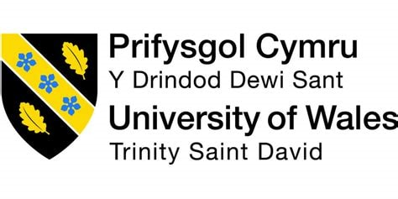

Topic - The use of social media platforms in customer relationship management: A case study of Coca-Cola

Student Name :- Macwan Smit Thomas
Student ID :- 2245268
Programme :- MBA
Module :- Dissertation Proposal
Code :- LCMB7020
Lecturer :- Tushara Balendran
Submitted On :- 30 March 2024

Table of Contents
Chapter 1: Introduction 3
1.1 Background of the Research 3
1.2 Problem Statement 3
1.3 Significance of Research 3
1.4 Research Rationale 4
Chapter 2: Literature Review 5
2.1 Review of the Previous Literature 5
2.1.1 Theme 1: The effective use of different IMCs by Coca-Cola for improved CRM 5
2.1.2 Theme 2: The Impacts of Social Media Platform Use on CRM Initiatives by Coca-Cola 6
2.1.3 Theme 3: The identified challenges and opportunities regarding the use of social media platforms 7
2.2 Literature gap 8
Chapter 3 Methodology 8
3.1 Research Philosophy 8
3.2 Research Approach 9
3.3 Research Method 9
3.4 Data Collection Method 10
3.6 Data Analysis 11
3.7 Ethical Consideration 11
Chapter 4: Resource and Planning 11
4.1 Research Timeline 11
Reference 13

Chapter 1: Introduction

1.1 Background of the Research
Currently, the increasing use of social media platforms employs a digital era to improve CRM practices. Organisations like Coca-Cola aim to engage with their customer base through different social media platforms. The main used social media platforms by Coca-Cola are Instagram, Facebook, Twitter, LinkedIn, TikTok, YouTube, Reddit, Google, and Flickr (Coca-Cola Canada, 2020). According to the social media policy by Coca-Cola, it uses platforms that responsibly and ethically carry the content. The company avoid those platforms for brand promotion that promote hatred or division. In the rapidly changing digital era customer loyalty and brand image in the market highly depend on the social media presence of a brand like Coca-Cola.

1.2 Problem Statement
The in-depth analysis of each aspect of the social media platform used by Coca-Cola, this research study identifies a crucial knowledge gap. Coca-Cola effectively leverages social media for CRM to explore business nuances and further strategies for positive brand promotion (Chaulagain, and Maharjan, 2020). There is a lack of in-depth studies that hinder a comprehensive understanding of best practices. Integration of social media into CRM frameworks bridging this void providing practical information of business aims. This research problem can be mitigated with the help of a thorough examination of Coca-Cola’s experiences and contemporary social media practices.

1.3 Significance of Research
This research study will carry profound significance for industry professionals, academia, and other businesses to understand their CRM strategies for improved brand presence and customer satisfaction. Analysis of the use of social media platforms by Coca-Cola This study provides valuable insights into modern CRM practices that shed light on the intricate dynamics of social media engagement. Marketing and communication industry professionals offer practical guidance for the best practices to harness social media (Chaulagain, 2020). Understanding customer's preferences this brand can increase their satisfaction level through this research. The overall significance revolves around theoretical knowledge and practical application to empower the brand and navigate the evolving landscape in the digital era.

1.4 Research Rationale
The overall research study is influenced by the requirement of the dynamic landscape of social media platforms in the rea lm of CRM that focuses on the customer engagement strategy of Coca-Cola. It is visible in this study that digital interactions can shape customer experiences and provide knowledge about prominent brand navigation to understand challenges as well as opportunities (Ajala, 2021). The research rationale lies in providing valuable insights to contribute to both practical applications and academic understandings. By analysing the effective nuances of social media strategies this research can fill identified knowledge gaps and provide guidance for optimise CRM approaches.
Aim: This research study aims to analyse the effective use of social media platforms in the CRM practices of Coca-Cola. A detailed analysis of the case study will explore the influences, challenges, opportunities and potential strategies to improve consumer engagement and satisfaction.
Objectives
- To analyse the use of different social media platforms by Coca-Cola for customer relationship management (CRM).
- To investigate different social media marketing strategies utilised by Coca-cola.
- To examine challenges and opportunities regarding the use of social media platforms.
- To assess potential strategies for improving CRM through the social media platform on Coca-Cola.
Research questions
- What are the current IMC strategies utilised by coca-cola?
- How does the use of social media platforms influence the CRM of Coca-Cola?
- What challenges and opportunities does Coca-Cola face regarding the use of social media platforms?
- What strategies can improve the CRM of Coca-Cola through social media platforms?

Chapter 2: Literature Review

2.1 Review of the Previous Literature

2.1.1 Theme 1: The effective use of different IMCs by Coca-Cola for improved CRM
Coca-Cola Effectively uses a variety of integrated marketing communication (IMC) to improve its overall CRM strategies. The company has demonstrated different versatile and strategic approaches to using social media platforms that can enhance CRM. Using Facebook, and Instagram the brand actively engages its community presence through promotions, interactive content, and responsive consumer service. Effective IMCs include public relations, advertising, digital marketing, direct marketing, and the use of social media. This effectiveness crucially builds a sense of brand loyalty among diversified users. Currently, Coca-Cola uses the new feature of Facebook and Instagram stories that allow visitors to use Gold Rooms to create 360-degree images for social media sharing (Armutlu, 2023). The real-time communication features of Twitter help Coca-Cola to identify customer inquiries promptly. For example, Coca-Cola use TV commercials and billboards to enhance brand image in market. Through email marketing initiative they employ direct marketing channels and encourage customer interactions. A diverse set of IMCs ensures cohesive brand experiences to resonate with consumers and result in improved CRM outcomes and customer loyalty and satisfaction. The brand uses Instagram as a visual storytelling platform to connect with a visually oriented consumer base through aesthetically pleasing contempt. In 2019 the brand collaborated with Instagram artists to create original art pieces about World Kindness Day to make positive relationships with customers.
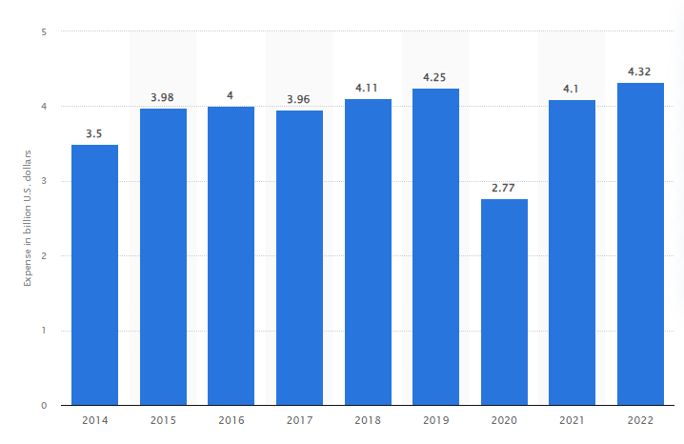
Figure: Coca-Cola Co.: Advertising Budget 2022
Source: (Ridder, 2023)
As per the above Figure, in 2022 Coca-Cola spent 4.32 billion USD on social media advertising. According to Ridder (2023), in 2023 in terms of fans, Coca-Cola ranked fifth on Facebook with almost 107 million user interactions. Currently, the YouTube channel of Coca-Cola has 3.28 billion views which showcases its strong CRM.

2.1.2 Theme 2: The Impacts of Social Media Platform Use on CRM Initiatives by Coca-Cola
The impacts of different social media platforms on CRM strategies create a high level of customer satisfaction and a positive brand image in a competitive market. Through platforms like Facebook, Instagram, Twitter, and TikTok Coca-Cola cultivate strong brand presence and consumer engagement. Promoting identifications of concerns and customer inquiries these platforms help Coca-Cola for further growth. As per Trivedi, and Malik, (2022), the social media strategy of this brand creates a two-way communication method to actively respond to customer feedback, messages, and comments. Social listening tools enable real-time marketing to monitor real-time social media conversations. Target ads campaigns by Coca-Cola through these platforms form meaningful relationships with customers to remain top of mind. Analysing data from these platforms allows the brand to understand consumers' choices, tailor new products, ensure marketing approaches, and identify market trends. This overall data-driven methodology improves the customisation of consumer experiences to boost the CRM frameworks. According to Angeloska-Dichovska, and Angeleski, (2020), Coca-Cola uses Salesforce, and SAP software to implement different strategies that fulfil consumer needs. The overall impacts are multifaceted and understand customer engagement, personalised experiences, and data-driven strategies to improve online reputation.

2.1.3 Theme 3: The identified challenges and opportunities regarding the use of social media platforms
Coca-Cola encounters both challenges and opportunities as it navigates the use of social media platforms for improved CRM. The major challenge involved with this platform is the effective handling initiatives of negative feedback and misinformation that can affect brand image. Swiftly spreading these channels, the brand can carefully balance between transparency and safeguarding overall market reputations. Inconsistent posting, low engagement, and no clear audience target create challenges for the brand. As per Chua, et al. (2020), in 2020 the company stopped all social media advertising and implemented stricter measures regarding social networks to reduce the impacts of inappropriate content on brand image. Managing the extensive data-generated content on social media Coca-Cola extracts valuable insights to employ robust analytics abilities. On the other hand, real-time engagement with customers helps the company to foster meaningful relationships with its target customer base. The various data analytics tools of different platforms facilitated target marketing and new product development opportunities. According to CRM theory, these initiatives improve brand profitability and streamline business processes for further improvements (Kim, and Jong-Chol, 2023).
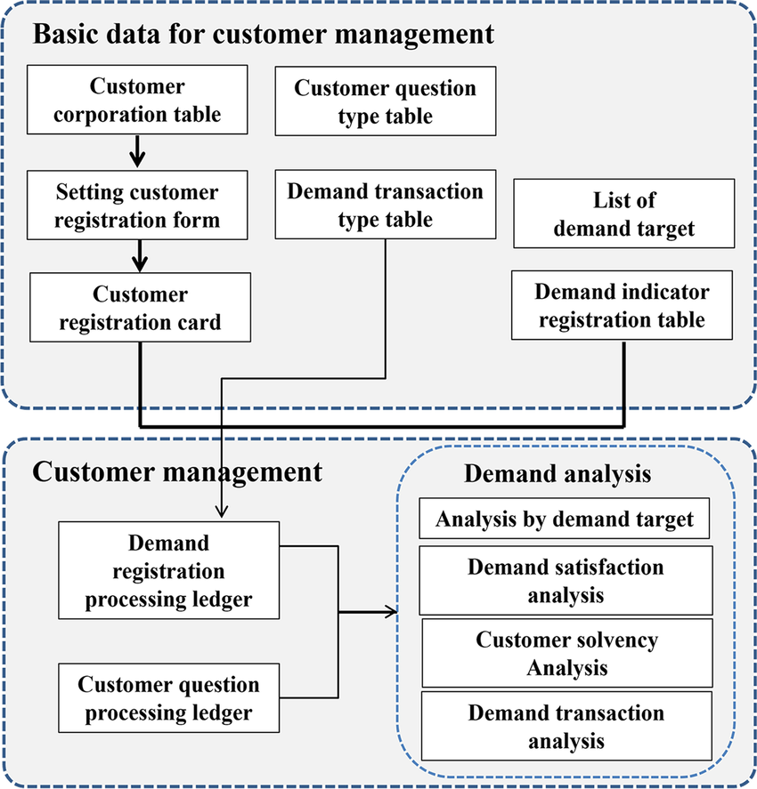
Figure: Information model of CRM system
Source: (Kim, and Jong-Chol, 2023)

2.2 Literature gap
The overall research study lacks a detailed examination regarding multinational cooperation that strategically incorporates social media into its CRM practices. While there is existing literature about social media platforms and CRM strategies a noticeable gap in understanding specific approaches faced by the brand (Aguda, 2023). A potential gap in leveraging social media this research identifies hurdles to provide unique insights. The effective interaction of these platforms can fill those gaps to mitigate concerns regarding literature review.

Chapter 3 Methodology

3.1 Research Philosophy
In the realm of the CRM strategy of Coca-Cola the positivist research philosophy relies on a quantitative data analysis approach. In this process, the company assess consumer data to understand the efficacy of consumer satisfaction levels (Alharahsheh, and Pius, 2020). It is prioritised through an understanding of the social perspective on the relationship between social media and CRM. Aligning with the quantitative nature of the research this philosophy analyses numerical data to uncover subjective nuances.

3.2 Research Approach
In this research study, the deductive research approach is applied to understand the hypothesis derived from existing CRM strategies in the organisation. In this approach, research data is collected to fine-tune strategies based on empirical evidence. The methodology chapter of this research will explore themes and patterns regarding research data with the help of a deductive research approach. This approach delves into some specific social media-centric CRM initiatives that will facilitate further research. (Proudfoot, 2023). The deductive approach emphasises flexibility and opens unexpected information to promote profound understanding.

3.3 Research Method
The quantitative research method presents a systematic approach that crucially gathers numerical data for further exploration of the topic. This method highlights subjective interpretation to analyse and uncover the rich. In this study, a quantitative research method will help to analyse various intricacies of social media-driven and consumer perspectives about CRM by Coca-Cola. Utilising primary data, survey results, content, and social observations this study will collect content-specific data for further research (Guha, et al. 2021).

3.4 Data Collection Method
Utilising a primary data collection method, this study will employ a valuable examination of the survey results conducted in this study about the brand Coca-Cola (Alam, 2021). This research mainly focuses on crucial insights into the participants' perspectives to understand their preferred CRM approaches by the company. The data will be collected through Google form and will take time of one week for the answers of the participants. This data collection method through the survey will create a solid understanding of social media platforms, business market trends, and related theories.
3.5 Sampling Size
This research study will collect valuable data related to the CRM strategy of Coca-Cola through a survey. In this survey, 50 participants will provide their viewpoints and perspectives about the topic-related questions. With 12 open-ended questions, this research will offer an in-depth understanding of the research topic. This sample will improve the statistical power of this research and ensure the feasibility of a comprehensive data collection method.

3.6 Data Analysis
In this study, the thematic analysis will promote systematic quantitative data investigation techniques (Kiger, and Varpio, 2020). This data analysis of gathered data sources of the survey involves identifying themes, and patterns, customers’ viewpoints that categorise for a thorough analysis of essential concepts. This analysis is mainly related to CRM strategies and the social media platform use of Coca-Cola. Data will be extracted from the survey results through information and promote interpretations of genuine research experiences.

3.7 Ethical Consideration
Ethical considerations, in this research, will manage the academic integrity of primary sources and maintain the confidentiality of all the participants. Effective evaluation of the reliability, and authenticity, of collected data sources in this research ensures overall accuracy (Hasan, 2021). By anonymising data, and safeguarding against unauthorised access the company maintain privacy and accountability in its survey practices.

Chapter 4: Resource and Planning

4.1 Timeline (Include a Gantt chart)
 | W  1 | W  2 | W  3 | W  4 | W  5 | W  6 | W  7 | W  8 | W  9 | W  10 | W  11 | W  12 | W  13 | W  14 | W  15 | W  16
Introduction
Literature Review

Research
Methodology
Creating the questionnaire
Collection of data
Analysis of data
Discussion/Data Interpretation
Conclusion and Recommendations
Discussion with Supervisor

Gantt Chart Source: (Self-Made)

Reference
Aguda, L.C., 2023. Enhancing Coca-Cola brand capacity building and its sustainability in the Turkish market environment (Master's thesis, İstanbul Gelişim Üniversitesi Lisansüstü Eğitim Enstitüsü). Available at: https://acikerisim.gelisim.edu.tr/xmlui/bitstream/handle/11363/7069/822154.pdf?sequence=1 (Accessed: 04 March 2024).
Ajala, O.I., 2021. An examination of the use of culture by Coca-Cola (Doctoral dissertation, Dublin, National College of Ireland). Available at: https://norma.ncirl.ie/5509/1/oladayoidowuajala.pdf (Accessed: 04 March 2024)
Alam, M.K., 2021. A systematic qualitative case study: questions, data collection, NVivo analysis and saturation. Qualitative Research in Organizations and Management: An International Journal, 16(1), pp.1-31. Available at: https://doi.org/10.1108/QROM-09-2019-1825 (Accessed: 04 March 2024)
Alharahsheh, H.H. and Pius, A., 2020. A review of key paradigms: Positivism VS interpretivism. Global Academic Journal of Humanities and Social Sciences, 2(3), pp.39-43. Available at: https://gajrc.com/media/articles/GAJHSS_23_39-43_VMGJbOK.pdf (Accessed: 04 March 2024)
Angeloska-Dichovska, M. and Angeleski, M., 2020. Customer relationship management (CRM)-how to build strong online relationships with customers. Horizons Series A, 27. Available at: https://www.researchgate.net/publication/366896587 (Accessed: 04 March 2024).
Armutlu, İ.İ., 2023. The Digital Era Effect on Brand Image and Brand Communication: The Coca-Cola Case Studies. In İletişim Bilimlerinde Son Yaklaşımlar (pp. 203-221). Özgür Yayın Dağıtım Ltd. Şti.. Available at: https://avesis.erciyes.edu.tr/yayin/524ce06f-ab57-4469-bc95-24957d67324c/medya-habercilik-alani-ve-sosyal-sermaye-iliskisi-tocqueville-putnam-ve-bourdieu-baglaminda-kuramsal-bir-inceleme/document.pdf#page=212 (Accessed: 04 March 2024).
Chaulagain, S. and Maharjan, S., 2020. Social Media as a Strategic Marketing Tool to Study the Consumer Behavior of Coca-Cola by K-Means Cluster Analysis: Evidence from Facebook. Available at: http://conference.ioe.edu.np/publications/ioegc8/ioegc-8-081-80111.pdf (Accessed: 04 March 2024)
Chaulagain, S., 2020. Facebook as a Strategic Marketing Tool for Understanding the Consumer Behavior of Coca-Cola by using K-Mean Cluster Analysis and Competitive Profile Matrix Model (Doctoral dissertation, Pulchowk Campus). Available at: http://elibrary.tucl.edu.np:8080/bitstream/123456789/7744/1/THE3423.pdf (Accessed: 04 March 2024)
Chua, J.Y., Kee, D.M.H., Alhamlan, H.A., Lim, P.Y., Lim, Q.Y., Lim, X.Y. and Singh, N., 2020. Challenges and solutions: A case study of Coca-Cola Company. Journal of the Community Development in Asia, 3(2), pp.43-54. Available at: https://doi.org/10.32535/jcda.v3i2.810 (Accessed: 04 March 2024).
Coca-Cola Canada (2020) Responsible social media principles, Coca-Cola Responsible Social Media Principles. Available at: https://www.coca-cola.com/ca/en/legal/responsible-social-media-principles#:~:text=We%20strive%20to%20work%20with,that%20promote%20hatred%20or%20division. (Accessed: 04 March 2024).
Guha, C., Viecelli, A.K., Wong, G., Manera, K. and Tong, A., 2021. Qualitative research methods and their application in nephrology. Nephrology, 26(10), pp.755-762. Available at: https://doi.org/10.1111/nep.13888 (Accessed: 04 March 2024)
Hasan, A., 2021. Ethical considerations in the use of secondary data for built environment research. In Secondary Research Methods in the Built Environment (pp. 26-39). New York, NY: Routledge. Available at: https://doi.org/10.1136/medethics-2020-106941 (Accessed: 04 March 2024)
Kiger, M.E. and Varpio, L., 2020. Thematic analysis of qualitative data: AMEE Guide No. 131. Medical teacher, 42(8), pp.846-854. Available at: https://doi.org/10.1080/0142159X.2020.1755030 (Accessed: 04 March 2024)
Kim, and Jong-Chol. (2023). Information system-theoretic view on the architecture of smart manufacturing systems: a case study in the Democratic People’s Republic of Korea. The International Journal of Advanced Manufacturing Technology. 126. 1-19. 10.1007/s00170-023-11193-8. Available at: https://www.google.com/url?sa=i&url=https%3A%2F%2Fwww.researchgate.net%2Ffigure%2FInformation-model-of-CRM-system-Source-Authors-drawing_fig4_369034878&psig=AOvVaw00Bhwtsfeif5EL9Ta4769Z&ust=1709625677452000&source=images&cd=vfe&opi=89978449&ved=0CBUQjhxqFwoTCMjpnYuS2oQDFQAAAAAdAAAAABAQ (Accessed: 04 March 2024).
Kumar, D.M., 2020. Marketing and its Application: Case Study of Ella Drinks Ltd: Comparative Analysis with Coca-Cola. Available at SSRN 3595239. Available at: http://dx.doi.org/10.2139/ssrn.3595239 (Accessed: 04 March 2024).
Proudfoot, K., 2023. Inductive/Deductive hybrid thematic analysis in mixed methods research. Journal of Mixed Methods Research, 17(3), pp.308-326. Available at: https://doi.org/10.1177/15586898221126816 (Accessed: 04 March 2024)
Ridder (2023) Coca-Cola Co.: Advertising Budget 2022, Statista. Available at: https://www.statista.com/statistics/286526/coca-cola-advertising-spending-worldwide/#:~:text=The%20Coca%2DCola%20brand’s%20image,views%20accrued%20by%20the%20channel. (Accessed: 04 March 2024).
Statista (2023) Brand Kpis for soft drinks: Coca-Cola in the U.S.​, Statista. Available at: https://www.statista.com/study/146974/brand-kpis-for-soft-drinks-coca-cola-in-the-us%25E2%2580%258B/#:~:text=It%20evaluates%20the%20brand’s%20performance%20across%20five,values:%20awareness%2C%20popularity%2C%20usage%2C%20loyalty%2C%20and%20buzz. (Accessed: 04 March 2024).
Terrell, S.R., 2022. Writing a proposal for your dissertation: Guidelines and examples. Guilford Publications. Available at: https://books.google.com/books?hl=en&lr=&id=7DGDEAAAQBAJ&oi=fnd&pg=PP1&dq=secondary+dissertation+limitation+&ots=PFg1fYdgd3&sig=YWDQHMua14cln51ZI_SqWkopm8o (Accessed: 04 March 2024)
Trivedi, S. and Malik, R., 2022. Social Media Marketing as a New Marketing Tool. In Research Anthology on Social Media Advertising and Building Consumer Relationships (pp. 18-33). IGI Global. Available at: https://www.researchgate.net/profile/Reena-Malik/publication/361074521_Social_Media_Marketing_as_New_Marketing_Tool/links/6364ebec54eb5f547ca26654/Social-Media-Marketing-as-New-Marketing-Tool.pdf (Accessed: 04 March 2024).
Ugwu, Chinyere and Eze, Val. (2023). Qualitative Research. 8. 20-35. Available at: https://www.researchgate.net/publication/367221023_Qualitative_Research/download?_tp=eyJjb250ZXh0Ijp7ImZpcnN0UGFnZSI6Il9kaXJlY3QiLCJwYWdlIjoiX2RpcmVjdCJ9fQ (Accessed: 18 March 2024)

