Mohammed Jahirul Haque Torofdar (1714787)

Effective Team Work and Communication
BMSK4002
HEALTHY FOODS LTD

Contents
Introduction 2
Effective team working and communication: Literature review 3
Knowledge and understanding of the subject 4
How well employers perform at communicating: real-life experience 6
Practical application and development 7
Skills for professional practice 8
Conclusion 10
References 11

Introduction
Communication refers to the process of disseminating information from one person to another or to many through some kind of media. The process can be oral, written or gestural. The media can be face-to-face, telephone, radio or any other means. Communication is there in every sphere of our life. The civilization is based on communication among different people(Van Emden & Becker, 2010). However, in a business context, communication carries some extra importance. The businesses must be effective in communicating to be successful. Especially, the businesses require effective teamwork, which is directly subject to effective communication (Jackson, 2011). In this report, the subject – communication will be explored in details. Using real-life experience, the importance of communication in business context will be explained. At last, some firm conclusion will be drawn about how to communicate effectively.

Effective team working and communication: Literature review
Team working refers to the phenomenon where more than two people group together to achieve a similar objective within a timeframe. Making the team working effective requires many other things like effective communication. Communication refers to the process of exchanging views and ideas with the help of mutually understood language (Worth, 2014). And effective communication refers to the process of communication, which imparts the exact message within shortest possible time and leads to immediate action. Effective communication is the precondition for a business to be successful by communicating its strategies, goals, targets and values (Wilkins et al., 2015).
There are many ways to communicate a message to the intended party. Speaking, writing, gesture etc. are some of the ways. The ways are appropriate in different circumstances differently. However, Jackson (2011) told that written communication is superior to all others in a business context. But Cottrell (2010) emphasizes a blend of written and verbal communication.
Chan (2012) clearly discusses the importance of communication in a business context citing the necessity of communicating all the business decisions throughout an organisation. According to him, not communicating effectively throughout the organisation is in turn inviting failure of the same. Therefore, the companies shall always put an effort forward to improve communication process.
There are different models and theories to improve the communication process in any organisation. Lasswell’s Five W’s model provides an idea about how to improve the communication effectively. The model first identifies the sender of the message followed by the message identification. Then the model shows the medium and points the receiver. Finally feedback, help to improve the whole process. This dissection of the communication process can help making the process effective (Dalley and Burton, 2010).

Knowledge and understanding of the subject
A business consists of different departments like production, marketing, investment, human resource etc. Moreover, there are different levels of management in a company. For example, top-level management, mid-level and low-level management. There has to be a combination, a cooperation among all these departments and all the managers and employees. Effective communication underlies the cooperation among the departments and managers (Gopal, 2014). The managers communicate the strategies, targets and goals to different departments. The communication must be effective. Because any distortion in communication might cost a company big.
An example could make the importance of effective communication clearer. Healthy Foods Ltd. is experiencing quality issues. The customers are complaining repeatedly about the quality of foods, service quality, and nutritious facts of the products. The demand is slackening apparently for the quality issue. The concerned top-level management investigated and found out that the problem is with the supply system. They hold a meeting with the suppliers with the company maintains a long tie. The MD of Healthy Foods Ltd. told the suppliers to supply quality raw materials at any cost. But unfortunately, the speech of the MD didn’t seem to be a request rather a threat. The offended suppliers increased the price in the name of better quality but even supplied low grade materials. The offending behaviour which in turn is ineffective communication cost the company even more.
However, to understand the communication process and to communicate effectively, it is essential to understand the process and modes of communication.
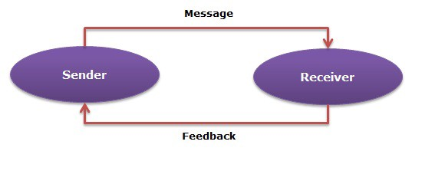
Figure 1: Communication process (Source: Bekki, 2015)
The process of communication, in simplest terms, starts with the sender sending a message. The message is received by the receiver who sends feedback afterwards. The sender should then observe the feedback in order to determine the effectiveness of the communication.

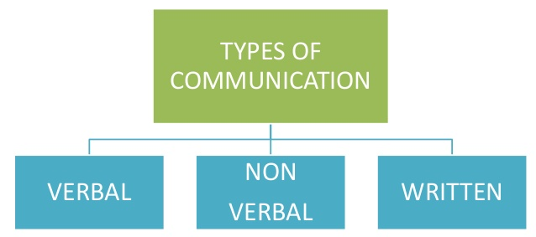
Figure 2: Communication modes (Source: Worth, 2014)
The modes of communication can take different forms like verbal, non-verbal, written. All the modes are useful in different circumstances. Verbal communication refers to oral communication. Non-verbal includes gestures, facial expressions, hand movements etc. Written communication includes the reports, documents etc. Any combination of these can be used to make the communication effective (Perry, 2013).

How well employers perform at communicating: real-life experience
Carter is a quality inspector in Healthy Foods Ltd. The company produces different consumer foods including fast foods, chips, soft drinks etc. In the local market, the company has huge demand. This company will be used to assess the communication effectiveness of the employers.
Healthy Foods Ltd. is an opportunity employer. The managers and leaders follow democratic leadership in the company. The employees from even root level has the opportunity to participate in the decision-making process. The top-level management of the company is very strict with the quality of the products. Therefore, the company always focuses on the satisfaction of the employees. Because the employees are the main factor of their production. However, the company arranges meetings with the employees on a regular basis. Seminars, motivations, brainstorming sessions etc. are very common in this company. The top-level management believes that satisfied and loyal employees will bring out the best efforts of themselves and will serve the company goal of maintaining best quality. Therefore, the top-level management continuously communicate the quality measures. In the seminars, the managers articulate repeatedly that the employees are the main asset of the company. This makes the employees feel better. However, after all the employers and top-level managers have created an impression of awareness among the employees by its leadership style, and continuous effective communication.
However, there is another side of the company in which it failed to communicate effectively which caused certain types of distortion. This is the supply side. The suppliers of Healthy Foods Ltd. suddenly for some reasons stopped supplying quality raw materials as before. The top-level management should have negotiated with the suppliers softly. But they didn’t communicate effectively and seemingly threatened the suppliers. This backfired and the company felt the pinch of ineffective communication.
From the real-life experience it can be said that effective communication brings better results for a company easily on the other hand ineffective communication can bring tremendous effects (Rai and Rai, 2015). Therefore, the employers shall try to communicate effectively in all the spheres of business.

Practical application and development
Below figure will help to understand the practical communication process throughout Healthy Foods Ltd.
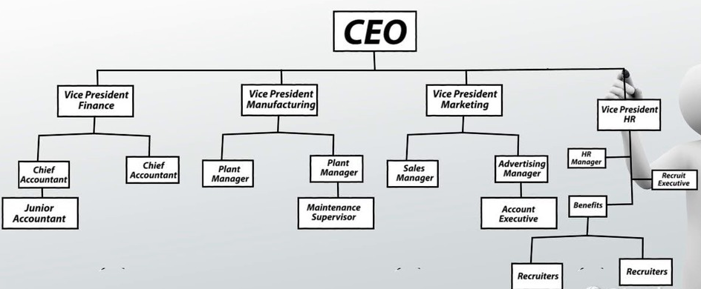
Figure 3: Communication Hierarchy (Source: Sennewald and Baillie, 2016).
Healthy Foods Ltd. applies the common communication hierarchy across the organisation. On the top of the hierarchy, the CEO stays. Below him vice presidents of different departments stay. Below them the mid-level managers exist. Low-level managers stay below the mid-level manager and under the low-level manager, the workers work. This communication hierarchy model suggests that chain of command must be maintained at any cost. The workers report to the supervisors who report to the mid-level managers who report to the top-level manager. The obvious rule of this model is that the workers cannot directly contact the vice presidents without the supervisors and mid-level managers knowing (Barker and Gaut, 2012).
But Healthy Foods Ltd. faced problems for following this model. One day, there was a workplace related issue, which caused the production department to be almost shut down. One worker jumped over the supervisor and mid-level managers to contact with the vice president. The worker complained about his supervisor: the supervisor was not treating him well. Then the top-level manager accused the supervisor both for his rude behaviour and for letting the worker reach him directly. However, the vice president summoned the supervisor to hold a face-to-face meeting. During the meeting, in absence of the supervisor, the workers grouped to protest the rudeness of the supervisor. The production department was shut down automatically. The vice president later on found in the investigation that the supervisor was very rude with the employees and for the set communication system, the workers were not able to surpass the supervisor ever. Therefore, the employees of the production department particularly were dissatisfied. However, other policies like seminars, meetings etc. worked with other departments except the production department.
Healthy Foods Ltd. shall keep a voice of the workers in all the departments to tackle these kinds of issues. The communication process shall be modified and developed to adopt the changes.

Skills for professional practice
However, for the professionals, there are some communication skills which ensure effective communication in the professional career. Below are some of them:
Listening carefully: The professionals should listen very carefully during communication sessions to understand the message of the counterpart and to determine the next message of himself. When somebody feels that the person he is talking to is sincerely listening, that somebody felt comfortable(Worth, 2014). This will make the communication process for the professional effective.
Non-verbal communication: Non-verbal communication plays an important role in imparting the message properly. Gestures, attitude, eye contact, hands movement etc. defines the expression of the message being communicated. Professionals must be trained to produce proper non-verbal communication (Karsten, 2009).
Friendliness: A professional must create an impression to the counterpart that he is friendly to them. Friendliness makes the communication process effective. Unfriendly messages have a little chance to get heed.
Confidence: Confidence of the communicator is important in communication process. A word articulated with confidence gets greater attention. Effective communication requires the professionals to be confident while talking.
Clarity and concision: The message delivered must be clear itself and it should be concise as well. Unclear message might carry a distorted meaning which might cause the communication process to be ineffective (Wilkins et al., 2015).
However, there are many other communication skills as well. Some of these skills are acquired and some of them are innate.

Conclusion
It can be concluded from the above report that effective communication is the bloodline of effective team working. And effective team working brings the success for the companies. However, companies shall follow the theories of communication to build the basic of its communication process. But it is a good idea to modify the model according to the unique necessity of the company. This will help the company to handle different situation effectively. As it is observed in Healthy Foods Ltd.’s case, the company should give a voice to all. It is clear that effective communication can prevent many unexpected and unnecessary situations within an organisation.

References
Barker, L. and Gaut, D. (2012). Communication. Needham Heights, MA: Pearson Professional Education.
Chan, J. (2012). Communication skills for managers. [New York]: American Management Association.
Cottrell, S. (2010) Skills for Success: The Personal Development Planning Handbook (2nd edition). Hampshire: Palgrave MacMillan.
Dalley, D., and Burton, L. (2010). Developing your Influencing Skills: How to influence people by increasing your credibility, trustworthiness and communication skills Universe of Learning Ltd.
Gopal, N. (2014). Business communication. New Delhi: New Age International.
Jackson, S. (2011). Diversity in the workplace. Guilford Press.
Karsten, M. (2009). Gender, race, and ethnicity in the workplace. Westport, Conn.: Praeger Publishers.
Perry, I. (2013). Safety puzzles for the hospitality industry. Amherst, Mass.: HRD Press.
Rai, U. and Rai, S. (2015). Effective communication. Mumbai [India]: Himalaya Pub. House.
Sennewald, C. and Baillie, C. (2016). Effective security management.
Van Emden, J. & Becker, L. (2010) Presentation Skills for Students (2nd edition). Palgrave Macmillan.
Wilkins, K., Bernstein, B. andBekki, J. (2015). Measuring Communication Skills: The STEM Interpersonal Communication Skills Assessment Battery. Journal of Engineering Education, 104(4), pp.433-453.
Worth, R. (2014). Communication skills. New York: Ferguson.

