To use labstats on SoAC:

- Go to https://remotepc.uwtsd.ac.uk
- Login using your email address and university password for Moodle, email etc.
- Find the IQ building picture, click on Dashboard
- In the left-hand side of the window, browse to the lab you want, from the right-hand side of the window, click on a PC and choose Connect
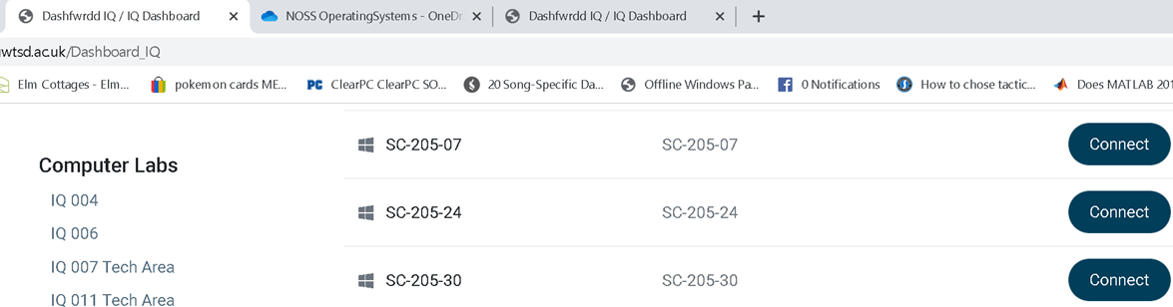

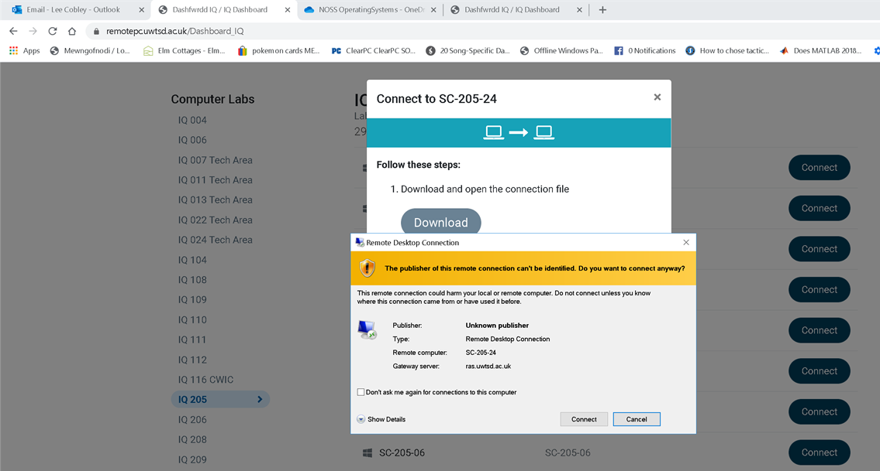

- Click Download BUT DO NOT YET CLICK CONNECT, INSTEAD CLICK CANCEL and then close the Remote Desktop Connection window that overlays this one (shown above). The RDP file we've just downloaded needs to be edited.
- Go into your Downloads folder (in Windows) and find the RDP file (in the instance above it is SC-205-24).
- Right click the file and choose Edit.
- Go to the Advanced tab, click on the Settings button and make sure the options look like this: It is important that the Use my RD Gateway credentials for the remote computer is checked off (see my example in the screen shot below)
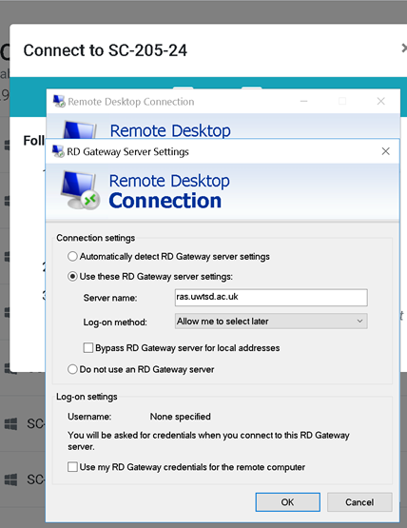

- Click Ok and then Connect.
- When prompted enter your full uni email address and password.
- You should now receive a MFA notification from Microsoft Authenticator on your mobile phone, approve this as you usually do.
- Now, you will be prompted again in Windows for your SoAC login details.
- This time click More Choices, then click where it says Use a Different Account enter your SoAC username and password: e.g. soac\s1092834 and your password (usually 123456), again see my example below for my account
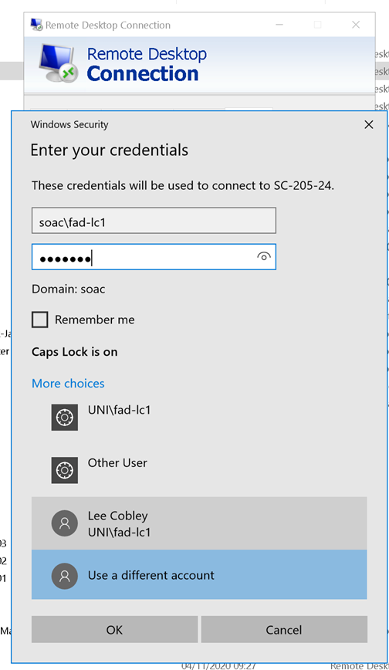

- Choose Ok Connect and Accept any further connection prompts.
- You should now be logged into the SoAC system.

