Ben Shepherd
2419241@student.uwtsd.ac.uk
ACBA 5019 Assignment
Construction Technology 2

Contents
Introduction 2
Site Analysis and Environmental Factors 3
Environmental Factors 3
Site Analysis 4
Structural Frame Option 6
Reinforced Concrete Frame 6
Structural Steel Frame 6
Composite Steel Frame with Reinforced Concrete Core 7
Foundations 7
Structural Performance / Fire Considerations 8
Building Envelope 8
Building Envelope Requirements 8
Roof Construction 9
Prefabrication & Onsite Construction 9
Benefits of Prefabrication 9
Hybrid Approach 10
Sustainability and Environmental Impact 10
Low Embodied Carbon Materials 10
Water and Waste Management 11
Architectural Concept and Aesthetic 11
Conclusion 12
Reference list 12

Introduction
This report has been prepared to advise the client on the appropriate construction technologies for the 8 story, luxury hotel proposed to be built near to the Singleton Hotel in Swansea. Due to the inexperience of the client knowledge surrounding construction technologies, this report should highlight the importance of durability, design, and manufacture quality to ensure that the customers experience luxury within the hotel.
The document provides an insight into some of the methods that are potentially suitable for this project and can therefore help guide the client to an appropriate decision due to their initial lack of knowledge. This will include the foundations and frame type of the building material use within and how the construction may occur on site or if it may be prefabricated due to the level of quality required, whilst also looking into the performance of each element considered making sure that the building is up to modern standards.
An additional insight which this report will bring attention to the client is relating to the coastal climate of the Swansea area and Figure 1 showing where the site will be, will incline some choices to be more suitable than others. This will be a benefit for the client due to the appropriate choice of material, structure and fabrication for the building will improve the longevity of the luxury hotel status without needing frequent maintenance.
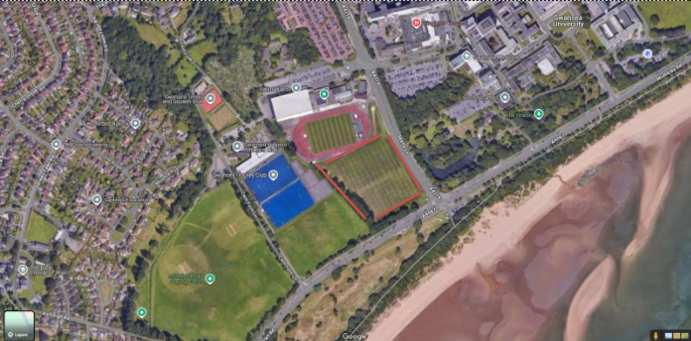

Figure 1 – Red Area of site

Site Analysis and Environmental Factors

Environmental Factors
Looking at figure 1, the site is located close to the Swansea Bay meaning that environmental factors need to be considered more due to them having a higher effect on buildings in this region.
The climate conditions of Swansea bay are more extreme than if you were located further in land away from the coast. In this location near to the Singleton Hospital, atmospheric salt levels are higher, exposure to more extreme winds from coastal gusts due to lack of protection from human or natural barriers being located on coast, high volumes of precipitation than UK average.
Swansea Bay receives 1022 of precipitation annually which is significantly higher than majority of England places at 600-800mm annually as seen in figures 2 &3 (Current Results, 2010). This can have an increased weathering effect making the discussion around material choice more important to improve quality and longevity.
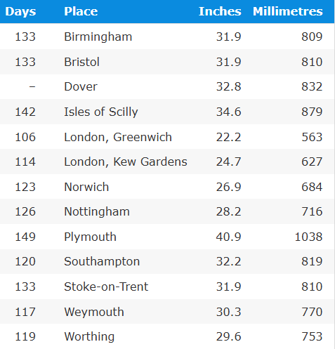

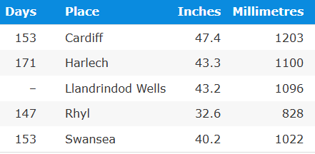

Figure 3 – Wales Precipitation

Figure 2 – England precipitation

Site Analysis
The proposed ground area for the construction in figure 1 near to Singleton Hospital would need a ground investigation to determine the ground makeup. At this moment in time, we have not got a borehole on the site itself however we can predict the ground makeup by looking at the boreholes from the Singleton Hospital as seen in figure 5.
Additionally, we would need to look at bomb surveys and check if there are any abandoned coal mines near to the area due to underground stream causing erosion of sediment which can then increase the risk of collapse.
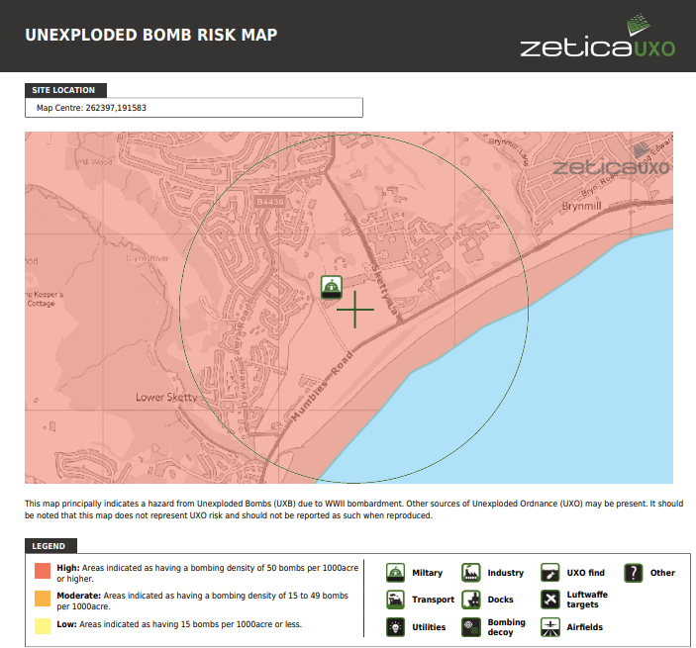
The bomb surveys are required especially in this region due to the Swansea Blitz in WW2 and Figure 4 suggest that there is an elevated risk making this an increased potential problem.

Figure 4 – Unexploded Bomb Risk Map
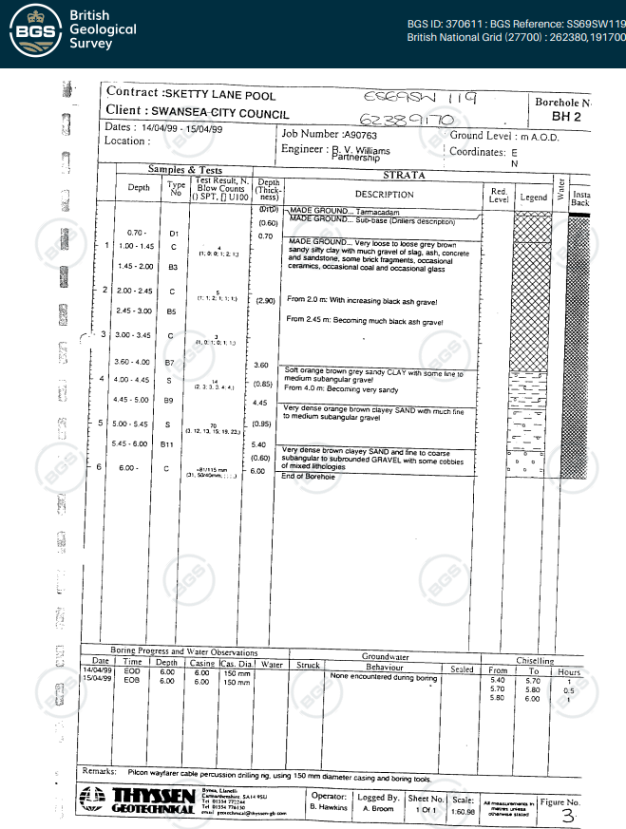
Figure 5 – Borehole from Singleton Hospital

Structural Frame Option
For this site, the choice of frame will be important to allow us to get the luxury feeling of the building whilst also have the strength to deal with the harsh conditions of the surrounding environment. This balance in design and practicality become more decisive the more the client wants to adapt the building to the required needs as it needs to offer more than just a place to rest.

Reinforced Concrete Frame
For the eight-story building the heavy structure may become an issue due to the increasing foundation loads which may have to be dug deeper to withstand this mass. A positive about the use of the reinforced concrete frame is that its excellent fire resistor and noise absorber helping to strengthen the building application for the development of the hotel (The Concrete Centre, 2019). Additionally, due to the location of the building being near the coastal regions, the saline conditions have a minimum corrosion risk, and the stiffness of the frame helps to mitigate the forces of the coastal gusts offshore (jonnyhough, 2025).

Structural Steel Frame
Steel frame is a more suitable construction frame for the 8-story building due to its high strength to weight ratio making it suitable for taller buildings because you do not put as high of a load onto the foundations. Prefabrication is a massive positive over concrete due to the speed and quality in which the frame can be constructed (Techsteel, 2025). This allows for a shorter construction phase which Is better in terms of a health and safety perspective as there will be a shorter window for risk to occur. The coastal environment is harsh against the steel frame if not protected correctly in terms of coating or some areas being exposed to the saline conditions. Additionally, the steel will need coatings to increase the fire protection to meet the regulations of the building.

Composite Steel Frame with Reinforced Concrete Core
The use of Composite steel frame with the reinforced concrete core helps take both advantages of both frame and combine them into an integrated system. The steel beams help to provide adaptability for the building which amplifies the luxury demands from the client whilst also being a strong skeletal frame for the building. The concrete cores help to provide rigidity against the strong coastal gusts coming from the Swansea Bay directly into the face of the hotel, which has an increased effect the more stories we have. The concrete and the composite metal sheets for the flooring at each level help make up for the steels poor fire resistance as both are excellent in repelling this making this the appropriate method of frame for the hotel. This hybrid approach helps to use both positives of each material and mitigate their weaknesses. This make it more efficient to be built, greater fire resistance due to multiple layers, overall strength and for the client gain, cost effectiveness due to the reduced volume of steel required (LLC, 2021).

Foundations
By looking at the boreholes from the surrounding area in figure 5, this gives us an initial perspective that deep foundations will be required to create a durable base to build upon. CFA (continuous Flight Auger) Piles, with a 600-900mm diameter, would be a strong method to reach firm sandstone at around 15-25m (Keller, 2018). Pile caps will be added to these to help distribute the weight of the building evenly throughout each pile to make sure that there is no overloading and potential chance of failure (Prasad, 2019). Additionally, the lowest story of the hotel would require increased waterproofing membrane due to the location of the hotel having an increased volume of ground water potentially having an effect of reaching and damaging this level. By having this setup for the foundations will ensure long term stability and helps to mitigate any risks when constructing on this type of ground in this location near to the coast.

Structural Performance / Fire Considerations
When looking at fire considerations and the structural performance in this situation, the hotels structure should be suitable to withstand 2 hours of fire resistance. This period allows for a safe evacuation of all personnel in the building and for the emergency services to reach the site. This would be through the concrete encasement of the core and coating of the steel work to withstand fires for 2 hours whilst also trying to encase it to one part of the building and stop it spreading. Wind loading analysis would also be required using BS EN 1991-1-4 which would consider wind gusts up to 45m/s for buildings up to 200m (Bsigroup.com, 2025). This would therefor require the structural frame to have an appropriate shape and flexibility which is suitable for this demand. If there may be an anomaly in terms of the gusts, which is especially likely due to the climate change impacts occurring on storms annually, the structural frame will need to progressively collapse instead of total failure at once through purpose break points built into the structure.

Building Envelope

Building Envelope Requirements
When constructing a new build in Wales, the building envelope must meet some requirements in quality to ensure its suitable for living within. As mentioned above fire safety and compliance is required, acoustic insulation between rooms, aesthetic quality, high thermal performance, and resistance to driving wind and rain to stop corrosion. By having these standards set high for the building will maintain its prestigious of the hotel being classed as luxury and will make it more in demand.
An example of meeting this would be by introducing double or triple Glazed windows filled with argon, instead of single glazed. This implementation helps significantly with the building envelope as this will increase the u-value efficiency of the hotel significantly and acoustic insulation from the exterior, which will be higher than normal due to being close to the coast. A 60:40 ratio of glazing and cladding is to be used on the building to help control daylight energy savings and the visual benefit of the hotel. This allows some aesthetic design to be implemented into the build to give the hotel its distinctive luxury look whilst still being practical.
Continuous air and vapour barriers will be installed across the building to prevent condensation forming in the wall cavity. This will help increase the longevity of the building whilst also preventing mold or damp to occur inside the building which is negative for the standard set by the hotel.

Roof Construction
The roof chosen for the hotel is to be a flat insulated roof, angled to help dissipate the wind and rain coming from the coast. This roof will require a reinforced concrete deck, vapour control layer, and PVC membrane to help protect any damage that could potentially occur from the eternal harsh conditions that are going to be present (O’Shea, 2025). A potential green roof could also be included into the design as this would help with drainage and aesthetically giving the hotel a unique look whilst also prolonging the lifespan of the flat roof beneath making it a cost effective solution to install (Green Roofers, 2016).

Prefabrication & Onsite Construction

Benefits of Prefabrication
The advantages of choosing prefabrication are that the construction phase of the building is faster due to the frame being ready to install as soon as the foundation piles have been installed. For the luxury hotel, the quality Is necessary and prefabrication offer this due to the factory conditions compared to on site construction being suitable for getting almost perfect results with smaller waste volumes also (LetsBuild, 2022b) . This is beneficial due to the costs of the steel frame for example being cheaper as the appropriate amount of steel will be used instead of having to cut and fix on site (vs-akpfuabtrqij-86393, 2025). HSE also propose prefabrication methods as it is safer to construct and deliver to site rather than having to weld at height on site causing another potential risk. Examples of suitable prefabrication area for the hotel are Steel frame, precast concrete planks, bathroom pods for each of the rooms. On Site construction components that would not be suitable for prefabrication are pile foundations, Roof waterproofing / plant installation, and landscaping.

Hybrid Approach
By combining the use of both methods of construction in their own suitable ways will help benefit rather than hinder the project of the hotel. By completing on site construction of groundworks and core and using prefabrication for structural and fit out elements of the build should result in a quick, accurate project with minimal disruption keeping costs down.

Sustainability and Environmental Impact
For the proposal of the new luxury hotel, its aims are to excel in every potential area and with the fact that it is a new build, it will be required to meet new regulations being proposed to meet NetZero. By considering the elements being installed into this construction project in terms of sustainability and environmental perspectives will help reach these targets more easily. The hotels target is to receive BREEAM Excellent which will need to consider the water conservation, waste minimalization, energy efficiency of the building and reduced embodied carbon in material installed (Encon Associates, 2024).

Low Embodied Carbon Materials
The frame used in the hotel is going to be a composite steel frame with the reinforced concrete core. We need to make sure that the frame still will do its job appropriately whilst also considering that there is a significant amount of embodied carbon being stored. To help reduce this value in this area we can use recycled steel which costs 800kgCO2e/tonne compared to virgin steel which costs 2800kgCO2e/tonne. (Hadley Group, 2024). Low CO2 cement substitutes such as fly ash, help reduce embodied carbon levels by 56.02% (Yang, Dong and Wang, 2025). These methods are going to help significantly with the reduction in embodied carbon within the frame of the building, allowing more luxury aesthetic higher embodied materials to be implemented inside for visitors.

Water and Waste Management
Integrating appropriate water management into the hotel is vital for an excellent BREEAM score. Rainwater harvesting near to the coast is an appropriate method which can be combined with the use of grey water recycling for toilets to help cut down on total water use due to clean new water not being used, therefor not adding to the water bill by 40-50% of the mains water usage increasing efficiency (UK Water Reuse Association, 2025).
Waste management segregation should be implemented appropriately to encourage recycling. As the new build is going to be a hotel, there is going to be significant waste compared to other building of this scale as there are going to hundreds of people producing waste day to day. This make it more important to manage this waste as the building will be held to high standards and this could cause it to lose its luxury or excellent reputation.

Architectural Concept and Aesthetic
The aim for the 8-story hotel is to be a sleek, modern looking hotel that can represent Swansea regeneration of the SA1 area. As mentioned previously there is going to be a window to cladding ratio of 60:40 adding to the modern look whilst also having benefits to enhance the buildings performance. The use of appropriate glass, metals and cladding in the right shape and ratio should portray into a luxury and modern outcome which makes visitors excited to visit due to the standard of class represented with it.
The shape of the building is to be distinctive to the surrounding area whilst also having its purpose to dissipate any energy brought from the coast in terms of wind so that the experience is better for the visitors attending.
Landscaping of the surrounding area, with the implementation of green areas across the build including the roof helps to dull down the sharp edges of the building helping it integrate into the surrounding area whilst also being distinctive.
Appropriate lighting will be used to clearly show and help people migrate through and around the building clearly as there are going to be multiple uses in terms of facilities which are going to be in use every day.

Conclusion
The proposed 8 story hotel in Swansea demands a structural envelope hat balances aesthetics, sustainability, and performance to the highest levels to reach its luxury standard.
The recommended composite steel frame with concrete core is to be proposed so that it can withstand the harsh coastal conditions of Swansea Bay, whilst also having the speed minimalised in the construction phase. Piled foundations are also going to be used to reach the firm sandstone layers to allow for a firm base to build upon due to the mass being applied on the ground.
The installation of sustainable but luxury methods within the services and plant in the building is to be used so that the standard of living is to meet the highest level for the visitors attending.
By combining this all together should result in the luxury appeal to the client ensuring that the building performs safely and sustainability throughout its lifecycle.

Reference list
Bob (2025). Fly Ash Vs Cement: A Comprehensive Guide To Sustainable Building Materials - ConcreteCaptain.com. [online] ConcreteCaptain.com. Available at: https://concretecaptain.com/fly-ash-vs-cement/ [Accessed 6 Jan. 2026].
Bsigroup.com. (2025). BS EN 1991-1-4 - Eurocode 1. Actions on structures. General actions. Wind actions. [online] Available at: https://landingpage.bsigroup.com/LandingPage/Undated?UPI=000000000030206733 [Accessed 6 Jan. 2026].
Current Results. (2010). Average Yearly Precipitation in the United Kingdom - Current Results. [online] Available at: https://www.currentresults.com/Weather/United-Kingdom/average-yearly-precipitation.php [Accessed 28 Oct. 2025].
Encon Associates. (2024). How to Achieve BREEAM Excellent Certification | Encon Associates. [online] Available at: https://www.enconassociates.com/blog-insights/how-to-achieve-breeam-excellent-certification/ [Accessed 6 Jan. 2026].
Green Roofers (2016). Advantages and Disadvantages of green roofs. [online] Green Roofers. Available at: https://www.greenroofers.co.uk/green-roofing-guides/advantages-disadvantages-green-roofs/ [Accessed 6 Jan. 2026].
Hadley Group. (2024). Low Embodied Carbon Steel EPD - Hadley Group. [online] Available at: https://www.hadleygroup.com/environment-and-sustainability/low-embodied-carbon-steel-epd/ [Accessed 6 Jan. 2026].
jonnyhough (2025). Cracks due to reinforcement corrosion | Concrete Society. [online] Concrete Society. Available at: https://www.concrete.org.uk/fingertips/cracks-due-to-reinforcement-corrosion/ [Accessed 6 Jan. 2026].
Keller (2018). CFA piles (auger cast). [online] Keller Group plc. Available at: https://www.keller.com/expertise/techniques/cfa-piles-auger-cast [Accessed 6 Jan. 2026].
LetsBuild (2022a). Ten benefits of prefabricated construction. [online] Aproplan. Available at: https://www.aproplan.com/blog/ten-benefits-of-prefabricated-construction [Accessed 6 Jan. 2026].
LetsBuild (2022b). Ten benefits of prefabricated construction. [online] Aproplan. Available at: https://www.aproplan.com/blog/ten-benefits-of-prefabricated-construction [Accessed 6 Jan. 2026].
LLC, E.S. (2021). ESC Steel LLC. [online] ESC USA and Canada. Available at: https://www.escsteel.com/post/steel-concrete-composite-construction [Accessed 6 Jan. 2026].
O’Shea, C. (2025). Flat Roof Systems Compared | TriRoof. [online] Tricel Composites. Available at: https://www.tricelcomposites.co.uk/construction-and-building/flat-roof-systems-compared/ [Accessed 6 Jan. 2026].
Prasad (2019). Pile Cap Design. [online] Structural Guide. Available at: https://www.structuralguide.com/pile-cap-design/ [Accessed 6 Jan. 2026].
Techsteel. (2025). How Long to Build a Steel Frame Building? | TechSteel. [online] Available at: https://techsteel.com.au/articles/how-long-does-it-take-to-construct-a-steel-frame-building/ [Accessed 6 Jan. 2026].
The Concrete Centre (2019). Fire resistance. [online] www.concretecentre.com. Available at: https://www.concretecentre.com/Performance-Sustainability/Fire-Resistance.aspx [Accessed 6 Jan. 2026].
UK Water Reuse Association. (2025). Rainwater Harvesting | UK Water Reuse Association (UKWRA). [online] Available at: https://www.ukwra.org.uk/rainwater-harvesting [Accessed 6 Jan. 2026].
vs-akpfuabtrqij-86393 (2025). Prefab vs On-Site Construction: Which Saves More Money? [online] Steelframestructure.com. Available at: https://www.steelframestructure.com/prefab-vs-on-site-construction-which-saves-more-money.html [Accessed 6 Jan. 2026].
Weather and climate (2024). Welcome To Zscaler Directory Authentication. [online] Weather-and-climate.com. Available at: https://weather-and-climate.com/average-monthly-precipitation-Rainfall [Accessed 28 Oct. 2025].
Yang, B., Dong, Y. and Wang, X.-Y. (2025). Analysis of the Strength Development, CO2 Emissions, and Optimized Low-Carbon Design of Fly-Ash-Enhanced Composite Concrete. Buildings, 15(4), pp.532–532. doi:https://doi.org/10.3390/buildings15040532.

