Case study report

Module: Psychology for Health and Social Care (BMHP4003)
Name: Corina Radu
Student ID: 2117956
Lecturer: Alice Clayton

Contents
Introduction 3
Psychological theories 3
Social identity theory 3
Theory of Planned Behaviour 4
Frustration Aggression Hypothesis 6
Development of and support plan 7
Conclusion and recommendations 8
References 10

Introduction

The current report, prepared for Youth Offending Team (YOT), will present the case of a young individual, Gareth Jones, recently released from the Parc Young Offenders Institute and noticed with aggressive behaviour and a lack of adherence to college classes. Based on psychological theories, Gareth’s behaviour will be explained, followed by the development of and support plan for Gareth, to be followed within the next period.
Theories that will be linked with the case study are the social identity theory, theory of planned behaviour and frustration-aggression hypothesis. By applying the theories to Gareth Jones’s behaviour, the root causes of its behaviour will be determined to develop a plan and make recommendations.

Psychological theories

Social identity theory

Henri Tajfel's greatest contribution to psychology was social identity theory. Social identity is a person’s sense of their identity based on their group membership(s).
Tajfel (1979) proposed that the groups (e.g., social class, family, football team etc.) to which people belonged are important sources of pride and self-esteem. Groups give us a sense of social identity: belonging to the social world.
Thus, the world becomes divided into “them” and “us” based on a process of social categorization (i.e., we put people into social groups).
Tajfel and Turner (1979) proposed that there are three mental processes involved in evaluating others as “us” or “them” (i.e., “in-group” and “out-group”. These take place in a particular order.
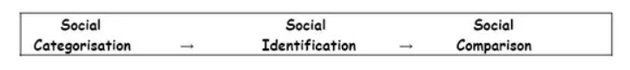
Figure 1: Social Identity Theory (Tajfel and Turner, 1979)
Discussing the case study, Gareth was noticed as being associated with individuals known by police, and he was involved with them before his conviction, considering them his in-group. Thus, this group was a source of Gareth’s pride and self-esteem, determining him to copy the negative behaviours: motoring offences and drug possession to sell them. The out-group, from Gareth’s perspective, is YOY, considering them to be controlling and restricting. Furthermore, YOT is considered by Gareth the authority that might influence his return to prison.
According to Reicher et al. (2008), it is important to understand the relationship of “in the group” (what is Gareth’s relation with the group members) rather than focusing on Gareth’s behaviour “out of the group”. The needs fulfilled by this group for Gareth need to be understood to identify alternative ways to achieve these needs with desirable behaviour.

Theory of Planned Behaviour

Developed by Fishbein and Ajzen in the 1970s, the theory is also known as the theory of reasoned action, stating that any behaviour will occur based on the previous intention. In contrast, intention is determined by personal attitude and perceived social norms (Madden et al., 1992).
The theory of Planned Behaviour (TPB) is considered a key social cognitive model developed to explain the variances of volitional behaviour. The central point of TBP is that individuals rationally take decisions through the information accessed systematically. The hypothesis of the model states that the causal antecedents of the behaviour are a reasonable series of cognitions. Furthermore, when the individual clearly states an intention to act, this will be an important and proximal predictor for future behaviour.
TBP is derived from the Theory of Reasoned Action (TRA) model since it was considered that TRA components are insufficient to predict behaviours where the volitional control is diminished (Glantz et al., 2016). Thus, the individual that has a high motivation to act (behave) in a certain way cannot prove that behaviour when environmental conditions are occurring.
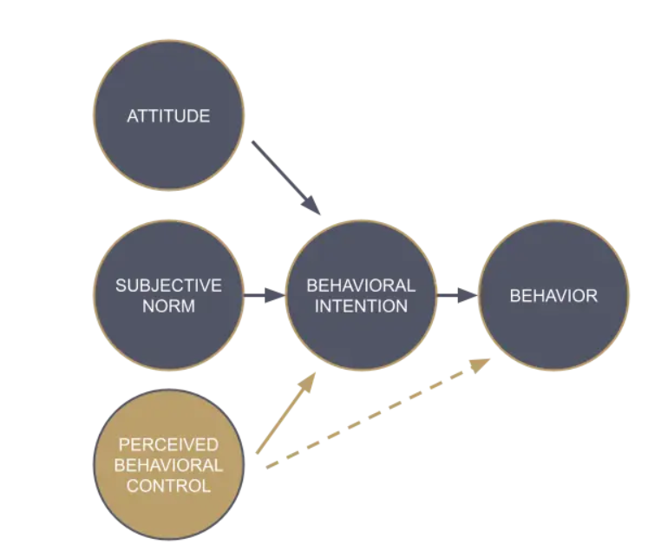
Figure 2: Theory of reasoned action (grey) /The addition of perceived behavioural control (brown) (Madden et al. 1992)
Main assumption within TBP is that the most proximal indicator of a certain behavior is the behavioural intention, understood as the individual readiness to behave in a certain way. There are three main categories of factors that will influence behaviour: personal, social, and control-related judgements. The behavioural intention will be foreseen through the attitudes towards the behaviour, by various subjective norms and through the PBC (perceived behaviour control). To summarize, three main categories of belief will influence the behaviour: the behavioural beliefs in case of attitudes (sense of advantages and disadvantages determined by the behaviour), the normative beliefs (perception of the significance of taking a specific behaviour) and normative beliefs (the importance for others when the behaviour is performed or not).
Relating the theory to Gareth’s case study, the teenager proves some positive attitudes linked to the behaviour by missing college classes and spending time with individuals knowing about his imprisonment. Thus, the teenager considers that behaviour is needed for social acceptance within the group of friends. The negative attitudes observed at Gareth are linked with the risks of going back to prison, risks he has been aware of since he is 17; there is also a risk of serving in prison for adults if the punishment is for more than one year. As a result, the prison isolation will prevent Gareth from progressing and changing his life. A feeling Gareth is challenged with is guilt: since YOT provided him support to enrol at college within a field interesting to him, the guilt is for lying to YOT and skipping classes. With this behaviour, he breached the oath. Furthermore, relating to his parents’ feelings, Gareth thinks he is a lost cause and does not deserve a second chance to behave properly. He thinks that they are disappointed and that they have high aspirations for him, and he lets them down.
Through a deep understanding of Gareth, by identifying the positive attitudes, he demonstrated that YOT could use subjective norms to determine the teenager’s internal and external factors for success. With this plan, YOT can give Gareth a stronger foundation to change his intentions and, consequently, his behaviour.

Frustration Aggression Hypothesis

Introduced in 1939 by John Dollard, frustration-aggression theory states that “frustration always produces an aggressive urge” and ‘aggression is always the result of prior frustrations’ (Miller, 1941).
Based on the psychodynamic approach, the frustration-aggression theory states that when individuals are frustrated, they will tend to develop aggressivity towards the source of the frustration, but most of the time is inappropriate or impossible; therefore, the source of aggression is moved to a different target. The concepts of catharsis (to relieve the emotional tension) are adopted, along with displacement (the defence mechanisms, unconscious, used by the human mind to redirect the emotions from the initial source to a less threatening one, thus leading to anxiety avoidance) (Nickerson, 2021).
Frustration is understood as a tense feeling experienced by individuals when the efforts to achieve an objective are blocked, leading to aggression (Dollard, 1939).
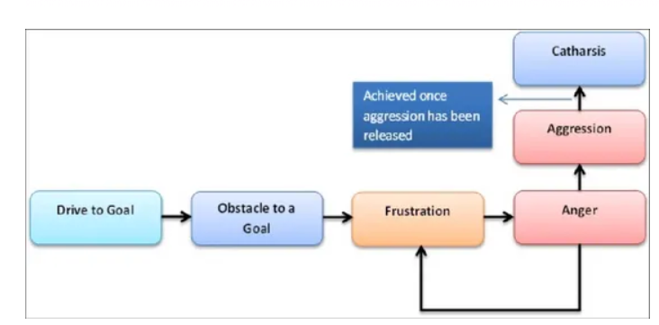
Figure 3 - Frustration Aggression Theory (Dollard, 1939)

Gareth, the adolescent, was released one month ago from the Parc Young Offenders after a period of 18 months serving due to drug possession (with the intention to sell them), and motoring offences behaviour can be explained through this theory. Since the goal of Gareth to continue the previous activities was identified (blocked) by the YOT team, he became frustrated, and his behaviour transferred into verbal aggressivity, walking out. The teenager felt he could not control the situation anymore since he was split into two directions: to conform (YOY) or not to conform (the group of friends).
Gareth’s aggression is displaced towards YOT; even the frustration is on himself and the friend’s group. Through a clear expression of his frustration, Gareth might be helped to clear his mind and to discuss with calm, an opportunity for him to identify a clear way for the future.

Development of and support plan

The change process can be daunting, and most individuals find it difficult. An important point to remember is that the change needs to be seen as a continuous process rather than a one-off event. The changes cannot be performed easily within a single step and involve the splitting of the larger objective into smaller ones along with commitment and planning. Maintaining motivation is challenging when the reward of changing behaviour is not seen clearly, or it is far in the future. When no rewards for a behaviour change are foreseen or when the behaviour change implies some costs, the maintenance of motivation can be challenging. Therefore, it is important to identify these aspects in advance and develop additional plans for their occurrence (Neuhaus, 2021).
As detailed above through the theories, several components influence the success of behavioural change. Only owning the intention to change will not necessarily determine the desired behaviour (Gollwitzer, 1999). Furthermore, Webb and Sheeran (2006) argue that a change in the intention in a medium to large measurement will change the behaviour in a small to medium size; this correlation is known as the intended behaviour gap.
According to Gollwitzer (1999), some important factors will support the behaviour change: objectives need to be set specific (not vague), the objective should not be projected in the distant future, the gain from the changing behaviour should be perceived as a positive improvement and not a loss of the negative one, learning needs to be the determinant of the behavioural change and not the achievement.
Implementation intention
An implementation intention is developing new habits and proving effective in different situations (Gollwitzer, 1999).
Thus, in Gareth’s case, developing new habits will involve college attendance and getting rid of the previous habits that led to offences.
Motivational interviewing
Motivational interviewing will contribute to the development of individuals to put clarity in their own thoughts and motivations for change, to identify the blockers to change to better consider the appropriate solutions, also known as “change talk”.
The main characteristic of motivational interviewing is the guidance and not the given directives, providing the individual with the opportunity to assess his own strengths and objectives, leading to the improvement of autonomy and self-efficacity (Rubak et al., 2005).
According to Sharot (2007), a behavioural neuroscientist, individuals should not be encouraged to see the risks in continuing a certain behaviour, as there is a method that will not be successful. Instead of this, social incentives, immediate rewards, and progress monitoring are also important factors that influence behaviour change.
The guidance needed to be provided to Gareth is recommended to be established as recognition of his progress by YOT, encouraging him to share his changing behaviour with other teenagers with similar experiences, and encouraging and supporting him to identify his strengths and clear objectives for the future.

Conclusion and recommendations

The current report discussed some psychological theories, linking the theories with the details from the case study.
As recommendations, Gareth Jones’s case needs to be closely monitored by YOT, with clear interventions that will guide and support the teenager. Once he managed first to be released from Young Offenders Parc, developing new habits is very important, along with a long-term plan, split into smaller objectives. Once Gareth notices small achievements, he will continue the journey towards achieving the big objective of being a trustworthy individual and member of society. Potential solutions and recommendations for Gareth: a) to receive a mentor (among individuals challenged with the same problems that managed to overcome the problems); b) to benefit from regular counselling; c) to be understood; d) to be encouraged and guided to find a hobby linked with his passion for rally driving.

References

BBC Prison Study (2008). The BBC Prison Study. Available at: http://www.bbcprisonstudy.org/bbc-prison-study.php (Accessed: 05 November 2022).
Madden, T.J., Ellen, P.S. and Ajzen, I. (1992) A comparison of the theory of planned behavior and the theory of reasoned action. Personality and social psychology Bulletin, 18(1), pp.3-9.
McLeod, S. (2019). Social identity theory. Available at: https://www.simplypsychology.org/social-identity-theory.html (Accessed: 02 November 2022).
Miller, N.E., (1941) I. The frustration-aggression hypothesis. Psychological review, 48(4), p.337.
Ministry of Justice (2022) Youth Justice Statistics 2020/2021. Available at:https://assets.publishing.service.gov.uk/government/uploads/system/uploads/attachment_data/file/1054236/Youth_Justice_Statistics_2020-21.pdf (Accessed 02 November 2022).
Nickerson, C. (2021) Frustration-Aggression Hypothesis. Available at: https://www.simplypsychology.org/frustration-aggression-hypothesis.html (Accessed 12 November 2022).
Rubak, S., Sandbæk, A., Lauritzen, T. and Christensen, B., (2005) Motivational interviewing: a systematic review and meta-analysis. British journal of general practice, 55(513), pp.305-312.
Tajfel, H., Turner, J.C., Austin, W.G. and Worchel, S., (1979) An integrative theory of intergroup conflict. Organizational identity: A reader, 56(65), pp.9780203505984-16.
Webb, T.L. and Sheeran, P., (2006) Does changing behavioral intentions engender behavior change? A meta-analysis of the experimental evidence. Psychological bulletin, 132(2), p.249.

