University of Wales Trinity Saint David
Institute of Inner-City Learning, London Campus
Master of Business Administration
LCMB7035 Dissertation
Dissertation Proposal
Energy Affordability and Vulnerable Customers in the UK Retail Energy Sector: A Comparative Study of British Gas and Octopus Energy
Student name: Kamrul Islam Bayazid
Student ID: 2506580
Supervisor: Dr Amir Homayounfard

AI Use Statement
Generative AI may be used within the limits of the assessment brief for source discovery prompts, grammar checking, clarity refinement and simple researcher-directed visuals such as the analytical framework, evidence charts and timeline. It will not be used to decide the research design, create synthetic evidence, code or classify the dataset, analyse personal information, or replace the researcher's judgement. All sources, interpretation and final academic accountability remain with the student.

Introduction and Rationale
Energy retail is an essential-service market, so affordability has a different meaning from price competition in ordinary consumer sectors. Electricity and gas bills affect heating, cooking, health, debt, family routines and basic dignity. The UK energy-price shock after 2021 exposed how quickly household pressure can become supplier debt, self-rationing and mistrust. Ofgem explains that the price cap limits unit rates and standing charges rather than the total bill, meaning households using more energy still face higher bills (Ofgem, 2026a). At the same time, government fuel poverty statistics continue to treat affordability as a live policy issue for England, including estimates, composition and projections for households in fuel poverty (DESNZ, 2025).

Figure 1. Affordability indicators supporting the research justification. Source: DESNZ (2026), 2025 data for England.
This study focuses on British Gas and Octopus Energy because they are highly visible suppliers with contrasting public profiles. British Gas is a long-established incumbent owned by Centrica and has faced intense scrutiny over customer service and prepayment-meter practices. Octopus Energy is a newer challenger brand that presents itself through technology, customer-service language and targeted affordability support such as Octo Assist. A comparison of these two suppliers can therefore show how affordability support is communicated by an incumbent under public scrutiny and a challenger positioning itself as customer-centred.
The topic is timely because Ofgem's consumer guidance places clear duties on suppliers. If customers are struggling, suppliers must work with them to agree an affordable payment plan and may offer payment breaks, payment reductions, time to pay, hardship funds and energy-saving advice (Ofgem, 2026b). Ofgem's Priority Services Register guidance also identifies forms of extra help for customers whose age, health, disability, pregnancy, language needs, bereavement, job loss or other circumstances create vulnerability (Ofgem, 2026c). These expectations make supplier communication important: support must not only exist, it must be easy to find, understandable and credible to households under pressure.
British Gas and Octopus provide useful examples of different support communication models. The British Gas Energy Trust describes itself as an independent charitable trust funded by British Gas, offering energy debt write-off grants, small grants, advice projects and outreach (British Gas Energy Trust, 2026). Octopus Energy describes Octo Assist as a customer help fund and support package including grants, standing-charge waivers, personalised account help, electric blankets and thermal-camera loans (Octopus Energy, 2022). These initiatives sit beside wider questions about customer trust, regulatory compliance and accountability. Recent reporting on British Gas's prepayment-meter settlement, for example, connects vulnerable-customer treatment with public confidence in the energy market (The Guardian, 2026).

Figure 2. Monetary components of the British Gas settlement response supporting the practical justification. Source: Ofgem (2026d); the £70 million debt-write-off figure is an upper limit.
The dissertation will not measure customer outcomes directly or judge which supplier is morally superior. Its purpose is more precise: to analyse how each supplier publicly communicates affordability and vulnerability support, and how secondary evidence helps interpret the strengths and limits of those communications. This is a suitable MBA topic because it links energy affordability, regulation, consumer trust and strategic communication in an essential-service market.

Aim, Objectives and Research Questions
The aim of this research is to critically examine how British Gas and Octopus Energy communicate support for energy affordability and vulnerable customers in the UK retail energy sector using secondary evidence.
The research objectives are:
1. To identify and compare how British Gas and Octopus Energy communicate support for customers experiencing payment difficulty, fuel poverty or vulnerable circumstances.
2. To analyse how the accessibility, transparency, targeting and accountability of these communications may influence perceived supplier trustworthiness in the UK retail energy sector.
The main research question is: How do British Gas and Octopus Energy communicate support for energy affordability and vulnerable customers, and what trust-related implications emerge from comparing their publicly available communications?

Literature Review and Policy Context
The proposal is informed by three connected bodies of literature and policy evidence: fuel poverty and energy affordability, vulnerability in essential services, and trust in regulated markets. Fuel poverty literature shows that energy hardship is not only a matter of low income. It is produced through the relationship between income, energy prices, housing efficiency, heating needs and household circumstances (Boardman, 1991; Bouzarovski and Petrova, 2015). Middlemiss and Gillard (2015) also argue that vulnerability is lived through practical constraints and coping strategies, not only through official definitions.
Energy justice research is relevant because affordability problems are distributed unevenly. Households with medical equipment, disability, older age, young children, insecure income or inefficient housing may face higher need and less flexibility to reduce consumption. Thomson, Snell and Bouzarovski (2017) link energy poverty with health and wellbeing risks across Europe, which strengthens the case for examining energy support as a consumer-protection and trust issue rather than a narrow billing matter.
Trust and service communication are central because energy customers rely on suppliers for an essential service. Sirdeshmukh, Singh and Sabol (2002) connect trust with reliability, competence and benevolence. In this sector, trust may be weakened by billing mistakes, unclear debt processes or public evidence of poor treatment. Conversely, it may be strengthened when suppliers explain help routes clearly, acknowledge limits, publish accessible guidance and show how complaints or hardship cases are handled. Ofgem's Consumer Vulnerability Strategy 2019-2025 reinforces this policy direction by setting priorities to protect gas and electricity consumers in vulnerable situations (Ofgem, 2020).
The literature suggests a gap that is appropriate for a proposal-level dissertation. There is substantial work on fuel poverty, energy justice and vulnerability, and there is current regulatory evidence about supplier obligations. Less attention is given to a focused comparative reading of how two major UK retail energy suppliers communicate affordability support to vulnerable customers and signal trustworthiness through public information. This study addresses that gap by examining public documents, support pages, regulator materials and reputable media evidence through a consistent analytical frame.

Methodology
Methodologically, the dissertation is planned as a desk-based qualitative comparison of two supplier cases. It will not conduct interviews, surveys, focus groups, observations or direct customer data collection. The evidence base will consist of publicly available documents and digital materials produced by suppliers, regulators, government, academic researchers, industry bodies and credible media organisations. This design is appropriate because the research question concerns public support communication and secondary interpretation of consumer trust. It is achievable within an MBA dissertation because the analysis is limited to attributable documents rather than internal supplier systems or private customer data.
Using Saunders, Lewis and Thornhill's (2019) research onion, the project takes an interpretivist position. Affordability support is not studied as a purely numeric variable; it is studied through language, access routes, eligibility explanations and the meanings attached to vulnerability. The approach is abductive rather than purely inductive. The study begins with concepts from fuel poverty, energy justice, service communication and trust, then refines themes through close reading of the documents.
The study will use framework-guided document analysis with a cross-case communication matrix. This is deliberately narrower than a broad thematic review. Each item of evidence will be mapped against a support pathway: affordability pressure, vulnerability identification, available support, route of access, eligibility, transparency, accountability or remedy, and trust implication. The comparison will then examine where British Gas and Octopus Energy converge or differ.
The main evidence streams are:
Evidence stream | Examples | Analytical use
Policy and regulator context | Ofgem price cap guidance, bill-support guidance, Priority Services Register guidance, Consumer Vulnerability Strategy | Establish duties, vulnerability concepts and affordability pressures
Government statistics | DESNZ fuel poverty statistics report | Explain the wider social problem and justify relevance
Supplier communications | British Gas Energy Trust pages, British Gas/Centrica public material, Octopus Octo Assist pages, supplier help pages | Analyse how each supplier presents support and access routes
Academic literature | Fuel poverty, energy justice, service communication and trust studies | Provide conceptual interpretation
Media and industry evidence | Reputable coverage of supplier performance, debt, prepayment meters and customer support | Add external context and reputational signals
The Energy Affordability and Vulnerable Customer Communication Framework will guide the analysis. It brings together affordability pressure, vulnerability, supplier support communication and trust interpretation.
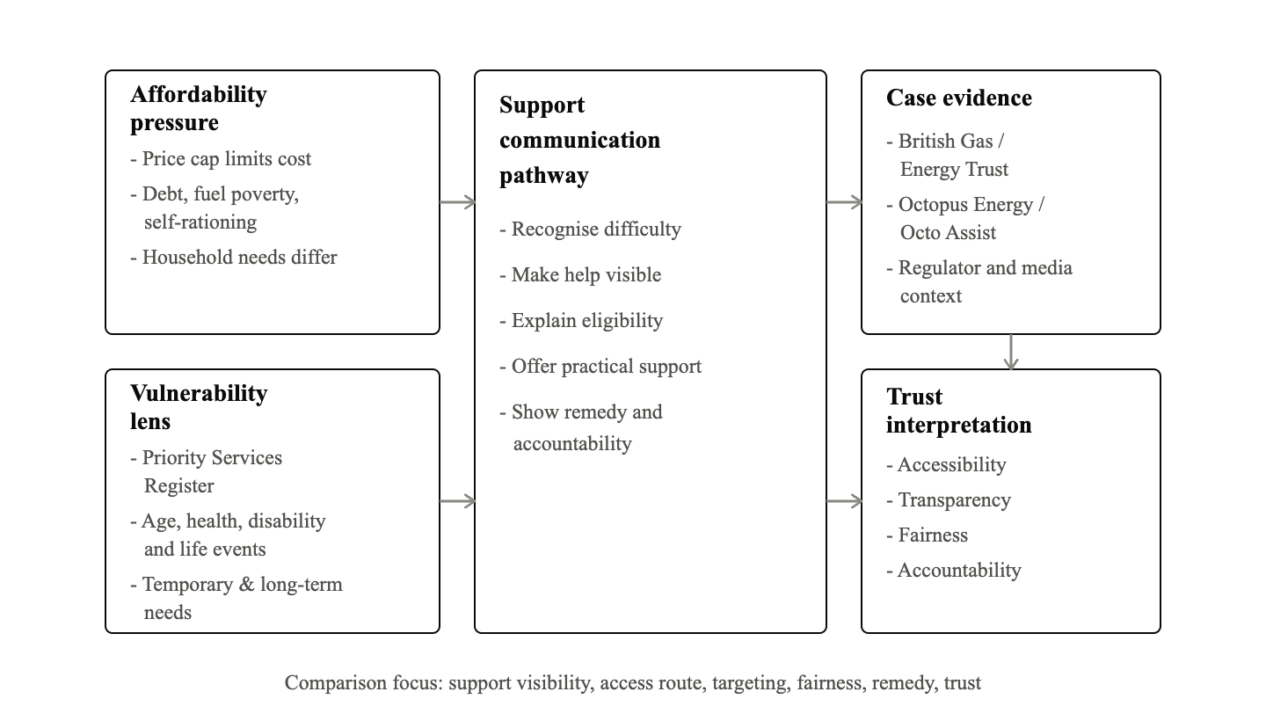
Figure 3. Energy Affordability and Vulnerable Customer Communication Framework for the proposed analysis.
The case selection is purposive. British Gas and Octopus Energy are both large UK retail energy suppliers, but they differ in history, brand identity and public support communication. British Gas provides a case of an established supplier with charitable support structures and recent scrutiny over vulnerable-customer treatment. Octopus provides a case of a challenger supplier that communicates support through visible customer-help initiatives and digital engagement. This contrast supports a meaningful comparison while keeping the scope manageable.
Data collection will follow a documented source log. Each source will be recorded with title, author or organisation, URL, date accessed, document type, case relevance and research-question relevance. The inclusion criteria will prioritise sources published between 2020 and 2026, with older sources retained only for established theory. Supplier pages must be publicly available and attributable. For academic literature, selection will favour peer-reviewed studies that directly clarify fuel poverty, vulnerability, service communication or trust. Media sources will be used cautiously for context, not as standalone proof of company performance.
Feasibility is strengthened by the availability of public documents across both cases. Supplier pages can show how support is described to customers, while regulator and government materials provide the rules and affordability context against which those messages can be interpreted. Academic sources provide concepts for vulnerability and trust, and media or industry evidence can identify contested issues without being treated as conclusive proof. The researcher will not claim that a webpage demonstrates actual customer outcomes. Instead, each source will be read as a communication artefact and compared with external evidence. This boundary keeps the project achievable through secondary research and reduces the risk of making causal claims that the design cannot support.
Data analysis will involve four stages. First, documents will be read and summarised in an extraction matrix. Second, evidence units will be coded against the communication pathway. Third, cross-case displays will compare British Gas and Octopus on accessibility, transparency, targeting, clarity, accountability and trust implications. Fourth, themes will be developed into an interpretation that answers the research question. Braun and Clarke's (2006) thematic analysis will inform the theme-development stage, while Bowen's (2009) document-analysis principles will support systematic handling of published materials.
Quality will be supported by transparent source logging, consistent coding criteria, careful distinction between company-reported claims and external commentary, and balanced language. The dissertation will avoid unsupported allegations about either supplier. It will analyse public communication and secondary evidence, not confidential operations or direct customer experiences.

Ethics and Quality Management
The ethics risk is low because the research uses public secondary evidence only. No participants will be recruited, no personal or special category data will be collected, and no vulnerable individuals will be approached. Ethical safeguards therefore concern accurate referencing, fair representation, secure document storage and cautious interpretation. The study will acknowledge permitted AI support for proofreading and simple graphics, but AI will not be used to analyse or classify the evidence.

Expected Contribution
The study may show that credible affordability communication depends on more than the presence of hardship funds or support schemes. Important differences may appear in how suppliers explain eligibility, make help visible, connect support to vulnerability, show accountability and repair trust after criticism. The expected contribution is a practical communication framework that can help retail energy suppliers make affordability support clearer and more credible.

Limitations
The study cannot directly measure customer trust, household outcomes or internal decision-making. Public documents may present suppliers in selective ways, while media coverage may emphasise controversy. The comparison is also limited to two cases. These limitations will be managed through triangulation across source types, neutral wording and a clear boundary between communication analysis and operational evaluation.

Timeframe
The dissertation will be completed over three project months. The schedule below avoids exact calendar dates and shows the planned sequence of work.
Activity | Month 1 | Month 2 | Month 3
Confirm final scope, ethics approval and source boundaries | ✓
Collect policy, regulator, supplier, academic and media evidence | ✓
Build source log and communication-pathway extraction matrix | ✓ | ✓
Code documents and prepare British Gas case display |  | ✓
Code documents and prepare Octopus Energy case display |  | ✓
Compare cases and develop cross-case themes |  | ✓ | ✓
Draft, edit, reference check and prepare final submission |  |  | ✓

Figure 4. Three-month Gantt chart for the proposed dissertation.

Conclusion
This proposal sets out a feasible secondary qualitative dissertation on energy affordability, vulnerable customers and supplier communication in the UK retail energy sector. By comparing British Gas and Octopus Energy, the study will examine how suppliers communicate support, how public evidence frames accountability, and how credibility may influence trust in an essential-service market. The project is academically grounded, ethically low risk and achievable through publicly available secondary evidence.

References
Boardman, B. (1991) Fuel Poverty: From Cold Homes to Affordable Warmth. London: Belhaven Press.
Bouzarovski, S. and Petrova, S. (2015) 'A global perspective on domestic energy deprivation: overcoming the energy poverty-fuel poverty binary', Energy Research & Social Science, 10, pp. 31-40. doi:10.1016/j.erss.2015.06.007.
Bowen, G.A. (2009) 'Document analysis as a qualitative research method', Qualitative Research Journal, 9(2), pp. 27-40. doi:10.3316/QRJ0902027.
Braun, V. and Clarke, V. (2006) 'Using thematic analysis in psychology', Qualitative Research in Psychology, 3(2), pp. 77-101. doi:10.1191/1478088706qp063oa.
British Gas Energy Trust (2026) Independent fuel debt advice. Available at: https://britishgasenergytrust.org.uk/ (Accessed: 16 June 2026).
Department for Energy Security and Net Zero (DESNZ) (2025) Annual fuel poverty statistics report: 2025. Available at: https://www.gov.uk/government/statistics/annual-fuel-poverty-statistics-report-2025 (Accessed: 16 June 2026).
Middlemiss, L. and Gillard, R. (2015) 'Fuel poverty from the bottom-up: characterising household energy vulnerability through the lived experience of the fuel poor', Energy Research & Social Science, 6, pp. 146-154. doi:10.1016/j.erss.2015.02.001.
Ofgem (2020) Consumer Vulnerability Strategy 2019-2025. Available at: https://www.ofgem.gov.uk/publications/consumer-vulnerability-strategy-2025 (Accessed: 16 June 2026).
Ofgem (2026a) Energy price cap and standing charges explained. Available at: https://www.ofgem.gov.uk/information-consumers/energy-advice-households/energy-price-cap-and-standing-charges-explained (Accessed: 16 June 2026).
Ofgem (2026b) Get help with your energy bills. Available at: https://www.ofgem.gov.uk/information-consumers/energy-advice-households/get-help-with-your-energy-bills (Accessed: 16 June 2026).
Ofgem (2026c) Join your supplier's Priority Services Register. Available at: https://www.ofgem.gov.uk/information-consumers/energy-advice-households/join-your-suppliers-priority-services-register (Accessed: 16 June 2026).
Octopus Energy (2022) Octo Assist: our customer help fund. Available at: https://octopus.energy/blog/octo-assist/ (Accessed: 16 June 2026).
Saunders, M., Lewis, P. and Thornhill, A. (2019) Research Methods for Business Students. 8th edn. Harlow: Pearson.
Sirdeshmukh, D., Singh, J. and Sabol, B. (2002) 'Consumer trust, value, and loyalty in relational exchanges', Journal of Marketing, 66(1), pp. 15-37. doi:10.1509/jmkg.66.1.15.18449.
The Guardian (2026) British Gas faces record £112m settlement over prepayment meter scandal. Available at: https://www.theguardian.com/business/2026/may/15/british-gas-prepayment-meters-compensation-customers (Accessed: 16 June 2026).
Thomson, H., Snell, C. and Bouzarovski, S. (2017) 'Health, well-being and energy poverty in Europe: a comparative study of 32 European countries', International Journal of Environmental Research and Public Health, 14(6), article 584. doi:10.3390/ijerph14060584.

