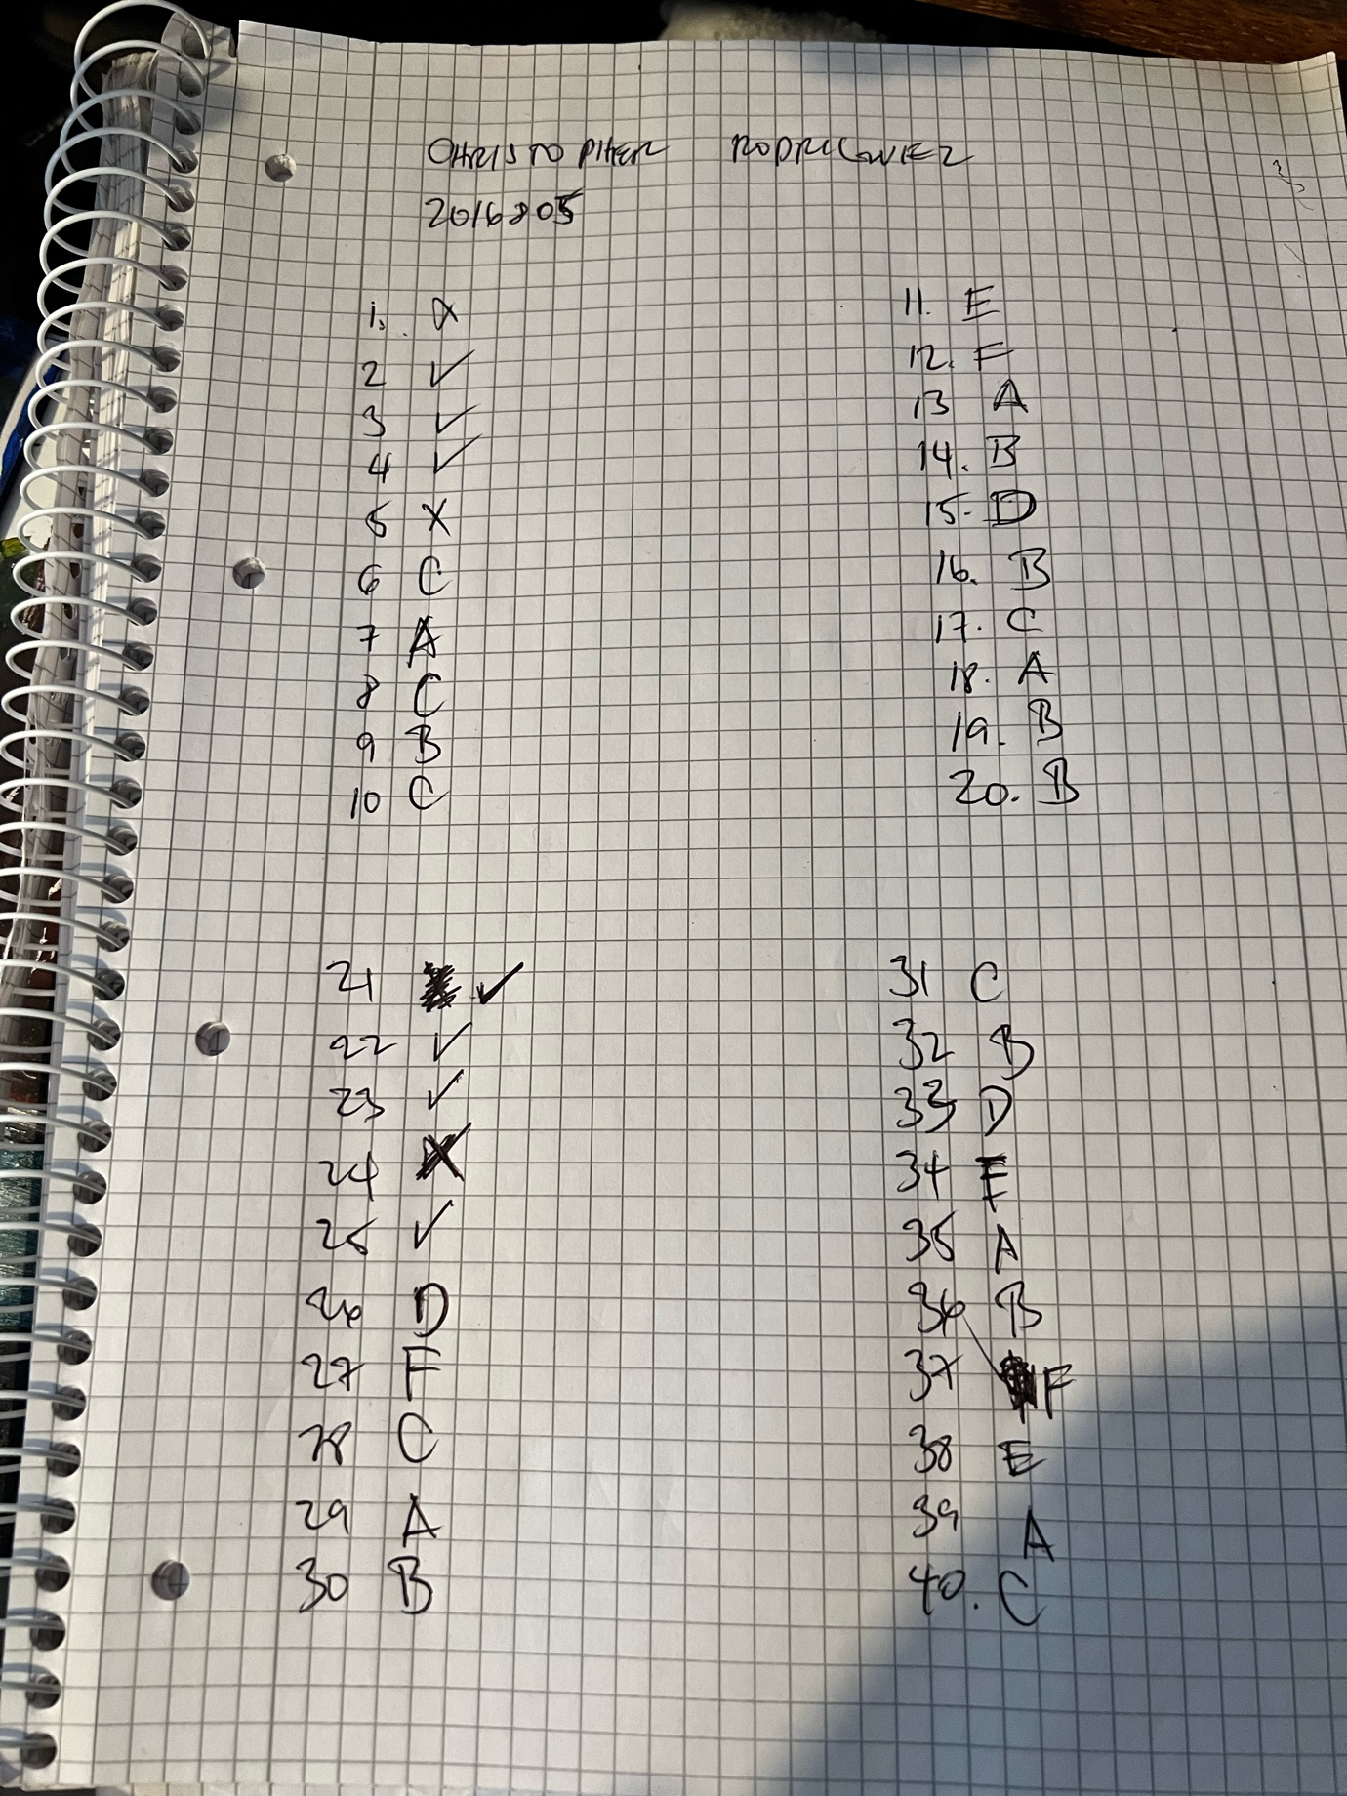
Mandarin exam
Submitted by : christopher rodriguez
ID number: 2016805
For module : foreign language module
Lecturer: ms Li
University of wales trinity Saint David

Final submission for mandarin examination for foreign languages

