Dr. Nitheesh Murugan Kaliyamurthy 5/7/2021

Networks and cyber security essentials
ACCA4024

Mark Williams – 2022279

Secure the network from common threats and attacks

Page 1………………………………………………………………………………………Front page
Page 2……………………………………………………………………………..………Title page
Page 3…………………………………………………………………………………..…Content page
Page 4 ………………………………………………………………………………….…Abstract
Page 5 …………………………………………………………………………………….Introduction
Page 6…………………………………………………………………………………..…Task-1
Page 7…………………………………………………………………………………..…Task-1 & Task-2
Page 8……………………………………………………………………………………..Task-2
Page 9…………………………………………………………………………………..…Task-2
Page 10…………………………………………………………………………………..Task-2 & Task-3
Page 11…………………………………………………………………………………..Task-3
Page 12…………………………………………………………………………………..Task-4
Page 13…………..………………………………………………………………..Task-4 & Conclusions
Page 14………………………………………………………………………………….. References

Abstract
Analysing the situation of the company Olive-Oyl and find security breaches from the description of the breach the company has had involving a .med malware attack by a competitor company ran by Bluto who hired an ex-employee of Olive-Oyl who Pop eye had to let go due to wanting to save money, then creating guidelines for employees and customers on how to avoid these types of attacks by gaining knowledge on what types of attacks are out there.

Introduction
Popeyes company “Olive-Oyl” has been attacked by a disgruntled ex-employee who was fired after Pop eye wanted to save money and fired four members of staff then delegated their responsibilities to other members of staff creating an over-flow of work which then had to be distributed among lower-level members of staff giving them complete access to the whole business which made the company a much larger target for cyber-attacks.
My duty as a cyber security consultant is to find possible cyber attack breaches within the company create, make Pop eye aware of these threats by creating reviews on the different types of attacks that could happen, then describing what cyber attack has actually happened to Olive-Oyl and advising on ways this can be resolved.
The final task will be creating a guideline on how Olive-Oyl can keep its customers safe and employees to stop attacks like this happening in the future and developing staff and the company to become a smaller risk for future attacks.

Task 1 – Security breaches

Possible security breach 1:
Complimentary Wi-Fi – Running the complimentary Wi-Fi on the same network as all business applications.
In the above description from Pop eye, it was stated that after Popeye appointed Wimpy as Market head and gave Wimpy the responsibility to increase the businesses income by 30% this placed Wimpy in a tight position and when creating and implementing his new idea of complimentary Wi-Fi for all customers Wimpy refused to invest in an infrastructure where the Wi-Fi would be on a separate network and instead used the same network that runs the business applications to grant users free Wi-Fi.
The reason this could be a potential breach for the Olive-Oyl company. This is because if anyone is able to connect to the complimentary Wi-Fi it is run on the same network that the business applications are run on which include business stocks, sales and accounting software. If someone were to infiltrate the network all they would need access to is the Wi-Fi to has access to all of the business applications and could shut down the company, steal information or even hold the company ransom.

Possible security breach 2:
Employees – employees were given access to all business applications
In the above description it was stated after Wimpy’s idea increased the business income by 30% Popeye removed the Market head position and then gave Wimpy more responsibility by giving him the responsibility of the 4 sales heads of which Popeye had fired to save money. Wimpy was overwhelmed with the new responsibility and he diversified the responsibility among the sales executives and granted them full access to all business applications.
This could lead to an increase in phishing attempts and with more staff having access to a network which have not been trained correctly and having a larger number of users having that much access to all of the business applications this gives attackers more targets and a higher chance of success. If any hackers were successful in getting staff to click on a link [1] they would have access to the entire business structure. If an employee were upset with management or going through different problems they might try stealing the business information, money for themselves as stated in the description given to us by Pop eye, the network is not high end and if all aspects of the business were attached the staff would be able to use this however, whenever they choose and could potentially steal, sell or even accidentally destroy information causing problems throughout the business.

Possible security breach 3:
Bluto a competitor of Popeye’s – hired ex employee’s
In the above description provided by Popeye, it was stated that a competitor of Olive-Oyl named Bluto was paying close attention to the company and after Popeye wanted to save more money after Wimpy increased profits for the company and fired Sales heads. Bluto knew this would cause a rift between the employee and the company for being treated poorly and took that opportunity to hire an ex-employee along with a hacker and together they were able to place a “.meds” which is part of the Djvu ransomware family which encrypted all of the business’s important documents and services which stops the business being able to use these services which forces the company to pay ransom to gain access again [2]. This was done by placing the .meds file on the network in the retail showroom. As stated in the possible breaches above this could have been done via the complimentary Wi-Fi or just connecting to a PC which every employee now has access to all aspects of the network due to Popeye firing staff to save money and Wimpy delegating work to all members of staff to help with the workload.

Task 2
Threats:
A threat to the business is having someone who is not supposed to have access to business applications gaining access and threating to disrupt normal business by destroying, stealing or holding certain information ransom which in turn stops the business from functioning causing the company to lose money. The different types of cyber threats a company can encounter are
- Malware – This type of threat is known as a type of malicious software attack where the software is designed to destroy, interfere or damage a business network or computer. This type of attack involves viruses, worms or trojan horses [3].
- Phishing - Is a threat designed using “deceptive techniques (social engineering) to carry out electronic fraud” [4]. Which is mainly done by the phisher emailing employees disguised as other employees with what looks like real information with links that will infect the computer, allow the phisher access to the network.

These types of threats can cause significant issues for the Network for multiple reasons if someone were to gain access to the network which is attached to the complimentary Wi-Fi they would have access to the entirety of the business applications and also access to the customers personal information.

Vulnerabilities:
In the description above the company has a few major vulnerabilities one of which is having a complimentary Wi-Fi network which is directly connected to the company’s network which means anyone who was able to gain access to this network has complete access to all applications within the network including stocks, important documentation/files and customer person details who have connected to the Wi-Fi. The way attackers could pull this off could be preforming a number of different attacks for examples phishing by emailing links to either customers who then connect to the Wi-Fi which will allow attackers access to the whole network or messaging employees and gaining access via that route.
Another vulnerability the company has is number of staff who have access to all aspects of the network as stated in the scenario above after Popeye fired some staff Wimpy then delegated work to other staff members which granted them access to all aspects of the company this leaves the business vulnerable because it now has a much higher number of people with access which gives attackers more options for ways into the network using Phishing or if they’re able to gain access to a computer they will have access to the network instantly. Attackers are able to gain access to the network using multiple different attacks such as phishing, malware or Man-in-the-middle attack which similar to phishing uses social engineering to make the victim believe they are communicating with someone they know such as a colleague and the attacker takes personal information such as login information or details such as in the description someone stating all members of staff now have access to all parts of the business network. [5]

Attacks:
The information gathered from the description given by Pop eye, gives multiple ways attackers could gain access into the company one of these ways is through gaining access through the complimentary Wi-Fi as stated this is the same network the business applications. Another attack would be phishing which again would grant the attackers access through either the complimentary Wi-Fi if they phished a customer or the attacker would be able to gain access through employees who have access to the network by sending them links that give the attackers access.

“.meds” file format attack:
The type of attack “.meds” file format attack is a type of malicious software that has been placed onto a computer that encrypts important programs, documents and files and this stopped the company and employees gaining access to these important parts of the business. This type of attack is usually preformed in different stages:
1. Surveying – which in this description involved Bluto noticing Popeye firing staff members and took this opportunity to hire the ex -employee along with a hacker to infiltrate the company.
2. Delivery – Using this ex-employee to help the hacker find vulnerable spots of attacking the company which as we have stated above the business has a few vulnerabilities.
3. Breach – Being able to attack these vulnerabilities in this case using a “.meds” malware to encrypt the documents, folders and files of the company holding them ransom.
4. Affect – After placing the malware software and encrypting the businesses important information the attacker then has complete control and holds the company ransom and are able to delete, modify, sell this information to 3rd parties for a price or hold the company ransom for money. [6]
The company could lose large amounts of money by not being able to serve customers or even lose masses amount of information and data being deleted if they don not cooperate with the attacker. The victims only option to gain access to their information again would be to usually pay the attackers to take the encryption software off the computer which makes this type of cyber-attack a ransomware.

Task 3
Introduction to Packet tracer results
Introduction to Packet tracer exam results, certificates, link and PDF file.

Exam 1 results:
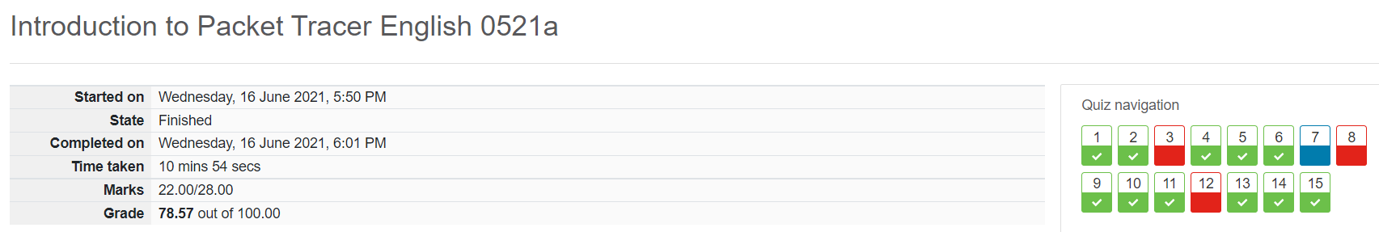
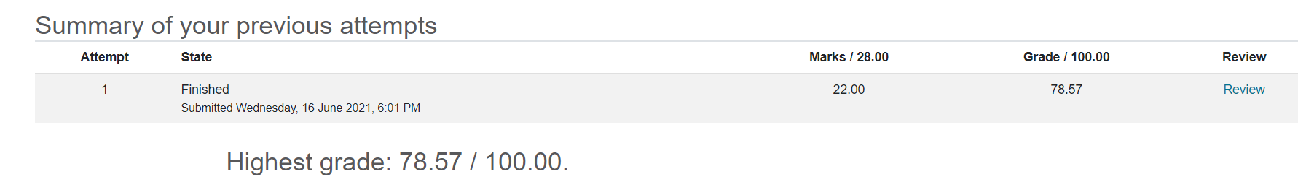
Exam 2 results:
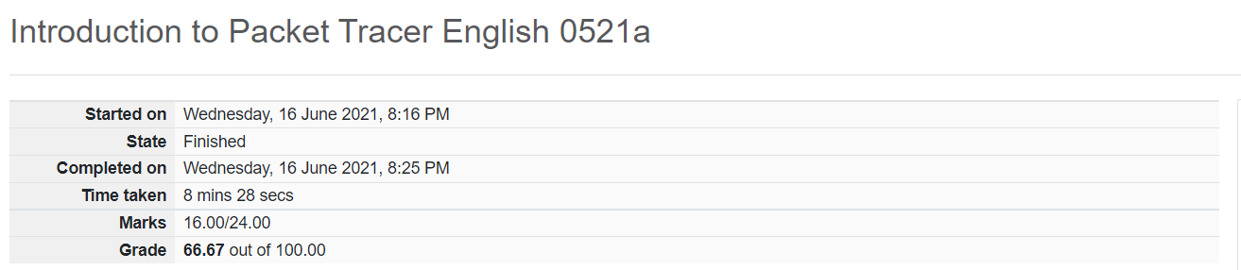
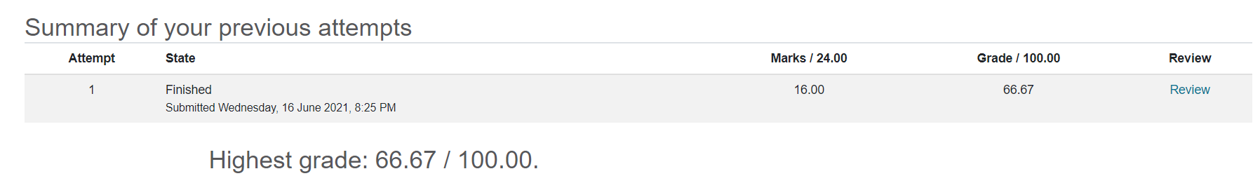

Certificate:
file:///C:/Users/markw/Downloads/MarkWilliams-Introduction%20to%20-certificate.pdf

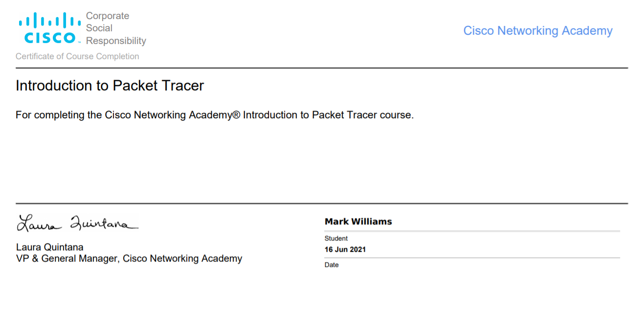

Task 4 – Guideline for Olive-Oyl employees, and customers
Introduction
Keeping your online data safe in our day of age is essential for everyone who goes online and will become a lot easier and safer if you follow this cyber security guideline on how to keep your personal and company information safe while browsing the web.

Keeping yourself safe online:
Below are five ways of keeping yourself safe while online.
1. Make sure nothing private is being displayed on the screen while in public! You do not know who could be watching.
2. If connecting to a Wi-Fi make sure its secure and you know where the connection is coming from.
3. Do not click on unfamiliar links.
4. Do not download any documents that are not secure and from known sources.
5. Do not disclose any information to strangers.
Following these five points while browsing the internet in public around Olive-Oyl will keep yourself safe and the company safe from attackers.

Some signs to look out for:
- Suspicious email addresses pretending to be companies/colleagues.

- People watching you while you are on your phone, laptop or computer.

- Never leave your device unlocked.

- Create a strong password using at least the following: 12 digits, 1 number, 1 symbol.

- Inform security if you suspect any suspicious activity.

These points are designed to keep your online personal information more secure and by following these guidelines you will be able to strengthen your online presence and make yourself and company a much harder target for all types of attacks.

Types of cyber-attacks:
The list below shows the different types of cyber attacks that are out there:
1. Phishing – Attackers will email you using social engineering and to make it seem like a colleague or company are emailing you usually containing a link.
2. Malware – Is a type of attack that involves attackers placing a software onto a computer that will damage the computer or network.
3. Denial of service – Where a service stops responding due to the attacker overloading the network and crashing the system, stopping the business and customers using it.
4. SQL injection – Allows attackers to view personal information also allowing the attacker to delete and modify the data by targeting data bases and allowing the attacker to receive the information that is placed.
If you keep follow the guidelines above you will be more protected and educated making yourself a harder target for all types of attacks keeping yourself a lot safer.

Conclusion

In conclusion to the research and my findings throughout the investigation of Olive-Oyl, my future recommendations would be to separate networks especially for a free Wi-Fi where anyone is able to join. Educate and keep staff up to date on all attacks that could be happening to keep themselves safe and the company. Become a harder target by updating security, creating stronger passwords and training staff on the seriousness of the responsibilities they have been given by having full access to the network or only provide staff with minimal access on certain machines, reducing the risk of malware attacks.
All of the steps above will build a better morale among colleagues and management and will help the company become a much safer environment to work for as well as keeping employees personal information secure and developing them to understand and being able to teach others on how to be safe from cyber-attacks.

References
[1] Article. Harrison, Brynne. Svetieva, Elena. Vishwanath, Arun,. “Individual processing of phishing emails: How attention and elaboration protect against phishing”, Online information review, 2016-04-11, Vol.40 (2), p.265-281, Full text: 1. Introduction and 3. Message-level factors influencing attention and elaboration.
[2] Article. Cabaj, Krzysztof ; Gregorczyk, Marcin ; Mazurczyk, Wojciech,. “Software-defined networking-based crypto ransomware detection using HTTP traffic characteristics”, Computers & electrical engineering, 2018-02, Vol.66, p.353-368, Introduction 1. 2nd paragraph.
[3] Article/Quiz. Cisco, “what is Malware?”, https://www.cisco.com/c/en_in/products/security/advanced-malware-protection/what-is-malware.html, Advanced Malware Protection (AMP), Types of Malware.
[4] Article. Jansson, K ; Von Solms, R,. “Phishing for phishing awareness”, Behaviour & information technology, 2013-06-01, Vol.32 (6), p 584-593, 1. Introduction 1st Paragraph.
[5] Article. Wikipedia, “Man-in-the-middle attack”,. https://en.wikipedia.org/wiki/Man-in-the-middle_attack, Examples and Notable instances. created 3rd Jan 2005
[6] Article. National Cyber Security Centre, “How cyber-attacks work”, “https://www.ncsc.gov.uk/information/how-cyber-attacks-work”,. Understanding the types of attacks, and the stages involved, will help you to better defend yourself,. Published 14th Oct 2015, reviewed 23rd June 2016,. Use of Stages of an attack steps.

