University of Wales Trinity St David
School of Engineering



Electronic ignition and Fuel injection systems
Electrical Control Systems(ACHA4010)

Jonathan Shallis
2113867
Automotive Engineering
April 2022

Table of Contents
1 Introduction 2
2 Literature Review 3
2.1 What is live testing on an engine? 3
2.2 Advantages of live testing on an engine 3
2.3 Disadvantages of live testing on an engine 3
3 Methodology 4
3.1 Method for testing the Motronic engine 4
3.2 Method for testing the LE3 engine 5
4 Analysis of results 6
4.1 Analysis of results from testing the motronic engine 6
4.2 Analysis of results from testing the LE3 engine 9
5 Discussion 11
5.1 The choice of engine 11
5.2 Systems that are in place in a motronic engine 11
6 Conclusion 12
6.1 What current systems are out there that could improve the motronic engine 12
7 Reference List 13

Introduction
This report is based on electronic ignition and fuel injection systems. An electronic ignition system is an ignition that generates electrical pulses using transistors controlled by sensors, without using mechanically actuated breaker points (Dictionary.com, n.d). A fuel injection system is an electronically controlled system that injects a precise amount of fuel into the cylinders or the intake airstream of an internal combustion engine (Merriam-Webster, n.d). Within this report, an argument will be developed that will compare two types of engines, a Vauxhall motronic engine and a LE3 engine. The report will state what sensors, injection systems and ignition systems each engine has. Then, by comparing the two engines the differences in the systems will be stated. In the final discussion, one of the two engines will be picked, and then current systems and sensors that exist that could possibly improve the chosen engine, will be suggested. This report will display results from the live tests carried out on the two engines in the workshops and those results will be analysed in the analysis part of the report. Research will be conducted within the report that will be used to support either side of the argument, and this research will be referenced correctly using Harvard referencing. In the methodology the overall method used for the live tests and the steps carried out to complete the tests will be discussed. The precautions that were taken to ensure that the testing was safe, and the equipment used to test the engines will be talked about. The advantages and disadvantages of live testing will be discussed in the literature review. Research will be conducted to determine what these advantages and disadvantages are. At the end of the report, conclusions will be drawn, and evaluations will be made having looked at both sides of the argument within the report.

Literature Review

What is live testing on an engine?
Live motor testing tests for voltage level, voltage imbalance, voltage distortion, service factor, overcurrent, efficiency, rotor bar, operating point, torque ripple, load history, haystack and operation condition tests (ATS, 2019). After researching this, precisely determining what it does is that it checks the overall health of the engine while it is running within its current environment.

Advantages of live testing on an engine
Live testing an engine provides many advantages as a method of testing. One advantage being that when the engine is running the results shown will be the most effective to improve the performance of the engine as it shows data from when the engine is required to perform. This testing almost guarantees that when the engine is running there will not be a failure, however when in use the engine can come under different stresses that could cause something to go wrong. In contrast to static testing where the engine is off, live testing tests the engine in an accurate case whereas static testing uses the worst-case possible method. This means that live testing gives more than one alternative for the state of the engine, looking at it from different case scenarios. With live testing the engine can be adjusted to the users needs. The RPM can be increased by pulling the throttle and from these variable results can be given, not just the engine running without any power. The engine can be tested to different extremes, so the RPM can be increased to the maximum that an engine would need to perform to. Collecting data such as voltage, current, torque, load and efficiency, live testing produces a comprehensive status of the engine. It shows a wide range of different values for these factors which means the analysis can be in depth and there will be a lot of results where analysis can be made. Live testing systematically monitors and logs test data over time. With this data being produced continuously, statistical analysis can be carried out to identify where failures are. After being identified these failures can be adjusted accordingly and fixed as required. (Technomax, 2022)

Disadvantages of live testing on an engine
As beneficial as live testing is, there are also disadvantages to this method of testing. It is required for the temperature of the engine to increase, and measurements must be taken every 10 degrees Celsius. This is to ensure that the most accurate and the best results are recorded. As the temperature gets higher, it must be ensured that the engine does not get touched as it is obviously very hot. This makes the equipment quite unsafe while the engine is running as it will not cool down.

Methodology

Method for testing the Motronic engine
There were two types of engines tested, a motronic engine and a LE3 engine. Firstly, this report will discuss the motronic engine test. The battery voltage of the engine was noted first as 12.46V. There were 33 different pins ranging from 1-55, a few in that range missing and for each pin the voltage was tested for. The voltage was tested with the ignition on and off. The resistance of the throttle potentiometer was determined using an ohmmeter and for pins 1 and 3 the throttle valve was open, and the value was 2560 ohms. For pins 1 and 2, the throttle valve was closed, and the resistance value was 2000 ohms. For each test there was a technical specification with a range of resistance values, for pins 1 and 3 the technical specification was 1900-2000 ohms and for pins 1 and 2 the technical specification was 1000-2000 ohms. The resistance value recorded should be within the technical specification for it to be a valid reading. As the resistance value of pins 1 and 3 was outside the technical specification, the value was invalid. The air flow sensor was then tested, again for resistance values, using a digital multimeter. Similarly to the throttle potentiometer test, 2 pins were connected to measure the resistance of the pins together. Pins 4 and 2 showed a resistance value of 340 ohms, 4 and 3 showed a resistance value of 560 ohms and for pins 4 and 1 the value was N/A as there was no pin 1. There was a technical specification for each set of pins as follows, 4 and 2 had a range of 8-2500 ohms, pins 4 and 3 had a range of 300-550 ohms and pins 4 and 1 had a range of 270-520 ohms. From the results recorded, pins 4 and 2 had the only value in the technical specification range, therefore, that was the most valid reading. To test the idle speed control valve, an ohmmeter is connected to two pins and the resistance is measured. The technical specification for the idle speed control valve was 8 ohms. The measured resistance for the valve was 8 ohms, therefore it was a valid value of resistance and therefore it was working well enough. The final reading of resistance values was the reading of resistance between the terminals of the injector valves. Injectors 1,2,3 and 4 were measured and the values respectively were 16.4 ohms, 16.3 ohms, 16 ohms and 16.4 ohms. The technical specification for all 4 injectors was a range of 15-17 ohms, as all the values are within this range, each injector is working perfectly fine. The final bit of testing carried out on the motronic engine was the testing for live data while the engine is running. The temperature of the engine was noted from 20 degrees Celsius to 80 degrees Celsius, increasing by a factor of 10 degrees Celsius every time. At each temperature readings were taken for different values, there were 6 pins where values were recorded, so for pin 45 the voltage was taken, for pin 16 the time was taken in ms, for pin 4 the percentage was taken, for pins 5 and 28 whether it was on or off and pin 44 also measured the voltage. The ETC was measured in ohms and specified. The engine temperature (cold cranking) was 18.2 degrees and the cold cranking injection in ms was 25.8. This data will be discussed in the analysis part of the report.

Method for testing the LE3 engine
Now, the testing of the LE3 engine will be discussed. The battery voltage of this engine was 12.41V. The fuel ECU was tested first, it was tested for 10 pins from 1-15 and tested for the voltage when the ignition was off and on. The Spark advance ECU was also tested for the voltage but using 13 pins instead of ten and these ranged again from 1-15. This was tested in the same way as the fuel ECU where it was tested when the ignition was both on and off. These sets of results will be discussed and analysed in the analysis of results. Then, the throttle switch was tested. To test the throttle switch, the connectors terminals had to be grounded for as the multimeter was put on black to negative and red to positive (Smith, 2021). The throttle switch was tested for resistance of 2 sets of pins which were pins 2 and 18 with a resistance reading of 0.8 ohms, and pins 3 and 18 which had a reading of infinity ohms. The technical specification for 2 and 18 was 0 ohms and infinity ohms for 3 and 18. Therefore 2 and 18 show an invalid reading and the throttle switch needs to be changed. The injector valves were tested the same way as they were in the motronic engine, injector valves 1,2,3 and 4 were tested for the resistance between the terminals. For 1 the resistance was 15.9 ohms, for 2 it was 15.9 ohms, for 3 it was 15.9 ohms and for 4 it was 16.1 ohms. The technical specification was the same as it was in the motronic engine, 15-17 ohms. All the readings were within this range; therefore, the injector valves were working fine. The auxiliary air valve was tested also for resistance between terminals and the value of that was 46 ohms, which was outside of the technical specification of 40 ohms. This meant that the auxiliary air valve needed to be changed. Finally, the Amplifier was tested with the ignition on for the voltage. To test the amplifier, a multimeter was connected to it, along with a speaker also connected and then to ensure continuity all fuses were checked (Odom, n.d). Pins 1 to 4 were tested and outputted value of 11.92V, 0.02V, 11.92V and 0.13V respectively. There was also the live data that was recorded while the engine was running. This time, the temperature started at 20 degrees Celsius but only increased to 60 degrees Celsius, still increasing by a factor of 10 degrees Celsius. The ETC was the first recording taken, measured in ohms, followed by a reading of the voltage for pin 8 and the time for pin 3, measured in ms. The specification for the ETC at 20 degrees Celsius was a range of 2100-2900 ohms, and for 60 degrees Celsius it was a range of 270-390 degrees Celsius. Like the live data from the motronic engine, these recordings will be discussed in the analysis of the results.

Analysis of results

Analysis of results from testing the motronic engine
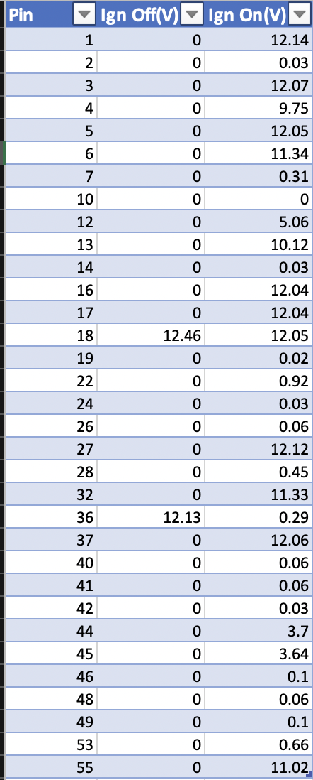
Throughout this section of the report, the results that have been produced from the testing of both engines will be discussed. Tables will be used ensuring that the results are shown in a clear way. In all the tests for this engine the battery voltage is 12.46V.
This is a table that shows the voltage in the engine from pins 1 through to 55. It shows the readings of voltage where the ignition is both on and off. As shown in the table, when the ignition is off the voltage is most commonly 0, apart from two anomaly readings at pin 18 and pin 36, this could be from a random shot of voltage going through the system. The reason the results show 0V most commonly is because there is no voltage in the system when the ignition is off, the battery is not on and therefore there is no voltage within the system. When it is tested with the ignition on, a variety of results show up some being high and some being low but there is one anomaly where 0V is outputted. When the ignition is on it is shown that there is voltage within the system at almost every pin apart from pin 10 where it is 0V.

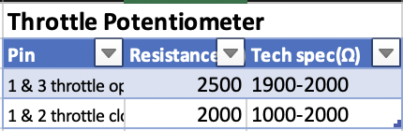
This is a table that shows the results from testing the throttle potentiometer. It tested for readings of resistance in ohms within two sets of pins, 1 and 3 with the throttle open, and 1 and 2 with the throttle closed. The table also shows the technical specification which shows the range in which the value of the reading should be in. For pins 1 and 3 the technical specification is 1900-2000 ohms, for 1 and 2 it is 1000-2000 ohms. When the throttle is open, the value of resistance is outside the range meaning that the potentiometer would be changed as there is too much resistance running through when the fuel valve is open.

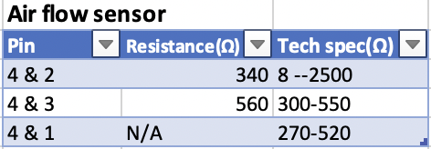
This is a table showing results from the test ran on the air flow sensor. It shows pins 4 and 2, 4 and 3 and 4 and 1, and for each pair it has a reading of resistance. As shown readings from the first two set of pins are within the technical specification, therefore, the air flow sensor is working perfectly fine. However, the reading of resistance for the third set of pins is N/A, this is because there is not a pin 1 therefore this does not affect the quality of the air flow sensor.
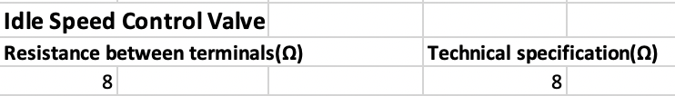
The table above shows the testing of the idle speed control valve. This shows a reading of a resistance between terminals in ohms. The reading as shown above is 8 ohms and the technical specification is 8 ohms. Therefore, the idle speed control valve is working fine.

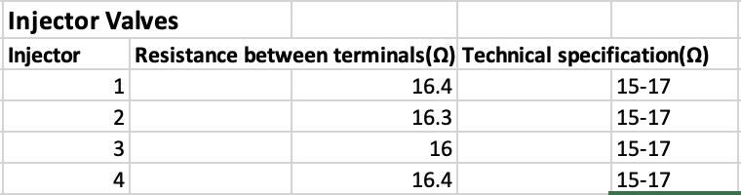
This table shows results from the test carried out on the injector valves. There were 4 injectors tested for the resistance between terminals. All the injectors had a technical specification of 15-17 ohms, and all the readings of resistance are within the range. This meant that the injector valves were working perfectly fine and nothing needed changing.

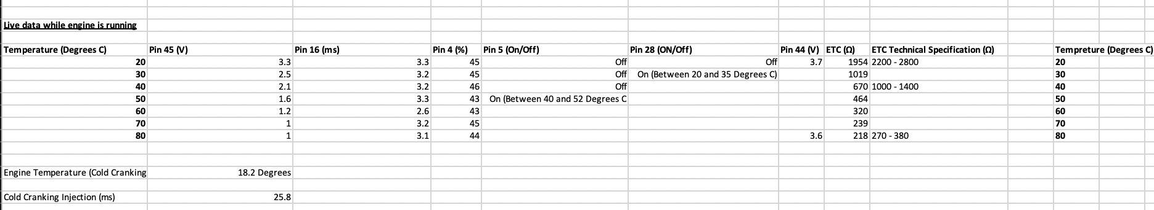
The table above shows live data from tests while the engine is running. The temperature has a scale of 20-80 degrees C increasing by a factor of 10 degrees C. The first test was to test the voltage at each temperature for pin 45, and as shown in the table, the voltage decreases as the temperature increases. This is because with increased temperature less energy is required by the engine, it doesn’t need to work as hard. Then the time measured in ms and percentage of pins 16 and 4 respectively is recorded. These both show steady readings that fluctuate with the temperature but never by much. The voltage for the temperatures 20 and 80 is recorded for pin 44, this is to show the voltage at the coolest point of the engine and at the hottest point of the engine. The ETC is recorded and measured in ohms. Only three technical specifications are set, and those are for temperatures 20, 40 and 80. Each reading of ETC is outside of its equivalent specification. The results also show a decrease in ETC with the increase in temperature. The temperature of the engine at cold cranking is shown at the bottom of the table, and the cold cranking injection measured in ms is shown.

Analysis of results from testing the LE3 engine

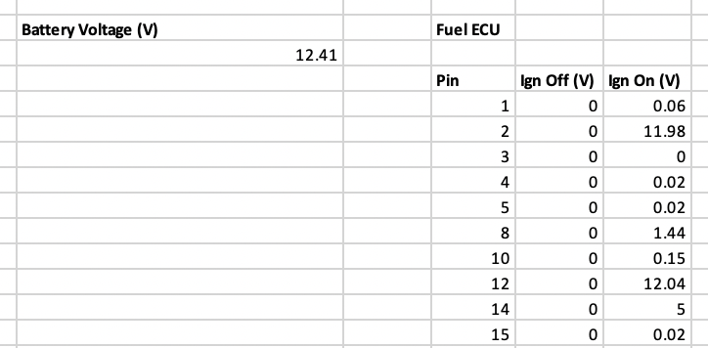
These set of results are the recordings taken from testing the fuel ECU inside this engine. There are 10 pins recorded from 1-15 and are tested with the ignition off and on to find out what the voltage is. The battery voltage is 12.41V. With the ignition off there isn’t a reading of voltage, this is because the engine is not running therefore the battery is off and not connected. This will show a straight set of 0V values. However, when the engine is running there is results for every pin apart from pin 3 which shows 0V.
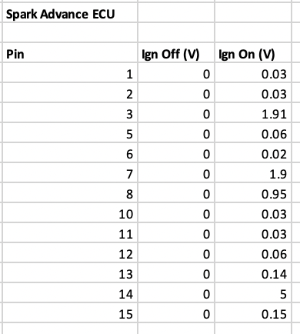
This test is almost the same as the test above, except it is for the spark advance ECU, and has got 2 more pins added. Nothing has changed from the readings when the ignition is off. However, when the ignition is on it does show voltages that are much smaller than the ones shown above.

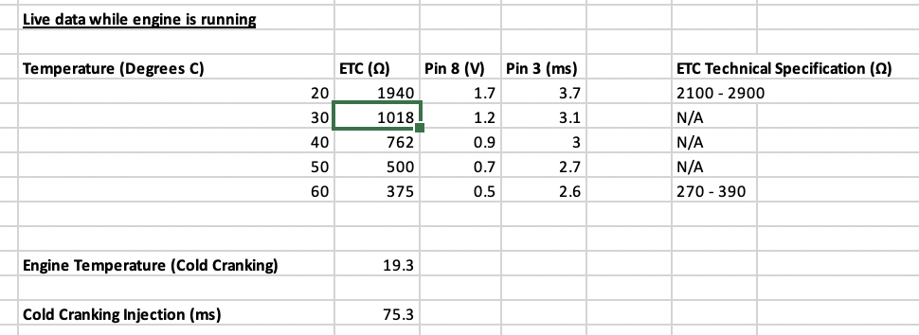
This is the live data recorded when this engine is running. Like the first one, the ETC is recorded. However, the temperature only ranges from 20 degrees C to 60 degrees C, and within this one the ETC at 60 degrees C is within the technical specification. The voltage for pin 8 is recorded and shows a steady decrease with an increase in temperature, and the time for pin 3 is shown which also steadily decreases.

Discussion

The choice of engine
Having conducted research on both engines, the engine that will be discussed is the motronic engine. The systems that are in a motronic engine will be discussed and then research on current systems that could possibly improve the engine will be carried out.

Systems that are in place in a motronic engine
There are many systems within a motronic engine. Firstly, the sensors inside this engine will be discussed. The first sensor is the air flow meter, this measures the air flow in the engine. Air flow meters can also measure the air pressure as well as the air flow. They are used to ensure the proper amount of air flows into the engine (Electrical4U, 2020). Then there is the water temperature sensor which measures the coolant temperature. The water temperature sensor identifies any unusual rises in temperature and detects when the engine is overheating (ValeoService, n.d). The throttle switch which corrects fuelling and indicates idle and high load positions of the throttle. The throttle switch ensures that the engine performs to its peak performance by ensuring the correct mixture of fuel and air is delivered to the engine (Mcspaddenautomotive, 2021). Another sensor is the throttle position sensor, this indicates all throttle positions and throttle movement. Also, the crankshaft sensor refers to the crankshaft position as well as the speed of the engine. The motronic engine uses the LE-Jetronic fuel injection system. This system takes readings from the air flow meter, and it controls the fuel injection accordingly. (E30 Zone, 2013).

Conclusion

What current systems are out there that could improve the motronic engine
Firstly, there are many sensors an engine requires for it to function properly. There are a few sensors on the motronic engine, however having researched there could be more to replace/add to those sensors. An oxygen sensor is very important to have in an engine as it carries the important job of monitors how much oxygen is in the exhaust (Carbiketechteam, 2014). To determine proper engine performance, oxygen is very important. To achieve the correct fuel-air ratio, oxygen sensors could be put in place in the engine (Carbiketechteam, 2019). Another sensor that could improve on the current sensors in place on this engine is a knock sensor. This sensor detects any engine knocking because of timing advance (Carbiketechteam, 2014). This is important as this can prevent any damage done to the engine internally. Engines that use a knock sensor can reduce fuel consumption and increase torque (Boschmobilitysolutions, n.d). This will ensure that the engine can perform at its peak performance. The last sensor that could be added to this engine to improve it is the fuel pressure sensor. This sensor measures pressure within the fuel system (Carbiketechteam, 2014). This sensor keeps track of the fuel pressure within the fuel rail. This sensor will then send a signal to the control unit and if there’s a problem with the fuel pressure then the computer will analyse the data and make any necessary changes to the fuel injection timings, and quantity (Stevens, 2022). The currently used fuel injection system for the motronic engine is good, but there are a variety of different systems that could improve on the current one. The first example is the single point injection. This system has one or two injector nozzles put into the throttle body. This system has got good control, is very cost effective and easy to service. This could possibly give it the edge over the current injection system. Port injection is another system that could possibly improve on the current one. Each cylinder is provided with a separate injector nozzle, outside its intake port. This system fuels very precisely and ensures a better air-fuel ratio is achieved. As the fuel vapour is shots into the intake port at such a short range, it ensures that the fuel will be completely drawn into the cylinder. The last system that has been researched is the direct injection system. This system directly injects fuel into the combustion chambers and past the valves. The fuel metering of this system is the most precise out of any of the systems and it gives engineers another variable to influence precisely how combustion occurs in the cylinders (Joe Bruzek, 2016).

Reference List
Dictionary.com(n.d) Dictionary.com
Available at: https://www.dictionary.com/browse/electronic-ignition
Accessed(22/04/2022)
Merriam-Webster(n.d) Definition of fuel injection
Available at: https://www.merriam-webster.com/dictionary/fuel%20injection
Accessed(22/04/2022)
ATS(2019) Online or Offline Motor Testing – Which is Right for You?

Available at: https://ats-inc.org/online-or-offline-motor-testing-which-is-right-for-you/

Accessed(22/04/2022)

Technomax(2022) Dynamic electrical Motor Testing

Available at: https://www.technomaxme.com/dynamic-electrical-motor-testing/

Accessed(22/04/2022)

Max Smith(2021) How to test a TPS sensor

Available at: https://askcarmechanic.com/how-to-test-tps-sensor/

Accessed(22/04/2022)

Derek Odom(n.d) How to test a car amplifier

Available at: https://itstillworks.com/test-car-amplifier-5022644.html

Accessed(24/04/2022)

Electrical4U(2020) Air Flow Meter Sensor: What are they?

Available at: https://www.electrical4u.com/air-meter/

Accessed(24/04/2022)

Valeoservice(n.d) Car water coolant temperature sensors

Available at: https://www.valeoservice.com/en-com/passenger-car/cooling-system-air-management-technologies/car-water-coolant-temperature-sensors

Accessed(24/04/2022)

Mcspaddenautomotive(2021) What are the symptoms of a bad or failing throttle position sensor?

Available at: https://mcspaddenautomotive.com/blog/what-are-the-symptoms-of-a-bad-or-failing-throttle-position-sensor

Accessed(24/04/2022)

E30Zone(2013) Jetronic

Available at: https://www.e30zone.net/e30wiki/index.php?title=Jetronic

Accessed(24/04/2022)

Carbiketechteam(2014) What are engine sensors?

Available at: https://carbiketech.com/engine-sensors/

Accessed(24/04/2022)

Carbiketechteam(2019) What is an oxygen sensor?

Available at: https://carbiketech.com/oxygen-sensor-o2-sensor/

Accessed(24/04/2022)

Boschmobilitysolutions(n.d) Knock sensor

Available at: https://www.bosch-mobility-solutions.com/en/solutions/sensors/knock-sensor/

Accessed(24/04/2022)

Mark Stevens(2022) 5 Symptoms of a bad fuel rail pressure sensor (and replacement cost)

Available at: https://cartreatments.com/fuel-rail-pressure-sensor/

Accessed(24/04/2022)

Joe Bruzek(2016) What are the different types of fuel injection systems?

Available at: https://www.cars.com/articles/what-are-the-different-types-of-fuel-injection-1420690418419/

Accessed(24/04/2022)

