HPFY3007: Part 1: By: Julia Jones 2007994

Title
Observations and interpretation of the Memorialisation to the Megicks Family Name through Affluence and Love, including expression of their Christian Belief through symbolism, and the display of bilingual typography in St Peters Church Lampeter.

Abstract
It is not difficult to be drawn to this grave/monument, due to its dominant size, Egyptian style, and concept of unity that it portrays.
In very close proximity to St Peters church, between the south and west entrances, it would have also been a prime spot for the earlier church situated just south of the church now standing.
With great views overlooking the town and surrounding vale of Teifi, the monument is in the style of Cleopatras Needle. Displaying twenty-eight names, Christian symbols, bilingual typography, and the continual love shown by the potted flowers before the monument itself.

Introduction
The earliest known reference to a church on this site was by Pope Nicholas in 1291. (oakley, 2020) The Egyptian style obelisk monument made popular by Queen Victoria. Representing Eternal Life or the rays of the sun shining down forever on the deceased. (Hill, 2018)
Only covering a mere 200 years in comparison to St Peters church’s history. However still as impressive now with its size, condition, placement, expensive imported stone, separation from others, unity of many family names and respect and remembrance still been shown to this day.

Key words – St. Peters church, Lampeter, SA48 7ER
Obelisk, Christian symbolism, Megicks family, affluence, love, longevity.

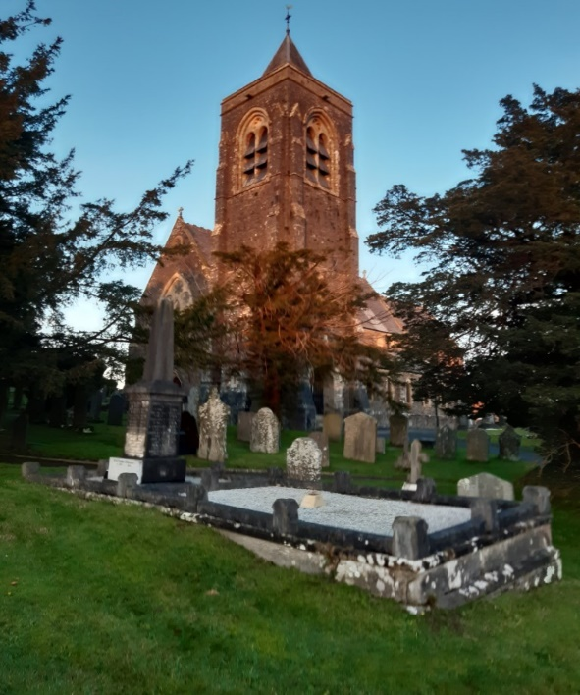
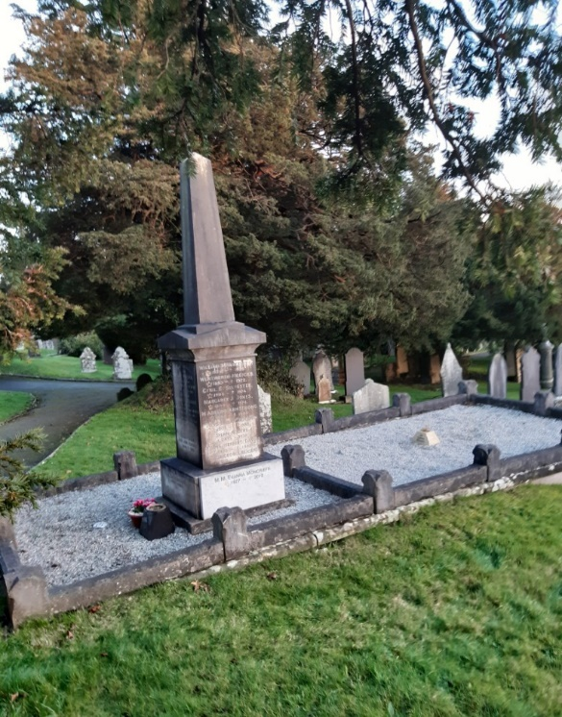
Fig.1 Fig.2 Method
After witnessing the ever-changing evolution undertaken in the graveyard and being repeatedly drawn to the same grave/monument, perhaps one of the largest there, observing its grandeur and symbolism, the sheer number of names and the beautiful pot of flowers placed within the bed of the monument (see Fig.2).

Copying the names down as seen in (Fig.3, below) and then researching them to see a glimpse into their life, work, standing in the community and what they looked like. (Anon., 2002-2020) Then researching the symbols and their meanings to gain better knowledge of their beliefs, (Anon., n.d.) the family’s love for the named departed and the facilitation for memorialisation.
Thirteen of the names have five pointed stars and Latin Christian crosses, (see Fig.5)
six of the names have stars with small decorative dots/rays between the spikes of the star with Latin Christian crosses, (see Fig.6) one name with a Greek Christian cross with star (see Fig.7) and eight with no symbols.
Next to James who died in 1902 and Mary who died in 1929 it had “corner shop” written in English, indicating they might have been the first to own the “corner shop” that would remain in the family for another two-hundred years. Additional research is subsequently required to investigate where their shop was, what they sold, how long had they been there and were there any other places where the Megicks family may have resided.

Lastly, taking photos to show the size, shape, stone type, inscriptions, symbols, position in relation to the church, and the love and thoughts still being demonstrated by the family.

The security and separation of the stone enclosure with its fifteen raised blocks, initials of stonemason – “J J.L” written on the stone surround, a double bed separated in the centre (see Fig.2, above) filled with smaller stones, a stone base plinth, an oblong block with two names and a main larger oblong block with the other twenty- six names, symbols, and dates. Above these is the grey obelisk on the top without writing or symbols. Running south of the church, lengthways seen in (Fig8, below).

Results: Table

Name | Surname | D.O. B | D.O. D | Age | Symbols
James | Megicks | 1829. | 31/01/1902 | 74 years | None
Margaret | Megicks | 1826. | 22/01/1906 | 81 years | None
David | Megicks | 1853 | 28/09/1853 | 1 month | None
Wentworth | Megicks | 1871 | 03/11/1875 | 4 years | None
Mary | Megicks | 1863 | 29/06/1929 | 66 years | None
James T | Megicks | 1855. | 30/11/1930 | 76 years | None
D J (Jack) | Megicks | 1907 | 1999 | 92 | Short Cross/star
Wentworth | Megicks | 1893 | 1972 | 79 | Cross/star
James.H (Bertie) | Megicks | 1903 | 1912 | 9 | Cross/star
David John | Megicks | 1857 | 1934 | 67 | Cross/star

Dewi M | Herbert | 1903 | 1966 | 65 | Cross/star
Cyril M | Herbert | 1898 | 1970 | 72 | Cross/star
Ann Jane | Herbert | 1904 | 1991 | 87 | None

William S | Moncrieff | 1924 | 1970 | 46 | Star/Cross
M M Evanna | Moncrieff | 1927 | 2010 | 83 | Star/Cross

Cyril E | Sylvester | 1905 | 1974 | 69 | Star/Dots or Rays/Cross
Doris V | Sylvester | 1901 | 1966 | 65 | Star/Dots or Rays/Cross

Margaret J | Jones | 1894 | 1974 | 80 | Star/Cross
John Lewis | Jones | 1897 | 1961 | 64 | Star/Dots or Rays/Cross
C Gareth M | Jones | 1925 | 1958 | 33 | Star/Dots or Rays/Cross

Madeline | Armstrong | 1895 | 1980 | 85 | Star/Dots or Rays/Cross
Charles T | Armstrong | 1883 | 1959 | 76 | Star/Dots or Rays/Cross

Dilys Lilian | Rogers | 1905 | 1988 | 83 | Star/Cross
Shan | Rogers |  | 1938 | 4 Days | None
Cecil George | Rogers | 1905 | 1998 | 93 | Star/Cross

Rosina Herbert | Davies | 1899 | 1992 | 93 | Star/Cross
Enock | Davies | 1892 | 1966 | 74 | Star/Dots or Rays/Cross
Fig.3

Key: Black – written on grave memorial, RED – Not written on grave memorial and may not be correct, Red. - Date found on www.myheratige.com

Discussion
Harold Mytum explains that “Monuments in the old tradition often spoke to the reader of the stone directly, with the deceased making a statement from the grave through both text and symbol, and in the new tradition, emphasis was much more towards defining and commemorating the deceased, and the text was usually in the form of a memorial statement which emphasised kinship, relationship, place residence or occupation and in Pembrokeshire, south-west Wales, it is possible to consider not only social position but also cultural affiliation through an analysis of memorials.
The obelisk is possibly made of white marble or white Portland stone indicating the desire for longevity as both stone and marble are well known for their durability, (wordpress.com, n.d.)reducing the chances of being moved in the future, unlike some of the smaller graves which have not only been moved around the graveyard but have completely disappeared over the centuries. As this stone would have had to be imported it would have been more costly than the average grave, giving the indication of wealth.
“In this area where both English – and Welsh - speaking populations can be found, the choice of language was used as a cultural indicator and, indeed, one of national allegiance”. (Mytum, 1944) Lampeter not being that different to a town in Pembrokeshire should have had similar interpretations.
The typography is bilingual with the “corner shop” written in English and everything else in Welsh. This could be an indication of their language abilities, as most locals would have only been able to speak Welsh, (Mason, 2009) whereas a higher standing member of society would have been able to speak and write bilingually as the wealthier you were the better educated you could be. The respect and acknowledgement of the Welsh language may be shown in later generations possibly adopting the welsh language as their own due to changes in England’s power over wales, memorialising the transition along the way.
This monument complements and mirrors the life story of the Megicks family as it is robust and has a stylish appearance, holistically expressing love and respect. The monument which remains just like the shop itself, ongoing with only superficial corrections, the shop changing with the times and to the needs of local people, showing an adaptable hardworking, respectable family. Not all the Megicks family are in this graveyard, they are also in Llanybydder, Llanwenog, and others including Oxford in England. (Anon., 2002-2020)

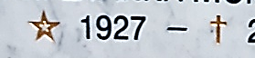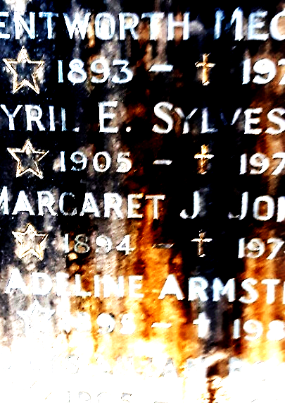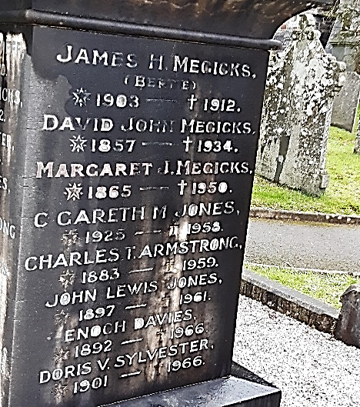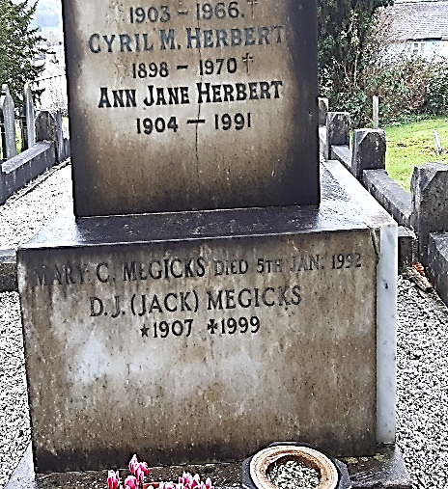 Fig.4 Fig.5 Fig.6 Fig.7

Symbols explained In the Funeral Guide state that the “Latin cross is one of the oldest symbols of Christianity and most used,(see Fig4) and the Greek cross has four equal arms equal in length and is a traditional symbol of Christian faith,(see Fig.7) (Anon., n.d.) The five-pointed star is a symbol of divine guidance and the four elements, for Christians it symbolises Christs wounds. For Pagans and Wiccans, it represents protection”, (Anon., n.d.) the dots/rays between the stars (see Fig.6) and star with flower/star? in the middle may have been decorative rather than symbolic as no reference to these were found, (see Fig.4) assumption made after having a conversation with. Pers. (Drew, 2020)
The Megicks family would have attended at least some of the many services held at St Peters, (Maps, n.d.) as well as being laid to rest there themselves. Situated in a prime position of the graveyard where the more affluent members of the town could be positioned. Very peaceful in comparison to the war memorial situated on the edge of town. (Council, 2016) And strong, hardwearing structure made with good quality materials that would last for centuries to come.

Conclusion
Close to the church, positioned between the south and west side, (Anon., 10 July 2015) with great views, From, what was observed in St Peters graveyard, backed up by what Harold Mytum’s work on Language as symbols in churchyard Monuments: (Mytum, 1944)
This grave monument represents, 200 years of history memorialised for all to see and for surviving members to still come and show their love and respect. This is clearly shown by the healthy appearance of the flowers potted at the base. (Fig.2). It enables their loved ones to feel close to their family members at times of need and remember their place in the upper levels of local society. This can be seen by their ownership of a substantial corner in the centre of town where they traded as iron mongers and general stores right up until the present day. However, this memorial grave does not contain all the named family members and there are several graveyards in the Lampeter and surrounding areas also containing the Megicks family. which leads me to believe that they were an affluent, respectful, loving, and capacious family.

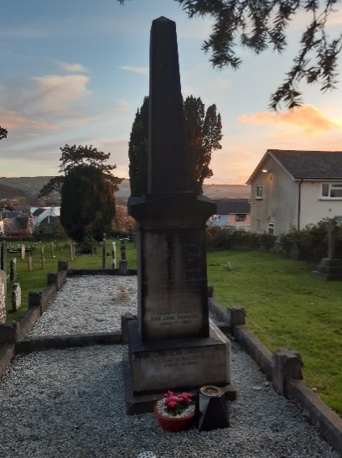 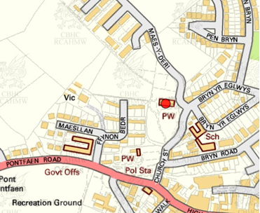 Fig.8 Fig.9 (RCAHMW, 2015)

Bibliography

Pers. Ros Coard
Pers. Quentin Drew

www.myheratige.com

Mytum, H. 1994. Language as Symbol in Churchyard Monuments: The Use of Welsh in Nineteenth- and Twentieth Century Pembrokeshire. World Archaeology, Vol. 26, No. 2, Communication and Language, pp. 252-267.

History & Tour of St Peters church leaflet by: J Oakley

https://headstonesymbols.co.uk

Obelisk Style Monument Designs | Rome Monument (romemonuments.com)

posthole_20_136.pdf

Churchyard Monuments and Cemetery Monuments - Bob Speel's Website

http://www.thecemeteryclub.com/symbols.htmlhttps://www.funeralguide.co.uk/cemetery-symbolism/

ST PETER'S CHURCH, LAMPETER | Coflein image (1200 x 797)

Coflein.gov.uk

GENUKI St Peter's ChurchyardURL
Corrected 2019 – Stephen Thomas + group – updated by Gareth Hicks – 09/04/2020

SA48 7ER - Google Maps - (Grid ref. For Church) Maesllan, Lampeter SA48 7EN, United Kingdom 4W89+25 Lampeter, United Kingdom

Lampeter War Memorial File
Extract from, L.J. Mason 'Communities in Mourning (PhD Thesis, Lampeter, 2009) Chapter 8.2, pp.207-15.
Updated 08/08/16

