Name: Chris Morris
Student Number: P149915
Module title: Network Services
Document: Assignment 1
Module code: M5X01050
Lecturer: Tim Bashford
Contents
Introduction 1
Content
Worksheet 1 1
Worksheet 2 2
Worksheet 3 2
Worksheet 4 2
Worksheet 5 2
References 2

Introduction

The overall objective, either alone or as part of team (the latter in the author’s case) is to complete several worksheets with screenshots as evidence to demonstrate understanding of working a virtual machine. The first four worksheets will be completed in the team, while the fifth must be done independently.

Content

Worksheet 1

The first worksheet established the creation of a Type 1 hypervisor to help control the three created operating systems and connect to them at any time.

Task 1

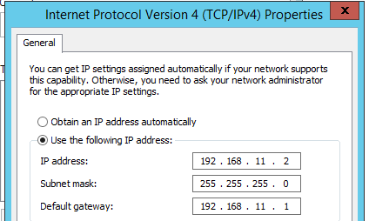
The process began at a server named Swansea, which was configured with an assigned IP address and gateway. This was then repeated for the standard Windows 7 client and the Cardiff server.
Figure 1: Setting IP address and gateway of Swansea server
Task 2
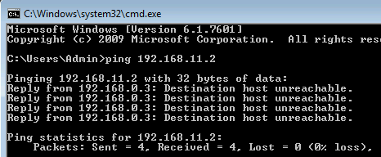
Each server attempted to ping each other, this was unsuccessful as a routing protocol was not assigned and a network path was not established.
Figure 2: Attempting to ping the Swansea server
Task 3
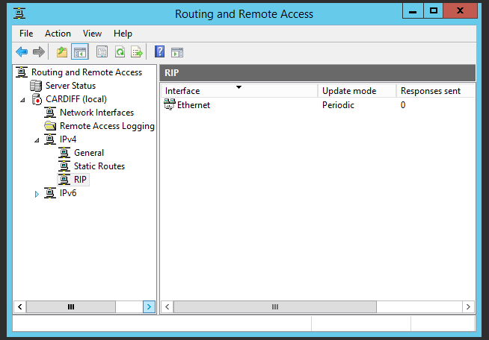
RIP (Routing Interface Protocol) was enabled on the Cardiff server to assign it as the master server.
Figure 3: Enabling RIP on Cardiff server
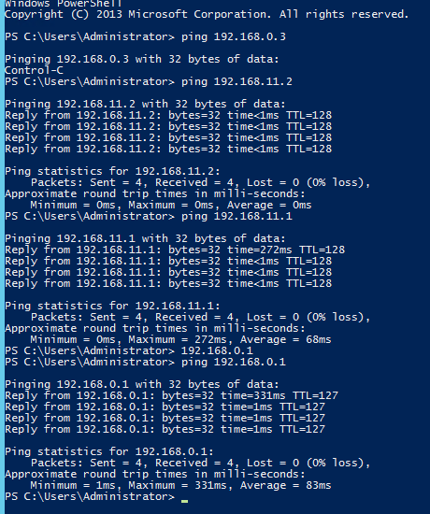
This enabled pinging to the other servers
Figure 4: Pinging other servers from Cardiff
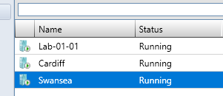
Access to all three servers was then spread to all three group members
Figure 5: List of systems
Task 4
The objective of the “route print” command is to list all important subnet information relating to a selected server. From it, a user can determine any IP settings easily, as the command splits information by server type (e.g. IPV4 information displayed via a table, followed by IPV6, followed by DHCP, followed by DNS).
Task 5
Routers are essential in a network, they are responsible for the sending of data packets between devices. The most common examples are wired and wireless (routers that apply cabling and routers that connect manually, respectively), but can also include virtual routers, which virtually imitate the equipment).
Information about connected routers is contained in a table, which details information such as IP addresses, which device the router is interfaced with, and the gateway assigned to a device to help it share information. This can quickly be opened by commanding a network to display its IP route, and is helpful in determining how a router will travel and if changes need to be made.
The most common examples of routing protocols include RIP, which, as demonstrated, provides a link for servers to connect and link information. Other examples include OSPF, which spots problems in a network structure and seeks the shortest path overall, and IGRP, which splits packets equally and is designed to continue operating despite information being adjusted.
The role of a subnet mask is to split an IP address into sections and help users identify their chosen section. There are two sections; network (which detail the amount of network subnets), and host (which detail the amount of hosts a network can hold). The number of subnets and hosts depends on which class the address is included in; A, B, or C. A network with less hosts ends up in Class A, and vice versa for Class C.
A Type 1 hypervisor was the format applied throughout this worksheet. This hypervisor is useful in the fact that it simplifies the overall network structure and provides direct hardware access. Examples of software is Xen, which can run several types of operating system on a sole network host, although the low number of machines could pose a security risk.

Worksheet 2

Worksheet 2 aimed to increase understanding of packet filtering, a process which helps data flow between more secure servers by scanning packets of data before they are sent.
Task 2
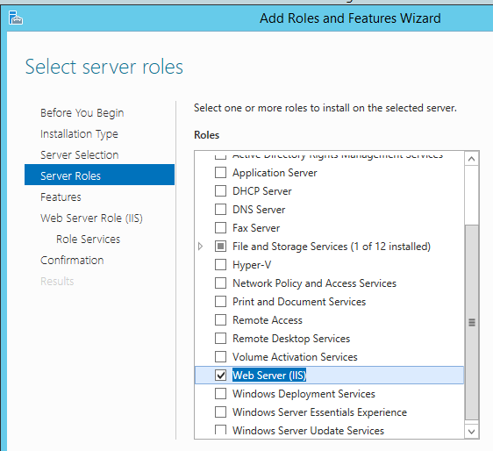
An FTP server was created, allowing for a swap and storage of computer files
Figure 6: Installation of FTP server
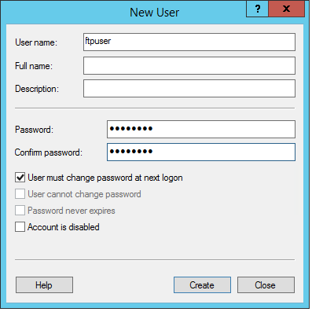
This was the central folder where testing of information exchange commenced
Figure 7: Proof of user folder
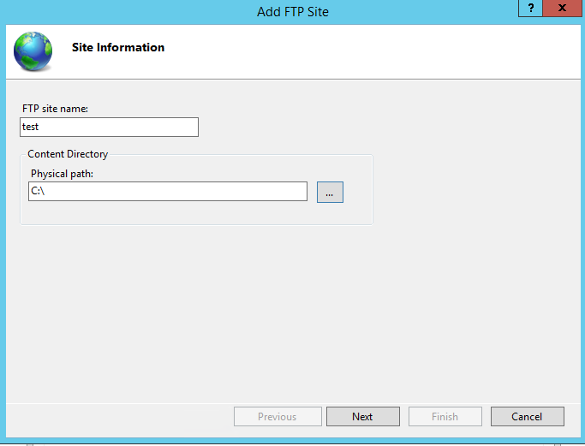
The test text file used to test whether the FTP will perform correctly
Figure 8: FTP directory
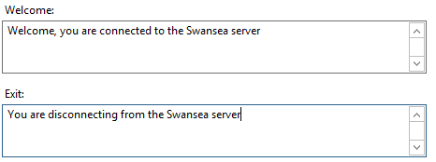
Messages used to verify linking to the server
Figure 9: Creating banner messages
A text file was stored successfully in the folder
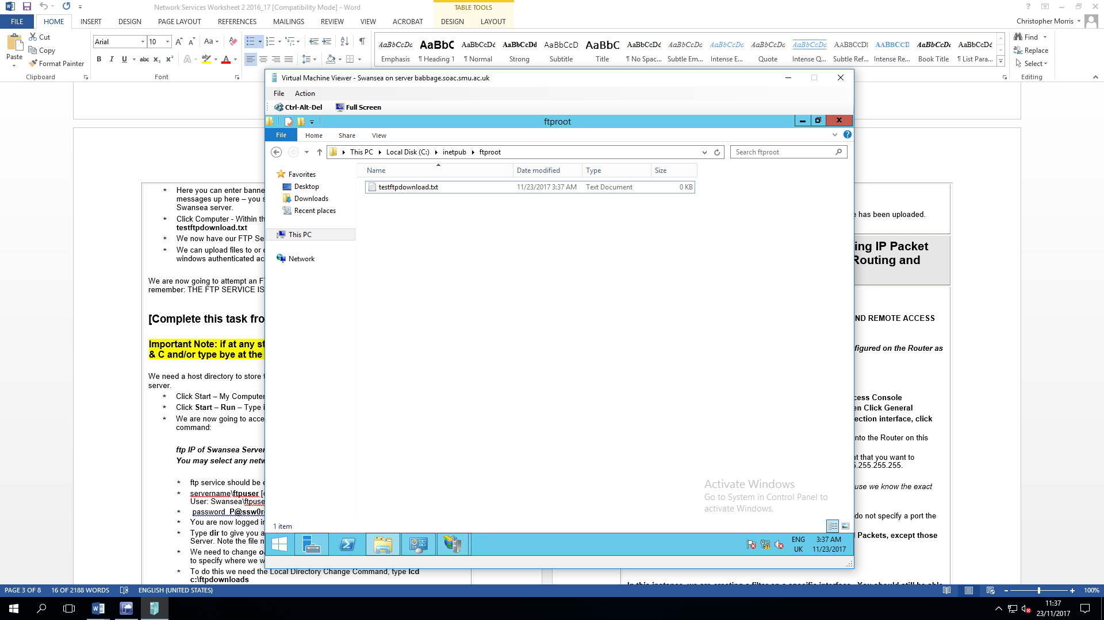
Figure 10: Proof of completed file
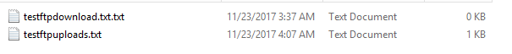
A file uploaded in Cardiff that Swansea could access
Figure 11: Shared text file
Task 3
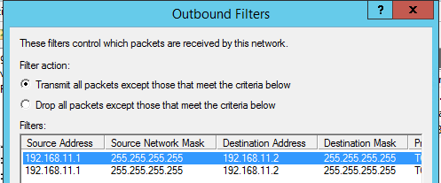
Cardiff is unable to ping Swansea due to above restrictions
Figure 12: Restricted outbound filter
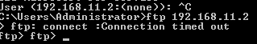
Figure 13: Unsuccessful ping
Task 4
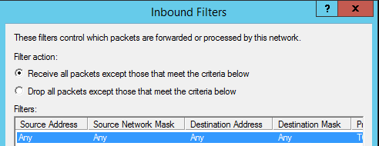
Removing restrictions to allow for successful ping
Figure 13: Configuring inbound filter
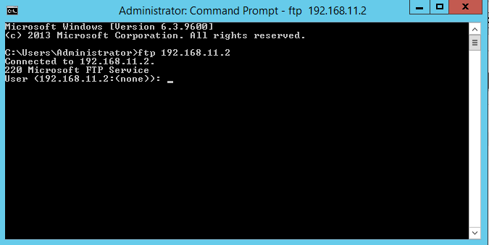
Figure 14: Successful ping
Task 5
There are several different protocols which help control the flow of routers. One example is RIP, a protocol that routing information such as the number of hops that are involved in a process, the overall speed, and the amount of distance involved. There are two versions of RIP, versions 1 and 2, the only difference between them being 1 is classful (stays in a fixed network range) and 2 is classless (vice versa).
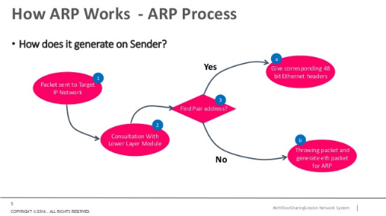 [1]
Address Resolution Protocol (ARP) makes discovering IP addresses simpler by defining rules such as its length. It is an important component of the Network Layer in the TCP/IP model, and helps convert Address into more unique MAC addresses to make information easier to remember when performing actions such as pinging two networks.
Packet filtering is the process that determines what data enters a router, acting like a network firewall. It examines where data is being sent to and where it has come from, deciding to block any data that could prove harmful. Throughout this task, it has been referred to as IP packet filtering as IP addresses have been where the activities have mostly occurred. Benefits of packet filtering include how little resources it consumes and how quickly it applies its effects.
Sending IP data across devices is made easier using contradictory filters. Filters are bound to both data coming in and going out, but a rule that applies to one does not apply to the other. It is possible, for example, for the second filter to reject any data that the first data approved for checking, making these filters possible in terms of packets.
As well as linking files between systems, an FTP server can also provide a means for people to edit text on websites. It can do this by allowing for integration with other services such as SSH, which provide FTP with either a local or remote connection. This is made easier still with the ability to lock information with passwords, making access clearer to establish.

Worksheet 3

Worksheet 3 involved assigning each system with its own network interface. To accomplish this, the TCP/IP protocol was used, to define the IP addresses that can be used and further control the range used.
Task 2
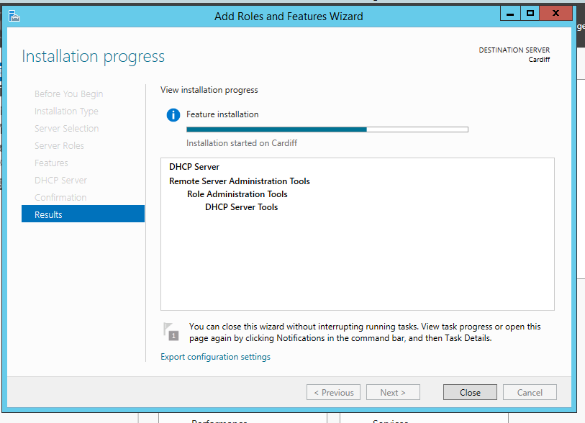
Successful DCHP server installation on Cardiff server
Figure 15: DHCP setup
Task 3
Screenshot of DHCP server when it was later installed in Worksheet 4
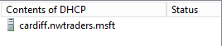
Task 4
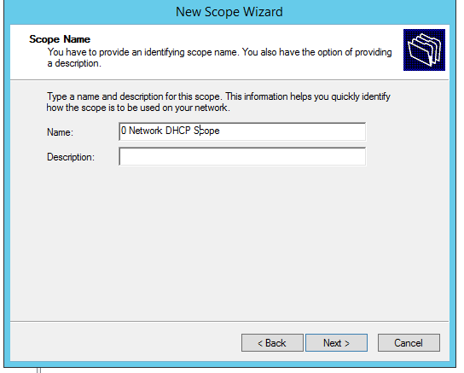
Cardiff defined the DHCP scope, allowing the other two servers to connect
Figure 16: Setting DHCP scope
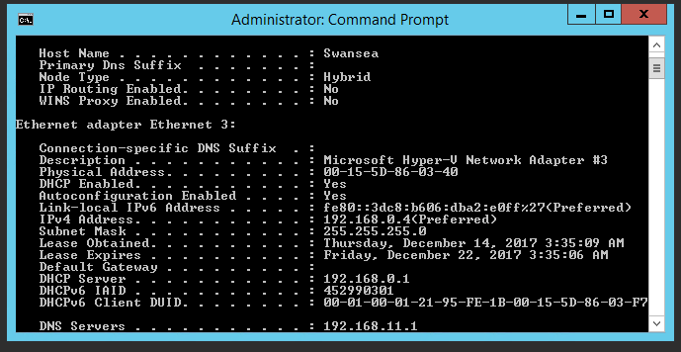
The IP addresses defined in the DHCP scope could successfully ping
Figure 17: DHCP pinging

Task 5
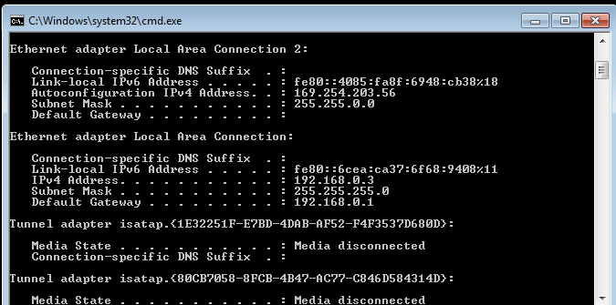
Windows 7 client testing after Cardiff converted DHCP addresses from leases to reservations via MAC addresses
Figure 18: Proof of DHCP IP testing
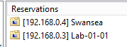
Swansea and Windows 7 added to server under Cardiff’s control
Figure 19: Added DHCP reservations
Task 6
A DHCP server can be used to select IP address without user input. This ensures that IP addresses are not repeated but are not controlled by the user. In this case, a server was used to adjust addresses and imply restrictions to make settings secure in the case of a disaster and discover what occurs, with proof that devices cannot ping if they do not link.
If a server configured with the TCP/IP protocol cannot link to its intended DHCP server, checks over the entered IP addresses should be completed. If all details are correct, a backup DNS server can be made, which can link with the intended server.
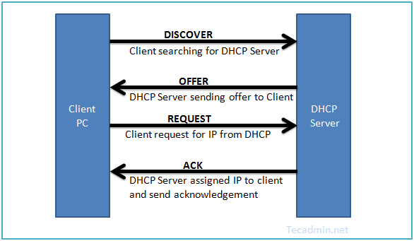 [2]
Listed above is the 4-step process in which a DHCP server secures an IP address, commonly known as a three-way handshake. A user sends a request to the server asking for a new address, after which the server retrieves one and acknowledges the original request, completing the process.
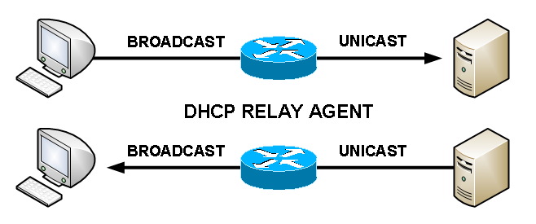[3]
A relay agent is a linking tool used to assist a user in connecting to a DHCP server remotely. One would use an agent to simplify linking to a known server beyond their physical subnet. An agent has several advantages; it runs on one sole layer (saving resources) and allows a user greater access to how a DHCP server flows in terms of traffic.

Worksheet 4

Worksheet 4 was an extension of 3, installing a DNS server to convert the domains of each machine into their own IP addresses, to make remembering details easier for any users.
Task 1
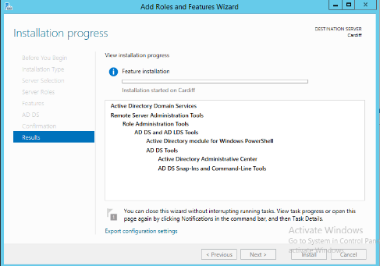
DNS server installed on Cardiff machine
Figure 20: Installation of DNS server
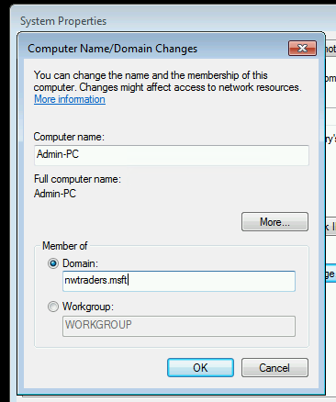
Server name defined
Figure 21: DNS server name
Swansea server
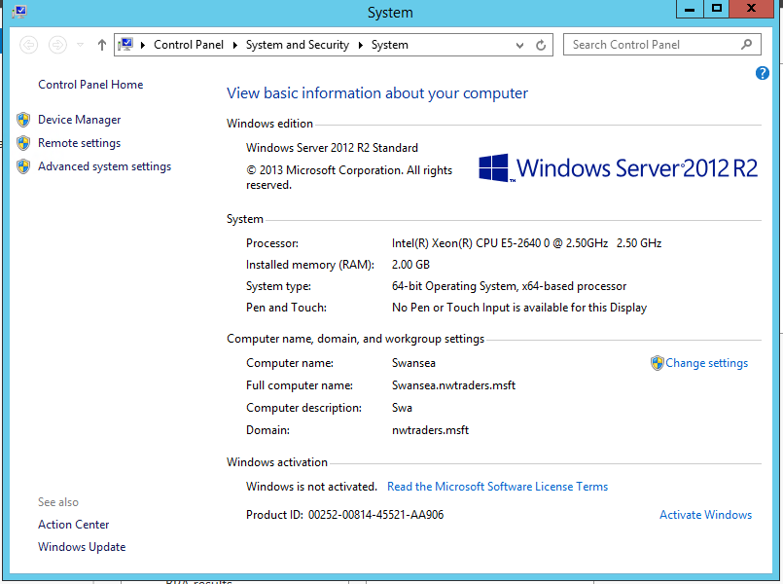
Process repeated on Swansea server
Figure 22: Continuation of DNS server
Task 2
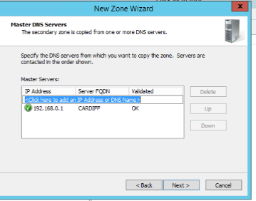
Cardiff established as master DNS server
Figure 23: DNS master zone
All folders together in DNS server; Swansea and Windows 7 added through reverse DNS zone
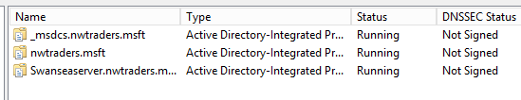
Figure 24: DNS folders
Task 3
Web creation
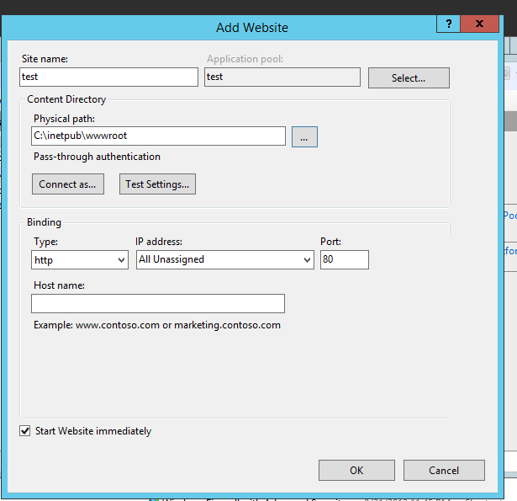
Settings made for test website examining overall DNS server
Figure 25: Implementation of test website
Evidence of website
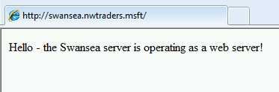
Settings made for test website examining overall DNS server
Figure 26: Completion of website
Task 4
The name of any specified IP addresses can be verified either via the -a command when pinging a server or the network command nslookup, after which it can be adjusted if necessary.
There are two main query processes that can help handle any requests related to DNS; iterative and recursive. Recursive involves the use of a second DNS server to resolve any issues related to user names, in the case that it cannot be determined. Iterative, meanwhile, allows for more leniency, where the server in question gives its most accurate approximation based on the data supplied. [4]
Another method of determining DNS user names is root hints. They are important in discovering the address of clients connected to others besides the primary server, storing the information in a table which describes the full domain name, enabling quick access if the server has not been edited to allow for forwarding of data.
The exact FQDN, based on the description given, is SubContA.nwtraders.msft/Server1. DNS configures FQDN so that the subdomain is given first, followed by the root and then the specified location. It follows this based on its tree-like model of splitting the domain name up, helping it become more identifiable.
This links to DNS zones, which help define how domains are broken up and are only accessible to administrators. Factors to be aware of include the relation of a server in accordance to the DNS server. One machine in the server is assigned as the core machine for storing DNS records via a primary zone, while the others can be used as backup via secondary zones and can be locked to prevent any changes not made by the core server.

Worksheet 5

There are several different web designs which can also be managed by clusters, a tool that spreads tasks across each web tier. It is common to have three web layers, and an example of a cluster that can assist it in performance is a load-balanced cluster (a cluster that aims to spread the workload as equally as possible among all tiers in a network).

Putting this cluster strategy into use, a possible 3-tier web system could include [5], for example, the presentation layer at the top (the finished raw data which has been processed and ready for usage), an application layer in the middle (which oversees setting into motion the information collected), and the physical layer at the bottom (the layer that the data begins at it when it is retrieved).

Compared to other clustering strategies, load balancing is cheaper as it uses less hardware and ensures that each section of a server is working to its full capability [6], but it lacks scalability due to working under one format, and potentially having too many servers can make it more difficult to control the overall network flow, depending on overall experience. It can be compared to a failover cluster, which provides high scalability due to the amount of point entries it includes, but issues arise if one of those entries fails.

Examples of tools that a high-availability cluster applies [7] includes a network storage area to store data non-volatility and disk duplicating as a backup procedure. These are achieved via technology such as single-copy clusters, which spreads a node of clusters amongst each network tier so that each can access them. [8]

The types of protocol one would use within this strategy is TCP/IP, to split traffic between all associated machines. It also simplifies the use of protocols of FTP, so much that if more than one server is present, it will subtract some of the speed and add it to the second server, reducing dependency and resulting in more spread-out speed.

Overall, it can be concluded that load-balancing is an efficient clustering strategy. While combining and spreading out functions across the network can make it harder to control, this greatly boosts overall speed and results in a greater flow of data. Combined with the fact that less resources are used with the joining of data, it could be considered useful in managing data and being available on a consistent basis.

References

[1] A. Nur, “6th floorsharingsession ep 1 - networking - arp v 1.0”. 2016.

[2] Microsoft Technet, “What Is DHCP Server?,” Technet.Microsoft.Com.

[3] ITGeared, “What is DHCP?.” 2012.
[4] Prohut IT Services, “Difference between Recursive query and Iterative Query in DNS.” 2014.

[5] H. Halvorsen and M. Sc, “Creating Web Services Step by step Exercises.”

[6] T. Cerling, J. Buller, C. Enstall, and R. Ruiz, Mastering Microsoft Virtualization. 2009.

[7] A. B. M. Moniruzzaman and S. A. Hossain, “A Low Cost Two-Tier Architecture Model for High Availability Clusters Application Load Balancing,” International Journal of Grid and Distributed Computing, vol. 7, no. 1, pp. 89–98, 2014.

[8] Microsoft Technet, “High Availability and Clustering Technologies,” Technet.Microsoft.Com.

