Martin Dunn 1705105 Computer Systems John Rees
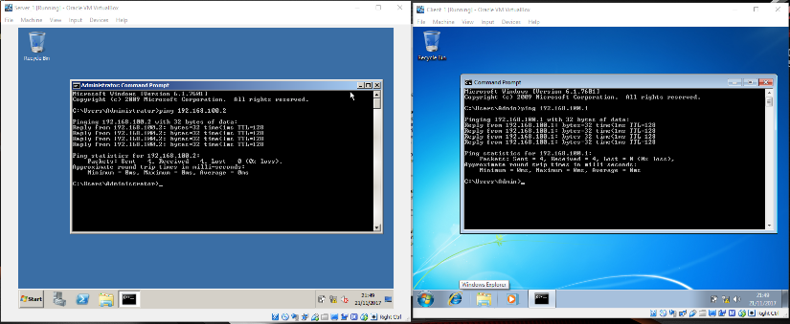
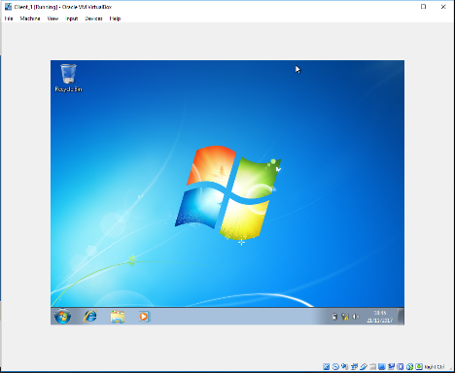
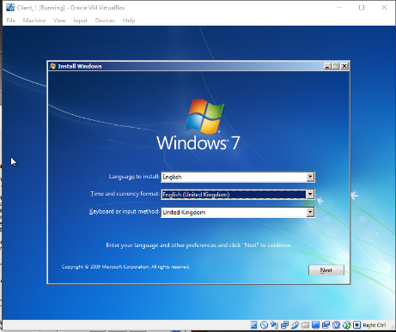
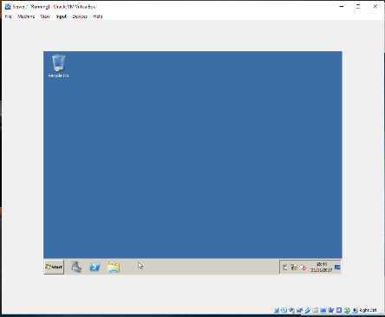
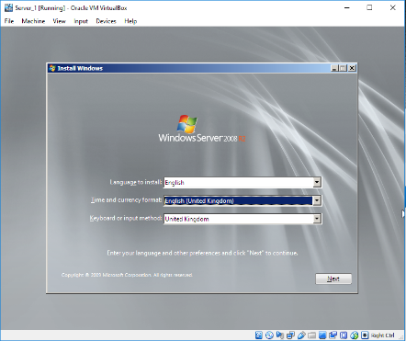
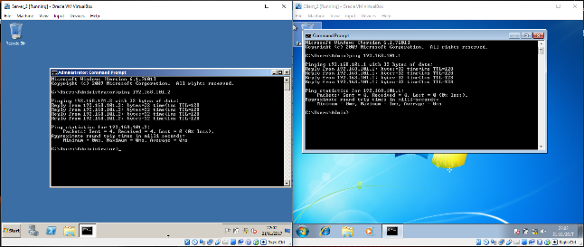
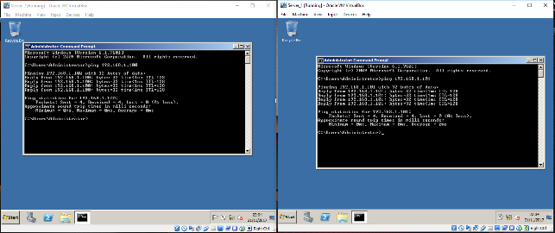
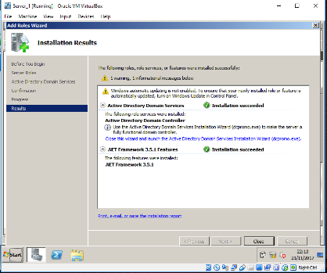
Server 1 pinging successfully to Client 1.
Windows 7 Running.
Installing Windows 7.
Client 2 is cloned from Client 2.
Windows Server 2008 running.
Installing Windows Server 2008 (Enterprise full installation 64-bit)
Server 2 is cloned from server 1.
Server 2 Pinging successfully to Client 2.
Server 2 pinging to server 1 successfully.
Installing Active Directory Domain Services (AD DS)

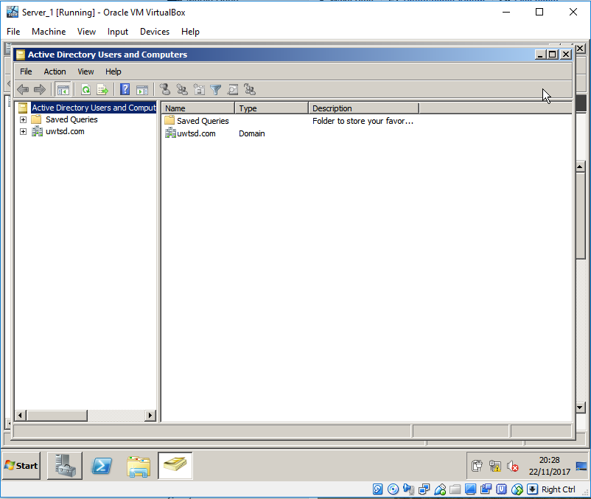
Active Domain.

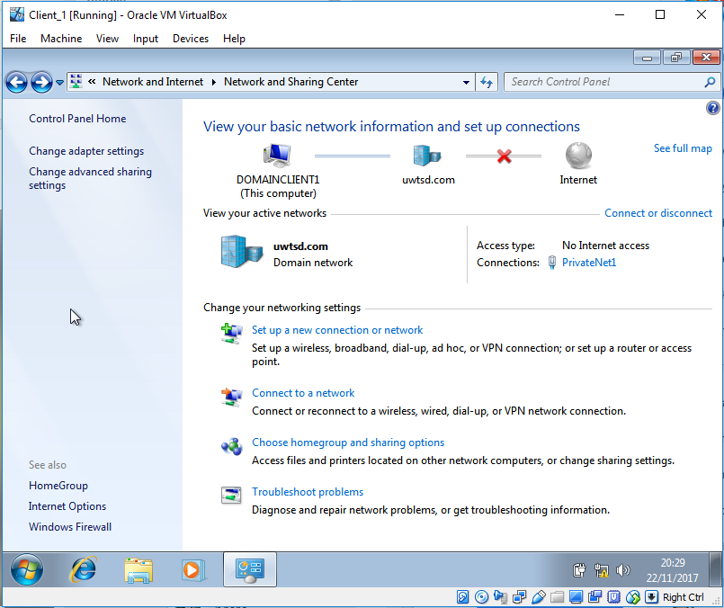
Client connected to domain.

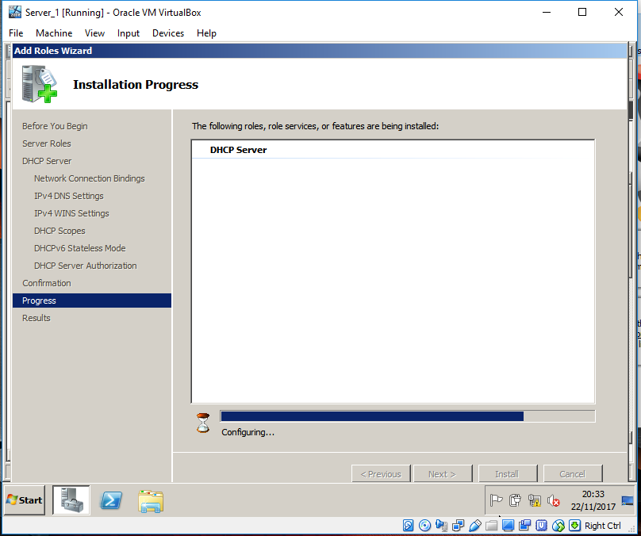

Installing DHCP Server.

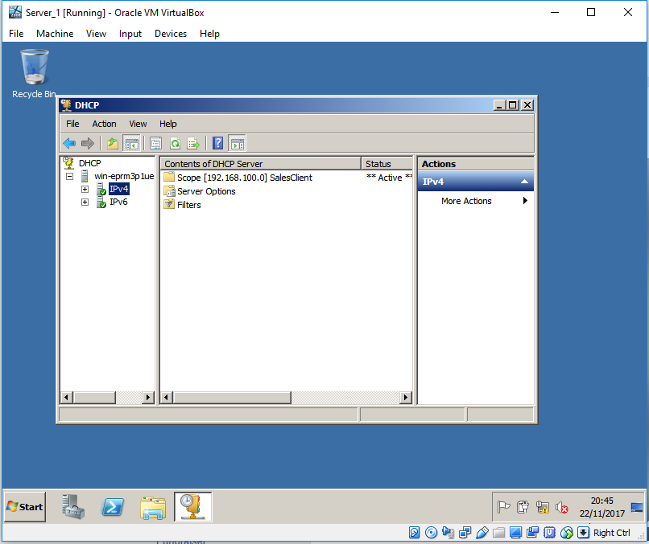

Active Scope

Ipconfig /all
Ipconfig /renew
Ipconfig /release
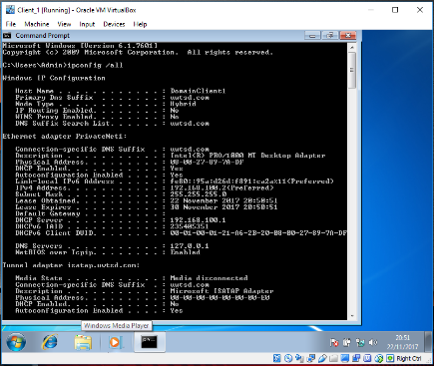
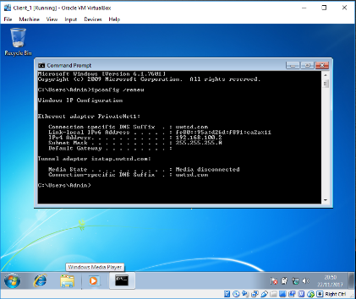
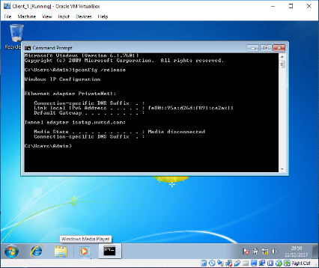

Altered Scope options to give the client a Default Gateway.

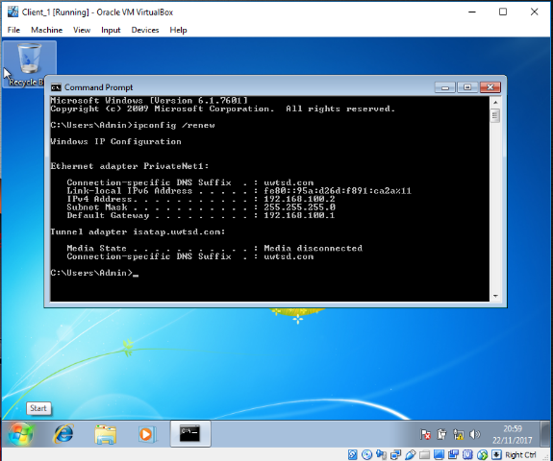
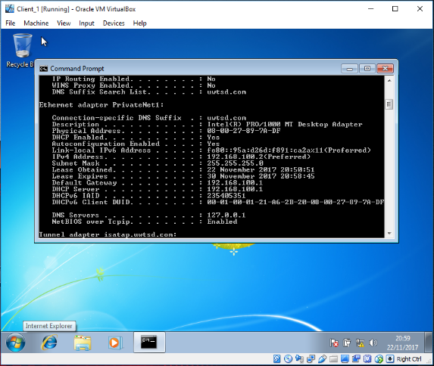

Observational Tasks

- Some of the benefits of T2 Hypervisor virtualisation software are that the virtual machine is running over software so if you’re testing something in your virtual machine and it does not go quite as planned you do not have to risk your primary OS, or and software for that matter. Also, if anything does go wrong with the machine you can just erase it and restart with almost no effort and not effecting the host machine. They can also be very useful for running a different OS on your system if your main OS does is not compatible with certain software and and things. E.g if you’re running Linux or Mac OSx and you need to use something that is only compatible with Windows, its much quicker and easier and cheaper to run windows as a Virtual machine then it is to reinstall an OS.
[1]
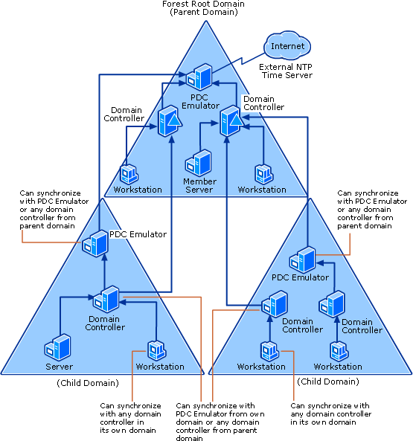
- “An Active Directory forest is the highest level of organization within Active Directory. Each forest shares a single database, a single global address list and a security boundary. By default, a user or administrator in one forest cannot access another forest” [1]

“A domain tree is made up of several domains that share a common schema and configuration, forming a contiguous namespace. Domains in a tree are also linked together by trust relationships.” [2]

“each domain below the root domain has exactly one superior, or parent, domain.” [3]

“A child domain is another domain under a parent one in an active directory domain hierarchy. A child domain under a parent first root domain form a Tree. All Trees exists within a Forest, a forest is the security boundary.” [4]

Inside an Active Directory there are Active Directory forests, Trees, Parent domains and child domains.
An Active Directory is a set of one or more trees. A tree is made up of a bunch of domains. A Parent domain is at the top of the active directory hierarchy after the root domain and a child domain is the level below the parent domain in the hierarchy.
- A Domain controller, by default stores one domain partition that holds information about the domain that it is in, and the schema and configuration directory partitions for the entire forest. There are specialized domain controller roles that preform specific functions in an Active Domain. Two of these Roles are Global Catalog Servers and Operation Masters.
Global Catalog Servers;
“Every domain controller stores the objects for the domain in which it is installed. However, a domain controller designated as a global catalog server stores the objects from all domains in the forest” [6]
So, for each object that is not in the domain for which the global catalog server is authorative as a domain controller, a limited set of attributes is stored in a partial replica of the domain. Basically, the global catalog server saves its own full, writable domain replica and also a partial, read only replica of every other domain in the forest. The global catalog is also automatically updated by the active domain replication system.
Operations Masters;
Some domain controllers hold operations master roles, these are designed to perform specific tasks to ensure consistency and to get rid of the potential for conflicting entries in the active directory database. Active directory defives five operations master roles; the schema master, domain naming master, relative identifier master (RID), primary domain controller (PDC) emulator and infrastructure master.
The schema master and domain naming master perform operations that must only occur on only one domain controller in the forest.
The other 3 roles must occur on only one domain controller in a domain.
- When a domain controller is in a forest is has connections with other domain controllers in the forest, so is a domain controller were to become unavailable to its domain another domain controller will take its place until it is available again.

References

[1] | Microsoft, "Microsoft," [Online]. Available: https://social.technet.microsoft.com/wiki/contents/articles/18573.time-synchronization-in-active-directory-forests.aspx. [Accessed 16 December 2017].
[2] | M. Rouse, "Whatis.com," june 2012. [Online]. Available: http://searchwindowsserver.techtarget.com/definition/Active-Directory-forest-AD-forest. [Accessed 16th december 2017].
[3] | Microsoft, "Microsoft," [Online]. Available: https://msdn.microsoft.com/en-us/library/ms675914(v=vs.85).aspx. [Accessed 16 December 2017].
[4] | Microsoft, "Microsoft," [Online]. Available: https://technet.microsoft.com/en-us/library/cc783351(v=ws.10).aspx. [Accessed 16 December 2017].
[5] | H. W. Elmosallamy, "Bayt," 2013. [Online]. Available: https://www.bayt.com/en/specialties/q/17634/what-is-the-difference-between-child-domain-and-domain-controller/. [Accessed 16 December 2017].
[6] | microsoft, "microsoft," [Online]. Available: https://technet.microsoft.com/en-us/library/cc786438(v=ws.10).aspx. [Accessed 16 December 2017].

