

Huawei Strategic Analysis Report

Course：Strategic Management

Course Number: BMMB7013

Module Instructor: Muhammad Tahir Mushtaq

Name: Zhiyu Liu

Student ID: 1803782

Content
Executive summary 3
1. Introduction 4
2. Main Finding 8
2.1 Internal environment analysis 8
2.1.1 Definition 8
2.1.2 Value chain analysis 9
2.2 External environment analysis 13
2.2.1 Definition 13
2.2.2 PESTEL analysis 14
2.2 SWOT analysis 20
3. Recommendation 23
3.1 Ansoff matrix 23
3.2 Strategic clock 29
4. Conclusion 32
Reference 35
Bibliography 36

Executive summary

The primary purpose of this report is to point out the shortcomings in Huawei's strategy and provide corresponding suggestions through the analysis of Huawei's internal and external environment. The theory and data listed in this article are all from published newspapers, news and related works.

In the first part, we first made a systematic introduction to Huawei's current situation, including corporate rankings, employee status, etc.

The second part is a systematic analysis of the internal and external environment of Huawei, the internal environment adopts the value chain model, and the external environment adopts the PESTEL model. After that, combined with the analysis results, SWOT analysis pointed out the problems and threats of Huawei at this stage;

In the third part, appropriate advice is given to the issues identified in the second part, and theoretical support is provided for the advice provided through the use of the Ansoff matrix and the strategic clock;

The fourth part summarises the full text and points out the practical significance of Huawei's case analysis for other companies.

Introduction

Founded in 1987, Huawei is a private communications technology company that manufactures and sells communications equipment. Headquartered in Shenzhen, China, it is the world's leading provider of information and communication technology (ICT) solutions (Wang, 2006). In 2013, Huawei surpassed global telecommunications equipment supplier Ericsson for the first time and became the world's largest telecommunications equipment manufacturer, ranking 315th in the Fortune Global 500 (FORTUNE, 2017). In August 2016, in the list of “Top 500 Chinese Private Enterprises in 2016” issued by the China Federation of Industry and Commerce, Huawei ranked first with an annual income of 395.09 billion yuan (Ministry of Economic Affairs of China, 2018). In July 2018, in the latest list of the top 500, Huawei ranked 72nd with a turnover of 105.191 billion US dollars (FORTUNE, 2018). In the same year, Vodafone and Huawei completed the world's first 5G call test (Mademann, 2018).

Huawei has 188,000 employees, and its business scope ranges from radio and microelectronics to communication, routing, and switching. In the process of development, Huawei has always adhered to the goal of “building a smart world of Internet of Everything” and adhered to the development philosophy of “doing only the best” and gradually moving towards the world. According to data from the World Intellectual Property, six of the top ten companies that submitted patent applications in 2018 came from Asia. In the technical field, digital communications surpassed computer technology and accounted for the highest proportion of published patent applications. The total amount was 8.6%, of which Huawei submitted 5,405 international patent applications, the highest among all enterprises, and created new records. Gao Rui, Director-General of the World Intellectual Property Organization, said: "This is an important milestone that highlights the historic shift of innovation activities from west to east" (Liu, 2019).

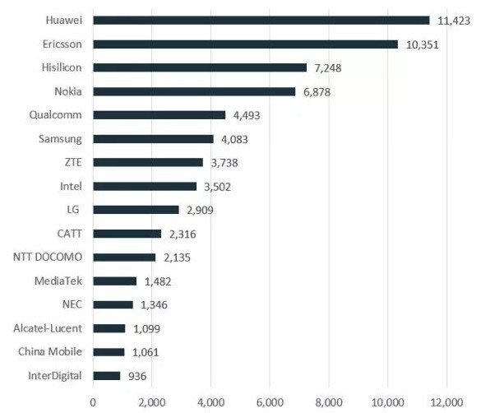

Technical contribution ranking for 5G standards
(Source：IPIytics)
Among all Huawei businesses, smartphones are the most well-known in public, and they are also the engine of Huawei. In 2018, the operating income of the mobile phone business increased to 348.9 billion yuan, accounting for more than 48% of the total operating income, becoming the largest source of revenue for Huawei (Ren, 2018). At the same time, according to IDC's 2018 global smartphone shipments, Huawei's handset shipments increased by 33.6% year-on-year, indicating a vast market recognition for Huawei handsets. Compared with the mobile phone shipments in the third quarter of 2017, the data in the third quarter of 2018 have significantly fluctuated. The mobile phone industry leaders such as Samsung suffered a crisis. Only Xiaomi and Huawei from China maintained a rapid growth momentum (Yang, 2019).

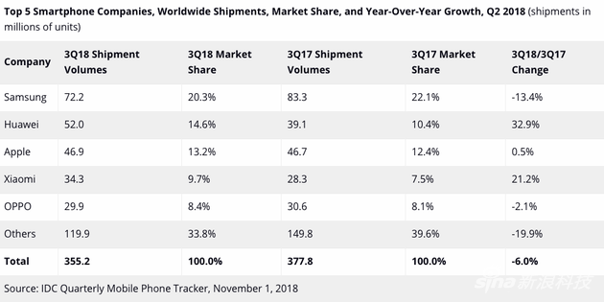

Correspondingly, the market share of Huawei mobile phones has increased year by year. Taking the Chinese market in 2017 as an example, local manufacturers have risen sharply. The Chinese mobile phone brand represented by Huawei has squeezed Samsung into the top five for the first time, while the market share of APPLE mobile phones has dropped to 9.3%. Also, Huawei's mobile phone, as one of the few mobile phone brands that can maintain positive growth, has topped the Chinese market (Melissa, 2018).

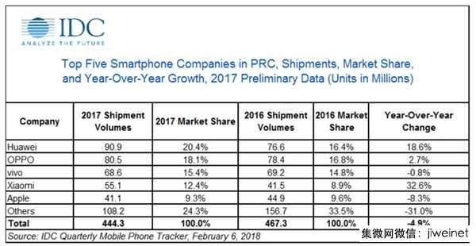

Pale data can sometimes show the suddenness of a company's rise. From the first team of only 14 people to today's nearly 190,000 employees, Huawei has completed the perfect counterattack. However, in 2018, Huawei has faced unprecedented challenges on the road to internationalisation. This report will focus on the internal and external aspects of Huawei's success and the crisis it has encountered. Then, appropriate warnings and measures were given to Huawei's crisis in the process of internationalisation.

Main Finding

This chapter will analyse and generalise Huawei's company from both internal and external environments, and use SWOT analysis to point out the problem.

2.1 Internal environment analysis

2.1.1 Definition

Michael Porter first proposed the concept of the value chain in his book in 1985. Porter believes that the value creation of a company is formed through a series of activities, which can be divided into main activities and support activities. Among them, the main activities include: inflow of goods, manufacturing operations, shipping logistics, marketing and after-sales services, etc.; and support activities are other activities that support major activities, such as human resources management, technology research and development, procurement and other auxiliary value-added Link (Presutti, Jr. and Mawhinney, 2009). On this basis, in 2001, Griffin analysed the international division of labour and industrial linkages around the world and proposed the concept of the global value chain. In general, value chain analysis is mostly used for the analysis of the internal environment of the enterprise. For global companies like Huawei, the use of global value chain analysis can more fully understand the role of each link (Walters and Rainbird, 2004).

2.1.2 Value chain analysis

For a company, it is essential to connect and create a single link of value quickly. By analysing Huawei's internal value generation system, it can be roughly divided into the following four main parts:

Product design

Excellent R&D capability is Huawei's core competitiveness, which is mainly reflected in the following two aspects:

- Low R&D costs. Compared with Samsung and Apple, Huawei's research and development costs are meagre. There are about 4 million engineering graduates in China each year (Zhang and Wu, 2018). Huawei can recruit outstanding graduates to conduct research and development work for Huawei. These graduates have similar aesthetic appeals to young people, and the products designed are natural to enter the younger generation. At the same time, Huawei benefited from China's substantial engineering reserves. In China, an R&D engineer earns about one-half of his European counterparts and works 1.5 times longer than European engineers. More than 80% of R&D expenses come from human resource costs. From this perspective, Huawei can spend the least amount of money to get the most research and development benefits.

- High-quality research and development. Within Huawei, more than 40% of its employees are engaged in R&D-related work. According to the European Union's "Industry R&D Investment Rankings for 2018" issued by the European Commission, Huawei's investment in R&D in 2018 reached 14.7%. The high investment in the R&D department has resulted in the summit of the number of patents in 2018.

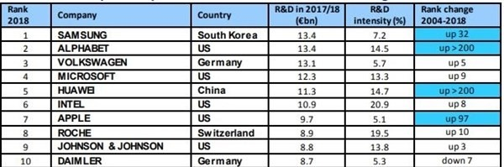
Enterprise R&D investment ratio
（Source: European Commission）

Production processes

The production process includes value-added links or auxiliary value-added links such as procurement and processing.

When sourcing raw materials, Huawei always adheres to the principle of “responsibility first” to ensure that its raw materials have qualified quality. Steady procurement is the cornerstone of the supply chain. After the development of a clear procurement plan, the establishment of cross-departmental cooperation mechanisms, supplier review and procurement performance assessment.

In the processing chain, through the long-term and stable supply agreement with suppliers to ensure that their supply chain is not affected. Taking China as an example, Huawei has signed a long-term strategic cooperation agreement with Foxconn to ensure stable shipments(Van Heerden, 2012).

Marketing link

Marketing is a crucial step in bringing its products to market. In the Chinese market, Huawei has two main marketing methods: online and offline:

- The first is online marketing. Since the beginning of the 21st century, Internet technology has been dramatically developed in China. The big data analysis company represented by Alibaba has excellent advantages in locating potential customers. Huawei cooperates with online sales platforms such as Taobao and Jingdong. It conducts an accurate analysis of each customer's big data and promotes products promptly. In 2018, in China's famous "Double Eleven Shopping Festival", Huawei's mobile phone shipments ranked fourth, online service satisfaction reached 91% (Xu, 2013), and achieved excellent results.

- Next is a large number of offline stores. As of September 2018, Huawei has more than 53,000 retail outlets worldwide, and more than 3,500 experience stores have been built, covering 110 countries. A large number of offline experience stores allow consumers to get close to their mobile phones. At the same time, a large number of offline marketing activities were held to expand sales channels for their products.

After-sales service
After-sales service is an essential part of the product to win the consumer's reputation. Huawei has a complete service system in all areas, not just mobile phones. By downloading Huawei's one-stop online service software, Huawei can quickly locate problems and solve problems. At the same time, if the consumer is not satisfied with the product, Huawei can provide free replacement service. Maximise the satisfaction of consumers.

An excellent internal operating environment is an essential condition for Huawei to win the market. However, as a company that can rise rapidly and occupy a large market share in a short period, the external environment factor cannot be ignored.

2.2 External environment analysis

2.2.1 Definition

PESTEL analysis is a standard tool for analysing the external environment of an organisation, and it can identify all the forces that have an impact on the organisation (LIU and LI, 2017). Each letter represents a factor that can be divided into six factors:

P (Political): refers to the political forces or related policies, regulations, etc. that have a potential impact on the organisation's business activities;

E (Economic): the economic structure outside the central organisation, industrial layout, development level and future economic trends;

S(Social): is the cultural tradition, values, education level, etc. of the society in which the organisation is located;

T (Technological): including the technologies and inventions that have caused change, as well as the development trends and application prospects of technologies related to enterprise production;

E (Environment): An element of a market environment that can interact with an organisation, such as a competitor;

L (Legal): A comprehensive system of law and civil law awareness outside the organisation.

The above points together constitute the most mainstream external environmental analysis tools of the enterprise. By examining the six external environmental elements in the PESTEL analysis, it can help the company to understand its position in the market to a large extent, and then make corresponding decisions.

2.2.2 PESTEL analysis

Political

The first is the analysis of the external political environment. In the current and future years, the political situation in China, which is the central sales location of Huawei, tends to be a stable political situation. "Peace and development" are the two major themes of today, and it is also the common aspiration of the people of all countries in the world.

As a place where Huawei has risen, the Chinese government’s one-party ruling tradition has created a reasonably coherent government policy that virtually reduces the cost of switching Huawei’s political power between different political forces. Second, the Chinese government encourages the development of the private economy. In many bureaus of the Chinese government's visit to foreign countries, a large number of private companies have followed and signed many mutually beneficial cooperation agreements, which has helped Huawei companies such as Huawei expand their international business to a certain extent.

In foreign markets, Huawei has expanded its local operations by working with local government agencies to invest in factories and increase local employment. At the same time, it cooperates with local telecom operators to jointly develop and test local models. In countries such as Europe, which have passed democratic elections, although there is a shortage of policy continuity, the overall social stability and sound legal policies make it possible for Huawei to ensure that the industry is not infringed.

Economic

Second is the level and trend of proper external economic development. Generally speaking, the development level of countries in the world is not average, and the level of development between different regions within a country has its advantages and disadvantages, and the sales results of smartphones depend in no small extent on the disposable income of residents — critical economic indicators. In China, for example, after Apple introduced the first IOS system smartphone, many consumers did not have enough spending power to pay for high mobile phones. With the slow development of the economy and the continuous improvement of people's living standards, people will not hesitate to buy their mobile phones. Also, with the rise of China's sizeable middle class, durable purchasing power has made companies like Huawei have tasted the sweetness.
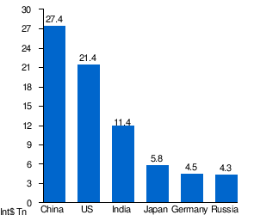
Largest economies by PPP GDP in 2019.
According to International Monetary Fund estimates
Social

A pleasant social environment is an important reason why companies can develop in a specific society. Since China resumed the college entrance examination system in 1978, the number of college graduates has increased year by year. From 2001 to 2017, the cumulative graduate population of Chinese college students reached 97.74 million (XIE Chen-ye, 2017). The emergence of higher education talents will promote the progress of the overall social environment, and at the same time provide sufficient talent for the recruitment of companies such as Huawei.

Huawei, which started in China, has a deep understanding of Chinese culture. It has attracted a large number of supporters by playing the slogan "Mobile phones made by the Chinese themselves". Respecting the traditional culture and understanding the aesthetic appeals of Chinese people is another magic weapon for Huawei's success.

Technological

The advancement of science and technology is the embodiment of social progress and an important factor for enterprises to survive. Countries around the world are investing more and more in science and technology. In the big market of the world, the United States has the most investment in technology and the largest output, so American companies are more competitive than other countries. In the past few years, China has increased its investment in technology research and development (Wu, 2018). Similar to artificial intelligence, big data has been fully developed in China, and the performance in the market is also surprising. On this basis, Huawei has built its core competitiveness in research and development capabilities through continuous improvement of its products.

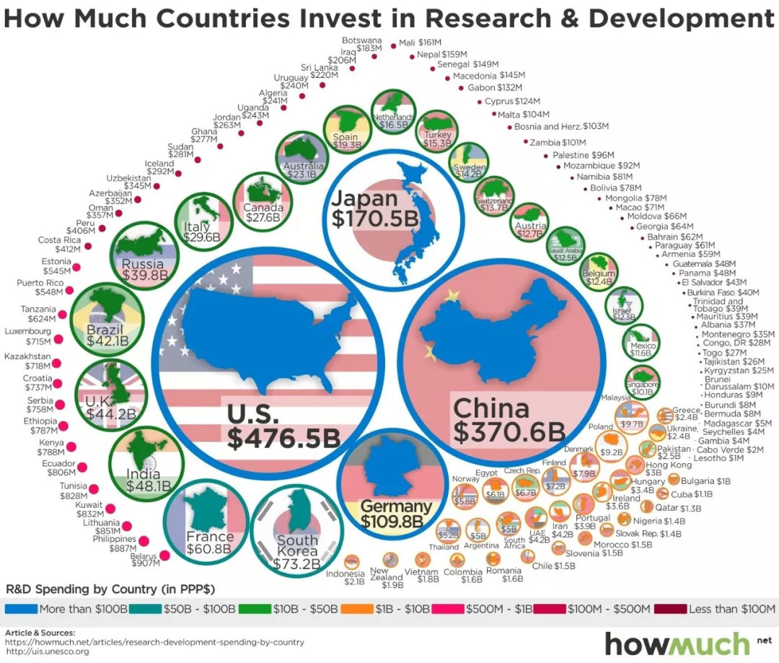
（Source：Howmuch.net、Unesco.org）

Environment

The market environment is another critical factor affecting the strategic decision-making of enterprises. Further improving its strategy by considering the factors of competitors is an essential part of the company's market launch. In the highly competitive smartphone market, Samsung and Apple are two rivals that Huawei can never ignore. In the early days of Huawei's establishment, Huawei could use its local advantages to compete against Samsung and Apple in the Chinese market. Nowadays, on the stage of the world, with the accumulation of domestic market for many years, Huawei's market share can also be maintained at a very high level.

At the same time, most industrial production inevitably produces a large amount of pollution, which severely damages the ecological environment. The sustainable development concept that Huawei has been adhering to has dramatically reduced the damage to the living environment. At the same time, the advanced scientific research system will also play a significant role in protecting the environment.

Legal

In the early days of Huawei's establishment, the Chinese government put forward many protective measures to protect local industries from severe damage from different industries. For example, foreign companies need to provide technology in exchange for the market. Therefore, domestic companies have developed to a large extent. This is unfair, but for local businesses, it gives them plenty of room to grow.

At the same time, China has promulgated the property law, which stipulates the inviolability of individual property and protects the real property of many private enterprises. Also, the Chinese government encourage public innovation, allocate high-quality social resources to these entrepreneurs who need help and make laws to ensure the openness and transparency of various approval procedures.

The above is the analysis of the internal and external environment of Huawei. It can be seen that while improving its capabilities, Huawei makes reasonable use of the external environment to push the company to a new stage. However, under the interaction of various factors, Huawei has also produced many hidden dangers. Next, this paper will use SWOT analysis to clarify Huawei's advantages and opportunities and point out its weaknesses and threats.

2.2 SWOT analysis

SWOT analysis is a method of analysing the competitive situation of enterprises. By understanding the strengths and weaknesses of their internal environment, companies can develop appropriate development strategies by combining opportunities and threats from the external environment. In an in-depth study of a business, the SWOT approach often provides researchers with a general direction.

We use SWOT analysis to make a general summary of Huawei's company:

The first is strength. Undoubtedly, Huawei is always the world's top research and development group, and its technology patents are its core strength to maintain its competitive advantage. Second, China, the world's largest sales market and talent market, has provided continuous impetus for Huawei's global business development. Finally, as a Chinese enterprise, both the cost of human resource management and the cost of enterprise research and development have formed cost advantages over competitors in other countries in the same industry.

Second is the opportunity. The development of big data is regarded as the signal of the fourth industrial revolution, and in China, where the development of big data is the fastest, Huawei can take the train of the times and take the opportunity to catch up with competitors. At the same time, Huawei also has excellent advantages in 5G patents. Taking the opportunity to seize the opportunity to develop the industry's 5G standard while promoting internationalisation can form an absolute competitive advantage for a long time.
The third is the weakness of Huawei itself. Ren Zhengfei, the founder of the military-born Huawei, played a vital role in winning the domestic market, and the identity of his military was the most serious obstacle on the road to internationalisation. When Huawei conducts international business expansion, the most important step is to win the trust of the local government, and its opaque political operating environment has left most governments away. At the same time, another critical area of Huawei, the communications business, although it has increased a large amount of revenue for enterprises, has also become a hindrance to its entry into developed countries. Communication business is related to national security, and Huawei with Chinese military background is hard to convince.

The last point is the threat that Huawei faces. Whether it is facing the pressure of the rise of Xiaomi and Vivo in the Chinese market, or the international market, facing the strong rivals of Samsung and Apple, Huawei seems to be a little powerless. Xiaomi and Vivo without political background are much smoother than Huawei on the road of international expansion: Xiaomi's market share in India has risen to the top. Secondly, the attitude of foreign politicians is vacillating, and Huawei is also exhausted.

In summary, we can see the various advantages and disadvantages of Huawei:

Strength | Weakness
- Excellent R&D and marketing capabilities  - Have the largest consumer market  - A large number of technology patents  - Low-cost social resources | - An opaque political operating environment  - The negative impact of the communications business  - Identity information of the primary founder
Opportunity | Threat
- The development and rise of the 5G market  - The advent of the era of big data | - Threats from competitors in the same industry in China  - Competitive pressure from Samsung and Apple

By analysing the weaknesses of Huawei and the threats it faces, in the next chapter, appropriate advice will be given to prevent further expansion of disadvantages and threats.

Recommendation

This chapter will provide solutions and measures for problems arising from the analysis of the previous chapter, and use the Ansoff matrix and strategy clock to provide theoretical support for the proposed recommendations.

Ansoff matrix

In 1957, Ansoff, the father of strategic management, proposed to establish a product and market as the two basic orientations, distinguishing the combination of four products and markets and the corresponding marketing strategy. Since its inception, the Ansoff Matrix has become one of the most widely used marketing analysis tools.
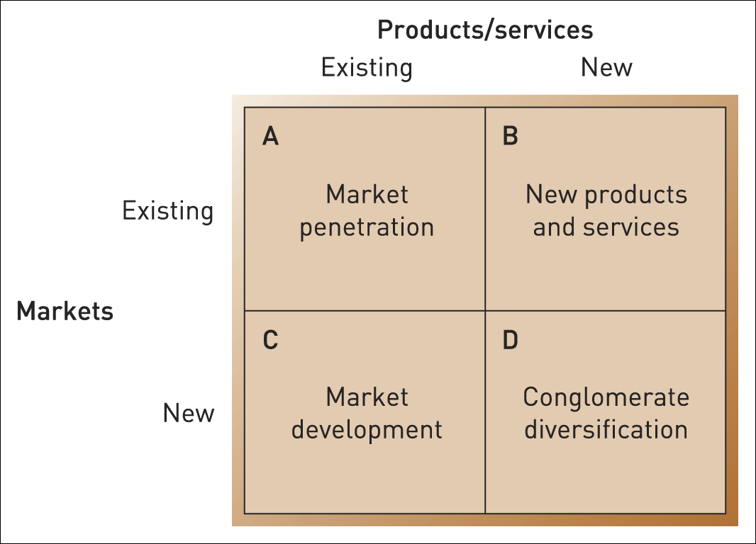
Source: Adapted from H.I. Ansoff, Corporate Strategy, Penguin, 1988, Chapter 6.

The Ansoff matrix (shown above), which corresponds to the product and the market, produces four different combinations (Ansoff, 1968). For Huawei, through the analysis and classification of its business, it is recommended to start from two aspects:

First of all, for existing markets: there are two primary forms of market sales:

The first is Market Penetration, which seeks to increase market share by targeting existing customers with existing products and services. Enterprises use the promotion or improve the quality of service to convince consumers to increase their purchases.

The second is Product Development, which introduces new products to existing customers, adopts product extension strategies, and leverages existing customer relationships to expand new business areas to achieve the “network” effect.

Through the analysis of Huawei's potential threats, we can understand those important competitors are mobile phone manufacturers such as Xiaomi, which is emerging from the Chinese market. The Chinese market is the foundation of Huawei. The sales in the Chinese market account for more than 40% of Huawei's total sales. Established in 1987, Huawei has already had a good reputation in the Chinese market, and its market share has always occupied the top position in these years. However, other smartphone companies, also from China, have risen rapidly over the years. In the top five list, except for Huawei, three seats are from domestic competitors. Therefore, for Huawei, the most urgent task is how to maintain or even expand its competitive advantage.
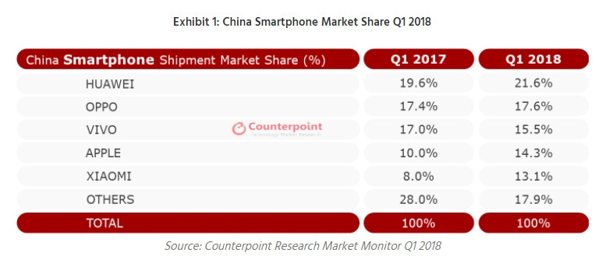

According to China Sohu.com, among users who use Huawei mobile phones, customers over 35 years old account for 55.2%, while only 13.5% of users are under 25 years old. And Xiaomi users, young people under the age of 25 accounted for 36.4%, more exaggerated is that Vivo's user group, 56.1% of customers are under 25 years old. Huawei is not the first choice in the choice of young people in China.

For Huawei, combining Market Penetration with Product Development is undoubtedly the most effective method. Launched a mobile phone designed specifically for young people, and went deep into the campus to carry out much publicity to increase market share, but also squeeze the survival space of competitors.

In the product development process, Huawei should develop more products and services that are bundled with Huawei's mobile phones in order to achieve the strategic locking effect: that users need a large number of conversion costs to replace the current product features.

Secondly, for the international market that Huawei is not familiar with, referring to the Ansoff matrix, there are also two different forms of business expansion.

The first is Market Development, which uses existing products to open up new markets. Companies need to find customers with the same product needs in different markets and win market share by defeating local competitors;

The second is Diversification, which offers new products to new markets. Companies need to provide products or services that have not been available before, based on different levels of development or social customs. The probability of failure is high, but the profits are prosperous.

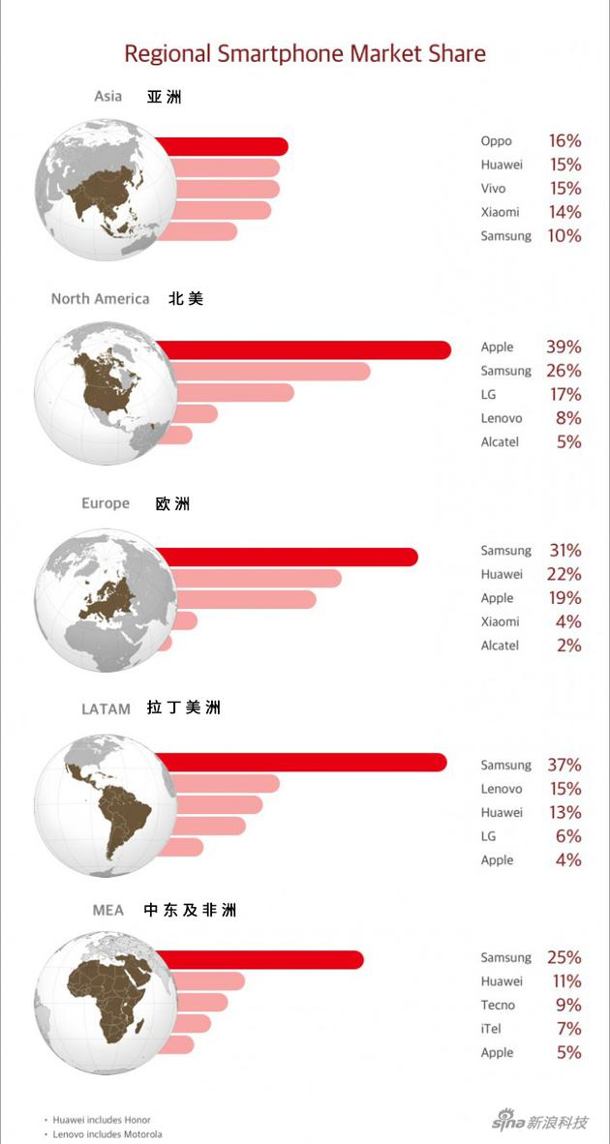
How to internationalise is a problematic problem Huawei has to face. Even in 2018, Huawei ranks the second in the world smartphone market, but in the final analysis, the contribution rate of over 40% from the Chinese market makes Huawei's market share in developed countries such as Europe and the United States not optimistic. In the US market, Huawei's market share is a pitiful 0.8%, even worse than that of its Chinese peer ZTE. In the emerging Indian market, Huawei is well below Xiaomi.
(Source：sina.com)

In view of the fact that Huawei's crisis in the world market is mainly from competitors in the same industry, in addition to using the Market Development method to confront competitors directly, Diversification is undoubtedly the best choice. Introduce affordable, fully functional smartphones for different levels of consumption. At the same time, as local competitors may be more aware of the local market, Huawei can cooperate with them to achieve mutually beneficial results.

3.2 Strategic clock

The strategy clock provides a more innovative approach to analysing companies and provides support for companies to develop next-stage strategies by locating the different stages of the company in different markets (Ely and Jacob, 2012).

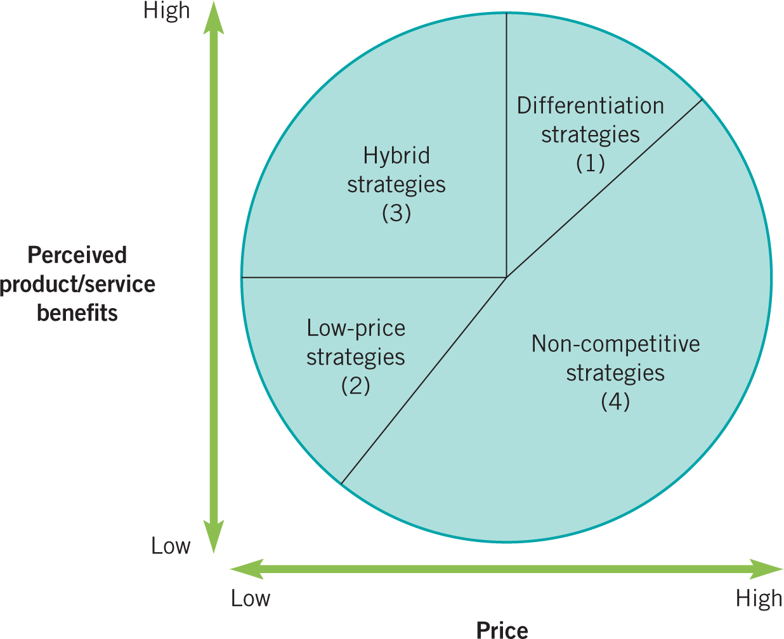
Source: Adapted from D. Faulkner and C. Bowman, The Essence of Competitive Strategy, Prentice Hall, 1995.
Through the demonstration of the strategic clock in the above picture, it can be found that from 7 o'clock to 9 o'clock, at this stage, the company is occupying the market in the form of low price and low profit. Then from nine o'clock to twelve o'clock, companies use a hybrid strategy to improve efficiency. Besides, different development strategies are proposed for different regions to achieve maximum sales.

Through the positioning of Huawei, it can be found that in India and Southeast Asia, Huawei is in the second part of the low-cost strategy. Therefore, Huawei should launch a lower-priced mobile phone to win market share (similar to Xiaomi). In countries with vast internal differences like China, mobile phones with different price points and different functions should be launched for different types of people to attack competitors in all directions, and the position is in the mixed strategic region. In developed countries such as Europe and the United States, the mobile phone market has become saturated, and the income is relatively fixed. It is difficult to compete with Samsung and Apple, which have become industry giants. Huawei should launch its differentiation strategy and improve its innovation ability on time, and become the leader in the new field (such as 5G).

Conclusion

Huawei has been in business for 32 years since its inception, and it is still a very young child compared to its major competitors around the world. However, Huawei's achievements have surprised these industry giants that have existed for decades. Looking back, Huawei's success relies heavily on a unique external environment:

The first is the policy tilt of the Chinese government to support local industries. This is followed by a substantial increase in the per capita income of Chinese citizens. The third is the overall recognition of the private sector by society. The fourth is the strong support from contemporary science and technology. The fifth is to establish a protective policy established by the early government to guarantee the survival of such local industries as Huawei mostly. The last point is that after the success of the company, a sound legal system guarantees that patents and property will not be violated.

Of course, the effects of Huawei's excellent internal operating system cannot be ignored. The low labour and R&D costs allowed it to invest a large number of resources in research and development at the beginning of its establishment, forming an excellent internal cycle. The comprehensive and responsible production process has established a good relationship with the local government while ensuring the supply of products. The unique marketing process makes the products no longer stick to the paper, but is quickly put on the market and has won huge profits. Moreover, the final after-sales service link, once again let their products and consumer word of mouth get sublimated.

Although Huawei's achievements are outstanding, it does not cover up the enormous problems of its existence. The opaque political activities have caused tremendous setbacks in international expansion, but the changing political landscape has made it impossible for the company's top management to start. At the same time, the market in the younger generation in China is lost, although the market share is still the first, the threat is massive. Besides, when Huawei expands its international business, it cannot achieve apparent advantages in the competition of specific regions, so that the market share cannot be improved.

In response to the problems encountered by Huawei, this paper proposes a corresponding solution: in China, pay attention to the primary mobile phone users of the youth, launch appropriate products and services, and occupy the market. In the international market, due to different levels of development in different regions, differentiated strategies are implemented, including low-cost strategies and mixed strategies.

Huawei's success has particular practical guiding significance for every emerging enterprise, but the problems encountered by Huawei also need to be carefully examined by various enterprises. No company can be perfect, and more is to adjust its strategy according to actual needs. Only by maintaining sufficient reaction to the market and having sufficient control over the strategy can we get a head start in the future competition.

Reference

Ansoff, H. (1968). The innovative firm. Long Range Planning, 1(2), pp.26-27.

Ely, T. and Jacob, B. (2012). Beating the Clock: Strategic Management under the Threat of Direct Democracy. Public Administration Review, 73(1), pp.38-48.

LIU, X. and LI, J. (2017). SWOT and PESTEL Analysis on the Coordinated Development of New Urbanization and Agricultural Modernization in Heilongjiang Reclamation Area. DEStech Transactions on Economics, Business and Management, (eced).

Liu, X. (2019). World Intellectual Property Organization: Huawei ranked first in the world in patent applications last year. Beijing: Xinhua.

Mademann, F. (2018). The 5G System Architecture. Journal of ICT Standardization, 6(1), pp.77-86.

Ministry of Economic Affairs of China (2018). 2016 China Top 500 Private Enterprises. Beijing: Xinhua.

Melissa, C. (2018). Smartphone Market Share. [online] Available at: https://www.idc.com/promo/smartphone-market-share/vendor [Accessed 23 Apr. 2019].

Presutti, W., Jr., N. and Mawhinney, J. (2009). The value chain revisited. International Journal of Value Chain Management, 3(2), p.146.

Ren, Z. (2018). Huawei Investment Holdings Co., Ltd. 2017 Annual Report. Beijing: Huawei.

Van Heerden, A. (2012). FLA Investigation of Foxconn in China. Global Labour Journal, 3(2).

Walters, D. and Rainbird, M. (2004). The value chain. Bradford, England: Emerald Group Pub.

Wu, M. (2018). [UN Statistics] China became the runner-up of 2017 global science and technology research and development investment, only 100 billion US dollars less than the United States. Beijing: sohu.com.

Wang, R. (2006). Realize your potentcal. 2nd ed. Shenzhen: Huawei, p.2.

Xu, H. (2013). Optimal platform strategies in the smartphone market. Electronics and Communications in Japan, 96(7), pp.1-10.

XIE Chen-ye (2017). A Study of the Employment Situation of English Major Graduates of Application-Oriented Universities in China—A Case Study of Ningbo Dahongying University. US-China Foreign Language, 15(5).

Yang, J. (2019). IDC Announces 2018 Global Smartphone Shipment: Huawei Slightly Apple, Xiaomi Ranks 4th. Beijing: Sohu.com.

Zhang, J. and Wu, J. (2018). The Chinese labor market, 2000–2016. IZA World of Labor.

Bibliography

FORTUNE (2017). 2017 Fortune World Top 500 Rankings. [online] Beijing: Xinhua. Available at: http://www.fortunechina.com/fortune500/c/2017-07/20/content_286785.htm [Accessed 23 Apr. 2019].

“Huawei Technologies”. (2015). IIC - International Review of Intellectual Property and Competition Law, 46(8), pp.965-966.

Imf.org. (2019). Report for Selected Countries and Subjects. [online] Available at: https://www.imf.org/external/pubs/ft/weo/2017/02/ [Accessed 23 Apr. 2019].

Luigi, D. and Mihai, I. (2011). Value Chain and Customer Relationship Cycle:Two Concepts of Relationship Marketing. International Journal of Trade, Economics and Finance, pp.103-108.

Pohlmann, T. (2019). Who is leading the 5G patent race? | IAM. [online] Iam-media.com. Available at: https://www.iam-media.com/who-leading-5g-patent-race [Accessed 23 Apr. 2019].

Zhang, J. and Wu, J. (2018). The Chinese labor market, 2000–2016. IZA World of Labor.

