

‘The Recognition of Faces following a Distractor Task’
Student Number: 1701786
University of Wales Trinity Saint David

Abstract
The purpose of the study was to determine whether individuals are likely to possess a greater ability to recognise own-race faces as opposed to other-race faces, a concept known as Own-Race Bias (ORB). Participants were tasked with recalling faces they had previously been shown on a screen, amongst faces that had not been previously displayed. Their responses had been recorded upon a recall sheet. T-value calculations had been used to determine the significance of the results. All participants consisted of white individuals, gathered from a single-honours psychology and joint-honours counselling and psychology course. The sample consisted of 22 females and 7 males. Findings from the study had shown that participants had displayed a greater ability to successfully recall other-race faces as opposed to own-race faces, disproving the hypothesis and serving as a potential contradiction to ORB. However, ORB’s potential prevalence amongst other races may require further study in the future.

Introduction
There have been many studies which have sought to determine whether an individual’s ability to recall faces from their own race would be greater than their ability to do so for other races, this concept is referred to as Own-Race Bias (ORB) (Meissner & Brigham, 2001). Various explanations have been suggested as to why this may occur such as personal racial prejudice (Chiroro & Valentine, 1995), the experience one may have with other races, affecting their recognition of other-race faces, otherwise known as cross-racial experience (Brigham, Maass, Snyder & Spaulding, 1982) or potentially the distinctiveness of an individual’s face may be a factor (Valentine, 1991). One of these studies includes Chiroro and Valentine’s study (1995) in which their hypothesis suggests that amongst their participants of black and white individuals, that white participants with low-contact from other races, were more likely to recall faces from their own race, and vice versa for black participants. While white participants with high-contact with other races, were less likely to adhere to this own-race bias with again, the same logic being applied to the black participants, the study had also taken distinctiveness of an individual’s face into consideration as this may affect the participants ability in their recall of faces. The study had demonstrated a significant result as participants recognised faces belonging to their own race in comparison to their recall of other-race faces. Malpass and Kravitz (1969) had also yielded similar results in two universities, consisting of black and white students from each university. The participants had displayed a greater to recall faces from their own race as opposed to other-race faces. Many other studies also provide evidence to make this suggestion (Meissner & Brigham, 2001; Valentine, 1991).

In contrast to this, there have been studies which have led to results suggesting otherwise. An example of this would be Cross, J.F., Cross, J and Daly’s study (1971), consisting of many procedures found within our current study, where in spite of results indicating white participants possessing a greater ability of recall for own-race faces as opposed to faces from other races, black participants had demonstrated the recall of own-race faces and other-race faces at an equal level of ability, suggesting a possible contradiction to ORB. In relation to a participant’s recall ability of other-race faces because of their experiences of interaction with other races, Chiroro and Valentine (1991) suggest that problems may arise in studies if the participant harbours fear over the possibility of appearing racist if a lack of other-race interaction experience is present. As demonstrated, ORB’s validity is based upon studies which both support and do not support its concepts. Based on these studies, the hypothesis of this study suggests that participants will display a higher ability to recall own-race faces as opposed to other-race faces. This is based upon the strong evidence provided that suggests this hypothesis to be a highly possible outcome to occur. The results of this study may serve to provide us with a better understanding of our efficiency in recalling other-race faces and would certainly prove to be valuable information in future discussions of the various social implications this study, as well as many other studies in the past, may indicate (Malpass & Kravitz, 1969).
Methods
For this study, there were 29 participants from a single honours psychology course and a joint-honours counselling and psychology course, consisting of 7 males and 22 females. The entirety of participants was white, consisting of an age range of 18-60 years old (M= 27.31, SD=10.81). Participants had been recruited through the process of opportunity sampling.

The design of the study had included the independent variable, which involved displaying own-race and other-races faces to the participants and the dependent variable, which involved measuring the participant’s ability to recall own-race faces and other-race faces. Participants were tasked with recording their recall of faces they had been previously been shown. The study had involved a within-subjects design with the t-value calculations involving a paired samples test.

The materials used for this study had included a PowerPoint presentation to display faces to the participants, consisting of 12 faces for part one, 6 black faces and 6 white faces, each being shown individually. Part two consisted of 6 faces per page, 6 pages with 36 faces displayed in total, with 18 white and 18 black, each page being displayed for 12 seconds each. In addition to this, a recall response sheet had also been used for the study. Demographic data such as age, race, etc., had been used to record their responses.

As for procedure, all participants had been placed into a single room where the study had been completed in a single sitting. Participants had then been provided with a consent form (Appendix A), detailing the participant’s right to withdraw as well as ensuring the data acquired from this study will remain confidential. Participants had also been provided with a recall sheet in which to record their answers for part two. Once participants had been provided with the necessary documents, they had then been instructed to watch a PowerPoint presentation (Appendix B) on a screen, with the screen providing additional instructions of the study. Participants had been instructed to remain quiet for the duration of the study due to the number of participants in a single room and to ensure that participants are enabled to place full attention to the screen. Once participants had placed their attention on the screen and further instructions had been provided, a countdown had begun on the screen, signalling the start of part one of the study. Part one consisted of 12 faces, each face being displayed for 2 seconds each. After part one, the researcher had then talked to participants as to serve as a distraction through introducing new information. A countdown had then begun part two of the study which displayed 6 pages, with 6 faces per page for a total of 36 faces shown for part two, 24 faces from part two had not been shown in part one. For part two, participants had been instructed to record the number associated with a face from part one, amongst the faces in part two. Part two’s conclusion had seen the end of the study in which participants had been instructed to turn their recall sheet facing down on the table and a debrief (Appendix C) had been provided on the screen, detailing information relating to the purpose of the study and informing participants of their right to withdraw their data from the study if they wished to do so.
Results
Results had shown black recall (SD=2.42, M=3.34) and white recall (SD=1.97, M=2.67) with the t-value test concluding a value of 3.13 (one-tailed test). When compared against the T-distribution table, the degrees of freedom were 28, resulting in the average t-value being approximately +/-2.06 to +/-2.04. Because of this, results are proven to be significant as shown in t = (28), 3.13, p<.05. All the results displayed had been calculated to 2 decimal points. As the results are shown to be significant for the greater recall ability of black faces over white faces, this would then indicate that our earlier hypothesis would then be rejected.

Discussion
As displayed in the results section, the hypothesis for this study has been rejected as participants had been shown to possess a greater ability to recall other-race faces more effectively than own-race faces. This would then serve to contradict the many studies (Valentine, 1991; Chiroro et al, 1995; Malpass et al, 1969; Meissner et al, 2001) which have suggested different results and may serve as evidence against ORB. It may also be possible that the information acquired from this study may serve as an example of society’s integration of multi-culturalism and equality amongst different groups of people have become more prevalent. For example, the Equality Act (2010) resulted in people possessing greater racial-integration, resulting in an increase in cross-cultural experience, therefore, cross-racial experience (Brigham, Maass, Snyder & Spaulding, 1982) may affected these results. However, limitations must be acknowledged to evaluate the validity of this study. Images on part 2 of the PowerPoint presentation were smaller than they had been in part 1, due to 6 photos shown per page as opposed to 1 per page. This may affect the participant’s ability to perceive the imagery provided and therefore, may also affect their ability to recall said imagery. Perhaps ensuring images are scaled appropriately, potentially through larger screens or by reducing the number of photos per page would alleviate this. Another example of this would be the number of participants as perhaps a larger sample would have served to provide greater accuracy for the results, also, perhaps conclusive data cannot be provided unless a sample is obtained which consists of various other races, to determine whether ORB is present amongst other races. This contrasts with previously mentioned studies in which multiple races had comprised their samples. Overall, it may be prudent to conduct further studies in the future as there are several considerations to consider for future reference such as the inclusion of a wider demographic for the sample or potentially editing the presentation to close the gap on possible visual errors that participants may encounter. Provided these suggestions are taken into consideration, this may potentially result in a stronger, accurate and more valid study.
Word count (Excluding references, appendices, titles and quotations): 1,639 words
References
- Brigham, J.C., Maass, A., Snyder, L.D., & Spaulding, K. (1982). Accuracy of
eyewitness indentification in a field setting. Journal of Personality and Social
Psychology. 42(4), p. 673-681.
- Chiroro, P. & Valentine, T. (1995). An Investigation of the Contact Hypothesis of the
Own-race Bias in Face Recognition. 48A(4). p. 879-894.
- Cross, J.F., Cross, J. & Daly, J. (1971). Sex, race, age, and beauty as factors in
Recognition of faces. 10(6). p. 393-396
- GOV.UK. (2013). Equality Act 2010: guidance. Retrieved from
https://www.gov.uk/guidance/equality-act-2010-guidance
- Malpass, R.S. & Kravitz, J. (1969). Recognition for Faces of Own and Other Race.
13(4). p. 330-334.
- Meissner, C, A. & Brigham, J.C. (2001). Thirty years of Investigating the Own-Race
Bias in Memory for Faces; A Meta-Analytical Review. 7(1). p. 3-35.
- Valentine, T. (1991). A Unified Account of the Effects of Distinctiveness, Inversion,
and Race in Face Recognition. 43A(2). p. 161-204.

Appendices
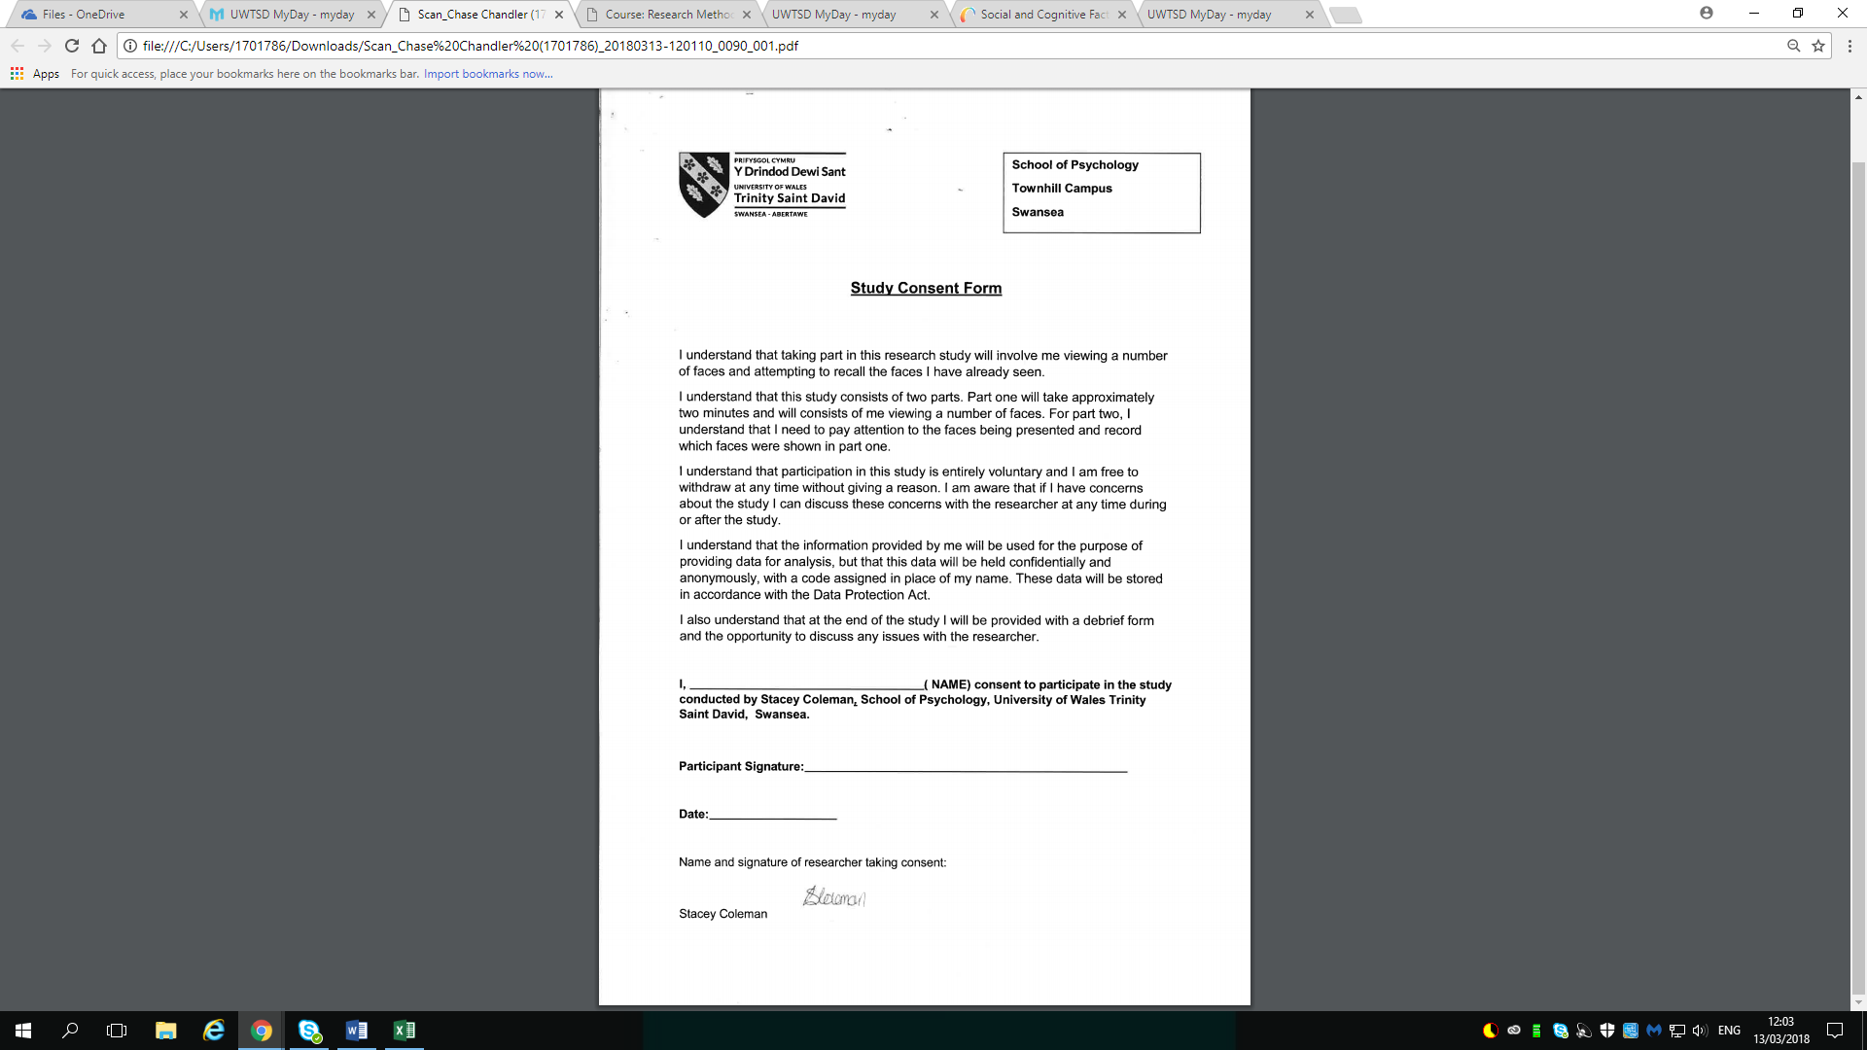
Appendix A: Consent Form

Appendix B: PowerPoint Presentation (Study Screens)
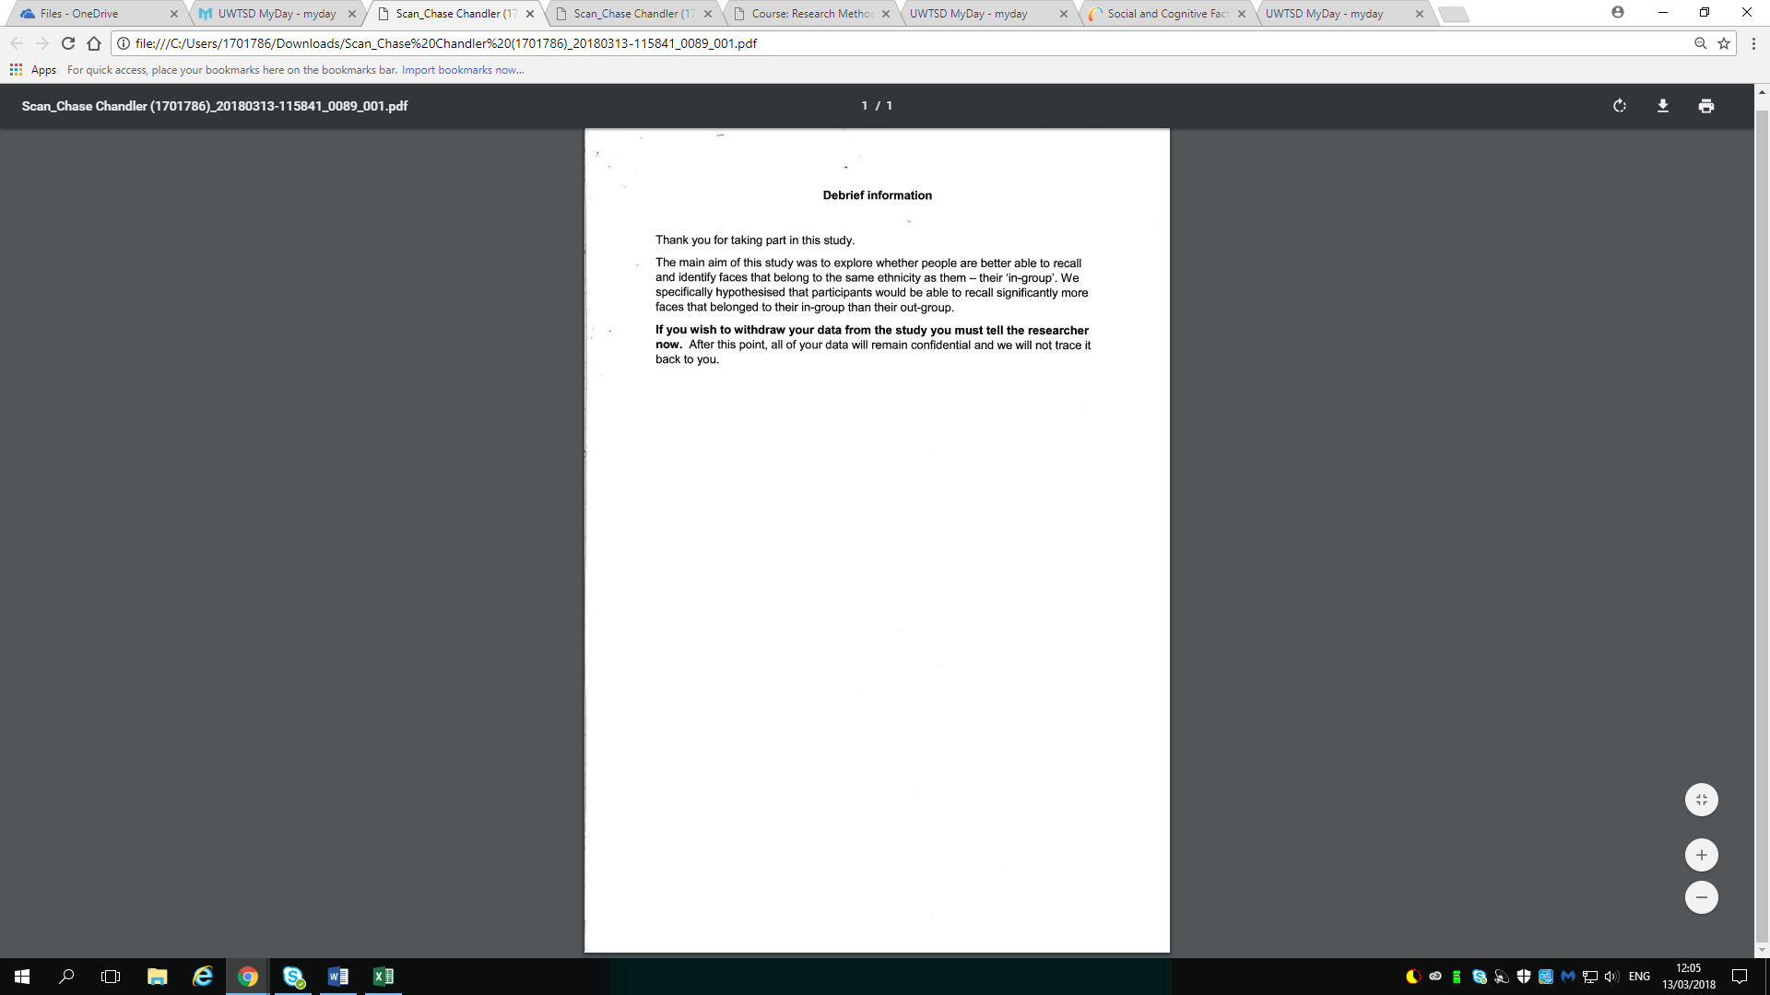
Appendix C: Debrief Slide

