Elanor Morris

BMSP6007

Economics of Sustainability

Assessment #1 - 2,500-word essay

April 29, 2023

INTRODUCTION
The alcohol industry in the United Kingdom has reached profits of £51.09 billion in 2023, and the market is predicted to grow by 4.56% annually (Statista, n.d.). The alcohol industry produces some economic benefits, such as creating jobs at pubs and bars, but it has proven itself to be detrimental to society, with three million deaths globally per year occurring from overconsumption of alcohol (World Health Organization: WHO, 2022). With the growth of the alcohol industry, it is necessary for the U.K. government to create solutions to address the negative externalities of alcohol consumption.

This essay will discuss the solutions that the U.K. government has put in place to minimize the social risk that is caused by alcohol misuse and explore if its solutions have been effective. The extent of the negative externalities caused by the alcohol industry will be discussed to comprehend the damage it is doing to society. Prior to discussing the solutions to the negative externalities, this essay will analyze the market failures surrounding the alcohol industry in the U.K., and discuss the social costs created by the negative externalities. This will be aided by data and a graph to explain the reason for the market failure. There will also be an analysis of the alcohol industry after solutions to market failures have been implemented to determine what effects the solutions have had on the industry and those affected by the negative externalities. This will be evidenced by the use of a variety of credible sources.

MARKET FAILURE OF THE ALCOHOL INDUSTRY BEFORE THE IMPLEMENTATION OF SOLUTIONS
Alcohol is a factor in more than 60 health conditions, including fetal alcohol syndrome, breast cancer, high blood pressure, and liver cirrhosis (Alcohol Statistics, 2022). Overconsumption of alcohol leads to impaired judgment, which can lead to violent decisions including assault, theft, or drunk driving. In England from 2015-2016, 39% of all people who committed violent crimes were believed to be under the influence by the victim (Alcohol Statistics, 2022). Between 2010 and 2020, an annual average of 41,737 were committed for drunk driving, and in 2019, 7,800 people were either killed or injured in a drunk driving accident in the U.K. (Salmon, n.d.). Other short-term risks include having unprotected sex which could lead to pregnancy, increased risk of injury, and alcohol poisoning (Alcohol Misuse, 2023). Long-term risks can range from divorce and unemployment to homelessness and domestic abuse (Alcohol Misuse, 2023). Alcohol consumption can also worsen mental health symptoms, including a higher risk of suicide and depression. Between 2007 and 2017, 5,963 people died from suicide that had a history of alcohol abuse in England (O’Connor, 2020). More minor social issues caused by alcohol consumption include excessive noise at late night hours, vandalism, and injuries, which leads to police or ambulance involvement, a cost that members of society bear through taxpaying. If private property is vandalized, the owner will have to bear that cost outright. Alcohol is also an addictive substance, which can lead to serious addiction, which in turn leads to a need for rehab, or potentially admittance into a mental hospital. This is a cost that the family or friends of the affected individual would have to pay. All of these issues are not reflected in the market transaction when one decides to purchase a drink and thus can be considered a market failure. The issues that affect third parties such as drunk driving accidents and abuse due to alcohol overconsumption can be classified as negative externalities. A negative externality of consumption can be defined as “when consuming a good causes a harmful effect to a third party,” (Pettinger, 2019).
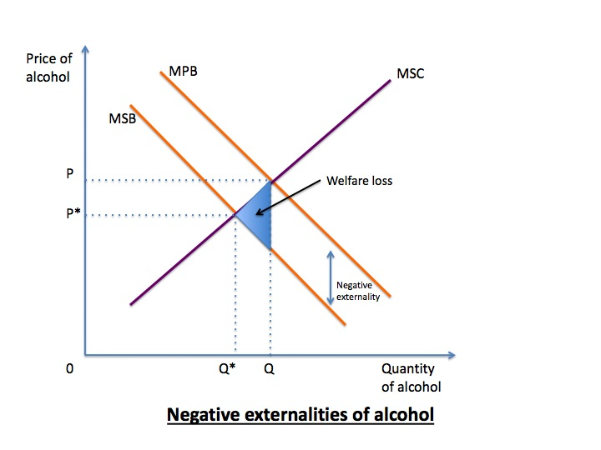
Figure 1: Negative Externalities of Alcohol Consumption (Cresma, 2010)
Figure 1 shows the Marginal Private Benefit (MPB) and the Marginal Social Benefit (MSB) curves creating a loss of welfare from a negative externality of consumption. MPB is the benefit gained by the party consuming the product, whereas MSB is the benefit gained by any third party (Externalities - AP Microeconomics, n.d.). This diagram assumes that third parties are not experiencing any benefits, only harm from alcohol consumption. When the consumer is reaping more benefits than society as a whole, and also does not take society into account when consuming a product, MPB > MSB. The vertical difference between the MPB and MSB curves represents the negative externality. Q*, the point where MSB meets Marginal Social Cost (MSC) is the optimal point of consumption for alcohol. The difference between points PQ and P*Q* is the welfare loss, or the amount that society loses due to negative externalities.

SOLUTIONS TO IMPROVE MARKET FAILURE

SOLUTION 1: PRICE FLOOR
In 2018, Scotland took the approach of a price floor for selling alcohol, making it illegal to sell a unit of alcohol for less than 50 pence, and Wales followed suit in 2020 (Griffith et al., 2022). When a price floor is set above equilibrium, the quantity supplied exceeds the quantity demanded, and results in excess supply (Price Ceilings and Price Floors (Article) | Khan Academy, n.d.).
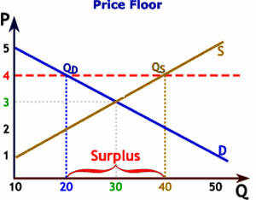
Figure 2: Price Floor Creating Surplus Supply (What Is Price Floor? Definition of Price Floor, Price Floor Meaning - the Economic Times, n.d.)
The price floor in Scotland has resulted in a 13% drop in deaths directly linked to alcohol consumption (Gregory, 2023). The price floor also effectively targeted heavy drinkers, with a 12% reduction in drinks bought by households that previously purchased 30 drinks per adult per week (Griffith et al., 2022). In Wales, there has been an 8.6% decrease in alcohol purchases per household compared to western England since 2020 (Alcohol Price and Duty, 2022).
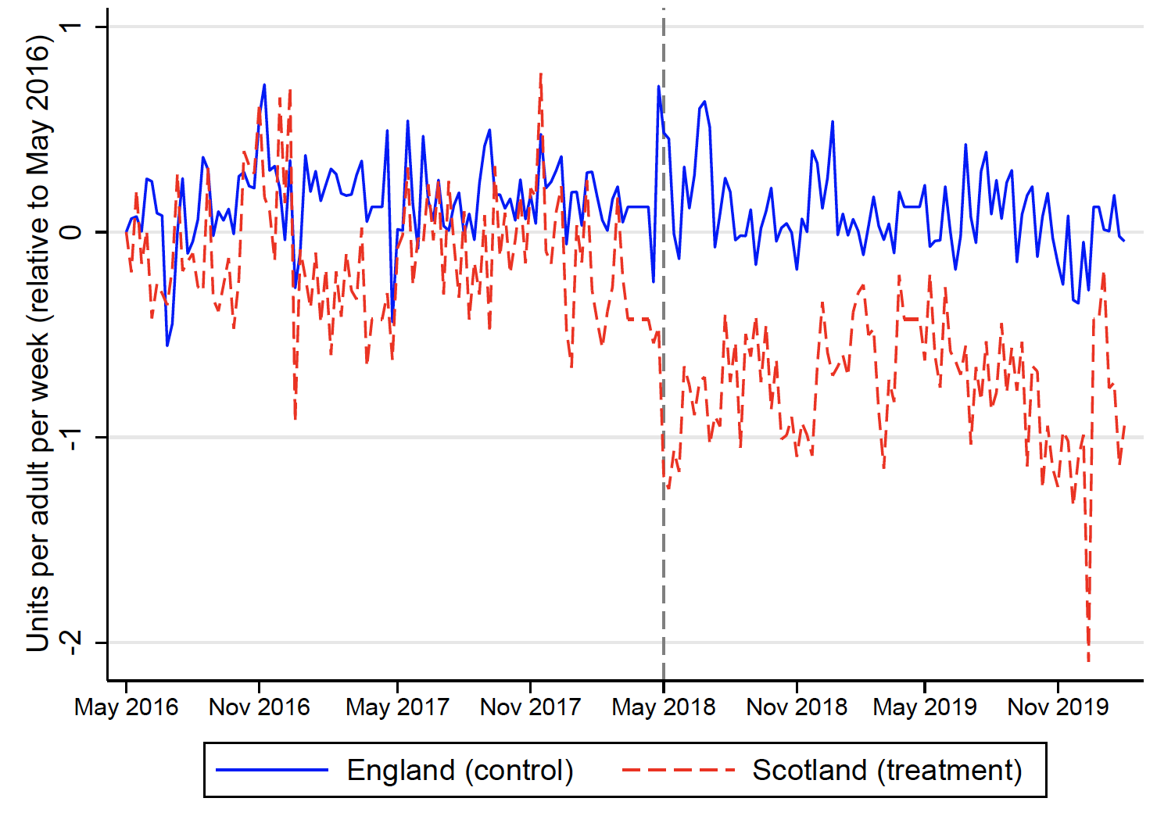
Figure 3: Units of Alcohol Purchased Per Adult Per Week, England vs Scotland (Alcohol Price Floors and Their Effect on Heavy Drinking, 2020)
The figure above shows the visible drop in alcohol sales in Scotland after the price floor was introduced in 2018, compared to England where no price floor was introduced. An average decline of 11% in quantity purchased took place in Scotland after 2018 (Alcohol Price Floors and Their Effect on Heavy Drinking, 2020). There is concern that with the implementation of a price floor, those who cannot afford the new prices will seek affordable prices elsewhere, for example, in England (Minimum Alcohol Pricing (Revision Essay Plan), n.d.). This could lead to the price floor not being as effective as the government had hoped.

SOLUTION 2: LEGAL DRINKING AGE
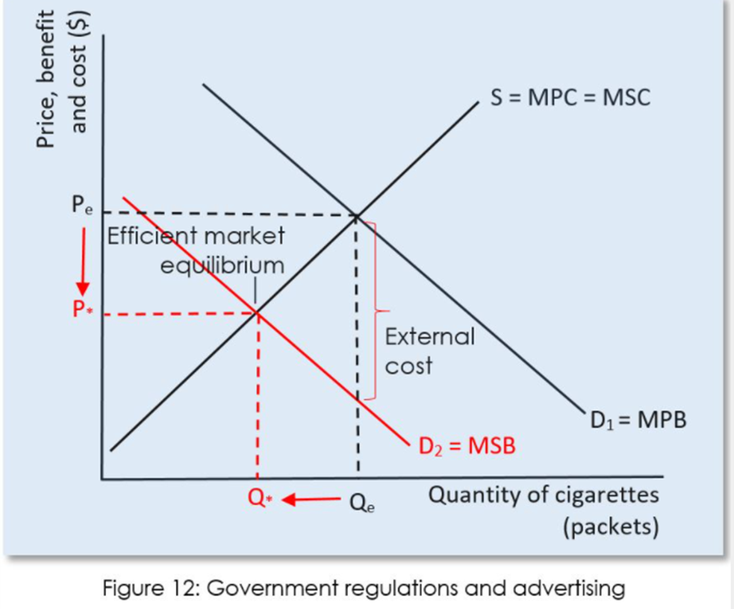
In the United Kingdom, the legal drinking age is 18, but supervised drinking at the age of 15 and up is considered acceptable (Drinking and You - Alcohol and Young People Under 18, n.d.). Many people have called for this number to be raised to 21, which is the legal drinking age in the United States (Poll Shows Public Support for Alcohol Age Rise, n.d.). In the United States, it is much harder for young people (under 21) to purchase alcohol than it is in the U.K. In the U.K., it is also legal for children above the age of five years old to drink at home in private with adult supervision. A study in Australia showed that 69% of children who were allowed to try alcohol from their parents resulted in becoming binge drinkers by the age of 18, versus 42% of children who were denied access to alcohol from their parents (Leatham, 2022). Young people are more likely to misuse alcohol resulting in accidents, injuries, and drunk driving (Pettinger, 2018). The biggest detriment to young people who drink alcohol is health issues such as alcohol poisoning, as the body is not equipped to deal with heavy alcohol consumption under the age of 18 (Drinking and You - Alcohol and Young People Under 18, n.d.). However, in terms of solving negative externalities, the law mandating the minimum drinking age in the U.K. has not seemed to have an effect on crimes such as vandalism or assault, but an increase in the minimum drinking age has been associated with a decrease in drunk driving accidents in 34 studies (Minimum Legal Drinking Age Laws | College of Policing, 2015).
Figure 4: Government Regulations to Remove Negative Externalities of Consumption
In the figure above, the effect of laws such as a minimum drinking age is shown on negative externalities. Mandating that the minimum legal drinking age is 18 or over in public decreases the demand for alcohol in those spaces. The demand curve will then shift from D1=MPB to D2=MSB, indicating that the externality has been removed or internalized. This would be the ideal outcome if the regulation were 100% effective at removing the externalities, and while the minimum drinking age law has seen varied success, it has not eliminated the externalities caused by alcohol consumption in its entirety.

SOLUTION 3: LOWERED RECOMMENDED DRINKING AMOUNT
In 2016, the U.K. announced that it would be lowering the recommended low-risk drinking guidelines from 21 units per week to 14 units per week (Snowdon, 2022). This number has been continually getting lower since 1979 when the guideline was 56 units per week for males (Snowdon, 2022). While it seems that this guideline change has had little to no direct effect on the negative externalities caused by alcohol consumption, there was a small and temporary reduction in alcohol consumption after the announcement was made in 2016 that the guideline would change (Holmes et al., 2020). However, the main goal of this guideline change may not have been to directly impact negative externalities. By moving the guidelines, there are now many more people who exceed them, creating cause for the government to notice this problem that has now been inflated, and create more taxes and bans on alcohol (Snowdon, 2022). So while the guidelines might actually have very little influence on the behaviors and consumption of drinkers in the U.K., it may encourage the government to create more binding regulations to solve this problem, thus eliminating the negative externalities. Referring to Figure 4 above, government regulation could potentially correct the negative externalities if those measures are effectively implemented.

SOLUTION 4: TAXATION
Since alcohol is considered a demerit good, or a good that causes harm to society instead of benefiting it, the UK government has placed a tax, or a duty, on it (Demerit Goods, n.d.). The money raised from taxing demerit goods is often used to aid in reducing negative externalities they cause (Externality Solutions - Econ 4 IB, n.d.). Currently, the UK duty system for alcohol varies by alcohol type and ABV, with lower ABV drinks getting taxed less, and wines and whiskeys getting taxed more (Davies, 2023). Ciders tend to get taxed the least, which is why they are able to be sold for so cheap (Alcohol Price and Duty, 2022). However, even with the duty in place, the revenue from the duty covers less than half of the damages caused by alcohol related activies - a measly £12 billion per year out of £27 billion (Alcohol Price and Duty, 2022). The duty on alcohol was actually frozen until last year, when the government called for the increased duty on wine and beer (Davies, 2023).
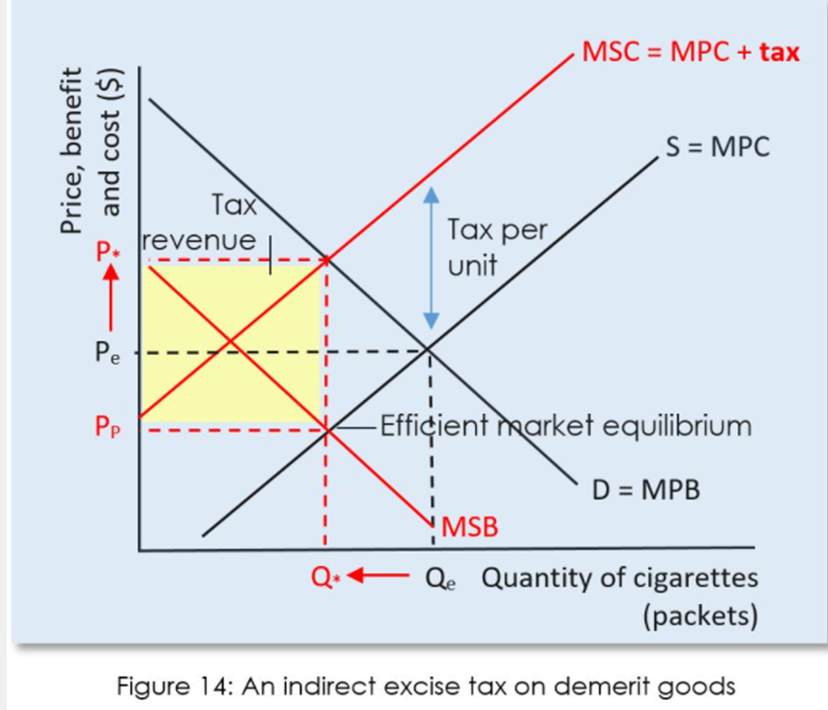
Figure 5: Government Tax Effect on Negative Externalities of Consumption
This diagram shows a basic example of how a tax on a demerit good should effect the negative externalities caused by it. The tax placed on a good like alcohol will be shared by the production company and the consumer, but due to the inelasticity of the demand of alcohol, the bulk of the cost will fall on the consumer. (Externalities - AP Microeconomics, n.d.). When a good is inelastic, the quantity demanded decreases less than it would for an elastic good, so consumers purchase more, and thus pay most of the tax (Externalities - AP Microeconomics, n.d.). The intersection of MSB and MPB is the new equilibrium, and consumers pay more for the good due to the tax (P*) (Externalities - AP Microeconomics, n.d.). At this price, the quantity being produced of the demerit good is allocatively efficient, thus internalizing the negative externalities (Externalities - AP Microeconomics, n.d.).

CONCLUSION
In conclusion, the solutions presented by the U.K. government have proven to be semi-effective at correcting the market failure caused by the overconsumption of alcohol and the negative externalities stemming from that. The market was failing, as seen by the social costs such as crime, assault, vandalism, and abuse; as well as health issues, mental health decline, and drunk driving accidents (Alcohol Statistics, 2022). With a reduction in alcohol sales, there will also be a reduction in liver cirrhosis, alcohol poisoning, suicide, and depression, along with the other consequences listed previously. The price floor introduced first in the U.K. by Scotland is the most effective measure for reducing negative externalities, as it targets heavy drinkers more than casual pub-goers (Griffith et al., 2022). This is the most effective demographic to target because they are more likely to be reckless and cause problems versus someone who is more or less sober. The legal drinking age law would be more effective if it was raised to 21 years of age, or if children were not permitted to drink under any circumstances, even in private. This would lead to less binge drinking by adulthood. The lowered recommended drinking amount would be most effective if it lead to any government regulations being put in place after drawing attention to the amount most people drink on a weekly basis. Finally, taxes are somewhat effective at reducing drinking and helping fix the negative externalities that arise from alcohol consumption, but the revenue raised from taxes only covers about half the cost of the damage done (Alcohol Price and Duty, 2022).

REFERENCES
Alcohol misuse. (2023, April 4). nhs.uk. https://www.nhs.uk/conditions/alcohol-misuse/#:~:text=As%20well%20as%20causing%20serious,as%20dependent%20drinking%20(alcoholism).
Alcohol price and duty. (2022, February 2). Alcohol Change UK. https://alcoholchange.org.uk/policy/policy-insights/alcohol-price-and-duty#:~:text=pricing%20(MUP).-,Alcohol%20duty,spent%20on%20vital%20public%20services.
Alcohol price floors and their effect on heavy drinking. (2020, December 11). CEPR. https://cepr.org/voxeu/columns/alcohol-price-floors-and-their-effect-heavy-drinking
Alcohol statistics. (2022, September 5). Alcohol Change UK. https://alcoholchange.org.uk/alcohol-facts/fact-sheets/alcohol-statistics
Cresma. (2010, February 17). Externalities: Boredom fuels teen alcohol use. Manon’s Econ Blog. https://11cresma.wordpress.com/2010/02/17/externalities-boredom-fuels-teen-alcohol-use/
Davies, R. (2023, March 15). Alcohol duty increase ‘historic blow’ to wine and whisky industry. The Guardian. https://www.theguardian.com/uk-news/2023/mar/15/alcohol-duty-increase-historic-blow-to-wine-and-whisky-industry
Demerit goods. (n.d.). [Video]. Market Failures | Learn Economics. https://www.learn-economics.co.uk/Demerit-goods.html
Drinking and You - Alcohol and young people under 18. (n.d.). http://www.drinkingandyou.com/site/uk/under18.htm
Externalities - AP Microeconomics. (n.d.). AP MICROECONOMICS. https://www.microeconomicsap.com/externalities-ap-microeconomics.html
Externality Solutions - Econ 4 IB. (n.d.). https://sites.google.com/site/econ4ib/home/microeconomics/market-failure/externality-solutions
Gregory, A. (2023, March 21). Scotland’s minimum pricing linked to 13% drop in alcohol-related deaths, study finds. The Guardian. https://www.theguardian.com/society/2023/mar/21/scotlands-minimum-pricing-linked-to-13-drop-in-alcohol-related-deaths-study-finds#:~:text=In%20May%202018%2C%20the%20Scottish,deaths%20a%20year%20on%20average.
Griffith, R., O’Connell, M., & Smith, K. (2022). Tackling heavy drinking through tax reform and minimum unit pricing. In Institute for Fiscal Studies. https://ifs.org.uk/publications/tackling-heavy-drinking-through-tax-reform-and-minimum-unit-pricing
Holmes, J., Beard, E., Brown, J., Brennan, A., Meier, P., Michie, S., Stevely, A. K., Webster, L. F., & Buykx, P. (2020). Effects on alcohol consumption of announcing and implementing revised UK low-risk drinking guidelines: findings from an interrupted time series analysis. Journal of Epidemiology and Community Health, jech-213820. https://doi.org/10.1136/jech-2020-213820
Leatham, X. (2022, November 22). UK’s legal age for drinking at home should be raised from FIVE, expert demands. Mail Online. https://www.dailymail.co.uk/health/article-11452807/UKs-legal-age-drinking-home-raised-FIVE-expert-demands.html
Minimum Alcohol Pricing (Revision Essay Plan). (n.d.). Economics | Tutor2u. https://www.tutor2u.net/economics/reference/minimum-alcohol-pricing-revision-essay-plan
Minimum legal drinking age laws | College of Policing. (2015, May 20). College of Policing. https://www.college.police.uk/research/crime-reduction-toolkit/minimum-legal-drinking-age-laws
O’Connor, R. (2020, November 17). Alcohol dependence and mental health. UK Health Security Agency. https://ukhsa.blog.gov.uk/2020/11/17/alcohol-dependence-and-mental-health/
Pettinger, T. (2018, January 9). Should the Legal Drinking Age be increased to 21? Economics Help. https://www.economicshelp.org/blog/36/society/legal-drinking-age/#:~:text=Raising%20the%20drinking%20age%20to%2021%20will%20reduce%20consumption%20amongst,accidents%2C%20death%20and%20health%20problems.
Pettinger, T. (2019, November 30). Negative Externalities. Economics Help. https://www.economicshelp.org/micro-economic-essays/marketfailure/negative-externality/#:~:text=Negative%20externality%20of%20consumption,less%20than%20the%20private%20benefit.
Poll shows public support for alcohol age rise. (n.d.). Priory. https://www.priorygroup.com/blog/poll-shows-public-support-for-alcohol-age-rise
Price ceilings and price floors (article) | Khan Academy. (n.d.). Khan Academy. https://www.khanacademy.org/economics-finance-domain/microeconomics/consumer-producer-surplus/deadweight-loss-tutorial/a/price-ceilings-and-price-floors-cnx
Salmon, C. (n.d.). UK Drink Driving Statistics - Updated 2022 | Quittance.co.uk®. Quittance Legal Services. https://www.quittance.co.uk/uk-drink-driving-statistics
Snowdon, C. (2022, September 15). The great alcohol cover-up: how public health hid the truth about drinking. The Spectator. https://www.spectator.co.uk/article/the-great-alcohol-cover-up-how-public-health-hid-the-truth-about-drinking/
Statista. (n.d.). Alcoholic Drinks - UK | Statista Market Forecast. https://www.statista.com/outlook/cmo/alcoholic-drinks/united-kingdom?currency=GBP
What is Price Floor? Definition of Price Floor, Price Floor Meaning - The Economic Times. (n.d.). The Economic Times. https://economictimes.indiatimes.com/definition/price-floor
World Health Organization: WHO. (2022). Alcohol. www.who.int. https://www.who.int/news-room/fact-sheets/detail/alcohol

