Question 2: “If we insist on telling children that everything in the garden is lovely, we’re doing them a disservice” (Browne quoted in Crown, 2009, p. 12). Analyse the work of illustrators and, particularly, author illustrators who tackle difficult, sensitive and sometimes shocking themes.

Death would seem to be an unpopular theme for a children’s picturebook. However, research has shown that picturebooks that contain topics that are relevant to real life can support children experiencing grief as it validates their emotions and experiences (Wiseman, 2012). The three books that will be discussed in this essay all discuss themes of death and grief in differing ways.

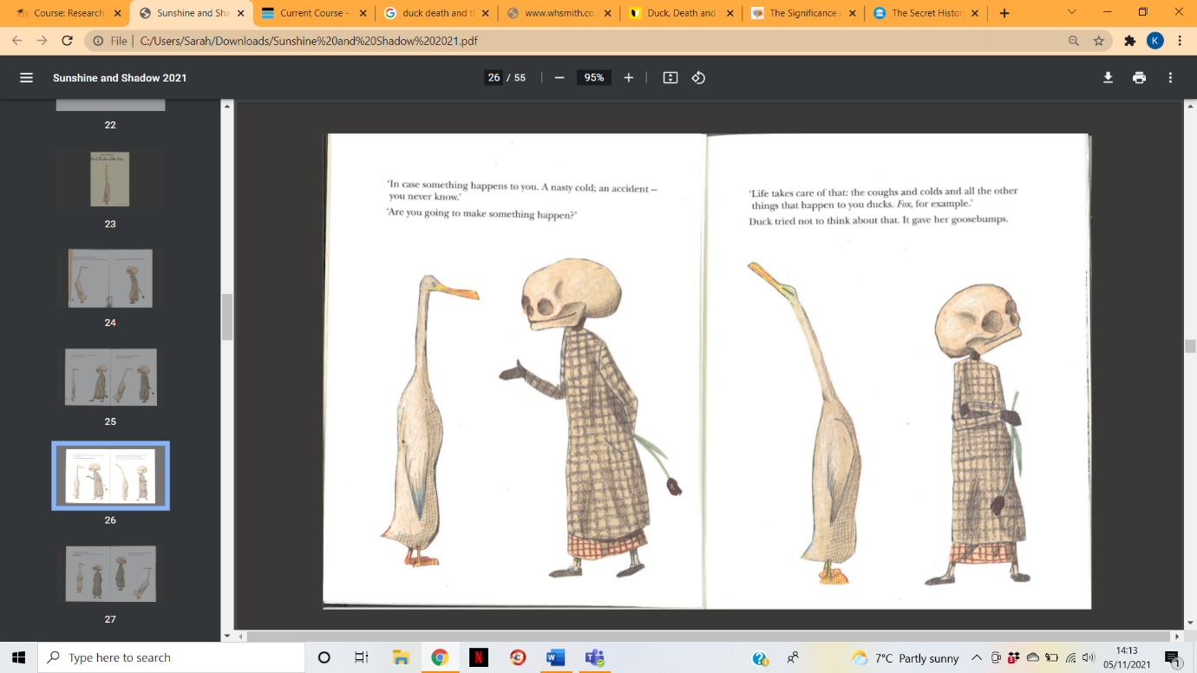
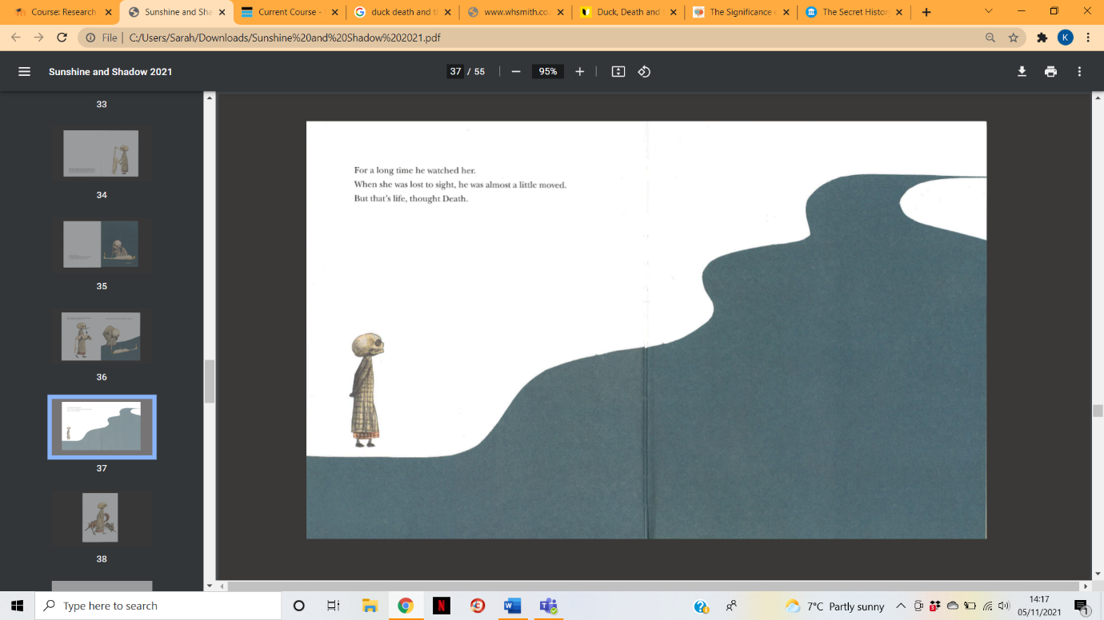
Duck, Death and the Tulip is a children’s book written and illustrated by Wolf Erlbruch. As described by Salisbury and Styles (2012, p.122), the book consists mainly of the characters Duck and Death’s philosophical conversation about death. Salisbury and Styles comment “death in its generalized sense often crops up in books for the young, but using the subject as the central theme of a picturebook is a very different matter” (2012, p.122). This is what is different about Duck, Death and the Tulip as opposed to other children’s books, death is the central theme and plot of the story. Erlbruch himself comments “the pinky aesthetics in English picturebooks” (Salisbury and Styles, 2012, p.122), perhaps suggesting that British children’s books largely gloss over issues that might be seen as shocking or sensitive. Erlbruch’s Duck, Death and the Tulip is far from the ‘pinky aesthetics’ that have become quite commonplace in the children’s book market. Although the term ‘pinky aesthetics’ could be used to discuss the surface level issues that popular children’s books tend to be about, he could also be referring to the style of illustration used. Erlbruch’s drawing style is far from the colourful, busy children’s picturebooks that can be found in British book shops. Popova describes the illustrations as “minimalist yet enormously expressive” (no date). Erlbruch makes ample use of white space and a limited colour palette. His illustrations are very economical. He only depicts what is absolutely necessary for the pictures to function. For example, figure 1 only consists of the two characters discussing death. Erlbruch relies on expressive character poses to add personality to the characters. It could be said that nothing else is needed for the illustration to serve its purpose. Aside from the characters of Duck and Death, Erlbruch introduces flowers, trees, a pond and a river, created using a collage technique. As in figure 2, a simple blue cut out to show the river is used. It follows the same, minimalist tone as the rest of the illustrations by being a vast block colour that takes up most of the double page spread. The use of perspective by making the river smaller as it flows up the page gives the impression that the river is vast. Erlbruch makes good use of scale by placing a very small Death next to the river. It suggests that even Death is small and insignificant, and nothing can stop the cycle of life and death. The dialogue between Duck and Death is very to the point and matter of fact surrounding the conversation about death, and this is mirrored in the illustrations and the tone of the story.
Figure 1- Duck and Death discuss death
Figure 2- Death watches the river
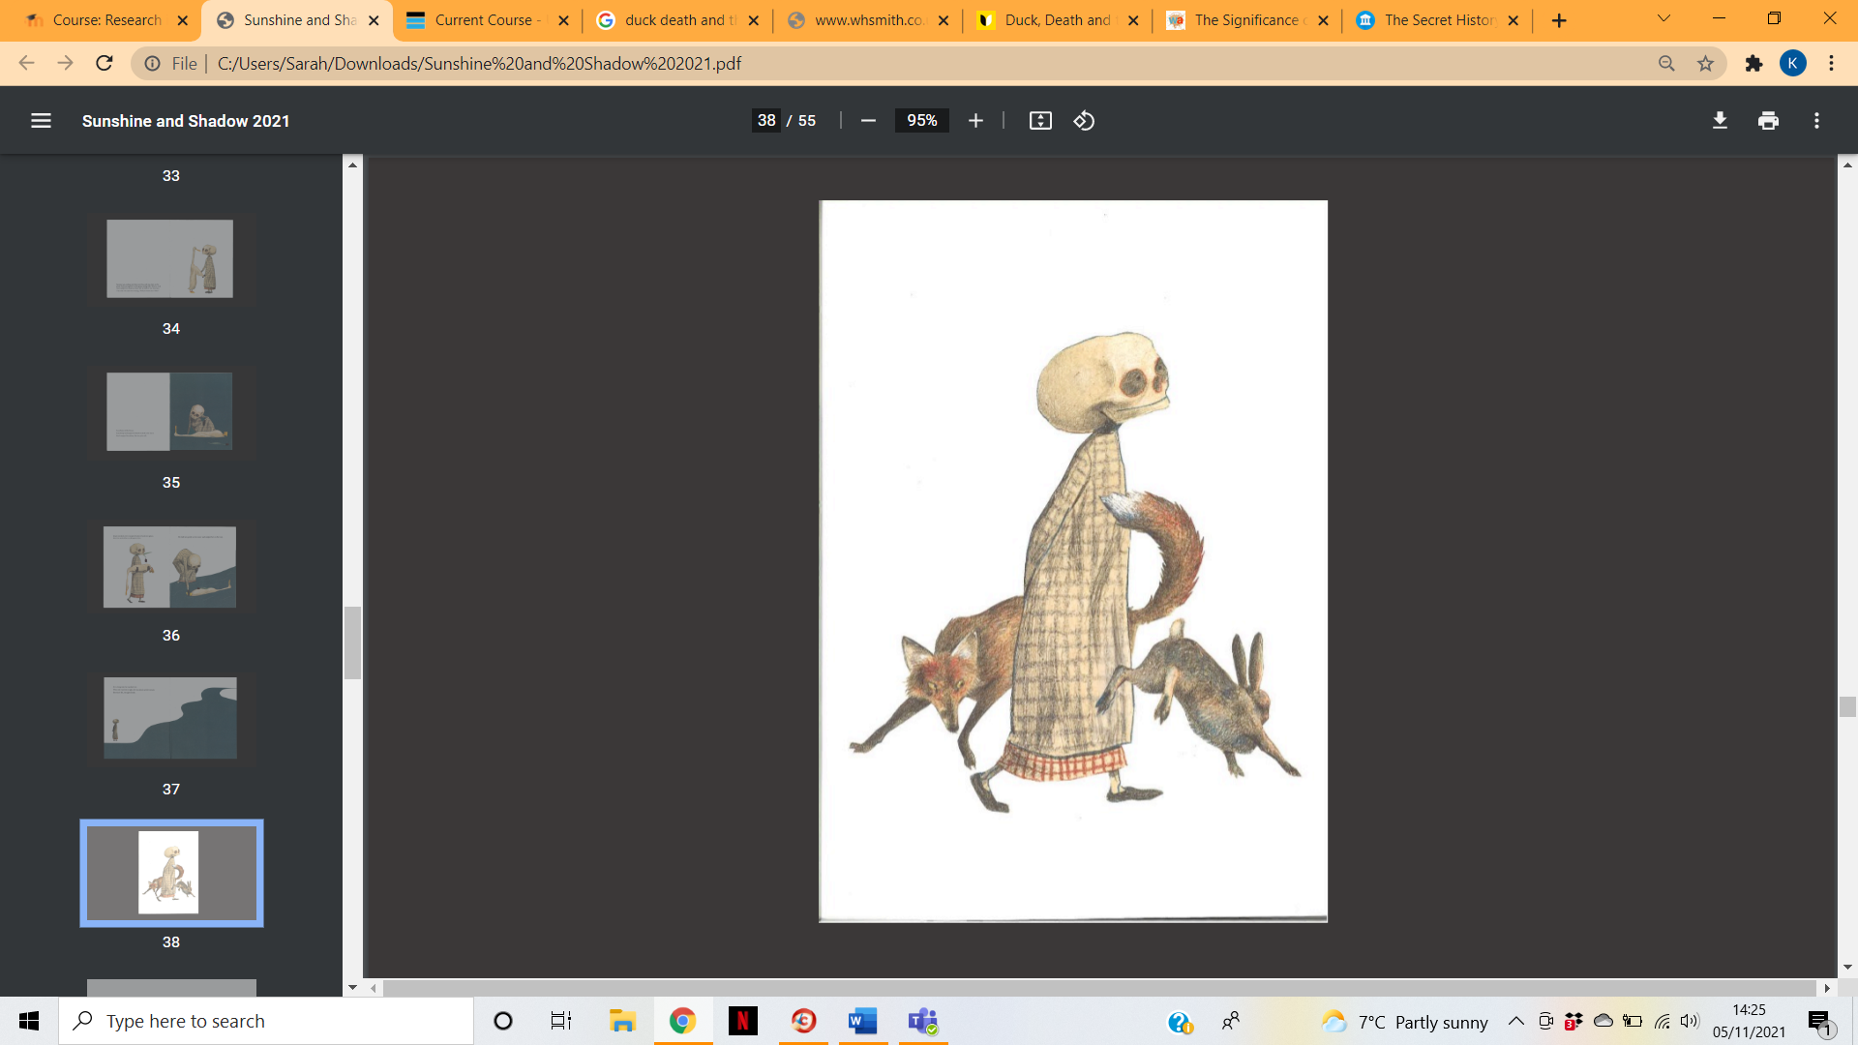
Erlbruch also uses the visual metaphor of a black tulip to represent death. According to some sources, black tulips can symbolise sacrificial love (Symbolsage, no date). Whether or not Erlbruch intended this, it is well agreed that the colour black symbolises death in popular culture (Funeral Guide, 2017). Death is holding the tulip when he first meets Duck. Therefore it could be inferred that the tulip is meant to be given to Duck as a sign of her death, as the tulip reappears at the end of story when she dies. Another way that Erlbruch uses imagery that symbolises death is the use of a skull for Death’s head. Davey writes that skulls are “a stark reminder of our mortality” (2015). There is no confusion about what this character represents. The character of Death is drawn in a friendly manner that prevents the idea of death from being scary. Even though he represents death, the muted colours and baggy dress that resembles a nightgown give Death an unthreatening appearance. Furthermore, Death is always drawn with a large smile, drawn with a simple long line that stretches past his eyes. Death is still smiling when Duck dies at the end of the book. In this way, Erlbruch does not present the idea of death as something that is to be feared. Referring to figure 3, which appears at the end of the book, Death walks seemingly unnoticed past the living animals. His placid smile and relaxed pose is contrasted by the scene of a fox chasing a rabbit. This further presents death as inevitable.
Figure 3- Death walking through forest animals

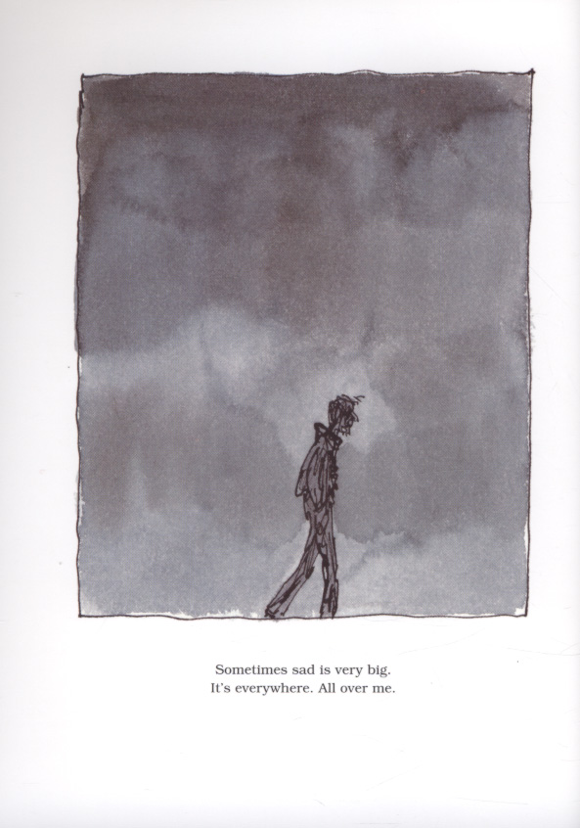
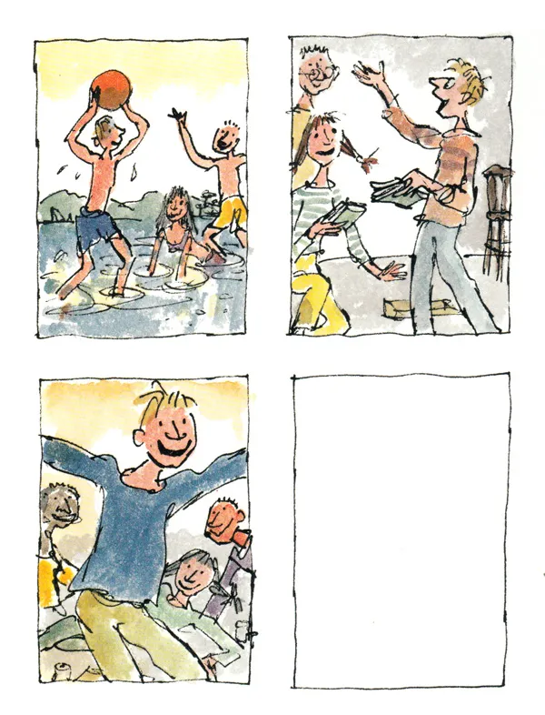
Another book that depicts the theme of death in the form of a children’s book is Michael Rosen’s Sad Book. It is written in first person by Michael Rosen and illustrated by Quentin Blake. In the story, Rosen describes his daily life living with grief after the death of his son, and how his sadness affects his view of the world. At the end of the story, aided by Blake’s illustrations, there can be seen glimmers of hope as Rosen recalls memories of his son. Jordison (2012) comments, “Rosen and Blake feeling sad? To know that it's these two in such misery adds special poignance. These two are bringers of joy. And not just any joy: they make children laugh”. The choice of Blake as illustrator adds particular context to the story. Blake is far more known for his colourful illustrations in children’s books, particularly on his work with children’s author Roald Dahl. Perhaps by choosing Blake to illustrate the story, Rosen is presenting death as something that should be openly discussed with children. Salisbury and Styles comment “the book’s treatment of some of the toughest emotions human beings ever suffer is frank, straightforward and true to life” (2012, p.124). Through his illustrations, Blake does not hide how grief can affect someone. Figure 4 in particular shows the weight of grief on Rosen, who is depicted as a small, scratchy figure at the bottom of the frame. Wiseman writes that “Children place significant emphasis on the visual images” (2012), which is why Blake’s illustrations are particularly affective. Blake uses washed out ink to create a dark, cloudy atmosphere that symbolises Rosen’s grief. The use of the colour black allows readers to understand more abstract concepts, such as death, in a more tangible way (Krishna, 2020). Rosen is drawn using a scratchy pen, perhaps revealing his inner turmoil. The decision to place Rosen at the bottom of a large frame makes him appear much smaller and weaker, displaying his grief as overwhelming. Salisbury and Styles describe Blake’s illustrations as “overwhelmingly grey with a few telling, scratchy pen-and-ink lines, they depict utter misery” (2012, p.124). It teaches that death is sad. It does not paint over this fact and shows a realistic depiction of depression and grief. Jordison comments “sad book doesn’t hide the darkness. It doesn’t pretend that suffering and sadness are easy to bear” (2012).
Figure 4- The wight of grief on Michael Rosen
Figure 5- Pictures in a photo album

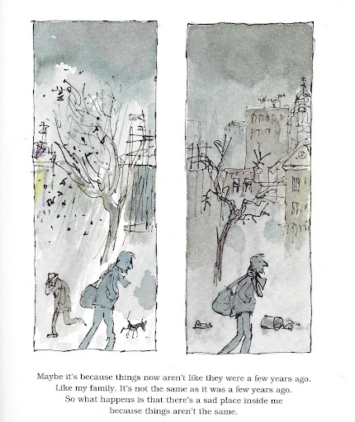
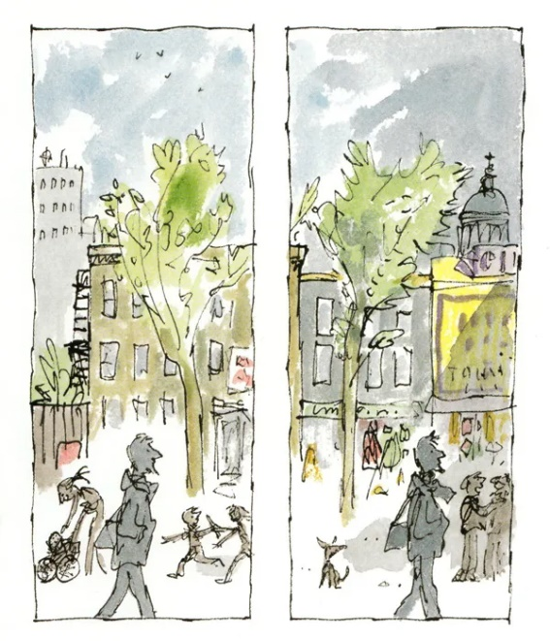
Blake uses frames in his compositions frequently throughout the book to illustrate feelings of loss and change. For example, in figure 5, there are pictures of Rosen’s memories of his son. The use of rectangular frames shows that these are photographs in an album. The illustrations appear happy and full of energy, which is contrasted with earlier illustrations of Rosen’s grief. Blake uses bright, primary colours and places Rosen’s son very large and at the centre of the frame. These memories are particularly happy. However, Blake includes a blank frame at the end of the series of frames. It shows that there will be no more happy memories for Rosen to remember. This presents death as sudden and unpredictable. Wiseman writes “children may have inaccurate ideas about the cause of death or even think that death is temporary” (2012). The blank frame is absolute, and there is no confusion to the reader that Rosen’s son is dead, and isn’t coming back. The fact that the book is about the sudden death of a child could frighten young readers, however Perring comments “children are generally capable of coping with more emotions than adults expect” (2005). Another instance where Blake uses frames to further portray grief is shown in figure 6. The four frames are over a double page spread, and show the same street getting progressively greyer and darker. Rosen is depicted as grey and unchanged in all of the frames, however his surroundings grow to match his demeanour. In the first frame, everything is bright and colourful and there are children in the background playing. However, the scene starts to become more bleak, with the leaves falling off the tree, people running for cover from the rain and a rubbish bin knocked over. The outside has become a reflection of what is inside Rosen. Rain is used to symbolise a feeling of foreboding that is primarily negative, and sometimes used to symbolise danger is coming (Naar, 2021). Blake is perhaps showing that grief can affect how people see the outside world. What was once a sunny scene becomes just as grey and dark as Rosen’s character.
Figure 6- Progressive frames

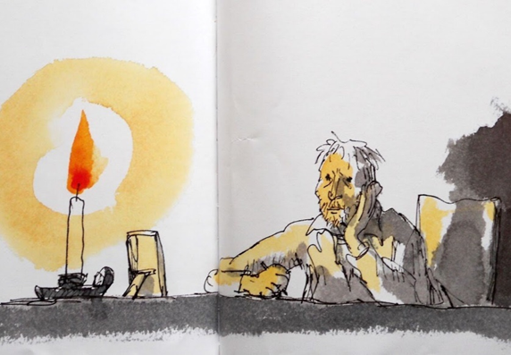
The final page in Rosen’s book (figure 7) offers a small amount of hope at the end of a book that has largely focussed on the harsh reality of grief. Jordison (2012) comments, “But it does at least show that it's okay to feel bad sometimes. We all do it – and so none of us is ever entirely alone. There's always some light, even if it's a single, lonely candle”. The large candle represents hope. In many cultures, light represents happiness, light and prosperity (Encylopedia.com, 2021), which is in contrast to the darkness that has been present in latter illustrations. The use of white space surrounding the candle gives the impression of the strength of light that the candle has. The warm orange tone from the candle is reflected on Rosen’s character, showing how he is being affected by the hope the candle offers. There is still a small amount of darkness present in the illustration, perhaps showing that hope and grief both have a place. Rosen’s character’s posture is still quite melancholy. There is hope to be found, but this doesn’t immediately take away the grief. Interestingly, Jordison writes at the end of his article on Rosen’s book “I've bought a copy for my daughter. But I don't know if I can bear to show it to her yet” (2012). What this shows is that parents may have a difficult decision to show this book to their children because of how blatant it is about death. However, an important aspect of responding to a child’s grief is by the way the parent responds to it themselves (Wiseman, 2012). Steele writes “Talking about death is complicated … As tough as it is, that doesn’t mean you shouldn’t try.” (2021). Perhaps a book that is so realistic about death is what is needed for children to start to understand the abstract concept of death.
Figure 7- Rosen watching a candle

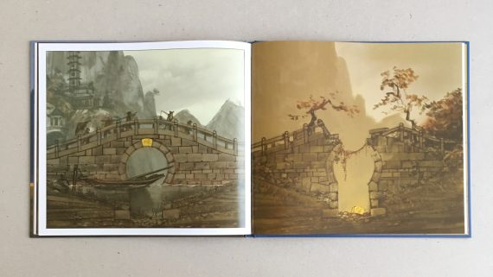
The last book that will be discussed is A Stone for Sascha, illustrated by Aaron Becker. The book is entirely a picturebook and features no text. In the story, it can be derived from the illustrations that a girl’s dog has passed away, and the girl struggles to come to terms with this loss. The rest of the story follows the journey of a special rock from the dawn of time, through thousands of years and different empires, until it comes to rest, small and polished, on the beach where the girl stands. The girl takes the stone home and places it on the grave of her pet, seeming to symbolise her acceptance. Becker describes his book as a “journey through space and time to see all the ways that things have come and gone for centuries”. Becker talks about on old building that was an inspiration for the book, where “the stones that were there would have been the same stones watching the rise and fall of empires” (2018). Becker uses the imagery of a stone moving through time as a metaphor for the cycle of life. Similar to the empires that can be seen in the book, every life has a beginning, middle and end. Throughout the book, Becker uses sequential imagery that show that time has moved on. For example, in figure 8, the precious stone has been used as part of a bridge. On the opposite page, the picture is mirrored, however here the use of sepia tones give a sense that time progressed. Ivy and trees have started to take over the bridge, and the stones have collapsed, making the bridge unusable. What this shows is that many structures made by man will be gone in a matter of years. The cycle repeats itself throughout the story. This fact is something that can help young children to understand death, “explain to your child that all living things die – leaves, plants, trees and our pets.” (BBC, no date). Understanding the idea that time and space is vast can help children accept that death is simply part of a larger cycle.
Figure 8- Destruction of the bridge

Becker comments “it's kind of a touchy subject which is of course death and it's always something that children are curious about and how do you talk to a child about this” (2018). The story uses the relatable incident of a pet passing away to tell a more meaningful story about grief and acceptance (Becker, 2018). Children’s books can help particularly to support a child who is experiencing grief, as Bestow writes,
These may include reading children’s books, watching movies, or listening to podcasts that deal with the topic of losing an animal. Connecting with characters or hearing another expert’s perspective may help them feel less alone in the experience. During the healing process, they will likely realize that this is something everyone has gone through either with a pet or a loved one.
(2019)
At the start of the story, the girl is presented as small and lost. In many scenes she can be seen grieving for her pet. Becker comments “She is having a hard time understanding how to grieve like what is grief how do I understand this loss” (2018). However, by the end of the story, the girl is shown to have accepted what has happened. In figure 9, which is at the end of the book, the girl is small in the frame and to the left, not at the centre. This perhaps shows that the girl has realised that there is greater things happening in the universe around her, as she is surrounded by a galaxy. Her posture is relaxed and at peace, therefore showing her acceptance.

Figure 9- The girl with the stone

Bibliography
BBC, (no date). Help Your Child Deal With the Loss of a Pet. Available at: https://www.bbc.co.uk/cbeebies/grownups/pet-loss (Accessed 27 November 2021)
Becker, A. (2018) A Stone for Sascha. London: Walker Books Ltd
Candlewick Press, (2018). Aaron Becker Discusses a Stone for Sascha. [Online Video] Available at: https://www.youtube.com/watch?v=Kb6EqKOVHKc (Accessed 27 November 2021)
Child Bereavement UK, (no date). Telling a Child That Someone Has Died. Available at: https://www.childbereavementuk.org/telling-a-child-that-someone-has-died (Accessed 20 October 2021)
Davey, L. (2015). The Significance of Skulls in Art Around the World. Available at: https://www.wanderarti.com/skulls-around-the-world/ (Accessed 25 October 2021)
Encyclopedia.com, (2021). Light and Darkness. Available at: https://www.encyclopedia.com (Accessed 15 November 2021)
Erlbruch, W. (2008). Duck, Death and the Tulip. New Zealand: Gecko Press
Funeral Guide, (2017). Colours of Mourning Around the World. Available at: https://www.funeralguide.net/blog/mourning-colours (Accessed 25 October 2021)
Jordison, S. (2012). Darkness in Literature: Sad Book by Michael Rosen. Available at: https://www.theguardian.com/books/2012/dec/12/darkness-literature (Accessed 30 October 2021)
McMurdie, D. (no date). 7 Beautiful Picturebooks to Help Children Understand Death. Available at: https://www.readbrightly.com/books-to-help-kids-understand-death/ (Accessed 20 October 2021)
Naar, D. (2021). What Does Rain Symbolise? Available at: https://www.reference.com/world-view/rain-symbolize-5892bd1c2cb7db83 (Accessed 30 October 2021)
Perring, C. (2005). Review of ‘Michael Rosen’s Sad Book’. Available at: https://www.pbmhmr.com/poc/view_doc.php?type=book&id=2645&cn=58 (Accessed 30 October 2021)
Popova, M. (no date). Duck, Death and the Tulip: a Surprisingly Tender Illustrated Meditation on the Cycle of Life. Available at: https://www.themarginalian.org/2016/05/04/duck-death-and-the-tulip-wolf-erlbruch/ (Accessed 25 October 2021)
Rosen, M. (2004). Michael Rosen’s Sad Book. London: Walker Books Ltd
Salisbury, M. and Styles, M. (2012) Children’s Picturebooks the Art of Visual Storytelling. London: Laurence King Publishing Ltd
Steele, L. (2021). How to Talk Sbout Death: The Right Words to Say. Available at: https://www.fatherly.com/parenting/how-to-talk-to-your-kids-about-death/ (Accessed 15 November 2021)
Symbolsage, (no date). Tulips- Meanings and Symbolism. Available at: https://symbolsage.com/tulips-meaning-and-symbolism/ (Accessed 25 October 2021)
Wiseman, A. (2012) Summer’s End and Sad Goodbyes: Children’s Picturebooks About Death and Dying. Available at: https://web-p-ebscohost-com.ezproxy.uwtsd.ac.uk/ehost/pdfviewer/pdfviewer?vid=1&sid=05e04395-7dd0-4842-b849-49717ee2141e%40redis (Accessed 6 December 2021)

References
BBC, (no date). Help Your Child Deal With the Loss of a Pet. Available at: https://www.bbc.co.uk/cbeebies/grownups/pet-loss (Accessed 27 November 2021)
Becker, A. (2018) A Stone for Sascha. London: Walker Books Ltd
Candlewick Press, (2018). Aaron Becker Discusses a Stone for Sascha. [Online Video] Available at: https://www.youtube.com/watch?v=Kb6EqKOVHKc (Accessed 27 November 2021)
Davey, L. (2015). The Significance of Skulls in Art Around the World. Available at: https://www.wanderarti.com/skulls-around-the-world/ (Accessed 25 October 2021)
Encyclopedia.com, (2021). Light and Darkness. Available at: https://www.encyclopedia.com (Accessed 15 November 2021)
Erlbruch, W. (2008). Duck, Death and the Tulip. New Zealand: Gecko Press
Funeral Guide, (2017). Colours of Mourning Around the World. Available at: https://www.funeralguide.net/blog/mourning-colours (Accessed 25 October 2021)
Jordison, S. (2012). Darkness in Literature: Sad Book by Michael Rosen. Available at: https://www.theguardian.com/books/2012/dec/12/darkness-literature (Accessed 30 October 2021)
Naar, D. (2021). What Does Rain Symbolise? Available at: https://www.reference.com/world-view/rain-symbolize-5892bd1c2cb7db83 (Accessed 30 October 2021)
Perring, C. (2005). Review of ‘Michael Rosen’s Sad Book’. Available at: https://www.pbmhmr.com/poc/view_doc.php?type=book&id=2645&cn=58 (Accessed 30 October 2021)
Popova, M. (no date). Duck, Death and the Tulip: A Surprisingly Tender Illustrated Meditation on the Cycle of Life. Available at: https://www.themarginalian.org/2016/05/04/duck-death-and-the-tulip-wolf-erlbruch/ (Accessed 25 October 2021)
Rosen, M. (2004). Michael Rosen’s Sad Book. London: Walker Books Ltd
Salisbury, M. and Styles, M. (2012) Children’s Picturebooks the Art of Visual Storytelling. London: Laurence King Publishing Ltd
Steele, L. (2021). How to Talk About Death: The Right Words to Say. Available at: https://www.fatherly.com/parenting/how-to-talk-to-your-kids-about-death/ (Accessed 15 November 2021)
Symbolsage, (no date). Tulips- Meanings and Symbolism. Available at: https://symbolsage.com/tulips-meaning-and-symbolism/ (Accessed 25 October 2021)
Wiseman, A. (2012) Summer’s End and Sad Goodbyes: Children’s Picturebooks About Death and Dying. Available at: https://web-p-ebscohost-com.ezproxy.uwtsd.ac.uk/ehost/pdfviewer/pdfviewer?vid=1&sid=05e04395-7dd0-4842-b849-49717ee2141e%40redis (Accessed 6 December 2021)

List of figures
Figure 1. Erlbruch, W. (2008). Duck, Death and the Tulip. New Zealand: Gecko Press
Figure2. Erlbruch, W. (2008). Duck, Death and the Tulip. New Zealand: Gecko Press
Figure 3. Erlbruch, W. (2008). Duck, Death and the Tulip. New Zealand: Gecko Press
Figure 4. Blake, Q. (2004). Michael Rosen’s Sad Book. London: Walker Books Ltd
Figure 5. Blake, Q. (2004). Michael Rosen’s Sad Book. London: Walker Books Ltd
Figure 6. Blake, Q. (2004). Michael Rosen’s Sad Book. London: Walker Books Ltd
Figure 7. Blake, Q. (2004). Michael Rosen’s Sad Book. London: Walker Books Ltd
Figure 8. Becker, A. (2018) A Stone for Sascha. London: Walker Books Ltd
Figure 9. Becker, A. (2018) A Stone for Sascha. London: Walker Books Ltd

