
Research into the stigma of ‘Sex work’ within the Police Service; from viewing ‘Sex work’ as a form of criminality or if this has shifted where ‘sex workers’ are now viewed as ‘vulnerable victims’ exposed to exploitation?
What changes can be made regarding the criminality linked to prostitution and what impact will this have on the risk of sex workers being exploited?

Jade Butterworth 2024358

BSC Bachelor of Science
Professional Policing Practice Year 3
09/10/2023
Word Count 8,068

Acknowledgements

Firstly, I would like to thank PC Mathew Screen, PS Kyle Tayler, PS Alex Kear and Inspector Nicholas Mancino from Gwent Police for their continued support throughout my Professional Policing Practice course and dissertation process; their kind support and understanding has enabled me to complete my dissertation whilst balancing a busy work schedule and taking care of my family.
Secondly, I would also like to thank Jane Davies, Rhiannon Sandy and Kelly Andrews from The University of Wales, Trinity Saint David, for their guidance and advice during the three-year course. Most importantly I would like to thank my Supervisor, Stephanie Brown, for her encouragement and reassurance throughout the dissertation process.
Finally, the completion of this course and dissertation process would not have been possible with out the kind support from my family and friends, who have been nothing but patient and comforting throughout; words cannot express my gratitude towards them.

Declaration
This work has not previously been accepted in substance for any degree and is not being concurrently submitted in candidature for any degree.
Signed: JADE BUTTERWORTH
Date: 08/10/2023

STATEMENT 1
This dissertation is being submitted in partial fulfilment of the requirements for the degree of BA.
Signed: JADE BUTTERWORTH
Date: 08/10/2023

STATEMENT 2
This dissertation is the result of my own independent work/investigation, except where otherwise stated.
Other sources are acknowledged by footnotes giving explicit references. A bibliography is appended.
Signed: JADE BUTTERWORTH
Date: 08/10/2023

STATEMENT 3
I hereby give consent for my dissertation, if accepted, to be available for photocopying and for interlibrary loan, and for the title and summary to be made available to outside organisations.
Signed: JADE BUTTERWORTH
Date: 08/10/2023

STATEMENT 4
I hereby give consent for my dissertation, if accepted, to be available on the university’s IT system to those who have consent to use the system.
Signed: JADE BUTTERWORTH
Date: 08/10/2023

Abstract

The purpose of this dissertation is to establish the police perspective on sex workers in today’s modern society. The objective of this research is to discover if the stigma remains to which police officers treat sex workers as suspects of crime with a zero-tolerance approach or weather, police treat them as vulnerable individuals who are being exploited and require safeguarding.

Existing research focuses on the sex workers relationship with the police in a negative light and the lack of trust they have with officers and the criminal justice system. It has discovered that there is very little research from the police perspective and how police view and address sex workers in today’s modern society. To get a clearer view into the police perspective; this research was conducted through an online questionnaire sent out to a range of serving police officers within Gwent and South Wales constabulary. This questionnaire aimed to gather data from both male and female officers, officers with a varied length of service, different ranks and from different departments to get a true reflection on this topic. By conducting online questionnaires with current serving police constables and higher ranked officers it will show their knowledge of what support is available to the sex workers to give them a path away from sex work and harm. By completing questionnaires with serving officers, it will establish if officers are interacting with sex work as part of their daily response duties and recommendations on how officers can better improve their relationships with sex workers.

The data has discovered knowledge gaps within the police where it was believed that sex work in the UK was illegal, which is not the case. This suggests that more clarity is sought around sex work for police to properly understand and investigate crimes surrounding this topic. This research found that the stigma on sex work within the police is diminishing over time and officers are in fact looking at ways in which they can protect and safeguard sex workers for them to complete their employment in a safe environment. Officers stated that they do not disagree with sex work as a form of employment; however, feel that the legislation around it needs to be modernised with the times to properly safeguard the individuals and provide police with clarity around dealing with sex workers and crimes that are linked to it. Officers felt it is important to treat sex workers with respect and dignity and ensure that they are treated in the same professional manner as any other victim of crime. Most officers completing the questionnaire had less than five years’ service and it questioned if this has played a part in the change of police perspective around sex work.

Due to the offences linked to sex work and the risks and dangers that surround this topic this research is important. Officers are attending emergency calls relating to crimes involving sex workers and it is important that their opinions of sex work are not affecting their judgment when dealing with these investigations.

Officers have suggested that the UK needs to implement the same rules and regulations as countries such as Amsterdam where the sex work industry is decriminalised and controlled by the police and health authorities. This prevents sex workers from hiding their employment and placing themselves at risk and allows them to work openly and honestly with the support of the police.

Table of Contents

Chapter 1.0 - Introduction 10
1.1 Background 10
1.2 Research Rationale 10
1.3 Aims and Objectives 11
1.4 Research Structure 11
1.5 Conclusion 11
__________________________________________________________________________________
Chapter 2.0 - Literature Review 12
2.1 Introduction 12
2.2 Dangers of sex work 14
2.3 The decriminalization of sex work 16
2.4 Conclusion 18
__________________________________________________________________________________
Chapter 3.0 - Methodology 20
3.1 Introduction 20
3.2 Research Strategy 20
3.3 Data Collection 21
3.4 Data Analysis 21
3.5 Limitations and Potential problems 22
3.6 Conclusion 22
__________________________________________________________________________________
Chapter 4.0 - Data Analysis and Findings 23
4.1 Introduction 23
4.2 Data Analysis 23
4.3 Method for Analysis 23
4.4 Analysis of Qualitative and Quantitative Data from the Online Questionnaire 24
4.5 Theme one – ‘Is sex work currently legal in the UK?’ 24
4.6 Theme two - ‘Examples of when officers have interacted with Sex Workers’..24
4.7 Theme three - ‘Should Sex work be decriminalised?’ 26
4.8 Theme four – ‘As a Police Officer how would you build trust with Sex Workers on the front line?’ 27
4.9 Theme five ‘What changes can be made regarding the criminality of Sex Work?’ 28
4.10 Matrix Analysis of Qualitative Data from Online Questionnaires 28
4.11 Conclusion 29
__________________________________________________________________________________
Chapter 5.0 - Conclusion and Recommendations 30
5.1 Introduction 30
5.2 Recommendation One: building trust between police and ‘Sex Workers’ 31
5.3 Recommendation Two: Providing a controlled environment like that of the ‘Red Light District’ 31
5.4 Findings and Conclusion 32
__________________________________________________________________________________
Bibliography 34
__________________________________________________________________________________
Appendices 42
Appendix A – Blank Online Questionnaire 42
Appendix B – Results of Online Questionnaire 50
Appendix C - Data Coding Table 66
Appendix D – Further evidence and research 67
Appendix E – Application for Ethical Approval 69
Appendix F – Research Proposal……………………………………………………87

__________________________________________________________________________________

List of Abbreviations
UK - United Kingdom
HM Government - Her Majesty's Government
UWTSD - University of Wales Trinity Saint David
WHISPER’ - Women Hurt in the Systems of Prostitution Engaged in Revolt
TICP - The International Committee for Prostitutes
PC – Police Constable
PS – Police Sargent
PCSO – Police Community Support Officer
OCG – Organized Crime Groups
SOCU – Serious Organised Crime Unit
NPCC – National Police Chiefs’ Council
PPU – Public Protection Unit
JFU – Joint Firearms Unit
CTU – Counter Terrorism Unit

Chapter 1.0 - Introduction:

1.1 Background:
This dissertation aims to discover the police perspective of sex work in today’s modern society and if the stigma remains within the police service; whereby ‘sex workers’ are viewed as suspects of crime or are considered as vulnerable victims of exploitation in a much wider criminal culture.

1.2 Research Rational:
I have chosen this topic as officers are brushing shoulders with sex workers regularly and it highlights several vulnerabilities and risks that sex workers face. Sex work has many ties to criminality such as ‘human trafficking, immigration crime, violence, drug abuse and money laundering; those targeted usually hold an immigration status, economic situation, or other vulnerabilities (The Crown Prosecution Service, 2022).

This topic is worth consideration for an undergraduate dissertation as it holds history and has been an ongoing issue within communities for many years. Sex work is legal in England and Wales; however, there are many areas within the legislation under (The Sexual Offences Act, 2003) that are criminalised (City of London Police, 2023).

For years sex workers were classed as the suspects of criminality and their vulnerabilities and risks around ‘prostitution’ were ignored. Over the years there has been a change of focus on the offences linked to sex work and the support that’s available to help them escape this dangerous choice of financial gain. The (Crown Prosecution Service, 2022) state that there is clear evidence to suggest that offenders deliberately target those who sell sex as there is a stigma that they believe the females selling sex will not make a positive complaint or report any crimes to the police to investigate.

There are many incidents in case law where prostitutes have been murdered for their involvement, links to gang violence, and trafficking, resulting in sex workers being brutally murdered for ‘knowing too much’ such as (Dutch Leah,1936). ‘Pimps’ such as (Kassel, 1936) have also come into danger and have been murdered due to their involvement in this topic This only supports how dangerous and how serious this topic is and why it’s such an important topic to review.

1.3 Aims and objectives:
I aim to understand how this topic is viewed in today’s police constabulary. This research will be conducted through online questionnaires sent electronically to current serving police constables and high ranked officers, with a 50/50 split between male and female officers. By conducting questionnaires with current serving police constables and higher ranked officers it will show the current police perspective on sex workers and their recommendations on how this can be improved achieving the overall objective.

1.4 Research Structure
This dissertation will be set out in chapters beginning with the literature review to get a deeper understanding of this topic and existing research. It will then discuss the methodology chosen to carry out the study. Following chapters will analyse the data retried from the methodology used and discuss the findings, limitations and recommendations discovered from the overall research.

1.5 Conclusion
This dissertation aims to establish the police perspective on sex work and what is being done to improve the relationship between the police and sex workers. It will seek to find new ways to improve these relationships by safeguarding them from exploitation. This next chapter will delve deeper into the understanding of sex work and existing research that is available.

Chapter 2.0: Literature review
2.1 Background
Sex work appears to be a term which can make members of society feel uncomfortable and for many years it has been a topic that has been isolated by communities and has been viewed in a negative light (Berthe, 2018). Due to this, sex workers have experienced isolation from their communities, faced exploitation, violence and felt neglected due to their employment leaving them vulnerable and at great risk with very little support (Toubiana and Ruebottom, 2022).

Berthe, (2018) argues the ‘whore stigma’ is a concept that has been created towards sex workers who are mainly women, who go against the norm and as their employment they sell their bodies for sex. These women complete fantasies for their customers and are believed to carry and transmit sexually transmitted diseases. Berthe, (2018) also argues that the ‘whore stigma’ has created a misconception; where society instantly view the sex worker as an individual with little or no money and that they have experienced a poor education. In argument to this, (Peterson-lyer,1988) states that this is not the full truth and that sex workers can come from higher educated backgrounds, have large amount of money, have families and children of their own that they support through sex work. Sex workers can also have college degrees or are still studying and using sex work to support them through this.

Sex workers are not yet accepted within society with most being viewed as disrespectful and with low morals regardless of the individual; forcing the sex worker to come up with different ideas on how they can conduct their line of work secretly without being isolated or shamed (Berthe, 2018). Toubiana and Ruebottom, (2022) argue that sex work is stigmatized as ‘dirty work’ supporting that sex work is viewed by many as disgusting and shameful due to their line of work involving physical, social, and moral stigma being at the forefront of what they do (Hudson, 2008). In a positive light it is argued that sex workers use this stigmatization to become unified as a group and build positive resilience to deal with this through being secretive or going against society in their beliefs (Hudson, 2008).

Pateman, (1999) argues that feminist view sex work as any other form of employment and states that many women chose sex work as a form of employment due to the ever-expanding ‘sex industry’. Some feminists do not necessarily disagree with sex work and see this as a sole transaction between the sex worker and ‘punter’; however, the concern is that this provides the ‘men’ purchasing sex with power and control (Pateman, 1999).

Pateman, (1999) discusses the contract between sex workers and their ‘punters’ and how this is like any other form of employment contract; however, due to the fact it involves most of the time a ‘woman’s body’ it is believed that due to emotional attachments that goes beyond just the employment contract and could be seen more as ‘slave labour’. In agreement with this (Peterson-lyer,1988) also references members of ‘WHISPER’ ‘Women Hurt in the Systems of Prostitution Engaged in Revolt’ that if sex work is viewed like all other forms of employment, it is only providing the ‘men’ with more power and rights to take control over women’s bodies for sexual gratification. (Peterson-lyer,1988) argues that sex work is dangerous, and women do not enter this voluntarily as each contract they carry out risks their freedom and their lives sex workers are placing themselves at great risk every day on the front line. (Streetlight UK, 2022) argue that sex workers are facing homelessness, violence, sexual abuse, drug use, poverty, debt, and poor education. They argue that the above vulnerabilities create barriers for them to escape the sex work industry and it makes it almost impossible for them to leave.

Saunders, (2004 p.2007) argues that sex workers are seen as individuals who are going out of their way to take risks and for this reason they are not protected by other members in society and their behaviours are seen as unacceptable and fall below the standards accepted of female femininity. Sex workers are not protected by the public as they are seen to be breaking the rules and therefore, they are ‘asking for it’ when they are at risk of danger or exploitation (Stanko, 1996). This creates the argument in relation to how sex work is viewed within society and how it is considered negatively and how sex workers are instantly viewed in a criminal light due to their employment decisions. Instantly sex workers human rights are viewed differently, and they are treated les inadequate than others due to their employment.
It is frequently overlooked the reason behind why individuals turn to sex work and individuals are quick to pass judgement on the topic without really understanding the underlying factors behind sex work and what it can involve (Stanko, 1996).

2.2 The Dangers of Sex Work
Rather than viewing the sex worker as ‘criminal’ its argued that they are vulnerable and at serious risk of being exploited due to the experiences and vulnerabilities they face. Sex workers face violence and place themselves at great risks to make quick money although some do this out of choice a study showed that 89% wanted to escape sex work (Allen, 2021). Allen, (2021) has also discussed a study ‘Prostitution and Trafficking in Nine Countries’ where it was found that 70-95% of the women had been physically assaulted, 60-75% were raped, and 89% told researchers that they urgently wanted to escape their situation. Allen, (2021) argues that even if sex work was considered a respectable employment; it is still a dangerous choice of profession where the chances of being exploited are extremely high.

Goodyear and Cusick, (2007) argue that at least six sex workers are murdered every year in the UK. At times, the individual feels that they have no other choice but to turn to sex work to make a living and once they are in that cycle, they state it’s almost impossible for them to escape (Allen, 2021). Stigma around sex work was seen in previous case law where five sex workers were found deceased in Ipswich; the media came under the firing line for highlighting them as ‘prostitutes’ it was felt that this was diminishing, and they were criticised for their support towards sex workers (Goodyear, 2007). This case law gave the family’s a voice and the opportunity to humanise the female victims; however, it highlighted the ongoing stereotyping of sex workers and misunderstanding over its complexity, social contact and the diversity in which sex work holds (Goodyear and Cusick, 2007).

Silbert and Pines, (1981) completed a study of two hundred female ‘street prostitutes’ to which supported the extreme amounts of victimization within sex work. The women recalled occasions where they had experienced physical violence and assaulted by their ‘punters and pimps’. The women also disclosed occasions where they have been raped, where punters have taken advantage of them beyond their original agreements, refusing to pay them, theft, and robbery (Silbert and Pines,1981). Whilst there are numerous means of conducting sex work the most dangerous form of sex work is ‘on-the street sex work’ rather than those behind closed doors (Church et al, 2001). A UK study was conducted through means of a survey that established out of 115 sex workers 81% had experienced violence in comparison to 45 % out of 125 who conduct their employment behind closed doors (Church et al, 2001). Due to this, there is a higher Police presence in ‘on-the street’ sex work that has also been a cause for debate. The stigma remains around sex work not only from the public but also within the Police. Due to this build-up of stereotyping over many years sex workers do not trust the Police and hold little or no confidence in the justice system (Pyett and Warr, 1997).

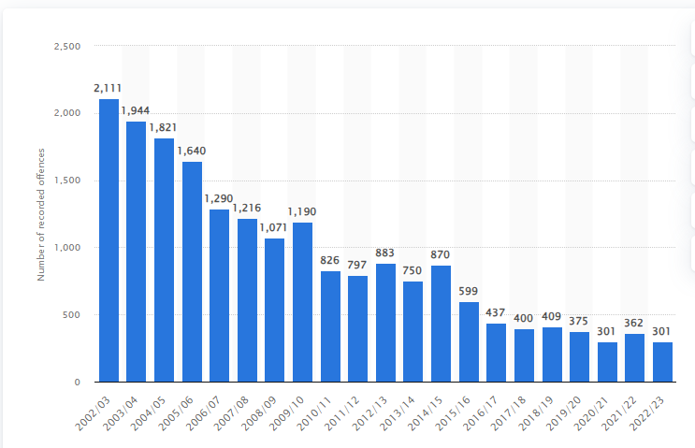
(Clark, 2023)

Clark, (2023) argues that there has been a severe decline in the number of soliciting offences recorded by the police in England and Wales. This could support that the stigma within the police force is changing and that officers are more aware of soliciting as an offence and are targeting high populated areas.

2.3 The decriminalisation of sex work
Throughout the years it has become a fast-developing debate regarding the decimalisation of sex work and the Police protecting vulnerable victims of exploitation. In recent research, sex work has been defined by Police as a ‘problem’ where Police are conducted to move sex workers out of an area and have been guilty in the past of ‘naming and shaming’ sex workers; which again supports the stigma of criminalizing sex workers (Thornton, 2003). There has been extensive research to support that sex workers don’t feel they are able to report crimes to Police and sex workers have raised concern that Police do not take their reports seriously and are less likely to believe them due to their line of work; in comparison to women who are non sex workers (Turek, 2022). Peterson-lyer,(1988) also argue that sex workers are powerless when reporting crimes to the Police as the nature of what they are doing falls on the side of criminalisation. Sex workers are also afraid to disclose information to Police as they are fearful, they will get arrested due to the legislation around sex work and don’t feel that the police view them as victims, and they only focus on the criminal aspect of what they are doing (Peterson-lyer,1988).

Other research conducted by (Dewey & Germain, 2014) involved conducting interviews with a hundred sex workers in Colorado on their experiences with Police and it’s discovered that they go by ‘it depends on the cop’. Firstly, some sex workers felt targeted by Police as they attend high populated sex work areas. Secondly, they felt they could talk their way out of arrests knowing the correct things to say and not showcase their sex work behaviours. Lastly, it was discovered that some Police abuse their powers by not adhering to their rights and some even sexually victimizing them. This research supports the negative opinions and views on the Police by sex workers and there was only a small amount of sex workers who provided a positive answer; believing that Police are ‘just doing their job’ (Dewey & Germain, 2014 p 256-270).

There are very rarely positives views provided by sex workers on the Police. It is known that in certain policing areas polices have worked hard at building relationships with the induvial sex workers to gather inelegance and tackling other areas of crime (Mathews, 2005). We have progressed through the years; Police are focusing on the theory of sex workers ‘welfare’ is at the forefront of their policing purpose; focusing on ways in which they can protect and support the sex workers. (Jordensen, 2018). This hasn’t always been the case and there is a lot of work to be done to change the opinions of the sex workers for them to feel confident enough to report offences to the Police and communicate openly to keep themselves safe (Medlicott, 2021). Medlicott, 2021 argues that sex workers are afraid to report crimes because they are fearful of being deported, ignored, fined, or evicted.

There are many factors still associated with sex work that remain criminalized and (Armstrong, 2016) argues that this has an impact on the sex workers safety, wellbeing and human rights and she believes that if the criminalization around sex work should be amended in two important ways. The first being that the Police should have fewer powers of arresting the sex workers and secondly, the sex workers should be empowered through the provision of rights. Armstrong, (2016) also argues that if these changes are made this will increase the safety of sex workers and better their relationship with the Police to offer them protection and lower the risk of them being exploited.

It is argued that this change will have a positive impact in relation to safe guarding sex workers and ensuring their human rights are met accordingly (Pyett and Warr, 1999); (Day and Ward, 2007); (Goodyear and Cusick, 2007); (Brooks-Gordon, 2008); (Jeffrey and Sullivan, 2009). Vanwesenbeeck, (2017) argues that legislation as it stands is to blame for the stigma around sex work as it focuses on the ‘sex’ rather than the crime element; believing that this focus doesn’t resolve the issues around sex work or provide any form of solution around the problems sex workers face. Raymond, (2003); Farley, (2004) argue that if these changes are implemented then the sex worker will be at a greater risk of being exploited and feels that if the barriers for customers are lowered than they will feel more empowered to take advantage of the sex working creating a greater risk to their safety, wellbeing and overall ‘welfare’.

Back in 1985 ‘The International Committee for Prostitutes’ was created to restore sex workers human rights and freedoms, and to fight for sex work to be decriminalized (Peterson-lyer,1988). However, this is still not the case and there is still a large amount of criminalisation that surrounds sex work. At present New Zealand is one of the fewer countries in the world where sex work has been decriminalized. The belief around decriminalization is that sex work has no legislation around it only in the aspect of employment law. Abel, Fitzgerald, Healy, & Taylor, (2010.p39) argue that if sex work is viewed solely as ‘work’ like any other employment this would change the stigma on sex work its self. Legislation in the UK hasn’t progressed dramatically over the years and even back when The Wolfden Report, (1959) was released and followed by the Sexual Offences Act, (1959) this still drove the legislation to protect communities from sex work. Hubbard, (2006) argued that it was not the laws’ purpose to involve itself with individual’s lives or to control their behaviours. This supports that there has been an ongoing debate around the criminalization of sex work, and this is still an ongoing argument. Scambler and Scambler, (1997) argue that the decriminalization of sex work should involve legislation that is specific to a particular line of work, which will pave the way for workers and remove the stigma by bringing sex work into the mainstream of society. This will allow sex workers to have rights and become basic citizens of their communities.

2.4 Summary
The aim of this dissertation is to delve deeper into a Police perspective on sex workers today. There is a large amount of research regarding the sex worker. However, from current outstanding research there is much less on the Police perspective and how they view sex work and as this is the root cause of change it’s an important focus. Jordensen, (2018) also agrees that there is little literature regarding the Police perspective on prostitution considering Police are brushing shoulders with punters, drug dealers, drug users, ‘prostitutes’ and many other offenders daily; he agrees that this is a problem due to how much of an impact Police influence the legislation around sex work. Jordensen, (2018) also argues that our behaviours are influenced by our perceptions which supports this topic as the Police perspective can hinder the way in which they behave towards sex workers. Jordensen, (2018) has conducted a similar study to understand this and in recent studies it’s been seen that younger Police officers are more for decriminalizing sex work than older and longer serving officers and its believed this may be due to a different generation Wilson.G.P, (1985, p.22-29). This dissertation aims to test this in a similar format; where questionnaires will be sent to Police officers to expand on this information gathering in relation to Police views on sex work. Without trust in the Police and building relationships with sex workers we will never move forward improving human rights and the safety of sex workers, and the stigma of sex work will always remain.

Chapter 3: Methodology
3.1 Introduction
The objective of this research is to determine if the stigma of ‘sex work’ remains or if it has changed within the Police over recent years; from viewing sex work as a form of criminality or if this has shifted where sex workers are now viewed as ‘vulnerable victims’ exposed to being exploited.

There has been a large amount of research into the perspective of the ‘Sex Worker’ and their relationship with police officers. However, as shown in the literature review, there has been very little research done from a 'Police perspective'. Wolf, (2019) argues that police officers are mostly seen in a negative light regarding sex workers yet there’s very little research around why this might be from the police officers that are working the front line and dealing directly with sex workers and the crimes linked around it (Jordensen, 2018). This research sets out to understand police officers thoughts around sex work to determine if officers are actively attempting to support sex workers when they are victims of crime or if the stigma of sex work is still clouding their judgement and the way they respond to these types of calls.

3.2 Research Strategy
To conduct my own research into this topic, I have chosen the format of an online questionnaire. I have chosen this method as police officers face heavy workloads and high demands; this method would be the least time consuming for them and that they would have easy access to it on any of their devices. Write, (2017) agrees that the use of online questionnaires is much easier, time saving, more modernised, continuously evolving, and popular with the younger generation. Police officers can complete the online questionnaire wherever they are, at any time, when practicable to do so. Police officers may not have the time to sit and complete a handwritten questionnaire; however, they may be able to complete one online whilst conducting a hospital watch or a 1-2-1 at custody, if able to do so. The online questionnaire opens the possibilities of more police officers successfully completing the questionnaire and providing greater sample and findings. The online questionnaire is a fast and easy way of including open questions with free format answers and closed questions, such as multiple choice and number rated questions. It will enable me to send the questionnaires to individuals of all distances and departments and it will only take them approximately five minutes to complete. Lefever et al, (2007) also agree that the online questionnaires are a good form of methodology due to its time efficiency and how it enables the research to target a larger audience of all distances. I wanted to ensure the questions were not exhausting where the individual would lose interest after a couple of minutes, and I have kept them short and simple to keep officers engaged.

3.3 Data Collection
I intend on sampling a total of 100 front line police officers ensuring a 50/50 split in gender, which will contribute to my results to see if the answers vary from male and female officers. I have also included samples of different ranked officers and officers with different lengths of service to see if this has any impact on the findings. Higher ranked officers tend to have greater years’ service within the police, and I wanted to see if this impacted the findings in comparison to newer officers. Officers can complete the online questionnaire remaining anonymous and well informed that their data will only be collected for the purpose of this research.

3.4 Data Analysis
My focus will be on quantitative and qualitative methods; whilst remaining easy, simple, and straight forward to complete. The qualitative methods I will use to ensure a larger response keeping the questionnaire simple and straight forward. VanderStoep (2008) agrees and states that qualitive methods provide a better chance of getting an accurate sample and will better reflect the overall participants. Carbonaro and Bainbridge (2000) also agree with this way of questionnaire and state that it is crucial for the questionnaires to be created in a simple format ensuring that it’s easy for the individuals to complete. I will include multiple choice questions and number rated questions to begin with and I will end it with qualitative methods which is a more detailed way of question to finish the survey to avoid them losing interest at the beginning. As quantitative methods are closed questions, I will gather officers’ feelings, insights and experiences by quantitative methods which will provide a more in depth result as supported by (Quinlan, 2023).

3.5 Limitations and Potential problems
I have considered potential limitations with the method of an online questionnaire; this can be where certain software systems available are costly for smaller research samples. I have ensured that the online questionnaire format is free of charge and still provides a wide enough sample. Hayslett and Wildemuth, (2004) have also identified this a problem and note that it can result in financial hardship for some small researchers as the software providers aim to make a profit by setting out limitations. Police officers face stressful workloads, high demands and not all officers are able to complete the questionnaires. This may impact the 50/50 split in genders which may affect the research to determine if the stigma of sex work is gendered; however, I will ensure that the questionnaire is sent out on all policing platforms to avoid this. In addition to this, higher ranked officers may also struggle to complete the survey which again will have an overall impact on my findings.

I have considered that individuals may experience difficulties gaining access to the research and I have ensured the use of a software that enables the online questionnaire to be used on all devices. However, this isn’t to say that some may still struggle to gain access and may affect the sample size and diversity of the findings. Hayslett and Wildemuth, (2004) have considered this as a problem stating that individuals may experience difficulties with the software making the responses, they provide harder to understand. I have also considered the topic of my questionnaire to be sensitive or uncomfortable to which some individuals may not want to provide their opinions due to the nature of sex work, which again may impact the overall findings.

3.6 Summary
This overall research methodology should provide a straightforward and interesting result to analyse the police perspective on sex work. The findings will provide an in-depth understanding around why the stigma between sex workers and police officers remains or how if it has changed.

Chapter 4.0 – Data Analysis and Findings
4.1 Introduction
This chapter will analyse data collected from my selected methodology of an online questionnaire and establish if the data has met the objective of this dissertation. I will analyse the results to establish if the stigma of sex work has changed within the police and establish the police perspective on sex workers in today’s society. I will also analyse suggestions made by the police on how they can improve their relationship with sex workers to prevent them from being exploited and ways in which they can safeguard them as vulnerable victims of crime.

4.2 Data Analysis
Before proceeding to examine my findings, I will analyse the data collected from the online questionnaire including both qualitative and quantitative data whilst focusing on my research objectives. By analysing the data collected it will enable a systematic approach of evaluating the data and providing a recap on the information in general (Responsible Conduct of Research, 2005). Shamoo and Resnik, (2003 p.46) state that various analytic procedures “provide a way of drawing inductive inferences from data and distinguishing the signal (the phenomenon of interest) from the noise (statistical fluctuations) present in the data”.

4.3 Method for Analysis
The online questionnaire was created using Google Forms as this was a free and simple way of sending the questionnaire out unanimously. The questionnaire would only take approximately ten minutes to complete, and it was stated that all officer identities would remain anonymous. The questionnaire was sent expeditiously and to a broad variety of police officers and staff and received a total of 64 responses. My original aim was to receive 100 responses; however, as predicted police officers are extremely busy and struggle to find the time to complete additional tasks on top of their daily priorities. Although there were only 64 responses; under participants questions 2, 3, 4 and 5 this included 40.6% female and 56.3% male participants ranging from 53.1% of participants being police constables and others ranging from police staff, PCSO and high ranked officers. Participants were from both Gwent Police and South Wales Police and included a length of service of between 0-20 years. The objective is to establish if the stigma of sex work has diminished over recent years ; however, this data may have an impact on the findings due to 45.2% of participants having under 5 years’ service. A blank copy of this questionnaire has been attached under Appendix A of this dissertation.

4.4 Analysis of Qualitative and Quantitative Data from the Online Questionnaire
To sanitise and simplify the data collected, I have used pie charts to display the quantitative data and a word cloud generator to display qualitative findings. This has enabled me to recognise trends in officers’ thoughts, suggestions, and experiences around the stigma of sex work today and compare them to outstanding research.

4.5 Theme one – ‘Is sex work currently legal in the UK?’
Theme one established that having asked under Q6 if sex work is currently legal in the UK 60.3% stated that it was not and only 38.1% select the correct answer that yes, it is. This indicates that there is a knowledge gap in this topic suggesting further research may be required to establish if this is an impact factor on the relationship between Sex Workers and the police.

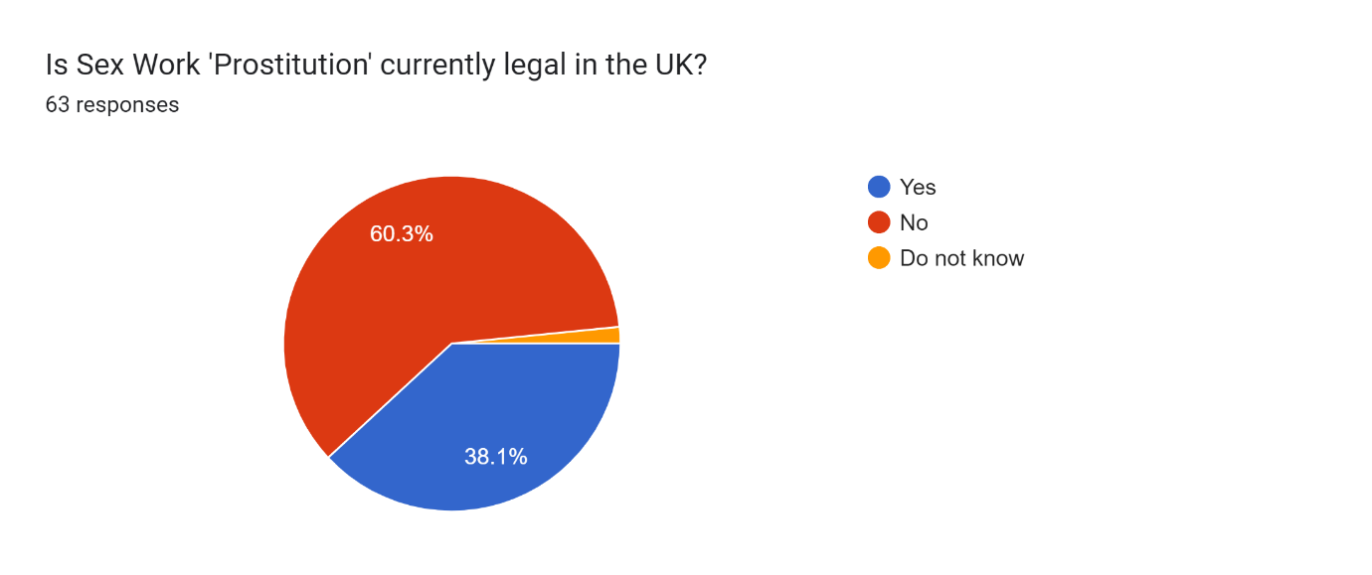 Google Form Questionnaire, (2023)

4.6 Theme two – ‘Examples of when officers have interacted with Sex Workers’
Over half of the sample stated in Q10 that they had encountered a sex worker within their response duties; supporting that sex work is something that police are brushing shoulders with regularly. Theme two was shown under Q11; where most officers had dealt with sex workers as victims of crime and very few had dealt with them as offenders. From officers’ experiences with sex workers, Q18 has shown that 81% believe that sex workers are being exploited and are placing themselves in high-risk circumstances supporting (Silbert and Pines,1981) argument that sex work is a dangerous industry. In Q8 71% of the sample agreed that sex work is gendered and in Q9 85.9% believed that sex work was mostly females with male clients supporting (Berthe, 2018) that this industry sex work is predominantly conducted by female sex workers. With 56.3% participants being male, this could have impacted the findings due to male and female officers having different experiences with sex workers. Male officers may feel uncovertebral in certain situations with sex workers and has potentially impacted the findings as in some questions they didn’t not wish to answer.

Below are key words collected from the qualitive data which demonstrates the type of criminal offences that are associated with sex workers.
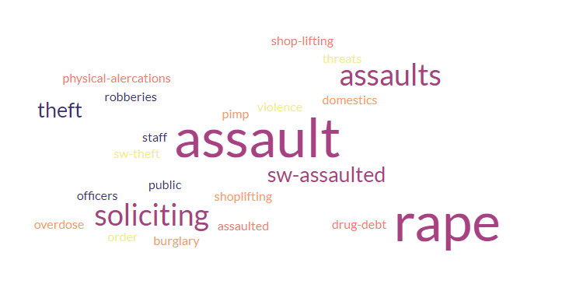

Figure 4.5 - Key words used by participants. Free word cloud generator, (2023)

The words used by officers reflect on the type of interactions they have experienced with sex workers and what offences they have disclosed. The words used support the risks involved with sex work and potential ways on how they are being exploited.

4.7 Theme three ‘Should Sex work be decriminalised?’
In Q23 41.3% believed that sex work should be decriminalised with only 27% arguing that it should not with the vast majority stating that the suspects are the ones facilitating the sex work not the sex workers themselves. This supports Jordensen, (2018) that the serving officers of today’s communities are for the decriminalisation of Sex Work in its entirety. Suggestions of a recurring theme have been discovered that participants believed that sex work should be decriminalised, and that there should be a more controlled and monitored environment making it a safe place for them to work supporting Armstrong, (2016). References to legalisation and policies set in place in Amsterdam around a controlled ‘Sex Working environment’ were also raised. In addition to this, suggestions were made around modernised legalisation for it to reflect today’s society supporting Vanwesenbeeck, (2017), Hubbard, (2006) and Scambler and Scambler, (1997). Participants disagreed with the above and agreed with Raymond, (2003); Farley, (2004) stating that regardless of Sex work being decriminalised it will always have ties with other offences and always be a dangerous form of employment.

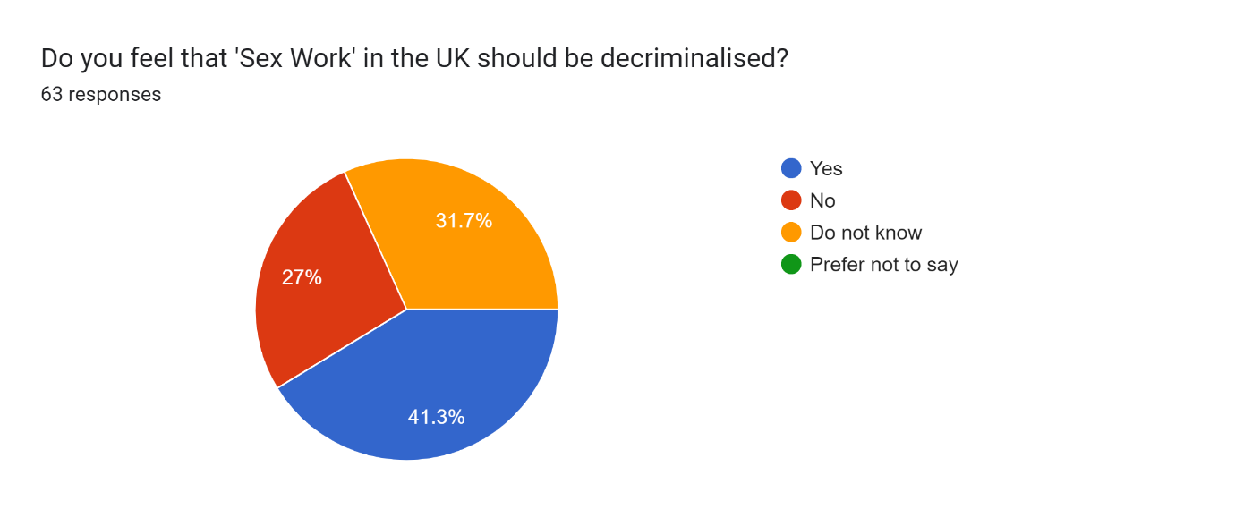
Google Form Questionnaire, (2023)

4.8 Theme four: As a Police Officer how would you build trust with 'Sex Workers' on the front line?
Officers have provided key suggestions on how they feel police could build trust with sex workers, and a common trend was through ‘engagement’. The suggestions displayed below support positive interactions with sex workers and the importance of the sensitivity around this topic. The findings go against Pyett and Warr, (1997) suggesting that police would be fair and non-judgmental when dealing with Sex Workers supporting that they want to build relationships with them to keep them safe. The data argues Peterson-lyer, (1988) point that police only view sex workers as criminals, as it suggests that police are focusing on the sex workers welfare and are attempting to treat them with respect and as victims of crime.

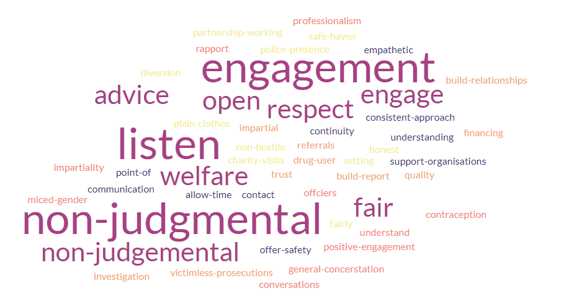

Figure 4.7 - Key suggestions used by participants. Free word cloud generator, (2023)

4.9 Theme Five: ‘What changes can be made regarding the criminality of Sex Work?’
As seen in Q14 and Q16 data supports that the police are knowledgeable around the offences linked to sex work and the offences that make them vulnerable. However, Q17 has discovered that 23.4% of participants did not know what support was available to Sex Workers. This suggests that there is a potential knowledge gap in what support is available for sex works which could impact the influence have when attending incidents involving sex workers. Further research into this area is required to establish if this impacts the relationship between police and sex workers.

Below is a display of key words provided from the data on recommendations that the police feel that could be made regarding the criminality of Sex Work.

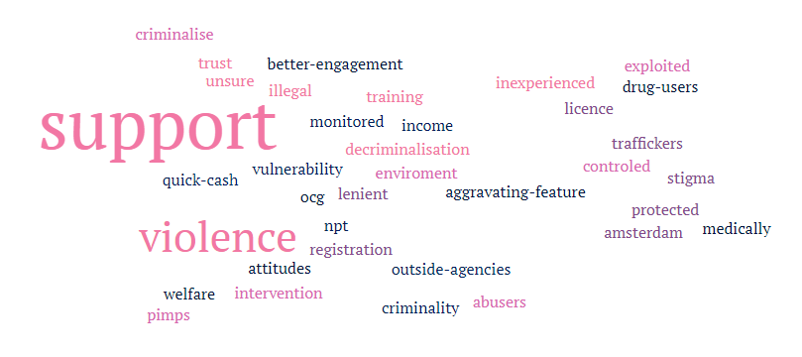

Figure 4.8 - Key suggestions used by participants. Free word cloud generator, (2023)

4.10 Matrix Analysis of Qualitative Data from Online Questionnaires
A full matrix analysis of the online questionnaire findings can be found at Appendix B of this dissertation.

4.11 Conclusion

The method of the online questionnaire has successfully provided findings around the police perspective of sex workers. This draws to the final chapter of this dissertation where I will discuss potential implications and recommendations around improving the relationships between the police and sex workers. It will recommend ways in which we can better protect sex workers from exploitation and aim to answer the main objective of; has the stigma has diminished over recent years between the police and sex workers.

Chapter Five: Results and Findings

5.1 Introduction
This chapter will discuss key findings behind the stigma of sex work within the Police and if this has changed over recent years, focusing on the police perspective and their current relationships with sex workers.

The questionnaire has shown that officers are encountering incidents involving sex workers in their response duties and view sex workers as vulnerable individuals placing themselves at great risks and subject to crime. 47.6% of officers agree with sex work as a form of employment and feel a safer environment is needed; enabling police to safeguard them and deal with crimes around sex work. Officers argue that sex workers are driven into secrecy to conduct their employment making it harder for police to build relationships and trust within the industry.

Officers agree with the (Crown Prosecution Service, 2022) that the police should be focusing on the individuals who are exploiting them such as PIMPS and Organized Crime Groups. This would allow police to support sex workers and work alongside third-party agencies; whilst protecting them from perpetrators who are controlling the sex workers. The majority of participants made recommendations on how police can improve their relationships with sex workers; however, this is still a sensitive topic where some officers may not feel they can express their true feelings which could have played an impact on some of the results. Due to an uneven split of responses from male and female officers the research was unable to identify if gender impacts the stigma on sex workers. With 56.3% of participants being male officers this may have impacted the findings due to most sex workers being female; further research would be required to delve deeper into this area. Some male officers raised that that they feel female officers would be better suited to engage with sex workers for them to feel more at ease and open to talk about sensitive and private matters.

This research has found that there are knowledge gaps within the police. Offices are not fully aware of the legislation and guidance behind sex work and linked offences. This isn’t necessarily down the police and more so due to the dated legislation. It has been recommended that new legislation is formulated where clearer guidance is provided to the police. This is an area that would benefit further research to look at ways in which this can be improved.

5.2 Recommendation One: building trust between police and ‘Sex Workers’
To build trust between the police and sex workers recommendations have been made that continuity is required when engaging with sex workers. This should provide them with a single point of contact where they are able to build trust and repour with an individual officer. Relationships between police and sex workers should be completed outside of a police station, with a female officer in plain clothing enabling sex workers to speak openly about their problems and enable them to report crimes in confidence. Officers feel that these suggestions will make the sex workers feel supported as victims rather than a suspects of crime.

The researcher tested this recommendation in a live policing operation on a large-scale organised crime group warrant. The warrant involved human trafficking, class A drugs, and firearm offences. Due to the risks involved both JFU and CTU were present along with unarmed officers and other supporting units such as CID, PPU and SOCU. This supported the serious risks and dangers linked to sex work at present. Sex workers were approached by plain uniformed female officers, in unmarked vehicles and taken to a place of safety; allowing them to speak openly and freely with staff members from the public protection unit. The suspects soliciting these offences were arrested by uniformed police officers and conveyed to custody in full marked police vehicles. Sex workers were not treated as suspects of crime and police focused on the individuals as victims of exploitation. It was still apparent that sex workers will still withhold information from the police to prevent criminalizing themselves, which could affect future progression. One sex worker stated that she felt she could not engage with the police due to the repercussions she may face in the future; suggesting there is still a form of secrecy within the industry causing a barrier between police and sex workers. This is discussed further in appendix D.

5.3 Recommendation Two: Providing a controlled environment like that of the ‘Red Light District’
Recommendations have been made that the UK take the same approach as the ‘Red Light District’ in Amsterdam where sex work in its entirety is legal; however, in a controlled environment as some officers stated a monitored market making the sex worker less acceptable to coercion, abuse and exploitation. Most officers feel that this approach would keep the sex worker safe without judgment or prejudice. This would enable a more controlled environment which would enable the police to deal with crime involved with sex work more efficiently. Officers agree with (Weitzer,2014) and feel that this would remove ‘street sex zones’ and provide a safer platform for the sex workers to conduct their employment. Willems, (2009) argues that the red-light district has not only improved working conditions for sex workers, reduced involved in organised crime groups, reduced public nuisances, and limited sex work to a single location. These are all objectives highlighted by officers in the questionnaire, who feel that if the UK conducted the same approach, it would be overall beneficial for the relationship between police and sex workers.

5.4 Conclusion
This chapter has demonstrated that we have come a long way from previous incidents where police officers were criminalising sex workers and over half the sample agree with sex work as a form of employment and would support a loved one if they chose this as a career. This would suggest that the stigma is gradually diminishing and that officers are beginning to view sex work differently. The results may reflect the newer and younger generation of officers due to the heavy turnaround of staff in response roles; with the older generation in alternative roles within the police or now retired and a more extensive research process could delve deeper into this to establish if this is reason behind the change of perspective.

Officers are less judgmental on the employment factor and aim to safeguard the sex workers from crime; however, feel legislation is currently preventing any kind of progression or improvement to help the police adapt. Officers view the sex worker as a victim, they understand the seriousness and offences involved. Officers want to respect sex workers and want to help make it safe for them with 46% of them stating they consider themselves impartial and with 82% of participants stating they would not allow the sex worker element to affect their professionalism when investigating crimes linked to this topic. Officers stated they would not let the sex worker title cloud their judgment when dealing with victims and potentially believe that offences against Sex workers should have an aggravating factor.

Little research has been done around the police perspective around sex work and more focus has been made on the negativity between the police and sex workers and how they feel they can’t trust or report crimes to the police. This study is important as the way officers view sex workers effects their decision making on applying the law when responding to incidents (Jorgensen, 2018). Jorgensen, 2018 agrees with the importance of this research and found that only one other small study had been conducted by (Wilson et al, 1985) around officers’ attitudes to sex work. Wilson et al, (1985) found that younger officers were more accepting towards sex work as a form of employment and argued this was due to them coming from a more liberal background. In disagreement with Wilson et al, (1985) more experienced officers gave detailed suggestions on how relationships between the Police and sex workers could be improved positively. Whereas younger serving officers had fewer suggestions which could be due to their lack of experience when dealing with sex workers.

This dissertation has identified issues within the legislation around sex work. Recommendations have been provided on how to build police relationships with sex workers and it has highlighted areas which require further research within this topic. Without changes being implemented within this area such as the Amsterdam model, it is believed relationships between the police and sex workers will struggle to progress.

Bibliography:
Abel, G.M. (2014), A decade of decriminalization: Sex work ‘down under’ but not underground, Criminology & Criminal Justice, 14(5), pp. 580–592. Available at: https://doi.org/10.1177/1748895814523024 (Accessed: May 5, 2023).
Apa PsycNet, (2018). American Psychological Association. American Psychological Association. Available at: https://psycnet.apa.org/record/1986-11691-001 (Accessed: May 5, 2023).
Armstrong. L, (2016) The British Journal of Criminologyy, Volume 57, Issue 3, 1 May 2017, Pages 570–588. Available at: https://doi.org/10.1093/bjc/azw019 (Accessed: May 5, 2023).
Buchanan-Dunne, (2016) ‘The unresolved murder of Dutch Leah 80 years on’ Murder Mile Walks [blog]. 4 May. Available at: The Unsolved Murder of Soho prostitute "Dutch Leah" - 80 Years On (murdermiletours.com) (Accessed: May 4, 2023).
Carbonaro, and Bainbridge, J (2000) Design and Development of a Process for Web-based Survey Research. Alberta Journal of Educational Research, 46(4), 392– (Available at: Design and development of a process for web-based survey research - ProQuest)( (Accessed: June 15,2023).
City Of London Police, (2023). Sex worker safety. Available at: https://www.cityoflondon.police.uk/advice/advice-and-information/sw/sex-worker-safety/ (Accessed: April 10, 2023).
D. Clark, (2023) Prostitution in England and Wales 2023, Statista. Available at: https://www.statista.com/statistics/283114/recorded-soliciting-for-prostitution-offences-in-england-and-wales-uk/#:~:text=Number%20of%20prostitution%20offences%20in%20England%20and%20Wales%202002%2D2023&text=There%20were%20301%20offences%20of,in%20the%20provided%20time%20period. (Accessed: 21 September 2023).
Davina, A, Griffiths, L & Lyne P, (2004), Understanding complex trajectories in health and social care provision. Available at: https://onlinelibrary.wiley.com/doi/full/10.1111/j.0141-9889.2004.00426.x (Accessed: May 3, 2023).
Dewey, S. and St. Germain, T. (2014) “‘it depends on the cop:’ street-based Sex Workers’ Perspectives on Police Patrol Officers,” Sexuality Research and Social Policy, 11(3), pp. 256–270. Available at: https://doi.org/10.1007/s13178-014-0163-8 (Accessed: May 4, 2023).
Ditmore, M.H, (2011) Prostitution and sex work. Google Books. Available at: https://books.google.co.uk/books?hl=en&lr=&id=d1Qx3qqRE3kC&oi=fnd&pg=PP2&dq=related%3Ak46zqZpNjHgJ%3Ascholar.google.com%2F&ots=hM52uCU4GE&sig=a1AvDwdw1ulSAZHqVlQYjfo3e4I#v=onepage&q&f=false (Accessed: May 4, 2023).

Farley and Cotton, (2008) Prostitution and trafficking in nine countries. An Update on Violence and Posttraumatic Stress Disorder, p.33-74. Available at: https://www.tandfonline.com/doi/abs/10.1300/J189v02n03_03 (Accessed: April 10, 2023).
Free word cloud generator, (2023). Available at: https://www.freewordcloudgenerator.com/generatewordcloud (Accessed: 04 August 2023).
Goff, P. (2022) Prostitution and human trafficking: Know the difference, The Exodus Road. Available at: https://theexodusroad.com/prostitution-and-human-trafficking-know-the-difference/ (Accessed: April 10, 2023).
Goodyear, M.D.E. & Cusick, L. (2007) Protection of sex workers, The BMJ. British Medical Journal Publishing Group. Available at: https://www.bmj.com/content/334/7584/52.full (Accessed: May 4, 2023).
Google Forms, (2023). Available at: https://docs.google.com/forms/u/0/ (Accessed: 04 August 2023).

Hayslett and Wildemuth, (2004) Pixels or Pencils? The relative effectiveness of web-based versus paper surveys. San Diego, CA: Elsevier Inc; Library & information science research, 2004, Vol.26 (1), p.73-93. (Available at: https://www-sciencedirect-com.ezproxy.uwtsd.ac.uk/science/article/pii/S0740818803000963) (Accessed: June 15, 2023).
History & Policy, (2023). Prostitution and the law in historical perspective: A dialogue, History & Policy. Available at: https://www.historyandpolicy.org/dialogues/discussions/prostitution-and-the-law-in-historical-perspective-a-dialogue (Accessed: February 27, 2023).
Huffman, (2006), Online Questionnaire Software Advantages/Disadvantages. Chapel Hill, North Carolina. P1, (Available at: Online_Questionnaire_Software_Advantages_Disadvantages..pdf) (Accessed: June 15,2023).
IPOS, (2023). Public's views on prostitution. Available at: https://www.ipsos.com/en-uk/publics-views-prostitution (Accessed: February 27, 2023).
Jorgensen, C, (2018) Badges and Brothels: Police Officers’ Attitudes Toward Prostitution. Sex and Sexualities, Volume 3. Available at: https://www.frontiersin.org/articles/10.3389/fsoc.2018.00016/full (Accessed: May 4, 2023).
Karras, R.M., (1996) Common women: prostitution and sexuality in Medieval England. Oxford University Press, USA.
Laite, J (2011) Common prostitutes and ordinary citizens: commercial sex in London, 1885-1960. Springer.
Lefever, S., Dal, M. and Matthíasdóttir, Á., (2007) Online data collection in academic research: advantages and limitations. British journal of educational technology, 38(4), pp.574-582. Available at: Online data collection in academic research: advantages and limitations.: EBSCOhost (uwtsd.ac.uk) (Accessed: May 5, 2023).
Matthews, R, (2005). Policing Prostitution: Ten Years On, The British Journal of Criminology, Volume 45, Issue 6, November 2005, Pages 877–895. Available at: https://doi.org/10.1093/bjc/azi046 (Accessed: May 4, 2023).
Medlicott, L. (2021) Sex workers must be allowed to report crime without fear of arrest, Left Foot Forward: Leading the UK's progressive debate. Available at: https://leftfootforward.org/2021/03/sex-workers-must-be-allowed-to-report-crime-without-fear-of-arrest/ (Accessed: April 10, 2023).
O'neill, M (2013) Prostitution and feminism: Towards a politics of feeling. John Wiley & Sons.

O'Neill, M, Sanders, T and Pitcher, J (2017), Prostitution: Sex Work, Policy and Politics. 2nd edn, SAGE
Pateman, C. (1983) “Defending prostitution: Charges against Ericsson,” Ethics, 93(3), pp. 561–565. Available at: https://doi.org/10.1086/292467 (Accessed: May 5, 2023).
Pateman, C. (2006) “what's wrong with prostitution?,” Prostitution and Pornography, pp. 50–79. Available at: https://doi.org/10.1515/9781503624603-006 (Accessed: May 5, 2023).
Perry, I. (1981) The Response to Prostitution in the Progressive Era. Journal of American History, Volume 68, Issue 1, June 1981, Pages 156–157. Available at: https://academic.oup.com/jah/article-abstract/68/1/156/76332(Accessed: April 10, 2023).

Peterson-Lyer, (1998) Prostitution: A feminist ethical analysis, Journal of feminist studies in religion, Vol.14, No.2, pp.19-44. Available at: https://www.jstor.org/stable/25002334 (Accessed: May 4, 2023).

Quinlan, (2023) Quantitative, qualitative, and mixed methods research - Technological University Dublin, Ireland, (Available at: Quantitative, qualitative, and mixed methods research | HSTalks (uwtsd.ac.uk)) (Accessed: June 15,2003).
Responsible Conduct of Research, (2005) Data Analysis. Available at: https://ori.hhs.gov/education/products/n_illinois_u/datamanagement/datopic.html (Accessed: 04 August 2023).
Samuel, K. (2020) The stigmatization behind sex work, Samuel Centre For Social Connectedness. Available at: https://www.socialconnectedness.org/the-stigmatization-behind-sex-work/ (Accessed: May 5, 2023).
Sanders, Laing and Feis-Bryce, (2018). Policing the sex industry, p.2007. Available at: https://books.google.co.uk/books?hl=en&lr=&id=lNZCDwAAQBAJ&oi=fnd&pg=PT27&dq=legistlation%2Bwhere%2Bprostitution%2Bis%2Bstill%2Bciminalised%2Buk&ots=RhjVEFoHhC&sig=hVRr-LKfcLPseEWlmMsiGdLDcFs#v=onepage&q=legistlation%20where%20prostitution%20is%20still%20ciminalised%20uk&f=false (Accessed: April 10, 2023).
Scoular and O'Neill, (2007) The British Journal of Criminology, Volume 47, Issue 5, p 764–778. Available at: azm014.indd (silverchair.com) (Accessed: April 10, 2023).
Shamoo, A.E., Resnik, B.R. (2003). Responsible Conduct of Research. Oxford University Press.Available at: Responsible Conduct of Research - Adil E. Shamoo, David B. Resnik - Google Books (Accessed: April 10, 2023).
Silbert, M.H. & Pines, A.M. (1981) Occupational hazards of street prostitutes, Criminal Justice and Behavior, 8(4), pp. 395–399. Available at: https://doi.org/10.1177/009385488100800401 (Accessed: May 4, 2023).
Slater, (2007) Pimps, Police and Filles de Joie: Foreign Prostitution in Interwar London, The London Journal, 32:1, 53-74. Available at: https://doi.org/10.1179/174963207X172911(Accessed: February 27, 2023).
Streetlight UK, (2022), Prostitution - the facts. Available at: https://www.streetlight.uk.com/the-facts/ (Accessed: April 10, 2023).
Taylor and Francis, (2017) Policing the sex industry. Available at:https://www.google.co.uk/books/edition/Policing_the_Sex_Industry/lNZCDwAAQBAJ?hl=en&gbpv=1&dq=%E2%80%A2%09Policing%2Bthe%2BSex%2BIndustry%3A%2BProtection%2C%2BPaternalism%2Band%2BPolitics%2C%2Bedited%2Bby%2BTeela%2BSanders%2C%2BMary%2BLaing&pg=PT5&printsec=frontcover (Accessed: May 4, 2023).
The Crown Prosecution Service, (2022). Prostitution and Exploitation of Prostitution. Available at: https://www.cps.gov.uk/legal-guidance/prostitution-and-exploitation-prostitution (Accessed: February 27, 2023).
The Police and Crime Act, (2009). S.16. Available at: https://www.legislation.gov.uk/ukpga/2009/26/content (Accessed: April 10, 2023)
The Serious Crime Act, (2015). S.68. Available at: https://www.legislation.gov.uk/ukpga/2015/9/contents/enacted (Accessed: April 10, 2023).
The Sexual Offences Act, (1956) Available at: https://www.legislation.gov.uk/ukpga/Eliz2/4-5/69/contents (Accessed: February 27, 2023).
The Sexual offences act, (2003). Available at: https://www.legislation.gov.uk/ukpga/2003/42/contents (Accessed: April 10, 2023).
The Street Offences Act, (1959). S.1.1. Available at: https://www.legislation.gov.uk/ukpga/Eliz2/7-8/57/body (Accessed: April 10, 2023).
Toubiana, M and Ruebottom, T. (2022) Stigma hierarchies: The internal dynamics of stigmatization in the sex work occupation, Administrative Science Quarterly, 67(2), pp. 515–552. Available at: Stigma Hierarchies: The Internal Dynamics of Stigmatization in the Sex Work Occupation - Madeline Toubiana, Trish Ruebottom, 2022 (sagepub.com) (Accessed: May 4, 2023).

Trove, (1936) Kassel Murder, p7. Available at: 04 Feb 1936 - Kassel Murder. - Trove (nla.gov.au) (Accessed: September 9, 2023).

Turek, A. (2022) Sex workers reveal the shocking things police say when they report violence and harassment. The Big Issue. Available at: https://www.bigissue.com/news/social-justice/sex-workers-police-harassment-violence/ (Accessed: February 27, 2023).
Vanderstoep, S.W. and Johnston, D.D. (2009) Methods for everyday life blending qualitative and quantitative approaches. Opinion change and performance facilitation as a result of objective self-awareness. Journal of Experimental Social Psychology, 7, pp.319-342.

Vanwesenbeeck, I. (2017) Sex work criminalization is barking up the wrong tree. Archives of sexual behaviour, 46(6), P1631-1640. Available at: https://link.springer.com/article/10.1007/s10508-017-1008-3 (Accessed: May 4, 2023).

Weitzer, R. (2014) New directions on research in human trafficking. The ANNALS of the American society of political and social science, 653, 6-24.

Willems, H (2009) Schipperskwartier: A seductive quarter in Antwerp. Ant-werp: Social welfare office.

Wilson, G.P., Cullen, F.T., Latessa, E.J. and Wills, J.S. (1985.) State intervention and victimless crimes: A study of police attitudes. Journal of Police Science & Administration, p.22-29. Available at: https://psycnet.apa.org/record/1986-11691-001 (Accessed: May 4, 2023).
Wolf, A. (2019) Stigma in the sex trades. Sexual and Relationship Therapy, 34(3), pp.290-308. Available at: 10.1080/14681994.2019.1573979 (Accessed: September 9,2023)
Wolfenden, J and Wolfenden, B. (1957) Report of the committee on homosexual offences and prostitution. HM Stationery Office.

Wright, K.B. (2017) Researching Internet-based populations: Advantages and disadvantages of online survey research, online questionnaire authoring software packages, and web survey services. Journal of computer-mediated communication, 10(3), p.1034. Available at: https://doi.org/10.1111/j.1083-6101.2005.tb00259.x(Accessed: September 9, 2023)

Appendices

Appendix A – Blank Online Questionnaire Sheet

https://forms.gle/Z6EoXG5CYuWmaDUP7

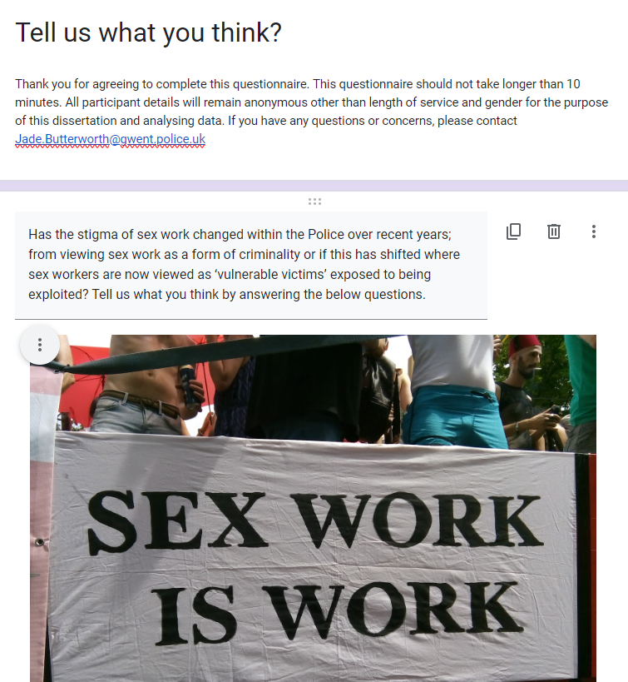
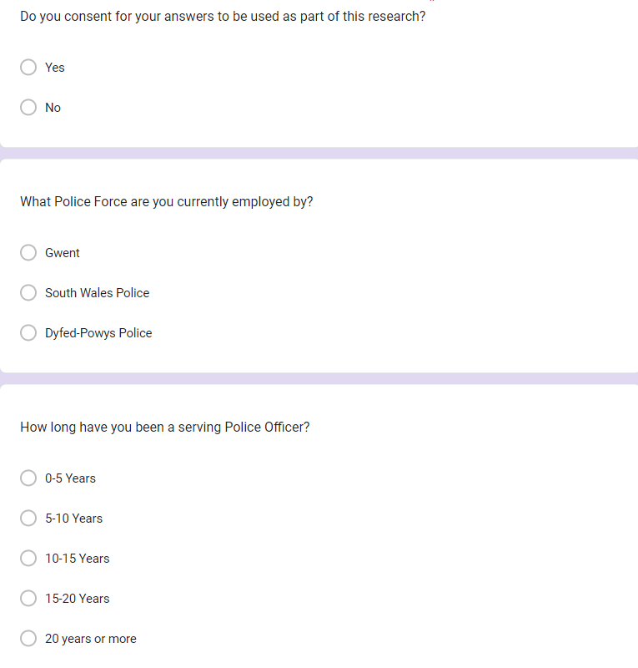


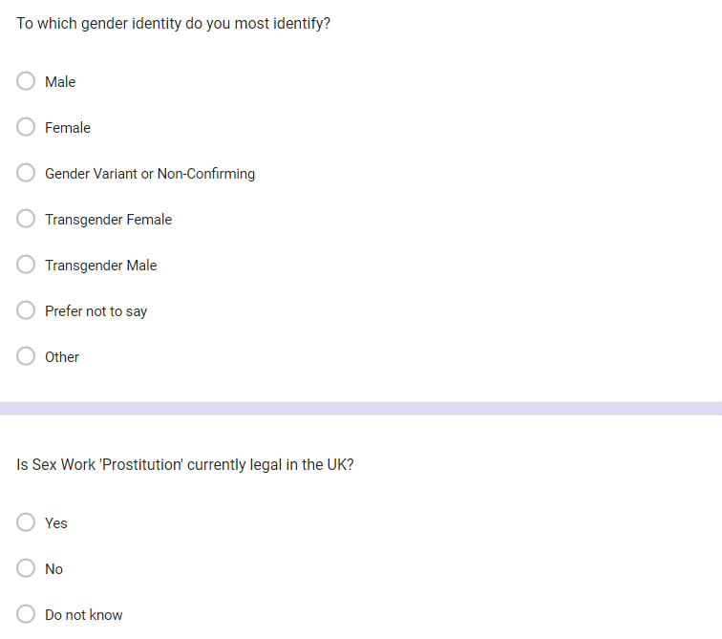

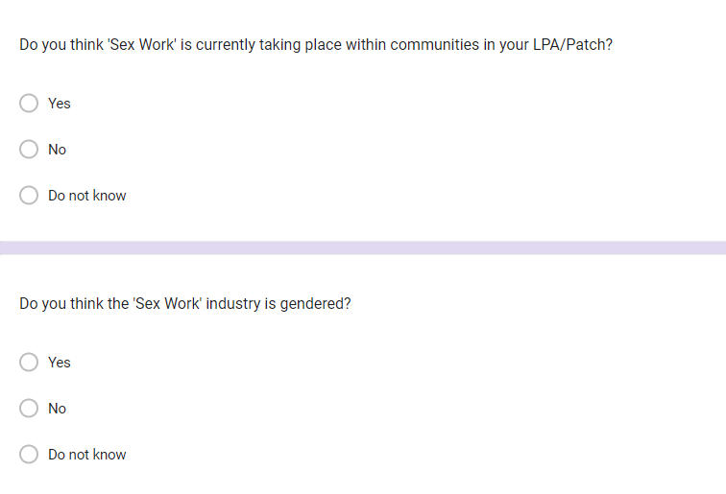

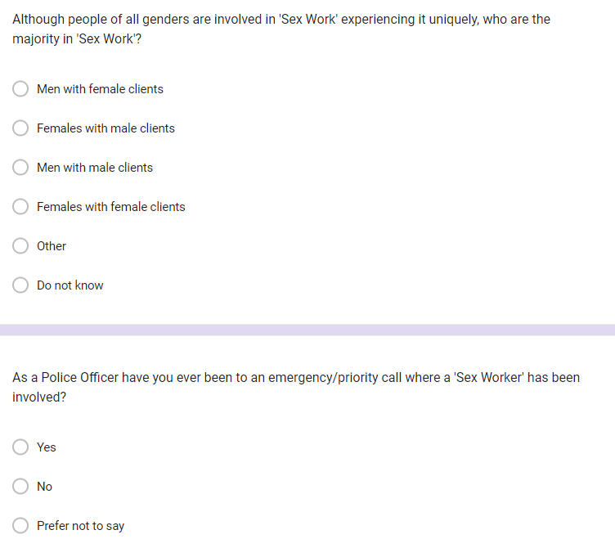

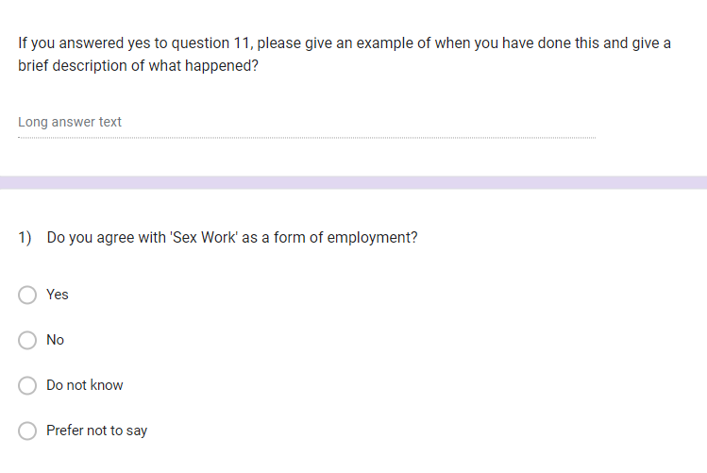

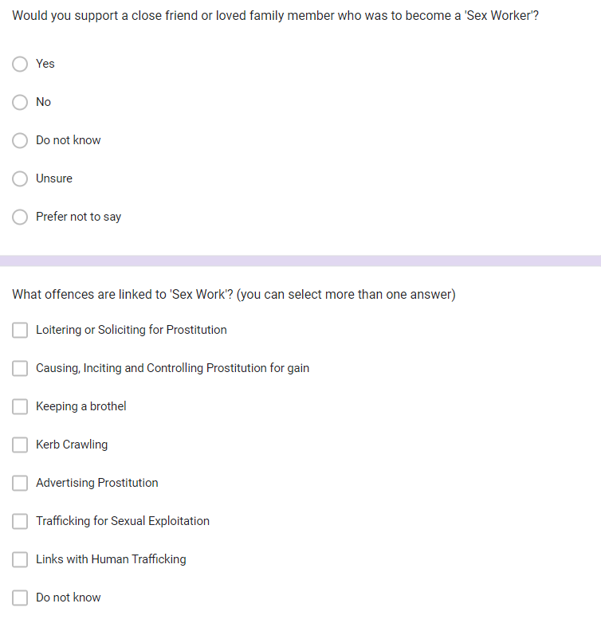

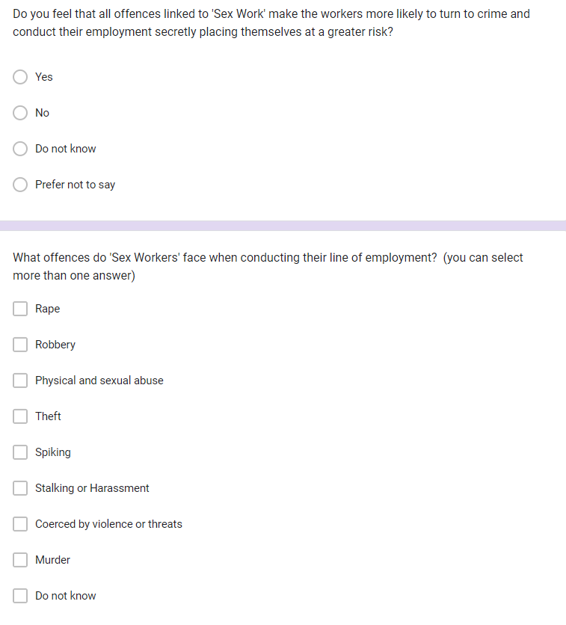
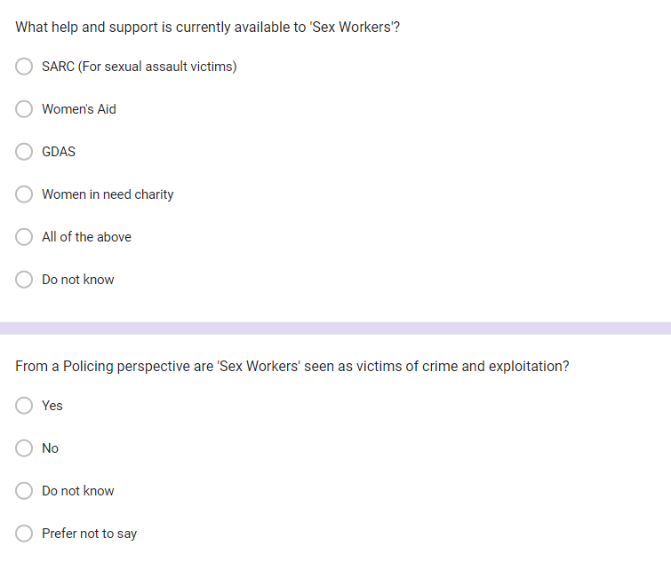
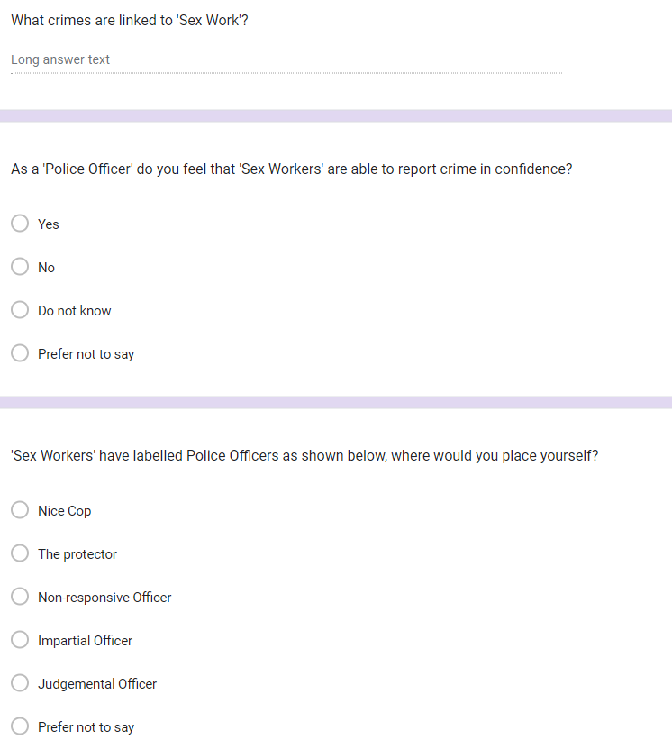
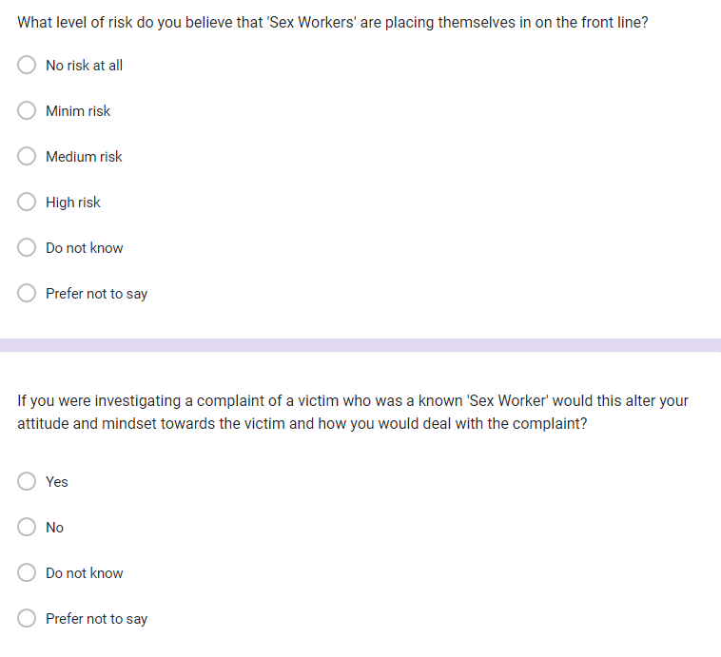
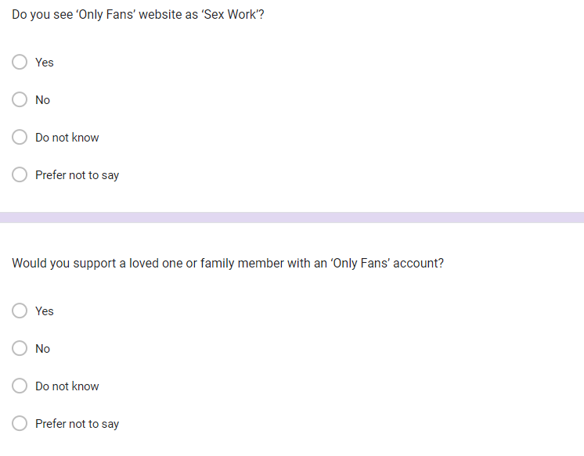
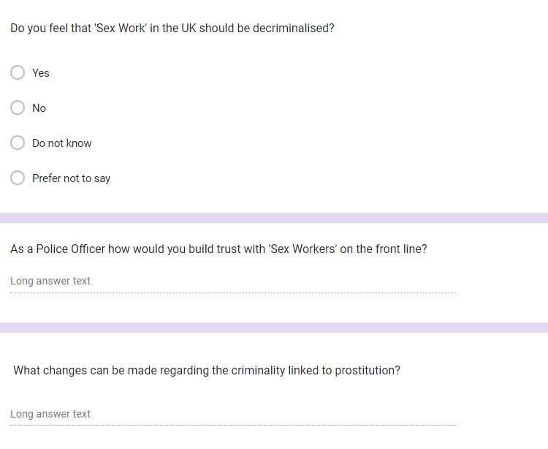

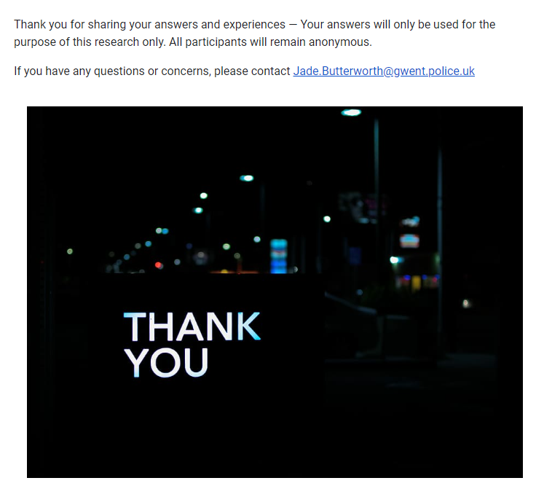

Appendix B – The questionnaire results in full - responses 1.xlsx
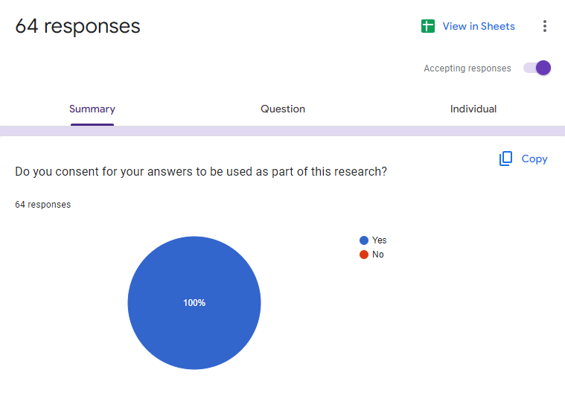

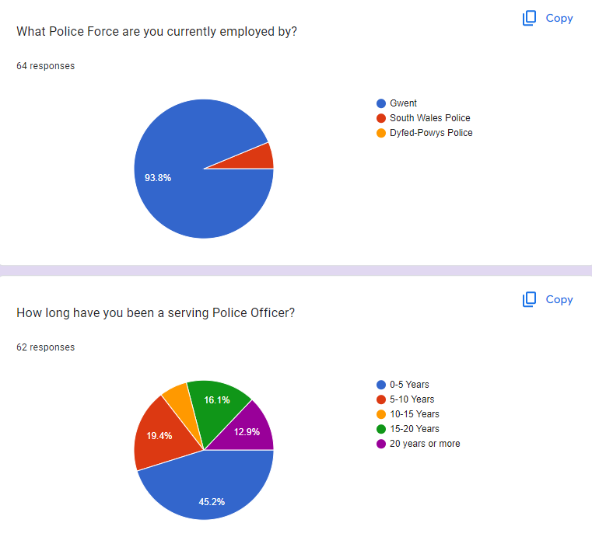

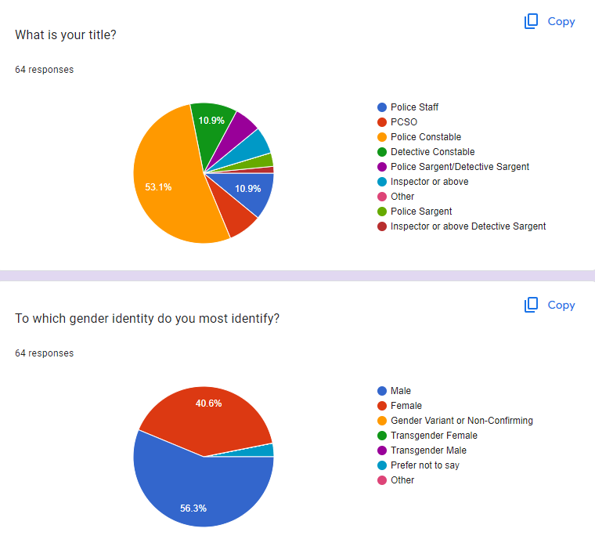
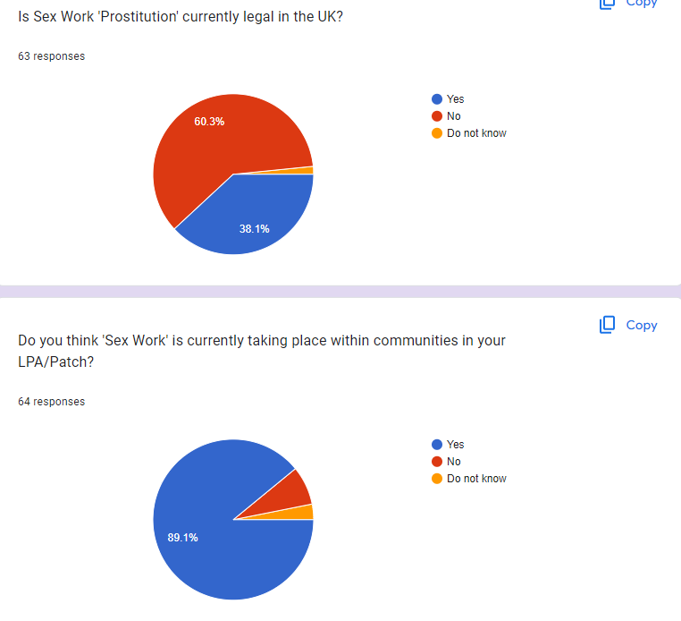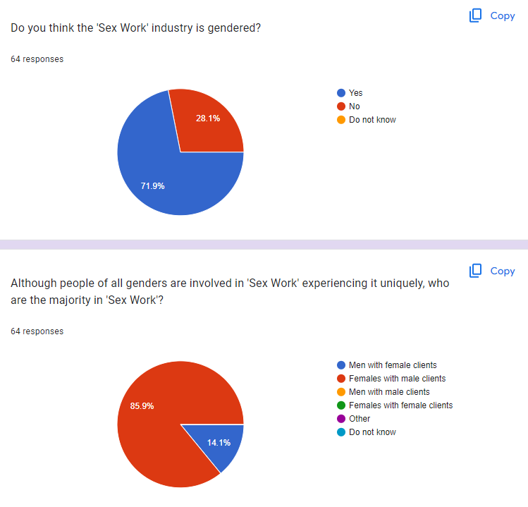

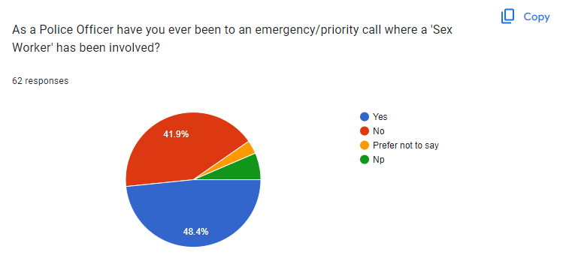
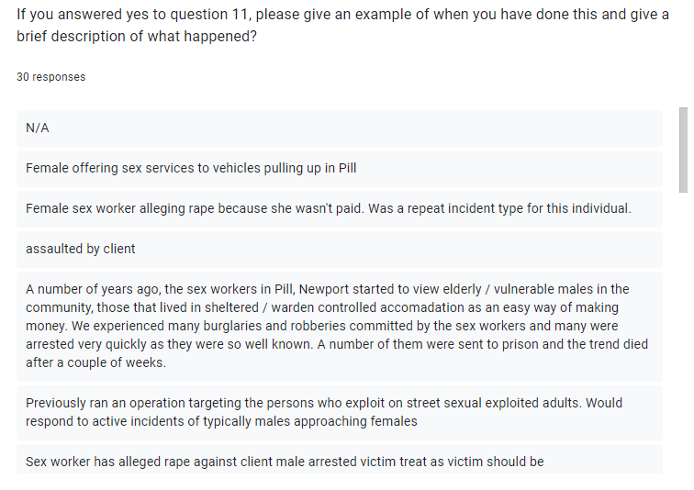
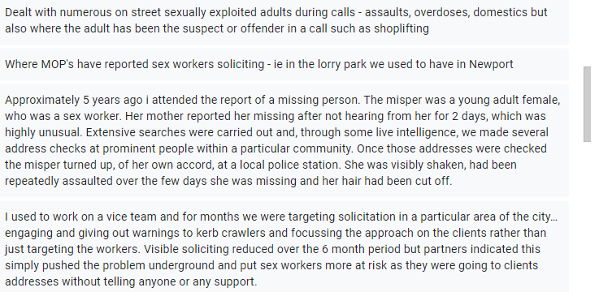

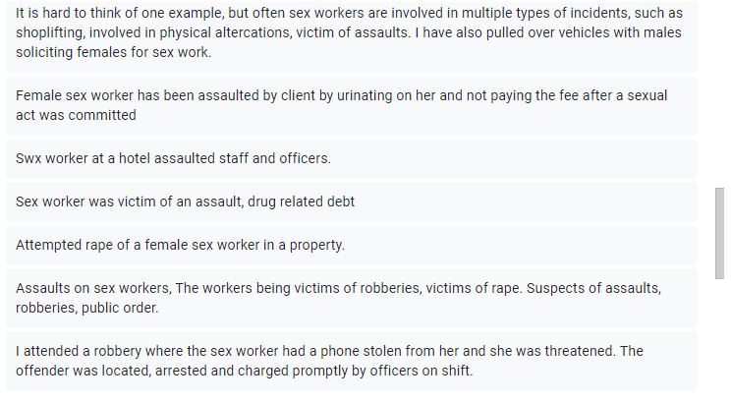
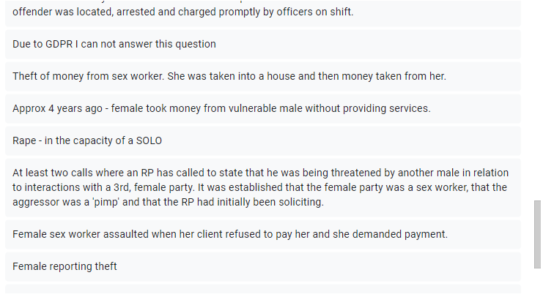
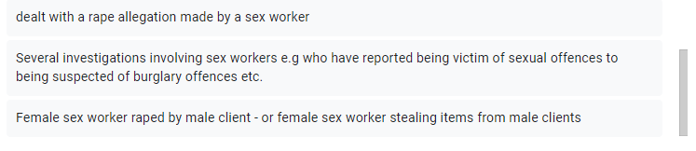

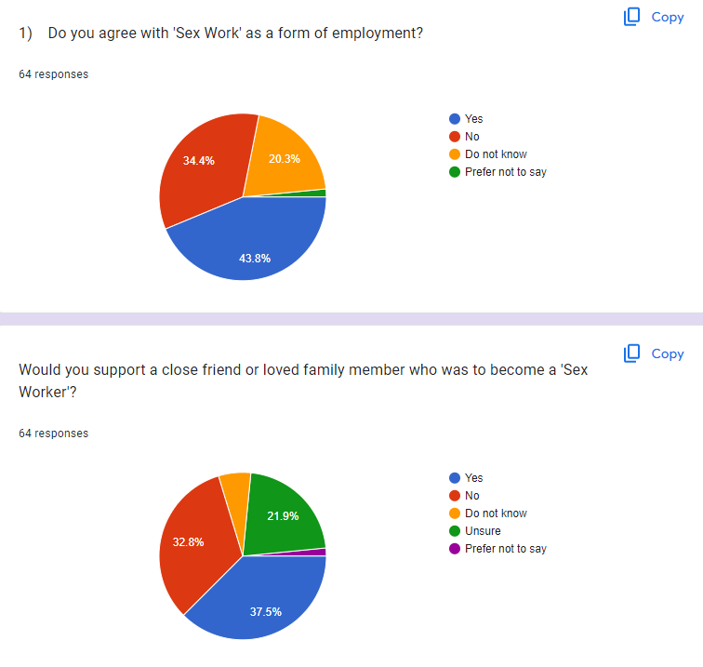
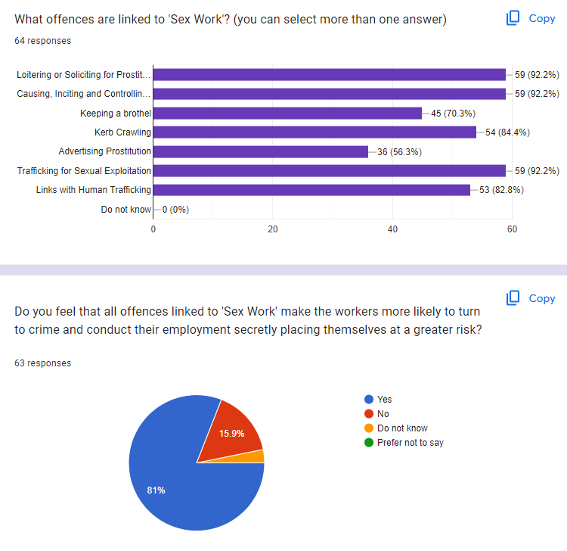
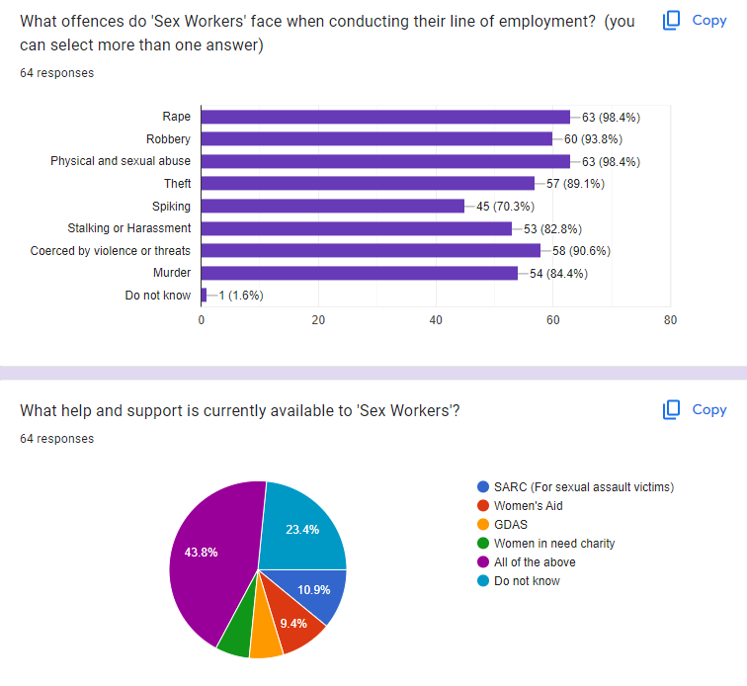
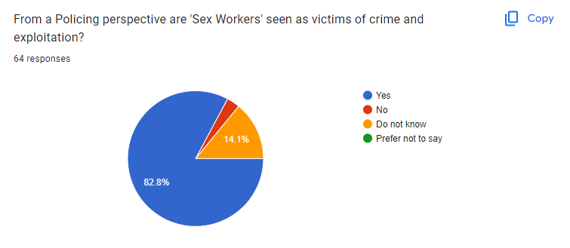
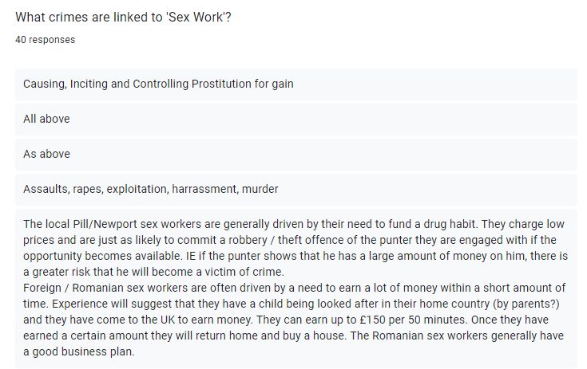
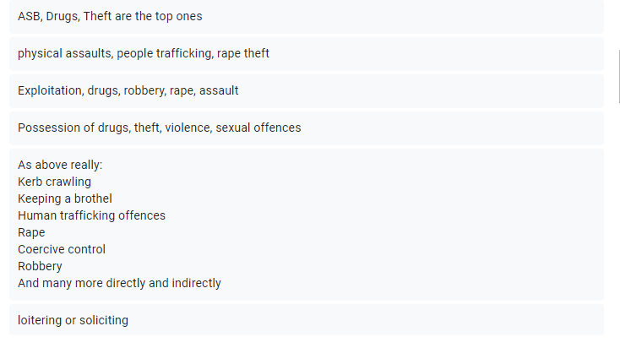
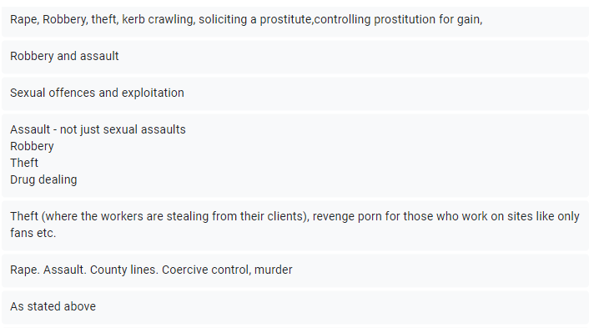
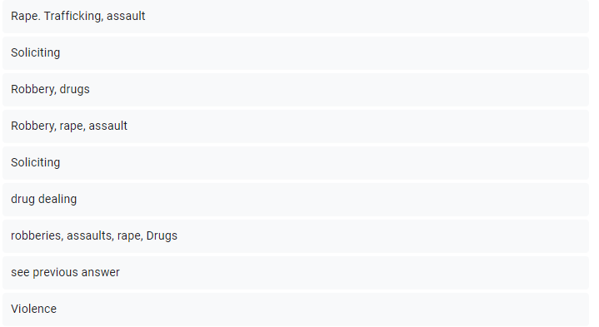
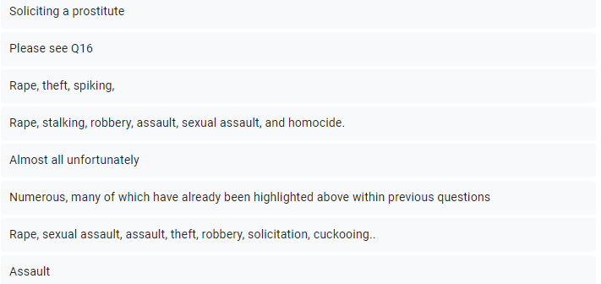
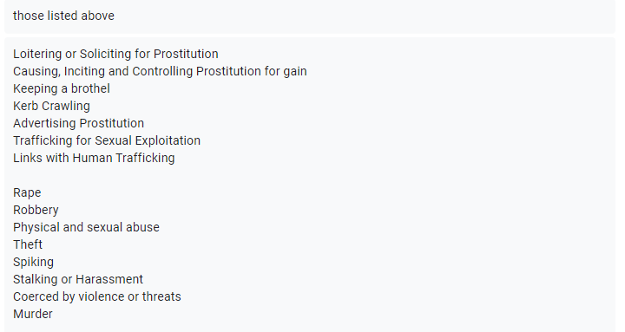
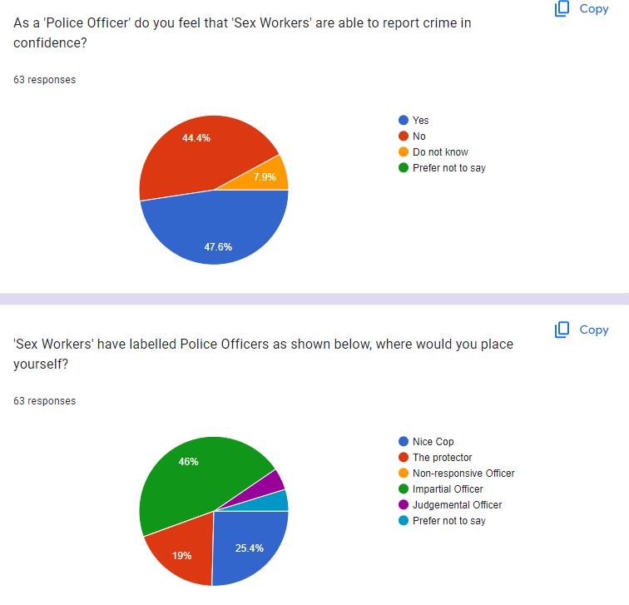
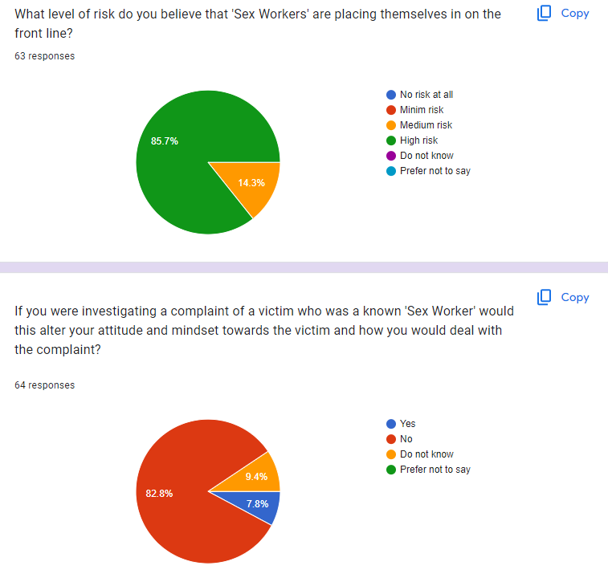

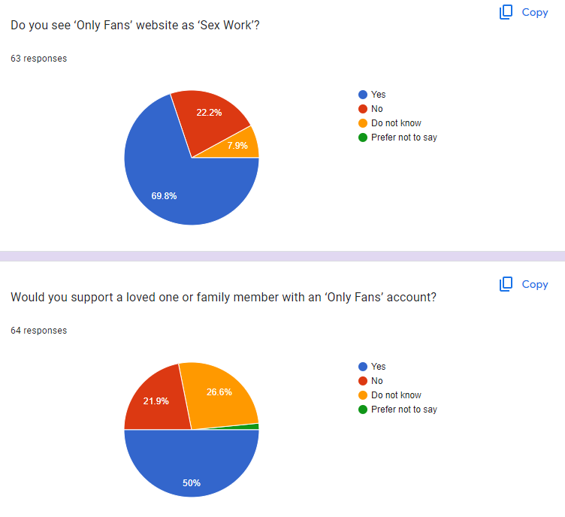
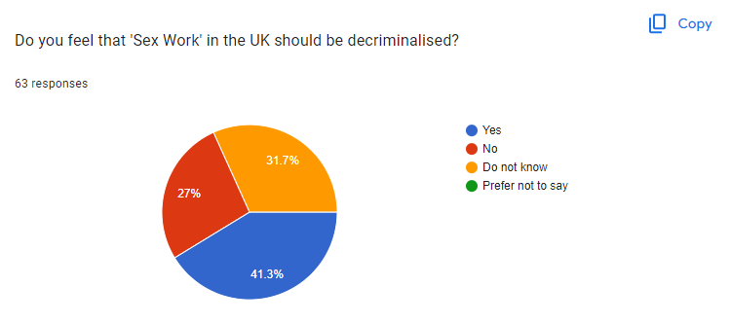
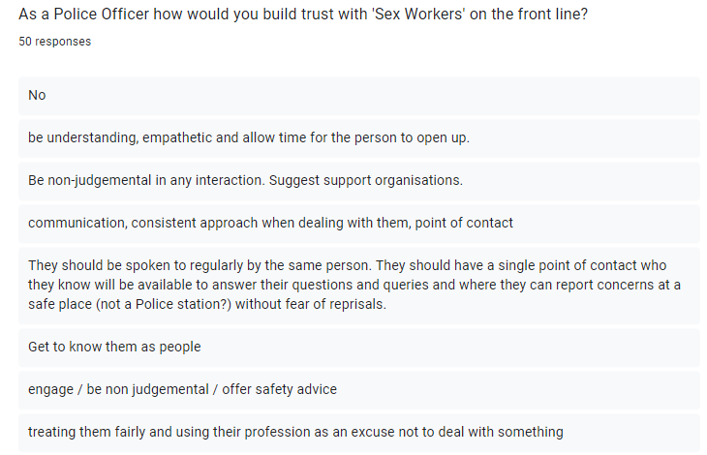
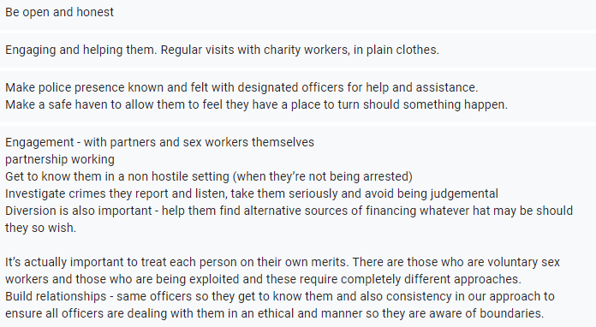
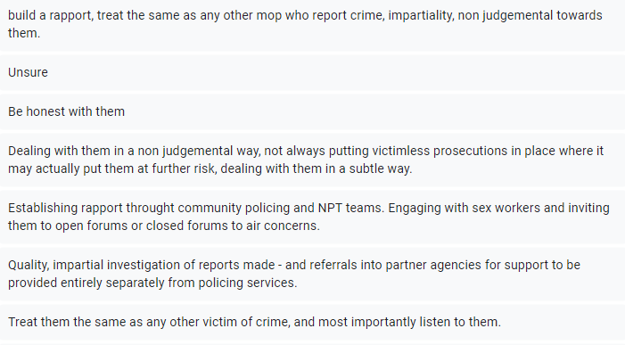
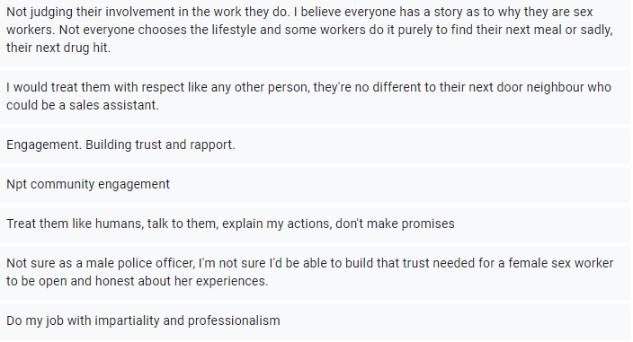
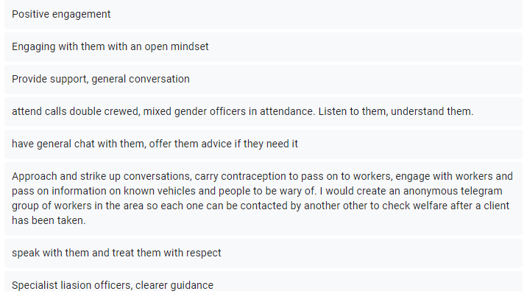
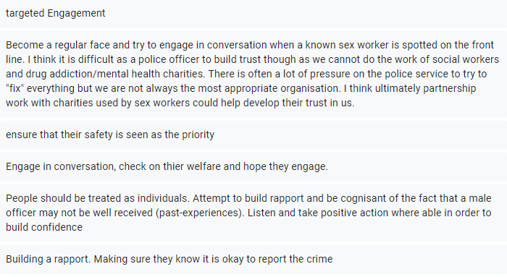
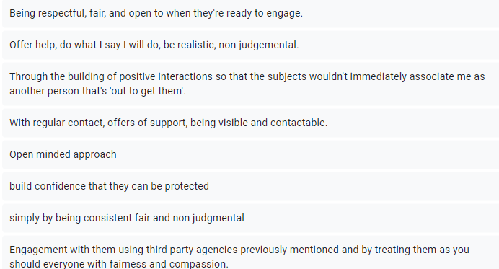
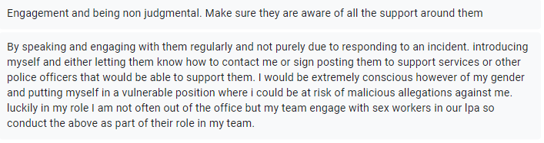

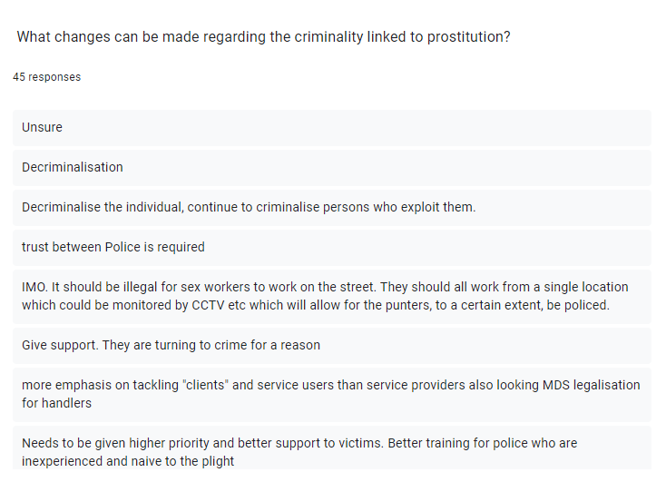
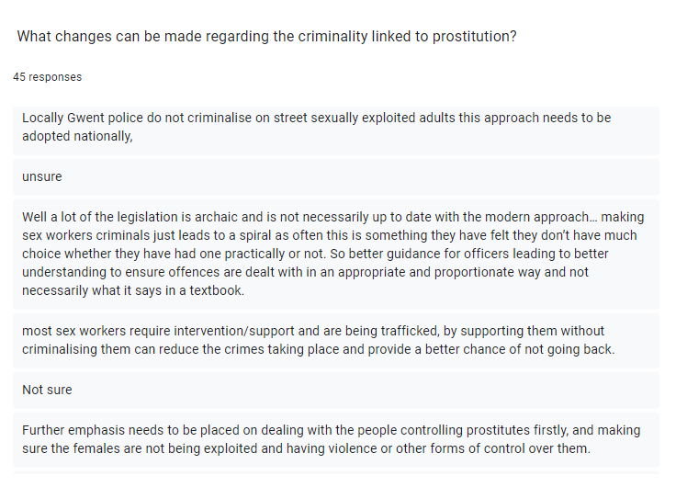
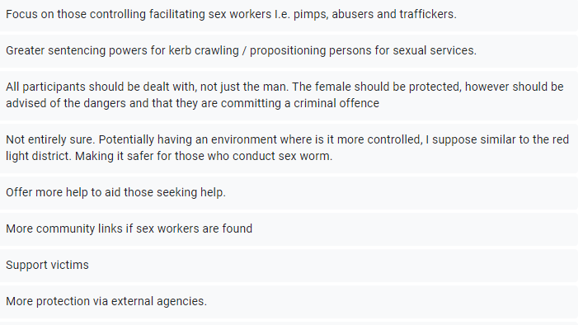
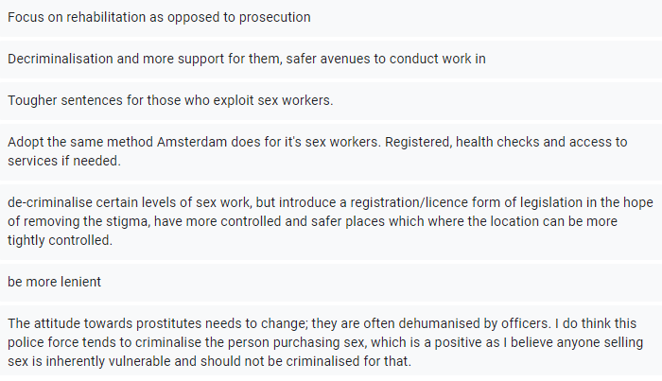
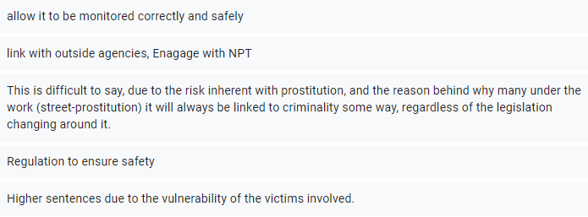
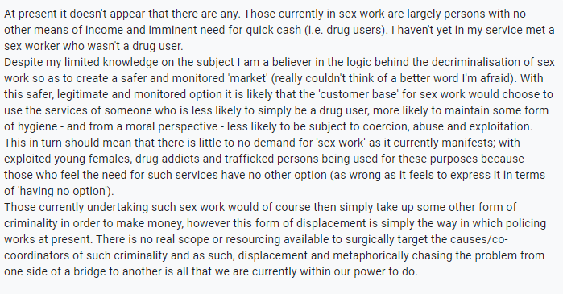
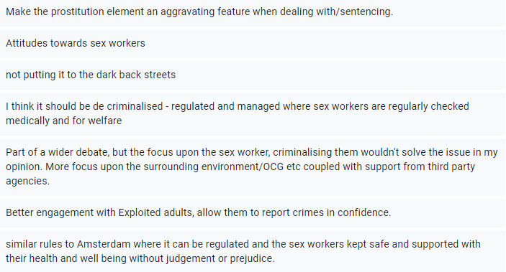

Appendix C – Data Coding

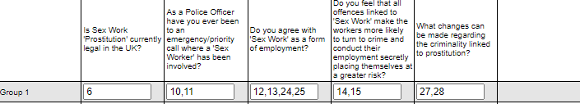

Appendix D – Further evidence and research
The researcher volunteered to be part of a large policing operation involving a dangerous organised crime group. The researcher’s role in this operation was to meet vulnerable ‘Sex Workers’ at the scene and transport them to a place of safety, where they were able to speak openly and honestly with members of the PPU – Public Protection Unit. The researcher was specifically asked to wear plain clothing to step away from a uniformed officer and was provided with an unmarked vehicle.

This operation was well organised and there was sufficient intel to suggest that sex workers were being exploited as part of the large organise crime group. In addition to this, there were also concerns of, firearms, drugs, and human trafficking. All crimes that have been previously discussed in this dissertation; supporting the dangers sex workers are associated with.

Once the warrant had been executed, the researcher was contacted to convey vulnerable sex workers from the scene and transport them to a nearby place of safety. The reason for a plain clothed operation was to ensure the women felt safe and not treated as suspects of crime. The plain clothing provided a softer approach and the use of an unmarked vehicle added to this evidence that Police are trying to do everything in their power to separate sex workers as victims of exploitation. The women were vulnerable and clearly unkept, underfed and appeared to be relived and thankful for being given a place of safety. The researcher was accompanied by a staff member from the PPU unit when conveying the sex workers to ensure they had a familiar face and a single point of contact providing them with a sense of security and comfort. Once the sex workers were conveyed to the place of safety police officers were not allowed past the entrance ensuring once again that the sex workers were kept separate from any kind of police action.

This approach supports the stigma has changed within the police from viewing the Sex worker as a suspect of crime and experienced first-hand that Police are now treated the sex workers a vulnerable victim of exploitation. Police are trying to build relationships with sex workers and have positive engagements with them and this is evidence by this policing operation. This needs to continue in future encounters with sex workers for this to progress and relationships to grow stronger between the police and sex workers.

The researcher had previously encountered one of the sex workers withing their daily response duties; however, when the sex worker recognised the individual as a plain clothed officer, she was more willing to engage and open to discussion. It could be argued that the regular police officer ‘bobbie on the beat’ may still find it difficult to build relationships with Sex works in comparison to a plain clothed officer. This is something that could be considered in the future to better engage with sex workers on the front line.

Appendix E - APPLICATION FOR ETHICAL APPROVAL

Ethics clearance Level 1 - 21/03/2023. (500 words)

APPLICATION FOR ETHICAL APPROVAL

In order for research to result in benefit and minimise risk of harm, it must be conducted ethically. A researcher may not be covered by the University’s insurance if ethical approval has not been obtained prior to commencement.

The University follows the OECD Frascati manual definition of research activity: “creative work undertaken on a systematic basis in order to increase the stock of knowledge, including knowledge of man, culture and society, and the use of this stock of knowledge to devise new applications”. As such this covers activities undertaken by members of staff, postgraduate research students, and both taught postgraduate and undergraduate students working on dissertations/projects.

The individual undertaking the research activity is known as the “principal researcher”.

Ethical approval is not required for routine audits, performance reviews, quality assurance studies, testing within normal educational requirements, and literary or artistic criticism.

Please read the notes for guidance before completing ALL sections of the form.

This form must be completed and approved prior to undertaking any research activity. Please see Checklist for details of process for different categories of application.

Delete the Guidance Notes at the end of the form BEFORE submitting your application

SECTION A: About You (Principal Researcher)
Full Name: |  | Jade Butterworth
Tick all boxes which apply: |  | Member of staff: | ☐ | Honorary research fellow: | ☐
Undergraduate Student | ☒ | Taught Postgraduate Student | ☐ | Postgraduate Research Student | ☐

Institute/Academic Discipline/Centre: | IMH
Campus: | Swansea
E-mail address: | 2024358@student.uwtsd.ac.uk
Contact Telephone Number:
For students:
Student Number: | 2024358
Programme of Study: | BSc (hons) professional Policing Practice
Director of Studies/Supervisor: | Stephanie Brown

SECTION B: Approval for Research Activity
Has the research activity received approval in principle?  (please check the Guidance Notes as to the appropriate approval process for different levels of research by different categories of individual) |  | YES | ☒ | NO | ☐
 |  |  |  | Date
If Yes, please indicate source of approval (and date where known): Approval in principle must be obtained from the relevant source prior to seeking ethical approval | Research Degrees Committee |  | ☐
 | Institute Research Committee |  | ☐
 | Other Jane Thomas |  | ☒

SECTION C: Internal and External Ethical Guidance Materials
Please list the core ethical guidance documents that have been referred to during the completion of this form (including any discipline-specific codes of research ethics, and also any specific ethical guidance relating to the proposed methodology). Please tick to confirm that your research proposal adheres to these codes and guidelines.
UWTSD Research Ethics & Integrity Code of Practice | ☒
UWTSD Research Data Management Policy | ☒
 | ☐

SECTION D: External Collaborative Research Activity
Does the research activity involve collaborators outside of the University? |  | YES | ☐ | NO | ☒
If Yes, please provide the name of the external organisation and name and contact details for the main contact person and confirmation this person has consented to their personal data being shared.as part of this collaboration.
Institution
Contact person name
Contact person e-mail address

Has this individual consented to sharing their details on this form? |  | YES | ☐ | NO |  |  | ☐
Are you in receipt of a KESS scholarship? |  | YES | ☐ | NO |  |  | ☐
Is your research externally funded |  | YES | ☐ | NO |  |  | ☐
Are you specifically employed to undertake this research in either a paid or voluntary capacity? | Voluntary | YES | ☐ | NO |  | ☐
 | Employed | YES | ☐ | NO |  | ☐
Is the research being undertaken within an existing UWTSD Athrofa Professional Learning Partnership (APLP) | If YES then the permission question below does not need to be answered. | YES | ☐ | NO |  |  | ☐
Permission to undertake the research has been provided by the partner organisation | (If YES attach copy)  If NO the application cannot continue | YES | ☐ | NO |  |  | ☐

Where research activity is carried out in collaboration with an external organisation
Does this organisation have its own ethics approval system? | YES | ☐ | NO | ☐
If Yes, please attach a copy of any final approval (or interim approval) from the organisation

SECTION E: Details of Research Activity
Indicative title:
Proposed start date: | 27/02/2023 | Proposed end date: | 09/10/2023
Introduction to the Research (maximum 300 words)
Ensure that you write for a Non-Specialist Audience when outlining your response to the three points below:
- Purpose of Research Activity
- Proposed Research Question
- Aims of Research Activity
- Objectives of Research Activity
Demonstrate, briefly, how Existing Research has informed the proposed activity and explain
- What the research activity will add to the body of knowledge
- How it addresses an area of importance.
Purpose of Research Activity

The purpose of the research activity is in order to review the current views of police constables on the exploitation of prostitution and if this has changed with legislation over the years. It will also review if the way in which police officers view the exploitation on prostitution and if this impacts the vulnerable sex workers confiding in the police and supporting prosecution. If prostitutes held trust in the police would this open doors into other criminal activity within the communities that are linked to prostitution.

(this box should expand as you type)
Research Question

Has the stigma of prostitution changed over the years from viewing the ‘sex worker’ as a form of criminality or if this has shifted were ‘sex worker’ is viewed as a vulnerable victim that is being exploited. What changes can be made in regard to the criminality linked to prostitution and what support can be implemented to safeguard the ‘sex workers?’

(this box should expand as you type)
Aims of Research Activity

The aims of research:

- To compare the views on the exploitation of prostitution and to review if this has changed over the years or does the stigma remain.
- What support is currently provided to prostitutes and how this can be improved
- How the police could improve on their trust with the sex workers enhancing their decisions to report criminal offences to police and providing positive statements. The way the police work with sex workers and the support they provide may help police support and safeguard them and enable police to detect links to other criminal activity.

(this box should expand as you type)
Objectives of Research Activity

- Review legislation and how this has changed over the years.
- Review case law and how this has impacted legislation over the years
- Review the background of how the ‘sex workers’ have chosen this as a career (adverse childhood experiences, mental health, homelessness, drug addiction, out of choice and freedom of their own bodies)
- Understand the support available for prostitutes on the front line both from a police aspect and support agencies.
- Understand the serious criminal offences linked to the exploitation of prostitution
- The importance of police building trust and relationships with the sex workers and how this will impact higher reports of crime and higher detection rates of serious criminal offences linked with the exploitation in prostitution.
- What operations and objectives the police currently have in order to build trust and support working girls on the front line and what can be improved or implements to strengthen this.
Proposed methods (maximum 600 words)
Provide a brief summary of all the methods that may be used in the research activity, making it clear what specific techniques may be used. If methods other than those listed in this section are deemed appropriate later, additional ethical approval for those methods will be needed.
- Questionnaires/Surveys issues electronically to officers in both GWP and SWP, officers of higher ranks and specialist units such as the public protection unit.
- Informal interviews – with staff members in support agencies to get a closer understanding behind the exploitation of prostitution without speaking to the vulnerable female sex workers directly.

(this box should expand as you type)

Location of research activity
Identify all locations where research activity will take place.
This research activity will mainly take place in the NEWPORT, WALES area. It will involve officers of different ranks and departments from Gwent Police and South Wales police to get a wide verity of research around this topic.

I will also be carrying out research within the NEWPORT area by contacting support groups around this topic.

(this box should expand as you type)
Research activity outside of the UK

If research activity will take place overseas, you are responsible for ensuring that local ethical considerations are complied with and that the relevant permissions are sought. Specify any local guidelines (e.g. from local professional associations/learned societies/universities) that exist and whether these involve any ethical stipulations beyond those usual in the UK (provide details of any licenses or permissions required). Also specify whether there are any specific ethical issues raised by the local context in which the research activity is taking place, for example, particular cultural and/or legal sensitivities or vulnerabilities of participants.
Although this topic has its importance in countries all around the world; this research activity will only be taking place inside of the UK.

(this box should expand as you type)
Use of documentation not in the public domain: Are any documents NOT publicly available? | NO | ☒
 | YES | ☐
If Yes, please provide details here of how you will gain access to specific documentation that is not in the public domain and that this is in accordance with prevailing data protection law of the country in question and England and Wales.

(this box should expand as you type)

SECTION F: Scope of Research Activity
Will the research activity include: | YES | NO
Use of a questionnaire or similar research instrument? | ☒ | ☐
Use of interviews? | ☒ | ☐
Use of diaries? | ☐ | ☒
Participant observation with their knowledge? | ☐ | ☐
Participant observation without their knowledge? | ☐ | ☐
Use of video or audio recording? | ☐ | ☐
Access to personal or confidential information without the participants’ specific consent? | ☐ | ☒
Administration of any questions, test stimuli, presentation that may be experienced as physically, mentally or emotionally harmful / offensive? | ☐ | ☒
Performance of any acts which may cause embarrassment or affect self-esteem? | ☐ | ☒
Investigation of participants involved in illegal activities? | ☐ | ☒
Use of procedures that involve deception? | ☐ | ☒
Administration of any substance, agent or placebo? | ☐ | ☒
Working with live vertebrate animals? | ☐ | ☒
Other primary data collection methods, please explain in this box  For example, ‘focus groups’. Please indicate the type of data collection method(s) in this box and tick the accompany box. | ☐ | ☐
Details of any other primary data collection method:

(this box should expand as you type)
If NO to every question, then the research activity is (ethically) low risk and may be exempt from some of the following sections (please refer to Guidance Notes).

If YES to any question, then no research activity should be undertaken until full ethical approval has been obtained.

SECTION G: Intended Participants
Who are the intended participants: | YES | NO
Students or staff at the University? | ☐ | ☒
Adults (over the age of 18 and competent to give consent)? | ☒ | ☐
Vulnerable adults? | ☐ | ☒
Children and Young People under the age of 18? (Consent from Parent, Carer or Guardian will be required) | ☐ | ☒
Prisoners? | ☐ | ☒
Young offenders? | ☐ | ☒
Those who could be considered to have a particularly dependent relationship with the investigator or a gatekeeper? | ☐ | ☒
People engaged in illegal activities? | ☐ | ☒
Others (please identify specifically any group who may be unable to give consent) please indicate here and tick the appropriate box. | ☐ | ☐
Other – please indicate here:

(this box should expand as you type)

Participant numbers and source
Provide an estimate of the expected number of participants. How will you identify participants and how will they be recruited?
How many participants are expected? | Approximately 100 individuals 50 males and 50 females – they will be recruited via an online questionnaire/survey sent through email.  Interviews will be conducted with individual officers from the Public Protection Unit to discuss how Police support the working girls on the front line and how this has changed. In addition to this they will be able to provide details on what operations are currently on going with in the police and what are we doing to help.  Interviews will also be attempted with workers from the support agencies on their first-hand experiences and to explain what current support is out there for the working girls and if this is sufficient or this an area that needs focus.
Who will the participants be? | Police Constables and officer of higher rank both in Gwent Police and South Wales Police.  Police staff in specialist units – Public Protection Units  Staff members at support Groups that offer support to working girls on the front line.
How will you identify the participants? | The online questionnaire/survey will be completed at random ensuring an equal split between male and female.

Information for participants: | YES | NO | N/A
Will you describe the main research procedures to participants in advance, so that they are informed about what to expect? | ☒ | ☐ | ☐
Will you tell participants that their participation is voluntary? | ☒ | ☐ | ☐
Will you obtain written consent for participation? | ☒ | ☐ | ☐
Will you explain to participants that refusal to participate in the research will not affect their treatment or education (if relevant)? | ☒ | ☐ | ☐
If the research is observational, will you ask participants for their consent to being observed? | ☒ | ☐ | ☐
Will you tell participants that they may withdraw from the research at any time and for any reason? | ☒ | ☐ | ☐
With questionnaires, will you give participants the option of omitting questions they do not want to answer? | ☒ | ☐ | ☐
Will you tell participants that their data will be treated with full confidentiality and that, if published, it will not be identifiable as theirs? | ☒ | ☐ | ☐
Will you debrief participants at the end of their participation, in a way appropriate to the type of research undertaken? | ☒ | ☐ | ☐
If NO to any of above questions, please give an explanation
(this box should expand as you type)

Information for participants: | YES | NO | N/A
Will participants be paid? | ☐ | ☒ | ☐
Is specialist electrical or other equipment to be used with participants? | ☐ | ☒ | ☐
Are there any financial or other interests to the investigator or University arising from this study? | ☐ | ☒ | ☐
Will the research activity involve deliberately misleading participants in any way, or the partial or full concealment of the specific study aims? | ☐ | ☒ | ☐
If YES to any question, please provide full details
(this box should expand as you type)

SECTION H: Anticipated Risks

Outline any anticipated risks that may adversely affect any of the participants, the researchers and/or the University, and the steps that will be taken to address them.

If you have completed a full risk assessment (for example as required by a laboratory, or external research collaborator) you may append that to this form.
Full risk assessment completed and appended? |  | Yes | ☐
 |  | No | ☒
Risks to participants
For example: emotional distress, financial disclosure, physical harm, transfer of personal data, sensitive organisational information
Risk to Participant:  This research will ensure that it adheres to all ethical aspects and that there is no risk to participants within this review.  Participants will not be asked person questions and vulnerable victims will not be spoken to. | How will you mitigate the Risk to Participant  - Ensure over 18 years of age.  - Identities will be kept anonymous such age name, dob, address and any contact information.  - Consent will be sought.  - Reassured that the information sought it solely for the purpose of the research and will not be used for any other reason.  - Reassured that the information will be destroyed once the review/research has been completed.  - That there is an equal 50/50 split between male and females  - That the research is open to all ranks with in the police force and therefore this will be kept confidential.
If research activity may include sensitive, embarrassing or upsetting topics (e.g. sexual activity, drug use) or issues likely to disclose information requiring further action (e.g. criminal activity), give details of the procedures to deal with these issues, including any support/advice (e.g. helpline numbers) to be offered to participants. Note that where applicable, consent procedures should make it clear that if something potentially or actually illegal is discovered in the course of a project, it may need to be disclosed to the proper authorities
This research will not be engaging with the vulnerable females directly and therefore this should not apply.

Risks to investigator
For example: personal safety, physical harm, emotional distress, risk of accusation of harm/impropriety, conflict of interest
Risk to Investigator:  No risk to the investigator | How will you mitigate the Risk to Investigator:
University/institutional risks
For example: adverse publicity, financial loss, data protection
Risk to University:  No risk to the University | How will you mitigate the Risk to University:

Disclosure and Barring Service
If the research activity involves children or vulnerable adults, a Disclosure and Barring Service (DBS) certificate must be obtained before any contact with such participants. | YES | NO | N/A
Does your research require you to hold a current DBS Certificate? | ☐ | ☒ | ☐

SECTION I: Feedback, Consent and Confidentiality
Feedback
What de-briefing and feedback will be provided to participants, how will this be done and when?
Feedback will be provided by a line manager who will discuss the feedback after submission.

Informed consent
Describe the arrangements to inform potential participants, before providing consent, of what is involved in participating. Describe the arrangements for participants to provide full consent before data collection begins. If gaining consent in this way is inappropriate, explain how consent will be obtained and recorded in accordance with prevailing data protection legislation.
Consent will be obtained via email/electronic means (along with the questionnaire/survey) to ensure participants approve of taking part ensuring that this is approved by the Ethic Committee.

I will ensure that all participants are provided with sufficient and detail information explaining what the research involves and why it’s being completed for them to make their own informed decision around taking part.

I will ensure the participants are fully informed on what is required from them and what is required from them before they decide to participate, and I will ensure there a written consent from before completion.

Confidentiality / Anonymity
Set out how anonymity of participants and confidentiality will be ensured in any outputs. If anonymity is not being offered, explain why this is the case.
I will ensure that all participants confidentially and anonymity is always kept, throughout this research.

I will ensure that privacy is kept on all documentation and password protected where no other person can gain access to the information. To ensure participants will not be required to provide personal sensitive information.

SECTION J: Data Protection and Storage
In completing this section refer to the University’s Research Data Management Policy and the extensive resources on the University’s Research Data Management web pages (http://uwtsd.ac.uk/library/research-data-management/).
Does the research activity involve personal data (as defined by the General Data Protection Regulation 2016 “GDPR” and the Data Protection Act 2018 “DPA”)? | YES | NO
“Personal data” means any information relating to an identified or identifiable natural person (‘data subject’). An identifiable natural person is one who can be identified, directly or indirectly, in particular by reference to an identifier such as a name, an identification number, location data, an online identifier or to one or more factors specific to the physical, physiological, genetic, mental, economic, cultural or social identity of that natural person. | ☐ | NO
If YES, provide a description of the data and explain why this data needs to be collected:
(this box should expand as you type)
Does it involve special category data (as defined by the GDPR)? | YES | NO
“Special category data” means sensitive personal data consisting of information as to the data subjects’ –  (a) racial or ethnic origin,  (b) political opinions,  (c ) religious beliefs or other beliefs of a similar nature,  (d) membership of a trade union (within the meaning of the Trade Union and Labour Relations (Consolidation) Act 1992),  (e) physical or mental health or condition,  (f) sexual life,  (g) genetics,  (h) biometric data (as used for ID purposes), | ☐ | No
If YES, provide a description of the special category data and explain why this data needs to be collected:
(this box should expand as you type)
Will the research activity involve storing personal data and/or special category data on one of the following: | YES | NO
Manual files (i.e. in paper form)? | ☐ | ☒
University computers? | ☐ | ☒
Private company computers? | ☒ | ☐
Home or other personal computers? | ☐ | ☒
Laptop computers/ CDs/ Portable disk-drives/ memory sticks? | ☒ | ☐
“Cloud” storage or websites? | ☐ | ☒
Other – specify: | ☐ | ☒
For all stored data, explain the measures in place to ensure the security of the data collected, data confidentiality, including details of password protection, encryption, anonymisation and pseudonymisation:
Information will be kept on my work laptop which is password protected. I will not be requesting personal details via the questionnaires/surveys and will ensure that this is anonymous.
All Data Storage
Will the research activity involve any of the following activities: | YES | NO
Electronic transfer of data in any form? | ☐ | ☒
Sharing of data with others at the University? | ☐ | ☒
Sharing of data with other organisations? | ☐ | ☒
Export of data outside the European Union or importing of data from outside the UK? | ☐ | ☒
Use of personal addresses, postcodes, faxes, emails or telephone numbers? | ☐ | ☒
Publication of data that might allow identification of individuals? | ☐ | ☒
Use of data management system? | ☐ | ☒
Data archiving? | ☐ | ☒
If YES to any question, please provide full details, explaining how this will be conducted in accordance with the GDPR and DPA (and/or any international equivalent):
List all who will have access to the data generated by the research activity:
Myself
List who will have control of, and act as custodian(s) for, data generated by the research activity:
Only myself
Give details of data storage arrangements, including security measures in place to protect the data, where data will be stored, how long for, and in what form. Will data be archived – if so how and if not why not.
All collated information will be kept secure in a password protected electronic file for the sole purpose of this dissertation. The information will be kept securely on my work laptop which is password protected and mobility secured. Once the dissertation has been completed and marked all information will be cleared and no longer stored.

Please indicate if your data will be stored in the UWTSD Research Data Repository (see https://researchdata.uwtsd.ac.uk/ ). If so please explain. (Most relevant to academic staff)
Data will not be stored in the UWTSD Research Data Repository.

Confirm that you have read the UWTSD guidance on data management (see https://www.uwtsd.ac.uk/library/research-data-management/) | YES | ☒
 | NO | ☐
Confirm that you are aware that you need to keep all data until after your research has completed or the end of your funding | YES | ☒
 | NO | ☐

SECTION K: Declaration
The information which I have provided is correct and complete to the best of my knowledge. I have attempted to identify any risks and issues related to the research activity and acknowledge my obligations and the rights of the participants.

In submitting this application I hereby confirm that I undertake to ensure that the above named research activity will meet the University’s Research Ethics and Integrity Code of Practice which is published on the website: https://www.uwtsd.ac.uk/research/research-ethics/
Signature of applicant: | Jade Butterworth | Date:  26/02/2023

For STUDENT Submissions:
Director of Studies/Supervisor: |  | Date:
Signature: |  | Date:

For STAFF Submissions:
Academic Director/ Assistant Dean: |  | Date:
Signature: |  | Date:

Checklist: Please complete the checklist below to ensure that you have completed the form according to the guidelines and attached any required documentation:
☒ | I have read the guidance notes supplied before completing the form.
☒ | I have completed ALL RELEVANT sections of the form in full.
☒ | I confirm that the research activity has received approval in principle
☒ | I have attached a copy of final/interim approval from external organisation (where appropriate)
☐ | I have attached a full risk assessment (and have NOT completed Section H of this form) (where appropriate) ONLY TICK IF YOU HAVE ATTACHED A FULL RISK ASSESSMENT
☒ | I understand that it is my responsibility to ensure that the above named research activity will meet the University’s Research Ethics and Integrity Code of Practice.
☒ | I understand that before commencing data collection all documents aimed at respondents (including information sheets, consent forms, questionnaires, interview schedules etc.) must be confirmed by the DoS/Supervisor, module tutor or Academic Director.
☒ | I have deleted the guidance notes before submitting the PG2 for consideration

RESEARCH STUDENTS AND STAFF ONLY
All communications relating to this application during its processing must be in writing and emailed to pgresearch@uwtsd.ac.uk , with the title ‘Ethical Approval’ followed by your name.
You will be informed of the outcome of your claim by email; therefore it is important that you check your University and personal email accounts regularly.

STUDENTS ON UNDERGRADUATE OR TAUGHT MASTERS PROGRAMMES should submit this form (and receive the outcome) via systems explained to you by the supervisor/module leader.

This form is available electronically from the Academic Office web pages: https://www.uwtsd.ac.uk/academic-office/appendices-and-forms/

Application Process

All staff research projects and all research students must submit the Ethical Approval Form to the University Research Ethics Committee via the Academic Office (pgresearch@uwtsd.ac.uk). Staff research directly in relation to personal study for taught undergraduate or Masters programmes should be submitted via the Institute procedures explained below.

Taught masters and taught undergraduate research Ethical Approval Forms are considered within Institutes. Institutes will provide details of the specific processes for this. Where the Ethical issues within any single ethical application are of particular concern the Institute will refer these to the University Research Ethics Committee. Any student activity that involves the collection of primary data needs to undergo Ethical approval, this includes assignment work as well as dissertations.

Appendix F – Research Proposal



UNDERGRADUATE DISSERTATION
RESEARCH PROPOSAL FORM

Please complete the following research proposal and submit it to Turnitin.
(1000 Words)

Which project option are you taking?

8,000 word project

 | NAME: Jade Butterworth | STUDENT ID No: 2024358
DRAFT RESEARCH TITLE QUESTION:

Has the stigma of sex work changed in the Police over the years from viewing sex work as a form of criminality or if this has shifted where sex workers are now viewed as a ‘vulnerable victim’ exposed to being exploited. What changes can be made regarding the criminality linked to prostitution and what support can be implemented to safeguard the sex workers at risk of being exploited?

INTRODUCTION:

Over the years the opinions and legislation around sex work has changed on the front line and this research is set to discover if the stigma remains around sex work being a crime or if the working females ‘prostitutes’ are now considered as vulnerable victims of exploitation in a much wider criminal culture.

I have chosen this topic as this impacts the front line and highlights several vulnerabilities and risks that prostitutes face daily. Prostitution also has many ties to other forms of criminality such as ‘human trafficking, immigration crime, violence, drug abuse and money laundering. Those targeted are usually hold an immigration status, economic situation, or other vulnerabilities (The Crown Prosecution Service, 2022). Other offences include forced drugs, sexual offences such as rape and sexual touching, physical violence, theft, domestic abuse and coercive and controlling behaviour.
There are many incidents in case law where prostitutes have been murdered for their involvement and links to gang violence and trafficking resulting in sex workers being brutally murdered for ‘knowing too much’ such as (Dutch Leah,1936). There has been previous incidents were the males involved such as ‘Pimps’ have also come into danger and have been murdered due to their involvement in this topic. This only supports how dangerous and how serious this topic is and why it’s such an important topic to review.
Sex workers are placing themselves at great risk every day on the front line and we must ask, ‘why is this?’. As stated by (Streetlight UK, 2022) sex workers are facing ‘homelessness, violence at home, runaways, sexual abuse, drug use, time in care, poverty debt and poor education.’ They also believe that the above vulnerabilities also create barriers for them to escape the sex work industry and it makes it very difficult for them to exit.’

Sex workers also suffer from mental health including anxiety and depression including being dependant on drugs as stated that they use as a coping mechanism to for fill their employment. (Streetlight UK, 2022) also support this and believe that sex work leads to ‘drug abuse along with dissociative disorders, anxiety disorders, sleeping disorders, depression, self-harm, eating disorders and obsessive-compulsive disorders.’ (Streetlight UK, 2022) have discovered that almost 76% of sex workers suffer with post-traumatic stress disorders and that 9 out of 10 sex works want to leave ‘prostitution’ totalling 90% of an estimated 105,000 individuals within the sex work industry and most of them being women’.

(Allen, 2021) has also discussed a study ‘Prostitution and Trafficking in Nine Countries’ where it was ‘found that 70-95% of the women had been physically assaulted, 60-75% were raped, and 89% told researchers that they urgently wanted to escape their situation’. (Allen,2021) also stated that even if the sex workers lived in was more accepting of sex work it was still a dangerous choice of profession where the chances of being exploited were extremely high.

A difficulty that the police face when dealing with prostitution is where the prostitutes are being sexually exploited and harmed and when police are involved its perceived that they don’t hold credibility, or they are too frightened to support prosecution. (Medlicott, 2021) a freelance journalist spoke directly to a sex worker from central London who stated that ‘Most sex workers are afraid to report crimes such as violence, pimping, robberies because they are fearful of being deported, ignored, fined or evicted’.

This raises concern that sex workers feel unable to contact or trust the police when as stated by (Medlicott, 2021) when ‘globally, between 45 and 75% of sex workers have suffered direct violence when conducting their employment and this ranges from harassment, robbery, physical assault, rape to the extent of murder’. To safeguard and protect vulnerable sex workers its important to build trust between them and the police in order to lower these statistics.

(Turek, 2022) wrote an article in The Big Issue where in 2016 a study including 240 ‘prostitutes’ in the UK where just under half of them were ‘unconfident’ to report any violence to the police as they felt they would not be taken seriously.

The (Crown Prosecution Service, 2022) state that there is clear evidence to suggest that offenders deliberately target those who sell sex as there is a stigma that they believe the females selling sex will not make a positive complaint or report any crimes to the police to investigate.

This topic is worth consideration for an undergraduate dissertation as it covers the vulnerabilities the sex workers face daily and how legalisation has changed to treat the females as victims rather than criminals.

This topic holds history as this has been an ongoing issue within communities for many years and although ‘it is still legal in England and Wales to exchange sexual services there are many areas within the legislation under (The Sexual Offences Act, 2003) linked to sex work that is now criminalised’ (City of London Police, 2023).

The (City of London Police, 2023) make it clear that offences such as ‘soliciting, paying for the services of a sex worker who's forced or threatened into it, owning, or managing a brothel, pimping, or advertising sexual services’ will be investigated and taken seriously and they aim to encourage sex worker to report any abuse or violence to the police.

(Crown Prosecution Service, 2022) also support that due to the new legislation under (The Sexual Offences Act, 2003) we no longer view the working girls as the subjects and instead, we attempt to bring those ‘soliciting’ and ‘loitering’ to justice. Police now focus on the persons ‘recruiting others into prostitution and their own gain or someone else’s’

For many years prostitutes were classed as the subjects of criminality and their vulnerabilities and the risk around prostitution were ignored. Over the years there has been a change of focus in order to focus on the offences linked to sex work and the support that’s available to sex workers to escape this dangerous choice of financial gain.

As per the (Crown Prosecution Service, 2022) it is in the public interest to ‘prosecute those who abuse harm and exploit rather than those who sell sex should not be routinely prosecuted offenders.

There is a large debate around this topic and in this research whereby the other argument is that the females are placing themselves at their own risk being fully aware of the dangers and that they are not valued members of the community due to their line of work and the worries of people’s opinions if the sex worker were a family member and how they would be viewed. This is discussed in (The Macmillan Report,1928) where it was the term ‘common prostitute’ is scrutinised.

I aim to understand both sides of the argument and gain an understand of how this topic is viewed in today’s police constabulary. I aim to understand what changes are being made and what support is being offered to help these women escape sex work or what support is being offered to keep them safe if sex work is of free choice.

SUMMARY OF RESEARCH OBJECTIVES:

The information

- This research is going to discuss and understand different arguments around sex work on the front line and where our policing focus lies. This research will determine if the stigma remains around sex worker being prosecuted and viewed as the subjects or if this has changed over the years where they are viewed as victims. This will be conducted with questionnaires and surveys to current serving police constables and high ranked officers.

- This research will be focusing on previous legislation and case law to the most recent legislation.

- By conducting questionnaires with current service police constables and high ranked officers it will show their knowledge of What support is available to the working girls to give them a path away from sex work and harm. Do officers feel there is sufficient help and support out there for working girls and are they aware of what they are?

- By completing questionnaires with servicing officers, it will establish their thought on what has led the working girls to the front line and this will also establish if they view the sex workers as victims or as subjects.

LITERATURE REVIEW:

The key literature I will be using as part of this research will be:

Journals & Articles:

- The British Journal of Criminology, Volume 47, Issue 5, September 2007, Pages 764–778 - Published: 13 June, (2007).

Policing the Sex Industry: Protection, Paternalism and Politics, edited by Teela Sanders, Mary Laing

Defending Prostitution: Charges Against Ericsson - Carole Pateman Ethics Volume 93, Number 3

Prostitution and Feminism: Towards a Politics of Feeling - By Maggie O'Neill , (2021).

The Response to Prostitution in the Progressive Era - By Mark Thomas Connelly, (1980).
- Common Women, Prostitution and Sexuality in Medieval England, By Ruth Mazo Karras, (1996).

Prostitution: Sex Work, Policy & Politics, Teela Sanders, ‎Maggie O′Neill, ‎Jane Pitcher, (2017).

Prostitution: Sex Work, Policy and Politics Teela Sanders, ‎Maggie O'Neill, ‎Jane Pitcher, ( 2009).
- Common Prostitutes and Ordinary Citizens, Commercial Sex in London, (1885-1960)

- From Law Enforcement to Protection? Interactions Between Sex Workers and Police in a Decriminalized Street-based Sex Industry (2016)

- Reports
      - The Wolfenden Report (1957)

- Case Law
- Legislation
- Government reports
- Online reading

I will be researching and reviewing:

- Section 1 (1) of the Street Offences Act 1959 amended under Section 16 of the Police and Crime Act, (2009).

- Section 1 (4) S1 – persistent on 2 or more occasions in any period of three months.

- Section 68 of the Serious Crime Act, (2015).

- The Sexual Offences Act, (1956).

- The Sexual Offences Act, (2003).

Although there is a large amount of research in relation to prostitution in England and Wales the discussion is still up for debate on how prostitution in viewed and this is still very much split down the middle. This research will look further into this and research how this can be improved and what further support could be considered to help the exploitation of prostitution.

(IPOS, 2023) completed research on prostitution where they created a survey back in 2008 on behalf of the Government Equalities Office. It was discovered that there were very mixed reviews where 49% out of the 1,012 adults felt that prostitutes are only working the front line as they are being exploited. 59% believed that women should be able to make their own choice when it comes to prostitution and that they should have the freedom to do this if that’s what they want to do. The remaining 27% disagreed. (IPOS, 2023)

The research will include reviewing (The Wolfenden Report,1957) to determine how prostitution was viewed previously in comparison to how it is now viewed today.

SUMMARY OF RESEARCH –SURVEY METHOD:

- This research will include research methods from online questionnaires and surveys to gather information around how the topic is viewed in today’s working environment and whether officers’ opinions have changed over the years or if the stigma around the topic remains. I will ensure this a 50/50 split between males and females to assess the results between sexes. In addition to this I will attempt to get a wide variety of the length of services officer have to determine if this has an impact on the results and if it differs in how much service officers have. In addition to this, I will attempt to compare the difference in age groups on their results to see if this impacts the statics.

- This research will also be using informal interviewing methods to gather further research from supporting agencies to get a deeper understanding of the topic without speaking directly to the vulnerable females.

- To get a wider understanding of this topic I will also be using online research along with journals and books to collate the current opinions and methodologies around this topic. I believe this will expose the current opinions and stigmas around this topic.

SUMMARY OF SAMPLING FRAMEWORK:

As part of my research, I intend on asking current serving police constables ranging from new in service to more experienced officers and those in higher rank positions by means of a questionnaire. I will be reaching out to both Gwent Police and South Wales Police as this is a topic that effects all forces especially in the city centres as this will provide wider verity. I believe this will be a positive way on gathering police constables working on the front line and to understand if the same stigma remains around prostitution on the front line or if this opinion has since changed.

I will also be seeking the perspectives of staff members working in the local supporting agencies on their views on the topic. I will do this through the means of an open survey to gage their experiences and deeper understanding of the individuals dealing with the vulnerable females on a one-to-one basis. I feel this would be the closest way to gain an understanding from the female’s perspective without speaking to them directly.

ETHICAL ISSUES:

To avoid any ethical issues during this research all persons involved will be made fully aware of what the research entails and that all persons are over the age of 18 years of age.

I will attempt to gather information from different age groups and person of the opposite sex, and I will ensure this is equal to compare the results ethically and fairly. However, I will make sure this is clear before the individual participate and ensure that they are happy to provide this information.

I will ensure that all personal and private information is not included and that the identities of the participants remain anonymous.

There had been considerations of speaking directly to the vulnerable females involved in this topic; however, due to the fact this would raise ethical issues and involve discussing sensitive and upsetting details, I have decided to discuss this with serving members of the police force along with supporting agencies who work alongside the vulnerable females.

To keep the research ethical, it will not include information directly from the source to protect their identity and this will ensure that they are not at risk due to their involvement.

TIME SCALE:

- 8th of May 2023 - Literature Review

- 19th of June 2023 - Methodology and Data Collection

- 7th of August 2023 - Data Analysis

- 11th of September 2023 - Findings and Conclusions

Research Proposal - REFERENCE LIST:
Goff, P. (2022) Prostitution and human trafficking: Know the difference, The Exodus Road. Available at: https://theexodusroad.com/prostitution-and-human-trafficking-know-the-difference/ (Accessed: April 10, 2023).
Medlicott, L. (2021) Sex workers must be allowed to report crime without fear of arrest, Left Foot Forward: Leading the UK's progressive debate. Available at: https://leftfootforward.org/2021/03/sex-workers-must-be-allowed-to-report-crime-without-fear-of-arrest/ (Accessed: April 10, 2023).
Prostitution and exploitation of prostitution, (2022). Prostitution and Exploitation of Prostitution |The Crown Prosecution Service. Available at: https://www.cps.gov.uk/legal-guidance/prostitution-and-exploitation-prostitution (Accessed: February 27, 2023).
Sexual Offences Act, (1956), Legislation.gov.uk. Statute Law Database. Available at: https://www.legislation.gov.uk/ukpga/Eliz2/4-5/69/contents (Accessed: February 27, 2023).
Serious Crime Act, (2015), Legislation.gov.uk. Statute Law Database. Available at: https://www.legislation.gov.uk/ukpga/2015/9/section/68 (Accessed: February 27, 2023).
City Of London Police, (2023). Sex worker safety. Available at: https://www.cityoflondon.police.uk/advice/advice-and-information/sw/sex-worker-safety/ (Accessed: April 10, 2023).
StreetlightUK, (2022), Prostitution - the facts. Available at: https://www.streetlight.uk.com/the-facts/ (Accessed: April 10, 2023).
Street Offences Act, (1959). Legislation.gov.uk. Statute Law Database. Available at: https://www.legislation.gov.uk/ukpga/Eliz2/7-8/57/section/1/2010-04-01 (Accessed: February 27, 2023).
Turek A, (2022). Sex workers reveal the shocking things police say when they report violence and harassment. The Big Issue. Available at: https://www.bigissue.com/news/social-justice/sex-workers-police-harassment-violence/ (Accessed: February 27, 2023).
History & Policy, (2023). Prostitution and the law in historical perspective: A dialogue, History & Policy. Available at: https://www.historyandpolicy.org/dialogues/discussions/prostitution-and-the-law-in-historical-perspective-a-dialogue (Accessed: February 27, 2023).
Pimps, police and filles de joie, (2023). Available at: https://www.tandfonline.com/doi/pdf/10.1179/174963207X172911 (Accessed: February 27, 2023).
Sanders, Laing & Feis-Bryce, (2018). Policing the sex industry, Google Books. Available at: https://books.google.co.uk/books?hl=en&lr=&id=lNZCDwAAQBAJ&oi=fnd&pg=PT27&dq=legistlation%2Bwhere%2Bprostitution%2Bis%2Bstill%2Bciminalised%2Buk&ots=RhjVEFoHhC&sig=hVRr-LKfcLPseEWlmMsiGdLDcFs#v=onepage&q=legistlation%20where%20prostitution%20is%20still%20ciminalised%20uk&f=false (Accessed: April 10, 2023).
Public's views on prostitution, (2023). IPOS. Available at: https://www.ipsos.com/en-uk/publics-views-prostitution (Accessed: February 27, 2023).
Taylor & Francis, (2008). Prostitution and trafficking in nine countries. Available at: https://www.tandfonline.com/doi/abs/10.1300/J189v02n03_03 (Accessed: April 10, 2023).
The Sexual offences act (2003). Legislation.gov.uk. Statute Law Database. Available at: https://www.legislation.gov.uk/ukpga/2003/42/contents (Accessed: April 10, 2023).
Case Law:
- (Dutch Leah,1936) female sex worker who was brutally murdered.
- (Kassel, 1936) Pimp that was shot and murdered.
- Soho murders
- The Sexual Offences Act, (2003)

