

Cover Page

Name: Aimnumhenfo Iyoha
Student Number: 2329981
Module Code: BMHP5015
Module Title: Changemakers: Building your Personal Brand for Sustainable Employment
Assignment Title: Component 1: Online Portfolio of Set Exercises

Task 1 – Personal Brand
Personal branding is described as how one promotes oneself to others through their values, skills and professional identity (Montoya and Vandehey, 2009). Personal branding enables the employer to understand what one can bring to the table and differentiate themselves from other job applicants (Montoya and Vandehey, 2009). Developing a robust personal brand is important for health and social care because employers look for compassionate, courageous, competent, communicative and committed employees willing to better people's lives (Department of Health and NHS Commissioning Board, 2012).
My personal brand is centered around compassion, competence and commitment to provide support to vulnerable individuals. I see myself as being approachable, patient and having good working relationships with different communities with respect, attributes that according to Jemal et al (2021) are important in a healthcare setting since patients often need to be supported emotionally, dignity and respect. Moreover, I have developed organisational and coping with pressure skills. However, there are aspects of my skills that need development. These are mainly leadership and communication skills and decision-making confidence. Acquiring such skills will make me a better manager in the care sector. Networking with professionals, participating in training and learning more will assist me in this process.
Inferentially, creating a personal brand will increase my employability and help me reach my target of being a care home manager. Professional identity is known to improve career options and allow one to contribute to health and social care services (Shepherd, 2005; Giles, 2024).

Task 2 - Network Map and Rationale
Figure 1: My Network Map
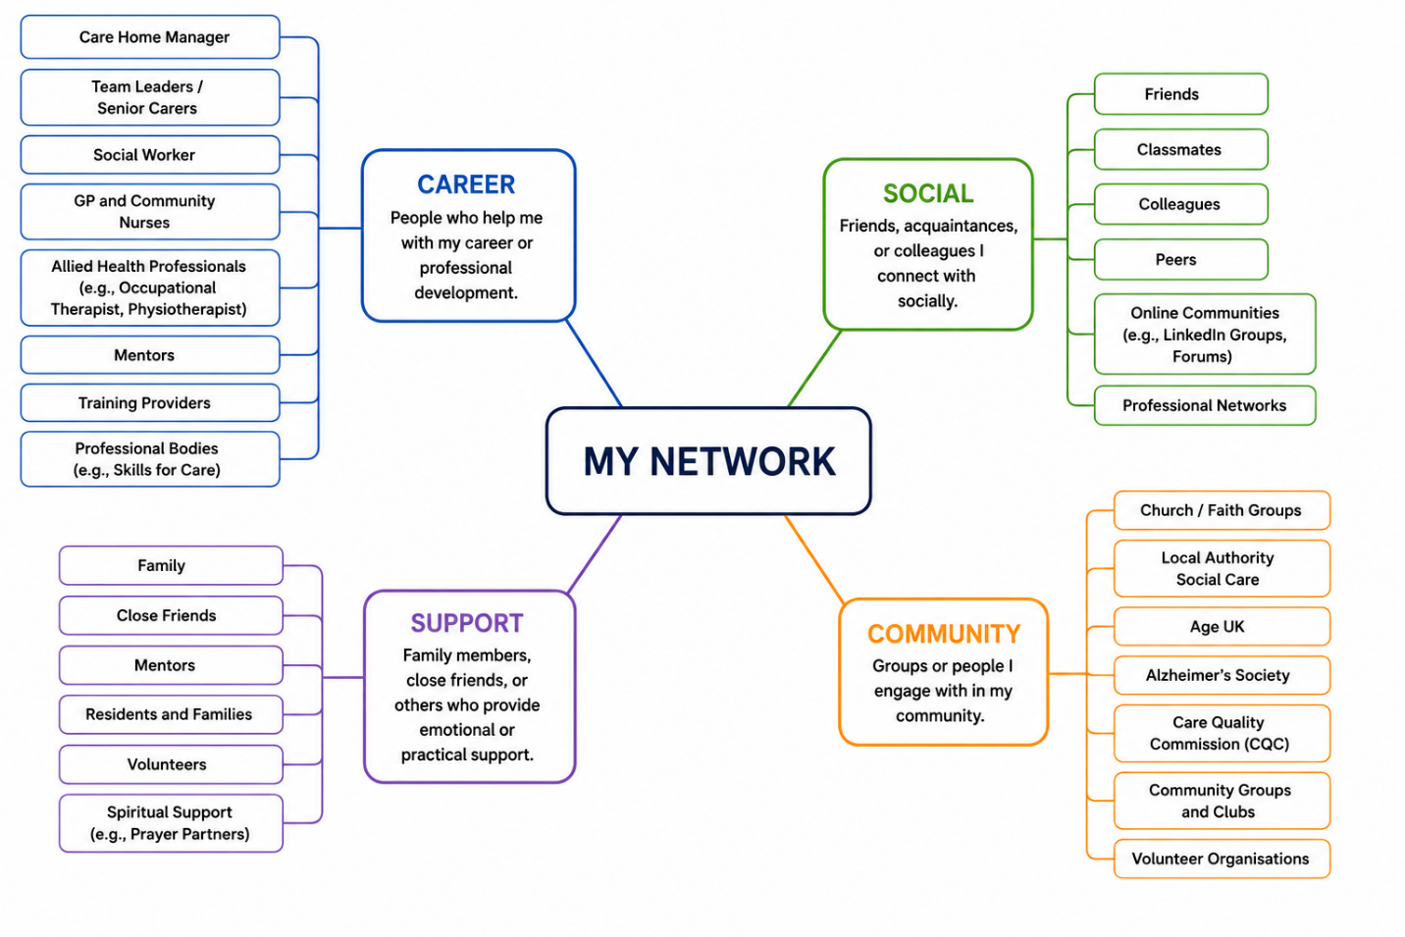
I believe that my network at the moment can be considered as a hybrid network because it involves both my personal and professional connections as shown in figure 1 above. Social networks according to Bonsignore (2011) are sources of resources, information and opportunities which allow personal and professional development of individuals. People from my network can offer me emotional, professional and educational support.
My support network is relatively strong, as it consists of my family members and close friends who motivate me, encourage and give me advice. These kinds of relationships are important for maintaining my resilience in hard times and improving my wellbeing. My social network involves my classmates and colleagues with whom I am able to establish connections on different levels. But my career network is underdeveloped and needs to be improved as I do not have relationships with senior managers, policy makers and leaders in the sphere of health and social care although I have some connections with lecturers, peers and healthcare professionals.
From the point of view of social capital, my bonding capital is quite high as I maintain connections with people who share the same background and experience with me. But I need to develop my bridging and linking capital more. In this case, the first type provides access to new knowledge and opportunities, while the latter connects people with influential people (Claridge, 2018). To improve my network, I plan to take part in professional conferences, volunteer work, use online platforms and establish closer connections with health and social care professionals. It will help me to realize my ambition of becoming a Care Home Manager.

Task 3- Blog
Improving Digital Care Planning in Care Homes: Why It Matters
Digital technology is becoming increasingly significant in health and social care settings (Kaihlanen et al., 2023). One of the digital innovations that have attracted increased interest lately is virtual reality (VR). VR is a technology that makes use of headsets to immerse people in various activities, environments, and situations (LaValle, 2023). In care homes, it could be used to enhance the quality of life of the older people, particularly those who live with dementia, loneliness and mobility problems.
Figure 2: Immersive Virtual Reality by a Care Home Resident
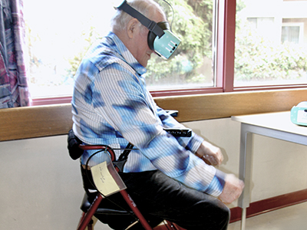
Source: (Vancouver Coastal Health Research Institute, 2023).
Most of the residents in care homes are socially isolated and have few opportunities to engage in meaningful activities. Many of them never leave the care home setting while others are characterized by poor memory and lack of interaction. Such a situation could have emotional implications which result in sadness, anxiety, and loneliness (Finnegan and Campbell, 2023). The use of VR in such circumstances would give an opportunity to these people to experience other environments or visit the places they remember. By wearing VR headset, a resident could walk along a beach, explore his/her old neighborhood and even tour a museum. The experience is not only fun but it stimulates the memory, encourages conversations, and creates a sense of happiness. According to Chaze et al. (2022), older people usually feel happier, calmer and more interested after participating in the VR activities. In addition, Navarro-Ramos et al. (2025) established that VR promotes cognitive functions and improves the memory, concentration and attention abilities of the elderly people, including those with dementia.
VR could be a way to promote social interactions since residents can engage in discussions about their experiences, tell stories and even undertake group activities. Such interactions would make them feel stronger and reduce the sense of loneliness (Metcalfe et al., 2025). Most of the VR programs incorporate physical activity which increases the physical fitness, enhances balance and general wellbeing of the residents (Trillo-Charlín et al., 2026). Moreover, personalized experiences through which residents can take part in the activities of their interests promote dignity and independence (Darley and Carroll, 2022).
Despite the cost and need for investment and training, the introduction of VR in care homes looks like a good idea. According to a study by Hepburn et al. (2025), the staff members are willing to accept digital technologies when supported accordingly. Hence, the use of VR technology goes beyond entertainment. It is an innovative solution that can enhance the wellbeing of the people living in the care homes.

Task 4- NHS Equality, Diversity and Inclusion Quiz (250 words equivalent)
- What is the primary goal of the NHS Equality, Diversity, and Inclusion Improvement Plan?
The main goal is to create a fair, inclusive and supportive workplace where all staff members are treated equally and have opportunities to succeed (NHS England, 2023).

- How does the NHS EDI Improvement Plan propose to tackle the gender pay gap?
The plan aims to improve transparency; monitor pay differences and ensure equal opportunities for career progression and promotion.

- What is meant by the term ‘intersectionality’ as used in the NHS EDI Improvement Plan?
Intersectionality means recognising that people can experience different forms of discrimination at the same time based on characteristics such as gender, race, disability or age.

- Why is it important for the NHS to create a psychologically safe work environment?
A psychologically safe environment encourages staff to express concerns, share ideas and report problems without fear of discrimination or punishment.

- How does the NHS EDI Improvement Plan suggest improving the experience of internationally recruited staff?
The NHS recommends better induction programmes, mentoring, training and support systems to help international staff adjust to the workplace.

- What role does leadership play in advancing EDI objectives according to the NHS Improvement Plan?
Leaders are expected to promote fairness, challenge discrimination and create an organisational culture that values diversity.

- Identify one way the NHS EDI Improvement Plan aims to reduce health inequalities within the workforce.
The plan promotes equal access to career development, education and wellbeing opportunities for all employees.
- Why does the NHS EDI Improvement Plan emphasise the importance of collecting and analysing data on protected characteristics?
Data collection helps organisations identify inequalities, monitor progress and develop targeted interventions

- Explain how flexible working policies can contribute to equality and inclusion in the NHS workforce.
Flexible working allows staff to balance personal responsibilities with employment, improving wellbeing and job satisfaction.

- What is one strategy mentioned in the NHS EDI Improvement Plan to combat bullying and harassment in the workplace?
The NHS encourages reporting mechanisms, leadership accountability and zero-tolerance policies to address bullying and harassment.

Task 5- A Letter to Yourself
Dear Younger Aimnumhenfo,

I understand that at this moment life seems tough to you. You struggle to handle all the obligations and uncertainties. At times you become overwhelmed and scared that everything will stay the same forever. What you do not know is that these struggles are what is making you strong. Emotional intelligence is one of the skills that will help you to understand your emotions and cope with stress more effectively. If you can take your time to read the Goleman’s (2020) publication on emotional intelligence which was originally published on 1995, you will learn how to be calm, how to communicate better and build positive relationships with other people.
You usually focus only on your weaknesses and forget about the strengths you already possess. Setbacks do not define who you are. According to Southwick and Charney (2018), everyone faces difficulties in life, but resilient individuals learn from those experiences and keep going. Also, I wish I told you much earlier that asking for help is not a sign of weakness. Discussing problems with relatives, friends and even teachers can give a lot of assistance when you face some difficulties. Mental health is very important, as well as academic and professional successes.
Dear Maureen, be kind to yourself, as growth takes time. Failures are chances to improve and develop. Gain self-confidence and appreciate small victories you achieve. If you keep on being hard-working, persistent and positive you will overcome many difficulties. The experience you find unpleasant now will turn into lessons you will be able to use in order to help and inspire other people later. Trust in yourself and the process, and always keep improving. Someday you will understand that resilience and emotional intelligence are your great qualities.

Best wishes,
Your Future Self.

Task 6- GANTT Chart (200 words equivalent)

My long-term employment goal is to become a Care Home Manager. In order to achieve this objective, I created a Gantt chart (see Figure 3) to indicate activities, time frames, dependency and milestones that will have to be accomplished for career development purposes. As shown in Figure 3 above, the initial step involves my studying at level 5 which began in September 2025 and should end in July 2026. After that, I want to study at level 6 from September 2026 till June 2027 as this will make me more qualified for the position of manager. Moreover, I will attend various care home workshops and other events from October 2025 till May 2027 in order to get better acquainted with the sphere and make my CV more appealing.
In addition, as seen in Figure 4 below, there are many activities in my career development plan which depend on the completion of previous tasks. For instance, my studying at level 6 depends on successful completion of my studying at level 5, whereas obtaining additional experience in care home management during January-June 2027 will help me develop leadership and managerial qualities. Next, I will update my professional CV in June-July 2027. Thereafter, I want to apply for the positions of Care Home Managers in July-September 2027 and prepare for interviews in September-October 2027.
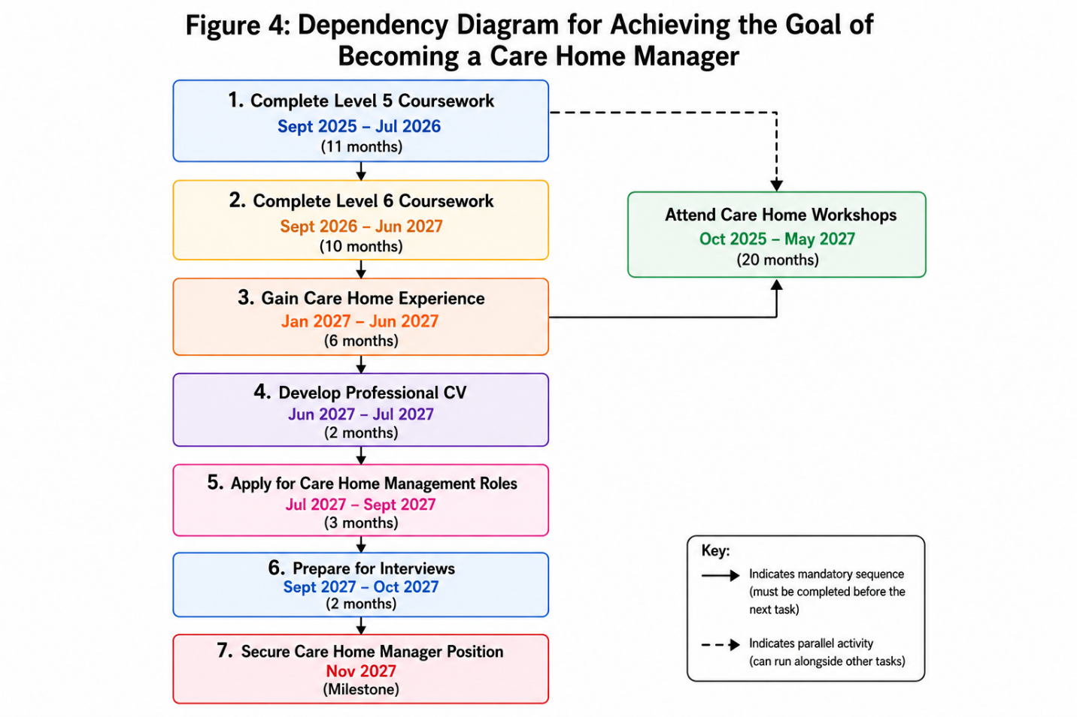

Finally, the last milestone in Figure 3 involves obtaining a position of Care Home Manager in November 2027. Dependency relationships depicted in Figure 4 clearly show that some activities depend on the accomplishment of the previous ones, whereas activities such as workshops may be conducted parallel to academic studying. Thus, the created Gantt chart and dependency diagram present a structured, realistic and attainable career development path.

Task 7- Making Changes- Report
Introducing Digital Care Planning in a Care Home
Introduction
As a future Care Home Manager, I would like to introduce an Immersive Virtual Reality (VR) Engagement Programme within a care home setting. The purpose of this initiative is to improve residents' emotional wellbeing, reduce loneliness and support cognitive stimulation, particularly for older adults living with dementia. Research shows that virtual reality can enhance mood, improve social interaction and increase engagement among care home residents (Chaze et al., 2022; Finnegan and Campbell, 2023).
Planning the Change
Lewin's Change Management Model provides a useful framework for implementing this programme (See figure 4 below). During the unfreezing stage, staff members would be informed about the benefits of VR through meetings, presentations and demonstrations. Evidence from research studies like Hepburn et al. (2025) would be shared to increase awareness and reduce uncertainty about adopting new technology. Furthermore, at the second stage, the changing (moving) stage, this would involve purchasing VR equipment, identifying suitable residents, developing safety guidelines and providing staff training. Residents would initially participate in short sessions to ensure comfort and confidence when using the technology. Activities could include virtual travel, reminiscence experiences, art programmes and light physical exercises. At the last stage, that is, the refreezing stage, focus would be on embedding the programme into everyday care routines. Participation records, resident feedback and staff observations would be used to evaluate the programme's effectiveness and encourage continuous improvement.
Figure 4: Proposed Change Model
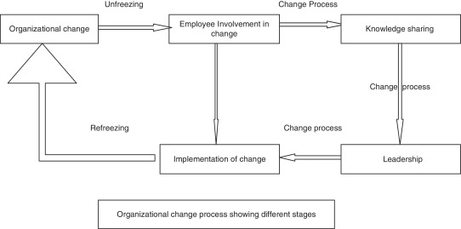
Adapted from: (Hussain et al., 2018).
Skills Required
Implementing this programme requires digital literacy skills to operate VR equipment, communication skills to engage residents, families and staff, and change management skills to support adoption. Training skills are also important to build staff confidence, while person-centred care skills ensure activities meet residents' individual preferences, needs and wellbeing goals.
Challenges and Solutions
One challenge may be staff resistance to technology. This can be addressed through training, practical demonstrations and ongoing support. Financial constraints may also limit implementation because VR equipment requires investment. Partnerships with charities, community organisations and technology providers may help reduce costs. Privacy and consent procedures must also be established to ensure compliance with data protection requirements.
Conclusion
VR represents an innovative approach to enhancing life within care homes. By improving wellbeing, encouraging social interaction and promoting meaningful experiences, a VR Engagement Programme can support person-centred care and contribute to better outcomes for older adults.

Reference List
Bonsignore, E., Hansen, D., Galyardt, A., Aleahmad, T. and Hargadon, S. (2011) The power of social networking for professional development. In Breakthrough teaching and learning: How educational and assistive technologies are driving innovation (pp. 25-52). New York, NY: Springer New York.
Chaze, F., Hayden, L., Azevedo, A., Kamath, A., Bucko, D., Kashlan, Y., Dube, M., De Paula, J., Jackson, A., Reyna, C. and Warren-Norton, K. (2022) Virtual reality and well-being in older adults: Results from a pilot implementation of virtual reality in long-term care. Journal of Rehabilitation and Assistive Technologies Engineering, 9, p.20556683211072384.
Claridge, T, (2018) Functions of social capital–bonding, bridging, linking. Social capital research, 20(1), pp.1-7.
Darley, A. and Carroll, Á. (2022) Conducting co-design with older people in a digital setting: methodological reflections and recommendations. International Journal of Integrated Care, 22(4), p.18.
Department of Health and NHS Commissioning Board (2012, December) Compassion in Practice. Department of Health and NHS Commissioning Board. Available at: https://www.england.nhs.uk/wp-content/uploads/2012/12/compassion-in-practice.pdf [accessed 1 July 2026].
Finnegan, D.J. and Campbell, S. (2023) Tackling loneliness and isolation in older adults with virtual reality: How do we move forward?. Gerontology and Geriatric Medicine, 9, p.23337214231186204.
Giles, N. (2024, February) Learning about professional identity for newly-qualified social workers. Skills for Care. Available at: https://www.skillsforcare.org.uk/news-and-events/blogs/learning-about-professional-identity-for-newly-qualified-social-workers [Accessed 1 July 2026].
Goleman, D. (2020) Emotional Intelligence: Why It Can Matter More Than IQ. London. Bloomsbury.
Hepburn, J., Williams, L. and McCann, L. (2025) Barriers to and facilitators of digital health technology adoption among older adults with chronic diseases: updated systematic review. JMIR aging, 8, p.e80000.
Jemal, K., Hailu, D., Mekonnen, M., Tesfa, B., Bekele, K. and Kinati, T. (2023) The importance of compassion and respectful care for the health workforce: a mixed-methods study. Journal of Public Health, 31(2), pp.167-178.
Kaihlanen, A.M., Laukka, E., Nadav, J., Närvänen, J., Saukkonen, P., Koivisto, J. and Heponiemi, T. (2023) The effects of digitalisation on health and social care work: a qualitative descriptive study of the perceptions of professionals and managers. BMC health services research, 23(1), p.714.
LaValle, S.M. (2023) Virtual reality. Cambridge university press.
Metcalfe, H., Robinson-Carter, E. and Joddrell, P. (2025) An Exploration of Exergaming for People Living with Dementia in Long-Term Care Settings: A Scoping Review. Home Health Care Management & Practice, p.10848223251359669.
Montoya, P. and Vandehey, T. (2009) The Brand Called You. New York: McGraw-Hill.
Navarro-Ramos, C.D., Murataya-Gutiérrez, J., Acosta-Quiroz, C.O., García-Flores, R. and Echeverría-Castro, S.B. (2025) Effects of cognitive training with virtual reality in older adults: A systematic review. Brain Sciences, 15(9), p.910.
Shepherd, I.D.H. (2005) From cattle and coke to Charlie: meeting the challenge of self-marketing and personal branding. Journal of Marketing Management, 21(5–6), pp. 589–606.
Southwick, S.M. and Charney, D.S. (2018) Resilience: The Science of Mastering Life's Greatest Challenges. 2nd edn. Cambridge: Cambridge University Press.
Trillo-Charlín, I., Bravo-Aparicio, J., Avendaño-Coy, J. and Beltrán-Alacreu, H., 2026. Impact of 4 Weeks or More Immersive Virtual Reality on Quality of Life and Physical Activity in Older Adults: Systematic Review and Meta-Analysis. JMIR aging, 9, p.e80820.
Vancouver Coastal Health Research Institute (2023) Reaching for the stars: Virtual reality program creates new experiences for seniors in long-term care. Vancouver Coastal Health Research Institute. Available at: https://www.vchri.ca/participate-research/2023/02/03/reaching-stars-virtual-reality-program-creates-new-experiences [Accessed 3 July 2026].

