Live Event Portfolio.
Elenid Marsh.
1800819.

Content.
-1: Description of the event

-2: Aims and Objectives.
-3: Market Research.
-3.1: Event marketing plan.
-4: Timing, location and event programme.
-5: Project planning techniques. Gantt charts
-6: Expected expenditure and income.
-7: Risk Management.
-8: Contingency plan.
-9: Evaluation.
-10: References.
-11: Appendix.
-11.1: Budget Plan.
-11.2: Gantt Chart
-11.3: Risk Assessment.
-11.4: WBS Tree Chart.

- Description of the event
Our task was to gather ourselves into groups and agree ideas for an event to plan and host.
Our group started generating a variety of different and unique ideas for events that we could host. Initially we concentrated on organising a different type of event and the first event we decided upon was an auction night. After spending some time on the initial planning, some members of the group realised that an auction night was not going to go as we planned and would be challenging and would not be suitable for our target audience aged 18-30’s that may not have disposable income to spend, we were also unsure if we could collect prizes within the timescales. As a result, we decided to change our event and to blend a re-make of ‘Bingo Lingo’ and a pub quiz. We named the event ‘Win or Booze’ Pub Quiz. This charitable event will include a pub quiz blended with music, dance (Bingo Lingo style), drinks and fun. We chose to hold a quiz to link in with the charity we are supporting which is tomorrow’s Generation. Tomorrow’s Generation is a charity that supports people with Dyslexia. It will also be ‘brain awareness week’ during the week of the event, and a pub quiz (and using our brains) links well with raising awareness. The event will be staged at the Hyst in Swansea High Street on the 18th of March, 2020, starting at 19:00pm. Even though our main target audience for this specific event is mostly students and the younger generation, the venue, The Hyst, also attracts an older generation which ensures that there will be a variety of people attending the event.
As part of our studies we must prove that we are capable of planning and hosting our own event and demonstrating our skills and abilities to create partnerships and applying our theories and research into our chosen charity into practice.
- Aim and objectives
We have planned this event, around three main aims which are: to hold a successful event for the public to enjoy, to demonstrate our organisational skills in developing a major event, and thirdly to raise awareness of the charity that we are supporting. To measure if we are achieving the first two aims, we must have an observer within our event who will monitor the audience’s response, sales and feedback. We will also supply surveys for us to receive feedback. To ensure success, we must plan carefully and thoroughly ensuring that we include even the smallest details of the event, including the time scales, consideration of what the public would want us to include as part of the event, and to keep everyone involved and up to date with all of the details. “The winning strategy is to make sure everyone involved with your event is on the same page.”[Killkenny. S. (2011)].
Our third aim is to raise awareness of a charity. The objective of this aim is to connect with a charity, and to promote its work. In our case we chose ‘Tomorrow’s Generation’ to join our event, a charity that is close and relevant to us all. To measure our achievement we must be sure that the public understand why we are raising awareness for this specific charity. To achieve this we will mention ‘Tomorrow’s Generation’ in all our marketing schemes, share its aims and objectives and share its story. We will achieve this through using the charity’s logo on our literature and on social media as well as ensuring a strong working partnership connecting with them and keeping them updated of our progress.

- Market research
We believed this specific event would appeal more to people aged 18 – 30, as a pub quiz appeals to the wider audience and does not narrow our target audience. We hope to welcome a maximum of 80 people to our event which is the venue’s capacity. We also have to consider risk management, by avoiding too much crowding and uncomfortable seating arrangements.
The Hyst is a pub situated in the High Street in Swansea. Our Win or Booze event is suitable for this venue because it is easy for students to access and attend. The pub is situated in a popular location and the venue itself is suitable for a pub quiz due to its size, capacity and the layout.
While researching for competitions, we firstly researched Pub quizzes in the Swansea area, and came across many quizzes. However, we decided this was not going to be an issue or a threat to our unique selling point because they were all themed quizzes, such as Star Wars. After clarifying this, we then researched events in the Swansea area on the 18th of March, 2020. Luckily only one event, which was a music event, was being held on the same date as our event. Again, this was not an issue for our unique selling point due to the fact that it is a totally different kind of event.
3.1 Event marketing plan.
There are so many different marketing methods available. While researching these methods, I came across some of the main processes we would be using. Sponsors and connections is one method we will be using which would involve working with our chosen charity, raising money and awareness of its work. Our second method will be the use of social media and traditional methods of marketing. We will be creating a Facebook page and Instagram stories, while also creating posters for the local meeting points such as the University canteen. As well as all of the above, we have relied on word of mouth, mainly through friends and family. Our marketing strategy will mainly focus on Social Media, such as an events page on Facebook, where all of the information such as the location, times/ dates and a small description of the event will be included. The reason behind leaning towards Social Media is because it is such a large network connecting millions of people, which proves it’s a tactical and effective method of marketing. “What Social media is all about, and especially applied to marketing, is the smart use of the natural conversational channels that develop between individuals. [Evans. D. Social Media Marketing 2nd ed. (2012)]. Communication of an event is so important in terms of marketing, as marketing determines how successful your event will be. “Event planners know and understand event marketing, but they must learn how to market themselves and their companies to gain the competitive edge in the event planning business.” [Allen. J (2004)].
The Event Marketing strategy is crucial. We used the screening process to have an understanding of the concept needed for our event. Firstly the Marketing Screen. We used this screen to decide on the target audience which is mainly aged 18-30s, the competing events being held nearby (the competition) and also the amount of tickets we are willing to sell. Our ticket strategy is to sell tickets before the event takes place and not on the door. This has proved to be challenging because people tend to rather pay at the door than beforehand.
Secondly the Operations Screen. This process identified the available locations and venues, who was going to work on the night, such as volunteers or were we going to handle it ourselves, what equipment we needed to bring ourselves compared to what equipment or technology was provided. The Operations screen also included the legalities. Would we need any licenses or insurances? Luckily we did not need any legalities.
Thirdly, the Financial Screen. This process concentrates on the event budget and the assess revenue and assess costs. Due to our event being non-budget, it could have made it harder to negotiate with companies, an example of this was negotiating the venue, however luckily The Hyst was very enthusiastic to join and cooperate. Also we had to take care of the assess cost due to our assess revenue, however, selling raffle tickets over a couple of weeks before the event, really helped.
- Timing, location and event programme.
When organising an event, it is important to ensure that the venue matches and supports your event concept. “Whether it’s a large conference, a small meeting or a glamorous gala dinner, the venue choice can really make or break an event”. [sundialgroup. (No date)]. In our scenario, the venue complemented the style of our event due to the layout and the ethos of a pub quiz. Even though it is suitable for our pub quiz event, we firstly visited the Bierkeller in Swansea as it has more of a student vibe and the layout of the tables were suitable for people to dance on and have fun. However, due to the lack of response from the Bierkeller we decided that The Hyst was a much better option. The best decision we made during the planning process was to view the venues instead of waiting for responses from the managers via email. This made it easier for us to finalise one venue quickly.
The event programme depends on different logistics. Firstly the on the day logistic. This includes the flow of people, important documents needed, communication and instructions. The flow of people on the night is down to the timing, which is to allow entry to a few people at a time to avoid overcrowding. This act connects to instructions, which is led by communication. The importance of ongoing clear communication is major in every kind of event. “Such as high level of communication and planning will take time and effort.” [Shone.A, Parry.B. pg 17. 2004].
For this event, we do not need many documents, but we do need risk assessments, an inventory lists, to be able to keep track of the ongoing processes on the actual night and also the contact information to keep track with the venue and the charity.
We are a small team and there will only be three of us planning and hosting the event on the night, it would be nearly impossible to have a success with this without some external suppliers. These include, bar staff at the venue itself, suppliers of the equipment needed, DJ’s if required and security staff at the door if needed to avoid any behaviour issues, especially with it involving alcohol.
- Project planning techniques. Gantt charts
There are many types of different project planning techniques to use to support your schedule behind planning an event, such as Gantt charts, diagrams and critical path analysis. These different techniques inside the project plan complement each other when they are used together, but it is not necessarily that they must be used together. “A project plan is the glue which will hold a project together and help to make it a success”. [Naybour. P. (2014)].
The techniques we decided to use was a Gantt chart, budget plan and a work breakdown structure chart. We decided on a Gantt chart because it shows our schedule clearly including what is needed to be done with a strict deadline. It is a comfortable structure to follow and to understand what needs to be achieved.
A budget plan is an important technique which always needs to be included in your planning process. It identifies your income and expenditures as well as your total profit at the end. This helps with knowing exactly what you have as a budget. And lastly, the work breakdown structure chart. This project planning technique displays a breakdown of all members of the groups’ tasks and what will lead from completing that specific task within an identified timescale.

- Expected expenditure and income.
As this is a non-budget event, we have had to take care with our expenditure, as it is more challenging. “It requires patience, persistence and amazing negotiation skills, but it can be done with little to no cash”. [Meyer – Delius.H. (No date)] Luckily, as this is a charitable event in partnership with a recognised charity, many venues agreed on hosting the event for free. As we do not have an allocated budget towards setting up the event we will hold a raffle which will allow us to raise funds towards our start-up costs. The charity are also helping us by donating the main raffle prizes in kind as all the proceeds from our event will be donated to them. As a result, Tomorrow’s Generation are happy to help in any way possible, which we greatly appreciate.

- Risk management plan / health and safety.
A risk assessment is one of the most important elements of an event. Without identifying and assessing risks it is not possible to host a safe and secure event. “Risk management planning is increasingly being demanded by event stakeholders such as the government and their insurance companies. Failure to do so is considered a breach or ‘duty of care’” [Moylan-Wynn. P. (2018)].
One of the main risks in a social event include, consumption of too much alcohol. Consuming too much alcohol can cause bad behaviour which could lead to fighting. The risk would be managed by producing ID at the bar, and ensuring that there is adequate security and First Aid staff present.
Injury is another high risk in public events. Slippery floors lead to serious injuries. To avoid these accidents there must be a wet floor sign placed at the area and ensure that floors are clean and dried as soon as possible. As well as slippery floors, care must be taken all night especially in areas where there are stairs. This risk is managed through adequate signage, lighting, stewards and staff. Thirdly, crowding. It is impossible to completely avoid crowding. Crowding happens at every single event, big or small. To avoid overcrowding, the door staff must allow a numbered amount of people entry to the venue to manage crowds at the bar and ensure that people are seated ready for the enjoyment. Last but not least, Fire safety is paramount. At every venue there are fire alarms spread throughout the building. But also there must be checks of fire equipment, such as fire extinguishers or fire blankets. We will ensure that we are aware of each fire escape and the evacuation processes before we open the doors in order to avoid any high risk hazards.
- Contingency plan.
With every type of event, it is crucial to apply a contingency plan. “Contingency planning is about thinking of everything that could go wrong, and then developing a planned response just in case it actually happens”. [Seese. M (2010)]
The meaning of a contingency plan is to have a second idea in place in case the main event has complications and therefore struggles to go ahead. Examples of complications could be, the weather for an outdoor event, the caterers not turning up to an event or even the equipment no longer working. Therefore the importance of a backup plan is important.
The main complications we had with our event was our marketing strategy and raising the profile of our event. Due to this we had to change and widen our marketing strategy by uploading our advertisement to different networking channels, instead of focussing on one which was Facebook.

- Evaluation strategy.
Evaluating any event is essential in order to reflect on the whole process and to understand the strengths of the event and also the weaknesses in order to improve next time.
We will monitor our progress against our SMART objectives and targets that we set out in our Gantt chart. We will monitor two elements of our event which are how successful was the event and how well did we work as a team to reach our targets in a timely manner.
We will evaluate how successful the event was by the use of customer satisfaction forms, these will be completed on the night by our audience. We will ask for feedback about the contents of the quiz, how well it was organised, any comments or any suggestions for improvement. We will also evaluate our work as a team through holding a team meeting to analyse our weaknesses and strengths as event organisers. One element, for example, that we know is a weakness is the way in which we sold tickets and the response. We will evaluate the process and identify how we can improve this next time. “The success or failure of any event is naturally aligned to the initial objective set.” [Wale. D, Robinson. P, et al. (2010)].

- References.
Allen. J. Available at Marketing Your Event Planning Business. Accessed on the 6th of March.
Evans. D Available at Social Media Marketing Second edition. Accessed on the 13th of March.
Killkenny. S. Available at The Complete Guide to Successful Event Planning. Accessed on the 6th of March.
Meyer – Delius.H. Available at https://blog.printsome.com/zero-budget-event/. Accessed on the 16th of March.
Moylan-Wynn. P. Available at Risk and Hazard Management for Festivals and Events. Accessed on the 13th of March.
Naybour. P. Available at https://www.parallelprojecttraining.com/ Accessed on the 13th of March.
Seese. M. Available at Scrappy Business Contingency Planning: How to Bullet-Proof Your Business. Accessed on the 11th of March.
Shone. A, Parry. B. Available at Successful event management. Accessed on the 13th of March.
Sundialgroup. Available at https://blog.sundialgroup.com/tips-selecting-the-right-venue-for-your-event. Accessed on the 16th of March.
Wale. D, Robinson. P, et al. Available at Events Management. Accessed on the 13th of March.

- Appendix.

  - Budget plan.

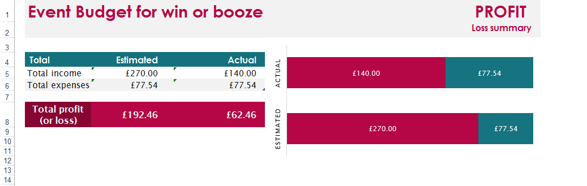

  - Gantt chart.

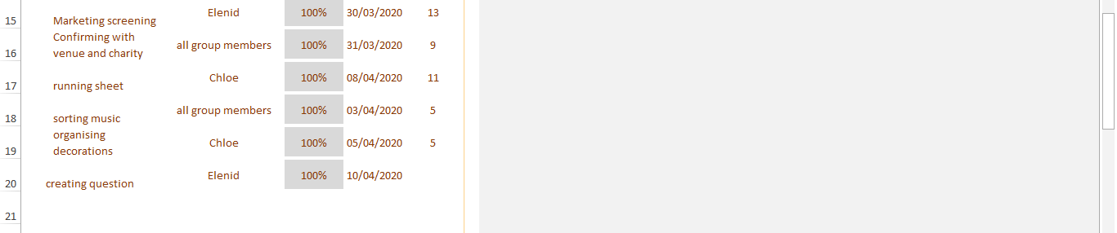
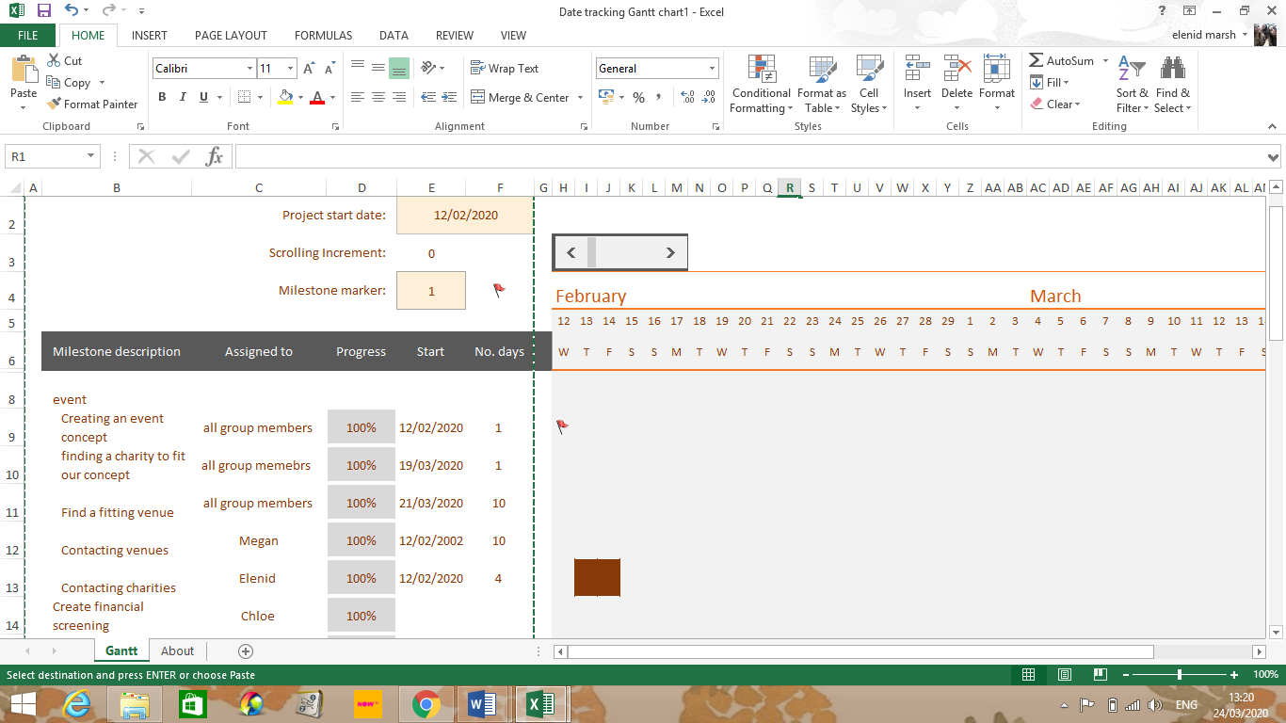

11.3 Risk assessment.

Risk | To whom? | Worst case outcome (A) | Likelihood (B) |  | Level of risk | Existing precautions | Further action to be taken | New level of risk | Who is responsible?
Crowding | All attendees | 5 |  | 5 | 25 | -Structure from opening time to closing.  -Briefings | -Constant flow of people. | 3 | -Event organisers  - Bar workers.  -On site manager
Alcohol | All attendees | 4 |  | 5 | 20 | -Constant Observing | -Limits | 3 | -Bar Staff.
falling/ slipping | All attendees | 4 |  | 5 | 20 | -Avoid any crowding.  -Place Signs for slippery floor. | -Clear structure to avoid collision.  -Clean / dry floors. | 2 | -Health and Safety staff.  -Event organisers.
Electricity wires. | All attendees | 4 |  | 3 | 12 | -Hide any wiring. | -Safety equipment. | 3 | -Managers  - Electrical suppliers
Fire | All attendees | 5 |  | 3 | 15 | -Avoid any hazards. | -keep on top of maintenance | 2 | -Managers  -Workers.  -Health and safety

  - WBS Tree Chart.



