Name: Lee Canning
Student Number: 2116294
Module: ACCA5023 Network Operating Systems and Services
Title: Build and deploy a type 2 hypervisor based virtualised network
Course: BSc Computer Networks and Cyber Security
Submission Date: 23rd February 2024
Table of Contents
Introduction 4
1. Hypervisor technologies 5
Types of hypervisors 5
Type 1: 5
Architecture 5
Features 5
Hardware Requirements 6
Type 2 6
Architecture 6
Features 7
Hardware requirements 7
Advantages, scalability, security, and compatibility 7
Use cases 9
Available solutions 9
2. Choice of hypervisor for virtual network implementation 11
3. Download and installation of hypervisor, server, and client OS 12
4. Implementation of network topology 13
5. IP Addressing 15
6. Network configuration 18
7. Testing 20
7.1 Network testing and troubleshooting techniques. 20
IP address conflicts 20
Packet loss 20
7.2 Testing and connectivity 21
Conclusion 27
Table of Figures 28
References 29

Introduction
Until recent times, computers would run a single operating system and dedicate all available resources to it. If there were a requirement for multiple operating systems, multiple machines would be deployed to host them. Given the rapid development of processing power, memory, and networking capabilities, it became apparent that resources were being wasted. Virtualisation allows a single physical machine to host multiple virtual machines, which are then allocated resources the hosts resources, such as CPU, memory, networking, and storage [1]. Virtual machines are essentially a digital replica of an actual machine and enable full utilisation of computing and networking power.
As the industry becomes more reliant on virtualisation, it is becoming increasingly common for organisations to rent or purchase virtual machines, rather than physical ones [2]. Virtualisation is now considered a fundamental technology for data centre optimisation and cloud computing [3].

1. Hypervisor technologies
A hypervisor is also known as a Virtual Machine Monitor (VMM). It is used to create, run, and manage virtual machines (guests) on a physical machine (host) [4]. Hypervisors are typically software but can sometimes be embedded in firmware. The guest operates most instructions on the native hardware. How this is achieved depends on the type of hypervisor. Because a VM runs its own OS, it can run multiple resource intensive functions. The increased resources available to VMs allow them to abstract, split, duplicate, and emulate entire servers, operating systems, desktops, databases, and networks [5].

Types of hypervisors
Type 1 hypervisors are known as native, or bare metal. Type 2 hypervisors are known as hosted. Each have similarities and differences in their architecture and functionality, as discussed below.

Type 1: Native / bare metal
Architecture
A bare metal hypervisor is installed directly on a host machine’s hardware [6]. This allows the VMs direct access to resources, which are negotiated, managed, and scheduled by the hypervisor. Because of this, a type 1 hypervisor is considered highly efficient and one of the main reasons they are more often used in enterprises and datacentres.

Features
There is no underlying OS, therefore VMs are fully isolated from each other. The hypervisor is powered on or off with the host machine. Unlike hosted hypervisors, they can offer High Availability (HA) via live migration, the ability to move a VM from one physical host to another while it is still running. This is particularly useful for load balancing and failovers [7]. The hosts can be clustered and appear as one to the VM, providing multiple options for a failover, which leads to improved business continuity and disaster recovery. These ensure that services remain available and minimises the negative impact on the organisation should hardware failure occur. Resource management: Hypervisors allocate the hosts resources to the virtual machines and manage them accordingly.

Hardware Requirements
Directly accesses resources like CPU, RAM, storage, and networking which are allocated and reallocated between existing and new VMs, depending on available physical resources. The more processing power, memory, and networking capabilities available, the more VMs can be deployed and ran efficiently.
Requires hardware acceleration technology to aid in managing the machine’s resources. Without this the hypervisor would need to manage these itself, leading to a reduction in performance and the number of VMs deployed [8].

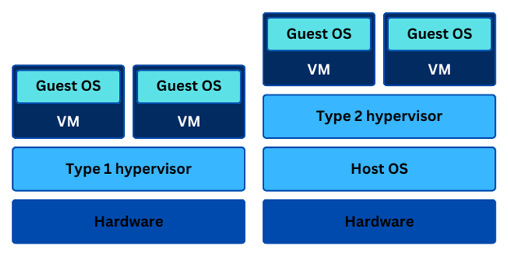
Figure 1: Comparison of type 1 and type 2 hypervisor architecture.

Type 2: Hosted
Architecture
Hosted hypervisors run on top of an OS as a software layer or application [9]. A VM monitor runs as a process on the host and abstracts guest OSs from the host OS. So, while it has access to the host’s hardware, this access is indirect. Hosted hypervisors demand less resources than native ones, which makes them more suitable for personal use, testing, and development. They are considered less efficient than bare metal hypervisors because they sit on top of the host OS and share its resources. They are also less secure, because the OS is an additional layer which can increase the potential the attack surface. While the VMs are isolated from each other, if the OS or the hypervisor itself is compromised then potentially all VMs can be too.
Features
Function in a similar manner and offer many of the same features and benefits of a native hypervisor, however a type 2 typically demands less resources and offers a lower level of functionality. They are rarely used in server-based environments. Several of them are open source, can be installed on a variety of host OS, and can run a variety of guest OSs. Typically, Windows Server, Windows and Linux are popular hosts/guests. Type 2 hypervisors typically offer less complex workloads, security, and cannot support as many VMs as their type 1 counterparts.
Hardware requirements
Far less demanding than a type 1. A hosted hypervisor can run a VM on a single core machine with 1G of RAM, though these resources are shared with the host OS. The VM would perform poorly if it were to run a modern OS such as Windows Server 2022. The more resources available, the better the performance applies here too; however, it is important to consider that a hosted hypervisor also must share these resources with the host OS and any other applications and services it is running. Type 2 hypervisors offer snapshots. When a snapshot is taken it records the state of the VM at that time, and allows users to roll back to this point, should they make any future changes that have adverse effects.

Advantages, scalability, security, and compatibility
Hypervisors allow for quicker and simplified deployment of resources. If an organisation requires an additional VM, they need only create one and allocate resources to it. Compared to purchasing a physical machine, installing an OS, and of course deploying that machine to its desired location. This also reduces the dependent workload.
An organisation’s resources can be vastly optimised and use of physical equipment far more efficient. This leads to an increase in server utilisation figures. They secure the operating environment from internal conflicts.
Hypervisors can employ full virtualisation, or para virtualisation. In full virtualisation, the guest OS is completely separated from the host’s hardware, and the hypervisor translates OS instructions during run-time and stores them for future reference. In para virtualisation the guest OS can interact with the hypervisor to improve performance. Para virtualisation in considered more efficient and secure, due the use of hypercalls to communicate. This is despite full virtualisation offering optimum isolation of VMs [10].
High availability and the ability to live migrate results in better uptime and availability of machines and resources. Combined with the rise of cloud computing and architecture, virtualisation facilitates remote working which can offer increased employee availability and performance.
The number of guests that hardware can host depends mainly on the number of physical cores available. Over-allocating these cores will negatively affect all VMs, the hypervisor, and the host machine [3].
A VM’s environment is isolated from the host system and other VMs so whatever runs inside it will not interfere with the host’s OS or hardware. If a VM is compromised, it is unlikely that other VMs or the host will be [11]. Although robust, the hypervisor itself could become an easy target, and vulnerability is increased because of the centralised system. If the hypervisor is compromised, every VM running inside it is potentially vulnerable. Type 1 hypervisors are more secure because there is no OS to compromise between them and the host CPU, where as a type 2 has a larger attack area due to the host OS. In a hosted hypervisor, security varies depending on the configuration of the host OS.
Many hypervisors are considered cross-platform, which means they can run a variety of OSs on VMs [12]. However, it is important to reference any hypervisor’s compatibility matrix to ensure available hardware and guest OS are supported.

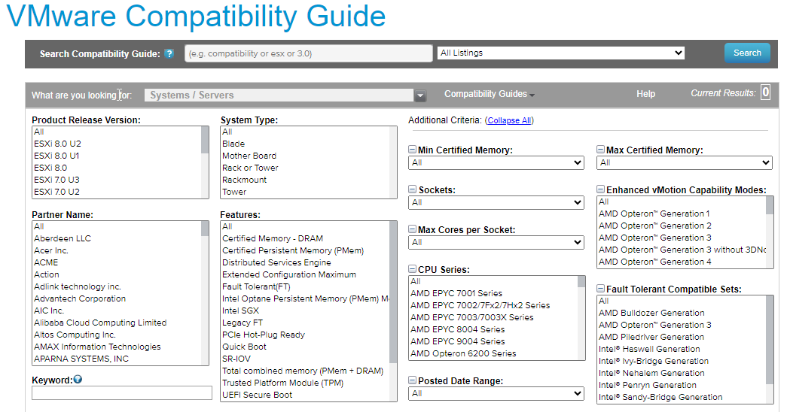
Figure 2: VMware compatibility guide, from www.vmware.com/resources/compatibility.

The above figure is more usual of type 1 hypervisors when used in datacentres or enterprises. Type 2 tend to be less restrictive as they are often run on individual’s computers.

Use cases
Type 1 are used in enterprise deployments and datacentres. Type 2 are more suitable for personal use, testing, and development.
The main use cases for hypervisors are resource optimisation, desktop virtualisation, failure recovery, and legacy system continuity. Employees can work remotely by emulating a version of their computer. Enterprises can consolidate multi-functional computers onto a single machine, even if they require different OSs [13]. This maximises resources. Snapshots capture a VMs state and allow administrators to roll back to this state at any point or make backups or clones.

Available solutions
Type 1: Microsoft Hyper-V, Citrix XenServer, KVM (Available as a Linux Kernel Module), Oracle VM Server for x86, VMware ESXi.
Type 2: QEMU, Oracle VirtualBox , VMware Workstation, VMware Player, VMWare Fusion.
Figure 3: Comparison of popular hypervisors.

2. Choice of hypervisor for virtual network implementation
The above comparison table shows general features of various type 1 and type 2 hypervisors. Considering NOSS is based in two locations, the option of either is viable, however with careful consideration, the ideal hypervisor would have been Microsoft’s Hyper V, as it is cost-efficient, secure, and supports live migration. Whilst Hyper-V can be activated within Windows OSs, it is known to be complicated to set up.
Considering the limited financial and hardware resources available to the organisation, the decision was made to install Oracle VirtualBox. VirtualBox supports hardware-assisted and software virtualisation, and it’s hosted VMs perform nearly as well as if they were natively installed. The host machine will need to support hardware virtualisation. One major benefit is that VirtualBox can deploy unlimited VMs, but of course this is resource dependent. Ideally, it would support live migration, however the organisation will need to suffice with cold migration for the time being. VirtualBox offers cloning, which will simplify the deployment of VMs once initial setup is complete.

3. Download and installation of hypervisor, server, and client OS
Oracle VirtualBox was downloaded directly from the official website, Oracle VM VirtualBox.
Windows Server 2019 and Windows 10 are the chosen server and client OS, with evaluation versions downloaded from Windows’ official website. Although there are newer versions (Server 2022 and Windows 11) available, the choice was made to make more efficient use of resources and represent a more real-world situation, as thousands of enterprises globally are still running these. In time, when NOSS provides more hardware resources, upgrades to the newer versions can be made.

4. Implementation of network topology
The host machine that runs the VirtualBox hypervisor and the 4 guest VMs has an Intel i3 4 core processor and 16 GB of RAM. Each VM has been allocated 2GB of RAM and 1 CPU/core. This leaves 8GB of RAM remaining to share with the host OS.
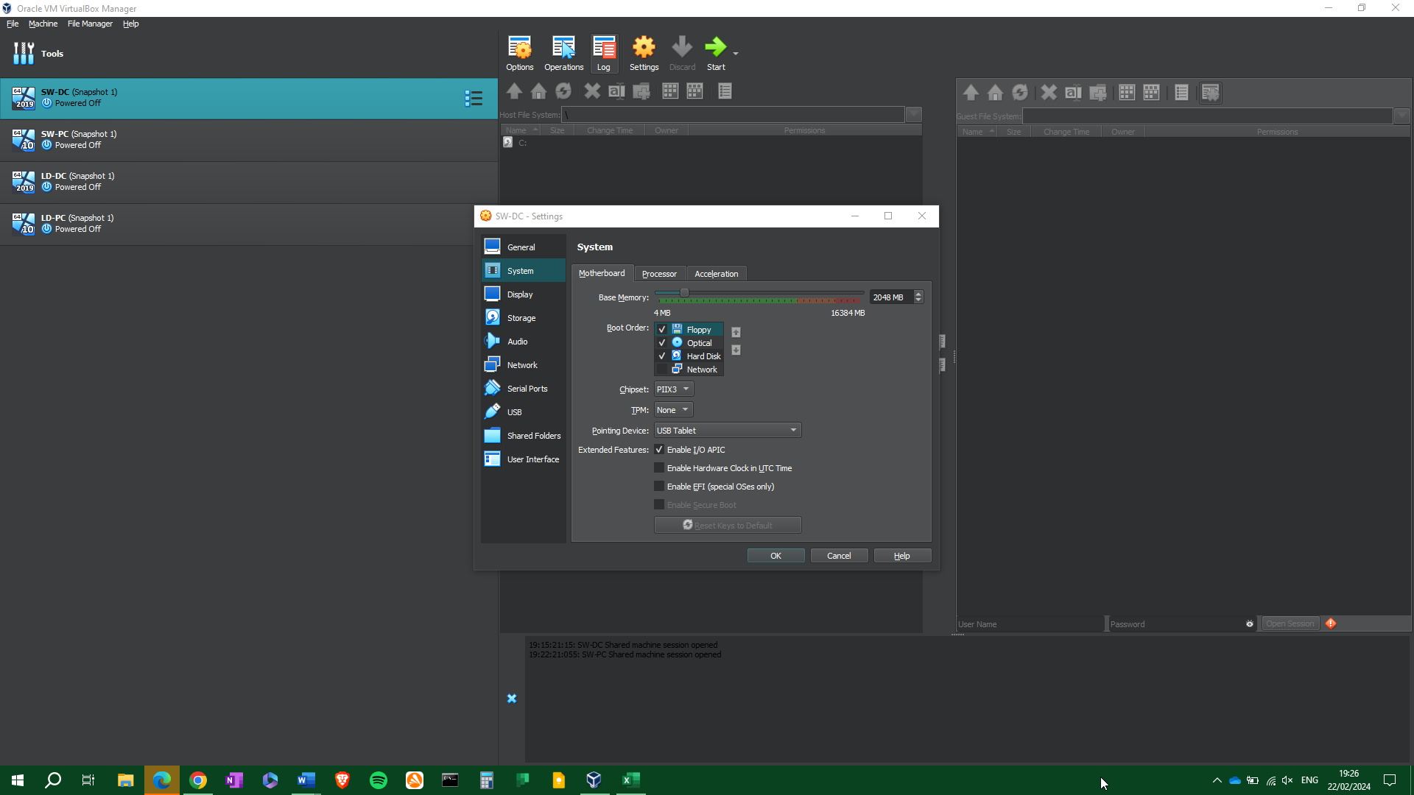
Figure 4: Allocating RAM to the VM.

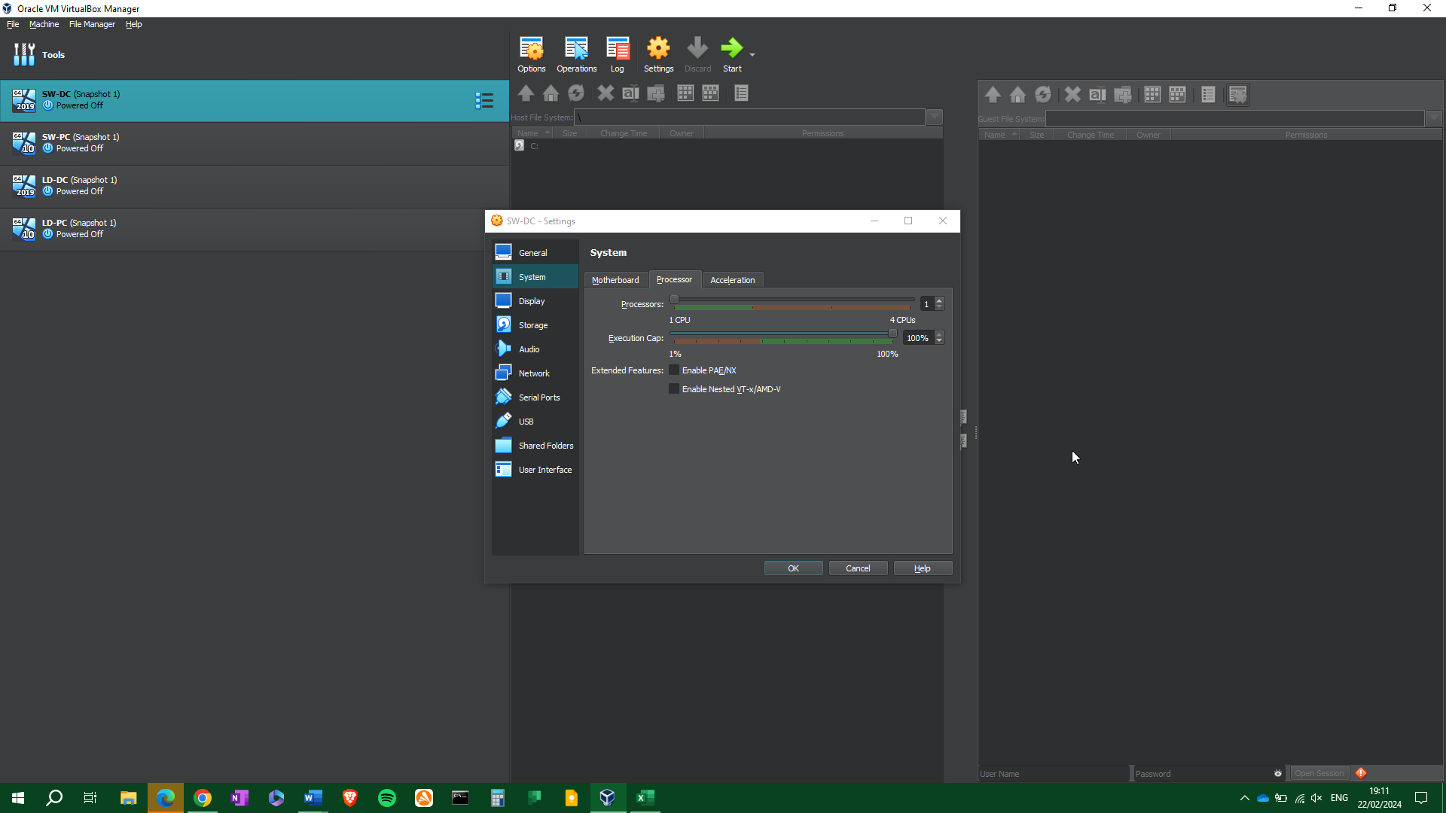
Figure 5: Allocating a CPU to the VM.
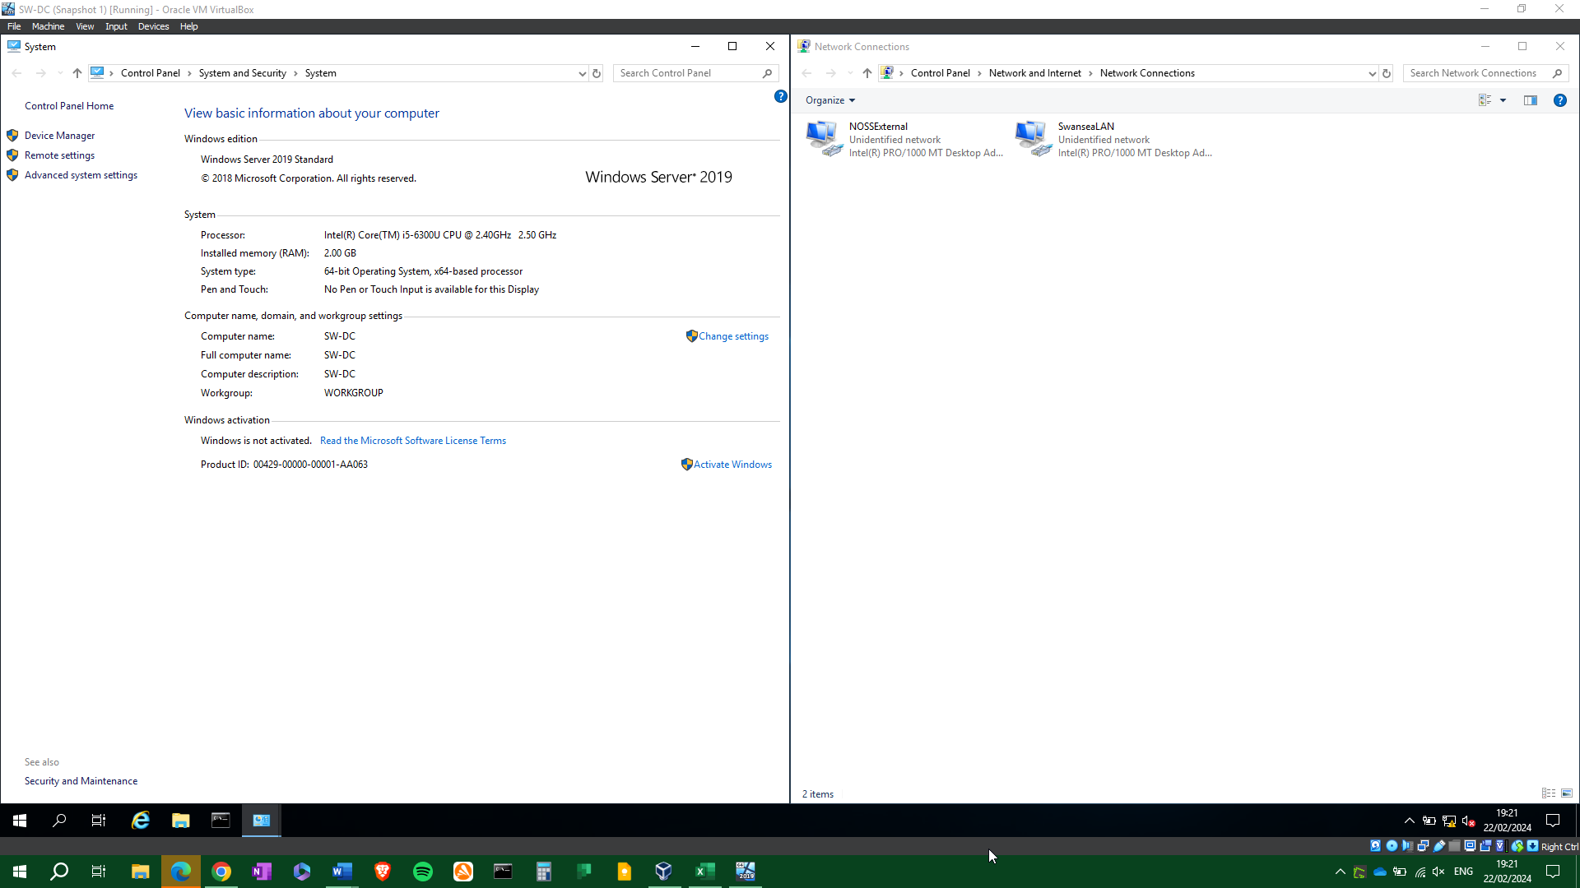
Figure 6: Initial system and network interface setup for SW-DC.
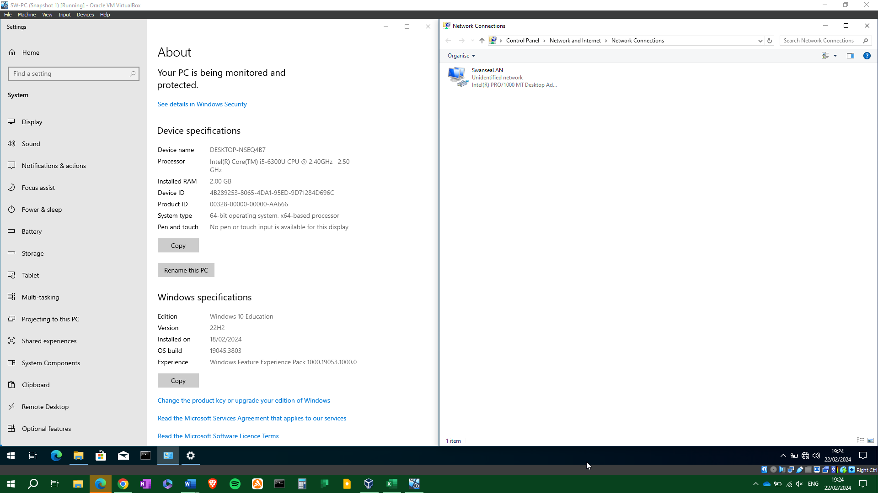
Figure 7:Figure 6: Initial system and network interface setup for SW-PC.
SW-DC and LD-DC have two network interfaces to connect to the LAN and external network, whilst SW-PC and LD-PC have one each, for the internal networks only.

5. IP Addressing
To travel through interconnected networks, data is broken down into packets. Packets are wrapped in a header which includes the source and destination IP address, and the order in which the packets should be reconstructed upon delivery. For example, a single audio file this could be 100MB’s in size. Attempting to send this in one go could work, but it’s more likely that the transfer will fail or cause network congestion Instead, it is broken down into multiple packets (the maximum packet size is 65535 bytes) . This enables a more efficient and reliable delivery. If some packets are lost, they can be resent, and because they are far smaller than the original file size, they do not congest the network. The TCP/IP protocol is responsible for distributing the packets.
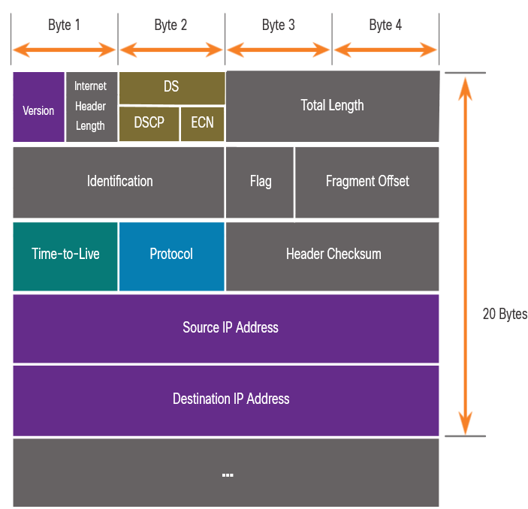
Figure 8: IPv4 packet, from www.cisco.com.

Every device connected to a network is identified by a unique IP address, which is used to determine where data is sent. There are two formats of IP addresses, IPv4, and IPv6.
IPv4 is denoted by a 32-bit number, separated into four 8-bit octets, and separated by decimal points, known as dot-decimal format. For example, www.google.com’s IPv4 address is 172.217.168.238.
An IP address is separated into a network segment, and a host segment, using a subnet mask.
Figure 9: Network and host portions of an IPv4 address, determined by a subnet mask.

Because it is denoted by binary bits, each octet can hold a value between 0 and 255. IPv4 supports 4,294,967,296 addresses, but this is not enough considering the abundance of connected devices globally. It will eventually be replaced by IPv6.
IPv6 is denoted by a 128-bit hexadecimal number, with colons separating each of the 8 segments. For example, 2001:db8:3333:4444:5555:6666:7777:8888. It has been developed to overcome the limitations of IPv4 [14]. IPv6’s network and note sections are split into two 64-but segments.
Subnetting is the process of dividing a network up into smaller networks known as subnets. The aim of this is to better utilise IP addresses, so that an organisation does not waste them. For example, the subnet mask 255.255.255.0 (/24 in CIDR notation) will provide 254 usable hosts. A subnet mask of 255.255.255.128 (/25) provides 126, and so on. If 100 hosts are required, then it is more efficient to use a /25 subnet than a /24 subnet. A subnet mask effectively divides an IP address into its network and host portions. Fixed length or variable length subnetting is available, depending on the circumstances and requirements [15].
Switches connect network devices and forward packets to and from those devices. This can be done by MAC address (layer 2 switch) or IP address (layer 3 switch). A MAC address is a unique address that belongs to a piece of networked hardware (or virtual hardware in some circumstances).
Routers differ from switches in that they actively route network traffic. Using an IP address, a router can determine if the target address is on the current network or not. A routing table holds this information and can be configured statically (better for small networks) or dynamically (better for large networks). The role of a router is to choose the most efficient route for data to travel. It can be configured to have preferred routes, or to send data across multiple routes (known as load balancing). If a router does not know where to send the packet, it will pass it to the next available router, otherwise it will drop the packet.

6. Network configuration
Considering the above research the network will be configured as follows:
Figure 10: Subnet table.
Both locations have been assigned /24 subnets, which provide 254 usable hosts each. It would have been possible to assign Swansea with a /25 subnet of 126 hosts, however this would allow little room for expansion in the future. The Swansea – London external network has been assigned a /30 subnet, 2 usable hosts, which efficiently allows for both servers to connect.
Figure 11: Table of IP addresses for SW and DC.
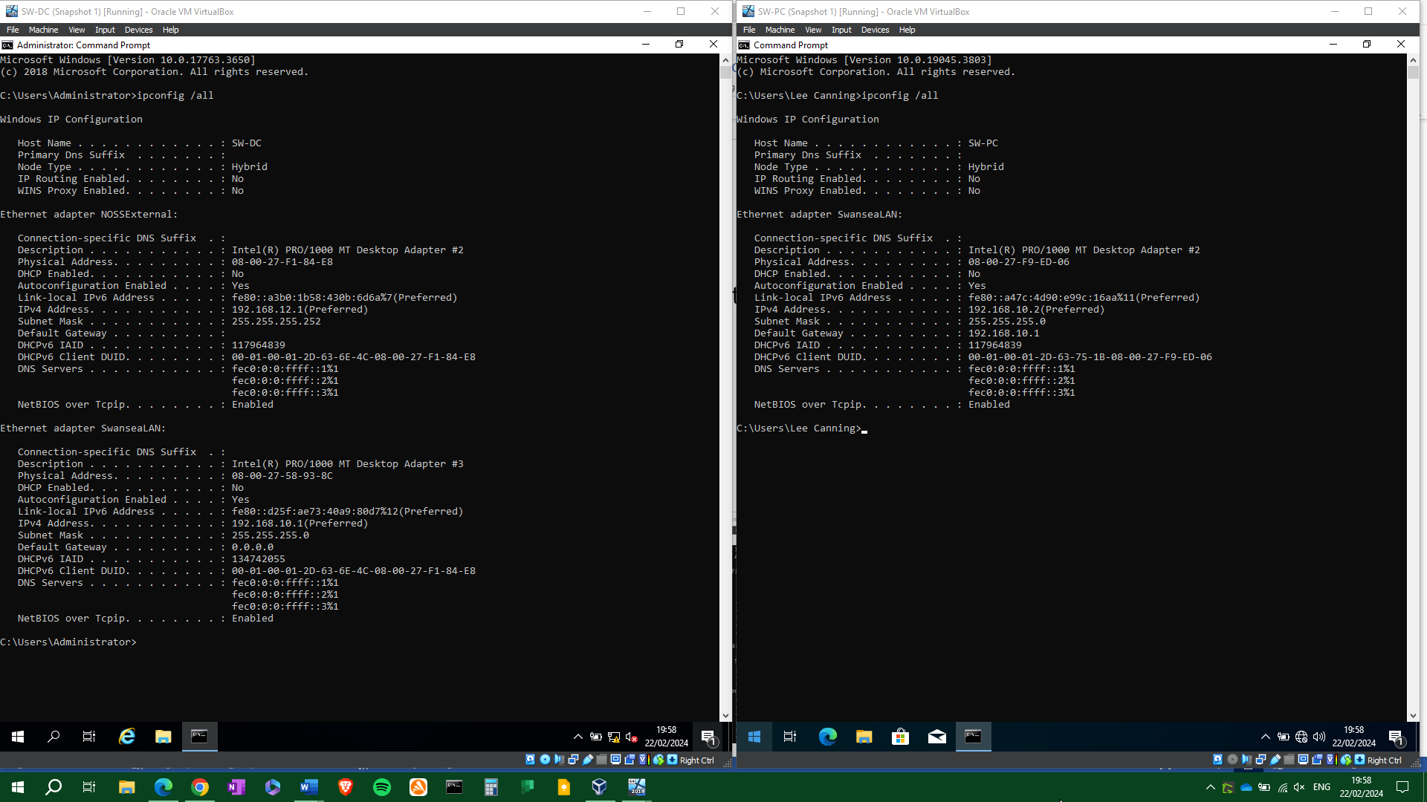
Figure 12: IP configuration of SW-DC and SW-PC.

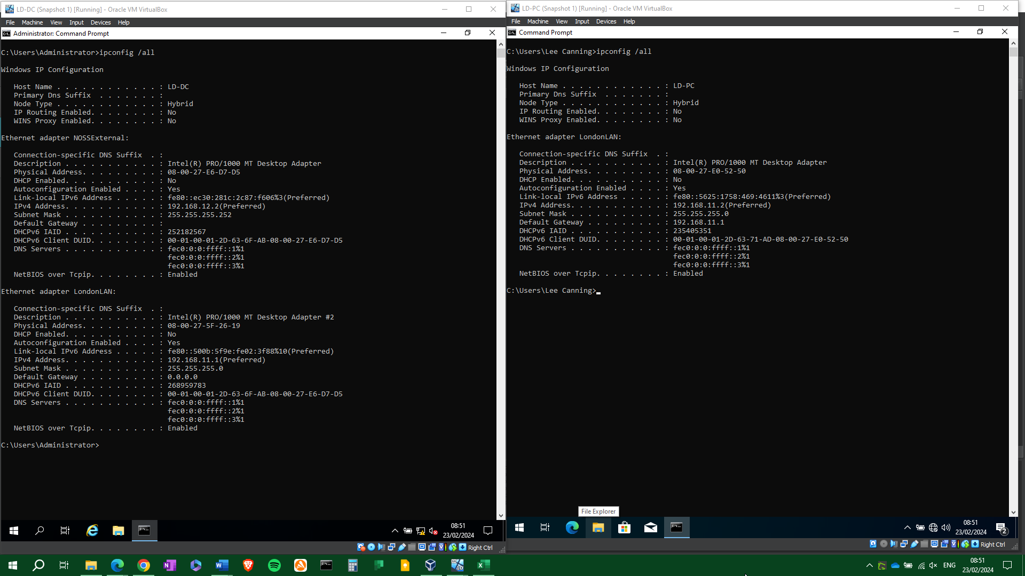
Figure 13: IP configuration of LD-DC and LD-PC

7. Testing

7.1 Network testing and troubleshooting techniques.
Should a network lose connectivity, whether it is to the internet / gateway or between hosts and clients, it is important to take a rigorous and thorough approach to diagnose the exact issue.
To identify the problem:
- Gather information about the network.
- Discover which errors occur, if any.
- Identify symptoms.
- Check for any recent changes.
- Define if there are multiple issues.
Some of the more common connectivity issues are discussed below.

IP address conflicts
These occur when more than one device in a network has been allocated the same IP address. DCHP allocated networks with some statically allocated devices, and static networks can suffer from this. the command “arp -a xxx.xxx.xxx.xxx” can be used to discover if an IP address is a duplicate, at which point it can either be reconfigured, or excluded from the DCHP scope.

Packet loss
Packet loss occurs when a network packet fails to reach its destination. Possible causes are network congestion, faulty hardware components, host machine security settings, DoS attacks, or network misconfiguration. Packet loss is often used as a congestion signal by TCP [16], so this should also be considered.
The primary step in confirming connectivity is to use the “Ping” command. This command sends an ICMP (Internet Control Message Protocol) echo request to the specified IP address and determines if data is reaching its destination. If the destination is reachable, the destination host responds with an echo reply such as “Reply from 127.0.0.1: bytes=32 time<1ms TTL=128”. If there is no reply, an error such as “Request timed out” or “Destination host unreachable” will be received. Ping will also provide information of how many packets were successful / lost, “Packets: Sent = 4, Received = 4, Lost = 0 (0% loss)” and from this it can be determined whether there is any communication at all, or if that connection is intermittently dropping packets.

7.2 Testing and connectivity
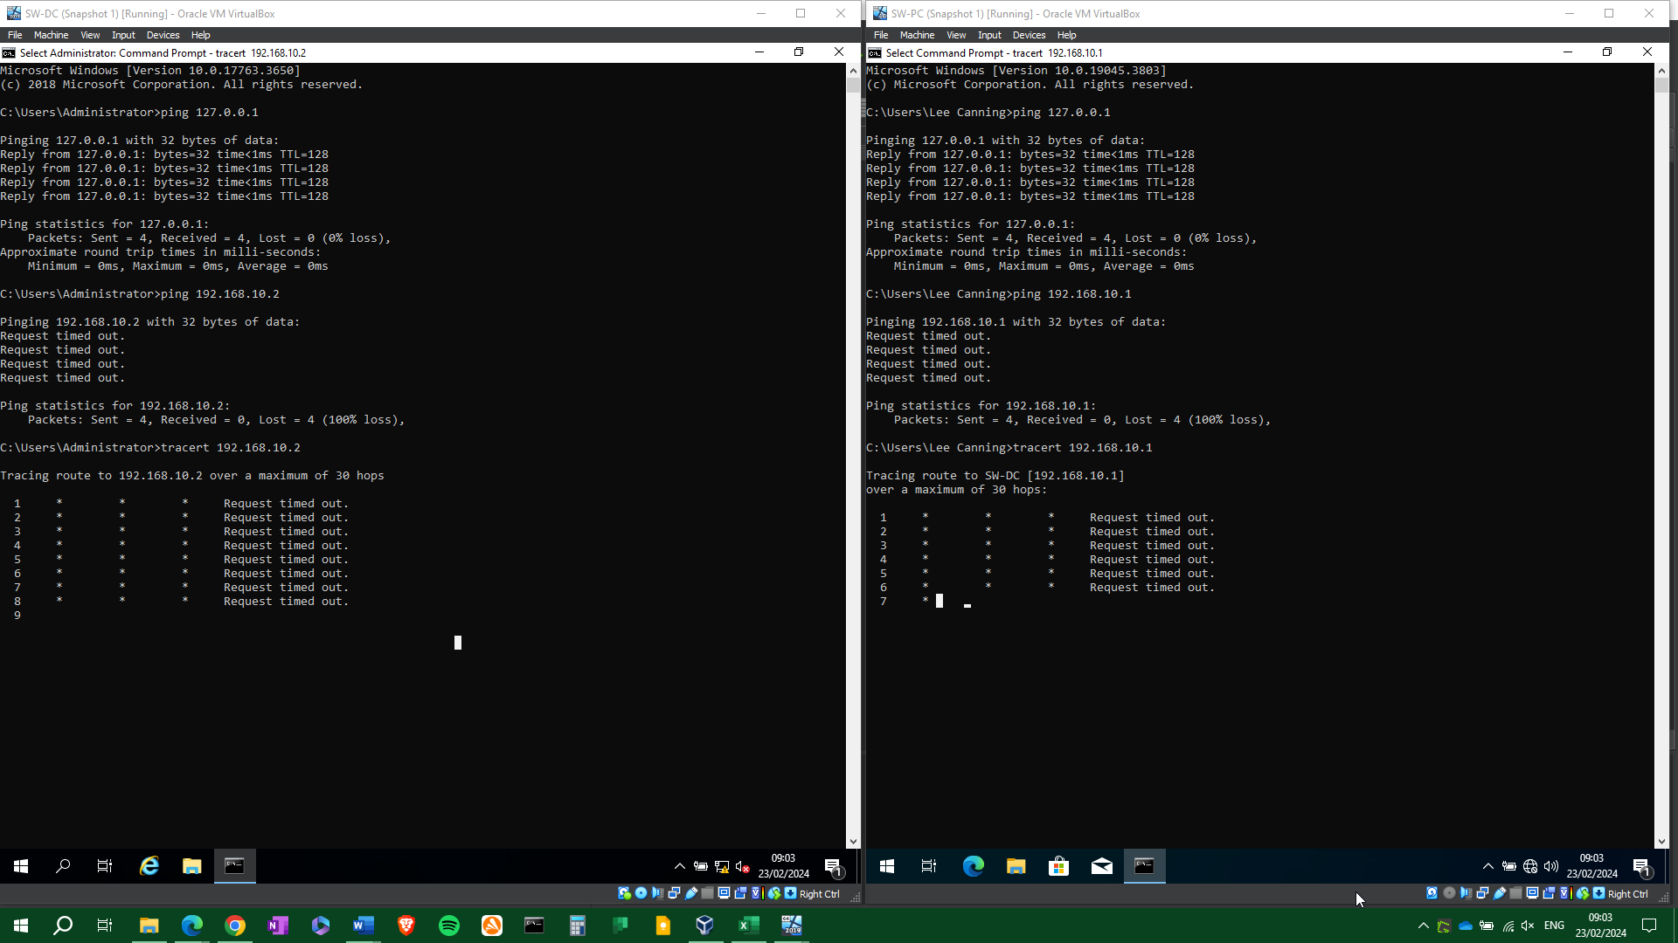
Figure 14: Unsuccessful ping between SW-DC and SW-PC
Initially we use the loopback address 127.0.0.1. This address points to the device / interface it originates from, so the successful pings shown above prove that the interface is active, and that the TCP/IP protocol is functioning correctly.
The attempts to ping between SW-DC and SW-PC were both unsuccessful with the message “Request timed out”. Either the echo request is not reaching its destination, or it is taking too long to get a reply.
The trace route command “tracert” was also unsuccessful, as there are no routers or IP enabled switches in the private network, so there was no route to trace.
After double checking that the IP addresses and subnet masks are configured correctly, it is likely that something is blocking the error request, rather than the IP addresses being incorrect. Searching on https://learn.microsoft.com/en-us/troubleshoot/windows-server/networking/troubleshoot-tcp-ip-communication-guidance suggests that the “Request timed out” error indicates that “ICMP traffic could be blocked by the firewall software”.
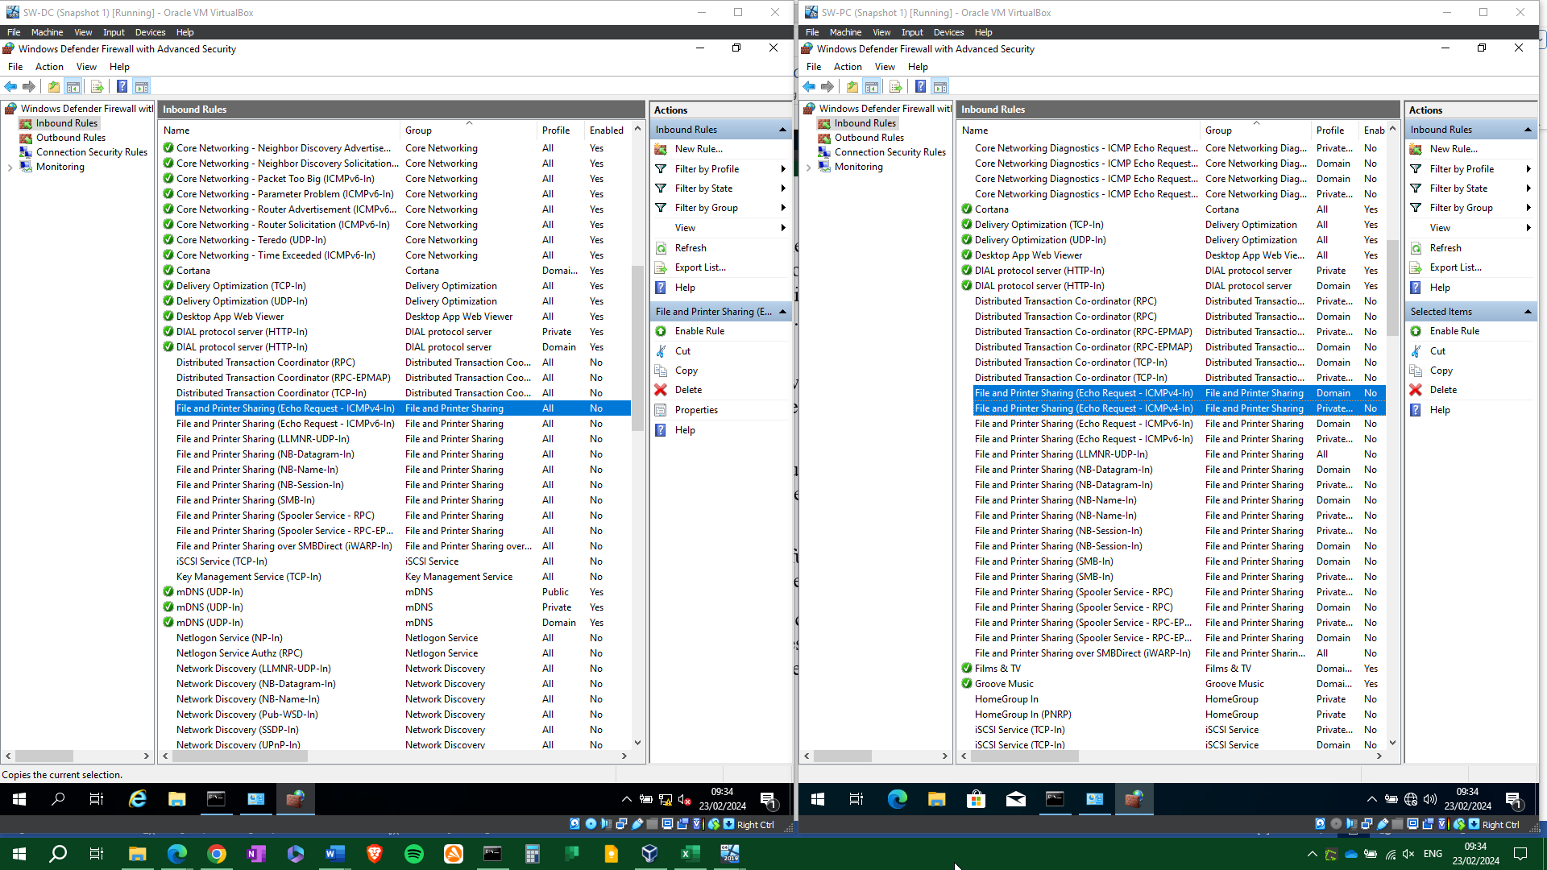
Figure 15: Windows Firewall blocking ICMP messages.

Windows Firewall inbound rules shows that “File and Printer Sharing (Echo Request ICMPv4)” is disabled. It appears the firewall is blocking the ICMP requests, which stops the ping command from getting a reply.
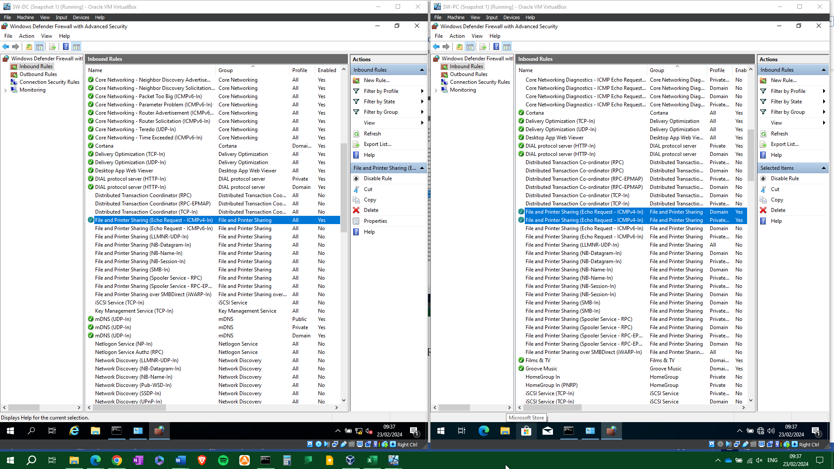
Figure 16: Allowing ICMP messages through the firewall.
The rules have been enabled for both SW-DC and SW-PC.

Figure 13: Table of IP addresses for SW and DC.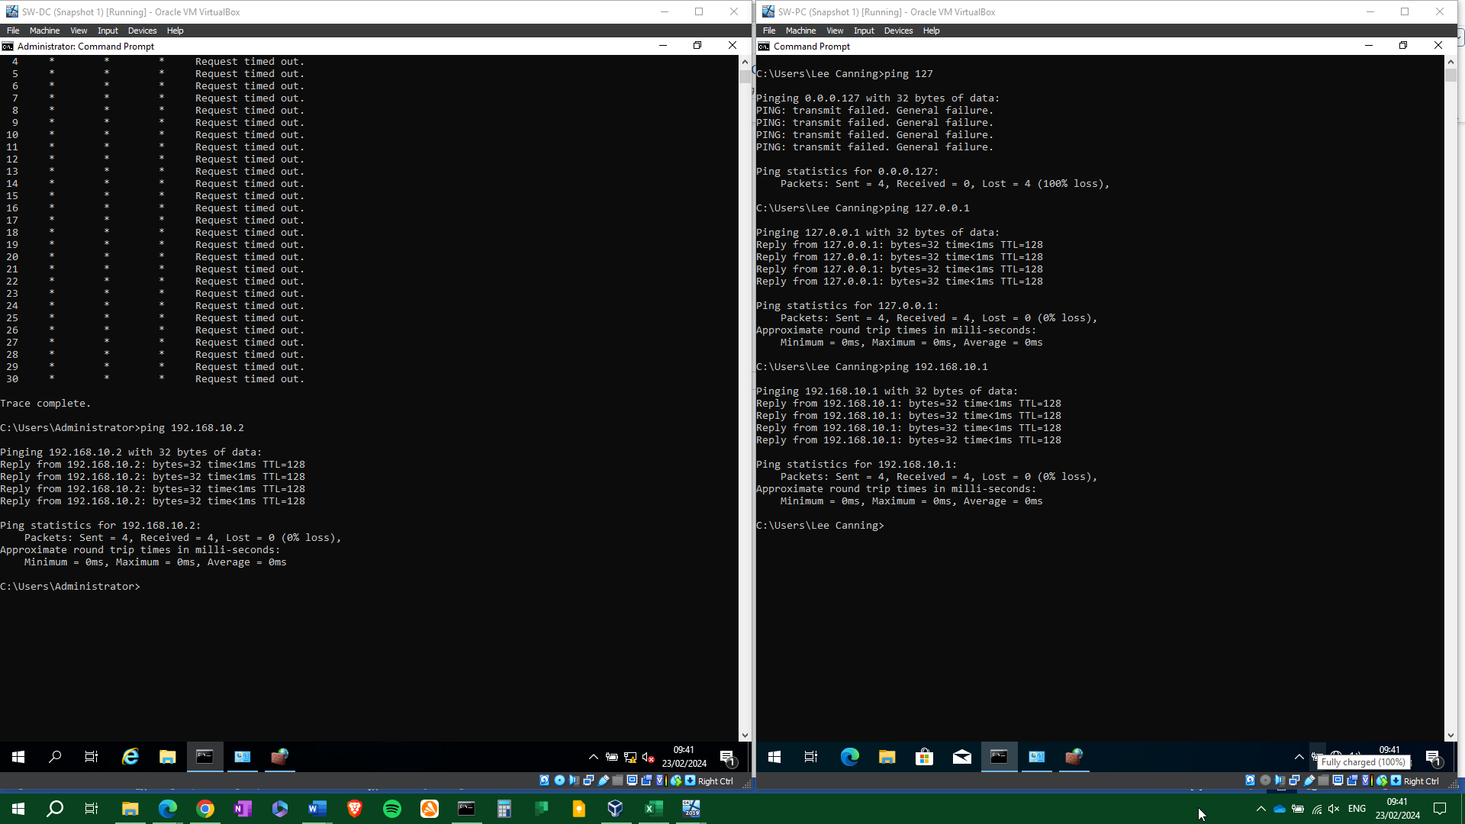
Figure 17: Successful ping between SW-DC and SW-PC
Enabling the inbound ICMP rule has allowed the echo request to reach its destination and send an affirmative reply. Communication has been established between SW-DC and SW-PC.

Now that it has been ascertained that Windows Firewall is blocking the ICMP messages, it should be a case of repeating these steps on LD-DC and LD-PC.
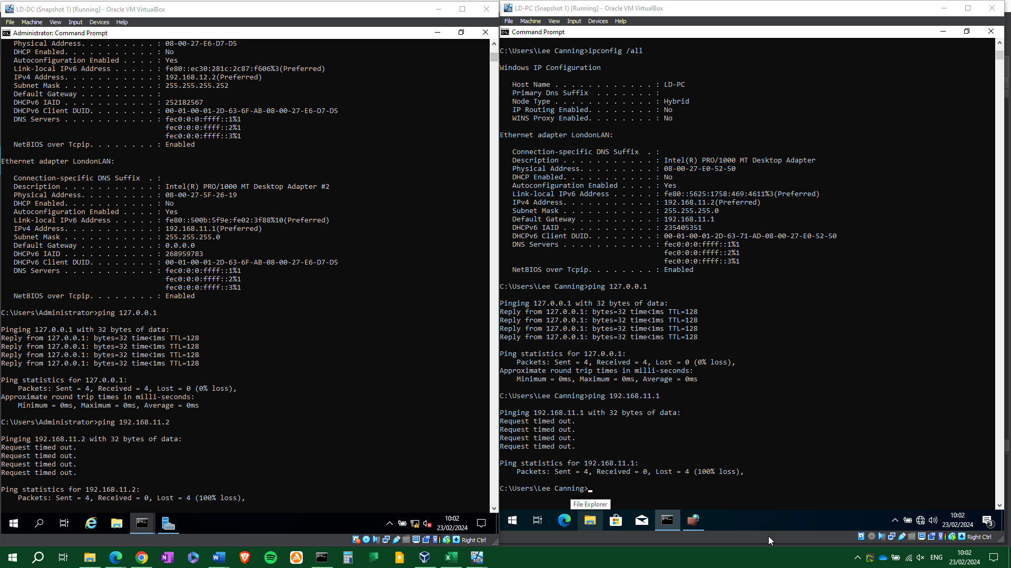
Figure 18: Unsuccessful ping between LD-DC and LD-PC

LD-DC and LD-PC can successfully ping the loopback address, but not each other.
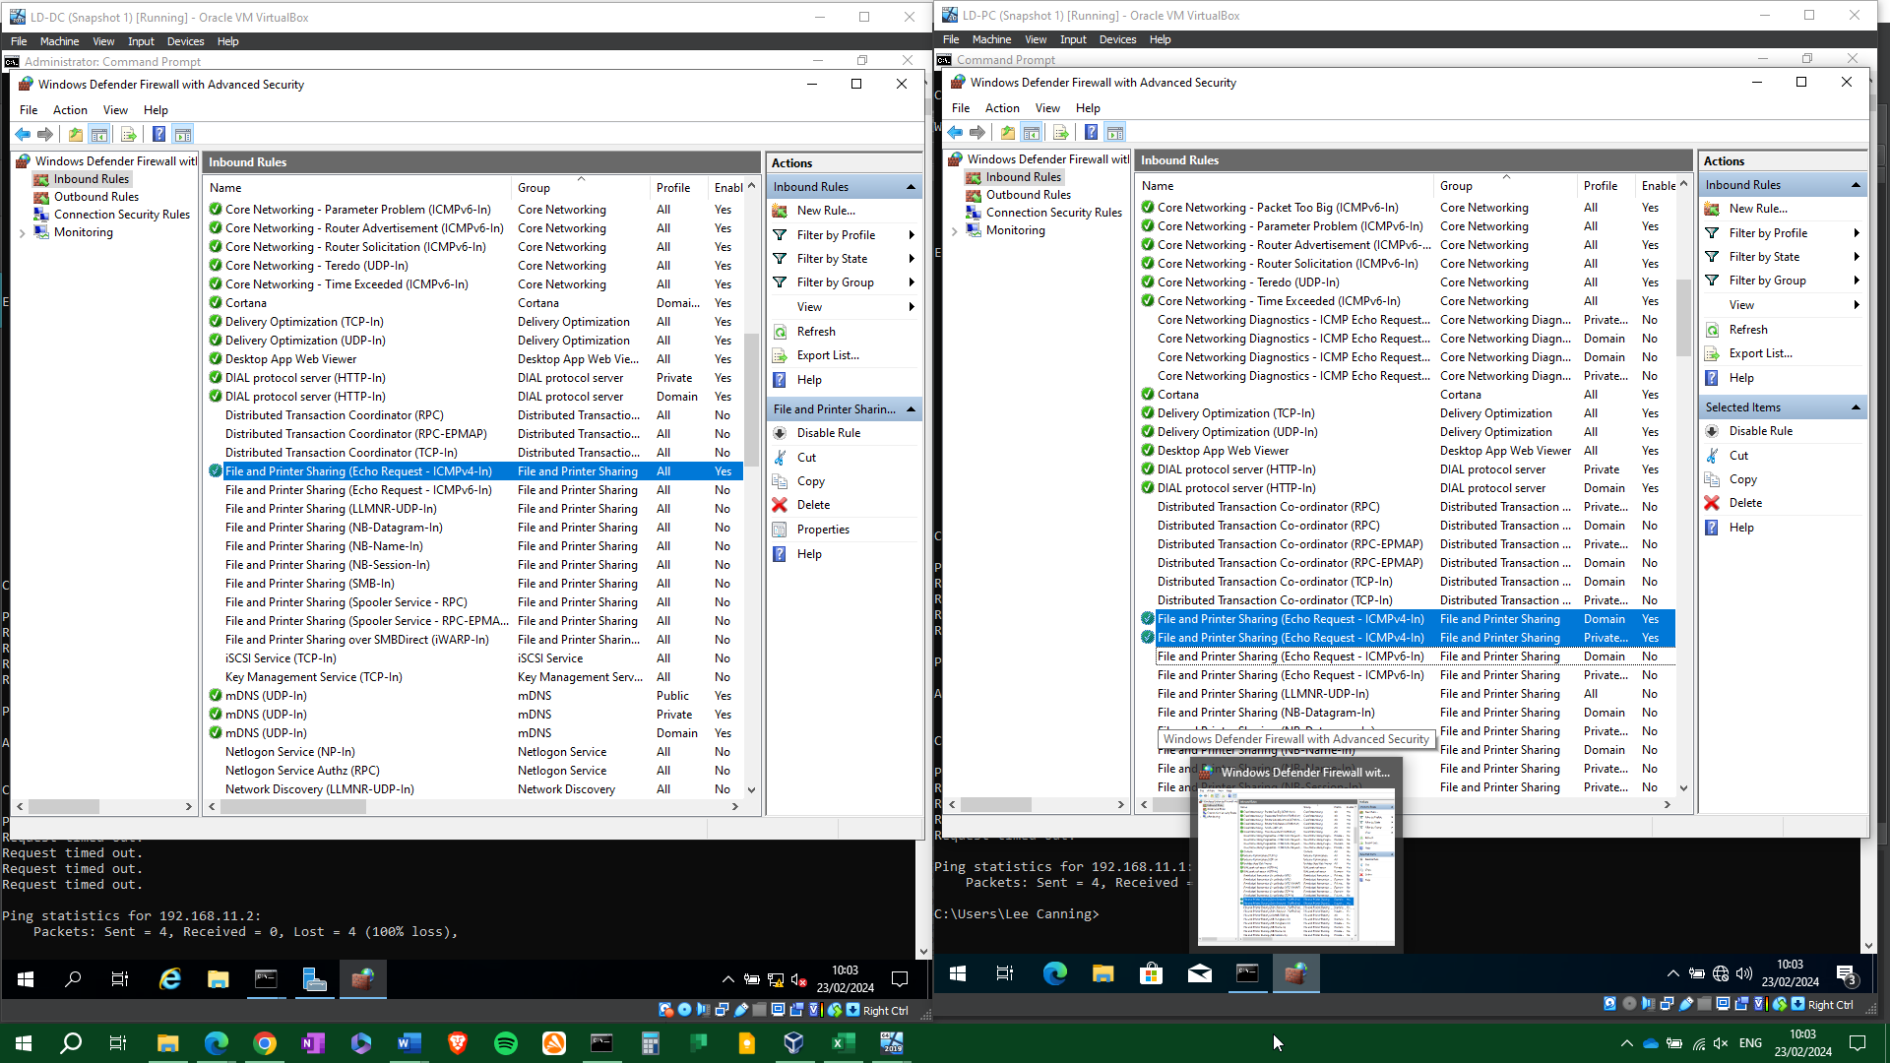
Figure 19: Enabling ICMP messages in Windows Firewall.
The file and printer sharing inbound rule has been enabled for both.
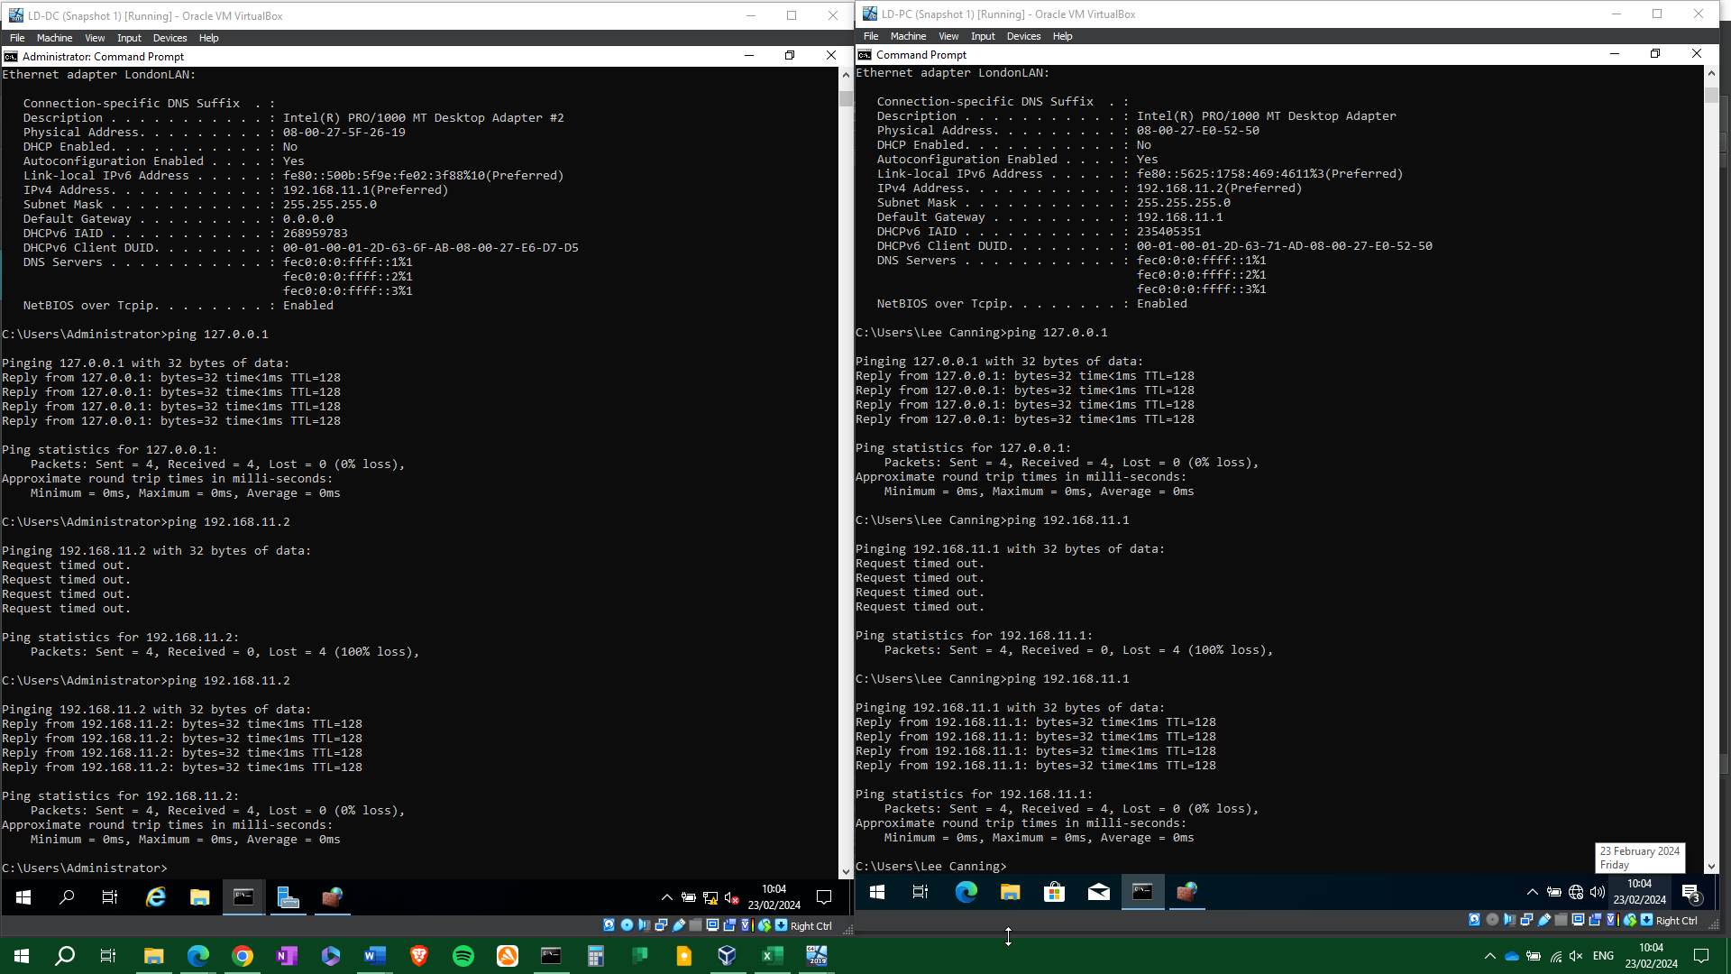
Figure 20: Successful ping between LD-DC and LD-DC.

The VMs have successfully pinged each other and established connectivity.
Finally, we aim to establish connectivity between SW-DC and LD-DC on the 192.168.12.0/30 external network subnet. As the firewall rules for ICMP have already been enabled, connectivity should establish on the first attempt, provided the subnet has been configured correctly.
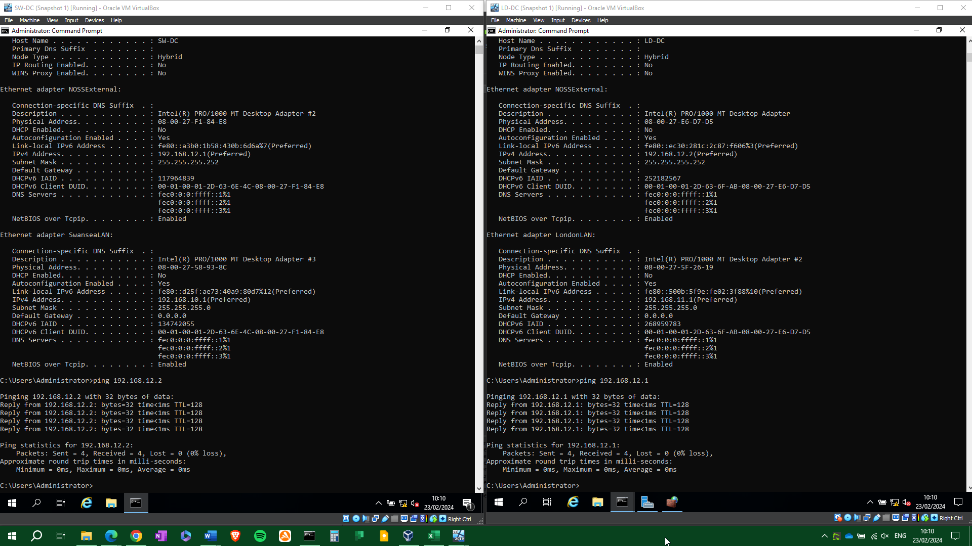
Figure 21: Successful ping between SD-DC and LD-PC.
Connectivity established between SW-DC and LD-PC at the first attempt.

Conclusion
Having researched hypervisors, IP addressing, and network connectivity troubleshooting, it is apparent how each rely upon each other to form a virtual network. Although the initial configuration is simple, it provides an insight into how larger networks would be implemented. In future work, using a bare metal hypervisor hosted on a machine with enterprise level hardware server would be of benefit, as it would then be possible to implement many of the features that type 1 hypervisors offer.

Table of Figures
Figure 1: Comparison of type 1 and type 2 hypervisor architecture. 6
Figure 2: VMware compatibility guide, from www.vmware.com/resources/compatibility. 9
Figure 3: Comparison of popular hypervisors. 10
Figure 4: Allocating RAM to the VM. 13
Figure 5: Allocating a CPU to the VM. 13
Figure 6: Initial system and network interface setup for SW-DC. 14
Figure 7:Figure 6: Initial system and network interface setup for SW-PC. 14
Figure 8: IPv4 packet, from www.cisco.com. 15
Figure 9: Network and host portions of an IPv4 address, determined by a subnet mask. 16
Figure 10: Subnet table. 18
Figure 11: Table of IP addresses for SW and DC. 18
Figure 12: IP configuration of SW-DC and SW-PC. 19
Figure 13: IP configuration of LD-DC and LD-PC 19
Figure 14: Unsuccessful ping between SW-DC and SW-PC 21
Figure 15: Windows Firewall blocking ICMP messages. 22
Figure 16: Allowing ICMP messages through the firewall. 22
Figure 17: Successful ping between SW-DC and SW-PC 23
Figure 18: Unsuccessful ping between LD-DC and LD-PC 24
Figure 19: Enabling ICMP messages in Windows Firewall. 24
Figure 20: Successful ping between LD-DC and LD-DC. 25
Figure 21: Successful ping between SD-DC and LD-PC. 26

References
[1] J. Savill, Mastering Windows Server 2016 Hyper-V, First Edition, Newark, UNITED STATES: John Wiley & Sons, Incorporated, 2016 Available: http://ebookcentral.proquest.com/lib/trinity/detail.action?docID=4751489.
[2] A. S. Tanenbaum and D. J. Wetherall, Computer Networks, Fifth Edition, Pearson, 2013 .
[3] S. G. Soriga and M. Barbulescu, "A comparison of the performance and scalability of xen and KVM hypervisors," in 2013 RoEduNet International Conference 12th Edition: Networking in Education and Research, 2013, . DOI: 10.1109/RoEduNet.2013.6714189.
[4] G. Santoso et al, "Optimizing I/O performance in ViMo-S hypervisor with zero-copy method," in 6th International Conference on Software and Computer Applications, pp. 50-54.
[5] RedHat. Containers vs VMs. Available: https://www.redhat.com/en/topics/containers/containers-vs-vms [Accessed 21 Feb, 2024].
[6] Amazon Web Services. What’s the Difference Between Type 1 and Type 2 Hypervisors? Available: https://aws.amazon.com/compare/the-difference-between-type-1-and-type-2-hypervisors/ [Accessed 21 Feb, 2024].
[7] IBM. What are hypervisors? | IBM. Available: https://www.ibm.com/topics/hypervisors [Accessed Feb 10, 2024].
[8] Anonymous. Type 1 and Type 2 Hypervisors: What Makes Them Different | by ResellerClub | ResellerClub | Medium. Available: https://medium.com/teamresellerclub/type-1-and-type-2-hypervisors-what-makes-them-different-6a1755d6ae2c [Accessed Feb 10, 2024].
[9] VMware. What is a Hypervisor? | VMware Glossary. Available: https://www.vmware.com/topics/glossary/content/hypervisor.html [Accessed Feb 6, 2024].
[10] Anonymous. Difference between Full Virtualization and Paravirtualization in Operating System - javatpoint. Available: https://www.javatpoint.com/full-virtualization-vs-paravirtualization-in-operating-system [Accessed Feb 22, 2024].
[11] RedHat. What is a Hypervisor? Available: https://www.redhat.com/en/topics/virtualization/what-is-a-hypervisor [Accessed 21 Feb 2024].
[12] S. K. G. and A. Singh, "Hands-on guide to virtual box," in Design and use of Virtualization Technology in Cloud Computing, P. K. Das and G. C. Deka, Eds. 2018, pp. 194-207.
[13] Amazon Web Services. What is a Hypervisor? - Hypervisors Explained. Available: https://aws.amazon.com/what-is/hypervisor/ [Accessed Feb 22, 2024].
[14] Cisco. IPv6 Address Examples | What is an IPv6 Address? ⋆ IPCisco. Available: https://ipcisco.com/lesson/ipv6-address/ [Accessed Feb 22, 2024].
[15] Huawei Technologies Co, Data Communications and Network Technologies, 2022, Available: https://link.springer.com/chapter/10.1007/978-981-19-3029-4_4#citeas.
[16] A. S. Tanenbaum and D. Wetherall, Computer Networks, 5th Edition, Pearson, 2013, p539.

