Kate Hessey

1603772

Independent Inquirey:

Investigation into the representation of the working class

Kate Hessey (1603772)
University of Wales Trinity Saint David

Contents
Introduction 2
Chapter 1 3
Chapter 2 8
Chapter 3 15
Conclusion 23
References 25
Bibliography 28

Figure 1: “The Gallery of Cardinal Silvio Valenti-Gonzaga in Rome” - Giovanni Paolo Panini, (1691-1765) 3
Figure 2: J.M.W Turner "Dido Building Carthage" (National Gallery, 2019) 4
Figure 3 Martin Shakeshafft photograph of miners strike 8
Figure 4: London Museums and Galleries, and accessibility index (Brook, Orien) 9
Figure 5: Predicted probabilities for attending museums and galleries in London (Brook, Orien) 10
Figure 6: Logistic regression model results, attending a museum/gallery in London (Brook, Orien) 11
Figure 7: GB England. Conservative 'mid-summer madness’ party by Martin Parr from ‘The Cost of Living’ 13
Figure 8: Profile of Liv Wynter () 15
Figure 9: Profile of Nan Goldin () 16

Introduction

This piece of research will be delving into the issues of ‘Do galleries exclude people of working class and can photography be considered as an art platform which helps to bridge this gap?’ within this essay there will be a discussion into if galleries do enough in order to widen their demographic of people who come to visit these places.
To begin to understand why you must first investigate how materialism works within art. To do this you must look back into the history of art and how art has been stigmatised, making people feel alienated and outcasted. This could be one of the main reasons why certain people do not go to see art shows. (this concept shall be explored in more detail)
I wish to focus this piece of writing on how British politics creates a further divide in class, the main example is of the Thatcherism era as it is a very controversial point of history (what is the link here with art & the political context?). I will compare this example with other key historical moments within the modern era.

It can be argued that there are social stereotypes of those who engage within the arts whether it be a career or simply engaging with art facilities such as art galleries . The topics being discussed will be delving into why the art scenes sole foundations primarily consist of those who are from a more financially stable background and why there is an absence of people from working class backgrounds as well as those outside of the white demographic. Whilst researching this topic there is a decrease in certain categories which show how things such as the location of gallery space and social media can really affect the turnout of someone going to an art gallery. It especially effects those in minorities. The studies I will be basing my research on is London/UK based galleries.

This will be linking to the use of photography as an art medium, exploring how photography is different to other artforms and how it has helped to capture our history and culture more than any other artform. Within this essay photographers such as Martin Parr and Chris Killip will be used as they both captured other individuals lives within their photography.

Assessing these photographers portfolios I will use them as examples of photography being a inclusive artform as well as being able to allow the public to address and protest issues that are unjust in the UK as a way of raising awareness of poor conditions. I will also be counter arguing this point by highlighting the issues with consent in photo imagery as well as how it can be sometimes damaging for people in these communities if they are misrepresented by visual media. This is a good thing to consider.

Chapter 1
To understand the topic there must be firstly a deeper understanding on the fundamental purposes of art such as what qualifies as a piece of art, more specifically, what qualifies as a piece of art in a capitalist market. You must also understand
the transition from how art developed from a craft trade such as paintings to record history and historical figures, to a new age of art history. How artists have now evolved to become more contemporary with their work and how that can widen the gap between those of working class.
When looking at art history there is a period between the 1500s and 1900s where traditional oil paintings would have been the primary source of maintaining the representation and history over other artforms. Oil painting has been around for an incredibly long time but at the beginning of the 15th century was when it was considered art. Many oil paintings between these time periods often would portray within them the subject matter of wealth and possessions and that these paintings would have been to have sold the ideology of wealth and prosperity. (Berger ‘Ways of seeing, 1972) Early works of oil paintings in the 17th century paintings often reflected upon those who were wealthy enough to commission them. For the Renaissance artist they would use their work not only to harvest knowledge but also as a way for investors to take interest in their work. An example of this is the gallery of Cardinal Valenti Gonzaga, a place where wealthy Italian merchants would request painters to paint their possession in hope their paintings would make it to a gallery so that it would confirm their possessions were beautiful and desirable enough to be displayed for the world to see for generations.
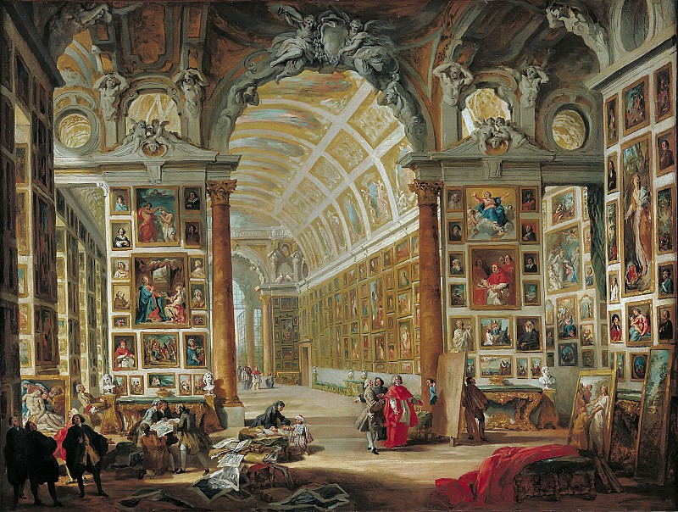
Figure 1: “The Gallery of Cardinal Silvio Valenti-Gonzaga in Rome” - Giovanni Paolo Panini, (1691-1765)

As a result of this some could argue that to someone untrained on the history of art it can be perceived as very confusing to decipher which pieces of artwork are of historical importance and which pieces are merely a bragging of wealth due to European traditions. (Berger ‘Ways of Seeing’,1972)
Due to this there seems to be a lack of representation of working people between this time frame as paintings would be paid for by those who were of wealth, however there are examples of artists around this time who did actually document the lives of working people and whose muse was to capture Britain for how it actually was. (Berger ‘Ways of Seeing’,1972)
J.M.W Turner is a classic example of an oil painting artist of the Reissuance period who represents the working class. For the most part his paintings captured ships going out to sea as well as ships at dock yards. Within those paintings of dock yards, it is a prime example of representation of workers who are not wealthy within the Resonance period. J.M.W Turner was seen as a mysterious character and was the youngest ever to be accepted in the Royal Arts Academy for his exceptional skill at using oil paint and water colours and his key signature within his paintings was the way he was able to capture the light in stunning colours, unlike other artists of this time Turner had a curiosity for how the world worked and wanted to capture this within his paintings. (Shank, 2019)

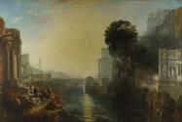
Figure 2: J.M.W Turner "Dido Building Carthage" (National Gallery, 2019)

Unlike J.M.W Turner there were a handful of other artists such as Gainsborough and John Constable who were less accepted for their art. (Gainsborough's House, 2019) (The National Gallery, L. (2019). John Constable ) What is your reference/source for this statement?X The artist John Constable focused his work off the British countryside in his home town of Surrey, his art is more appreciated now and is seen as an artist who created the idyllic landscape of what the British country life should be. However during his life, he was seen as a controversial painter as those who critiqued art thought that his work shouldn’t be counted as true works of landscapes as his paintings would frequently have the growth of industrialisation within his landscape paintings. The people within these paintings would typically be working in the agricultural industry and Constable like J.M.W Turner was a standout artist for his time. His work often depicted ‘realism’ which went against the grain in comparison of other artists works who primarily created work for the middle/upper classes as mentioned before. Constable created his pieces in order to preserve history and is a strong early example of an artist using their medium in order to document their current time. His paintings can be described a creating a social harmony by having the rural poor alongside with nature within the English countryside. (The National Gallery, 2019)
Gainsborough on the other hand (The National Gallery, 2019) would be commissioned to paint lords and ladies on their estates which in the backgrounds would show glimpses of not only their land but of workers on their fields. Gainsborough and Constable were revolutionary due to the topics of their paintings went against what was considered an acceptable depiction of a landscape. Due to going against the grain of the time they were detested the Italian Renaissance movement as their paintings did not fit with their standards of what art should be. Gainsborough’s most famous painting ‘Mr and Mrs Andrews’ is an example of this, they themselves are positioned in the corner of the painting with the rest of their land covering the rest of painting. This painting cannot determine exactly what point in his career it was created but in a lot of his earlier works he found joy in painting the industrial landscapes. He used to display his work at galleries ran by the Royal Arts Academy although over time Gainsborough stopped showing his work entirely at these types of shows, it is speculated that this is because his rival Reynold was the head of the RA and since, like Constable, he went against what was considered at the time as the natural idyllic landscape he suffered a lot of criticism against his work. (The National Gallery, 2019)
This style of documentation changed once photography was introduced, photography was invented in 1839 (Wells, 2015) but the concept and development had been around for a lot longer than that.
When documentary photography took place in the 1800’s many documentary photographers tried to find harmony between creating an interesting image without altering their surroundings, such as French photographer Henri Cartier-Bresson who painstakingly would try to find this balance of visually accurate information and what would be aesthetically pleasing to the viewer. Cartier called this ‘the decisive moment.’ (Liz Wells, 2004) Photography went from recording what have been seen as major subjects to instead exploring cultural life and experiences that other people had turned more to representation, Cartier Bresson’s work is regarded as documentary photography/ photojournalism but he stood out from other photographers of his time as he focused more on the cultural representative aspects of photography giving it greater meaning. Alan Sekula a photographer and theorist had quoted this:
‘Documentary is the thought to be art when it transcends its reference to the world, when the work can be regarded, first and foremost, as an act of self-expression on the part of an artist.’ -Sekula (1978)

Since then, not only has photography been deemed as a more accurate way at storing historical evidence but the photographs taken can be argued as a significant step up for the representation of class since whereas before oil paintings could only be afforded by those with wealth, once photography became a more accurate way to record history of events and buildings it meant a larger range of people and locations could be included. After the 1900’s there was a large rise in documentary photographers who documented the working class. (Liz Wells, 2004)

Chapter 2

During Victorian times photography was widely accepted as it confirmed the subjects to be accurate to what many other artists with different skills were trying to convey at this time. Due to photography it releveled a side of culture that many middleclass people were uneducated on at that time. It is argued that many Victorian actuality photographs were in the category of authentic this is because the subject of the images were of poor people that a middle-class spectator would view as a simple life or real. (Wells, 2015)
An example of this in the UK would be a photograph taken by Thomas Annan of the slum streets in Glasgow which was taken in 1869. This photograph showed the inhabitants clustered together at the end of street allowing for the streets which originally wouldn’t have likely been shown the light of day to be visually inspected. Within these types of surveying photographs, it would show the lives of women and children in working conditions which was a rare topic to show for other artforms at the time. Despite this, most documentary photographers such as Thomas Annan would use their skills in order to highlight an issue within the country in order to create change for the positive. (Wells, 2015)
However, it can be argued, this did create some controversy as in 1880 it was deplored if a photographer took pictures of people with wealth whereas if the subject/s were classed as degenerates they would not have to seek a permission to take their photograph and many photographers were middle class due to camera technology being so expensive and new at the time.
The repetition of history can also be related for documentary photography in the 1980’s during the reign of Margaret Thatcher. Margaret Thatcher disliked the industrial industry immensely, before her the country was led by the Labour party who gave power to the workers union for these small communities such as coal power houses that allowed people to have a job, a home to stay as well as earning a living wage. However, during the years of Labour these workers unions held a lot of power and often go on strike if they wanted a pay increase or felt that their rights as human beings were being infringed upon. Thatcher then decided enough was enough and chose to force almost all coal mines from production leaving many workers with no replacement/ alternative but to turn to the dole, many losing their homes and turning to substance abuse over the loss of their lively hoods. (Jones.O)
Like the some of the original documentary photographers previously mentioned within this chapter, key photographers and video makers kept catalogue of the events as it unfolded during this sad and desperate time. Martin Shakeshaft is one photographer who photographed the events of a Yorkshire based coal mine shutting down and the events unfolding, the imagery he took have been used in many articles and documentary’s covering the epidemic allow for those either keying up on the history or learning about it for the first time to have a better understanding on a visual level. Source? Reference? Visuals?
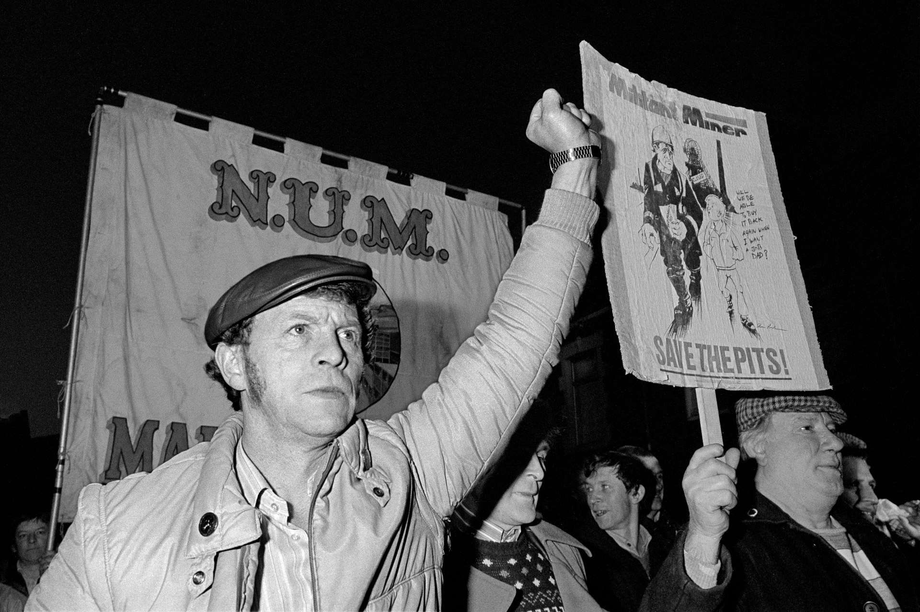
Figure 3 Martin Shakeshaft photograph of miners’ strike

By removing the mines it destroyed the infrastructure that helped to secure the livelihoods of the working class, as a result in towns that were once industrial based for their work has meant a raise in poverty level which meant fewer jobs, less substantial work and poorer education etc leading to a wider divide between working class and middle class.
According to ‘The Responsive Museum’ a book written by Caroline Lang, John Reeve, during the 1960’s museums and galleries considered their relationships with their audiences as something that was one-dimensional as museums had an unconsented authority to them. Staff who wold work in these places saw the public who would visit these places as like themselves and would see the types of people who would attend as knowledgeable and would assume each attendee would have prior understanding of the symbolism of what they were about to see.
Over the past few decades museums and galleries have been recognising more differentiating types of groups of people, many of which are interested in expressing their needs, including the groups who wouldn’t typically attend. Through this it has allowed museums to have a better appreciation for projects that stimulate types of audiences.
The types of audiences that attend museums and galleries often go as a way of increasing their cultural capital, much like economic capital or social capital, people will attempt to expand their cultural capital as a way of gaining advantages as well as status. When to comes to art galleries on the other hand it seems to be the case that they are more aware of audience and public agendas. Described as the ‘high priests of modernism’, contemporary art is argued the most problematic when it comes to learning and accessibility. This sib due to the artwork being presented is very new and often will have exclusive behaviour of its advocates, both curatorial and educational. (LANG, 2017)
A research paper which pairs well with ‘Responsive Museum’ titled ‘Spatial equity and cultural participation: how access influences attendance at museums and galleries in London’ which was published by Orion books goes more in depth with explanations to why people may not associate them with culture as well as the social standing traditions and stigmas that may block them from doing so. It goes into a more statistical analyse of the types of people who are more and less likely to go to a gallery/museum as well as how things such as area of a gallery/museum or the transport system to get to said gallery may affect the turn out that a museum may get. This study focused mainly on the on the statistics of galleries in London as its one of the largest cities in the UK as well as there being a wide varying amount of different incomes from zone to zone.

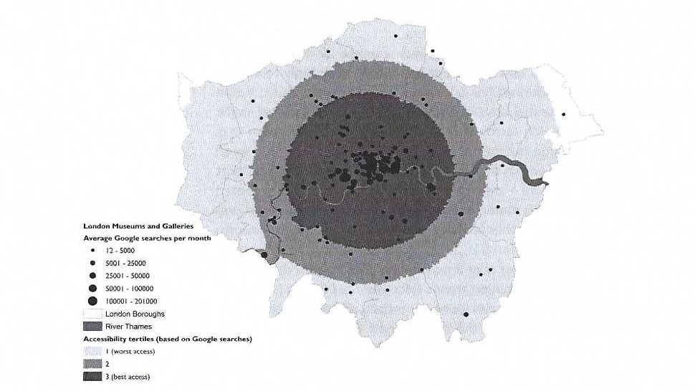
Figure 4: London Museums and Galleries, and accessibility index (Brook, Orien)

Neighbourhoods that have art galleries/museums will get people within them going to these places as it becomes more of a social normality as people within the neighbourhood such as friends and family are more likely to attend events held within these spaces. Another factor for a successful gallery/museum is if the area is also near amenities such as schools and shops etc which would therefore mean people would be more likely to spend more time in their neighbourhood rather than commuting elsewhere. In order for an art gallery to thrive, accessibility is key. A study done on googled museums and galleries names revealed that unsurprisingly museums that are located central of London (they also would have the capacity in order to hold more work) with better underground stations and roads would have higher search terms in comparison to those places where the galleries would be located more towards the outskirts of London. This is because it is harder for people to get transport to these areas. People who are living in a higher income area are nearly 50% more likely to attended than people with a lower income area.

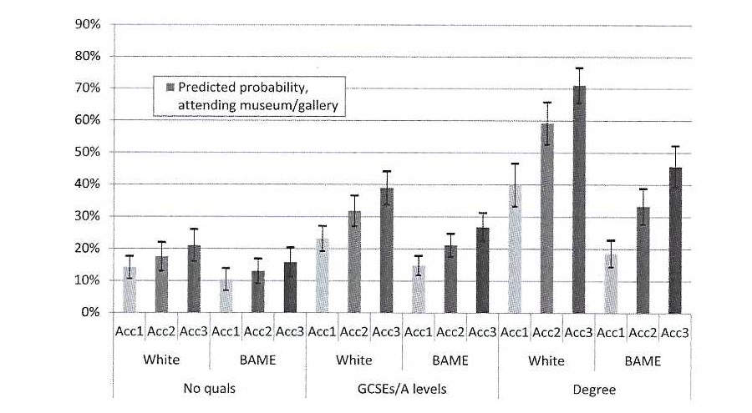
Figure 5: Predicted probabilities for attending museums and galleries in London (Brook, Orien)

There is also a correlation with educational qualifications that also plays a significant factor to whether someone is likely to attend a gallery/museum. The people who are least likely to frequent an art gallery or museum are those with no qualifications or with only a small amount of GCSE’s or equivalent qualifications compared to those who have attended university and have gotten masters and PHDs. Also, if the person has been taken to galleries as a child this also increases the likelihood of attending in the future since for those people it has been shown as a social normality at a younger age which there is a strong generational transfer. Another factor is to do with ethnicity as black and minority ethnics are less likely to attend in comparison to white.(Brook, Orien) There is a significant gradient between black and minority ethnics with degrees and those without, where those with access to these museums and galleries are 2.5 times more likely to attend in comparison to those who are the least likely to attend (46% vs 19%). (Brook, Orien)
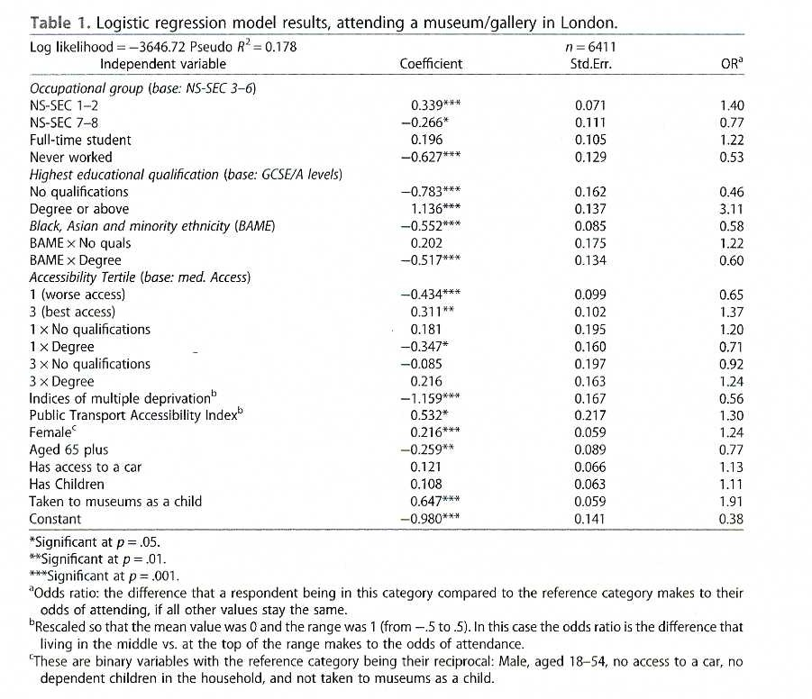
Figure 6: Logistic regression model results, attending a museum/gallery in London (Brook, Orien)

Due to these findings it further proves that social class will always play a socio-demographic factor when it comes to cultural participation.
Another study orchestrated in 2011 which used art and creativity-based activities such as ‘mindfulness-based methods’ on young people who were either in child protective services or mental health institutions. This study encouraged the participants to be creative when it came to be expressing their feelings by using the basic art supplies provided to see if it would improve on self-esteem and resilience. A second study ran the following year in 2012 by Rydzik focusing more on engaging participants on the research process by using arts as an approach to their methodology. The reason this type of methodology was chosen was to explore ‘the journeys and experiences of tourism’s female immigrant workforce’ (Rydisik et al. 2012: 284) of which held eight participants and two of which were part time artists. To help with productivity they created art works using various forms of mediums and their work was exhibited during a two-day exhibition during a community event that was attended by 150 people who were academics, professionals and policy makers (Rydzik et al. 2012: 284). According to Rydzik’s study it was a crucial project as they state it ‘contributed significantly to the participants’ empowerment and brought their voices into the wider public domain’ (Rydsik et al. 2012: 284). Since both studies are visually orientated it was studied alongside with how imagery is read and how they are used’ (Prosser and Loxley 2008: 11) According to research done by Prosser and Loxley they believed visual studies took up concepts derived from cultural studies and it further pursues the course of various image making practices that are based on more thoughtful approaches. (Prosser and Loxley 2008) This can also be compared to documentary photographers who as their professions will often pursue projects that will usually record personal and procedural used in a field diary for example as a way of building trustworthiness into their research (Prosser and Loxley 2008:16).
Due to these studies I personally have reached the conclusion that the arts are beneficial for communities to thrive and due to these studies being compared to documentary photography highlights the fact that in order to get art more relatable to marginalized groups and working class groups there needs to be a sense of relatability. These studies really help to highlight the tie between community and personal meaning being he bridging gap between art and how people to relate to it.

Chapter 3

Photography can be considered as a bridging point between people who often feel excluded from the arts community due to lack of educational funding or flaws in the social class system.
Martin Parr is a photographer that is renounced for his work that he did in Blackpool and his projects that pull contrasts between the middle class and working class. He points out cultural differences in an eye catching and sometimes comical way. Parr choses to photograph this type of topic to criticise the way we live making his work to be understandable and accessible as well as entertaining for a viewer. (Weski, 2020)
Another project contrasting from his work ‘The Last Resort’ is Parr’s project ‘The Cost of Living’ where he focuses his work on depicting the middle class, this project was published in 1989, a portrait of a decade of Thatcherism. This project reflects a type of individual and plays into the stereotypes of what it is meant to be middle class under an identity crisis from Thatcher’s rein. When presented in gallery they were initially all untitled, perhaps this was because Parr wanted the narrative of these images to speak for themselves.
Parr’s style of documentary photography is usually very candid shots and usually the subjects in his images are either seemingly unaware of the image being taken or it is taken just as the subject realises that their photograph is about to be taken. Due to this, It can be argued that in both of these projects Parr is creating a false narrative that may take the subject in the photograph out of context,
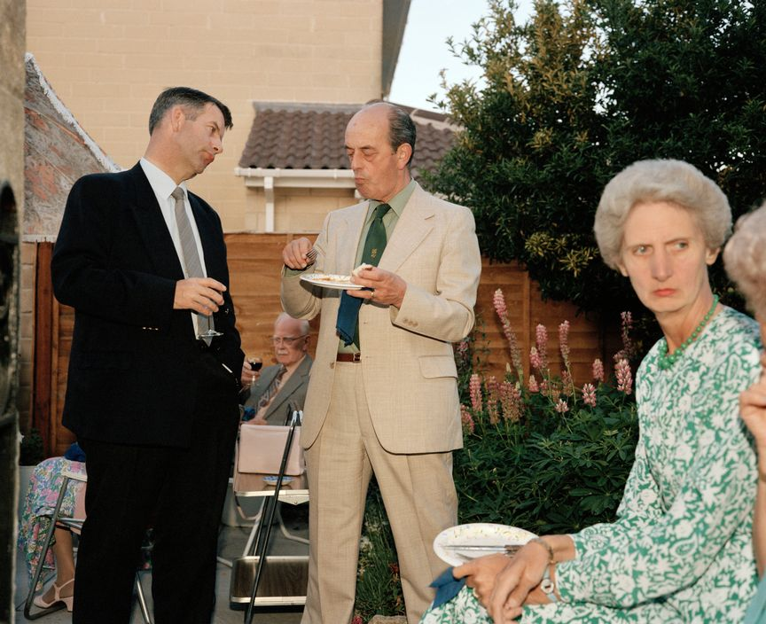
Figure 7: GB England. Conservative 'mid-summer madness’ party by Martin Parr from ‘The Cost of Living’
(Magnum Photos, 1989)

Not only does he capture the lives of everyday people so that his work creates more of statement he also presents his work in the stylings of art photography. (Weski, 2020) I would argue this to be a bridging point that would positively encourage those to go to museums and galleries or consider further arts education.

(what could be a negative point? Be like however this might also be ….)
Recently in December 2019 an exhibition that is currently being held in the Tate Britain is an gallery of photographs of every year three class in London which has been created by Steve McQueen who wanted to express that the access to art education will be only for those who are privately educated if the government does not increase funding for cultural studies across the UK. (Brown, 2020)
This complaint stretches across the UK with not only Tate joining forces with McQueen but also 35 other museums and galleries across Britain who also feel strongly that the public-school curriculum has let the youths of Britain down. This exhibition has been a huge success with more than 600 schoolchildren a day visiting the Tate Britain to see the year 3 photos which feature 76,146 children, which is two-thirds of London’s seven to eight-year olds. (Brown, 2020)
Steve McQueen states “The curriculum needs to be big enough to include all subjects and be all for all children. Art and creativity are so important to science, to maths or to any other academic venture. Cutting arts education means you cuts off inventiveness, which impacts on being creative” as well as stating that “Arts education gives that sense of possibility.” (Brown 2020)
Using younger pupils as a source of inspiration to encourage those to pursue the arts has been done before. Wendy Ewald an American based photographer is a good example of a photographer who embraces activism and education by doing collaborative. Ewald has been doing these projects since 1975 which have turned existing ideas of authority and ownership. Ewald for long periods of time would move to rural communities from across the world such places like Morocco, India, Netherlands etc. in order to teach the local children on how to work a camera to create their own photographs. The photographs would then be credited to both Ewald and Ewald’s students who would be able to choose the titles of their photographs as well as having their names credited for the photographs they took. Wendy Ewald pioneered this type of work before “socially engaged art” had become a term. (Scott, 2018)

On the other hand, it can be argued that Tate’s morals of acceptance and diversity is actually shallow, this can be seen with the ways of who they chose to represent their gallery such as the case of Anthony d’Offay who is considered a powerful figure when it comes to the contemporary British art world. In 2008 d’Offay donated almost all of his original artworks to the Tate galleries for the sum of the original price he had bought those work for, it was seen as the most generous gift the gallery could have ever been given but after recent allegations of sexual assault in 1997 the Tate suspended their connection with the dealer. There was further outrage sparked when Maria Balshaw the current director of the Tate made an ignorant comment on the matter stating “I personally have never suffered any such issues. Then, I wouldn’t. I was raised to be a confident woman who, when I encountered harassment, would say, ‘Please don’t’… or something rather more direct.” This comment was made in a meeting when the ties were cut with staff at the Tate in 2018. This led the artist in residence Liv Wynter to quit her residency due to sexual harassment comments made by the Tate director Maria Bashaw. Wynter decided to leave the Tate just before International Women’s Day to strengthen the impact of her leaving due to her claims of ‘failing women’ due to the lack of combating sexual harassment and it not fostering the diversity it needs. According to Wynters there are ‘Invisible inequalities’ at the Tate where she add in her resignation letter “I cannot describe to you the personal shame I feel as a survivor of domestic violence, to work for someone who could think so little of me whilst simultaneously profiting off my ‘survivors’ and the work I dare to make about it,’ . (Quinn, 2018)
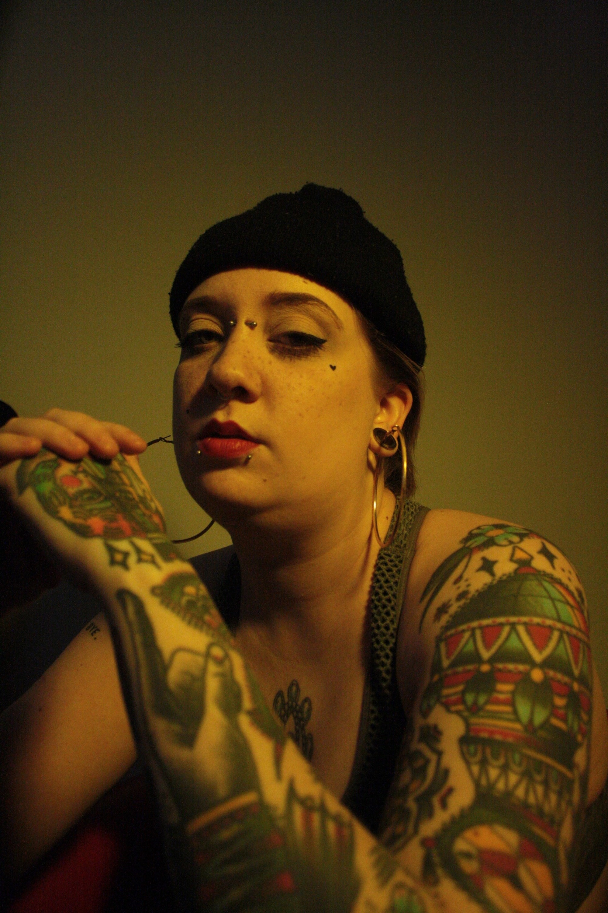
Figure 8: Profile of Liv Wynter ()

Liv Wynter’s is from a working class background and represents a part of society that feels alienated in a gallery setting, Wynter’s says that the ignorance that she faced from those from higher up are shocking and believes that those who choose to be so ignorant should have these types of roles. This story points out a fundamental flaw within gallery spaces and raises the question if the reason why people feel alienated especially from working class backgrounds is it because those who run them have no way of relating to them in the first place. This was not the only inappropriate comment that Balshaw had made, another comment on a separate occasion was a comment made on her satisfaction of seeing a group of black men eating fried chicken. Referring to the second chapter, one of the main categories of people who are least likely to go to a gallery are those who identify as BAME, Wynter also pointed out that only 13% of the workforce identify as BAME and that every director is of white ethnicity. This could be a contributing factor to the divide of people who go to galleries. (Alemoru, 2018)

In relation to Wynter’s claims, the choices that the Tate have chosen to represent their brand have been poor at times an example of this is the instance not long before the Wynter’s resignation, they struck a nerve with the cleaning staff and rallied together with the Independent Workers Union of Great Britain (IWGB) at the Tate Modern when accepting money of the company known as Ernst & Young who sponsored the Picasso 1932 exhibition. Ernst & Young which is a multinational services firm, had contracts for their cleaning staff. These cleaning staff at the time were facing many redundancies and were low paid mostly migrant workers who protested at the Tate Modern in order to earn respect for the work that is vital to society. (Theartnewspaper.com, 2018).

There is a fundamental flaw with art galleries, people who fund galleries often do not have association with lower classes or use them as means of profit with little remorse. Nan Goldin for instance, most famous for her photography book ‘The Ballad of Sexual Dependency’ and has infamous ties with drug and sex abuse, set up organisation called P.A.I.N (Prescription Addiction Intervention Now) that protests funding for art galleries from the Sackler family which for many years have invested their money in art institutions. The issue with this family is that their main source of income is the sale of Oxycontin, an opioid based drug that Nan Goldin struggled with an intense addiction towards, Goldin put pressure on these galleries and was able to pursued the National Portrait Gallery who turned down a £1m grant from the Sackler’s as well as the Tate who soon followed suit. Goldin’s battle to stop the Sacklers doesn’t end there, Goldin also plans on rectifying the damage this family has caused by pressuring them to invest their money into prevent the damage that is caused by opioid addiction. (Goldin, 2018)

Figure 9: Profile of Nan Goldin ()

The Sacklers are not the only controversial family/brand to donate money towards big museums and galleries, there have been other instances that have also struck up outrage such as the protest in 2015 at the Louvre in Paris where protestors in 2015 rallied at the Louvre Pyramid and protest the established museum from being sponsored by the French oil giant Total as well as the Italian company Eni. This peaceful protest that used umbrellas to get their message across, around 200 protestors were arrested. (Goldin, 2018)
By having these types of protests it creates a sense of community and strength that helps to bond others together, in order for galleries to be seen as more relatable it should be a case of rejecting unethical funding from sources where the income affects the lives of people in a negative way. Whether that be the mistreatment of workers or the environment. Like the protests that were held by Nan Goldin, they help set a morally correct example of how galleries should be accepting funds, thus not isolating others by choosing to stick with the social stigmatisms that scare people away.
This is not the only example of gallery foundations, when looking at the founders of most galleries they were often previously owned by those with a lot of wealth who would often be involved in dark trades that would employ workers who would have been treated unfairly or these founders would sell products without care of what damage it would cause others.
When it comes to competitions, they are usually sponsored by a large conglomerate such as the issue of when BP a large fossil fuel company sponsored the Portrait Prize in 2019 where the judges found this to be ‘a problem’. The competition had been sponsored by this company for the past 30 years but due to growing concerns with the environment it has caused criticism over if the contest should be accepting money from such a business. The competition is looking for a new way to fund itself, and is aware that it may difficult to find a new sponsor, but feel that it is the right thing to do. By ditching this sponsor, it could jeopardize the other programme that BP has ran since 2010 of the ‘BP Portrait Award: Next Generation’ a programme that specialises in seeking out talented artists between the ages of 14 to 21 years old. (Artlyst, 2017) Despite this BP have been doing their best efforts to support the arts and without their financial support competitions such as the ‘BP Portrait Award: Next Generation’ may not exist or be as successful without the large amount of funding given by the BP oil company. But despite this, there have been activists who were able to cut some of the ties BP has such as a 26-year running sponsorship of the Tate Galleries in the UK. (Vaughan, 2018) there have been cases of companies that have chosen to no longer fund these types of art spaces and venues such as the case in 2018 where after a series of protests the oil company Shell decided to let their sponsorship expire after 12 years of funding the National Gallery due to protests about the companies controversies when it came to the environment and how those who support the National Gallery and the arts in general. This is positive in the sense that the money can no longer be used as a way to clean up a company’s image and does show that if people campaign hard enough change will eventually happen. Counter argument to this is that more oil based companies such as shell and BP have moved their money into to STEM based studies which only means that they are funding another type scheme to create a cleaner image for their companies and in a more beneficial way as children from BP future type projects could potentially be trained better in that industry thus further taking away the importance and skills in the arts by lessoning the amount of funding. (Vaughan, 2018)
For instance take Tate and Lyle the sugar company who are the founders of the Tate galleries across the UK, despite their company starting out in 1830 after salivary started to become abolished in 1807 and then being fully abolished in 1833/34 does not end their ties with slavery, where even Tate confess in a statement about the founders ties with slavery ‘we believe the firms founded by the two men, which later combined as Tate & Lyle, do connect to slavery in less direct but fundamental ways.’ The Tate have admitted to pieces of artwork that have been donated and purchased by people who have either been a part of the slave trade or have been known to have owned slaves. (Tate, 2019)

Conclusion
The conclusion reached from this study suggests photography does bridge this gap however upon further study, there should be more done not just in the realm of photography but in the art community in order to increase inclusivity within its walls. When looking at documentary photography’s history it shows there is a representation still being upheld.
Photography has been used countless of times to document the reality that is life and spread awareness to issues that would have either been unknown to many or may have had a blind eye turned otherwise.
It is important to be aware by using quantitative data that has been collected via questionnaires can be argued as not being the most reliable as there is always a margin of people who do go to museums/galleries that are not being represented due to being the types of people who wouldn’t have filled out a survey. That aspect of the research is flawed. There is also another disadvantage of using surveys which the fact they are London based, it would have been more ideal to find surveys that effected the UK more widely however with London being such a large city with such a large economic differences from postcode to postcode I feel that there is still relevant and is fairly accurate in comparison to the other parts of the UK. The higher the level of education that a person has, according to research, does play a main factor on the likelihood they are to visit a gallery is an unsurprising one since arts does not get taught in depth or at a wider level until after secondary school in the UK. Most secondary schools will only teach a fraction of what the creative industry can cover. It isn’t usually until an individual will either go to a college where the number of subjects to choose will increase but then by that point the likelihood of them choosing a creative subject decreases due to the lack of foundation that secondary and primary education provides.
There is also just a general stigma around the creative industry of being a ‘waste of time’ and that there is a lacking of jobs but this is not so much the case but rather that a lot of creative industry jobs typically take longer to get into compared with other career paths. However, this is not true based on research.
Who galleries accept money from can also affect the outcome of who feels comfortable on visiting museums and galleries, such as those who have mass wealth from the misfortune from others highlights an issue with morals that many galleries must face. Despite my argument that galleries should not accept funding from these large conglomerates it is a massive challenge to gain funding elsewhere. Since the government (as pointed out in the second chapter by Steve McQueen’s work) does not give enough funding for said arts generally, to ethically and sustainably be able to create enough income in order to avoid such donations. There is no real easy way out of this aspect of finding funds, based on the research, one possible reason for this challenge is that a lot of the issues all stems from lack of funding and care in the education system when it comes to the arts. Where there would be more funding and care it would generate more young people pursing creative careers thus generating more wealth in the arts community.
There needs to be more diversity within the arts community in higher power in order to make the arts seem more welcoming towards other ethnicities, in recent exhibitions at the Tate for example there has been more inclusion of diverse artists such as Kara Walker who specialises in contempory arts, she has recently displayed her work as a part of the Hyundai Commission in 2019 titled ‘Fons Americanus’ her own version of monument depicting the atrocities that happened to Africans and Afro – Brazilians and Afro- Caribbean during the ruling of the British empire. Where typically a monument would be created and displayed as a celebration of achievements, this monument is the complete opposite and was made as a harrowing reminder of the terrible actions that were committed by the UK and the US. This monument highlights key points in black history in ways that is both eye catching as well as visual informative for people who either wish to know deeper about their own heritage or have not been taught on the matter. (Tate 2019 Kara Walker)
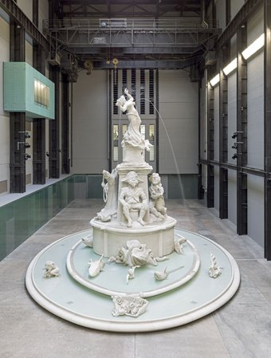
Figure 10: Hyundai Comission (2019) 'Fons Americanus' by Kara Walker (Tate 2019, Kara Walker)

For larger galleries it is perhaps that the more representation of other cultures that are implemented into their gallery shows, the wider the demographic will visit their galleries. When it comes to smaller less accessible galleries such as galleries outside of London which are on a much smaller scale, they must themselves make sure that their gallery spaces are more local community orientated in order to gain a wider demographic, this can be achieved by running arts programmes as well including history about the locations that they are in.

References
[Schuster, A. (2019). Henri Cartier-Bresson Shines at Phillips. [online] Robb Report. Available at: https://robbreport.com/shelter/auctions/henri-cartier-bresson-at-phillips-2767992/ [Accessed 9 May 2019].Accessed 8 May 2019]. x
Alemoru, K. (2018). Why the Tate’s artist in residence has quit. [online] Dazed. Available at: https://www.dazeddigital.com/art-photography/article/39336/1/liv-wynter-tate-artist-in-residence-quit-protest [Accessed 30 Jan. 2020].
BBC News. (2019). Banksy shredding 'did not go to plan'. (online] Available at: ttps://www.bbc.co.uk/news/entertainment-arts-45900314 (Accessed 9 May 2019]. x
Bbc.co.uk. (2019). BBC - History - William Henry Fox Talbot. [online] Available at: http://www.bbc.co.uk/history/historic_figures/fox_talbot_william_henry.shtml [Accessed 5 Dec. 2019]. (Bbc.co.uk, 2019)
Berger, J. (2008). Ways of seeing. London: British Broadcasting Corporation. x
Brook, Orian. Spatial Equity and Cultural Participation: How Access Influences Attendance at Museums and Galleries in London: 21-34. Web.
Brown, M. (2020). Tate and Steve McQueen call for 'arts-rich' school curriculum. [online] the Guardian. Available at: https://www.theguardian.com/education/2019/dec/17/tate-and-steve-mcqueen-call-for-arts-rich-school-curriculum [Accessed 21 Jan. 2020].
Cosslett, R. (2020). Hats off to Nan Goldin for calling out UK arts institutions on the Sacklers | Rhiannon Lucy Cosslett. [online] the Guardian. Available at: https://www.theguardian.com/commentisfree/2019/mar/27/nan-goldin-uk-arts-sacklers-opioid [Accessed 28 Jan. 2020].
Delrieu, Varina, and Gibson, Lisanne. Libraries and the Geography of Use: How Does Geography and Asset "attractiveness" Influence the Local Dimensions of Cultural Participation?: 18-33. Web.
ExpertPhotography. Available at: https://expertphotography.com/most-expensive-photographs/ [Accessed 9 May 2019]. x
Fondation Henri Cartier-Bresson. (2019). Biography - Fondation Henri Cartier-Bresson. [online] Available at: https://www.henricartierbresson.org/en/hcb/biography/ [Accessed 9 May 2019]. x
Gainsborough's House. (2019). About Thomas Gainsborough. [online] Available at: http://www.gainsborough.org/about/about-thomas-gainsborough/ [Accessed 4 Dec. 2019].
Gainsborough's House. (2019). About Thomas Gainsborough. [online] Available at: http://www.gainsborough.org/about/about-thomas-gainsborough/ [Accessed 4 Dec. 2019].
Goldin, N. (2020). Mission Statement. [online] P.A.I.N Sackler. Available at: https://www.sacklerpain.org/mission-statement [Accessed 28 Jan. 2020].
Howard, E. (2015). Activists arrested in Louvre oil protests. [online] the Guardian. Available at: https://www.theguardian.com/environment/2015/dec/09/activists-arrested-in-louvre-oil-protests [Accessed 29 Jan. 2020].
Hull, C. and >, M. (2019). The 7 Most Expensive Photographs Ever Sold by 2019. (online) x
Magnum Photos. (2019). William Boyd on Raymond Depardon's Grisaille Vision of 1980s Glasgow • Magnum Photos. [online] Available at: https://www.magnumphotos.com/arts-culture/society-artsculture/william-boyd-raymond-depardon-1980s-glasgow/?fbclid=lwAR3XXF4TDKwz3Uu5Bn2cdeYICVRUWm-bhCo2Vxod4O0ylz463sx1_VTLbHY x
O’Hagan, S. (2020). Nan Goldin: 'I wanted to get high from a really early age'. [online] the Guardian. Available at: https://www.theguardian.com/artanddesign/2014/mar/23/nan-goldin-photographer-wanted-get-high-early-age [Accessed 28 Jan. 2020].
Parr, M. (2019). What cameras do you use? I Martin Parr. (online) Martinparr.com. Available at: https://www.martinparr.com/faqs/what-cameras-do-you-use-3/(Accessed 9 May 20191. x
Pro.magnumphotos.com. (2019). Magnum Photos. [online] Available at: https://pro.magnumphotos.com/C.aspx?VP3=SearchResult&ALlD=2S5RYDYDHEB9 [Accessed 9 May 2019]. x
Prodger, M. (2020). Photography: is it art?. [online] the Guardian. Available at: https://www.theguardian.com/artanddesign/2012/oct/19/photography-is-it-art [Accessed 28 Jan. 2020].
Quinn, B. (2018). Tate artist in residence quits, claiming gallery is failing women. [online] the Guardian. Available at: https://www.theguardian.com/artanddesign/2018/mar/07/tate-modern-artist-quits-saying-gallery-is-failing-women [Accessed 29 Jan. 2020].
Scott, A. and Scott, A. (2020). What Resulted When a Photographer Gave Rural Children Cameras. [online] The New Yorker. Available at: https://www.newyorker.com/culture/photo-booth/what-resulted-when-a-photographer-gave-rural-children-cameras [Accessed 18 Jan. 2020].
Segalov, M. (2019). Martin Parr: 'There's no time for being intimidated', [online] the Guardian. Available at: https://www.theguardian.com/artanddesign/2018/dec/15/martin-parr-there-is-notime-for-being-intimidated [Accessed 9 May 20191. x
Shakeshaft, M. (2019). Strike84. [online] Strike84.co.uk. Available at: http://www.strike84.co.uk/strike84.html [Accessed 9 May 2019]. x
Shank, I. (2019). What You Need to Know about J.M.W. Turner. [online] Artsy. Available at: https://www.artsy.net/article/artsy-editorial-jmw-turner-britains-great-painter-tempestuous-seas [Accessed 3 Dec. 2019].
Tate. (2019). Kara Walker's Fons Americanus – Look Closer | Tate. [online] Available at: https://www.tate.org.uk/art/artists/kara-walker-2674/kara-walkers-fons-americanus [Accessed 5 Feb. 2020].
Tate. (2019). 'Mrs Carl Meyer and her Children', John Singer Sargent, 1896 | Tate. [online] Available at: https://www.tate.org.uk/art/artworks/sargent-mrs-carl-meyer-and-her-children-t12988 [Accessed 9 May 2019]. x
The National Gallery, L. (2019). John Constable (1776 - 1837) | National Gallery, London. [online] Nationalgallery.org.uk. Available at: https://www.nationalgallery.org.uk/artists/john-constable [Accessed 4 Dec. 2019].
The National Gallery, L. (2019). Thomas Gainsborough (1727 - 1788) | National Gallery, London. [online] Nationalgallery.org.uk. Available at: https://www.nationalgallery.org.uk/artists/thomas-gainsborough [Accessed 4 Dec. 2019].
Theartnewspaper.com. (2018). Tate Modern hit with protests over cleaner dispute. [online] Available at: https://www.theartnewspaper.com/news/tate-modern-hit-with-protests-over-cleaner-dispute [Accessed 29 Jan. 2020].
Visitflorence.com. (2019). Florence Museums:Main Museums to Visit in Florence,ltaly. [online] Available at: https://www.visitflorence.com/florence-museums/ [Accessed 8 May 2019]. x
Wells, L. (2015). Photography A Critical Introduction. London: Taylor & Francis.
Weski, T. (2020). Martin Parr • Photographer Profile • Magnum Photos. [online] Magnum Photos. Available at: https://www.magnumphotos.com/photographer/martin-parr/ [Accessed 21 Jan. 2020].
Woollard, Vicky. The View from Within: A Curatorial Account of the Rise and Fall of Visits to London Museums from 1851–2016. A Research Note: 251-269. Web.
Tate. (2019). The Tate Galleries and Slavery | Tate. [online] Available at: https://www.tate.org.uk/about-us/history-tate/tate-galleries-and-slavery [Accessed 3 Jan. 2020].

Howard, E. (2020). Activists arrested in Louvre oil protests. [online] the Guardian. Available at: https://www.theguardian.com/environment/2015/dec/09/activists-arrested-in-louvre-oil-protests [Accessed 10 Jan. 2020].

Vaughan, A. (2018). Shell ends National Gallery sponsorship – to delight of campaigners. [online] the Guardian. Available at: https://www.theguardian.com/business/2018/oct/19/shells-ends-national-gallery-sponsorship-to-delight-of-campaigners [Accessed 14 Jan. 2020].

Gallerix.ru. 2020. “The Gallery Of Cardinal Silvio Valenti-Gonzaga In Rome” - Giovanni Paolo Panini. [online] Available at: <https://gallerix.org/storeroom/459208198/N/1934970522/> [Accessed 3 April 2020].
Pro.magnumphotos.com. 1989. Magnum Photos. [online] Available at: <https://pro.magnumphotos.com/C.aspx?VP3=SearchResult&ALID=29YL53AJJYY#/SearchResult&ALID=29YL53AJJYY&VBID=2K1HZSVHJR43N&POPUPIID=29YL53ZP8S3B&POPUPPN=61> [Accessed 12 April 2020].
LANG, C., 2017. RESPONSIVE MUSEUM. [Place of publication not identified]: GARLAND Science.

Bibliography
[Schuster, A. (2019). Henri Cartier-Bresson Shines at Phillips. [online] Robb Report. Available at: https://robbreport.com/shelter/auctions/henri-cartier-bresson-at-phillips-2767992/ [Accessed 9 May 2019].Accessed 8 May 2019].
2019].
Pro.magnumphotos.com. 1989. Magnum Photos. [online] Available at: <https://pro.magnumphotos.com/C.aspx?VP3=SearchResult&ALID=29YL53AJJYY#/SearchResult&ALID=29YL53AJJYY&VBID=2K1HZSVHJR43N&POPUPIID=29YL53ZP8S3B&POPUPPN=61> [Accessed 12 April 2020].

LANG, C., 2017. RESPONSIVE MUSEUM. [Place of publication not identified]: GARLAND Science.

Alemoru, K. (2018). Why the Tate’s artist in residence has quit. [online] Dazed. Available at: https://www.dazeddigital.com/art-photography/article/39336/1/liv-wynter-tate-artist-in-residence-quit-protest [Accessed 30 Jan. 2020].
BBC News. (2019). Banksy shredding 'did not go to plan'. [online] Available at: https://www.bbc.co.uk/news/entertainment-arts-45900314 [Accessed 9 May 2019].
Bbc.co.uk. (2019). BBC - History - William Henry Fox Talbot. [online] Available at: http://www.bbc.co.uk/history/historic_figures/fox_talbot_william_henry.shtml [Accessed 5 Dec. 2019]. (Bbc.co.uk, 2019)
Berger, J. (2008). Ways of seeing. London: British Broadcasting Corporation.
Brook, Orian. Spatial Equity and Cultural Participation: How Access Influences Attendance at Museums and Galleries in London: 21-34. Web.
Brown, M. (2020). Tate and Steve McQueen call for 'arts-rich' school curriculum. [online] the Guardian. Available at: https://www.theguardian.com/education/2019/dec/17/tate-and-steve-mcqueen-call-for-arts-rich-school-curriculum [Accessed 21 Jan. 2020].
Cosslett, R. (2020). Hats off to Nan Goldin for calling out UK arts institutions on the Sacklers | Rhiannon Lucy Cosslett. [online] the Guardian. Available at: https://www.theguardian.com/commentisfree/2019/mar/27/nan-goldin-uk-arts-sacklers-opioid [Accessed 28 Jan. 2020].
Delrieu, Varina, and Gibson, Lisanne. Libraries and the Geography of Use: How Does Geography and Asset "attractiveness" Influence the Local Dimensions of Cultural Participation?: 18-33. Web.
ExpertPhotography. Available at: https://expertphotography.com/most-expensive-photographs/ [Accessed 9 May 2019].
Fondation Henri Cartier-Bresson. (2019). Biography - Fondation Henri Cartier-Bresson. [online] Available at: https://www.henricartierbresson.org/en/hcb/biography/ [Accessed 9 May 20191.
Gainsborough's House. (2019). About Thomas Gainsborough. [online] Available at: http://www.gainsborough.org/about/about-thomas-gainsborough/ [Accessed 4 Dec. 2019].
Goldin, N. (2020). Mission Statement. [online] P.A.I.N Sackler. Available at: https://www.sacklerpain.org/mission-statement [Accessed 28 Jan. 2020].
Howard, E. (2015). Activists arrested in Louvre oil protests. [online] the Guardian. Available at: https://www.theguardian.com/environment/2015/dec/09/activists-arrested-in-louvre-oil-protests [Accessed 29 Jan. 2020].
https://pro.magnumphotos.com/C.aspx?VP3=SearchResult&ALlD=2S5RYDYDHEB9 [Accessed 9 May
Hull, C. and >, M. (2019). The 7 Most Expensive Photographs Ever Sold by 2019. [online]
Jones, O. (n.d.). Chavs. Verso Books.
Jones, S. (2013). Against Technology. Florence: Taylor and Francis.
Magnum Photos. (2019). William Boyd on Raymond Depardon's Grisaille Vision of 1980s Glasgow • Magnum Photos. [online] Available at: https://www.magnumphotos.com/arts-culture/society-artsculture/william-boyd-raymond-depardon-1980sglasgow/?fbclid=lwAR3XXF4TDKwz3Uu5Bn2cdeYlCVRUWm-bhC02Vxod400ylz463sx1_VTLbHY
O’Hagan, S. (2020). Nan Goldin: 'I wanted to get high from a really early age'. [online] the Guardian. Available at: https://www.theguardian.com/artanddesign/2014/mar/23/nan-goldin-photographer-wanted-get-high-early-age [Accessed 28 Jan. 2020].
O’Hagan, S. (2020). Nan Goldin: 'I wanted to get high from a really early age'. [online] the Guardian. Available at: https://www.theguardian.com/artanddesign/2014/mar/23/nan-goldin-photographer-wanted-get-high-early-age [Accessed 28 Jan. 2020].
Parr, M. (2019). What cameras do you use? I Martin Parr. [online] Martinparr.com. Available at: https://www.martinparr.com/faqs/what-cameras-do-you-use-3/ [Accessed 9 May 2019].
Pro.magnumphotos.com. (2019). Magnum Photos. [online] Available at:
Prodger, M. (2020). Photography: is it art?. [online] the Guardian. Available at: https://www.theguardian.com/artanddesign/2012/oct/19/photography-is-it-art [Accessed 28 Jan. 2020].
Quinn, B. (2018). Tate artist in residence quits, claiming gallery is failing women. [online] the Guardian. Available at: https://www.theguardian.com/artanddesign/2018/mar/07/tate-modern-artist-quits-saying-gallery-is-failing-women [Accessed 29 Jan. 2020].
Artlyst. (2017). BP Portrait Award Cannot Escape Tainted Sponsorship Allegations - Artlyst. [online] Available at: https://www.artlyst.com/news/bp-portrait-award-cannot-escape-tainted-sponsorship-allegations/ [Accessed 26 Jan. 2020].
Scott, A. and Scott, A. (2020). What Resulted When a Photographer Gave Rural Children Cameras. [online] The New Yorker. Available at: https://www.newyorker.com/culture/photo-booth/what-resulted-when-a-photographer-gave-rural-children-cameras [Accessed 18 Jan. 2020].
Segalov, M. (2019). Martin Parr: 'There's no time for being intimidated'. [online] the Guardian. Available at: https://www.theguardian.com/artanddesign/2018/dec/15/martin-parr-there-is-notime-for-being-intimidated [Accessed 9 May 2019].
Shakeshaft, M. (2019). Strike84. [online] Strike84.co.uk. Available at: http://www.strike84.co.uk/strike84.html [Accessed 9 May 20191.
Shank, I. (2019). What You Need to Know about J.M.W. Turner. [online] Artsy. Available at: https://www.artsy.net/article/artsy-editorial-jmw-turner-britains-great-painter-tempestuous-seas [Accessed 3 Dec. 2019].
Tate. (2019). Kara Walker's Fons Americanus – Look Closer | Tate. [online] Available at: https://www.tate.org.uk/art/artists/kara-walker-2674/kara-walkers-fons-americanus [Accessed 5 Feb. 2020].
Tate. (2019). 'Mrs Carl Meyer and her Children', John Singer Sargent, 1896 | Tate. (online] Available at: https://www.tate.org.uk/art/artworks/sargent-mrs-carl-meyer-and-her-children-t12988 [Accessed 9 May 2019].
The National Gallery, L. (2019). John Constable (1776 - 1837) | National Gallery, London. [online] Nationalgallery.org.uk. Available at: https://www.nationalgallery.org.uk/artists/john-constable [Accessed 4 Dec. 2019].
The National Gallery, L. (2019). Thomas Gainsborough (1727 - 1788) | National Gallery, London. [online] Nationalgallery.org.uk. Available at: https://www.nationalgallery.org.uk/artists/thomas-gainsborough [Accessed 4 Dec. 2019].
Theartnewspaper.com. (2018). Tate Modern hit with protests over cleaner dispute. [online] Available at: https://www.theartnewspaper.com/news/tate-modern-hit-with-protests-over-cleaner-dispute [Accessed 29 Jan. 2020].
Visitflorence.com. (2019). Florence Museums:Main Museums to Visit in Florence,ltaly. (online] Available at: https://www.visitflorence.com/florence-museums/ [Accessed 8 May 20191.
Wells, L. (2015). Photography A Critical Introduction. London: Taylor & Francis.
Weski, T. (2020). Martin Parr • Photographer Profile • Magnum Photos. [online] Magnum Photos. Available at: https://www.magnumphotos.com/photographer/martin-parr/ [Accessed 21 Jan. 2020].
WNYD, 2008. YouTube. [Online] Available at: https://www.youtube.com/watch?v=kkIWW6vwrvM [Accessed 21 Janurary 2020].
Woollard, Vicky. The View from Within: A Curatorial Account of the Rise and Fall of Visits to London Museums from 1851–2016. A Research Note: 251-269. Web.
Tate. (2020). Director | Tate. [online] Available at: https://www.tate.org.uk/about-us/director [Accessed 17 Jan. 2020].
Tate. (2019). The Tate Galleries and Slavery | Tate. [online] Available at: https://www.tate.org.uk/about-us/history-tate/tate-galleries-and-slavery [Accessed 3 Jan. 2020].
Howard, E. (2020). Activists arrested in Louvre oil protests. [online] the Guardian. Available at: https://www.theguardian.com/environment/2015/dec/09/activists-arrested-in-louvre-oil-protests [Accessed 10 Jan. 2020].
Vaughan, A. (2018). Shell ends National Gallery sponsorship – to delight of campaigners. [online] the Guardian. Available at: https://www.theguardian.com/business/2018/oct/19/shells-ends-national-gallery-sponsorship-to-delight-of-campaigners [Accessed 14 Jan. 2020].
Gallerix.ru. 2020. “The Gallery Of Cardinal Silvio Valenti-Gonzaga In Rome” - Giovanni Paolo Panini. [online] Available at: <https://gallerix.org/storeroom/459208198/N/1934970522/> [Accessed 3 April 2020].

