

BA International Hotel Management
Foreign Languages
BMIH5003
Presentation Word count: 622

Student Name: Jozef Kotalr
Student ID: 2207347
Lecturer’s Name: Giulia Chifari

Contents
PRESENTATION 1
Introduction 1
Benefits of Speaking Different Languages 1
Spanish: A Useful Language 1
Being Polite in Spanish-Speaking Cultures 2
Language Awareness Skills for Our Staff 2
Conclusion 2
References 3

PRESENTATION

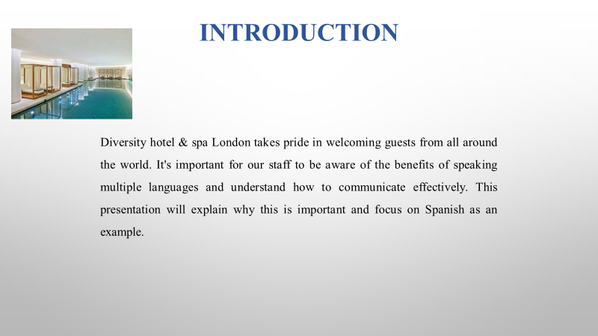

Introduction
Diversity Hotel & Spa London takes pride in welcoming guests from all around the world. It's important for our staff to be aware of the benefits of speaking multiple languages and understand how to communicate effectively. This presentation will explain why this is important and focus on Spanish as an example.
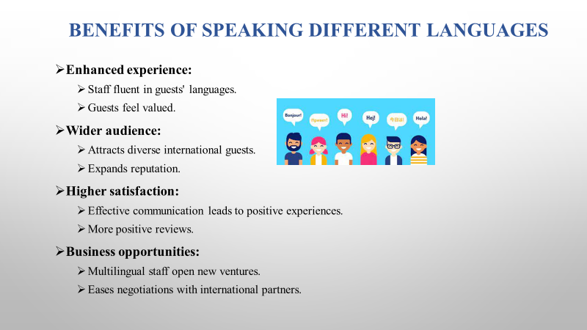

Benefits of Speaking Different Languages
Speaking different languages brings numerous benefits. Especially in a diverse environment like Diversity Hotel & Spa London:
1. Enhanced Guest Experience: It creates a welcoming and comfortable atmosphere. When our staff can communicate with guests in their native language. Guests feel understood and valued.
2. Wider Audience Reach: Being able to speak multiple languages opens up doors to a broader range of guests. We can attract visitors from various countries. Expanding our clientele and reputation (Deresky et al., 2017).
3. Increased Customer Satisfaction: Guests are more likely to have a positive experience and leave with a good impression if they can communicate effectively with our staff. This leads to higher satisfaction scores and positive reviews.
4. Business Opportunities: Speaking different languages can open doors to new business ventures and partnerships. It can also facilitate negotiations with international clients or partners.

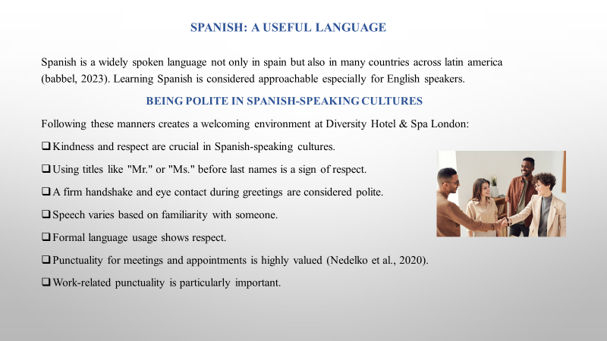

Spanish: A Useful Language
Spanish is a widely spoken language not only in Spain but also in many countries across Latin America (Babbel, 2023). Such as Mexico, Argentina, and Colombia.
Learning Spanish is considered approachable especially for English speakers. The language shares similarities with English due to their common Latin roots. While there may be some pronunciation nuances and verb conjugation challenges (Glossika, 2020).

Being Polite in Spanish-Speaking Cultures
It's really important to be kind and respectful in Spanish-speaking cultures. When saying hello, using titles like "Mr." or "Ms." before someone's last name shows respect. Giving a strong handshake and looking into the person's eyes when saying hello is also a nice way to be polite. They also have a special way of talking depending on how well you know someone. Using the more formal way of talking like saying "Mr." or "Ms." instead of using first names shows respect. Being on time for meetings and appointments is a big sign of respect too (Nedelko et al., 2020). Even though they might take it a bit easy in social situations. Being on time for work stuff is very important. Following these manners helps make everyone feel welcome and comfortable at Diversity Hotel & Spa London.

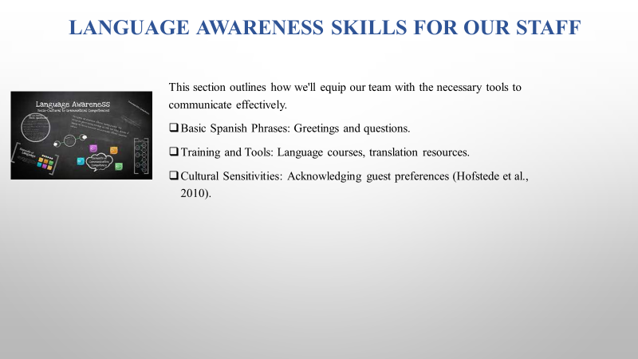

Language Awareness Skills for Our Staff
It's important for our staff to have the right language skills to ensure that our guests feel truly welcome and comfortable during their stay at Diversity Hotel & Spa London. This section outlines how we'll equip our team with the necessary tools to communicate effectively.
Basic Phrases: We'll start by providing our staff with essential greetings and useful questions in Spanish. Simple phrases like "¡Buenos días!" (Good morning) can go a long way in making our guests feel at ease.
Training and Tools: Our commitment to staff development includes offering language courses and access to translation resources. These tools will empower our team to assist guests in their preferred language. Ensuring a smoother and more enjoyable experience.
Respecting Different Cultures: Understanding and appreciating diverse customs and traditions is vital. Our staff will receive training on cultural sensitivities to ensure that every guest's unique needs and preferences are acknowledged and respected (Hofstede et al., 2010).
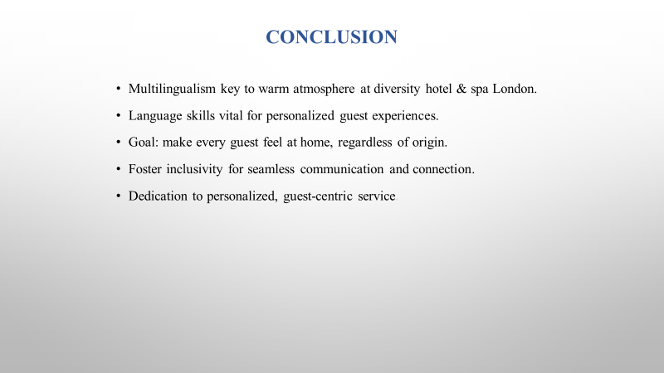

Conclusion
We can create a warm and inviting atmosphere at Diversity Hotel & Spa London by embracing multilingualism and understanding the importance of language skills. Our goal is to make every guest's stay special and language plays a big part in achieving that. Let's work together to make our guests feel at home. No matter where they come from.

References
Babbel, (2023). Where In The World Is Spanish Spoken? [Online] available at: https://www.babbel.com/en/magazine/how-many-people-speak-spanish-and-where-is-it-spoken#:~:text=There%20are%20many%20Spanish%20speaking,%2C%20Nicaragua%2C%20Panama%2C%20Paraguay%2C [Accessed on 12th October, 2023]
Deresky, H. (2017) International Management: Managing Across Borders and Cultures: Text and Cases. 9th Ed. Harlow: Pearson Education Ltd.
Glossika, (2020). 21 Spanish Verbs Native English Speakers Already Know. [Online] available at: https://ai.glossika.com/blog/english-spanish-verb-cognates [Accessed on 12th October, 2023]
Hofstede, G., Hofstede, G.J. and Minkov, M. (2010) Cultures and organizations: software of the mind. 3rd Ed. New York: McGraw-Hill.
Nedelko, Z. and Brzozowski, M. (eds) ‘Recent advances in the roles of cultural and personal values in organizational behavior’ in Ordóñez de Pablo, P. (2020) Advances in Human Resources Management and Organizational Development Book Series. Hershey: IGI Global.

