DS 1 My Digital Life

WhatsApp
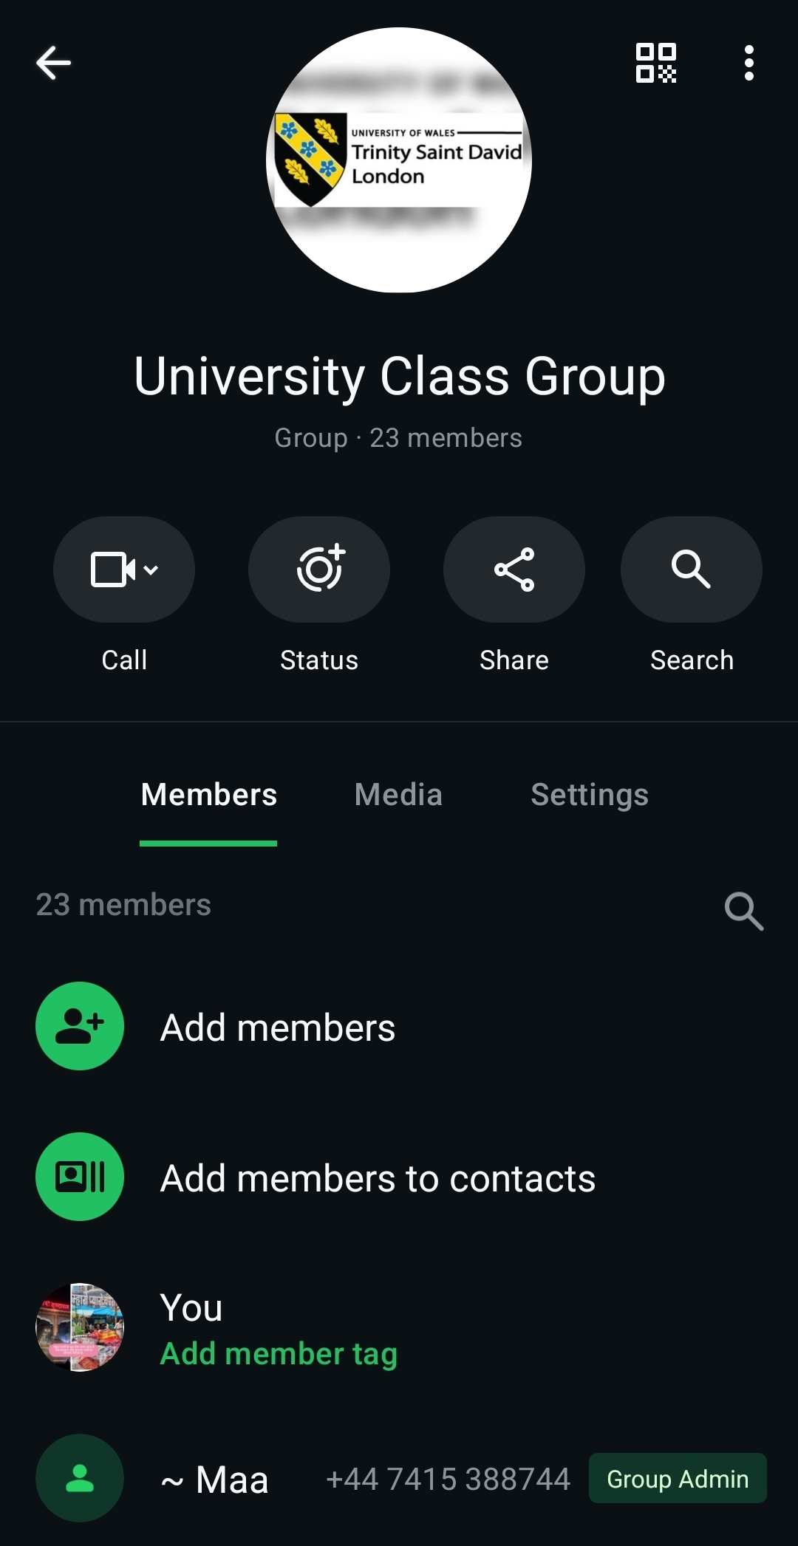
This a WhatsApp group that I use for my university class with all my classmates in it so we can help each other with any questions and doubts. We all come from different background and this is my first time in a university doing full time course CERTHE Business Skills for the Workplace and this group on WhatsApp certainly makes it convenient to quickly chat with classmates if I am stuck or have questions.

Canva

I use Canva to make templates/invites for my friends and families as I am part of a charity and we organise events and celebrate festivals together and it is so fun to use Canva because I can add as much and as little details in it and customise it as per my requirements. This is the latest invite I have made and added information as needed. There is a paid version also available but the free version is good enough too. I like to organise events and parties and Canva makes lie so much better. I have also used Canva to make YouTube Thumbnails too.

Yahoo Email
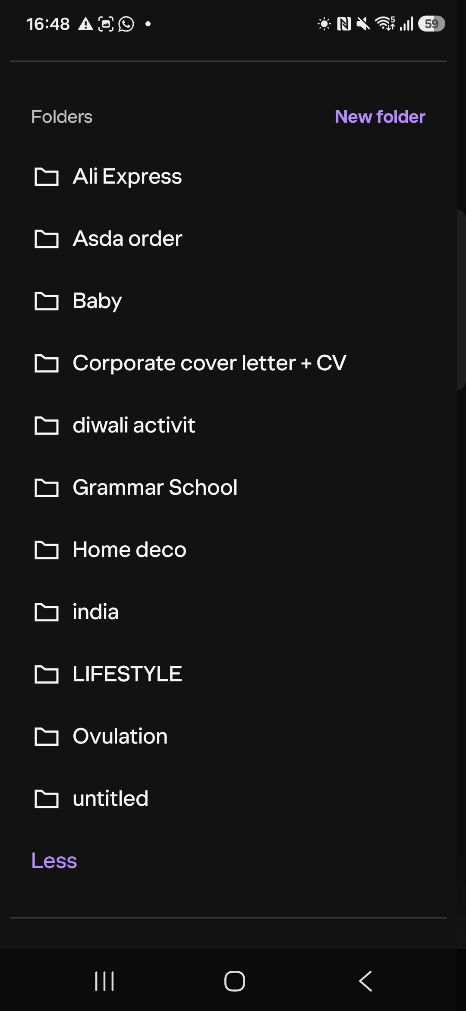
This my Yahoo email that I use everyday as one of my mode of communication and to make it use better I have added folders so I can move the relevant emails to them. It certainly helps me in organising my email folder better and helps me in keeping all the relevant emails stored in the respective folders and search them easily and saves time and looks neat.

Word Document
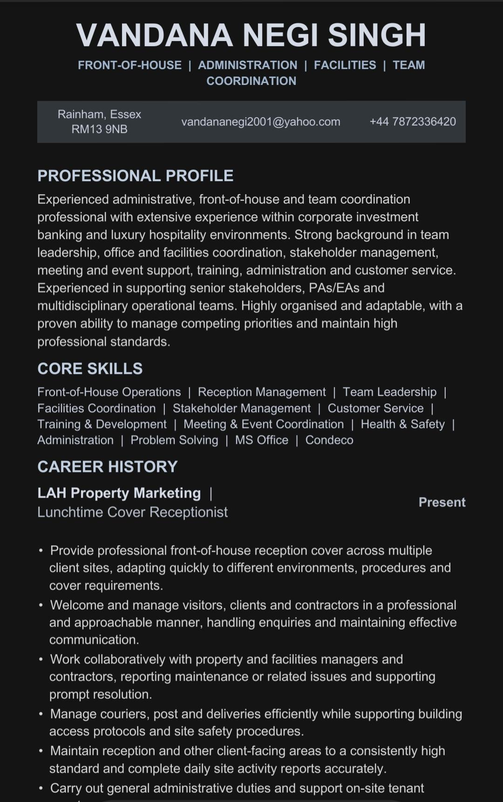
I have used word to make my cv and update it recently as I started to look for work after a career break of five years and now I use it regularly at work too. Makes life so much easy because it can correct mistakes, grammar, we can save our work and start again from where we left, we can share this word document with other people with ease and quickly. It is such a simple document to use in everyday life.

Uber App
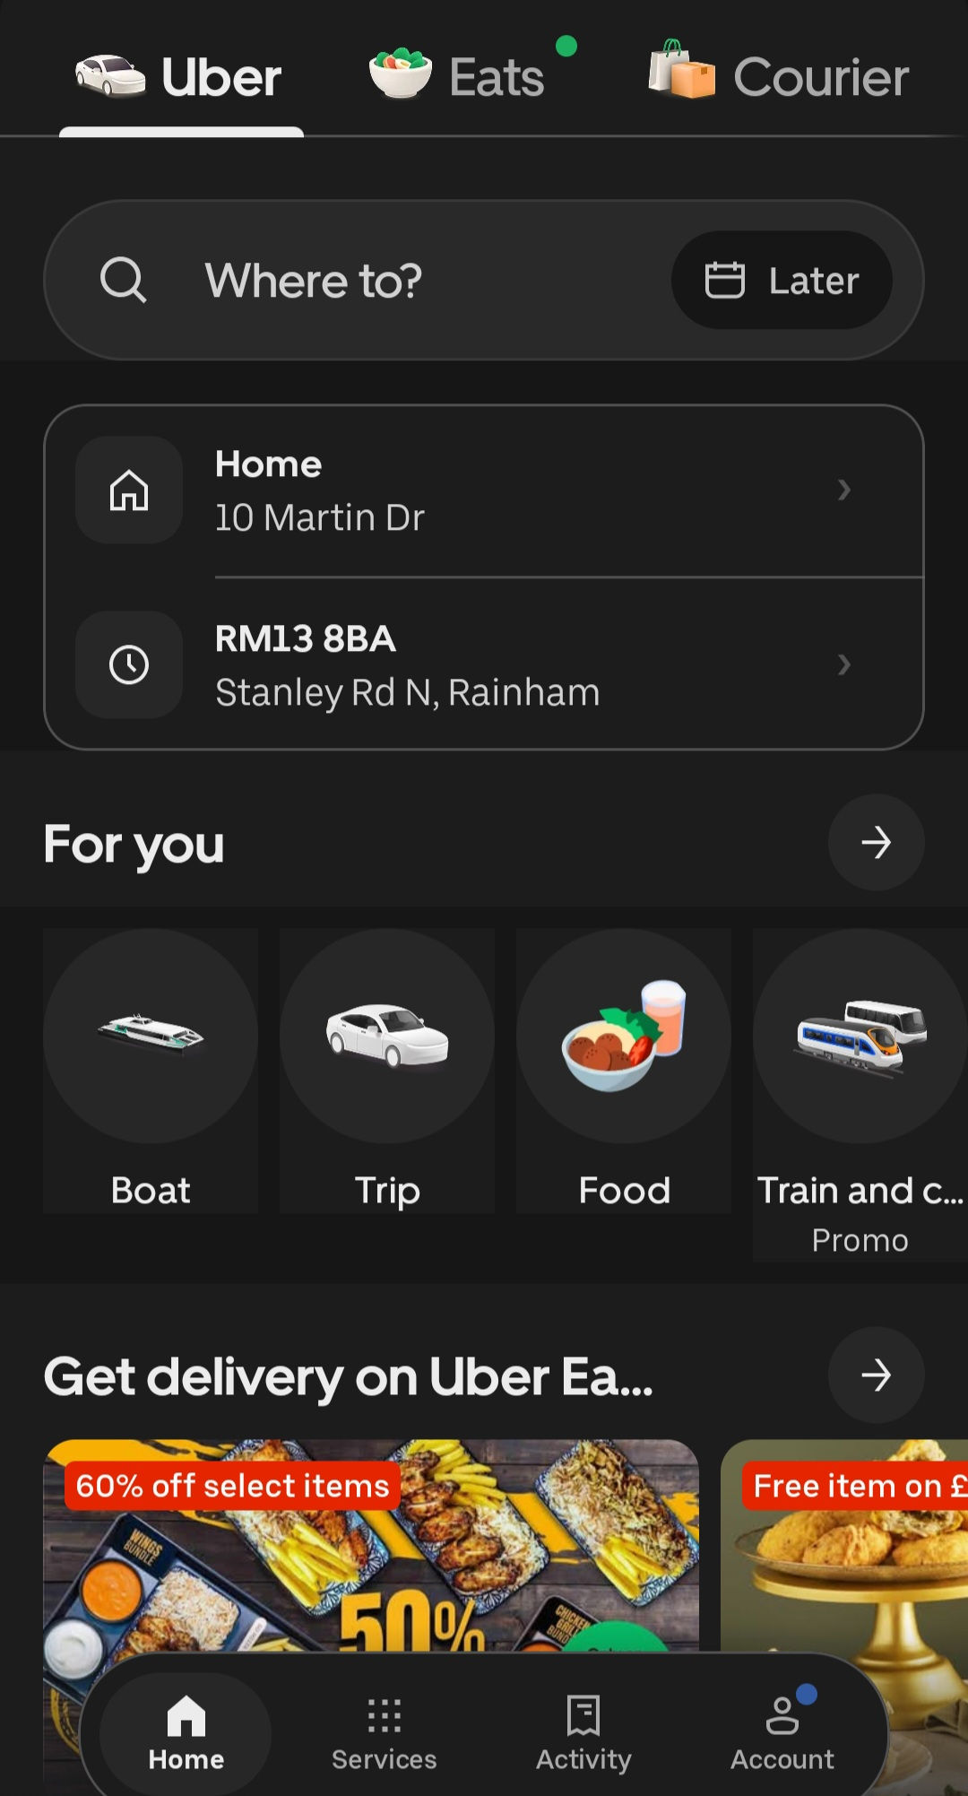
I often use Uber when I am unable to travel by public transport because i don’t drive and this app is pretty straightforward, user friendly and saves time. You can check the price by putting your destination and see the price before booking the service. It also gives rating of the driver and even the customer’s too and so you can choose a driver with good rating and otherwise cancel the ride and rebook.

6. Excel Sheet
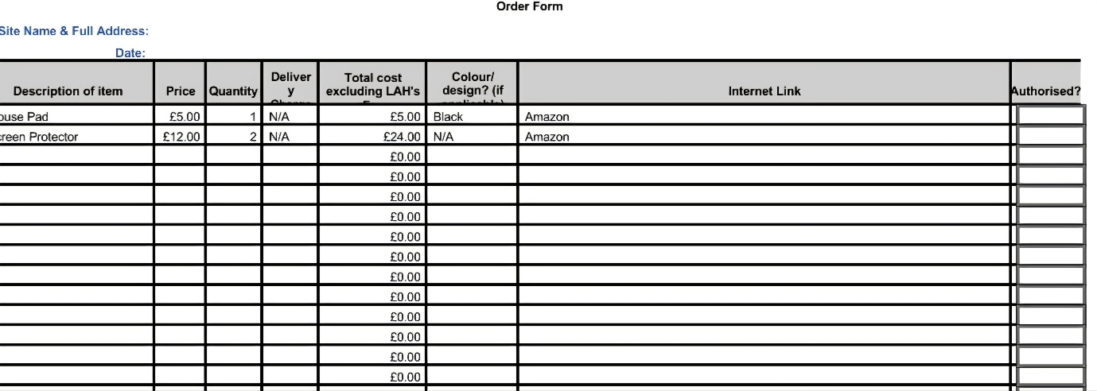
I use Excel sheet at my workplace to place orders for my office supplies. It is very basic at the moment but helps in organise office supplies request and also helps in calculations. Excel sheet certainly helps in saving time, reduces calculation errors and keeps ordering process efficient and organised.

My Short Reflection
I use all of the above tools and many others on a regular basis in my digital life and feel very confident in using these day in and day out apart from Excel. I need to learn the formulas in excel so I can use it better at an advance level as currently I am on basic/intermediate level. I’m hoping with this module will help me get better at my excel skills and take it from basic/intermediate to advance. Digital skills are of utmost importance to me especially in today’s fast paced technology driven world where everything is on a click of a finger, having knowledge to use digital skills makes life so much better, efficient and convenient . I am very excited item to expand my knowledge and put the skills that i have learnt in to practice.

Vandana

Submission Checklist
Before you submit, please check:
​​​ ☒ I added 4–6 screenshots
☒ I wrote short sentences for each screenshot
☒ I wrote my short reflection
☒ My work is my own
☒ My file opens correctly
​​☒ My file opens correctly

