

Report for Strategic Management
Assignment 2019 Using the Case Study Zara

Module Name: Strategic Management
Student Name: Huijuan Li
Student Number: 1805161

Executive Summary
The aim of the report is to reshape Zara’s strategic directions and come up with robust recommendations based on a series of strategic analysis.

Key findings:
- Customer expectations focus on more sustainable and ethical products, fast fashion industry is confronted with sustainable and ethical challenges.
- Faster fashion captures market share gradually due to the development of e-commerce, posing a great threat to the service and speed of Zara.
- Zara faces a host of successive lawsuits since 2011, including discrimination, inequality, sweatshops and copy issues.
- Vertical integration and agile supply chain are not Zara’s sustainable competitive advantages anymore, and it needs to investigate future sustainable competitive advantages.
- Zara is undergone incremental changes through the development of online platforms and sustainable initiatives, but it needs greater changes rapidly to maintain its leadership in fashion industry.

Recommendations:
- Strategic market penetration and expansions in emerging markets
- Strategic collaborations with local e-commerce giants
- Acquisitions of sustainable and ethical fashion groups
- The combination of a seamless mobile, website and in-store customer experience
- Adjustments and improvements in training courses by HR department
- Creativity encouragement
- Application of block chain
- Open day to monitor sustainable development annually

Table of Contents
Executive Summary 1
1.0 Introduction 3
1.1 Company Profile 4
2.0 Strategic Analysis 5
2.1 Macro-environmental analysis 5
2.1.1 PESTEL analysis 6
2.1.1.1 Political analysis 6
2.1.1.1.1 Brexit uncertainty 6
2.1.1.1.2 Government interventions 6
2.1.1.2 Economic analysis 6
2.1.1.2.1 Business Cycle 6
2.1.1.2.2 World GDP 7
2.1.1.2.3 Personal disposable income 8
2.1.1.2.4 Interest, inflation and foreign exchange rate 8
2.1.1.3 Sociocultural analysis 9
2.1.1.3.1 Aging populations 9
2.1.1.3.2 Changes in lifestyles and fashions 9
2.1.1.4 Technological analysis 10
2.1.1.4.1 Development of digitization and E-commerce 10
2.1.1.4.2 Popularity of social medias 11
2.1.1.5 Ecological analysis 12
2.1.1.6 Legal analysis 12
2.1.2 Porter’s five forces analysis 12
2.1.2.1 Threat of new entrants 12
2.1.2.2 Threat of substitutes 13
2.1.2.3 Bargaining power of customers 13
2.1.2.4 Bargaining power of suppliers 14
2.1.2.5 Competitive rivalry 14
2.2 Internal environmental analysis 14
2.2.1 Small lots products in Zara 15
2.2.2 Customer-oriented work team in Zara 15
2.2.3 Strong customer loyalty in Zara 16
2.2.4 Vertical integration in Zara 17
2.2.5 Inventory management in Zara 18
3.0 Main Findings of Strategic Analysis 19
3.1 Existing corporate-level strategies 19
3.2 Existing business-level strategies 21
3.3 Brand management 22
3.4 Strategic changes 23
4.0 Conclusion 25
5.0 Recommendation 26
5.1 Corporate-level strategies 26
5.2 Business-lever strategies 26
5.3 Brand management 27
6.0 References 28

Table of Figures
Figure 1 : Different Phrases of the Business Cycle of Economies - Source: Fidelity Investments (2019) 8
Figure 2 : World GDP Growth Trend - Source: IMF (2019) 8
Figure 3 : Personal Disposable Income between 2014 and 2019 - Source: Conerly (2017) 9
Figure 4 : Pound Performance between 2009 and 2019 - Source: BBC News (2019) 9
Figure 5 : Retail E-commerce Sales Worldwide from 2014 to 2021 (in billion U.S. dollars) - Source: Statista (2018) and Forbes (2018) 11
Figure 6 : Digital Disruption Changed the Rules: A New Kind of Competition: Winner-Take-All - Source: Forbes (2018) 12
Figure 7 : Zara’s resources and capabilities analysis based on VRIO framework - Source: Adapted from Johnson, et al. (2016) 16
Figure 8 : Zara’s existing strategies between 2016 and 2019 based on Ansoff’s matrix - Source: Adapted from Ansoff’s matrix (1988) 20
Figure 9 : Zara’s jeans customization - Source: Reuters (2019) 22
Figure 10 : The strategy clock - Source: Adapted from Faulkner and Bowman (1995) 22
Figure 11 : Strategic Drift - Source: Johnson, et al. (2016) 24
Figure 12 : Four Generic types of change - Source: Balogun, et al. (2016) 24

1.0 Introduction
The report is undertaken to reshape Zara’s strategic direction and come up with practical recommendations through critical strategic analysis and main findings. The PESTEL analysis and Porter’s five forces shall identify Zara’s current market position and its potential opportunities, threats and weaknesses. The internal environmental analysis based on VRIO model shall focus on its strengths to understand Zara’s sustainable competitive advantages. Main findings show a critical assessment of Zara’s existing strategy based on the strategic analysis.

Under the guidance of academic theories with regard to Porter's (1979) five forces, PESTEL analysis and VRIO framework, the report shall analyze Zara’s internal and external environment at present through diversified peer reviewed journals and news, official data and evidence.

1.1 Company Profile
Zara, as described by Marketline (2018), is one of largest fast fashion offering retailers, belonging to Inditex SA. It is founded by Amancio Ortega and Rosalía Mera in Spain in 1975 (Inditex, 2019). The company, headquartered in Arteixo, Spain, retails a variety of apparel and accessories such as dresses, skirts, jacket, jeans, outerwear, sweaters, outfits, shoes, bags, belts, etc. There are a series of private brands of Zara: Massimo Dutti, Pull&Bear, Bershka, Stradivarius, Oysho, Zara Home, Uterqüe, etc. Zara is also an international fashion corporate since its first global expansion in Porto, Portugal in 1988 (Inditex, 2019). The fashion group operating nearly 220 markets and 2,200 stores in over 96 countries launches online platforms in Singapore, Malaysia, Thailand, Vietnam and India to integrate stores and online mode in 2017 (Inditex, 2017; Forbes, 2019). Therefore, its services include online ordering, shopping, tracking, shipping, returns and exchanges and delivery nowadays.

According to Inditex (2017), Zara’s total revenue reached 16.6 billion euros in 2017, and its online sales soared roughly 41 percent accounting for 10 percent of its total in 2017. While its reported revenue was 18.9 billion US dollars in 2018, its revenue growth has been slower than before (Forbes, 2019). In 2018, it ranked forty-sixth among the world’s most valuable brands issued by Forbes (Badenhausen, 2018).

As stated by the official website of Inditex (2019), it is owing to customers as its key of unique business mode that the top priority of Zara is to guarantee and enhance the quality of customer service. Therefore, the group is committed to creating attractive and responsible fast fashion offering based on its core value of beauty, clarity, functionality and sustainability. Both Join Life and the eco-stores are main programme for Zara to be underway.

2.0 Strategic Analysis

2.1 Macro-environmental analysis

2.1.1 PESTEL analysis

2.1.1.1 Political analysis

2.1.1.1.1 Brexit uncertainty
Brexit uncertainty leads to negative repercussions of international stability (Porter, 2016). Although free trade agreements make European countries reduce or eliminate trade barriers all the time, Brexit may bring termination of this agreement (Chu, 2019). In other words, political uncertainty and potential tariffs will have a negative impact on businesses sales and profits.

2.1.1.1.2 Government interventions
Global companies may face various national policies due to local governments interventions so that it is difficult for international enterprises to enter or further develop a new market (Shah, 2018). For instance, China and India governments require that foreign firms need to cooperate with a local organization if they want to enter these two markets (Ren, 2017).

2.1.1.2 Economic analysis

2.1.1.2.1 Business Cycle
According to Hofschire, et al. of Fidelity (2019), most of developed countries have stepped into expansion stages of the business recycle, showing that global economy presents positive but more uneven growth. China’s contraction, in addition to national policy easing measures and trade-policy uncertainty, will have a negative influence on global economies as well.
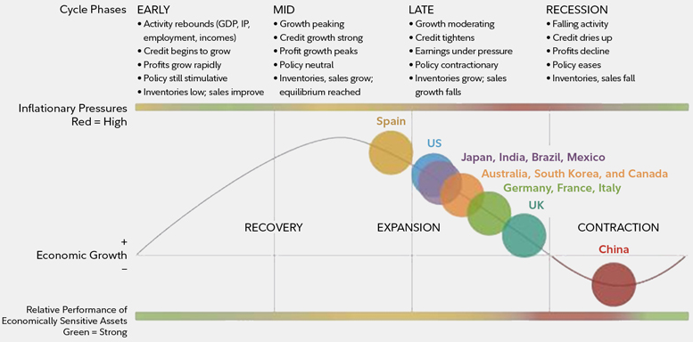
Figure 1: Different Phrases of the Business Cycle of Economies - Source: Fidelity Investments (2019)

2.1.1.2.2 World GDP
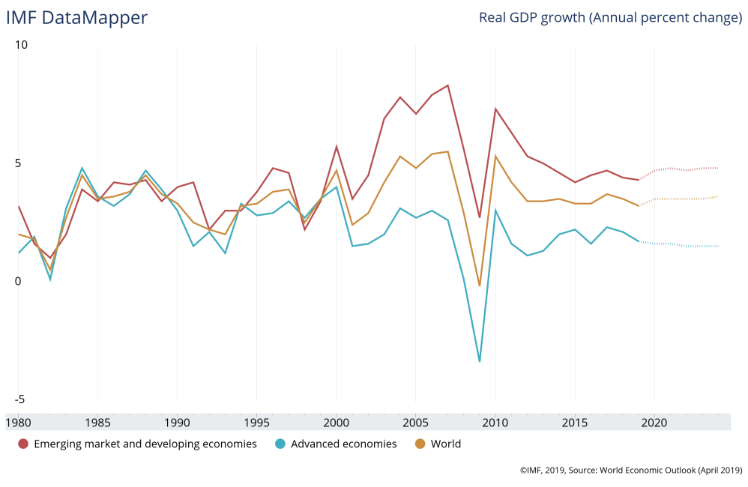
Figure 2: World GDP Growth Trend - Source: IMF (2019)

According to International Monetary Fund (2019), although GDP growth of advanced economies is becoming slower than before, but it is still on the increase. World GDP is expected to improve since 2019, which means that world economy is still overall stable.

2.1.1.2.3 Personal disposable income
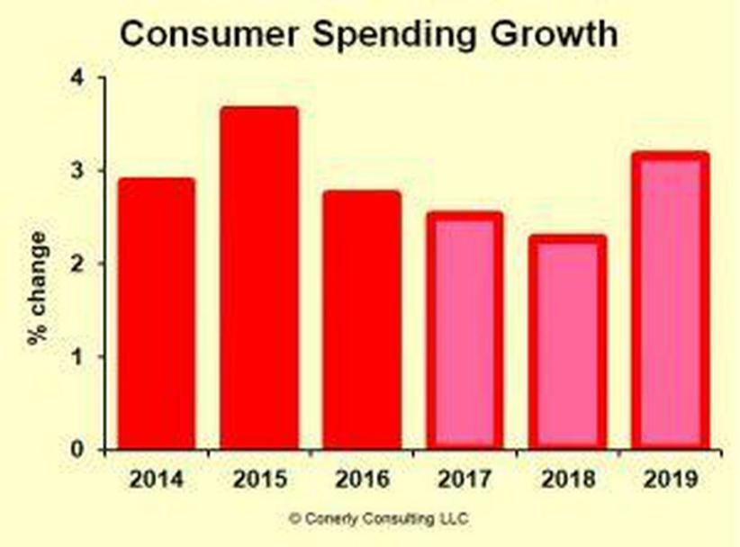
Figure 3: Personal Disposable Income between 2014 and 2019 - Source: Conerly (2017)

World disposable income is expected to be on the increase in 2019 based on the predict by Conerly (2017). In other words, increasingly consumers will be willing to spend their money rather than save it in banks. Hence, Zara can seize this opportunity to expand and develop businesses in the future.

2.1.1.2.4 Interest, inflation and foreign exchange rate
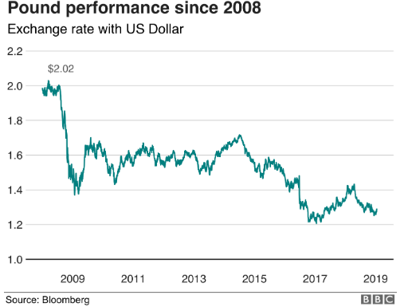
Figure 4: Pound Performance between 2009 and 2019 - Source: BBC News (2019)

Although world’s inflation presents moderate, there is an upward trend among many developed economies (United Nations, 2019). In order to strain increased inflation rate, many countries choose tightening monetary policy to restrain purchasing demand of consumers (Hofschire, et al., 2019). In addition, fluctuations of interest rate and foreign exchange rate will affect consumers’ choices and businesses development (Tchakarov and Elekdag, 2006; Engel, 2016). For example, Brexit uncertainty leads to weaker pound sterling, and foreign companies can spend less money to enter or develop Britain market (Mustoe, 2019). Therefore, Zara in United Kingdom may need to change its strategy to face fluctuations of interest, inflation and foreign exchange rates and use less money to invest in the British market.

2.1.1.3 Sociocultural analysis

2.1.1.3.1 Aging populations
Increasingly countries, as demonstrated by the United Nations (2017), has entered into the aging society, and it further predicts that approximately eight in ten of the elder people around the globe will be living in the developing regions by 2050. In other words, Zara owing manufacturing factories in developing countries will be challenged by inadequate workforce and increased workforce costs. The United Nations (2017) also predicts that the number of older persons will surpass that of children aged ten by 2030 and that of adolescents and youths by 2050, indicating that Zara will face more and more older consumers rather than merely youths and adults in the future.

2.1.1.3.2 Changes in lifestyles and fashions
With the development of multipolar world, growing digital-connectivity trends are undergoing huge changes. Consumers prefer engaging experience, responsible living, uniqueness and creativity (Kantar Consulting, 2018). What is more, according to the fashion future report of Accenture (2018), there are five mega-trends indicating the future of sustainable fashion. Connected clothes enable consumers digitalize and personalize clothes. Innovative recycling brings disruptive ways to recycle worn out clothes. Power of nature makes firms adopt natural substances and organic processes. Closet renting fits sharing economy. Long-live fashion promotes re-selling platforms and re-design concepts of clothing.

2.1.1.4 Technological analysis

2.1.1.4.1 Development of digitization and E-commerce
According to Forbes (2018), sales of worldwide retail e-commerce are expected to grow over triple in 2021 compared to that over 2014. Deloitte (2017) shows that e-commerce has great impact on sales of bricks and mortar owing to the development of digitization. The fashion industry also faces the challenge of digitization and e-commerce affecting organizations’ internal culture (Lay, 2019). For example, ultra-fast fashion groups are those online-only players such as Boohoo.com and Missguided, replicating fast fashion groups’ business model but showing faster production and lower costs than fast fashion industry (Dowsett, 2018b).
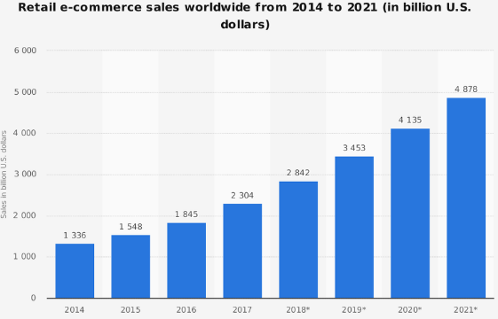
Figure 5: Retail E-commerce Sales Worldwide from 2014 to 2021 (in billion U.S. dollars) - Source: Statista (2018) and Forbes (2018)
As shown in the figure 6, it is obvious that digital disruption provides diversified enterprises with an important opportunity to change their strategies and gain competitiveness (Singh, 2018). In addition, according to World Economic Forum (2016), artificial intelligence is considered as the fourth industrial revolution. Therefore, international organizations should make the most of digital technology to seize this great chance to develop themselves such as augmented reality (AR), virtual reality (VR), AI, blockchain, Internet of Thing (IOT) (Card, 2016).
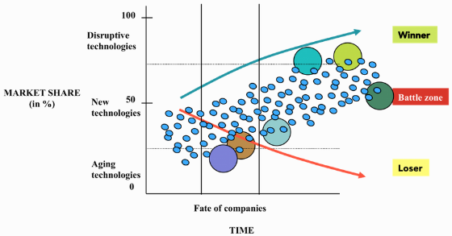
Figure 6: Digital Disruption Changed the Rules: A New Kind of Competition: Winner-Take-All - Source: Forbes (2018)

2.1.1.4.2 Popularity of social medias
According to McCue (2018), almost each corporate begins to set up official account in social medias to push relevant notifications and messages and build a closer relationship with current consumers and potential customers owing to increasingly popularity of social medias. McCue (2018) further points out that social media has been one of major sources for consumers to look for information related to brands and services. Zara spent less money on marketing though, it is active in social medias such as Facebook, Youtube, Instagram, Twitter and LinkedIn and regarded as one of successful fashion groups due to a large volume of followers on social medias (Ravi, 2018).

2.1.1.5 Ecological analysis
Increasingly consumers would like to purchase things within the scope of sustainable brands nowadays, and generation Y is regarded as green generation (Rogers, 2013). However, the development of fast fashion industry worsens global warming and pollutions (Harrabin, 2018). Therefore, more and more fashion organizations focus on sustainable development and corporate social responsibility (CSR) so that they can be recognized by customers (BBC News, 2018). As a famous fashion retailer, Zara also begins to lay emphasis on sustainable development in each process. For example, parts of Zara’s clothes are made of organic or recycled fabric, and they launch a series of projects such as JoinLife (Inditex, 2017).

2.1.1.6 Legal analysis
Different laws and regulations in countries require that international organizations need to abide by local business-relevant regulations such as labor laws, health and safety laws as well as copyright laws (Dewhurst, et al., 2012; Hansen, 2012). Zara as a global company produces and sells its products in different countries while it faces a variety of lawsuits in recent years. It was accused of gender discrimination, anti-semitism and anti-gay discrimination, child labor, sweatshops in other countries (Burgen, 2011; Clare, 2015; Girit, 2017). It can be concluded that global enterprises are supposed to fully understand and abide by local laws and regulations when they want to expand and develop themselves in other countries.

2.1.2 Porter’s five forces analysis

2.1.2.1 Threat of new entrants
There is high threat of new entrants for Zara. In terms of fast fashion industry, there is low entry barrier for start-ups and independent designers or studios on the account of the convenience and direct communications of online platforms (Edelman, 2015; Jallad, 2017). Although Nicole (2016) and Peter (2017) states that fashion firms with economies of scale or long-term customer loyalty are hard to be caught up by other companies, faster fashion groups such as Boohoo.com and Missguided break through these limitations and now they are popular among younger generations (Dowsett, 2018b). Moreover, ready-to-wear fashion industry has witnessed slower revenue growth in recent years while super-fast fashion faces growing revenue (McKinsey, 2019). Obviously, with the advent of e-commerce, fast fashion companies have been deeply influenced by new entrants.

2.1.2.2 Threat of substitutes
Zara is also exposed to high threat of substitutes, especially the rise of ethical and sustainable fashion and second-hand fashion. As stated by Pinnock (2018a), increasingly customers are concerned about green fashion. Sustainable fashion and ethical fashion in Google Search have grown nearly 46 percent and 25 percent respectively since 2012. A variety of green fashion brands are preferred by customers, such as Veja, Reformation and Nanushka (Pinnock, 2018b). What is more, According to ThredUp Resale Report (2018), it is estimated that second-hand fashion is worth of roughly 20 billion dollars at present and 41 billion dollars by 2010 so that this kind of fashion can be considered as big business in fashion industry. Haan (2019) also describes that there are many popular online resale platforms now, showing that green fashion is becoming more attractive to consumers.

2.1.2.3 Bargaining power of customers
As described by high threat of substitutes, customers have shown the third preferences and tastes in fashion industry, which poses a big threat to those famous fast fashion brands including Zara. Indeed, fast fashion brands has lost customers’ expectations so that consumer role has shifted to a more dominant influencers (Lay, 2019). They prefer ethical, sustainable or second-hand fashion and online shopping and payments. All transformation challenges fast fashion brands, and customers have high bargaining power.

2.1.2.4 Bargaining power of suppliers
Ready-to-wear fashion is characterized as effective supply chains so that it can thrive on constant changes of customers’ needs and keep up with modern fashion (Hines, 2010). Obviously, fast fashion brands have strong bargain power over suppliers when they choose to set up manufacturing factories in developing areas or cooperate with local manufacturers in developing countries such as China and India (Remy, et al., 2016).

2.1.2.5 Competitive rivalry
Intense competitions are in the fast fashion market for two reasons. First of all, there are many famous and popular global fashion groups such as Zara, H&M, Forever 21, which have commanded a majority of market share worldwide (Wattles, 2016). Besides, there are many small, local or emerging ready-to-wear fashion companies around the globe to serve customers by means of their own unique features and characteristics (Keller, et al., 2014). Then, Zara’s rivals like H&M and Gap would like to mark down prices during various festivals to clear its products while Zara expresses that it does not discount. Therefore, with the development of intense competitions including new entrants, green fashions and fast fashion groups, Zara may not be chosen as the top priority by customers any more (Dowsett, 2019). Secondly, ethical, sustainable, second-hand and faster fashion attempt to seize the market share gradually, as what has been analyzed above.

2.2 Internal environmental analysis
There are totally five significant and competitive resources and capabilities to make Zara a top dog in the fast fashion industry, and these five factors are analyzed in this section based on VRIO framework to investigate Zara’s sustainable competitive advantages.
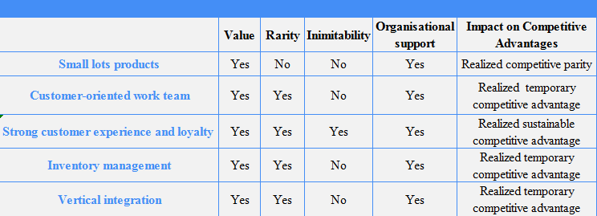
Figure 7: Zara’s resources and capabilities analysis based on VRIO framework - Source: Adapted from Johnson, et al. (2016)

2.2.1 Small lots products in Zara
Different from other fast fashion corporate through its manufacturing process at first, Zara manufactures and sells their apparel and accessories in small lots. In other words, customers need to make a decision to purchase it or not at once because products will be changed after two weeks, which can cause customers’ impulsive consumption easily (Prasad, 2015). Indeed, small-batch manufacturing and sales often stimulate consumers’ desires to purchase their products due to a scarcity value so that the fashion groups are able to make more profits. (Hill, et al., 2016). Zara strongly supports the mode of small-batch manufacturing and sales. As shown in the table, small lots products are valuable to Zara because this kind of manufacturing and sales mode provides Zara with a differentiated opportunity to make profits, create a scarcity value and lead fast fashion. However, many other fast fashion organizations follow suit such as H&M (Wilson and Yllka, 2017). Therefore, small lots products can be regarded as a realized competitive parity based on the criteria of VRIO model.

2.2.2 Customer-oriented work team in Zara
Zara is proud of its customer-oriented design team, products managers. On the one hand, store managers, as described by Danziger (2018), are responsible for collecting and monitoring to customers’ initial reactions and in-season feedback. For example, there are totally over 17 million inquiries from their customers in 2016 and products managers can collect these data and report to the Zara’s headquarters in order to improve its products and services at all times. Danziger (2018) also states that Zara focuses on the training of work team based on Zara’s initiatives of diversity, mutual respect, equality, work-life balance, etc. Zara tries to foster professional work teams capable of high-engaged interactions with customers. On the other hand, Zara’s design team will constantly develop specific fashion designs according to feedback received from managers and newest trend and send these designs to factories rapidly to produce them (Hansen, 2012). Undoubtedly, Zara’s work teams are committed to fashionable apparel and accessories designs and production on the basis on their customers’ changing tastes and preferences. Compared to other fast fashion groups, Zara is distinguished from its customer-oriented work team based on a pull model (Robinson, 2015). Nevertheless, this competitive advantage can be copied by other companies through flexible adjustments to work teams training so that it belongs to a realized temporary competitive advantage.

2.2.3 Strong customer loyalty in Zara
Generally speaking, a loyal customer is expected to visit physical stores twice to three times per year, but the appearance of Zara breaks this norm because its loyal customer can visit it nearly six times annually, indicating that customers show a strong loyalty to Zara (Kohan, 2018). Typically, loyal customers are estimated to account for nearly 80 percent of the sales of organization. In other words, more loyal customers indicate higher profit margins and market share (Tugend, 2016). Indeed, Zara is one of world’s strong performers in fast fashion industry at present, which cannot be separated from this competitive advantage. What is more, these loyalists are cultivated to become brand evangelists and influencers to share and recommend Zara to their social webs on social medias, attracting more potential shoppers to be attached to Zara (Danziger, 2018). Thus, strong customer loyalty can be considered as a realized sustainable competitive advantage but it needs Zara’s constant efforts and innovation to maintain this competitive advantage.

2.2.4 Vertical integration in Zara
At the heart of Zara’s success is its vertical integration including self-designed process, just-in-time production, marketing and final sales (The Economist, 2011). In general, most of fashion brands take at least 6 months to finish the whole process from the design stage to the shop floor while Zara’s vertical integration accelerates the process and it only takes ten to fifteen days to finish all processes (Petro, 2012). There are three parts which are deeply influenced by vertical integrated business model. Firstly, its designers and other personnel are organized as a vertical team as what has been discussed above. Secondly, Zara’s agile supply chain laid a solid foundation for its business model. Rather than outsourcing, Zara as an international company ensures roughly 60 percent of its productions and operations are close to its Spanish headquarters (Inditex, 2017). As described by Ruddick (2014), Zara prefers proximity markets such as Portugal and Morocco, which is singularly different from other fast fashion groups because they give preference to low-costs labor from the third world. Moreover, Zara established more than 14 high-automated factories in Spain where robots produce many unfinished “gray goods” (Petro, 2012). Then, with the proximity of these factories, their products can be quickly delivered to its Spanish distribution center and shipped to its world’s physical stores twice a week (Bailey, 2015). It can be noticed that Zara’s vertical integration support it to own the entire supply chain and manage all processes to guarantee quality and speed. However, Bailey (2015) also points out that vertical integration business model makes Zara unable to acquire scale economies so that Zara is impossible to enjoy the advantages of manufacturing large quantities of products for a discounted rate, and other ready-to-wear fashion companies also can replicate its agile supply chain and vertical integration model in the future although there are a few companies to do so. All in all, it is a realized temporary competitive advantage.

2.2.5 Inventory management in Zara
Zara pioneers its inventory management to keep low inventory all the time compared with other retailers (Morris, 2014). During the process of production, Zara requires its automated factories to adopt just-in-time inventory management invented by Toyota Motor Company so that it can minimize inventory holding costs and reduce wastes (Petro, 2012). What is more, Zara uses technology to forecast customers’ demands to manufacture goods (Loeb, 2013). As for the sales stage, Zara deploys Radio Frequency Identification (RFID) technology to integrate its inventory in physical stores with its online warehouses. This different inventory management is valuable and rare but it is also easy to be replicated by its competitors.

3.0 Main Findings of Strategic Analysis
Combined with the previous environmental analysis, the section assesses Zara’s existing strategies based on academic theories and models to investigate its future strategic directions.

3.1 Existing corporate-level strategies
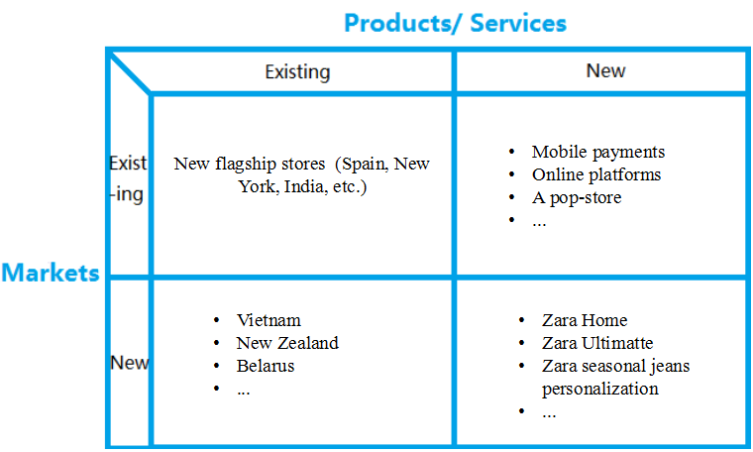
Figure 8: Zara’s existing strategies between 2016 and 2019 based on Ansoff’s matrix - Source: Adapted from Ansoff’s matrix (1988)
Ansoff’s matrix consists of market penetration, products and services development, market development and diversification on the basis of two dynamic indicators (Johnson, et al., 2016). As shown in the figure 7, Zara developed four growth strategies to maintain its leadership, expand market shares and achieve strategic growth between 2016 and 2019. In terms of market penetration, Zara prefers cities’ shopping districts or busy areas with large volume of people to inaugurate its flagship stores. In 2016, Zara opened the doors of its new flagship stores with 3,600 square meters in Barcelona’s famous architecture built for the World Fair in 1929 (Inditex, 2016). The same year, it opened one of biggest stores with 47,361 square meters in Manhattan's SoHo district (Inditex, 2016). Besides, it unveiled 524 new stores in 58 markets in 2017 and 51 markets in 2018 (Inditex, 2017; Inditex, 2018). As for market development, Zara’s international expansions focus on new markets of Vietnam, New Zealand and Belarus from 2016 to 2017 (Nhi, 2016; Redstall, 2016; Inditex, 2017). It is worth noting that these shops are eco-efficient on account of Zara's environmental plan. However, as analyzed by the previous section of PESTEL analysis, although customers’ disposable income is expected to increase, strong foreign exchange rate such as euro take toll on profits of Zara’s market penetration and expansions (Dowsett, 2018a). Aging populations may lead to less workforce and higher labor costs (Lee and Mason, 2017). A series of lawsuits damage Zara’s brand image so that the public is hard to trust Zara statement. For instance, Zara announced that they launched initiatives such as JoinLife and eco-efficient stores but the public suspects it may be greenwashing (Kaushik, 2017). For new products and services in existing market, Zara has supported mobile payments across all Spanish flagship stores for the improvement of customer experience and simplification of purchasing processes since 2016 (Inditex, 2016). In 2018, Zara opened its first pop-up store as brand-new concept, marking a millstone of integration of online platforms with physical stores (Inditex, 2018). Moreover, Zara announced that its online platforms can be available in 106 markets in 2018 and its online presence will be displayed in 202 markets by 2020 (Inditex, 2018). However, Zara offered online shopping since 2007 and guaranteed further online presence, but it is still inevitable that Zara faces challenges from e-commerce including Amazon, Boohoo.com and so on (Dowsett, 2018b). Hence, it still needs to speed up the integration process, find its unique competitiveness and make the most of it as soon as possible to compete with these strong opponents. In terms of diversification strategy, Zara debuts Zara Ultimatte lipsticks recently (Winter, 2018). In 2019, Zara is intend to launch customization service for jeans to satisfy customers’ needs (Dowsett, 2019). However, Dowsett (2019) also shows that it has not brought much profits actually but it follows the hottest trend.
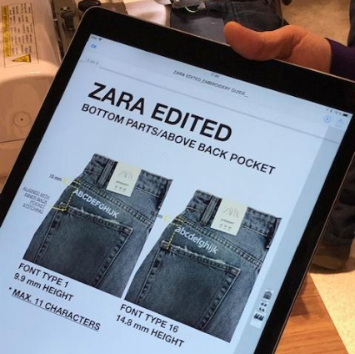
Figure 9: Zara’s jeans customization - Source: Reuters (2019)

3.2 Existing business-level strategies
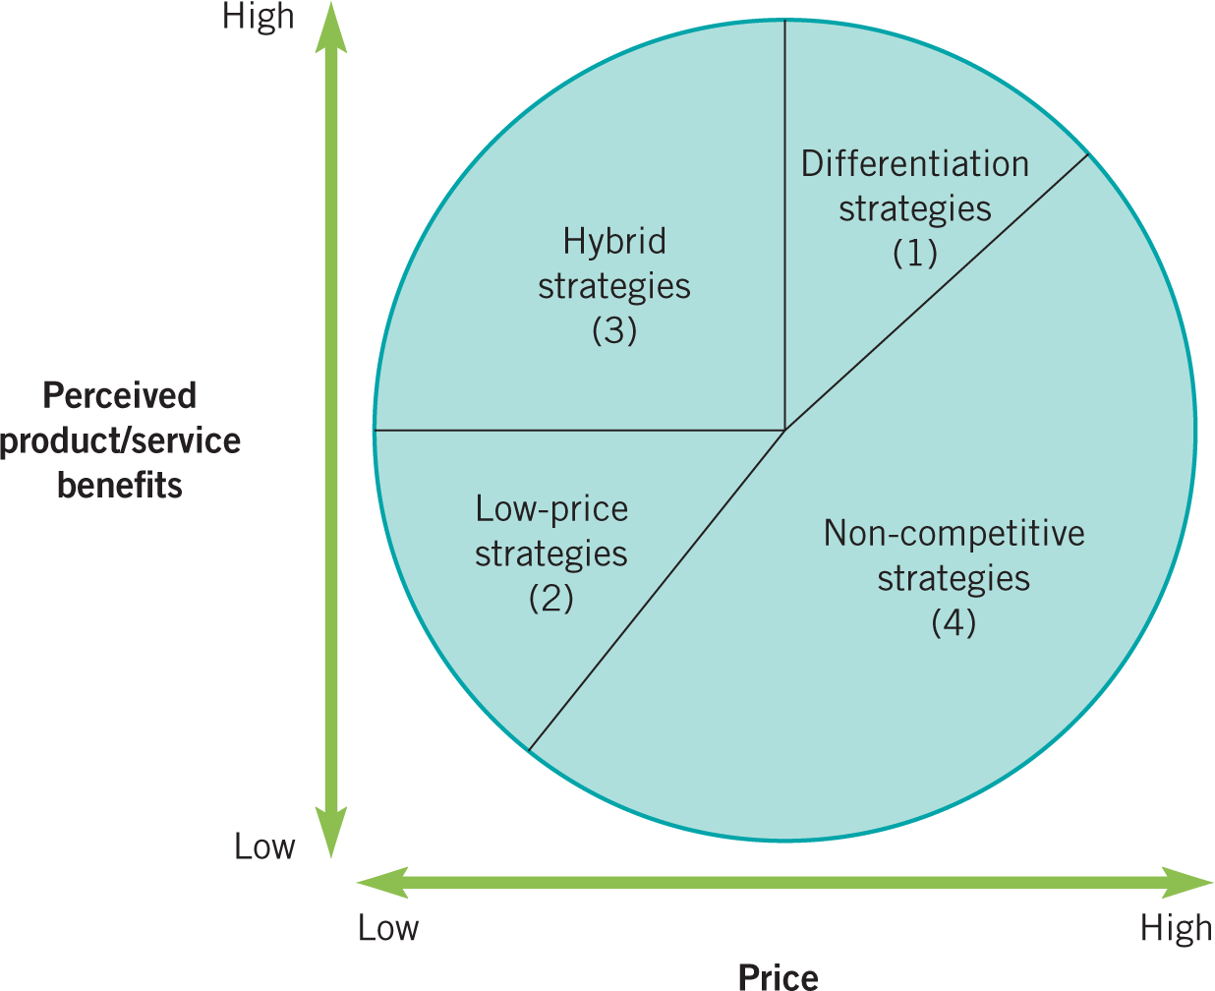
Figure 10: The strategy clock - Source: Adapted from Faulkner and Bowman (1995)
According to the internal environmental analysis, it is obvious that Zara adopts a hybrid strategy at 12 o’clock of the strategy clock. Zara has built its differentiation strategy in order to respond customer trends rapidly through customer-oriented designers, small lots products and vertical integration (Petro, 2012; Madden, 2015; Loeb, 2015). As for its cost-leadership strategy, Zara is characterized by its forward and backward integration to save costs, and its effective inventory management eliminates wastes and minimizes unnecessary inventories. Although its costs decreased a lot, its prices are still a little higher than other fashion groups because it provides better quality than them. It is owing to high-quality products at moderate prices that Zara attracts more customers and gains brand loyalty (Hansen, 2012; Louw and Venter, 2013). Nevertheless, as what has been mentioned above in the Porter’s five forces, its hybrid strategy is difficult to maintain. Ethical, sustainable and second-hand fashion demonstrates greater differentiation and customer preferences while super fast fashion shows faster processes, lower prices and more styles.

3.3 Brand management
According to Inditex (2019), multiculturalism, diversity, respect and equality is its commitments to their employees. Indeed, there are 174,386 staff speaking 57 languages from 97 countries up to now, indicating that the group supports diversity and inclusion policy. In addition, the group reached an agreement with UNI Global Union to guarantee all the labor rights in 2009. The same year, it supported Gender Equality Plans to prevent gender discrimination and sexual harassment. In order to reduce gender discrimination, it has implemented the EQUAL Community Initiative proposed by the European Commission, the Spanish Coordinator of the European Women's Lobby and the Carolina Foundation since 2006. All these actions show the group wants to create an inclusive and equal work environment. However, Zara was accused of slave labor, child labor and sweatshops in Brazil in 2011 (Burgen, 2011). It faced a 40 million dollars discrimination suit in 2015. A former in-house counsel called Miller said Zara’s discrimination culture because he is Jewish, American and gay as well as Zara’s creator Amancio Ortega because he emailed porn picture and boasted sexual exploits with female staff to Miller (O'Connor, 2015). In 2017, it was met with a controversy not paying wages for over 140 workers in Turkey (NilKöksal ,2017). These suits obviously is not in accordance with their commitments and agreements, damaging its brand image. Besides, Zara is also mired in controversy related to copy (Puglise, 2016; Hanbury, 2018). To be honest, Zara’s image is not what it used to be before although it offers better quality at moderate prices, impacting customers’ experience and brand values. Therefore, Zara needs to lay emphasis on changes in brand management and internal
management.

3.4 Strategic changes
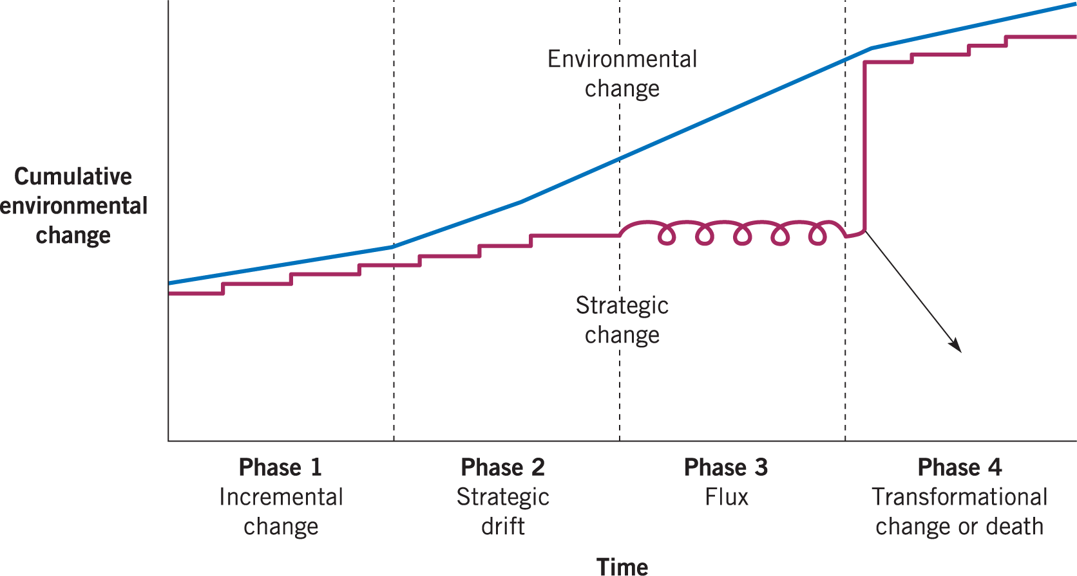
Figure 11: Strategic Drift - Source: Johnson, et al. (2016)
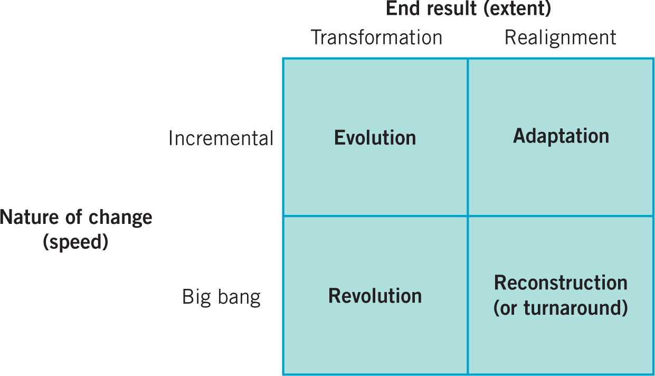
Figure 12: Four Generic types of change - Source: Balogun, et al. (2016)
Through the previous analysis, digitization and sustainable development are influential mega-trends. In order to keep up with environmental changes, Zara develops eco-efficient stores and JoinLife initiative as well as launches online platforms in 202 markets (Kaushik, 2017; Inditex, 2018). So, it can be noticed that Zara is in incremental change at present, and therefore Zara obviously adopts adaption to carry out strategic changes. Nevertheless, these actions are not enough for Zara to maintain its leading position and develop itself. Besides, both JoinLife and personalization are small-scale, accounting for low proportion of profits (Dowsett, 2019).

4.0 Conclusion
Zara, a world-class fast fashion corporate, features agile supply chain, vertical integration and hybrid strategies. The group leads the trend of fast fashion worldwide and captures the whole market rapidly, defeating traditional fashion companies. However, it states that the growth of revenue has been slower than before recently. The report therefore conducts the following in-depth strategic analysis to evaluate its existing strategies and reshape its strategic directions.

First of all, PESTEL analysis finds that political and economic environments are generally stable although Zara as a global company may be influenced by Brexit uncertainty, governments interventions and fluctuations of national economic indicators. The future impact of aging populations, changes in lifestyle, fashions and the rise of e-commerce and the implementation of CSR need to be taken into considerations so that Zara is capable of preventing potential issues, and legal analysis shows that Zara is confronted with a host of lawsuits and its brand management needs to be improved. Secondly, Porter’s five forces demonstrate that Zara faces intense competitions with sustainable, ethical, second-hand and faster fashion opponents so that customers’ bargaining power is stronger than before as well. Then, VRIO model finds that its competitive advantages arising from fast fashion are not sustainable anymore and it should make the most of its strong customer loyalty to investigate its future competitive advantage. Lastly, in order to put forward new problem-oriented strategies, main findings of strategic analysis give critical assessment of Zara’s existing strategies combined with the previous strategic analysis, identifying its strategic problems.

5.0 Recommendation

5.1 Corporate-level strategies
Although increasingly customers in developed countries prefer green and faster fashion, there are still many consumers enjoy ready-to-wear fashion in other countries. Zara therefore should continue to develop its market penetrations and expansions to win strong global presence as its one of competitive advantages. The group needs to pay more attention to emerging markets such as India, China and ASEAN due to a tremendous jump in consumers’ income and expenses (World Economic Forum, 2019). What is more, in terms of Zara’s online presence, strategic partnerships with local e-commerce giants should be taken into consideration. If there are strong local e-commerce opponents, collaboration is better than competition because local third-party platforms can help Zara reach more local consumers rapidly and save digital costs.

5.2 Business-lever strategies
Zara adopts a hybrid strategy to achieve its strategic intent that fashionable products at highest possible quality can be affordable (Inditex, 2017). However, it is impacted by emerging competitors. Nowadays, Zara needs to lay more emphasis on differentiation. The best way for Zara is to combine the advantages of sustainable fashion and faster fashion. On the one hand, sustainable and ethical fashion does not lay a solid foundation now while Zara with strong customer loyalty, economic power and global presence can undertake strategic mergers and acquisitions of these fashion groups and preoccupy most markets rapidly. On the other hand, for faster fashion and e-commerce, Zara needs to speed up the integration of online platforms with physical stores to achieve the combination of a seamless mobile, website and in-store customer experience as its one of competitive advantages that online competitors cannot replicate. For instance, Zara can offer services such as in-store pickup and virtual assistants.

5.3 Brand management
There are three ways to repair Zara’s damaged image. First of all, HR departments should make reasonable adjustments and improvements with regard to employees’ training and selection. It can set up new training courses related to gender, racial equality and sexual harassment. Besides, HR practitioners are supposed to ensure every employee understand its zero tolerant attitudes towards these issues and direct consequences for those employees who fail to comply with these regulations. As for designers, Zara should begin to encourage designers to unleash their creativity and design by themselves, indicating that Zara needs to achieve shifts from copycats to self-designed brand. Secondly, Zara needs to draw up a specific plan or utilize block chain technology to monitor its outsourcing factories regularly. Lastly, Zara can choose an open day annually to invite its customers and medias to visit their sustainable activities.

6.0 References
Ansoff, H.I. (1988) Corporate Strategy. Penguin.

Accenture (2018) Trend report: Future of sustainable fashion. Accenture.
[Online]. Available at:
https://www.accenture.com/t20170410T044051Z__w__/us-en/_acnmedia/Accenture/Conversion-Assets/DotCom/Documents/Global/PDF/Consulting/Accenture-HM-Global-Change-Award-Report.pdf
[Accessed 9th May 2019].

Burgen, S. (2011) Zara Accused in Brazil Sweatshop Inquiry. The Guardian. p. Online Extra.

Balogun, J. Hailey, V. H. and Gustafsson, S. (2016) Exploring Strategic Change. Pearson.

Badenhausen, K. (2018) The World's Most Valuable Brands 2018. Forbes. p. Online Extra.

BBC News. (2018) Can the 'Broken' Fashion Industry Become More Sustainable? BBC News. p. Online Extra.

Clare, O. (2015) Fast Fashion Giant Zara Faces $40 Million Anti-Semitism, Anti-Gay Discrimination Suit. Forbes. p. Online Extra.

Card, J. (2016) The Eight Technologies Every Entrepreneur Should Know about. The Guardian. p. Online Extra.

Conerly, B. (2017) Economic Forecast 2018-2019: Consumer Spending Grows Slowly. Forbes. p. Online Extra.

Chu, B. (2019) Brexit: Rolled-over UK Free Trade Deals 'are Incomplete'. BBC News. p. Online Extra.

Dewhurst, M., Harris, J. and Heywood, S. (2012) The Global Company’s Challenge. McKinsey. [Online]. Available at:
https://www.mckinsey.com/business-functions/organization/our-insights/the-global-companys-challenge
[Accessed 9th May 2019].

Deloitte (2017) Disruptions in Retail through Digital Transformation: Reimagining the Store of the Future. Deloitte. [Online]. Available at:
https://www2.deloitte.com/content/dam/Deloitte/in/Documents/CIP/in-cip-disruptions-in-retail-noexp.pdf
[Accessed 9th May 2019].
Danziger, P. N. (2018) Why Zara Succeeds: It Focuses on Pulling People In, Not Pushing Product Out. Forbes. p. Online Extra.

Dowsett, S. (2018a) Strong Euro Takes Toll on Zara Owner Inditex. Reuters. p. Online Extra.
Dowsett, S. (2018b) Zara Looks to Technology to Keep up with Faster Fashion. Reuters. p. Online Extra.

Dowsett, S. (2019) Zara to Open Denim Customization Pop-ups in Three Stores. Reuters. p. Online Extra.

Edelman, B. (2015) How to Launch Your Digital Platform. Harvard Business Review. p. Online Extra.

Engel, C. (2016) Exchange Rates, Interest Rates, and the Risk Premium. American Economic Review. p. Online Extra.

Forbes (2019) ＃304 Zara. Forbes. p. Online Extra.

Girit, S. (2017) Turkey: Zara Shoppers Find Labor Complaints Inside Clothes. BBC News. p. Online Extra.

Hines, T. (2010) Trends in Textile Global Supply Chains. Textiles. 37 (2): 18–20.

Hansen, S. (2012). How Zara Grew into the World’s Largest Fashion Retailer. The New York Times. p. Online Extra.

Hill, C., Schilling, M. and Jones, G. (2016) Strategic Management: Theory: An Integrated Approach. Cengage Learning.

Harrabin, R. (2018) Fast Fashion is Harming the Planet, MPs say. BBC News. p. Online Extra.

Hanbury, M. (2018) Zara and Forever 21 Have a Dirty Little Secret. Business Insider. p. Online Extra.

Haan, C. (2019) The Easiest Way to Practice Sustainable Fashion — And Make Money Doing It. Forbes. p. Online Extra.

Hofschire, D., Lisa, E., Joshua, L. and Jacob, W. (2019) Market outlook: Increased uncertainty. Fidelity. [Online]. Available at:
https://www.fidelity.com/viewpoints/market-and-economic-insights/business-cycle-update-feb-2019
[Accessed 9th May 2019].

Inditex (2016) Zara Inaugurates a Flagship Store in the Heart of Barcelona with a Space Stretching More than 3,600m². [Online]. Available at:
https://www.inditex.com/en/article?articleId=265929&title=Zara+inaugurates+a+flagship+store+in+the+heart+of+Barcelona+with+a+space+stretching+more+than+3%2C600m2
[Accessed 9th May 2019].

Inditex (2016) Zara Unveils a 47,361 ft2 Flagship Store in the Heart of SoHo. [Online]. Available at:
https://www.inditex.com/en/article?articleId=196733&title=Zara+unveils+a+47%2C361+ft2+flagship+store+in+the+heart+of+SoHo
[Accessed 9th May 2019].

Inditex (2016) Inditex is Launching Mobile Payments Z cross the Group's Entire Spanish Store Base Tomorrow. [Online]. Available at:
https://www.inditex.com/en/article?articleId=211427&title=Inditex+is+launching+mobile+payments+across+the+Group%27s+entire+Spanish+store+base+tomorrow
[Accessed 9th May 2019].

Inditex (2017) Inditex Annual Report 2017. [Online]. Available at:
https://www.inditex.com/documents/10279/563475/2017+Inditex+Annual+Report.pdf/f5bebfa4-edd2-ed6d-248a-8afb85c731d0
[Accessed 9th May 2019].

Inditex (2017) Inditex Opens its First Stores in Belarus and Reaches 94 Markets. [Online]. Available at:
https://www.inditex.com/en/article?articleId=426575&title=Inditex+opens+its+first+stores+in+Belarus+and+reaches+94+markets
[Accessed 9th May 2019].

Inditex (2018) Zara Débuts Pop-up Store Focused on Online Orders in London.
[Online]. Available at:
https://www.inditex.com/en/article?articleId=544094&title=Zara+d%C3%A9buts+pop-up+store+focused+on+online+orders+in+London
[Accessed 9th May 2019].

Inditex (2018) Inditex's Net Sales Rise 9% to €25.34 Billion in Fiscal 2017.
[Online]. Available at: https://www.inditex.com/en/article?articleId=552792&title=Inditex%27s+net+sales+rise+9%25+to+%E2%82%AC25.34+billion+in+fiscal+2017
[Accessed 9th May 2019].

Inditex (2018) Inditex Net Sales Climb 3% to €18.4bn in First Nine Months, up 7% in Local Currencies. [Online]. Available at:
https://www.inditex.com/en/article?articleId=607204&title=Inditex+net+sales+climb+3%25+to+%E2%82%AC18.4bn+in+first+nine+months%2C+up+7%25+in+local+currencies
[Accessed 9th May 2019].

Inditex (2018) Zara Launches Online Sales in 106 New Markets through New Global Platform. [Online]. Available at:
https://www.inditex.com/en/article?articleId=605438&title=Zara+launches+online+sales+in+106+new+markets+through+new+global+platform
[Accessed 9th May 2019].

Inditex (2019) Zara. [Online]. Available at:
https://www.inditex.com/about-us/our-brands/zara
[Accessed 9th May 2019].

Johnson, G., Whittington, R., Scholes, K., Angwin, D. and Regnér, P. (2016) Exploring corporate strategy: text and cases. New York, Prentice Hall.

Jallad, R. (2017) How to Take Your Fashion Business Direct-To-Consumer and Succeed in The Digital Era. Forbes. p. Online Extra.

Keller, C., Magnus, K., Hedrich, S., Nava, P. and Tochtermann, T. (2014) Succeeding in Tomorrow’s Global Fashion Market. McKinsey. [Online]. Available at:
https://www.mckinsey.com/business-functions/marketing-and-sales/our-insights/succeeding-in-tomorrows-global-fashion-market
[Accessed 9th May 2019].

Kaushik, A. (2017) ZARA: Real or No Real? Fashion Compassion.
[Online]. Available at:
https://www.fashioncompassion.co.uk/zara-join-life-sustainable-collection/
[Accessed 9th May 2019].

Kantar Consulting (2018) Taking the Consumer Lifestyle Trends into 2018 and beyond. Bord Bia. [Online]. Available at:
https://www.bordbia.ie/industry/manufacturers/insight/publications/bbreports/ConsumerLifestyleTrends2018/Consumer%20Lifestyle%20Trends%202018%20-%20Full%20Report.pdf
[Accessed 9th May 2019].

Loeb, W. (2013). Zara’s Secret to Success: The New Science of Retailing. Forbes. p. Online Extra.

Louw, L. and Venter, P. (2013). Strategic Management. Cape Town: Oxford

Lee, R. and Mason, A. (2017) Cost of Aging. International Monetary Fund.
[Online]. Available at:
https://www.imf.org/external/pubs/ft/fandd/2017/03/lee.htm
[Accessed 9th May 2019].

Lay, R. (2019) Disruptions in Retail through Digital Transformation: Reimagining the Store of the Future. Deloitte. [Online]. Available at:
https://www2.deloitte.com/ch/en/pages/consumer-industrial-products/articles/ultimate-challenge-fashion-industry-digital-age.html
[Accessed 9th May 2019].

Marketline (2018) Zara. [Online]. Available at:
https://advantage-marketline-com.ezproxy.uwtsd.ac.uk/Product?ptype=Companies&pid=C0031C53-477C-48C1-9BD5-26A0256DD40C
[Accessed 9th May 2019].

Madden, A. (2015). 19 Things You Never Knew about Zara. Business Insider. p. Online Extra.

McCue, T. (2018) Social Media is Increasing Brand Engagement and Sales. Forbes. p. Online Extra.

Mustoe, H. (2019) How does Brexit Affect the Pound? BBC News. p. Online Extra.

Nhi, L. (2016) Zara to Open First Shop in Vietnam. Vietnam Economic Times. p. Online Extra.

Nicole, L. (2016) Customer Loyalty in Today's Modern Retail World. Forbes. p. Online Extra.

NilKöksal (2017) Unpaid Zara Garment Workers Say They Still Haven't Seen a Cent. CBC News. p. Online Extra.
O'Connor, C. (2015) Fast Fashion Giant Zara Faces $40 Million Anti-Semitism, Anti-Gay Discrimination Suit. Forbes. p. Online Extra.

Petro, G. (2012) The Future of Fashion Retailing: the Zara Approach (Part 2 of 3). Forbes. p. Online Extra.

Prasad, B. (2015) Nimble: How Intelligences can Create Agile Companies and Wise Leaders. Random House India.

Porter, C. (2016) After Brexit, Which Way for Fashion? Financial Times. p. Online Extra.

Puglise, N. (2016) Fashion Brand Zara Accused of Copying LA Artist's Designs. The Guardian. p. Online Extra.

Peter, B. (2017) Advertising Agencies Hit with New Competitive Threat. Forbes. p. Online Extra.

Pinnock, O. (2018a) The Problem with The Term "Ethical Fashion". Forbes. p. Online Extra.

Pinnock, O. (2018b) Sustainable Fashion Searches Surged In 2018. Forbes. p. Online Extra.

Rogers, G. (2013) The Rise of Generation Y in the Sustainable Marketplace. The Guardian. p. Online Extra.

Ruddick, G. (2014) How Zara Became the World's Biggest Fashion Retailer. The Telegraph. p. Online Extra.

Robinson, A. (2015) How Zara used Lean to become the largest fashion retailer. LinkedIn [Online]. Available at:
https://www.linkedin.com/pulse/how-zara-used-lean-become-largest-fashion-retailer-nathan-robinson
[Accessed 9th May 2019].

Redstall, S. (2016) Zara Opens Doors to First NZ Store. Newshub.
[Online]. Available at:
https://www.newshub.co.nz/home/money/2016/10/zara-opens-doors-to-first-nz-store.html
[Accessed 9th May 2019].

Remy, N., Speelman, E. and Swartz, S. (2016) Style that’s sustainable: A new fast-fashion formula. McKinsey. [Online]. Available at:
https://www.mckinsey.com/business-functions/sustainability/our-insights/style-thats-sustainable-a-new-fast-fashion-formula
[Accessed 9th May 2019].

Ren, X. (2017) Land Acquisition, Rural Protests, and the Local State in China and India. Environment and Planning C: Politics and Space. p. Online Extra.

Ravi, K. (2018) How Zara Built an Engaging Brand on Social Media. Unmetric.
[Online]. Available at:
https://blog.unmetric.com/social-media-strategy-zara
[Accessed 9th May 2019].

Singh, T. (2018) Artificial Intelligence in Enterprises - Businesses Are Waking Up. Forbes. p. Online Extra.

Shah, K. (2018) Implications for Government Intervention in Foreign Direct Investment: The E-commerce Sector in India. Master Thesis. Auckland University of Technology.

Tchakarov, V. and Elekdag, S. (2006) The Role of Interest Rates in Business Cycle Fluctuations in Emerging Market Countries: The Case of Thailand. International Monetary Fund. [Online]. Available at:
https://www.imf.org/en/Publications/WP/Issues/2016/12/31/The-Role-of-Interest-Rates-in-Business-Cycle-Fluctuations-in-Emerging-Market-Countries-The-18998
[Accessed 9th May 2019].

The Economist (2011) Spain’s Zara: Floating on air. [Online]. Available at:
https://www.economist.com/business/2001/05/17/floating-on-air
[Accessed 9th May 2019].

Tugend, A. (2016) Cultivating Brand Loyalty in Even the Toughest Customer. The New York Times. p. Online Extra.

The United Nations (2017) World Population Ageing.
[Online]. Available at:
https://www.un.org/en/development/desa/population/publications/pdf/ageing/WPA2017_Highlights.pdf
[Accessed 9th May 2019].

The United Nations (2019) World Economic Situations Prospects.
[Online]. Available at:
https://www.un.org/development/desa/dpad/publication/world-economic-situation-and-prospects-2019/
[Accessed 9th May 2019].

World Economic Forum (2016). The Fourth Industrial Revolution: What it Means and How to Respond. [Online]. Available at:
https://www.weforum.org/agenda/2016/01/the-fourth-industrial-revolution-what-it-means-and-how-to-respond/
[Accessed 9th May 2019].

Wattles, J. (2016) Gap still Getting Clobbered by 'Fast Fashion'. CNN Business. p. Online Extra.

Wilson, O. and Yllka, A. (2017) Digital Marketing Strategies for Fashion and Luxury Brands. IGI Global.

Winter, L. (2018) Zara has just Launched Lipsticks for the very First Time. Glamour.
[Online]. Available at:
https://www.glamourmagazine.co.uk/article/zara-ultimatte-lipstick-review
[Accessed 9th May 2019].

Wertz, J. (2018) Digital Transformation Is Critical for Business Development. Forbes. p. Online Extra.

World Economic Forum (2019) Future of Consumption in Fast-Growth Consumer Markets. [Online]. Available at:
https://www.weforum.org/projects/future-of-consumption-in-fast-growth-consumer-markets
[Accessed 9th May 2019].

