Christopher Pace

1708232

Network Security - M7X01691

Design and Evaluation of Computer Networks

Dr Carlene Campbell

Table of contents
Abstract
List of figures and tables
List of Acronyms
Part 1 - Research and Evaluation of Modulation Schemes
- What is modulation?
- Why use Modulation?
Explain fundamentals of ASK, QPSK and QAM
- ASK,
- QPSK
- QAM
- Simulink models
- Compare ASK, QPSK and QAM
Part 2 -Wireless Network Design & Evaluation
- Design
- Riverbed Model
- Comparison of results
Bibliography

Abstract
This paper attempts to explain the modulation techniques of Amplitude Shift Keying (ASK), Quadrature Phase Shift Keying and Quadrature Amplitude Modulation, together with a comparison of the 3 modulation techniques against Bit Error Rate.
Also an attempt to create a Wireless Sensor network for a Smart Garden in UWTSD, monitoring Weather, Air and Seating Occupancy using a 802.11g Wireless Network.

List of figures and tables
Figure 1 - Carrier Signal
Figure 2 - Modulating Signal
Figure 3 - Modulation Techniques
Figure 4 - Minimum antenna height - 10 kHz equation
Figure 5 - Minimum antenna height - 1 MHz equation
Figure 6 - ASK equation
Figure 7 - Input message signal
Figure 8 - OOK ASK modulated waveform
Figure 9 - ASK binary modulated waveform
Figure 10 - QPSK phases
Figure 11 - QPSK I/Q signals
Figure 12 - QPSK constellation diagram
Figure 13 - Gray Coded Symbol Mapping
Figure 14 - QAM I/Q locations
Figure 15 - QAM constellation diagrams
Figure 16 - ASK Simulink Model
Figure 17 - QPSK Simulink Model
Figure 18 - QAM Simulink Model
Figure 19 - Modulation comparison chart
Figure 20 - Theoretical modulation comparison chart
Figure 21 - Smart Garden outline design
Figure 22 - Monnit wireless seat occupancy sensor
Figure 23 - AQM 65 Ambient Air Monitoring Station
Figure 24 - Aeroqual connect software
Figure 25 - Riverbed Smart Garden Model
Figure 26 - Weather/Air Quality Application
Figure 27 - Seating Occupancy Application
Figure 28 - Wireless LAN Settings
Figure 29 - Database Server Settings
Figure 30 - Seat Occupancy Sensor Throughput
Figure 31 - Seat Occupancy Sensor Delay
Figure 32 - Seat Occupancy Sensor Packet Loss
Figure 33 - Weather Sensor Throughput
Figure 34 - Weather Sensor Delay
Figure 35 - Weather Sensor Packet Loss
Figure 36 - Database Server Throughput
Figure 37 - Database Server Delay
Figure 38 - Wireless LAN Throughput

List of Acronyms
AM - Amplitude Modulation
FM - Frequency Modulation
PM - Phase Modulation
ASK - Amplitude-shift keying
FSK - Frequency-shift keying
PSK - Phase Shift Keying
BPSK - Binary Phase Shift Keying
QPSK - Quadrature Phase Shift Keying
QAM - Quadrature amplitude modulation
BER - Bit Error Rate
AWGN - Additive white Gaussian noise

Part 1 - Research and Evaluation of Modulation Schemes
What is modulation?
Modulation is the process of varying one or more properties of a periodic waveform, called the carrier signal, with a modulating signal that typically contains information to be transmitted.
The principal objective of modulation in a communication system is to produce a modulated signal appropriate to the characteristics of a transmission channel. [1][2][3]
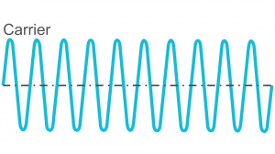
Figure 1 - Carrier Signal [2]
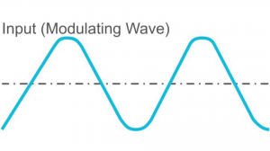
Figure 2 - Modulating Signal [2]
There are three fundamental modulation techniques that can be used to produce the modulated signal: -
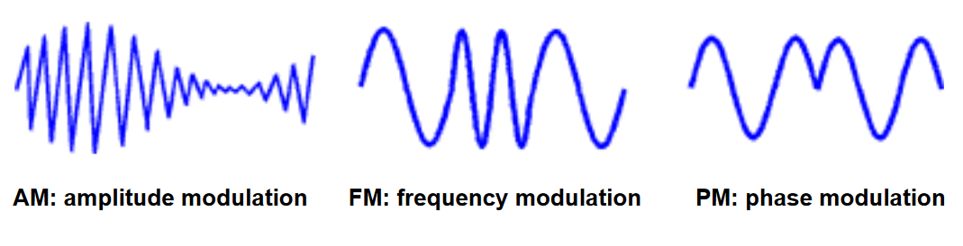
Figure 3 - Modulation Techniques [3]

- AM: Amplitude Modulation (E_{c})
a modulation technique where the strength/height (amplitude) of the carrier signal is varied in proportion to the message transmitted, frequency and phase remain unchanged during the transmission.
Below is an example of modulation technique that uses AM: -
  - ASK - Amplitude-shift keying
FM: Frequency Modulation (ω_{c})
a modulation technique where the frequency of the carrier signal is varied in proportion to the message transmitted, amplitude and phase remain unchanged during the transmission.
Below is an example of modulation technique that uses FM: -
  - FSK - Frequency-shift keying
- PM: Phase Modulation (θ)
a modulation technique where the phase of the carrier signal is varied in proportion to the message transmitted.
Below are a few examples of modulation techniques that use PM: -
  - PSK - Phase Shift Keying
  - BPSK - Binary Phase Shift Keying
  - QPSK - Quadrature Phase Shift Keying
  - QAM - Quadrature amplitude modulation
By changing the frequency, amplitude or phase, or an amalgamation of the three signal characteristics, information can be added as modulation to a signal. [1][2][3]

Why use Modulation?

1. Height reduction in the antenna
Radio signals require the height of the antenna to be a multiple of λ/4.
$$λ=\frac{c}{f}$$
λ = wavelength .
c = speed of light
f = frequency of the signal being transmitted
For a baseband signal with a frequency of 10 kHz the minimum height of the antenna is calculated as follows: -
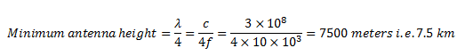
Figure 4 - Minimum antenna height - 10 kHz equation [4]
Construction of an antenna of this height would be physically impossible.
If we were to consider a modulated signal of 1MHz, we would calculate the antenna height as follows: -

Figure 5 - Minimum antenna height - 1 MHz equation [4]
The construction of an antenna of this height is much more achievable, therefore, we can assume that modulation can help reduce the size of the antenna needed.[4]

2. Mixing of signals can be avoided

If multiple transmitters were to transmit a signal concurrently without using modulation, then all the signals will be within the same frequency range, therefore, making it impossible to for the receiver to distinguish them from each other.
Modulation avoids mixing signals, by the use of different channels within the frequency domain, as each baseband signal is modulated by a different carrier. [4]

3. Range of Communication increased
Attenuation becomes an issue when low frequency baseband signals are transmitted, therefore, distance becomes an issue.
Attenuation decreases with the increase in frequency, therefore the transmitted signal can travel further.
The range of communication is increased during the modulation process as frequency is increased. [4]

4. Multiplexing

Multiplexing is a method which allows more than one signal to be transmitted over a single medium communication channel simultaneously. Multiplexing can only be achieved using modulation [4].

5. Quality of Reception Improves
Reception quality improves with the use of Frequency Modulation and digital communication technique such as Pulse-code modulation (PCM) [4].

Explain fundamentals of ASK, QPSK and QAM

ASK
During ASK modulation only the amplitude of the carrier signal is modified. It is generally agreed that on-off keying OOK is the simplest form of ASK. In OOK if the input message is 1 then a burst of the carrier wave is transmitted, if the input is a 0 then nothing is transmitted. ASK does come in a different form, where instead of nothing being transmitted for a 0, the amplitude is set to a differing amplitude. [5]
ASK can be represented by the following equation: -
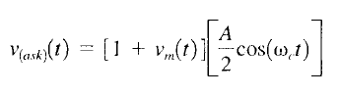
Figure 6 - ASK equation [4]
where
v_{(ask)}(t) = amplitude-shift keying wave
v_{m}(t) = digital information (modulating) signal (volts)
$\frac{A}{2}$= unmodulated carrier amplitude
c = analogue carrier radian frequency
The below figure shows the input message signal: -
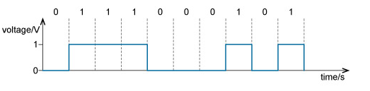
Figure 7 - Input message signal [5]
Below figure shows the modulated waveform when using OOK: - 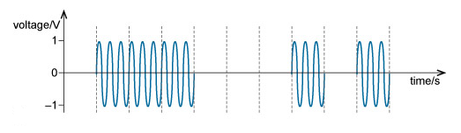
Figure 8 - OOK ASK modulated waveform [5]

Below figure shows the modulated waveform when using binary ASK: -
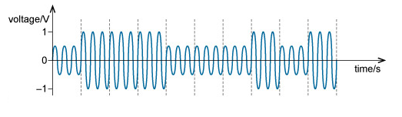
Figure 9 - ASK binary modulated waveform [5]
ASK is used to transmit digital data over optical fibre.

QPSK
QPSK transmits 2 bits per symbol, i.e. 00, 01, 10 or 11 during its modulation process.
It is possible to transmit two symbols as variations in the carrier signal are not restricted to two states. This is due to the fact that the carrier varies in both phase and frequency, and not only amplitude as in ASK. These extra variations allow for the 4 possible phase shifts.
As we have 360° of phase to create our four phase states, we can determine that the separation should be 360°/4 = 90°, i.e. a 90° phase shift. We can calculate that there are 45°, 135°, 225°, and 315°.[6]
Below is a diagram showing these phase: -
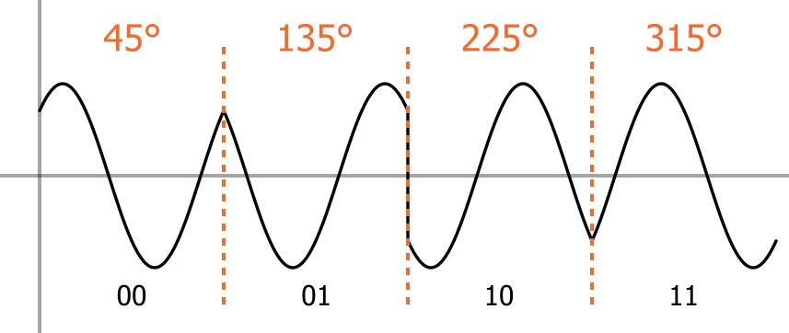
Figure 10 - QPSK phases [6]
These phases are easily generated using I/Q modulation techniques because adding I and Q signals which are either inverted or noniverted will result in the above four phase shifts. The below table shows this [6]: -
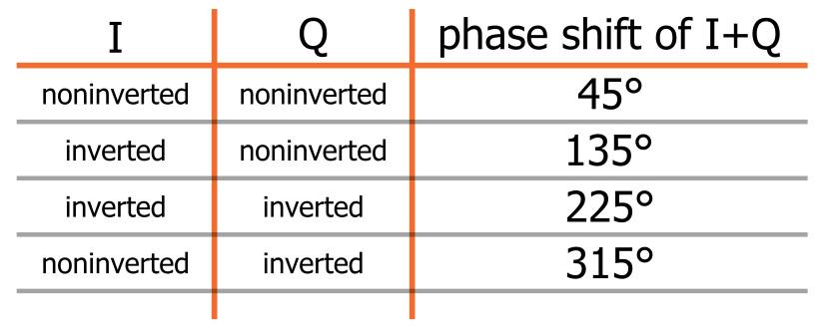
Figure 11 - QPSK I/Q signals [6]

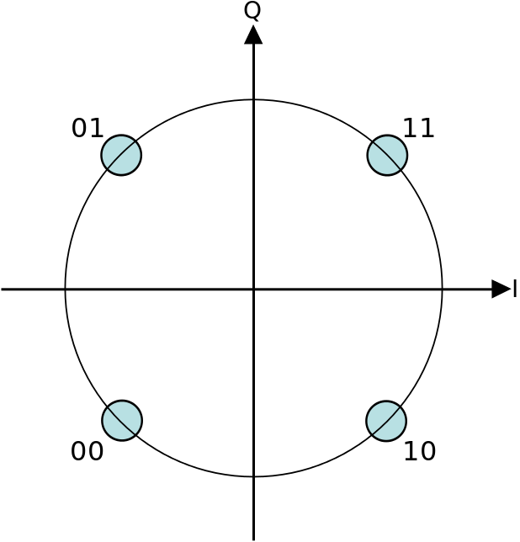
Figure 12 - QPSK constellation diagram [6]

Comparing QPSK to either modulation schemes that only transmit 1 bit per symbol, we can determine that QPSK is much more bandwidth efficient. QPSK uses the same baseband frequency to transmit 2 bits per symbol period, thus its bandwidth efficiency is higher by a factor of 2 compared to ASK. [6]
QPSK is used in amateur radio and heavily in WiFi.

QAM
Quadrature Amplitude Modulation (QAM) is a modulation technique, which is extensively used because of the benefits gained over other modulation technique such as BPSK.
During QAM modulation two carriers are shifted in phase by 90 degrees, the result of this shift is that both the amplitude and phase are varied. This variation in phase and amplitude could be seen as a combination of phase and amplitude modulation.
When QAM is used in digital transmission of radio communication, higher data rates are achievable compared to regular amplitude and phase modulation techniques.
It is possible to transmit more bits per symbol by using higher order modulation layout. This comes with the drawback that the closer the points are together the more vulnerable to data and noise errors. As a consequence, higher order versions of QAM are only utilised when there is a high enough Signal to Noise Ratio
Typically, when using QAM a square grid with equidistant vertical and horizontal spacing, consequently the most familiar forms of QAM in use have a constellation with the number of points equal to a power of 2 i.e. 4, 16, 64 . . . .
Below is a constellation diagram showing how QAM operates, it details the bits associated with the different states in 16QAM. As you can see 16QAM uses 4 bits per stream. [5]
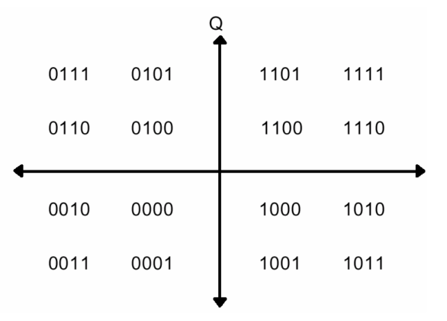
Figure 13 - Gray Coded Symbol Mapping [5]
During the QAM process, both phase and amplitude are changed within a QAM signal.
To create a QAM signal by generating two signals that are 90° out of phase and them add them together to produce the sum of both waves, the will create a different amplitude and phase dependant on the original two signals. [5]

When the amplitude of one signal is changed then both the phase and amplitude of the overall signal is also affected, the leans more towards the higher amplitude content.
I - In-phase and Q - Quadrature signals, are the two RF signals that can be modulated.
Below you can see how the I and Q signals are characterized: -
I = A cos(Ψ) and Q = A sin(Ψ)
As the two signal are 90° out of phase with each other, we can determine that they are characterized as cosine and sine waves.
The two equations can be used to express the signal: -
cos(α + β) = cos(α)cos(β) - sin(α)sin(β)
A cos(2πft + Ψ) can be used to express the carrier signal.
A cos(2πft + Ψ) = I cos(2?ft) - Q sin(2πft)
carrier frequency is represented by f . [5]
Below are some examples of the above: -
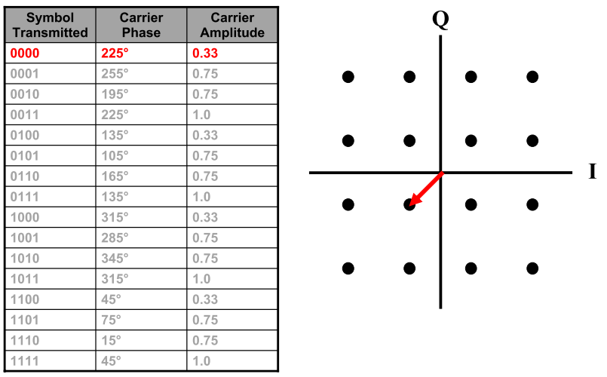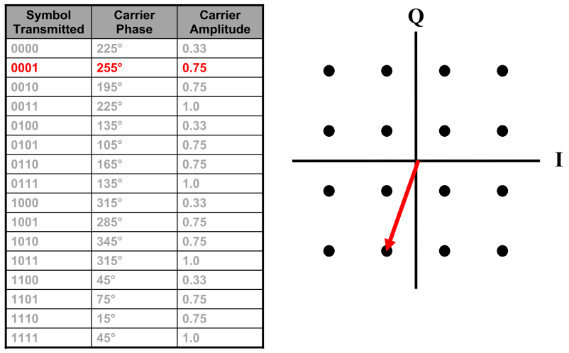

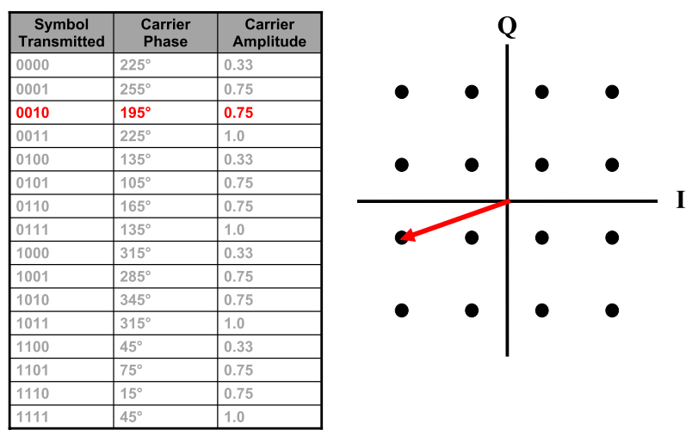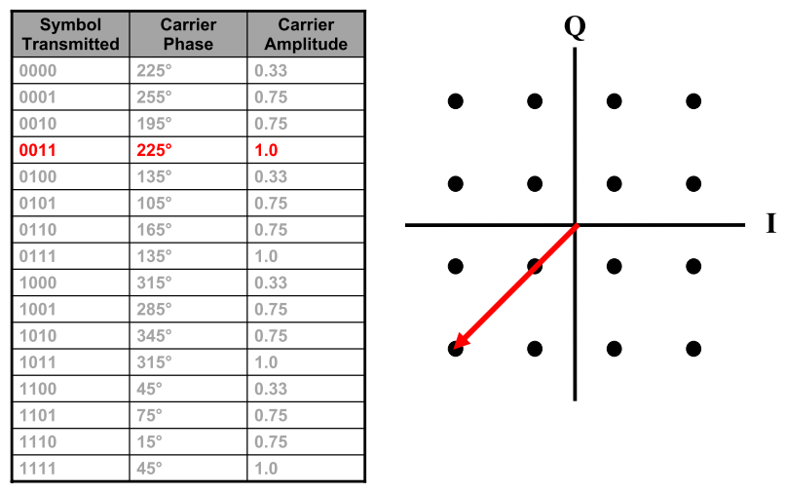
Figure 14 - QAM I/Q locations [5]

The below constellation diagrams show the different positions for the states within different varieties of QAM. As the order of the modulation increases, so does the number of points on the QAM constellation diagram. [5]
The diagrams below show constellation diagrams for a variety of formats of modulation: -
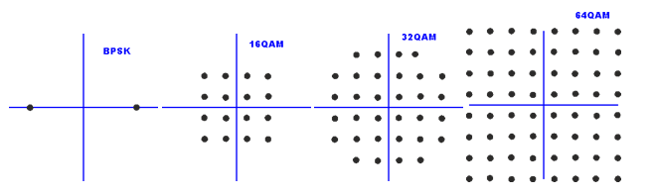
Figure 15 - QAM constellation diagrams [5]
Higher order forms of modulation have the advantage of carrying more bits of information per symbol, thus the data rate is increased.
QAM is used on various data delivery applications and radio communications. Specific standards and applications require a certain variant of QAM.
Within the UK, 16QAM and 64QAM are currently being utilised to transmit digital terrestrial television using DVB (Digital Video Broadcasting). This is not exclusive as 64QAM and 256QAM can also be the modulation of choice.
Additionally, cellular and wireless technology applications use different variants of QAM. [5]

Simulink Models
ASK
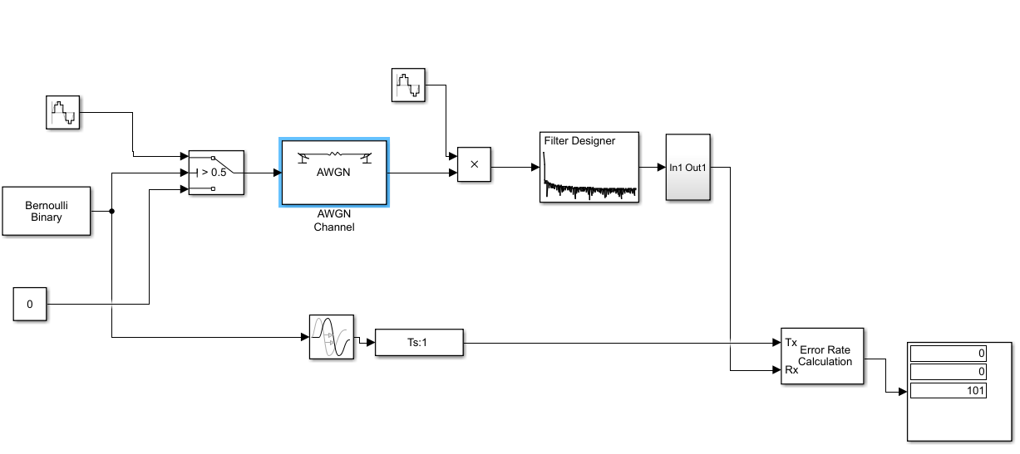
Figure 16 - ASK Simulink Model

QPSK
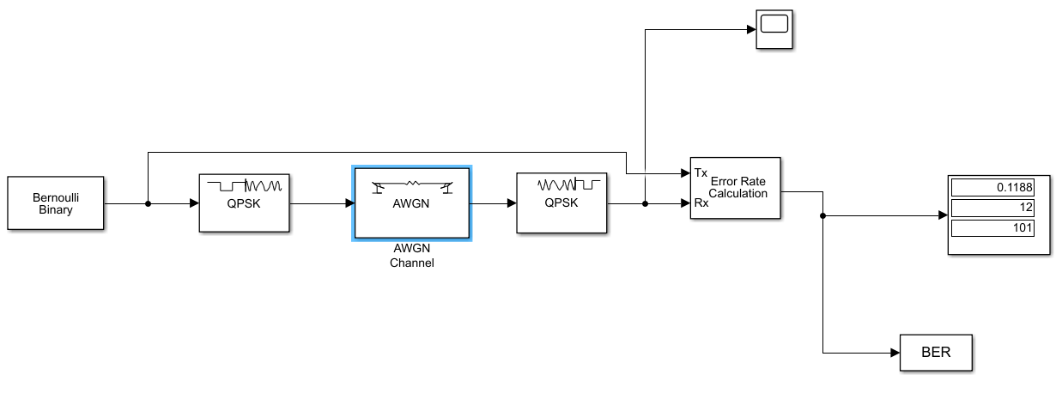
Figure 17 - QPSK Simulink Model

QAM
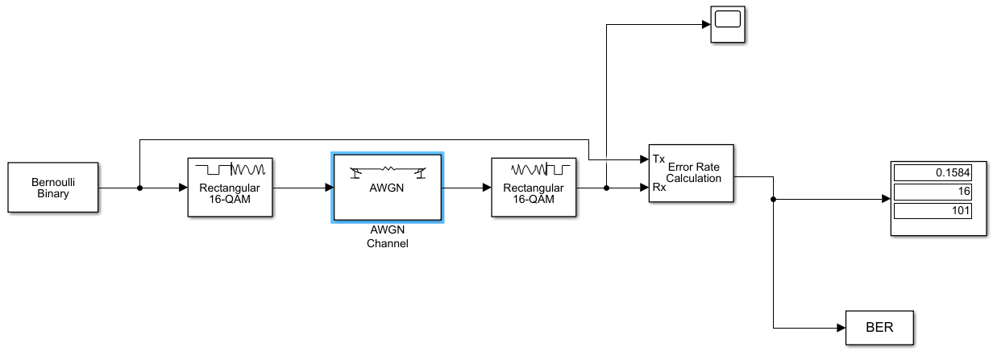
Figure 18 - QAM Simulink Model

Compare ASK, QPSK and QAM
To compare ASK, QPSK and QAM we are going to use the AWGN to see what affect changing the between 0db & 9dB will have on the Bit Error Rate BER.
Below is a graph of the results from running the above simulink models: -

Figure 19 - Modulation comparison chart
We can see here that there is a distinct difference in the BER between the 3 modulation techniques. Ruling out ASK as the BER is drastically worse than QPSK and QAM we will expand our analysis with only these 2 modulation techniques.
We can see that the affect of the AWGN noise has a worse effect on QPSK than on QAM, this can be seen by the lower BER of 16QAM compared to QPSK, on average at every dB point the BER is 0.06534 lower in QAM than QPSK.
We can also use the bertool within MATLAB to generate theoretical result for 16QAM and QPSK, below is the output from the tool:-
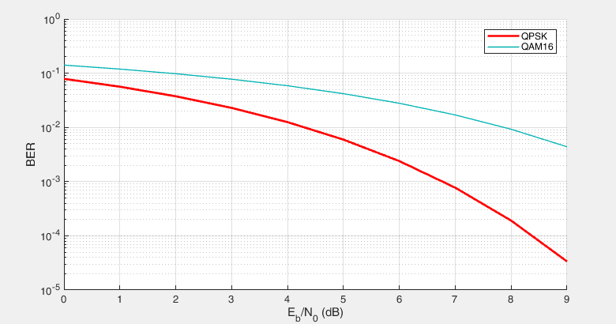
Figure 20 - Theoretical modulation comparison chart
As you can see above the theoretical results do not match the actual result from the testing. These result show that QPSK has a lower BER than 16QAM, this contradicts the actual results. This may be due to the incorrect configuration of the simulink models. These results show that 16QAM would be most affected by the AWGN.
Therefore, in conclusion QPSK would be the modulation of choice, although the data rate achievable for QPSK is less than that of 16QAM. There is a trade off between data rate and BER.

Part 2 -Wireless Network Design & Evaluation
Figure 21 - Smart Garden outline design

Above is the overall design for the Smart Garden. The design contains the following nodes: -
- Database Server
This will run the software required to monitor the Air Quality, Weather conditions, Seat Occupancy Software.
- Estates Monitoring PC
This will allow the estates team to monitor the information being gathered by the sensor within the Smart Garden.
- Wireless Access Point
This will be used to connect all the wireless sensors to the LAN.
- Router
This will be used to route information between VLANS
- Wireless Seat occupancy Sensors x 16

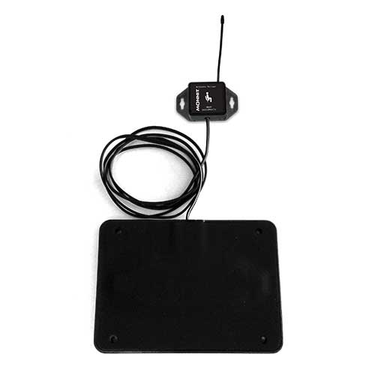
Figure 22 - Monnit wireless seat occupancy sensor
Within the Smart Garden we have assumed a total of 16 seats are to be available. On the seats will be the above wireless seat occupancy sensors. These sensors work by using a stress sensitive ribbon which measures the force that is being applied to the plate. Notifications can be sent when a seat becomes occupied, frequency of the readings can also be set to send to the iMonnit online sensor monitoring system database is amended.
The sensor has the below specifications: -
- 5 Year battery life
- Solar Power option
- Wireless Range: 250 - 300 ft. (non line-of-sight / indoors / through walls, ceilings & floors)
- iMonnit basic online wireless sensor monitoring and notification system to configure sensors, view data and set alerts via SMS text and email.

- AQM 65 Ambient Air Monitoring Station
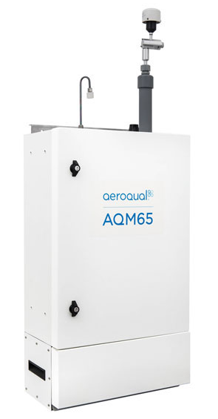
Figure 23 - AQM 65 Ambient Air Monitoring Station
Also within the garden we will be using the above Wireless Air Quality sensor. This sensor has a fully integrated air monitoring station. It can monitor up to 20 gaseous and particulate pollutants at any one time, as well as weather conditions.
Below is a list of what this sensor can monitor: -
- Ozone (O3)
- Nitrogen dioxide (NO2)
- Nitrogen oxides (NOx)
- Carbon monoxide (CO)
- Sulphur dioxide (SO2)
- Volatile organic compounds (VOC)
- Hydrogen sulphide (H2S)
- Non-methane hydrocarbons (NMHC)
- Carbon dioxide (CO2)
- Particulate matter (TSP, PM10, PM2.5, PM1)
- Noise
- Rainfall
- Temperature
- Humidity
- Pressure
- Wind speed
- Wind direction

Each Seat within the Smart Garden will include a Wireless Seat occupancy Sensors. These sensors will be linked back to the Database Server, connected to the Seat Occupancy Software. Each sensor will connect to the Wireless Router to enable them to connect to the LAN with which the Database server resides.
The AQM 65 Ambient Air Monitoring Station will be connected back to the Database Server, linked to the Aeroqual connect software. The sensor will connect to the Wireless Router to enable it to connect to the LAN with which the Database server resides.
The Estates Monitoring PC will connect to the Database server via a web browser over the LAN to connect to the Seat Occupancy and Aeroqual connect software to allow them to monitor the sensor conditions.
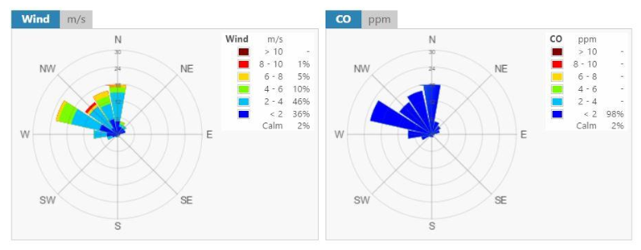
Figure 24 - Aeroqual connect software
Below is a screenshot of the Riverbed simulation: -
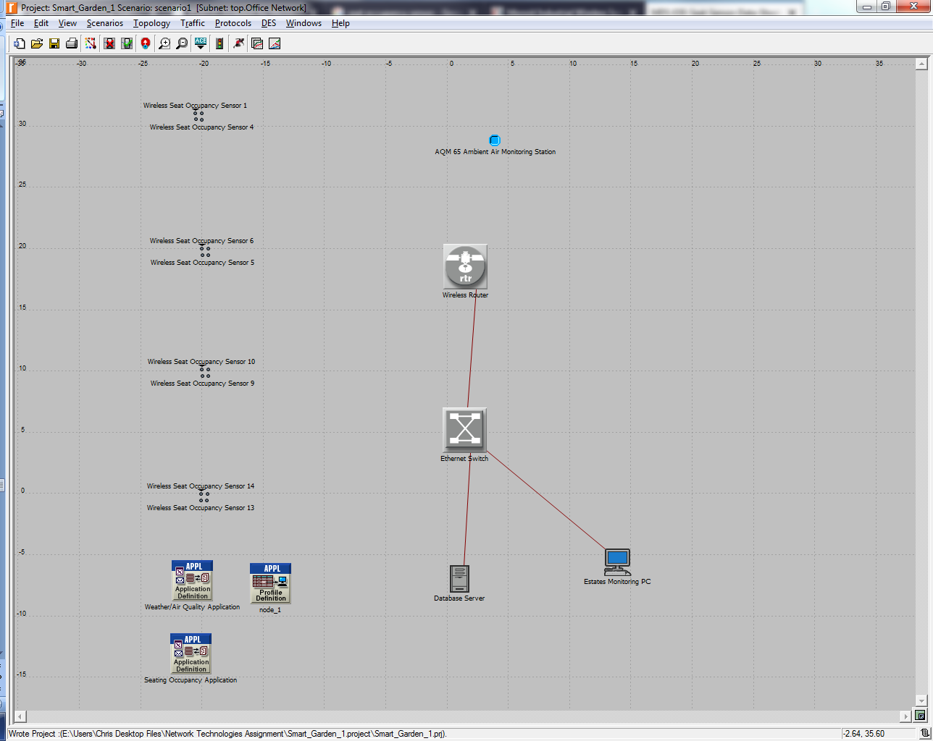
Figure 25 - Riverbed Smart Garden Model

Two applications have been defined: -
- Weather/Air Quality Application
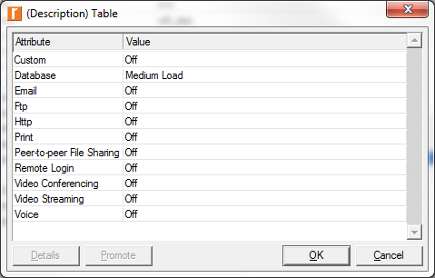
Figure 26 - Weather/Air Quality Application
This has been defined as a Medium Load Database application, this will be used by the AQM 65 Ambient Air Monitoring Station.

- Seating Occupancy Application
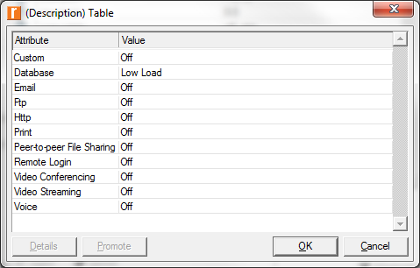
Figure 27 - Seating Occupancy Application
This has been defined as a Low Load Database application, this will be used by the Seat Sensors.
Each WLAN Node is configured to use the following: -
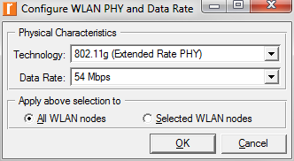
Figure 28 - Wireless LAN Settings
The database server will support the following applications: -
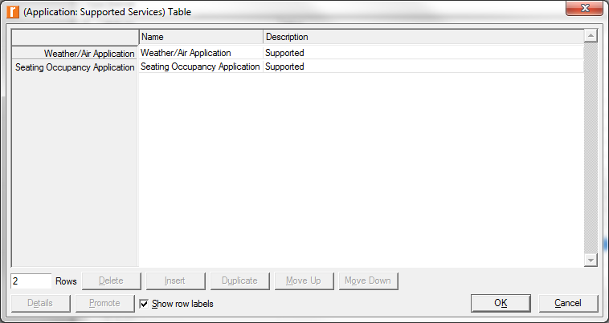
Figure 29 - Database Server Settings

Below are outputs from the Simulation for the Seat Occupancy Sensors. The simulation was run over a simulated 8 hour period. Results have been collated from 1 seat occupancy node in each of the 4 clusters of sensors. This includes Throughput, Delay and Packet Loss.
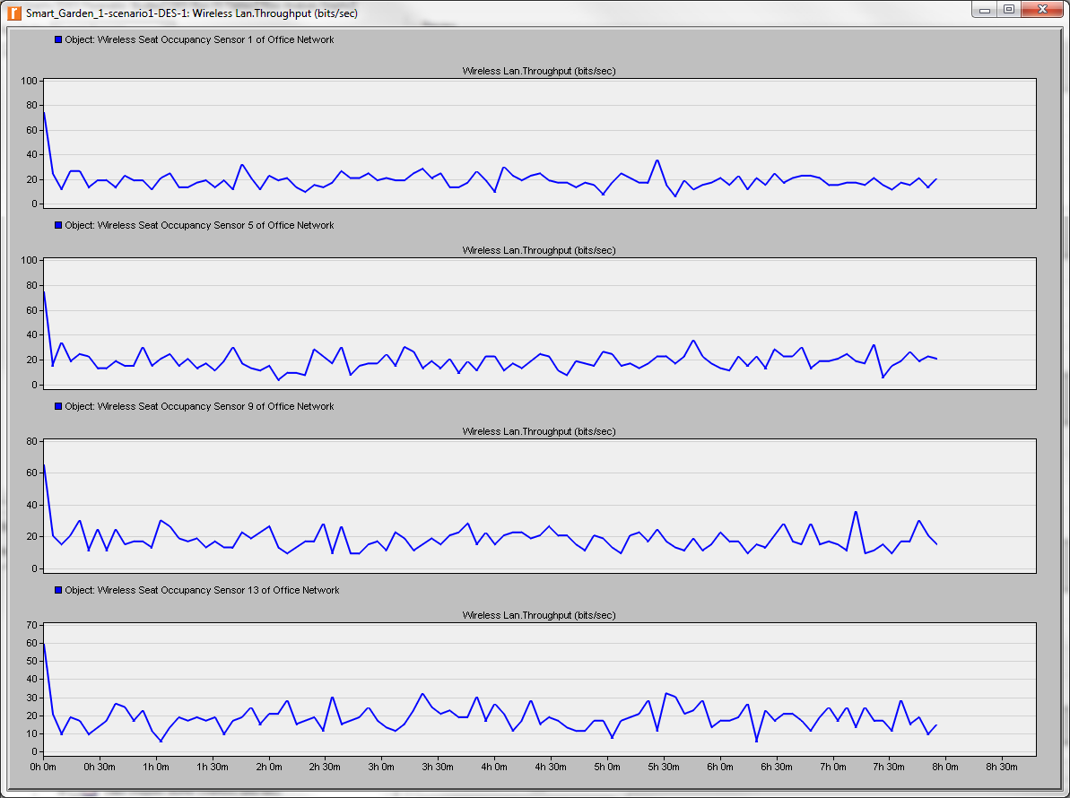
Figure 30 - Seat Occupancy Sensor Throughput
As can be seen above, initially there is a 60 bits/sec throughput for each node, but over the next 10 minute period this drops drastically to under 20 bits/sec. This then fluctuates over the next 8 hour period between 10 and 40 bits/sec on each node.
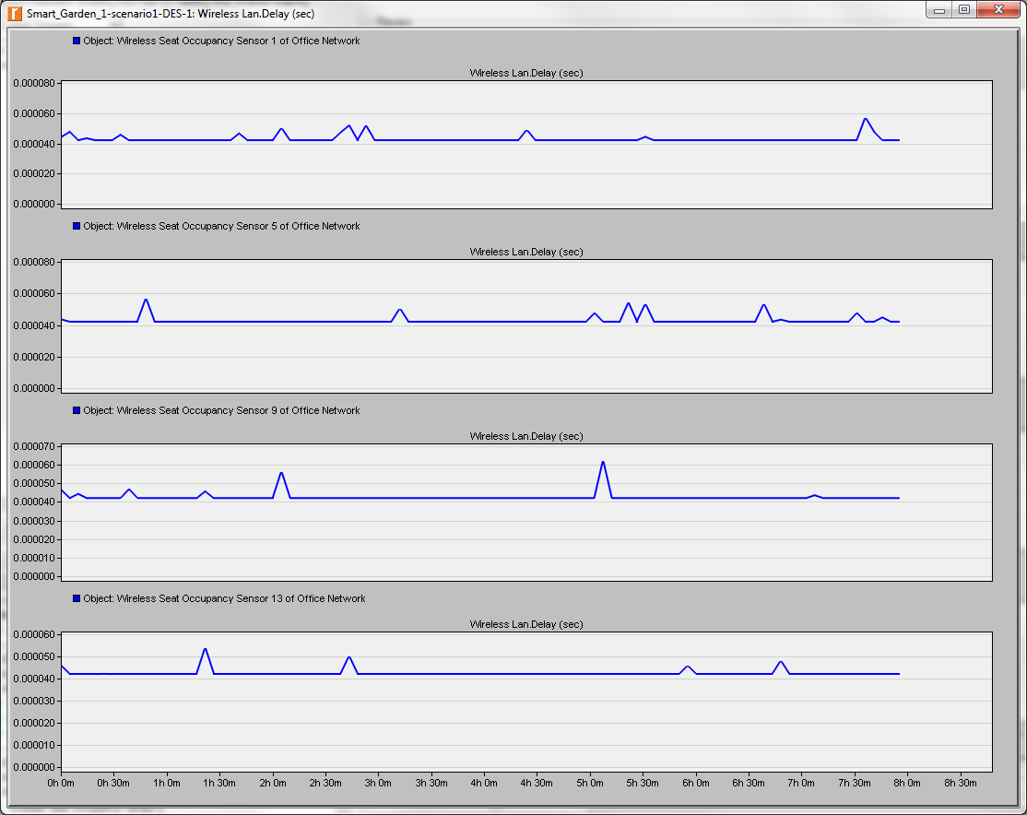
Figure 31 - Seat Occupancy Sensor Delay
As can be seen above there is a consistent delay on each node of circa 0.000040 seconds. this remains constant over the 8 hour period, with random fluctuation on each node between 0.000040 and 0.000060 seconds.

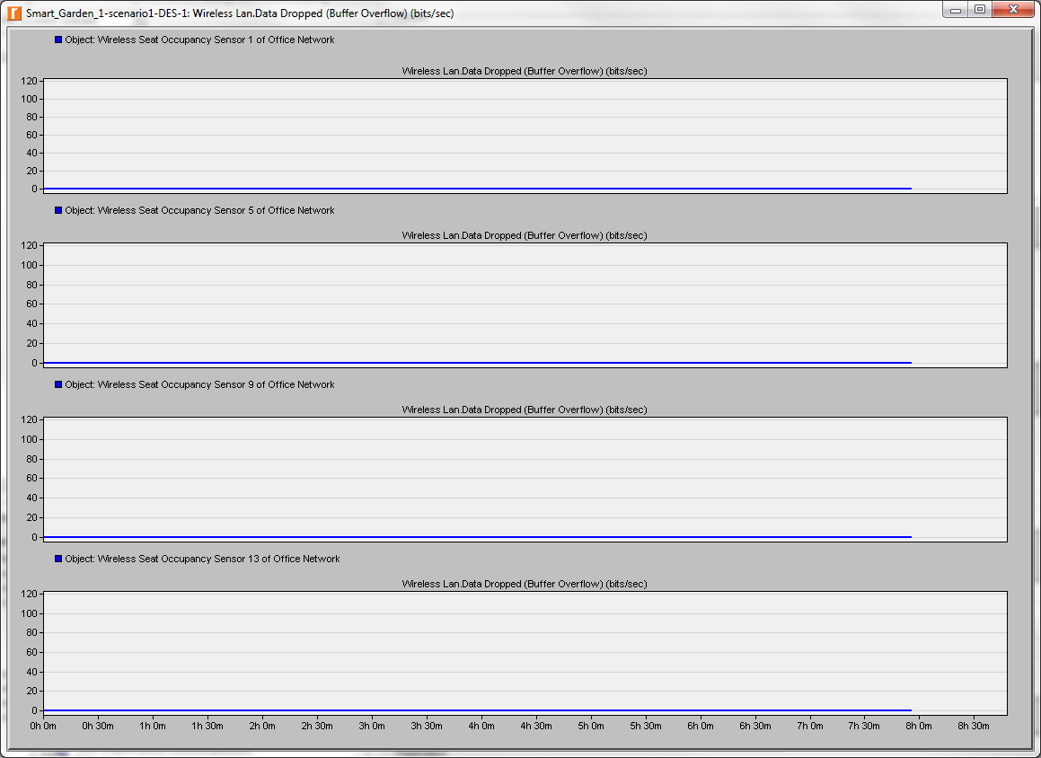
Figure 32 - Seat Occupancy Sensor Packet Loss
As can be seen above, throughout the 8 hour simulation period, each node does not experience any packet loss.
Below are outputs from the Simulation for the AQM 65 Ambient Air Monitoring Station. The simulation was run over a simulated 8 hour period, which includes Throughput, Delay and Packet Loss.
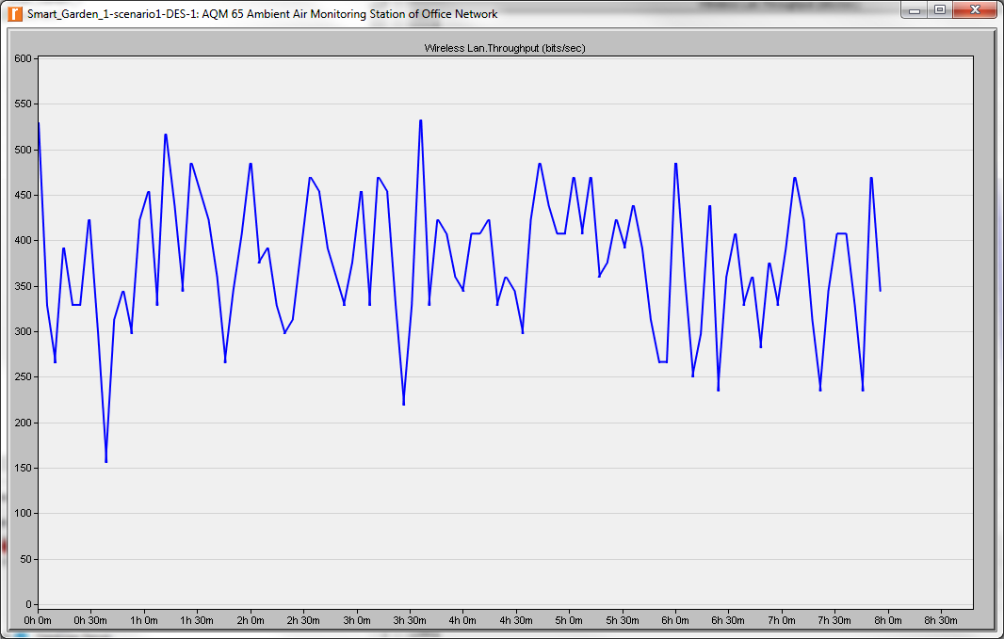
Figure 33 - Weather Sensor Throughput
As can be seen above the throughput fluctuates between 160 and 525 bits/sec, averaging at roughly 400 bits/sec.
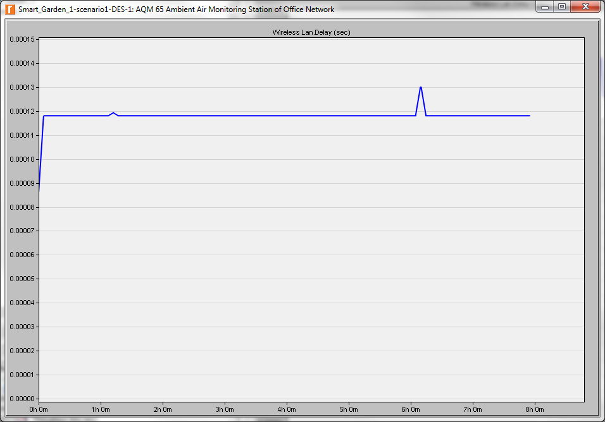
Figure 34 - Weather Sensor Delay
As can be seen above there is a consistent delay on of circa 0.000012 seconds, this remains constant over the 8 hour period, with random fluctuation of 0.00013 seconds.

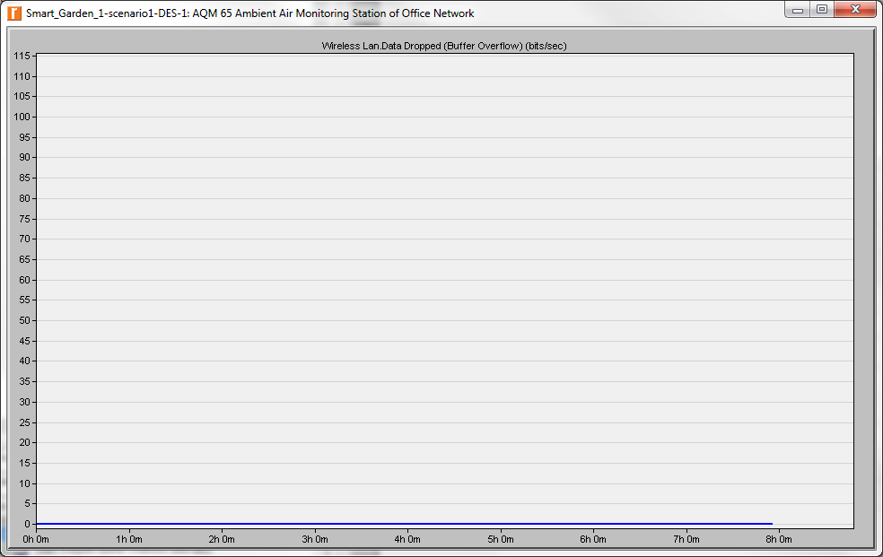
Figure 35 - Weather Sensor Packet Loss
During the simulation no experience of packet loss was observed.
Below is the results output from the database server.
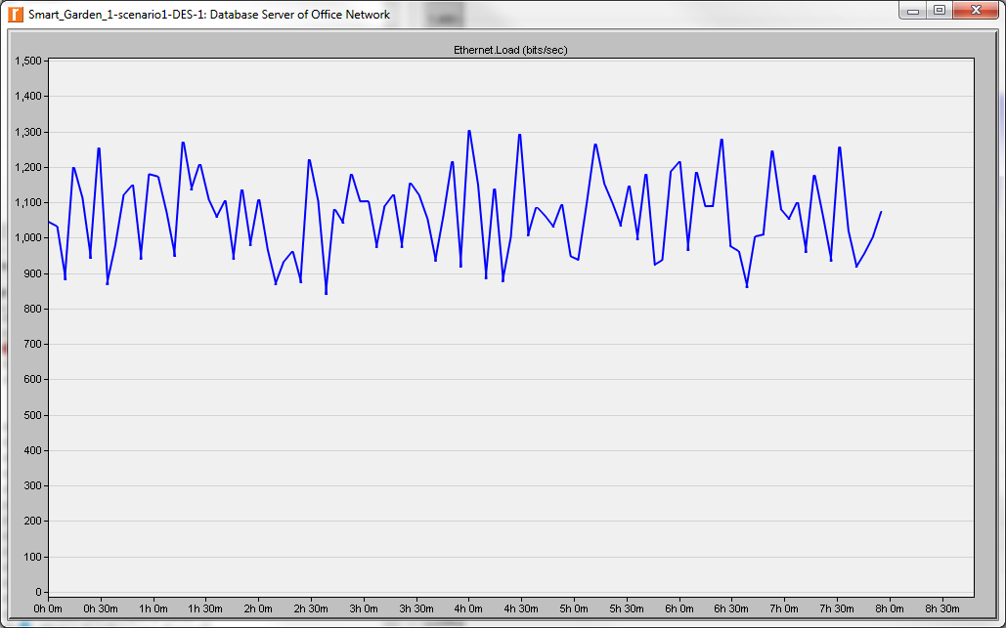
Figure 36 - Database Server Throughput
As can be seen above the throughput fluctuates between 900 and 1300 bits/sec though out the 8 hour simulation period.
Below is the output of the results for the Global Statistics for the Wireless LAN.
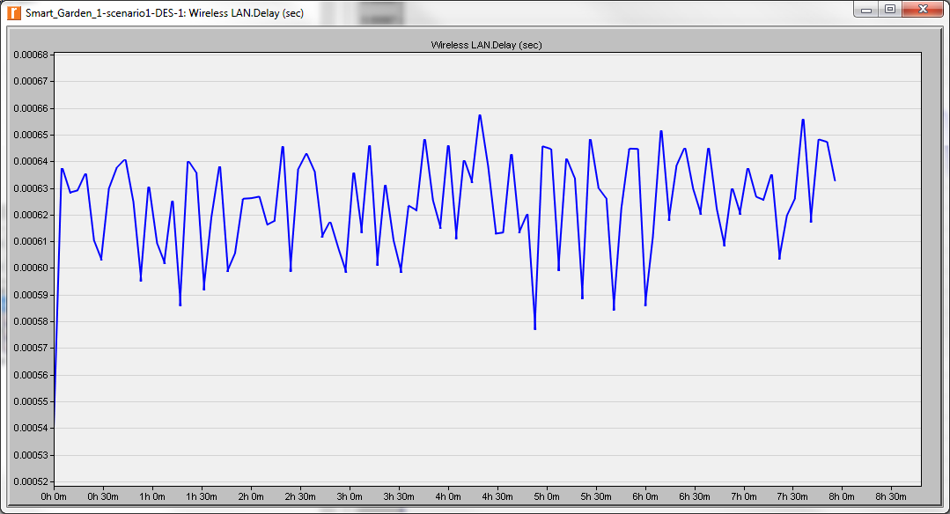
Figure 37 - Database Server Delay
As can be seen above initially delay starts very low at 0.00054 seconds, but rapidly increases to 0.000635, fluctuating for the remaining 8 hour period between 0.00058 and 0.00066 seconds.
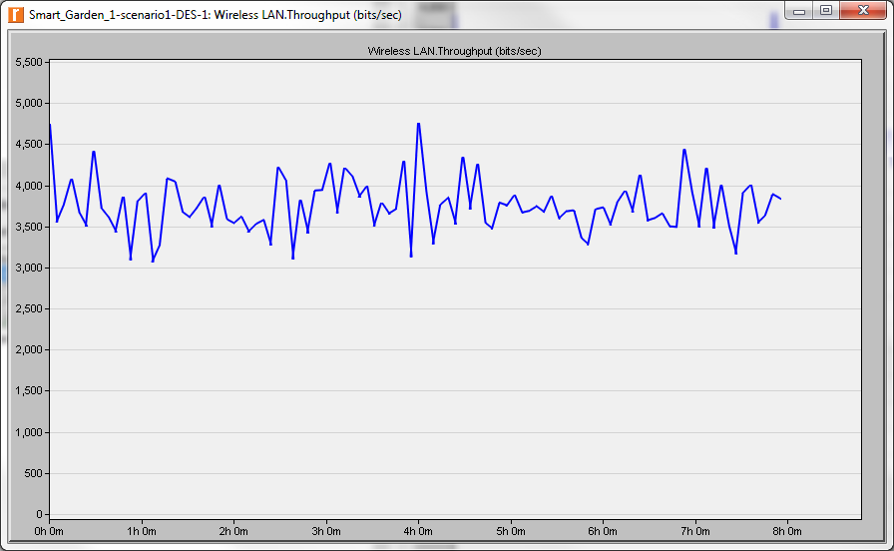
Figure 38 - Wireless LAN Throughput
As can be seen above throughout remains pretty constant throughout the simulation period, fluctuating between 3000 and 4500 bits/sec.
Unfortunately, due to the limitations with the software comparison of the researched modulation techniques was not able to be tested. This was due to the restrictions of the software package.
If we were to deploy the different modulation techniques within the Smart Garden network, I would presume that using the ASK modulation technique would have produced the highest BER thus resulting in the highest packet loss within the network.
Analysing the results of QPSK and QAM it would be prudent to say that QAM would give the highest data transfer rates due to the ability to transmit larger amount of symbols.

Bibliography
[1] “Basics of Modulation and Demodulation.” [Online]. Available: http://www.mwrf.com/systems/basics-modulation-and-demodulation. [Accessed: 01-Jan-2018].
[2] “How does modulation work? | Tait Radio Academy.” [Online]. Available: https://www.taitradioacademy.com/topic/how-does-modulation-work-1-1/. [Accessed: 01-Jan-2018].
[3] R. Hranac, “QPSK and 16-QAM.”
[4] “Explain the need for modulation in a communication system – Electronics Post.” [Online]. Available: https://electronicspost.com/explain-the-need-for-modulation-in-a-communication-system/. [Accessed: 01-Jan-2018].
[5] “What is QAM | Quadrature Amplitude Modulation | Radio-Electronics.Com.” [Online]. Available: http://www.radio-electronics.com/info/rf-technology-design/quadrature-amplitude-modulation-qam/what-is-qam-tutorial.php. [Accessed: 02-Jan-2018].
[6] “Understanding Quadrature Phase Shift Keying (QPSK) Modulation.” [Online]. Available: https://www.allaboutcircuits.com/technical-articles/quadrature-phase-shift-keying-qpsk-modulation/. [Accessed: 03-Jan-2018].

