5/5/2024
Assessment
Portfolio Report on Contemporary Software Applications for Business


Student Name:
Student ID:

Module NaMe: Software solutions for business
Module Code: ACCA 4026
Lecturer: Koushik Modak
Trinity saint david University of Wales (London Campus)

Table of Contents
Introduction 2
Main Body 2
Task 1 2
e-Commerce Website builders/software solutions 2
Task 2 2
Mind-map of Contemporary Software Applications 2
Task 3 3
Office Applications for Creating, Storing, Presenting, and Analysing Data 3
a. 3
b. 3
Task 4 3
Communication and Collaboration applications 3
a. 3
b. 4
Conclusion 4
References 4

In an increasingly digital environment, software solutions are essential for organisations to function effectively and maintain their competitiveness. Our business-focused software solutions are made to facilitate data-driven decision-making, increase productivity, and streamline processes.We develop and implement dependable, expandable, and secure software that is suited to certain organisational needs. Our solutions, which range from automation and digital platforms to specialised applications and system integrations, match technology with business objectives.We assist companies in optimising processes, cutting expenses, and swiftly responding to shifting market needs by concentrating on quality.

Custom Software Development
Custom software is developed to meet specific business needs. These solutions help improve effectiveness, accuracy, and overall performance by supporting daily business operations.
Web and Mobile Applications
Web and mobile applications allow businesses to manage services and communicate with customers easily. These applications are designed to be user-friendly and accessible on different devices.
Business Process Automation
Automation software reduces repetitive tasks and minimizes errors. This helps businesses save time, reduce costs, and focus on important activities.
System Integration and Data Management
Software solutions integrate different systems to ensure smooth data flow. Proper data management supports better decision-making and improves operational efficiency.
Security and Maintenance
Security measures are implemented to protect business data. Regular maintenance ensures that software systems remain reliable and up to date.

Task 1

e-Commerce Website builders/software solutions
Shopify, Wix, BigCommerce, and Weebly are among the most widely used e-commerce website builders, trusted by millions of entrepreneurs, businesses and customers around the world. These platforms have grown in popularity because they offer intuitive design tools, reliable hosting, and strong features that make it easy for anyone regardless of the experience or knowledge to launch and manage an online store. Whether a business is just starting out or scaling to reach customers all around the world, these leading e-commerce solutions provide the functionality, flexibility, and support needed to succeed in today’s digital marketplace.
Shopify is one the most dependable e-Commerce platform that is important for businesses of all capability and by ensuring they have an all in one, easy to use to platform that makes managing and running an online store more efficient for them.Its interface and drag and drop builder makes it easier, faster to create, its can easilty be accesed by people with little knowledge. A cloud-based platform, inventory management, a variety of payment options for order and shipment administration, mobile-responsive themes, and a vast app marketplace are some of its key features. A cloud-based platform, inventory management, a variety of payment options for order and shipment administration, mobile-responsive themes, and a vast app marketplace are some of its key features. Shopify's ease of use, which enables users to easily set up an online store without requiring sophisticated technical knowledge, is one of its primary advantages. Additionally, the platform manages software updates, hosting, and security, guaranteeing scalability and dependability for expanding companies. Shopify does have some restrictions, though, such as monthly subscription costs and extra fees for transactions made through third-party payment gateways. Additionally, compared to open-source platforms, there are less customisation choices, and many sophisticated features need for premium programs. Shopify is still a well-liked option for small and medium-sized companies looking for a dependable and expandable e-commerce solution in spite of these drawbacks..
Weebly is a contemporary e-commerce website builder that enables users to create online stores using a simple drag-and-drop interface. Its major features are product listings, shopping cart practicality, basic inventory management, mobile-responsive templates, and integration with popular payment methods such as PayPal. One of the benefits of Weebly is that is easy to use, making it suitable for beginners and small businesses with limited technical skills. It also offers affordable pricing plans.However, Weebly has limitations, particularly in terms of scalability and advanced e-commerce functionality. It shows fewer customization options, limited third-party incorporations and lacks advanced tools required for large or complex online stores. Weebly is effective for small-scale e-commerce websites, but may not be suitable for businesses with long-term growth or complex operational needs.

Task 2

Mind-map of Contemporary Software Applications
Mind mapping is a visual method of organising information and ideas by placing a main topic at the centre of a blank page and drawing branches that show related ideas, subtopics, and connections. Unlike more of a traditional note-taking method mind maps use astructure of branches that visualise how the human brain naturally processes and associates information. This visual approach helps individuals and teams see the relationships between ideas,help forms ideas and make complicated nformation easier to understand and remember.In business operations, mind mapping has become a valuable tool for enhancing creativity, planning, collaboration, and communication. One key benefit is that mind mapping boosts creativity and idea generation. Mind maps are particularly helpful in brainstorming sessions and strategic planning because they inspire users to think beyond linear thinking and uncover connections that could otherwise remain buried by letting thoughts flow naturally from a central theme.
Additionally, mind mapping improves teamwork and communication.Team members are better able to communicate ideas, agree on objectives, and comprehend one another's viewpoints because mind maps provide a single visual reference that can be shared and changed jointly. This shared visual language reduces misunderstandings and helps ensure that everyone is on the same page when working toward common objectives. Additionally, mind mapping supports better memory and retention, as the visual format, use of colours, and structured layout create multiple cognitive cues that make information easier to remember. This benefit is particularly useful during planning sessions, training, and presentations, where recalling complex details can be essential.
Overall, mind mapping is a adaptable and practical tool in business operations that promotes creativity, organisation, collaboration, and clear communication, making it an effective method for tackling complex challenges and improving team productivity

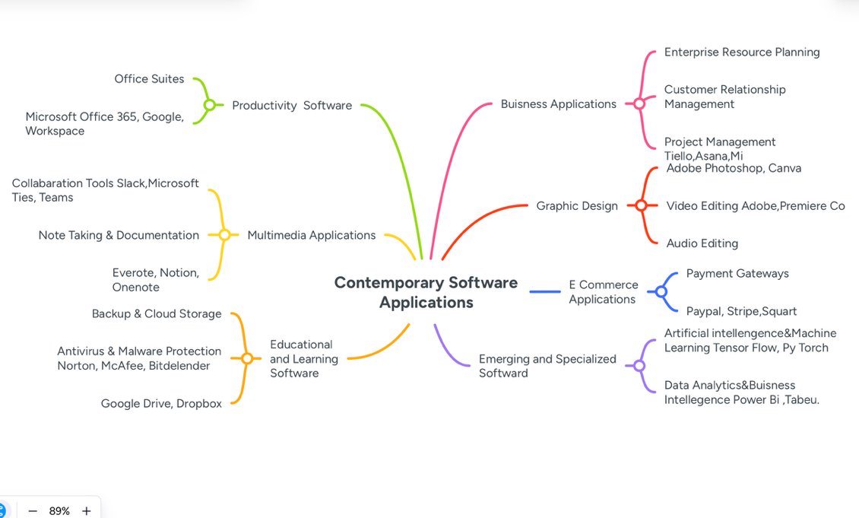
https://mm.tt/map/3894187914?t=4FBFnuX6Xm

Task 3

a.
Microsoft Word is a word processing software widely used in business operations for creating, editing, and formatting text-based documents such as reports, letters, and memos. Its major features include text formatting, spell check, templates, tables, images, and collaborative tools like track changes and comments. The benefits of MS Word include producing professional documents quickly, improving communication within the organization, and supporting collaboration among team members. However, it is primarily suited for text-heavy documents and may slow down when handling very large files or complex layouts, limiting its use for tasks that involve extensive calculations or data management . One of Word’s biggest advantages for business is its versatility: it supports extensive formatting and design options, integrates with cloud storage such as OneDrive for access across devices, and now increasingly incorporates AI-assisted content suggestions and refinements to help users write clearer text and generate content faster. Real-time co-authoring lets multiple users work on the same document simultaneously, enhancing teamwork especially in remote or hybrid work settings. owever, there are limitations to Word that businesses should consider. While it excels at text and layout, Word is not designed for heavy data analysis or complex calculations — tasks better suited to spreadsheets. Its collaboration tools, although robust, are still less dynamic than dedicated project management or team communication platforms. Large documents with many graphics and embedded elements can also become unwieldy and slow to load, particularly on older hardware. Additionally, access to the full suite of advanced features often requires a modern subscription such as Microsoft 365, which adds ongoing licensing costs.
Microsoft PowerPoint is a presentation software that allows businesses to create visual and interactive slideshows for meetings, training, and marketing purposes. Its key features include slide templates, animations, transitions, charts, multimedia integration, and collaboration tools. The benefits of PowerPoint include enhancing communication by visually presenting ideas, engaging audiences effectively, and simplifying the explanation of complex concepts. Its limitations include the potential for distraction if animations or slides are overused, dependence on accurate content input, and limited capability for in-depth data analysis. In business, PowerPoint’s benefit lies in making complex information accessible and engaging. Presentations can summarise lengthy reports, illustrate trends via graphics, or help align teams around a strategic vision. For remote teams, presentation sharing over video conferencing platforms like Microsoft Teams further enhances communication effectiveness
PowerPoint does have limitations. Overreliance on animations or overly complex slides can distract or overwhelm audiences. Additionally, creating high-quality slide decks often requires good design judgement; without careful planning, presentations may come across as cluttered or unprofessional. PowerPoint is also not designed for data processing or heavy numerical analysis, so its usefulness depends on effective integration with data sources, usually provided by Excel or business intelligence tools.
Microsoft Excel is a spreadsheet software used for organizing, analyzing, and visualizing data in business operations. It offers features such as formulas, functions, pivot tables, charts, and data filtering. Excel benefits businesses by simplifying calculations, supporting financial analysis, budgeting, and reporting, and providing tools for data visualization and decision-making. However, Excel can be complex for beginners, errors in formulas may lead to inaccurate results, and it is not ideal for handling unstructured data or very large relational datasets, limiting its use for certain advanced data management tasks. The benefits of Excel in business are substantial. For financial analysts, its ability to perform complex calculations and automate repetitive tasks with functions or macros can save significant time. Data visualisation features help stakeholders understand trends and performance. In operations, Excel can be used for inventory tracking, scheduling, and KPI monitoring. Its flexibility means it’s used across departments — finance, HR, marketing, and supply chain.
Excel’s limitations largely stem from the fact it is not a database management system. While it handles moderate amounts of data well, very large data sets can become unwieldy or slow. Excel users also risk errors in formulas, which can propagate through reports if not checked carefully. Collaborative editing without proper version control can lead to conflicting data — issues that dedicated data platforms or databases handle more robustly. Despite these constraints, Excel’s sheer versatility and analytical power make it a cornerstone of business operations worldwide.
Microsoft Access is a database management system that enables businesses to store, organize, and retrieve structured data efficiently. Its major features include tables, queries, forms, reports, and automation through macros, as well as integration with other Microsoft applications. The benefits of Access include effective data management, improved reporting, multi-user access, and automation of repetitive tasks. Its limitations include a learning curve for new users, reduced suitability for extremely large enterprise-level databases, and limited advanced analytical capabilities compared to specialized database or analytics software.
In a business context, Access can streamline operations such as contact management, project tracking, inventory control, or custom CRM solutions. Its ability to join related data from different sources helps ensure consistency and enables more complex queries across datasets. The software also includes templates and wizard tools to help users build database applications quickly, and macros that automate tasks like opening forms or generating reports.
However, Microsoft Access has notable limitations. Its scalability is limited compared to enterprise database systems; Access databases have a file size limit (typically 2 GB) and may perform poorly beyond moderate data volumes or many simultaneous users. It also lacks the robust cloud-native architecture and advanced security or scalability features found in server-based solutions such as SQL Server or cloud databases. Furthermore, mastering advanced database design and querying still requires training, which may present a learning curve for some users. Despite these constraints, Access remains suitable for small to medium data management tasks and is particularly valuable for rapid development of custom data solutions without the need for complex programming.
Microsoft Word, PowerPoint, Excel, and Access each serve different purposes in business operations, though they complement one another. Word is ideal for creating and formatting text-based documents, while PowerPoint focuses on visually presenting ideas through slideshows. Excel specializes in organizing and analyzing numerical data, supporting calculations, charts, and reporting, whereas Access is designed for managing large structured datasets through databases with tables, queries, and reports. In terms of benefits, Word and PowerPoint enhance communication and collaboration, Excel improves data analysis and decision-making, and Access allows efficient data storage and retrieval. However, limitations exist: Word is less suited for complex calculations, PowerPoint relies on external content accuracy, Excel can be complex for beginners and prone to formula errors, and Access requires training and is less suitable for very large enterprise-level databases. Overall, these tools provide complementary functions, supporting various aspects of business operations from documentation and presentation to data analysis and management.

b.
Mail Merge is a feature in Microsoft Word that allows businesses to create multiple personalized documents, such as letters, invoices, labels, or emails, by combining a standard template with data from an external source, usually an Excel spreadsheet or a database. This feature is especially useful for businesses that need to communicate with many clients or customers individually without manually editing each document.
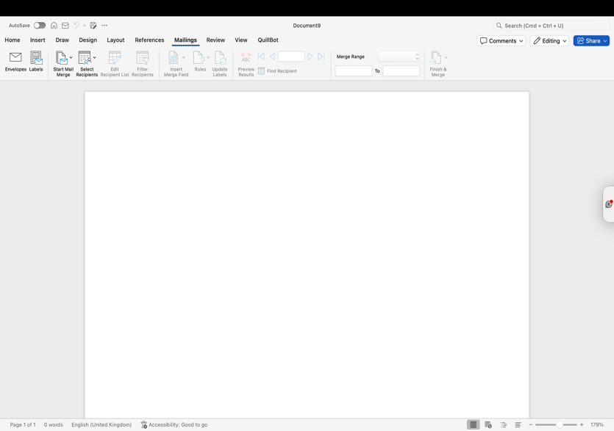
1.Open Microsoft Word On the Tab Press Mailings

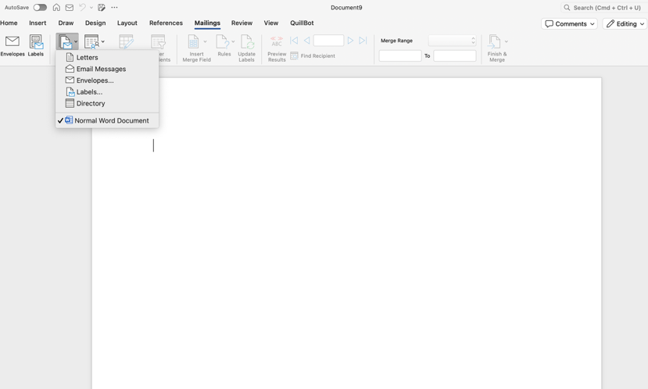
2. Click “Select Recipients” → “Use an Existing List” and choose an Excel file containing recipient names, addresses, or other data.

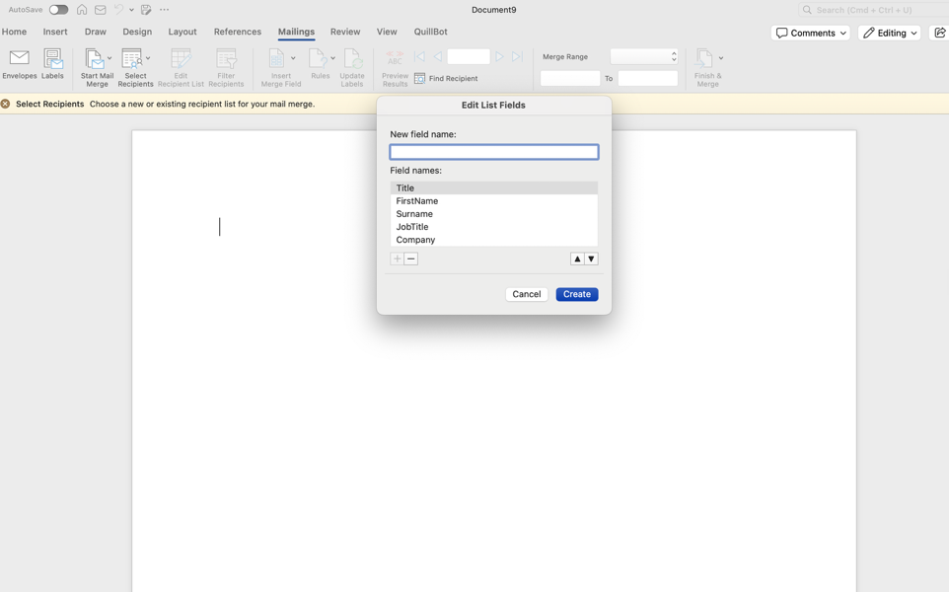
3. Insert placeholders (merge fields) into the letter by clicking “Insert Merge Field” (e.g., Name, Address).

The IF function in Microsoft Excel is a logical tool that allows businesses to make decisions based on specific conditions by returning different results depending on whether a condition is true or false. It is commonly used to analyze data, monitor performance, and automate decision-making processes. For example, a company can use the IF function to identify sales that meet or fall below targets, categorizing employees as “Target Achieved” or “Below Target.” Its benefits include saving time, reducing errors, and enabling efficient analysis of large datasets, while it can also be combined with other functions for more complex business calculations.
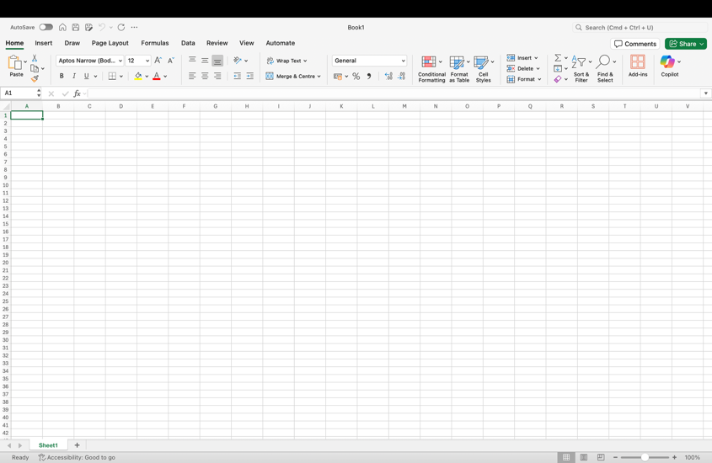

1.Open Excel and enter your data. For example, create a tablewith Employee Names and Sales.

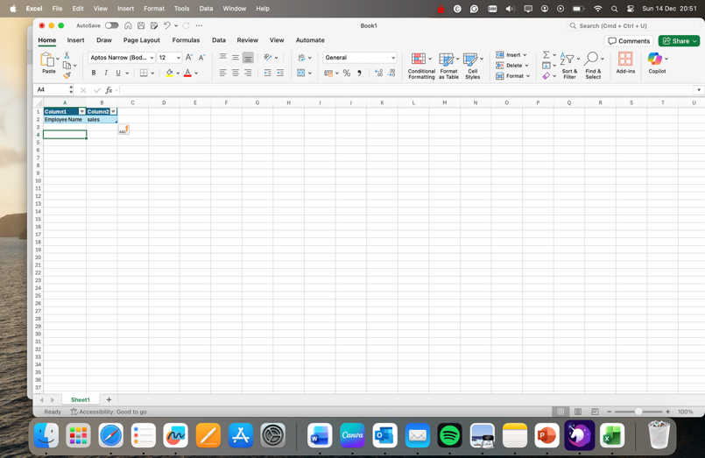

2.Enter data needed

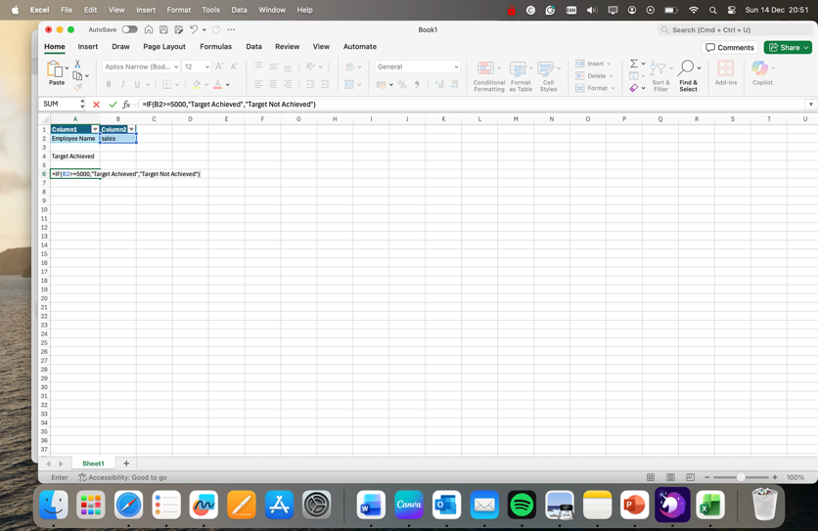

3. Select an empty column and type the formula:
=IF(B2>=5000,"Target Achieved","Target Not Achieved")
Here, B2 contains the sales figure.
Press Enter, then drag the formula down the column to apply it to all rows.
Excel will display “Target Achieved” or “Target Not Achieved” based on the condition.

Task 4
a.
In today’s fast-paced business environment, effective communication and collaboration are crucial for organisational success. Two widely used tools that support these functions are Email, as a contemporary communication application, and Microsoft SharePoint, as a collaboration platform. Both play distinct yet complementary roles in modern business operations.
Email remains one of the most essential communication tools in business, enabling organisations and individuals to send, receive, and manage messages electronically. Platforms such as Microsoft Outlook or Gmail for business offer features that go beyond simple message exchange. Users can attach documents, images, and spreadsheets, schedule meetings through integrated calendars, manage tasks, and organise contacts. Email is particularly valuable for formal communications with both internal teams and external clients, allowing businesses to maintain a written record of correspondence that can be archived and referenced when needed. One of the key benefits of email is efficiency; messages can be delivered instantly to multiple recipients, which is vital for time-sensitive communications such as announcements, meeting invitations, or policy updates. It also supports accessibility, as emails can be sent and received from various devices, including desktops, laptops, and smartphones, facilitating remote work and global business operations. Despite these advantages, email has some limitations. Security remains a concern, as phishing, spam, and data breaches are potential risks if proper security measures are not in place. Additionally, the tone and context of written messages can sometimes be misinterpreted, leading to misunderstandings. Information overload is another challenge, as employees may struggle to manage large volumes of emails, potentially delaying responses or missing critical messages.
Microsoft SharePoint, in contrast, is primarily a collaboration and document management platform. It allows businesses to create team sites, intranets, and document libraries that centralise information and enable structured storage of organisational data. SharePoint supports real-time co-authoring of documents, which helps teams work simultaneously on reports, presentations, or proposals without version control issues. Its integration with other Microsoft 365 applications, such as Teams, OneDrive, and Power Automate, enables workflow automation, streamlining processes such as document approvals and task tracking. The benefits of SharePoint are substantial. By providing a centralised repository for documents, it reduces duplication and confusion, ensuring that all team members have access to the latest information. It also enhances collaboration, as multiple users can access and edit content simultaneously, improving productivity and efficiency. SharePoint’s robust security features, including user permissions and encryption, protect sensitive business information, helping organisations meet regulatory compliance requirements. However, SharePoint has limitations as well. New users may face a steep learning curve due to its complexity, and navigating large datasets can be challenging without clear governance. Additionally, while SharePoint Online offers flexibility, some customisation options are limited compared to on-premises versions, which may affect organisations with specific workflow or design needs.
In summary, Email and SharePoint serve different but complementary roles in modern business operations. Email provides a fast, reliable, and documented method of communication, crucial for daily correspondence and formal business interactions. SharePoint, on the other hand, enhances collaboration, document management, and workflow automation, supporting efficiency and productivity in team-based projects. While both tools have their limitations, such as email security risks or SharePoint’s learning curve, their combined use enables organisations to communicate effectively, manage information efficiently, and maintain a competitive edge in today’s digital business landscape

Gmail
You can use gmail for business use by sending personalized emails to multiple clients or team members for announcements, newsletters, or updates. Companies use Gmail to send a weekly newsletter to clients, attaching product updates and offers. This streamlines communication and ensures information reaches the right audience.
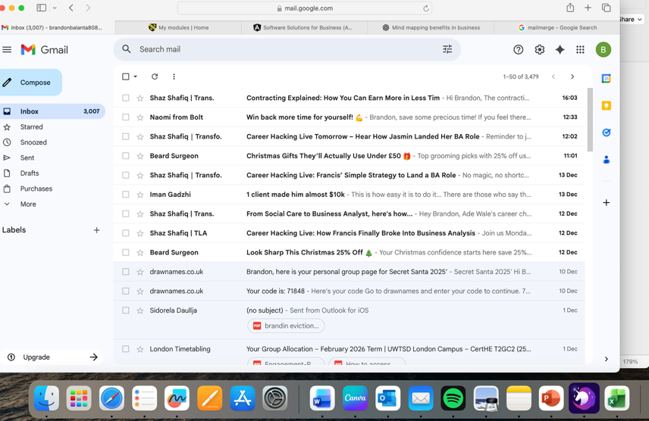
1.Open Gmail: Log in to your Gmail account.This screenshot demonstrates the main Gmail interface, which includes inbox, sent mail, and folders for organizing emails.


2.Compose a New Email: Click the “Compose” button to start a new email. Shows where the recipient email address, subject line, and message body are entered.


3.Add Recipients: Enter one or multiple email addresses or use a contact group.Email with multiple recipients added. Demonstrates how Gmail can reach multiple users simultaneously, useful for team or client communication.

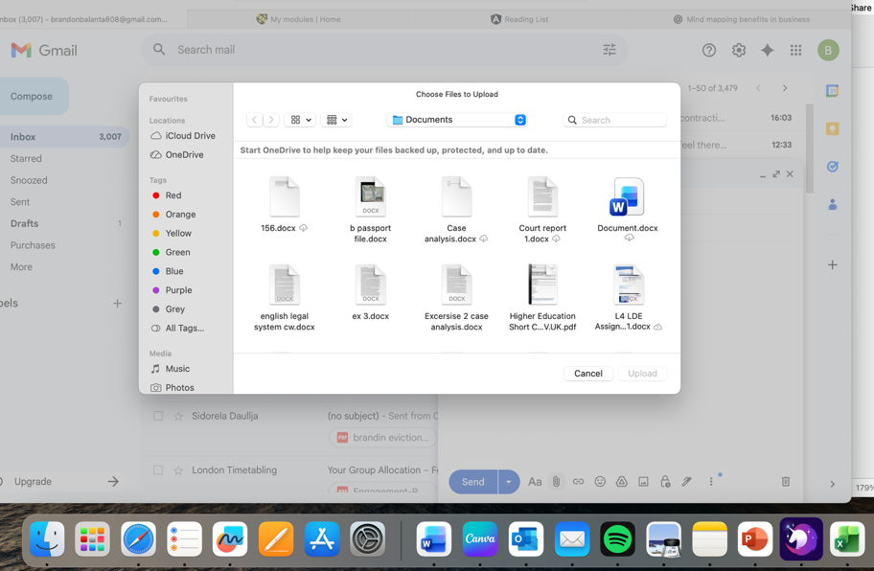
Insert Attachments: Click the paperclip icon to attach files like reports, presentations, or images.Email with an attached file. Shows how Gmail allows users to share documents efficiently.

Microsoft Teams
Real-time collaboration among team members, including chat, file sharing, and video meetings. A marketing team uses Microsoft Teams to collaborate on a campaign. Team members share content, discuss ideas in chat, and conduct virtual meetings to ensure all tasks are aligned.
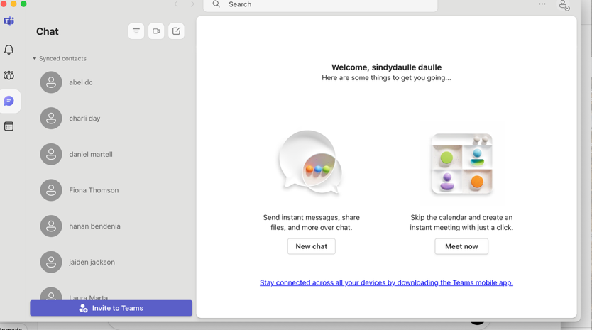
1. Open Microsoft Teams: Log in with a free Microsoft account or Microsoft 365 account.
Teams dashboard showing channels, chats, and teams.Shows the main interface where team members can interact and access shared files.

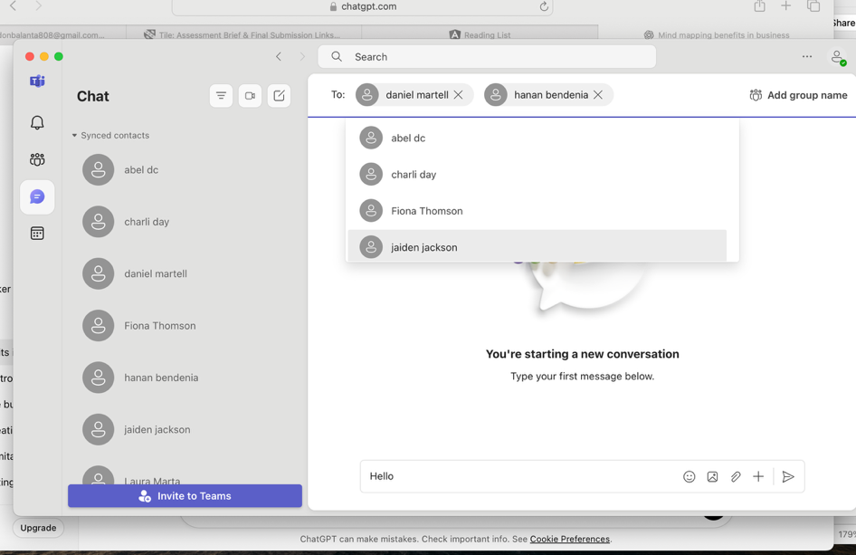
2.Start a Chat: Click “New chat” to message a team member or a group. Chat window with a message typed. Shows instant messaging capability, allowing quick clarification of tasks or questions.

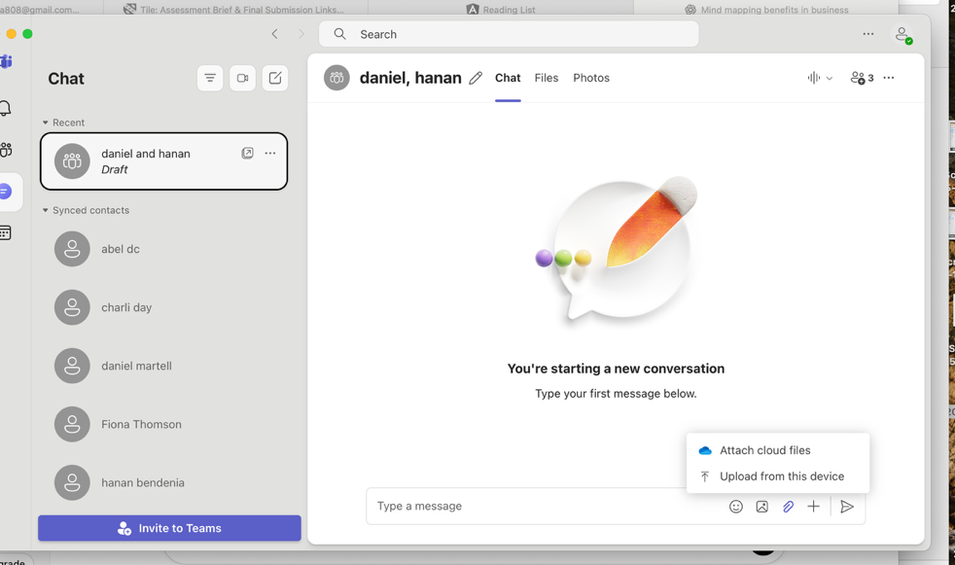
3. Share a File: Click the “Attach” button to share a document.File shared in a Teams chat.Demonstrates how Teams enables document collaboration without sending emails. Start a Video Meeting: Click “Meet now” or schedule a meeting in the calendar.

In conclusion Software solutions for business assessment enable organizations to make data-driven decisions, improve efficiency, and respond quickly to market changes. By providing clear insights into performance, operations, and customer trends, these tools help businesses optimize resources, identify growth opportunities, and maintain a competitive edge. Adopting such solutions ensures smarter strategies and sustainable success.

References
Present 10-15 sources. Please use IEEE referencing style. Do not forget to use in-text citations all the way through out this portfolio report.

