Soapbox race car

Daniel morgan P no. – 1708390

07/11/18
Soapbox racer report for team 7, we were tasked to design a theoretical model race car for the red bull downhill soapbox challenge, a gravity powered race car to be occupied by a single driver, no engines are permitted, and it must be pushed to a rolling start and then to let gravity take care o the rest of the acceleration. It must be able to turn, stop and handle to some degree to remain competitive amongst the other teams.
The car also needs to be viable, in both cost and functionality, there will be obstacles and jumps along the course of the track, and the car will need to be rigid enough to withstand these without failing to be in for a shot at finishing, watching other cars race has taught me that strength and durability is more key than handling or speed.
Contents

Here are the various pages where each component and report can be found
- Introduction
- Chassis
- Suspension
- Steering
- Wheels
- Brakes
- Body & aerodynamics
- Materials and costs
- Project planner
- Conclusion
- References

Introduction

Team 7 is to produce a soapbox racer, but only in theory, the car will be produced via CAD, and planning schematics to be a competitive racer in the RedBull soapboax derby, a light hearted and fast paced race series for the public, each entrant has their own design and, in most cases, a unique comedy value.
This report will document the various reasons to support why I am choosing each component and my research surrounding the decision, why they are cost effective, and the impact they will have on the car.
There will be ramps to present jumps in the course, I will need to have a rigid chassis and sound suspension system to handle these, also a good connection between he suspension and the wheels.
There are also obstacles in the route such as hay bails and cones, these can quickly destroy a weak car should they collide with any, a good bumper and bodywork can help with deflection should a collision happen.
The car will need brakes to come to stop, and to be better in corners, braking before a tight corner will result in a better finish time, thus being far more competitive.
Areas such as steering, wheel design, and the suspension all need careful consideration to be effective.
The cost of the car is a major decision, there will be a limited budget and certain areas of the car cannot soak up too much of the funding, or other areas will be left deprived.
In the chapters in this report I will identify problems to overcome, why I have chosen certain methods, and support my choices with research.

Chassis
By adopting a Steel square section, mig welded frame, the chassis will have a strong yet durable and light construction, many racers from go karts to full sized circuit race cars have used this design for decade with much success.
There are 3 variations of materials I have considered, steel, aluminium and carbon fibre, both cost difficulty to work with will be a deciding factor
Steel is the material of choice and welding is readily available for it through the workshop

(Ford, 2014) We were confident that a well-designed monocoque could be as strong, if not stronger than a tubular frame but unfortunately time and cost limitations meant that we had to modify our plans so that the outer shell was not structural, and the loads be taken with an internal frame instead.
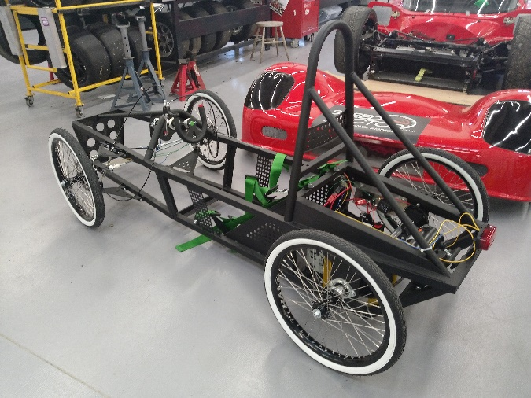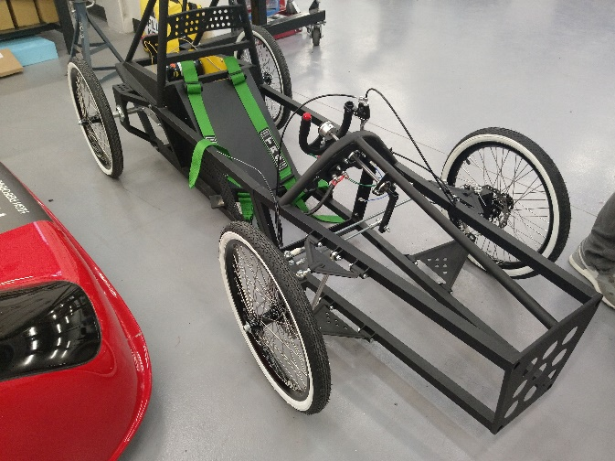

Suspension
The suspension is to be a double wishbone arrangement, featuring a hub for the front, to allow steering via a tie rod and rack system.
The wishbones are to be mounted to the chassis via direct mounts, using a simple rubber bush and bolt arrangement, both wishbones will attach to the hub via a rose joint.
The lower wishbone will incorporate a mount for an upright shock absorber, this shock will run up to the chassis between the upper wishbone, this shock absorber will be sourced from a mountain bike and will be used on all four wheels
The rear suspension will have a solid mounted hub to avoid it turning or pivoting.

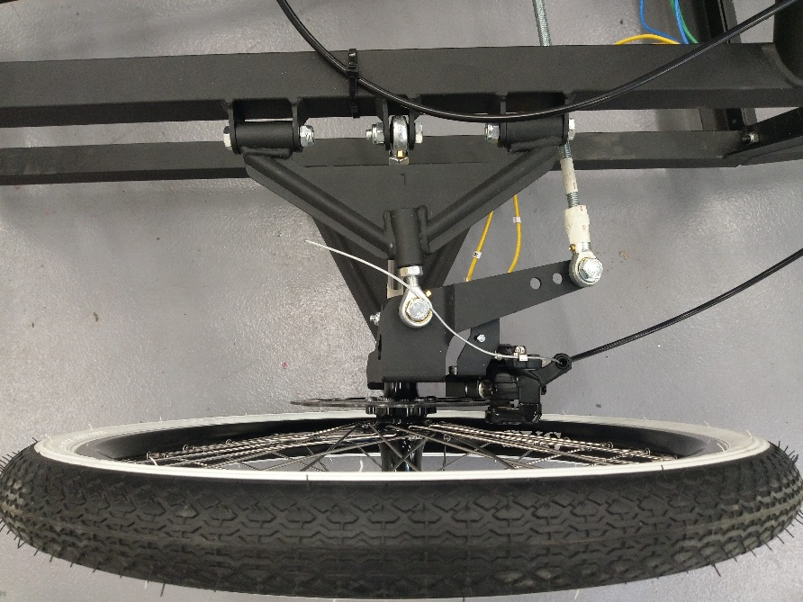

Steering
For steering we have chosen a simple go-kart like set-up which will include a steering wheel, steering rod, plastic track rods and stubs bolted onto a welded stub bracket which is welded to the chassis.

The steering bracket is bolted to a Steele plate welded to the chassis and has a small rose joint to allow movement.

At the end of each track rod there is small rose joints bolted to either the stub or the steering bracket. Then the rose joints thread into the track rods. There is 1 right hand and 1 left hand thread rose joint and they have a certain way they thread into the track rod because you adjust the tracking by threading the track rod further away or closer to the rose joint.
The stubs are then bolted to the stub bracket which is welded to the chassis also.

To allow the stubs to pivot and move they each have two chamfered needle bearings both packed well with grease.
Underneath each stub there is a grease nipple to keep the needle bearings inside well-greased.

This steering setup is very affective and practical for our soap box because it is very lightweight and does not take up much room in the soap box.
Also the plastic track rods are very useful and perfect for the soap box because the track rods are very flexible and bend and if we happen to crash there is less chance that it will break and stop us from continuing on with the race.
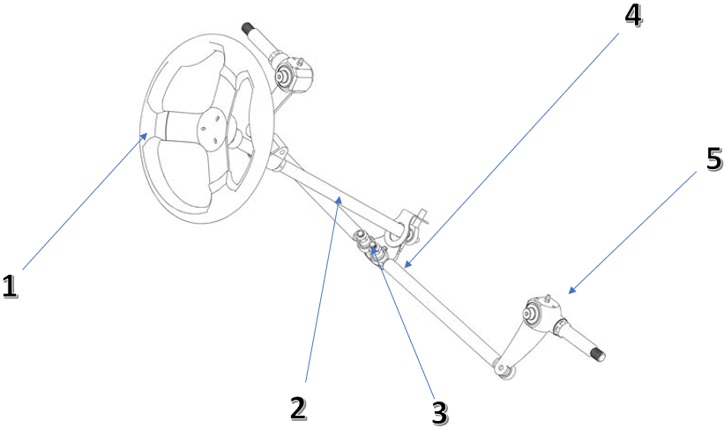
- steering wheel
- Steering rod
- Steering Colum
- Track rod
- Stub

Wheels
There are 3 types of wheels that I have in mind to attach to our soapbox. Each type of wheel has pros and cons.
Quad wheels - these wheels are strong and can be taken through the toughest conditions of off-road and asphalt. This is good because the soapbox track has some jumps and harsh terrain and we would need wheels to be able to softly land without losing traction. along with the suspension setup, it will provide a smooth a ride. having a lower tire pressure will also allow the soapbox to have more contact with the road.
Go kart/pit bike wheels - These wheels are racing slicks that are used on go karts and can be used on pit bike wheels they have a wide surface area for grip. for more grip you can apply heat to the tires to stick to the surface better. This would be good for the corners so it won’t be able to slide out as much. Also these type of wheels are very strong and durable. Pit bike wheels are also all terrain which can be pushed to the limit since it’s strong and reliable. This type of wheel is perfect for street use.
Scooter wheels are very small for the of the soapbox and would provide a harsh ride for the driver. these wheels are very light and produces less drag.
We have decided to go for pit bike wheels because it’s a cost effective option that’s worth the money. A set of pit bike wheels for 2 brand new is around £139.99, this is for a size of 14 inch and 12 inch wheels. However these types of wheels are made with high quality aluminium which means there one of the top of the ranges . For tyres we have decided to go slicks on the pit bike wheels that can cost around £100 for a set of 2 that’s 12 inch.

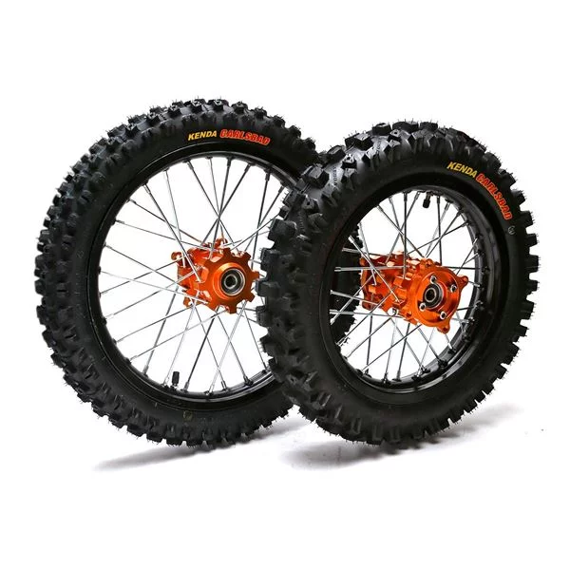

Brakes
For the braking system we’ve chosen to go with hydraulic motocross brakes mixed with go kart brakes.
The reason for this is because it provides very good braking power without being too heavy. Also, its reasonably priced and isn't overly complicated install, use and setup.
This will use a steel braking rotor at the wheels. From there it is used like a go kart brake pedal, so it’ll be foot operated, this meaning that it uses a motocross steel brake disk along with motocross caliper that is to be bolted to the hub, brake line and master cylinder but uses the brake pedal to actuate the braking system. once the pedal is pressed it pushes a small slave cylindre into the master cylinder this then operates the braking system. From the master cylinder we will have brake line going down to the caliper. This then squeezes the brake pads onto the disk providing stopping power, we will only need 1 pair of disc setups as they're very effective, fitted to the 2 front wheels.
The one master cylinder will activate both front brakes simultaneously.
As were only using 2 setups it remains very inexpensive yet reliable and strong.
1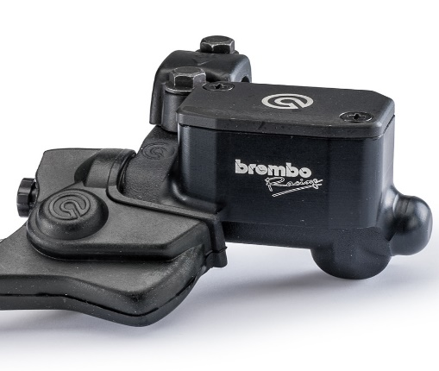2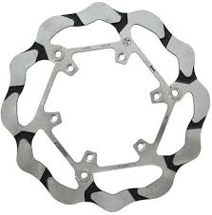
3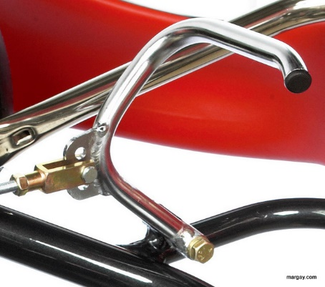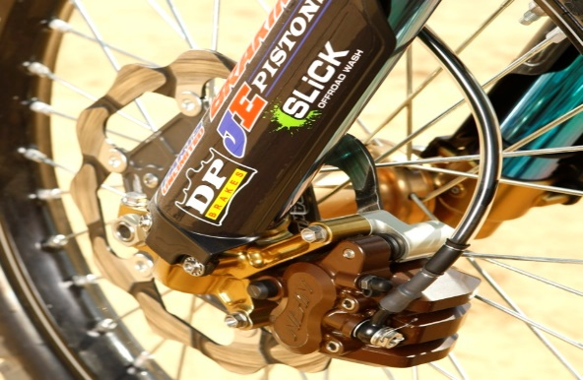4

Body & Aerodynamics
In this design the desired material to be used would be carbon fibre to make the body out of but as this is too expensive being a costly £58.84 for approximately 2mm thickness 0.48m x0.76m*, we shall be using fiberglass, this is a much cheaper and easier material to use. Research shows that a 2mm Fibreglass Flat Sheet - Super White would cost approx. £34 for a 0.6m x 0.6m sheet *.
There has been many shapes of soap box race cars tried and tested, in the research one of the best soap box race cars for the speed and stability is the shape of like a dart with a tail inwards at the rear to make the shape a good aerodynamically fast soap box racer. I.e. a formula one vehicle. In my design I have decided to integrate the front wheels into the body to reduce the drag around the front wheels also to reduce damage if there is any impact taken to the front wheels. The front of the vehicle will be at a low increasing in height gradually up to the max height while will be slightly behind the driver’s head. There will be a cover over the driver which will be made out of clear PVC. This will allow clear vision for the driver but once again reduce the drag, it will be secured with Velcro strips to ensure the driver is able to leave the vehicle unaided.
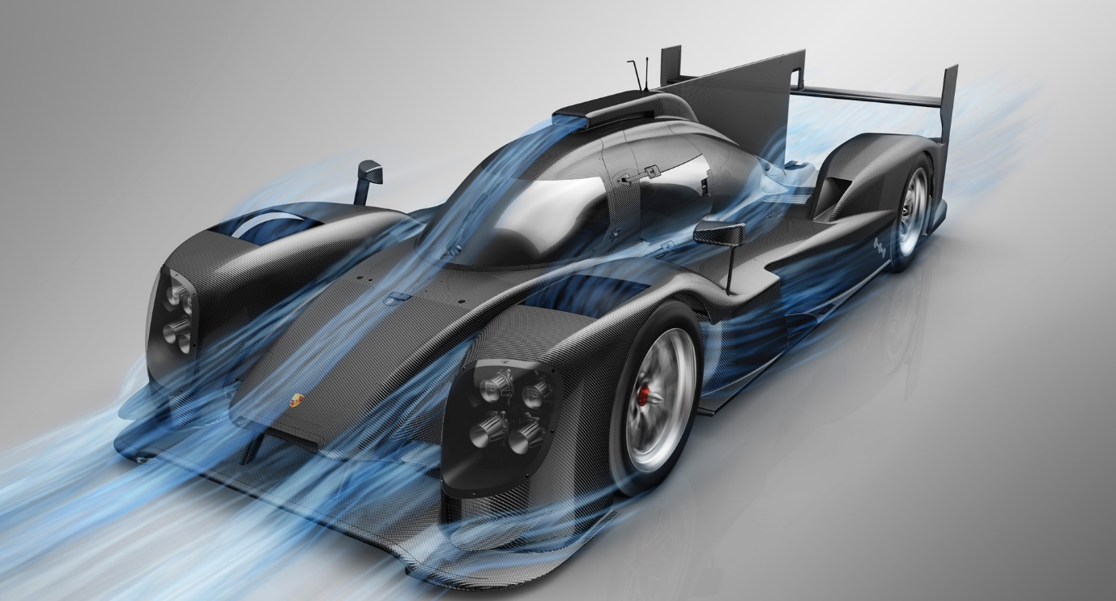
1.a

Materials and costs
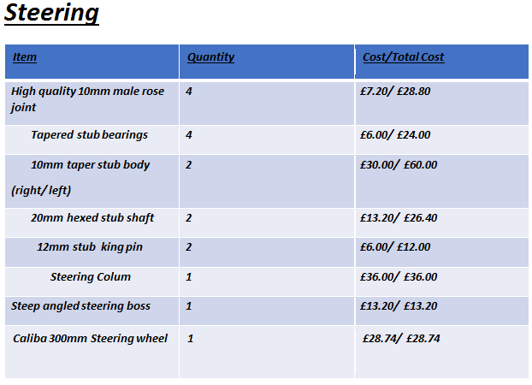
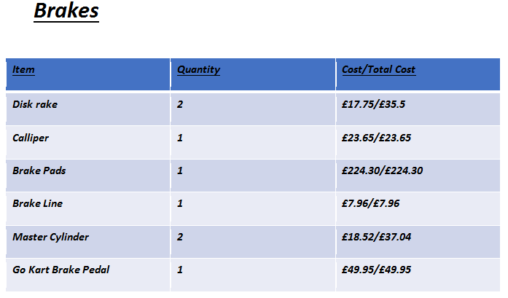
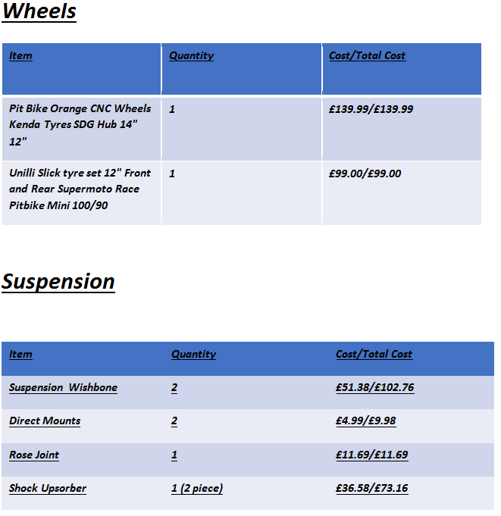

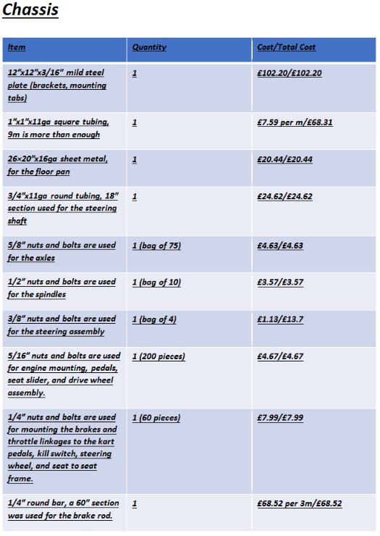

Project planner

Our plan as a group was pretty simple and we set our goals and roles within 4 meetings as a group.
At our first meeting as a group we discussed general ideas and simple things that we could put together to make a soapbox. Also, we looked at other people’s soapbox projects on google to start us off with ideas of materials and parts.
After our first meeting we all had some ideas in our head and we went back and researched what we thought would be the best parts and materials.
Our second meeting started off with all of us sharing our ideas and what each of thought would be the most practical. After we all discussed what would be best for our soapbox we then went on to choose our roles for the project and which areas we would all cover and what would suit us best.
Our third meeting was just a small group discussion and was to see how everyone was getting on and if anyone needed help with anything they were unsure of.
We met as a group to pitch our idea as a PowerPoint presentation to our tutor, we all spoke for our individual roles, showing photos to back up what we have learned, this went very well.
Finally, our fourth and final meeting was a to finalise our final idea and to show all our group members that we had all completed our sections and that we were ready for it to be submitted.

Conclusion
We as a team are setting out to design a soapbox racer that will be competitive, after meetings and discussions we as a group decided that steel chassis, is the best idea, using a “bullet” shaped body by covering the chassis in fibre glass panels, incorporating a Perspex canopy to keep the streamlined design.
We did consider other materials for the design, however due to costs and difficult of using the aluminium and carbon fibre, we found it is just not viable to use. Steel we found offered the best cost-effective strength and weight ratio, the fibre glass is similar in that its cheap enough, and is very durable, but mostly, it is easy to buy and work with compared to carbon fibre.
Moving onto the wheels and brakes, pit bike wheels running slicks will provide excellent strength and grip, many wheels come free from damage during the jumps found at the soapbox derby and this effectively ends the race for the team, using strong stub axles, bearings, and lubrication the wheels will be very strong, and stable, taking damage should be a low risk.
Brakes are going to be of an amalgam of pit bike callipers and master cylinder, and rotors from a go kart, and the pedal will also be removed from a go kart design, and used to actuate the cylinder, using a conventional push rod slave cylinder, both front wheels will have the same set up, giving excellent braking power.
Steering will be of again, go kart design, using a simple track rod and hub set up, its very durable and not much can go wrong with the design
The suspension will be of double wishbone design, allowing for good articulation, in both steering angle, and suspension travel, which will be using a shock and coil system from a pit bike

What we as a team have designed will be very cost effective, and not only competitive, but also strong and resistant to damage, compared to some other designs it will be heavy, but it wont be passed the point its no longer efficient.

References

1.a, Ford, J (2014) The Engineer, www.theengineer.co.uk/issues/november-2014-online/sheffield-hallam-university-helps-guy-martin-break-downhill-speed-record (8/11/2018)

1, https://www.demon-tweeks.com/richbrook-real-carbon-fibre-sheet246957/?sku=R/B4000.44&istCompanyId=a2904180-3a7d-4e56-b876-cf81c9512180&istItemId=- xpwapmqqrl&istBid=t&utm_source=bing&utm_medium=cpc&utm_campaign=PX%20-%20DT%20- %20Shopping%20-%20Generics&utm_term=4583108064908999&utm_content=Performance%20- %20Vehicle%20Styling&gclid=CIDDk73w2N4CFYaMhQodfcED2w&gclsrc=ds

2, https://www.ecfibreglasssupplies.co.uk/product/2mm-fibreglass-flat-sheet-super-white

Picture 1 3,https://www.bing.com/images/search?view=detailV2&ccid=NTlIX1IA&id=1CEB2375FA89D78DA4A 121108966CC520BB12066&thid=OIP.NTlIX1IA3mH6CrBX6Wf31gHaD_&mediaurl=https%3a%2f%2fbl ogs.studyinsweden.se%2fwp-content%2fuploads%2f2017%2f06%2faerodynamicsporsche.png&exph=1029&expw=1911&q=aerodynamic+of+a+race+car+2018&simid=608007165233 465178&selectedIndex=0&ajaxhist=0

Brakes.
Pic 1. https://www.google.com/search?q=motocross+master+cylinder&source=lnms&tbm=isch&sa=X&ved=0ahUKEwikmu-UlvPfAhVgHTQIHX9CCAAQ_AUIDygC&biw=1440&bih=826#imgrc=8Rg6Hklmq2QoBM:
Pic 2. https://www.google.com/search?biw=1440&bih=782&tbm=isch&sa=1&ei=WJk_XJiaOqPB7gK2gqGIBg&q=motocross+brake+roter&oq=motocross+brake+roter&gs_l=img.3...557549.560439..560849...0.0..0.320.1954.2-6j1......1....1..gws-wiz-img.......35i39j0i24.ubnwn_6h0Mk#imgrc=hywuPg79meA_DM:
Pic 3. https://www.google.com/search?biw=1440&bih=826&tbm=isch&sa=1&ei=epc_XPriMYXD0PEP9qGp-Ac&q=go+kart+brake+pedal&oq=go+&gs_l=img.1.0.35i39j0i67l3j0i10i67j0j0i67l4.194459.291706..293716...0.0..3.414.5408.2-15j3j1......5....1..gws-wiz-img.....0.iqVdHxW2W_w#imgrc=wCmKg2FCjGCmiM:
Pic 4. https://www.google.com/search?biw=1440&bih=826&tbm=isch&sa=1&ei=o5g_XMCbON3C0PEPrLKnEA&q=motocross+brake+caliper&oq=motocross+brake+caliper&gs_l=img.3..35i39j0i24.162277.178827..179304...0.0..3.366.11403.2-27j13......1....1..gws-wiz-img.....0..0j0i8i30j0i67j0i5i30.hSuruiLvx0o#imgrc=FBZelYawYkWvdM:

Steering
Parts;
https://shop.bizkarts.com/Catalogue/Kart-Parts/Commercial-Kart-Parts/Steering-Components-2
Pic 1:
https://shop.bizkarts.com/Catalogue/Kart-Parts/Commercial-Kart-Parts

Wheels
Parts/pic wheels:
https://www.funbikes.co.uk/p2362_pit-bike-gold-cnc-wheels-kenda-tyres-sdg-hub-14-12?gclid=CjwKCAiA1ZDiBRAXEiwAIWyNC4nyUR_Dyh3KGlfDs6ksi4FPMvCYuCfeGiHHOK4qEsdkryCqG1A8yRoCzVUQAvD_BwE
Parts/pic tyres:
https://www.ebay.co.uk/itm/Unilli-Slick-tyre-set-12-Front-and-Rear-Supermoto-Race-Pitbike-Mini-100-90-/152835585251

