Programme: BA (Hons) Business Management
Module: Project Management
Module code: LCBB5005
Assignment Title: Component 1: Coursework: Essay - Project Plan
Lecturer name: David Oyebisi
Student name: Iulian Neagu
Student ID: 2107401

Table of Contents
Introduction 4
Aim, Objectives, and Scope 4
Aim 4
Objectives 4
Scope 5
Deliverables 5
Homes Fitted with Solar Panels 5
Site Assessment Reports for Each Home 6
Permits and Approval Papers 6
User Guides for Homeowners 6
Direct Outcomes 6
Energy Savings for Homeowners 6
Positive Feedback from Homeowners 7
Identification of Activities and Sub-activities 7
Activity 1: Installing solar panels 7
Planning and Coordination 7
Procurement of Materials 8
On-site Installation 8
Activity 2: Conducting site assessments 8
Initial Homeowner Contact 8
On-site Inspection and Data Collection 8
Assessment Report Preparation 8
Activity 3: Obtaining permits 8
Regulatory Research 8
Permit Applications 9
Activity 4: Provision of user guides 9
Content Development 9
Printing and Distribution 9
Work Breakdown Structure (WBS) for Solar Panel Installation Project 9
Identifying the deliverable and milestone(s) of each task 11
Resource Usage Explanation 12
Conclusion 13
References 14

Introduction
Installation of solar panels on domestic houses is a vital aspect of renewable energy systems, reducing the consumption of fossil fuel and carbon emissions (Palm, 2018). The objective is to make sure solar panel installation on new houses in Edinburgh in order to generate a clean and affordable source of energy. With the increase in the cost of energy and the problem of global warming becoming more of an issue, renewable energy is needed more than ever. Edinburgh, being a city renowned for its green pursuits and sustainability, is a welcoming place for such a venture.
The project aims to integrate solar energy systems into new-build homes to improve long-term affordability and residents' independence from energy providers. With the implementation of innovative photovoltaic technology, the project will maximise energy efficiency, improve independence, and enable Scotland to achieve renewable energy targets. The project is also in line with government policy and initiatives for the fitting of clean energy.
By working with property developers, policymakers, and energy providers, the project will make solar panels fit the norm in new-build housing developments. By doing so, it not only saves householders money on their bills but also further cements Edinburgh's reputation as a front-runner for renewable energy take-up.

Aim, Objectives, and Scope

Aim
The overall goal of this project is to promote mass residential solar panel installation on new Edinburgh homes as an affordable and green source of power.

Objectives
- Increase Solar Panel Take-up: Work with builders to have solar panels installed on at least 60% of new homes built in Edinburgh within the next five years.
- Make Solar More Affordable and Accessible: Discover affordable finance plans, including government subsidies and incentives, to make solar installation available at an affordable cost to homebuyers.
- Reduce Carbon Footprint: Help Edinburgh reach zero net carbon emissions by reducing household use of fossil fuel-produced electricity significantly.
- Encourage Policy Support: Work with local leaders and policymakers to establish supportive regulations and incentives for residential solar power usage.
- Educate and Raise Awareness: Organise awareness campaigns to educate homebuyers and developers about the long-term advantages of solar energy.

Scope
The project shall target new housing development in Edinburgh and shall remain in close touch with developers of property, contractors of buildings, and government agencies to enable proper integration of the solar panels. It will involve all stages from feasibility studies to procurement, installation, and post-installation inspection to determine energy efficiency (Fares and Webber, 2017). The project will also examine the cost viability of different funding options, including government incentives and private funding, to ensure it is affordable.
Although the main target is confined to Edinburgh, conclusions drawn from this project can be utilised for overall applications in other cities that desire to adopt analogous renewable energy programs. The project shall also take into account possible challenges that might come from regulatory hurdles, technological suitability, and market demand obstacles and decide on the essential strategy for renewable resources of energy.
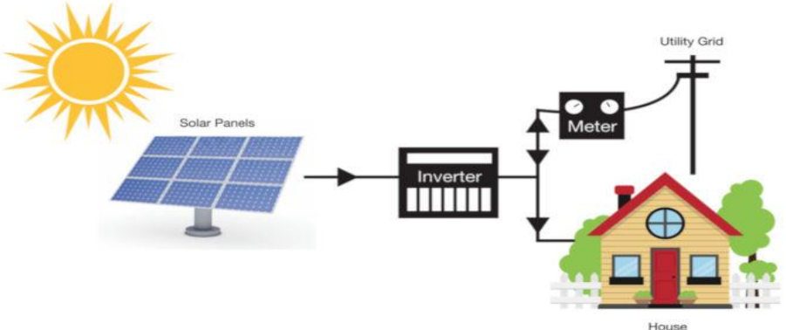
Figure: On-grid solar system without battery backup
(Source: Ahmed et al., 2000)

Deliverables

Homes Fitted with Solar Panels
Solar panels will be installed on around 1,000 homes across Edinburgh. Each installation will consist of solar panels and inverters capable of converting sunlight into electricity. The average household in the UK with a solar panel can reduce bills of electricity by up to 50%. This can tend toward savings of around £400 per annum depending on the size of the system and the usage of energy. Homeowners will be active contributors to the reduction of the emissions of carbon. Households contributed to more than 330 million tonnes of CO2 in 2022 in the UK (Gov.uk, 2023). This can be prevented through the generation of their own electricity.

Site Assessment Reports for Each Home
A number of detailed reports will be provided for the complete range of 1,000 homes. These reports will assess the size, angle, and exposure to sunlight. These are vital for the generation of the maximum amount of energy from solar panels. Homes in Edinburgh can generate up to 3,500 kWh of electricity annually through a system with a good placement. This is sufficient to cover the majority of household-related requirements related to electricity.

Permits and Approval Papers
The project will ensure the complete range of required permits and approvals. This can ensure alignment with the regulations in the UK. The government of the UK committed to the installation of 600,000 heat pumps and millions of solar panels as a component of its plan to reach emissions of net zero by 2050 (Gov.uk, 2023). The project will contribute to this target. This can be achieved by ensuring the alignment of the complete range of installations with the legal standards and requirements related to safety introduced by councils and regulators of energy at a local level.

User Guides for Homeowners
Each homeowner will receive a simple guide on the way to operate and maintain their systems related to solar panels. A sizeable number of homeowners are interested in the management of solar energy. This is associated with the growth of solar panels in the UK by 80% in 2022 (Mintel, 2025). The guide will be helpful for homeowners in grasping the way to enhance the output of their system in a gradual way along with maintaining it. This can ensure the system’s lifespan of solar panels for a typical period associated with around 25 years.

Direct Outcomes

Energy Savings for Homeowners
Homeowners will commence to save money on their bills related to utilising energy. Such savings will increase over time due to the growth of prices of energy. Solar panels will be helpful for homeowners in the production of their own electricity. This can reduce the amount of electricity required to purchase from energy-based business entities (Shali, 2024).

Positive Feedback from Homeowners
Feedback from homeowners will be collected regarding the procedure of installation and the performance of the system. Such feedback will be helpful in grasping the level of satisfaction of customers with their solar panels. It will additionally be helpful to introduce improvements in the existing set of projects. A positive form of feedback can be utilised to attract an additional set of customers along with building trust in the services.
Aligning Technology Acceptance Model (TAM)
The perceived usefulness of solar panels lies in savings in energy during the growth of prices. On the other hand, the perceived seamlessness of utilisation is enhanced by a positive form of feedback on the installation and performance of the system to boost further adoption (Fatui, 2022).

Identification of Activities and Sub-activities
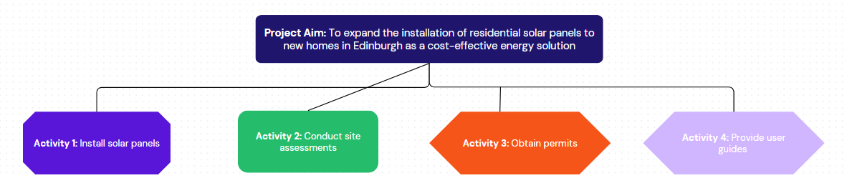
Figure: WBS of Main Activities
(Source: by the learner)

Activity 1: Installing solar panels
The installation of solar panels with planning is associated with incorporating relevant materials to promote a renewable form of energy. It is helpful for a number of homeowners in the generation of clean energy-based output. The planned approach can reduce the probability of failure related to systems eventually.

Planning and Coordination
- Creation of a timeline and the assignment of teams to a specific smaller set of areas
- Communication with homeowners to coordinate dates of installation

Procurement of Materials
- Securing a number of solar panels, inverters, and tools related to installation from suppliers
- Tracking inventory to ensure the materials’ arrival on time

On-site Installation
- Installing panels along with connecting them to the electrical system of the home
- Testing the system to ensure functions in a proper way and output energy

Activity 2: Conducting site assessments
The conduction of assessments of the site ensures the placement of the most suitable type of solar panels at the correct time. This can increase the efficiency and output of energy at a gradual rate (Incitti, 2024).

Initial Homeowner Contact
- Contacting homeowners to arrange visits to the site along with explaining the procedure
- Understanding a number of specific concerns or preferences

On-site Inspection and Data Collection
- Measuring the size of the roof, angle, and exposure to sunlight
- Spotting a number of obstacles in the form of trees capable of reducing the amount of sunlight

Assessment Report Preparation
- The analysis of datasets collected along with recommendations for the placement of panels for the best output of energy
- Provision of homeowners with a brief overview of eventual findings and potential savings in energy

Activity 3: Obtaining permits
Obtaining permits is vital for ensuring alignment with a number of regulations and standards related to safety along with notifying the Distribution Network Operator (DNO). Considering a larger solar PV than 3.68kW should be through notification related to G59 prior to installation (Holmes, 2023).

Regulatory Research
- Spotting the required permits to ensure alignment with the existing regulations
- Staying updated on any modifications in the regulations regarding the installation of solar panels at a local and national level

Permit Applications
- Submitting a number of permits along with follow-up with several councils
- Keeping track of the complete range of approval-based documents considering records of compliance

Activity 4: Provision of user guides
User-based guides are vital for assisting homeowners in grasping and managing their exclusively installed solar systems. They provide a neat set of instructions on the operation, monitoring, and maintenance. A set of designed guides ensures the maximum benefit to users from their system in an impeccable manner (Dain, 2023).

Content Development
- The creation of a simple guide for the operation and maintenance of solar panels
- Inclusion of tips and instructions regarding troubleshooting and monitoring energy

Printing and Distribution
- Printing guides for homeowners along with distribution of digital versions through email
- Creation of a website to be helpful in accessing information

Work Breakdown Structure (WBS) for Solar Panel Installation Project
A Work Breakdown Structure (WBS) breaks down the project into manageable smaller tasks systematically, promoting clarity during execution. The following is the systematic activity breakdown, sub activity, and tasks required for the successful installation of solar panels for residential purposes in new Edinburgh homes.
Activity 1: Solar Panel Installation
1.1 Planning and Coordination
- Create a project timeline and milestones
- Allocate teams to specific installation areas
- Coordinate with homeowners to schedule installation
1.2 Procurement of Materials
- Identify and procure solar panels, inverters, and mounting hardware
- Contract with suppliers to deliver on schedule
- Monitor stock and logistics for synchronization with the project schedule (Kocian et al., 2021)
1.3 Site Installation
- Ready roofs for mounting panels (cleaning, bracing, safety inspections)
- Mount panels and link to electrical infrastructures
- Carry out first-time performance checks to ensure the functionality of the system
1.4 Site Assessment Reports per Dwelling
- Pull together installation statistics, issues, and suggestions
- Record system performance and anticipated power output
Activity 2: Site Assessments
2.1 Initial Homeowner Contact
- Arrange for site visits with homeowners
- Inform homeowners about the assessment process and the benefits of the project
- Discuss any particular concerns or tastes
2.2 On-site Visit and Data Collection
- Take roof size, slope, and orientation measurements for maximum panel placement
- Locate shading obstructions (trees, chimneys, nearby buildings)
- Obtain solar exposure data using technical equipment (McKenna et al., 2018)
2.3 Preparing Assessment Reports
- Examine the data collected to identify the best panel positioning
- Draw up reports that include efficiency forecasts and energy savings
- Provide assessment results to homeowners for decision-making
Activity 3: Permit Acquisition
3.1 Research on Regulations
- Determine required permits at local and federal levels
- Keep current with changing regulations on solar installations
3.2 Permit Submissions
- Submit permits and maintain compliance with safety regulations
- Track approvals with regulatory agencies (Guno et al., 2021)
- Keep records of approvals for documentation and audit purposes
Activity 4: User Guide Provision
4.1 Content Creation
- Create a simple-to-follow homeowner manual for system operation (Arani et al., 2017)
- Add troubleshooting procedures and energy-monitoring methods
4.2 Printing and Distribution
- Print hard copies for homeowners
- Release digital copies through email and an online project website
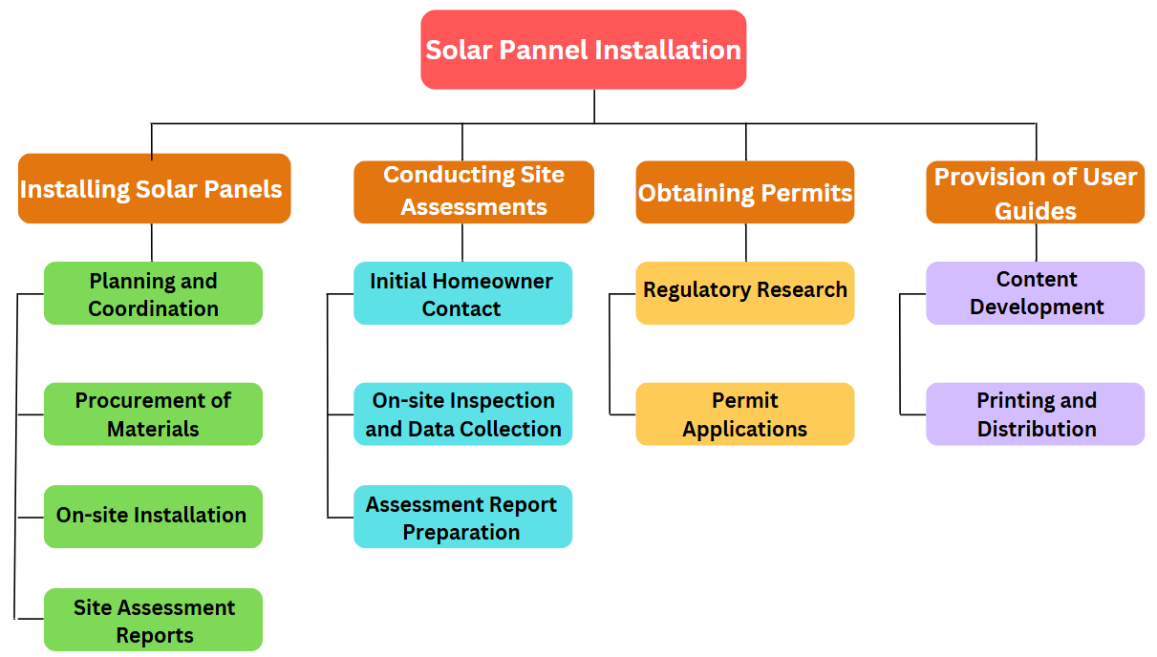
Figure: Work Breakdown Structure (WBS) for Solar Panel Installation Project
(Source: Learner)

Identifying the deliverable and milestone(s) of each task
Task | Deliverable | Milestone | Timeline
Feasibility Study | Market & Technical Feasibility Report | Approval of the feasibility report | Month 1-2
Regulatory Approvals | Approved Permits & Compliance Certificates | Receipt of all necessary permits from authorities | Month 3-4
Supplier Selection | Signed Contracts with Solar Panel Suppliers (Asrama et al., 2021). | Finalization of supplier contracts | Month 5
Installation | Fully Installed and Tested Solar Panel Systems | Achievement of key milestones (100, 300, then 500 homes installed) | Month 6-18
Customer Training | Training Materials & Conducted Sessions | Completion of homeowner training sessions | Month 7-12
Monitoring & Evaluation | Performance Reports and Energy Savings Data | Final project review meeting confirming energy targets | Month 12-24

This table outlines each of the critical task along with its actual specific deliverable, the main milestone that mainly signifies the main successful completion of that of the task and the timeline allocated to finish it (Wei et al., 2021). For instance, the Feasibility Study venture will culminate with a complete document that, once accepted, permits the undertaking to transport into the regulatory phase. Similarly, the Installation venture is segmented into progressive milestones to make certain gradual and practicable deployment. These Truely described deliverables and milestones ensure that undertaking progress is measurable and that every section meets its set objectives in advance than proceeding.

Resource Usage Explanation
To successfully complete each task within the particular project, a particular range of human as well as the material resources is very much meticulously allocated as well as properly managed. A devoted mission supervisor oversees the whole technique, making sure that every venture is finished as planned and inner charge variety, even as specialised groups comprising engineers, technicians, and compliance officials are assigned primarily based totally on their realize-how to cope with technical checks, installations, and regulatory submissions respectively (Seijun et al., 2021). During the Feasibility Study and Regulatory Approvals stages, engineers and compliance officials collaborate intently to gather vital information and strong lets in, requiring minimum but noticeably professional manpower. In the Supplier Selection phase, procurement professionals have interaction with multiple companies, leveraging their negotiation competencies to constant favourable contracts for solar panels and associated electric components collectively with wiring, inverters, and mounting systems (Schulte et al., 2021). The Installation phase demands a robust group of technicians and area engineers, who artwork in shifts to ensure that installations are completed efficiently and adequately, using extremely-current tools and device. Additionally, education classes for proprietors are conducted thru a specialised advertising and advertising and marketing and customer support team prepared with nicely-organized training substances and virtual publications to facilitate a clean transition to renewable strength usage. Throughout the Monitoring & Evaluation segment, information analysts and discipline inspectors use superior typical overall performance monitoring equipment to track power economic financial savings and machine reliability, making sure that the venture meets its sustainability goals. This comprehensive resource planning not handiest guarantees that each assignment is staffed with the correct information however also that the substances used—from amazing solar panels to the present-day monitoring era—are available at each stage, thereby optimizing performance and making sure that the mission milestones are met inside the described timeline.

Conclusion
In summary, the growth of residential solar panel installations in new homes in Edinburgh is a cost-saving and eco-friendly energy option. Through adequate planning, resource utilization, and coordination with stakeholders, this project offers effective implementation. The Work Breakdown Structure ensures organized installation, from site analysis and permitting through final deployment and homeowner assistance. By incorporating solar technology in new constructions, the project aligns with Edinburgh's green vision, reduces carbon footprints, and achieves long-term economic benefits for its residents. The project also initiates policy support and public awareness, resulting in greater adoption of renewable energy. With a well-defined plan and well-structured implementation, the program is a key catalyst for Scotland's sustainability goals, resulting in a cleaner, energy-efficient future.

References
Ahmed, S., Ahsha, K.N. and Mondal, M.N.A., 2000. Rooftop solar: A sustainable energy option for Bangladesh. IOSR J. Mech. Civ. Eng, 17, pp.58-71.
Arani, K., O'Shaughnessy, E., Fu, R., McClurg, C., Huneycutt, J. and Margolis, R., 2017. Installed cost benchmarks and deployment barriers for residential solar photovoltaics with energy storage: Q1 2016 (No. NREL/TP-7A40-67474). National Renewable Energy Lab. (NREL), Golden, CO (United States), pp.1-41.
Dain, M. L., 2023. Solar Power Is Finally Becoming Accessible To Everyone, Forbes. Forbes Magazine. Available at: https://www.forbes.com/sites/markledain/2023/03/23/solar-power-is-finally-becoming-accessible-to-everyone/ (Accessed: 15 February 2025).
Fares, R.L. and Webber, M.E., 2017. The impacts of storing solar energy in the home to reduce reliance on the utility. Nature Energy, 2(2), pp.1-10.
Fatui, O., 2022. Determinants of intention to purchase photovoltaic panel system: An integration of technology acceptance model and theory of planned behaviour. International Journal of Energy Economics and Policy, 12(3), pp.432-440.
Gov.uk, 2023. 2022 UK greenhouse gas emissions, provisional figures. Available at: https://assets.publishing.service.gov.uk/media/6424b8b83d885d000fdade9b/2022_Provisional_emissions_statistics_report.pdf (Accessed: 15 February 2025).
Gov.uk, 2023. Greener buildings article great.gov.uk international (no date) article great.gov.uk international. Available at: https://www.great.gov.uk/international/investment/sectors/greener-buildings/#:~:text=As%20part%20of%20the%20UK,manufacturing%20base%20in%20this%20technology (Accessed: 15 February 2025).
Guno, C.S., Agaton, C.B., Villanueva, R.O. and Villanueva, R.O., 2021. Optimal investment strategy for solar PV integration in residential buildings: A case study in the Philippines. International Journal of Renewable Energy Development, 10(1), p.79.
Holmes, J., 2023. Do I Need Planning Permission for Solar Panels? Evergreen Energy. Available at: https://www.evergreenenergy.co.uk/solar-panel-guides/do-i-need-planning-permission-for-solar-panels/#:~:text=Connecting%20to%20the%20Grid,larger%20systems%20to%20be%20installed. (Accessed: 15 February 2025).
Incitti, G., 2024. Council Post: How To Manage the Seven Big Risks in Solar Development, Forbes. Forbes Magazine. Available at: https://www.forbes.com/councils/forbestechcouncil/2024/10/15/how-to-manage-the-seven-big-risks-in-solar-development/ (Accessed: 15 February 2025).
Kocian, J., Pardo Picazo, M.Á., Villenova, S. and Kasyanov, D., 2021. Life cycle assessment and economic energy efficiency of a solar thermal installation in a family house. Sustainability, 13(4), p.2305.
McKenna, E., Pless, J. and Darby, S.J., 2018. Solar photovoltaic self-consumption in the UK residential sector: New estimates from a smart grid demonstration project. Energy Policy, 118, pp.482-491.
Mintel, 2025. UK Solar Panels Market Report - Solar Panels Market Growth. Available at: https://store.mintel.com/report/uk-solar-panels-market-report-2022#:~:text=In%20the%20first%20six%20months%20of%202022%2C%20the%20UK%20installed%20556MW%20of%20solar%20PV&text=growth%20of%2080%%20in%20new%20solar%20PV%20installations%20compared%20to%20last%20year (Accessed: 15 February 2025).
Palm, J., 2018. Household installation of solar panels–Motives and barriers in a 10-year perspective. Energy Policy, 113, pp.1-8.
Shali, A., 2024. Council Post: How Solar Companies Can Bring Renewable Energy To The Masses More Effectively, Forbes. Forbes Magazine. Available at: https://www.forbes.com/councils/forbesbusinesscouncil/2021/03/15/how-solar-companies-can-bring-renewable-energy-to-the-masses-more-effectively/ (Accessed: 15 February 2025).
Asrama, R.F., Sohani, A., Saed Panah, E. and Sayyad, H., 2021. Towards achieving the best solution to utilize photovoltaic solar panels for residential buildings in urban areas. Sustainable Cities and Society, 71, p.102968.

Wei, M., Lee, S.H., Hong, T., Conlon, B., McKenzie, L., Hendron, B. and German, A., 2021. Approaches to cost-effective near-net zero energy new homes with time-of-use value of energy and battery storage. Advances in Applied Energy, 2, p.100018.

Seijun, K., Begor, S., Aleksandr, K., Farrukh, D., Mukhtiyar, M. and Akbar on, A., 2022. Prospective aspects of using solar energy. Journal of new century innovations, 18(1), pp.142-148.

Schulte, E., Scheller, F., Sloot, D. and Bruckner, T., 2022. A meta-analysis of residential PV adoption: the important role of perceived benefits, intentions and antecedents in solar energy acceptance. Energy Research & Social Science, 84, p.102339.

