Managing Enterprise in the 21st Century

Title: Bubble Heaven
Module: Managing Enterprise in the 21st century BMSW4006
Students and ID Numbers:
Evdokiya Stefanova(2018698)
Mihaela Lovu (2112981)
Lecturer Name: Zahida Khan
Table of Contents
Executive Summary 4
Bubble Heaven Overview 5
Products and Services 6
Bubble Tea 6
Mochi rice cake 6
Fidelity Card 6
Click & Collect 6
Market audit (SWOT Analysis) 7
Strengths 7
Weaknesses 7
Opportunities 7
Threats 7
Market audit (PESTLE Analysis) 8
Political 8
Economical 8
Societal 8
Technological 8
Legal 8
Environmental 8
Market audit (Competitor’s Analysis) 9
Cost 9
Flavours 9
Target Customers 9
Marketing 9
Wait times 9
Extras 9
Target Market (Segmentation) 10
Target market 10
Segmentation 10
Marketing Plan 11
Management Team 12
To be hired 12
Financial Plan 13
Cashflow forecast 13
Break-even point 13
Three-year overview 14
References 15

Executive Summary

Bubble Heaven established in 2022, based in Birmingham, UK.
Bringing the taste of Asian culture to the western world, delivering high quality beverages and snacks from across the world.
The drink industry is well-established and coffee is currently dominating it, however our business brings diversity and competition in the industry by bringing in new products.
The financial forecasts predict huge profit margins due to the relative low cost of production and maintenance.

Bubble Heaven Overview

Bubble Heaven is a partnership led by young entrepreneurs in touch with the current trends. We are based in Birmingham and are looking to expand throughout the UK in the future. A general partnership is ‘a business arrangement by which two or more individuals agree to share in all assets, profits, and financial and legal liabilities of a jointly-owned business’ according to Bloomenthal (2020).
The business is equally owned amongst two people who are completely involved in the running of the establishment from sales to marketing. After travelling all over Asia and discovering the culture of bubble tea, we saw a business opportunity of spreading it throughout the UK.
Bubble tea is not very well established in western society though its popularity is certainly rising, we aim to offer bubble tea to all types of customers, going the extra mile to achieve this by using products which respect the food preferences of everyone.
Our main product is bubble tea, we are looking to start with more than 20 flavours of tea and pearls. The product is unlike others due to our ingredients being one hundred percent vegan and halal, making sure to respect everyone’s preferences and offering them the enjoyment of bubble tea so that anyone can partake with no concerns and enjoy the new rival of coffee.
Additionally, we will serve our tea with mochi Japanese rice cakes, due to their similar texture with tapioca pearls it is a great complement to enjoy our beverage with.

Products and Services

Bubble Tea
With a wide range of more than 20 flavours of tea and pearls, we make tasty beverages for people to enjoy and incentivize them to come back to try the other flavours and find their favourite. In the future we will add more flavours to keep customers engaged and our products fresh and innovative.
It is a perfect drink for those looking to refresh themselves. The current drink filling this position is coffee, however bubble tea offers a caffeine-free alternative which is more popular amongst younger people, as well as being more modern which makes it exciting.
The cups will come in two sizes, regular and large, with the regular costing £5 and the large being £7, an affordable price for students and young adults, our main demographic, and still netting good profits as the cost of production is low and storage is anywhere from 6 to 12 months, making it convenient and easy to have a healthy stock at all times. You can store an unopened bag of tapioca pearls for 6-12 months says Bubbleteasupply (2022).

Mochi rice cake
As a side product and appetizer, we offer Japanese rice cakes of 5 different flavours which accompany the tea well due to the similar texture of tapioca pearls and the mochi. Usually coffee shops offer appetizers as well, to make sure we satisfy customers we offer the same services.
Mochi is cheap and durable as it lasts up to 14 days when stored properly.

Fidelity Card
To keep our regulars satisfied, we plan to implement a fidelity system in which customers get a card which is stamped every time they order with us, every 7 orders they get 1 free tea of their choice with a rice cake.
In the future we are looking to create an online app or website where people can have their accounts and keep track of their fidelity through there.

Click & Collect
We want to create an app to order online for pick-up, helping customers with busy schedules get their products without delay, and encouraging them to come back to us knowing it is just a small stop in their day for an enjoyable refreshment. This is in line with coffee establishments such as Starbucks which offer the same convenience.

Market audit (SWOT Analysis)

Strengths
Our strengths mainly lie in the fact that our product is suitable for mostly everyone, and that it is a growing market. According to a Fortune Business Report (2020) ‘boba tea market size was USD $2.02 billion in 2019, and it is projected to reach 3.39$ billion by the end of 2027’, showing a promising future in this business.

Weaknesses
Our weakness is that the product is not as popular with older generations and it is not a common drink everywhere yet. Coffee has been ‘initially consumed in England in the 17th Century’ says El-Beih (2020) and has been popular ever since, making a strong contender.

Opportunities
The main opportunities is growing in popularity with the younger demographics and becoming their go-to when they want a refreshment, having strong chances to monopolize the market and revolutionize the sector.

Threats
Our biggest threat is coffee businesses which are well-established already, making a strong competitor. Breaking into a market is also expensive and hard which means we will have to be efficient and incite people to come try out something new.
The easiest way to achieve this is a shop in a concurred and densely populated area which can be expensive to rent, ‘land rent theory assumes a central business district representing the most desirable location’ which increases the price due to higher demand.

Market audit (PESTLE Analysis)

Political
Political instability, due to the war in Ukraine or other things such as Brexit are affecting consumerism and could potentially make it difficult to kick-start a business right now. This is due to uncertainty causing customers to save their money in case of financial trouble, ‘UK’s decision to leave the EU has generated a large, broad and long-lasting increase in uncertainty’ says Bloom et al. (2019).

Economical
Inflation is getting higher every year, increasing cost of living and causing what economic experts believe to be a recession, ‘the outbreak of the COVID-19 pandemic at the beginning of 2020 intensified the crisis’ Victor et. Al (2021). This means people are less likely to want spend on luxuries such as bubble tea, which is why it is important that our product is affordable.

Societal
Bubble tea is a trend amongst young people, meaning most will try it because of word of mouth and because it is new and innovative in the UK, many will come to like it and become regulars to it. Also people need places to meet and relax with their peers, bubble heaven aims to be such a place, in their study of social space, Siagian (2016) finds that ‘a social network is constructed between customers’ which is exactly the environment we want.

Technological
The growth of technology such as smartphones and the internet means a lot of marketing can be done online now as it is more convenient. New machines which can streamline the production of goods are also available and affordable more and more each passing year, which could be beneficial to our business.

Legal
Tax policies, import and export policies and health and safety guidelines when handling food products are all laws that must be followed and impact the functioning of our business.

Environmental
Unprecedented weather might affect our sales, as well as climate change becoming worse which leads to people worrying about plastics and other materials the business might use.

Market audit (Competitor’s Analysis)
Comparing bubble heaven’s competencies and details to other existing businesses in the area has allowed us to see where we can improve and how potentially attractive we will be to customers.

Cost
Our cost is £5 which is in line with two of the three other businesses, with one of them being classed as expensive at £8. This reinforces the idea that £5 is an affordable price that people are willing to pay.

Flavours
We rank second in flavour availability, but we are quite far behind the business with most flavours, meaning we will need to expand this section of our products as soon as possible to cater to different tastes.

Target Customers
The customer base of all businesses studied is mainly young people, the marketing ads, flavours, and snacks are all catered to young adults which tells us this is indeed the main market we are aiming at.

Marketing
Online marketing seems the go-to for all businesses, with one also having TikTok accounts where they engage with customers and encourage them to produce videos with their bubble tea, getting free marketing via social media. This suggests we should look into expanding our social media reach and interacting as an entity.

Wait times
We have one of the shortest wait times as we receive orders online and prepare them before the customer reaches our shop, the other businesses struggle more with orders only being possible at the establishment, or long traditional methods of preparation.

Extras
We have the most amount of extra services when compared to other businesses, most have delivery and loyalty systems, and one has extra snacks, however we provide all of those combined.

Target Market (Segmentation)

Target market
Our target market is mainly young people, vegans and people who choose to eat halal products. We are focusing in young adults and students because bubble tea’s popularity is highest amongst their age group, according to Ren (2021) ‘94% of those aged between 20 and 29 bought boba tea in the last three months’.
The bubbles in bubble tea usually contain gelatine which makes it a no-go for vegans and people who only consume halal products, our bubble tea ingredients are gelatine-free and avoiding of alcohol derivatives for flavouring to keep it suitable for the needs of people who follow those lifestyles.

Segmentation
The main sections in which we divide our customer base is through 4 segments:
- Geographic: where our customers are.
- Psychographic: people who want to be healthy, vegans, halal eaters, people following trends.
- Behavioural: regulars, people looking for cheap drinks, people grabbing a drink while socializing.
- Demographic: young individuals and students, halal eaters, businessmen, athletes.
Other types of segmentation we consider are:
- Generational: we can investigate the main interests amongst our highest customer base generation, though this is expected to be gen Z and millennials.
- Online customer: we can easily monitor through a web/app if our visitors and traffic are first time visitors, returning, repeat customers, or people who cancelled their orders, this allows us to offer customized messages such as promoting our loyalty card service to regulars, suggesting our most popular drinks for the first timers, or suggesting more affordable orders to people who cancelled.
- Cultural: This allows us to separate and notice if a big portion of our customer base happens to be from a specific culture, such as Asians that might want to remember their native country bubble tea, which could allow us to offer more products of their home countries and keep them happy.

Marketing Plan
Our marketing plan includes posting about ourselves all over social media where our main demographic is most likely to come from, as well as putting ads on the local newspaper. We will design our own logo to be recognizable and make our brand identifiable.
We’ll take feedback and interact with our customers online via Twitter/Instagram to maintain a friendly appearance and better understand how we can improve, and use e-mail for business correspondence such as mass orders for special events, new opportunities and to resupply our stocks.
Our goal is to become a market leader when it comes to bubble tea, we will explore every method available to promote ourselves, to achieve this we plan to hire a digital marketer to take care of our online branding and advertising.

Management Team

Our shop will initially be manned by the two founders, we will split the tasks and hire people as necessary along our business growth.
Administration and finance will be lead by Evdokiya Stefanova Stefanova. With more than 5 years of experience working as bar manager and other management positions, her numerical and organizational skills are essential. Stock re-orders, new hiring of staff and bookkeeping duties are the main things constituting her role.
The shop manager will be Mihaela Lovu, with more than 4 years experience in customer service positions she has a good disposition and is an efficient problem solver, she will man the shop and use the machinery to produce tea.

To be hired
A software developer to develop a mobile app and webpage, a cashier to help man the shop as popularity rises, and a digital marketer to advertise through social media and the internet will be hired soon after the business opening.

Financial Plan

Cashflow forecast
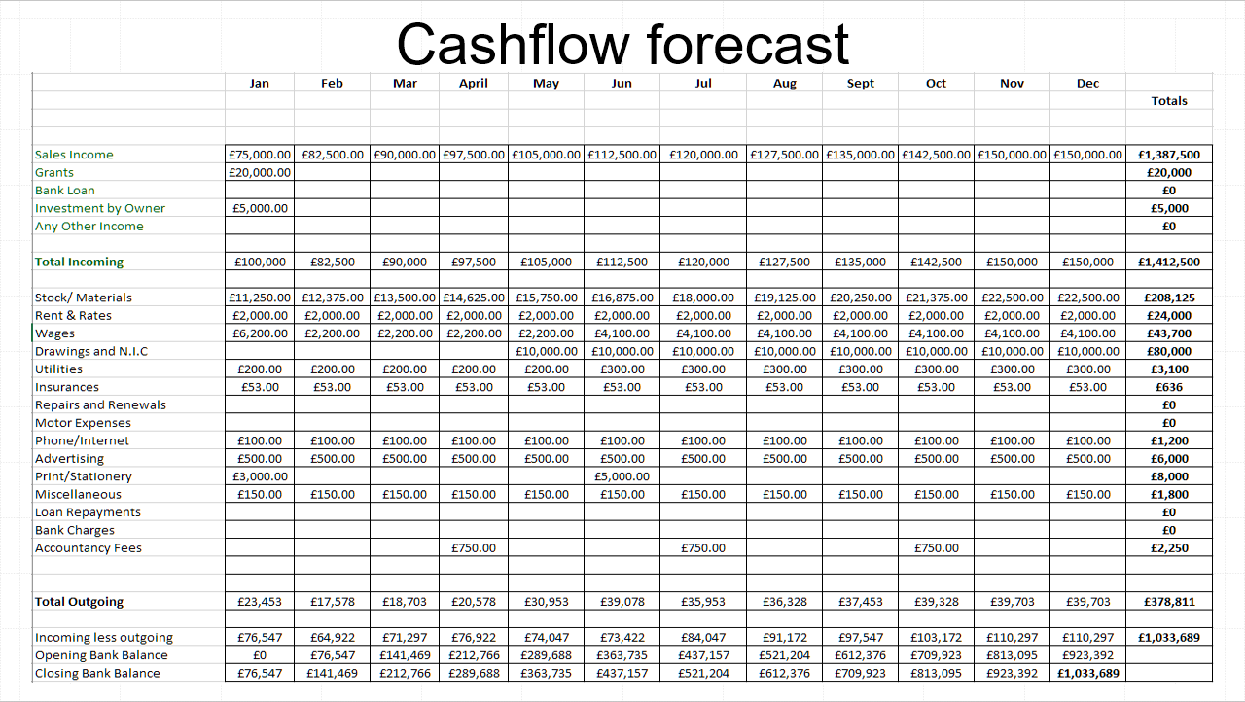
In this cashflow forecast we can see that sales are expected to go up by 50 cups per day on average until they cap out at around 1000 cups per day, materials price follows accordingly. Stationery has two big investments which is the purchase of a bubble tea making machine, and later the purchase of a refrigerator storage unit to help keep stock fresh and available for faster servicing.

Break-even point
Our break-even point is £97,942.01 which will be achieved at the beginning of May according to the forecast.

Three-year overview
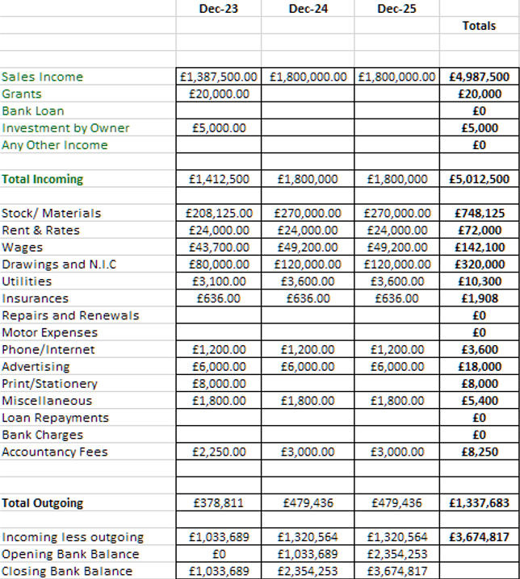
We can see that the business forecasts to be extremely profitable with a cup of tea costing 65p to produce and selling for almost ten time that price. Wages expense will grow as we hire more people into the team.

References

Bloom, N., Bunn, P., Chen, S., Mizen, P., Smietanka, P., & Thwaites, G. (2019). The impact of Brexit on UK firms (No. w26218). National Bureau of Economic Research.

Bloomenthal, A. (2020, November 12). General partnership. [blog] Investopedia. Available at: https://www.investopedia.com/terms/g/generalpartnership.asp (Accessed: 7th November 2022).

Bubbleteasupply (2022). Bubble tea FAQ. Available at: https://www.bubbleteasupply.com/faq/ (Accessed: 14th November 2022).

El-Beih, Y. (2020) How coffee forever changed Britain, Bbc.com. Available at: https://www.bbc.com/travel/article/20201119-how-coffee-forever-changed-britain (Accessed: 14th November 2022).

Fortune Business Insights (2020) Bubble Tea Market Size, Share & Covid-19 Impact analysis. Available at: https://www.fortunebusinessinsights.com/industry-reports/bubble-tea-market-101564 (Accessed: 4th November 2022).

Ren, S. (2021, June 24). Luckin Coffee Failed but Cheese-Flavoured Bubble Teas Are Coming. [blog] Bloomberg. Available at: https://www.bloomberg.com/opinion/articles/2021-06-24/luckin-coffee-failed-to-convert-china-to-coffee-now-bubble-tea-wants-a-chance (Accessed: 7th November 2022).

Siagian, M. (2016). Social space as people-gathering tool. Procedia-Social and Behavioral Sciences, 234, 265-270.

The Geography of Transport Systems (2017). Land Rent Theory and Rent Curve. Available at: https://transportgeography.org/contents/chapter8/urban-land-use-transportation/land-rent-theory-curve/ (Accessed: 14th November 2022).

Victor, V., Karakunnel, J. J., Loganathan, S., & Meyer, D. F. (2021). From a recession to the COVID-19 pandemic: Inflation–Unemployment Comparison between the UK and India. Economies, 9(2), 73.

