
Knowledge and Information Management Skills for the Workplace

STUDENT: JOMIR ULLAH 1708855
LECTURER: DR. DOMNAN FREEMAN MIRI

Contents

Introduction 3
Data, Information and Knowledge 4
Differentiation between Data, Information and Knowledge 5
Tacit knowledge 8
Explicit knowledge 8
Decision Making: Recognising DIK(W) 10
Decision Making: In the Absence of DIK(W) 11
Case Study- American Airlines and Sabre 15
Strategic use of IS and Competitive Advantage 16
Information Systems 18
Categories of CBIS and How it can aid Managers in Decision Making 21
Operational Level 21
Knowledge level 22
Managerial level 23
Strategic level 24
Conclusion 25
References 26

Introduction

In modern day society people are preoccupied by the digital revolution which has made a significant impact on how people interact and do business. Most business and social activities are taking place on a digital platform. Society has moved from agriculture to manufacturing to service and now to an information and knowledge society. Where knowledge is power. People want to be informed about the latest research, development in technology and how to work and do business online to gain a competitive advantage.
This report will look into the DIKW concept and analyse how business are taking advantage of knowledge management (KM) and Information System (IS) practices to deliver quality service to their customers and to help their employees achieve their full potential through the utilisation of Information Technology (IT).
The field of knowledge management has gained so much momentum due to globalization and product innovation. To keep ahead of their rival competitors businesses need to differentiate their products and services. Customers are always looking for new products and better value for money. Cost leadership and product differentiation business can gain loyalty through a positive and enhanced customer experience.
Also the changing business surroundings impact how the firms operate. New IT services are quickly absorbed and utilised as businesses want to remain competitive in the marketplace. Knowledge now can be quickly shared due to computer networks and databases so knowledge acquisitions , retention and transfer is made relatively easy.
As a result of using the extranet i.e. internet, the composition of organisation have changed. The business can also operate as a virtual organisation and overcome costs and concentrate on business growth.
The latter part of this report will look into the case study of American Airlines (AA) and International Business Machines (IBM) product Semi-Automated Business Reservation Environment (SABRE). Further the use of IS has gained popularity and more firms are now adopting these systems and creating value from their business assets.

Part 1

Data, Information and Knowledge

The figure below is an example of data. According to Zins (2011) data is a series of numeric, alphanumeric, and special characters which have no meaning and or context. Data on its own is not processed and thus can be difficult to transform into meaningful information.

e.g. Fig.1 shows a sign used by the Department of Transport to inform motorist of a possible hazard ahead. This is understood by motorist as they are able to interpret the data, they have had previous exposure to this signage during their theory test and driving experience. A non-motorist or lay person will find this data useless as they have may not processed or understood this message. Further, the recipient may interpret the data incorrectly and arrive at a totally different understanding to the original context of the data.
Figure 1 Hazard Ahead DofT Source: (Dept for Transport, 2017, p14)

Figure 2 Vital Patient Statistics Source: ( Baget, A 2019, www.shutterstock.com)
In a medical environment the data here is facts and figures displayed on a monitor. Fig. 2 This is useful to the doctors and nurses as they can measure the patients wellbeing. However, the patient themselves or another person who can’t decode these figures may find the data useless. The former user has applied meaning and context to the raw data. The absence of meaning and context makes the data useless to some.
This new meaning to the numbers now provides knowledge as the user now can draw conclusions from this information. If the numbers suggest that blood pressure is low then the user can make a fast decision. i.e. take medication if necessary. Likewise with Fig 1. The user is able to plan ahead and take necessary precaution to avoid the hazard. Therefore, this information can be deemed as knowledge as the information gained from the data is applied and a proactive practical approach is taken to counter any negative effects.

Differentiation between Data, Information and Knowledge

Ackoff (1989) presented the DIKW model which has gained popularity for its simplicity in explaining the terms. He presents the terms in the form of a pyramid. This model defines a purported relationship between the level, where the lower levels are the building blocks of the upper levels. the aim is to reach the top by understanding and applying the lower levels to improve one’s principles and self-reflection to gain wisdom.
Data: Data artefacts can be in the form of semiotics such as signs and symbols (Skaggs, 2017) It can also be in a semantic form (Landman, 2019) such a words, discrete facts and objective reality. It can represent empirical and non-empirical stimuli as well as perception. in IS data is used as an ‘input’ as it is without interpretation and meaning, thus Artificial Intelligence (AI) and computer models can be used to record and transform raw data into valuable information. Data does not depend on information. The key differentiation between data and information is its function and relevance. Sadiq and Indulska, 2017 describe how the quality and quantitative nature of data also play a key part in determining what trends or pattern can be identified after processing.
Information: This comes from providing context to data. When data has been endowed with meaning and purpose it becomes information. (Adami, 2016) states that information is the organisation of data into descriptions it represents , sentences, equations and questions. Information can be used for deductive and inductive reasoning. If we did not have information then we could not make prediction or deduce outcomes and thus fall into entropy. in IS information is the processed output of elicited data. E.g. Format of alpha-numeric is now used for identification purposes such as Driver license number. Information can be polymorphic. The quality and truthfulness of information is a significant in making informed decisions. (Baškarada and Koronios, 2014)

Knowledge: A combination of numerous sources of information over a set period which help creates conceptual frameworks, theories and axioms. This process involves transformation of information into a logical manner. Knowledge gives context through experience, values and insight. Which can be formalised and codified into written instructions. Knowledge is structured and has long term impact on the recipient. Such as how to assemble a flatpack from IKEA. The knowledge can be inferred from explicit or tacit experiences in life.
According to Andrews and Smits (2018) Explicit knowledge is routines and procedures, formalised information that has been applied and recorded on paper or digital format. Tacit knowledge is the ability to recognise patterns and ability to discriminate perceptions and cognitive process. Have mental models to follow and make a typical judgment of the event or situation. They assert that these types of Knowledge are critical in the success and growth of the organisation, higher tacit skill level will facilitate innovation, creative problem solving, better teamwork and add value to organisational learning.
Upward movement in the DIKW architecture requires intellectual reasoning that integrates and synthesises the lower levels into a more prearranged and pattern. Going down the hierarchy involves analytical reasoning. Where frameworks are dissected into their basic parts.
However, critiques (Rowley, 2007) argues that this pedagogy model is flawed. Ali et al., (2016) focuses their research more on algorithm non algorithm which is useful in a computer environment. Mishra, (2018) emphasised more on meaning and value of the levels and cognitive process rather than a linear relationship in the hierarchy.

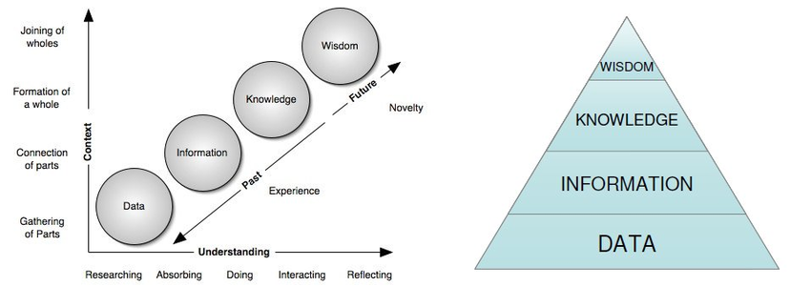
Figure 3 Ackoff DIKW source: https://www.researchgate.net/figure/Ackoffs-DIKW-Model_fig3_325215806

Knowledge In A Card Game

Tacit knowledge

Knowledge which is tacit has an idiosyncratic dimension. Once made symbolic and objective ( explicit) it is condensed to information which can disseminated. It can be said that knowledge is the human interpretation of information. Researchers in knowledge management (Zaim et al., 2015; (Guang-bin, Yi-Jun and Liang, 2010) and (Chugh, 2015) describe tacit knowledge as acquired knowledge from your experience’s, prejudice’s and intuition.
As a result the brain has elicited data to be useful and codified it. This data has now been interpreted as information to guide the user to make suitable decisions. The link between tacit and explicit knowledge is interchangeable as stated by (Nonaka and Takeuchi, 1995), as a result the user has gained either tacit or explicit knowledge from cognitive processing.
Tacit knowledge is internal knowledge (Polanyi and Sen, 2013) and can include personal beliefs and personal knowledge gained through life experiences and experience of playing the game beforehand. Such as Poker or Blackjack. An experienced player is knowledgeable and may use tactics to gain an advantage over the other players as they are accustomed to the formal rules of the game. This is explicit knowledge.

Explicit knowledge

Explicit knowledge is formalised and codified information such as written instructions and rules and procedures. According to Girard and Girard (2015) and empirical research by Urbancová and Vnoucková (2015) in talent management. They state how tacit knowledge can be transferred into explicit knowledge to make it available for others in a tangible format such as videos, audio, or picture format. For this to take place you need to have long term contact with the person or store the knowledge in a app… simulation.
Rules of the game can be found in a written format and players can understand the basic format of the games. Card players take advantage of their explicit knowledge as they can see what cards are available before them to decide if they want to play with their heart.. i.e. flutter, if they can’t play a logical game. After all it is a game of chance and the results can go in favour or against the player.
In a card came a player will use both tacit and explicit knowledge. (Dubickis and Gaile-Sarkane, 2016) When a player transfers their tacit experience into action it is called intuition. According to Allal-Chérif and Makhlouf (2016) their research into serious gaming supports the SECI model Fig 4. (Nonaka and Takeuchi, 1995), for understanding how individuals use both tacit and explicit knowledge to gain an advantage in a competitive state.
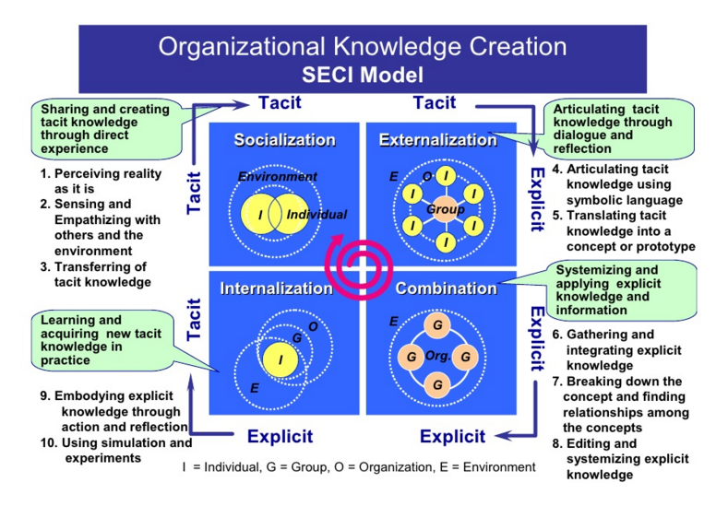

Figure 4 SECI model ( Nonaka and Takeuchi 1995) adapted from slideshare.net

Decision Making: Recognising DIK(W)

 | Data / Input | Information | Knowledge
Task 1  Charging a mobile | Flashing red light  Low battery sign | Without a working phone I will not be able to communicate remotely | Charged phone will allow full use of IT to make decision and avoid missed communication such as voicemail, email.
Task 2  Waiting for the bus | Printed timetable | Choose to wait for bus. Plan my journey | If bus is late or timetable unreliable. I can use alternative transport.
Task 3  Making a cup of tea | Resources required. i.e. tea bags, water, sugar, kettle and milk. | In what order to use the ingredients to make a perfect tea. | Overlooking the process to ensure right amount milk is added. I am diabetic no sugar needed.
Task 4  Listening to music | Compact disc. Digital data (songs) | Words and sentences | Meaning derived from the words. A hidden message to improve mood.
Task 5  Reading a bank statement | Numerical data | Context shows deposits and debits from account | Available balance to budget for future plans.

Table 1 List of Decisions Made using DIK(W)

Decision Making: In the Absence of DIK(W)

In the absence of these components one is not able to make a timely decision, the decisions made would be costly, time consuming and potentially have a negative impact on the overall outcome (Intezari, Pauleen and Taskin, 2016).Therefore, it is imperative that one comprehends the relevant input, processes the data, use the information, accordingly, relate to personal tacit and explicit knowledge. (Nurulin and Skvortsova, 2018).Having applied the knowledge gained one can achieve wisdom.
Task:
1. No data: without the warning light a user will not instantly know that the battery is low.
2. No information: the passenger may wait hours before a bus arrives, this is time consuming and reduces productivity.
3. No knowledge experience: the user may boil water too much and make the tea concentrated.
4. No knowledge / information: if the user does not understand the words or the meaning then they won’t gain any new knowledge or lesson from the lyrics
5. No information: if there is no context i.e. currency signs the user may not fully comprehend the data on the paper.

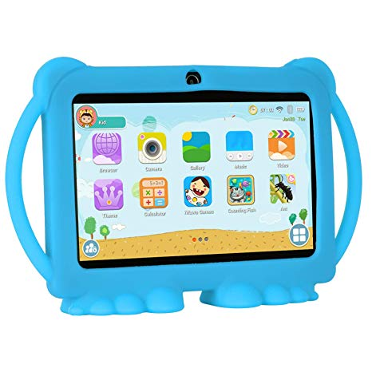
Hypothetical Product Promotion
Figure 5 children’s touch screen toy source:amazon.com
Product promotion requires a lot of effort in terms or research and development and advertising cost. The initial investment will identify the market whom the product is to appeal. As people don’t have similar wants and needs the process of market segmentation will allow to breakdown the process.
Demographics of the population will include the age, gender, income level and education level of the intended buyer. This type of statistical data can be gathered from secondary sources or primary research.
Primary research is very costly and time consuming. However it can generate constructive feedback and get first-hand data and information into the wants and needs of the customer. Although people are cautious in providing personal data secondary sources such as electoral roll and business analytical statistics can aid in the promotion of a product.
The sample of the population needs to be a cross section and be representative of the target market
Listed below are reliable sources of data and information which will be used to promote a child’s toy.
Primary data:
- questionnaire: either in digital format on a social media platform or written format.
- interviews with parents and carers of children.
- experiments and surveys
Secondary data:
- Census
- Journal articles
- Official reports
Although secondary data is already collected data which has been processed, it gives an indication of other areas to look for in primary research.
Demographic data from various sources:
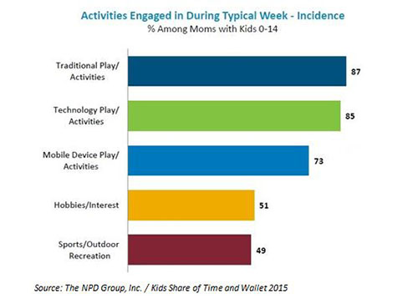
Figure 6 Time spent on play
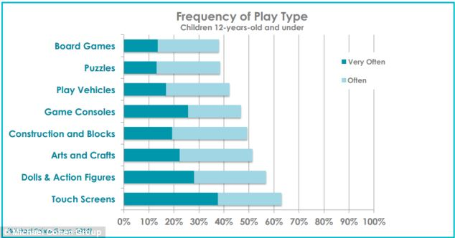
Figure 7 source: dailymail.co.uk

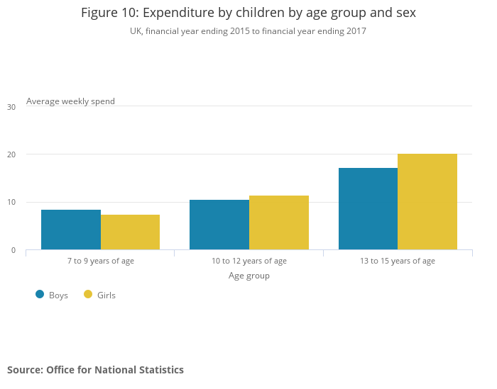
Figure 8 expenditure by age group of children

The above data shows that traditional toys are common amongst children and the biggest age group for expenditure is the 13-15 age group. This type of data and information would suggest that a touch screen-based toy would be most successful.
For the promotion of this product advertising cost will be high as the market is very volatile and competition is high. Possible advertising techniques would be a billboard, leaflets in schools. Also to have an educational purpose built into the game to increase its attractiveness to the target population.
It is strongly recommended to launch the product in a specific location, differentiate the product and then release to market..

Part 2

Case Study- American Airlines and Sabre

Cost leadership:
Firms can use business strategy to remain competitive. Cost leadership is a strategy used to lower the operational cost of the organisation by taking advantage of economies of scale. American Airlines chose to outsource their daily operation to SABRE system. This enabled the handwritten manual system of airlines to be updated to an innovative system. This system had the ability to perform at real-time speed where previously reservations were batch processed which increased waiting for customers. An online web-based system helped to automate the reservation process to avoid long delays and thus to reduce their transaction processing cost.
Originally, the process of booking a flight was complicated. SABRE demand increased as it added new functions to the operating system that added greater convenience to meet customer demands such as locating low fares, by filtering through the data on stored on the sabre database and finding the most cost-effective flight for the passenger. The services that were provided were increased to include extra services to book hotels and train ticket for continuing journey. This simplified the process of air travel and as a result it gained popularity very quickly. This in turn increased the profits of the organisation.

Product Differentiation:
SABRE provided AA with a solution to their reservation system. a new product which is different or first of its kind add value to the business. This is called product differentiation.
The product can further be developed to include additional products and services based on Market trends and consumer behaviours. Knowledge is a valuable resources and it creates values for itself. Like coca cola no one needs knows the recipe. This provides a Comparative advantage.

Strategic use of IS and Competitive Advantage

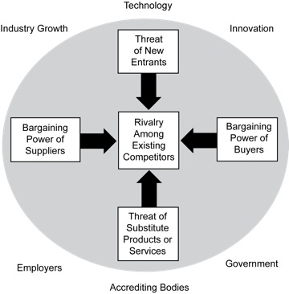
Michael Porter created a framework (Porter Five Forces) Fig.5 to establish how competition would impact on the success of the business.
Figure 9 Porters Five Forces. (Porter, 2008)
Threat of new entrants would hamper the success of AA as they would need to compete with others who may lower their prices. i.e. price wars.
This may attract customers to use a substitute service. AA puts barriers in place to counter these factors. By investing in research and development, and strengthening their supply chain and further improving their economies of scale so that it is the lowest cost per unit for booking through their online systems. The initial high capital investment in the business would discourage other rivals setting up in the marketplace as difficult to simulate the economies of scale.
If there are similar substitute products in the marketplace customer may choose to use these over AA. Alternative products such as Amadeus which is an offshoot of SABRE is likely to cause concern for AA.
This type of threat can be controlled by focusing on a service element of the business rather than a product such as the SABRE system. Customers are more likely to be attracted to other features of the system as an additional service such as hotel, train and car reservation. Alternatively, AA can increase switching cost and tap into the needs of the customer rather than just concentrate on selling the system.
The bargaining power of supplier plays a significant role in the aviation industry as raw material such as oil, jet parts and logistics are necessary for a smooth operation. Major suppliers in the market can demand higher prices for supplies which can erode competitive advantage.
Bargaining power of the buyer. Every customer hopes to secure a competitive prices for the goods and services they pay for. This factor depends on the size of the customer base. As AA had a large customer base bargaining power of the buyers were low in early days. No other rival had a system in place that can carry out so many functions and offer different services on an electronic level. To keep on top of this force AA can continue to develop new services and products to keep the customer stimulated with innovative offers and service and prevent them looking in other places.
Rivalry in the industry is very strong as each airline is fighting for business. This has a very high impact on the overall long-term success for the business. At the time of SABRE, AA enjoyed a period of monopoly. But soon others had access to the same framework.
In such a volatile market, it is wiser to collaborate with other to improve the efficiency and service provided to the customer than to compete for a small share of the business. Other factors to consider are further product differentiation and finding ways to reduce cost and become more energy efficient.
Factors which lead to erosion of market leadership.

Regulation changes in the airline industry on how fares are calculated along with the Value of knowledge of the sabre system allowed for the disappearance of competitive edge as sabre were allowing other organisation, airlines and travel agents to use their Patented software. AA did not have the power to control the diffusion of this valuable business data and intelligence to cross over to their competitors. As a result AA lead in the market dropped.
To counter this effect AA created their own system which PARS, however the success of sabre and the ease of use, and switching cost discouraged others to fully take up this new product.

Part2

Information Systems

An information system is a set of various components which collaborate together to achieve a common goal or objective (Neumann, Sobernig and Aram, 2014). Fig shows a generic setup of the system environment and boundary. This is similar to the human body with its distinctive system such as the nervous system, digestive system. Another example of a system would be a government within a country. governments have separate departments or systems in place to deliver a service to their citizens.
The basic function of IS are:
- detailed in Fig 6.
- Input of raw data
- Process data to transform into information fig.
- Storage of data into data warehouses and repositories
- Control processing and evolution of the system.
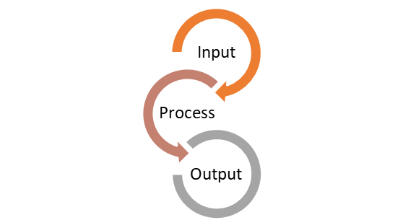
Figure 10 Generic process of IS. source: (Ivy 2015) https://lifestylecpa.com/2018/07/22/building-a-profitable-business-input-process-output/

Components of the system include:
Hardware: this includes devices for storage and telecommunication devices
Software: this is a computer programme designed to meet the objectives of the business such as an EPOS system. To take orders and record customer credentials.
Network: is required to fully connect all the subsystems to the internally and externally access the internet and other resources
Procedure: these a rules that govern the usage of the system and allows only authorised user to access data based on their rank within the organisation.
People: this is most critical component as it is the user who operate the system that make it beneficial. By accurately recording data and using the data to make informed decision and problem solving.
A computer-based information system (IS) is a tool, hardware, software, database and network which elicits, stores, analysis and computes a set of data for a meaningful purpose. In the organisation IS will hold employee and customer records, workflow, sales figures, marketing, recruitment and finance strategies. (Rainer and Prince, 2019) The system controls the flow of information so that it is accessible in a timely manner to the right person at the right time. Easy access to this repository will help the organisation to use information gathered from these systems to make informed decisions and analyse trends and patterns in their own organisation as well as global trends.
e.g. Police national records, government departmental database. In organisation they will also hold personal data and information for their customers and supplier. Historical and current data
Rainer, Prince and Cegielski, (2014) assert a system is where business data is stored from internal and external sources. The data is analysed and processed to inform and allows to make relevant and timely decisions for product development, pricing, packaging, distribution and advertising through appropriate social media technologies.
They may also have digital copyright material stored in their database such as \Netflix whom provide movies on the go relatively cheaply. Patented business intelligence assets such as apple iPhone firmware.

Demerits of IS
- Unemployment: as computer are now automating office processes. There is less demand for people to be present in the office.
- Privacy: Computer security and privacy are very significant ethical factors that are often exploited by security hacks and data breaches
- Lack of job security: major advances in technology means that training is crucial to remain competitive and productive. Skills gaps need to be identified and addressed quickly.

Categories of CBIS and How it can aid Managers in Decision Making

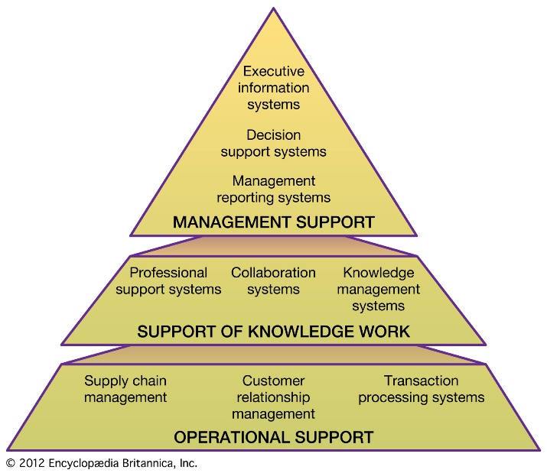
Categories or marts are sub section of the repository which is the storage component of the system. In a business, decision makers, managers and employees use different types of IS to perform their daily operation.
Figure 11.1 Different levels of CBIS categories

Figure 11.1 Different levels of CBIS categories
Figure 12 Different levels in CBIS

Figure 12 Different levels in CBIS
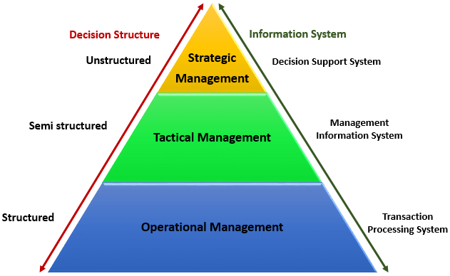
Figure 13 Decision Types

Figure 13 Decision Types

Operational Level:
This is the primary level in the business where daily recording of transactions are taking place such as the supermarket. Transaction processing systems (TPS) collects, stores, modifies and retrieves daily data transactions of an enterprise.
Currently real time processing is available so we are going towards a cashless society, making contactless payments.eg online banking makes it possible transfer money instantly, which increases the customer experience of the service. What’s app offers real-time processing. Where you can check every keystroke the system is updating.
TPS can also be accessed from alternative devices such as desktop or mobile app. Both have the same capability to elicit data. This makes is more user friendly for the consumer. Current TPS system can handle high volume demands for data and information. Latest music video. These attributes makes the TPS. Data integrity is important. Incorrect data entry can result in losses for the business.
This level involves structured decision making where the rules and constraints governing the decision are clearly defined such as supervisory activities, implementation of daily task to meet the objectives of the business. The TPS system is the most frequently used system. This system records transactions, stores, retrieves, update and even delete data. Or transfer information to another user of the system.
E.g. Buying an airline ticket: this involves sharing data and recording entries.
This the data gathering stage. Further up the level it is analysed for trends and pattern
Knowledge level:
OAS office automation system is an amalgamation of hardware software and resources to enhance communication and augment efficiency. Its software that digitally generates and stores and manipulate office information to fulfil a task or objective. Include MS office, word , excel. Office efficiency. Ability to control temperature and lighting reduce costs for the business. These system allows the organisation to fully use the resources available to them to make their business efficient. Also automate the process of notifying others in an emergency like fire. They can monitor employee efficiency and productivity.
KM Systems:
This is a unique database for KM, it is an information repository that provides a means for information to be elicited, organised, shared, searched and utilised. Its functions includes storage and retrieval of knowledge, locate and share knowledge sources and mine repositories for hidden knowledge. Also to function as a database for communities of practice. (CoPs), (Pyrko, Dörfler and Eden, 2016) discussing like-minded issues and storing that knowledge for later use, e.g. A health forum, online blogs. This helps in gaining tacit knowledge. Unintentionally or intentionally.
Hislop (2013) states that these manager at this level will make semi-structured decisions and can include auditors and advisors and consultation to the business. Knowledge workers make the business profitable in comparison to their competitors such as google employees. Organisation growth depends on the knowledge of the employees as they are experts in the field.
KMS tries to capture the knowledge of experts and by extracting value from the knowledge and storing it in a database, making it explicit knowledge. This would be advantageous if a members leave the organisation their tacit knowledge remains in a codified form within the organisation. this knowledge can be useful to train new members. The knowledge level of the workers forms a part of the overall business intelligence.
KMS allows for knowledge to be shared among other users of the system. The database can be used as FAQ, to improve productivity in a business.
KDD data discovery data (Mayer-Schönberger and Cukier, 2013) can be used to mine, harvest data and to find unknown or hidden patterns in the data. This can provide competitive advantage to the business.

Managerial level:
MIS and DSS systems
Managers have a challenging role to play in managing staff performance, quality control, tracking cost ad production.
These are used by middle level management team such branch managers and regional managers. It is a system which allows for pre-selected information to be available in digital format. The information shown is gathered from the TPS database. This allows managers to plan, analyse and control certain factors of the business to make better choices and decision for the firm. They too will make semi-structured decision where the outcome may not fall into a specific category.
The mangers take into consideration the long-term aspirations of the business and dissect them into short term objectives. The use of MIS guides them to reduce costs, change process to improve production or make investments in research and development.
e.g. MIS is used airline reservation systems, bank operation, logistic management.
DSS- helps the manager to make difficult decision based on the available information. the interactive system software compile and analyse information and will give the manager a computer programme or model to generate variables based on the inputs into the system. The manager can use their personal knowledge or use the DSS model to forecast ahead and identify and solve problems. They may also rely on knowledge and information from external sources such as the internet.
The information gin user friendly format. Such as graphs bar chart.
OLAP- this is an integrated multidimensional analytical tool often used for data mining. This generates and process vast amounts of information to identify trends and patterns in the marketplace. (Mayer-Schönberger and Cukier, 2013)
Subsystems include: (Supply Chain Management), MRP (Material Requirement Planning), ERP (Enterprise Resource Planning)

Strategic level:
Executive IS, these are director, CEO, they set the vison and mission for the business so it is imperative that the decisions they take will have a wide impact on the whole organisation. They will make unstructured decisions which have no defined rules. The impact of the decisions are wide and will channel down to the lower levels of the business. They need to act on reliable and valid data which provides valuable information to make better business decisions.

Conclusion

The DIKW concept provides a guideline for individuals and business to understand and appreciate the power of knowledge and wisdom and how it is derived from the lower levels through Appling context and meaning to raw data and information.
In today’s society knowledge is power and it needs to be harnessed, captured and stored so that future generations can also benefit and improve standards in innovation and problem solving. In the organisation managers have access to a wide range of computer-based system at their disposal to carry out their daily operation in an efficient and productive manner.
This use of these systems enabled data and information to be viewed and manipulated to gain competitive advantage and also helps in the forming a strategic plan for the continued success of the business.
The use of IT and software has enabled managers and business owners greater power n how they run their business. It also aids them to have a greater control of business operations.

References

- Adami, C. (2016). What is information?. Philosophical Transactions of the Royal Society A: Mathematical, Physical and Engineering Sciences, 374(2063), p.20150230.
- Ali, M., Awad, N., Suganthan, P. and Reynolds, R. (2016). A modified cultural algorithm with a balanced performance for the differential evolution frameworks. Knowledge-Based Systems, 111, pp.73-86.
- Allal-Chérif, O. and Makhlouf, M. (2016). Using serious games to manage knowledge: The SECI model perspective. Journal of Business Research, 69(5), pp.1539-1543.
- Andrews, M. and Smits, S. (2018). Knowing What We Know: Uncovering Tacit Knowledge for Improved Organizational Performance. Journal of Organizational Psychology, 18(5).
- Baškarada, S. and Koronios, A. (2014). A Critical Success Factor Framework for Information Quality Management. Information Systems Management, 31(4), pp.276-295.
- Chugh, R. (2015). Do Australian Universities Encourage Tacit Knowledge Transfer?. Proceedings of the 7th International Joint Conference on Knowledge Discovery, Knowledge Engineering and Knowledge Management.
- Curtis, Graham. Business Information Systems : Analysis, Design and Practice. Wokingham: Addison-Wesley, 1989. Print.
- Dubickis, M. and Gaile-Sarkane, E. (2016). Tacit vs Explicit Knowledge Dichotomy: State-of-the-Art Review for Technology Transfer Purposes. Financial Environment and Business Development, pp.423-433.
- Frésard, L. and Valta, P. (2015). How Does Corporate Investment Respond to Increased Entry Threat?. Review of Corporate Finance Studies, p.cfv015.
- Girard, J. and Girard, J. (2015). Defining knowledge management: Toward an applied compendium. International Institute for Applied Knowledge Management, 3(1).
- Guang-bin, C., Yi-Jun, L. and Liang, D. (2010). Study on the incentive mechanism model of tacit knowledge sharing. 2010 2nd IEEE International Conference on Information Management and Engineering.
- Hislop, D. (2013). Knowledge management in organizations. 3rd ed. Oxford: Oxford University Press, pp.105-120.
- Intezari, A., Pauleen, D. and Taskin, N. (2016). The DIKW Hierarchy and Management Decision-Making. 2016 49th Hawaii International Conference on System Sciences (HICSS).
- Landman, F. (2019). Towards a theory of Information. Berlin/Boston: Walter de Gruyter GmbH.
- Mayer-Schönberger, V. and Cukier, K. (2013). Big Data. Boston: Houghton Mifflin Harcourt.
- Mishra, A. (2018). A DIKW Architecture for Cognitive Engineering. Procedia Computer Science, 123, pp.285-289.
- Neumann, G., Sobernig, S. and Aram, M. (2014). Evolutionary Business Information Systems. Business & Information Systems Engineering, 6(1), pp.33-38.
- Nonaka, I. and Takeuchi, H. (1995). The knowledge-creating company. New York: Oxford University Press.
- Nonaka, I. and von Krogh, G. (2009). Perspective—Tacit Knowledge and Knowledge Conversion: Controversy and Advancement in Organizational Knowledge Creation Theory. Organization Science, 20(3), pp.635-652.
- Nurulin, Y. and Skvortsova, I. (2018). Conceptual model of information support for taking decisions. SHS Web of Conferences, 44, p.00064.
- Polanyi, M. and Sen, A. (2013). The tacit dimension. Chicago, Ill: The University of Chicago Press.
- Porter, M. (2008). Competitive strategy. New York: Free.
- Pyrko, I., Dörfler, V. and Eden, C. (2016). Thinking together: What makes Communities of Practice work?. Human Relations, 70(4), pp.389-409.
- Rainer, R. and Prince, B. (2019). Introduction to information systems. Singapore: John Wiley & Sons, Inc., p.11.
- Rowley, J. (2007). The wisdom hierarchy: representations of the DIKW hierarchy. Journal of Information Science, 33(2), pp.163-180.
- Sadiq, S. and Indulska, M. (2017). Open data: Quality over quantity. International Journal of Information Management, 37(3), pp.150-154.
- Skaggs, S. (2017). The semiotics of non-virtuous data visualization. Information Design Journal, 23(2), pp.219-233.
- Urbancová, H. and Vnoucková, L. (2015). Application of talent and knowledge management in the Czech and Slovak Republics: First empirical approaches. Ekonomski anali, 60(205), pp.105-137.
- Zaim, H., Gürcan, Ö., Tarım, M., Zaim, S. and Alpkan, L. (2015). Determining the Critical Factors of Tacit Knowledge in Service Industry in Turkey. Procedia - Social and Behavioral Sciences, 207, pp.759-767.
- Zins, C. (2011). Conceptual approaches for defining data, information, and knowledge. Journal of the American Society for Information Science and Technology, 58(4), pp.479-493.

