Ecey 6005 ocean crocker

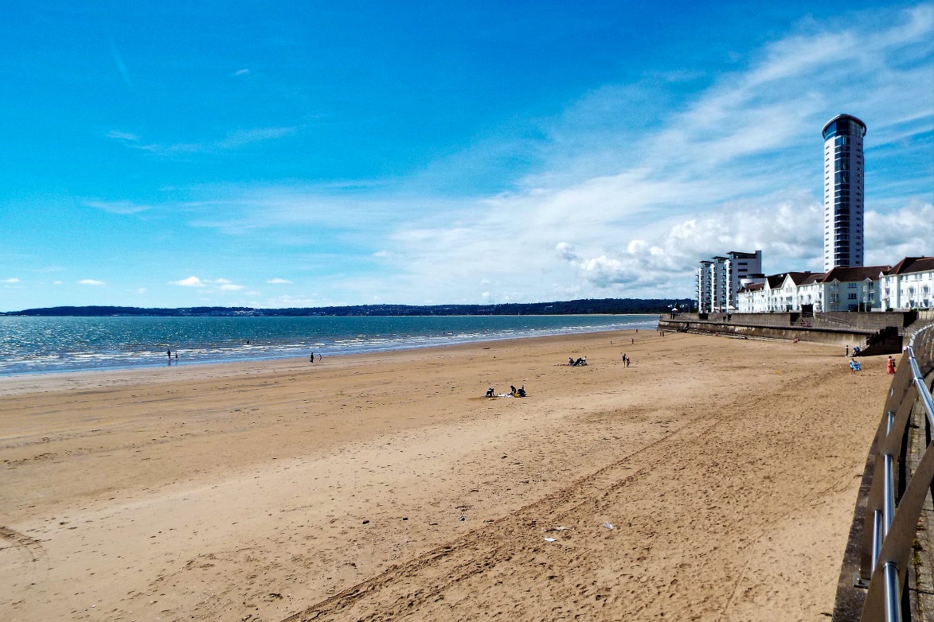
My scrapbook will be based on Swansea beach, discovering the area. Through expoloring the a local beach area ive engaged deeply with the natural environment- observing, learning and connecting with the coastal landscape in new and meaningful ways. the beach is more than just sea and sand, its living ever changing environment filled with delicate ecosystems and wildlife, each vist brings more insights, from tide patterns to shoreline creatures. through photographs, sketches and reflections and facts this scrapbook captures the process. like john muir who believed in the power of nature to educate and inspire, this project brings curiosity to the nature world.

wildlife at the beach
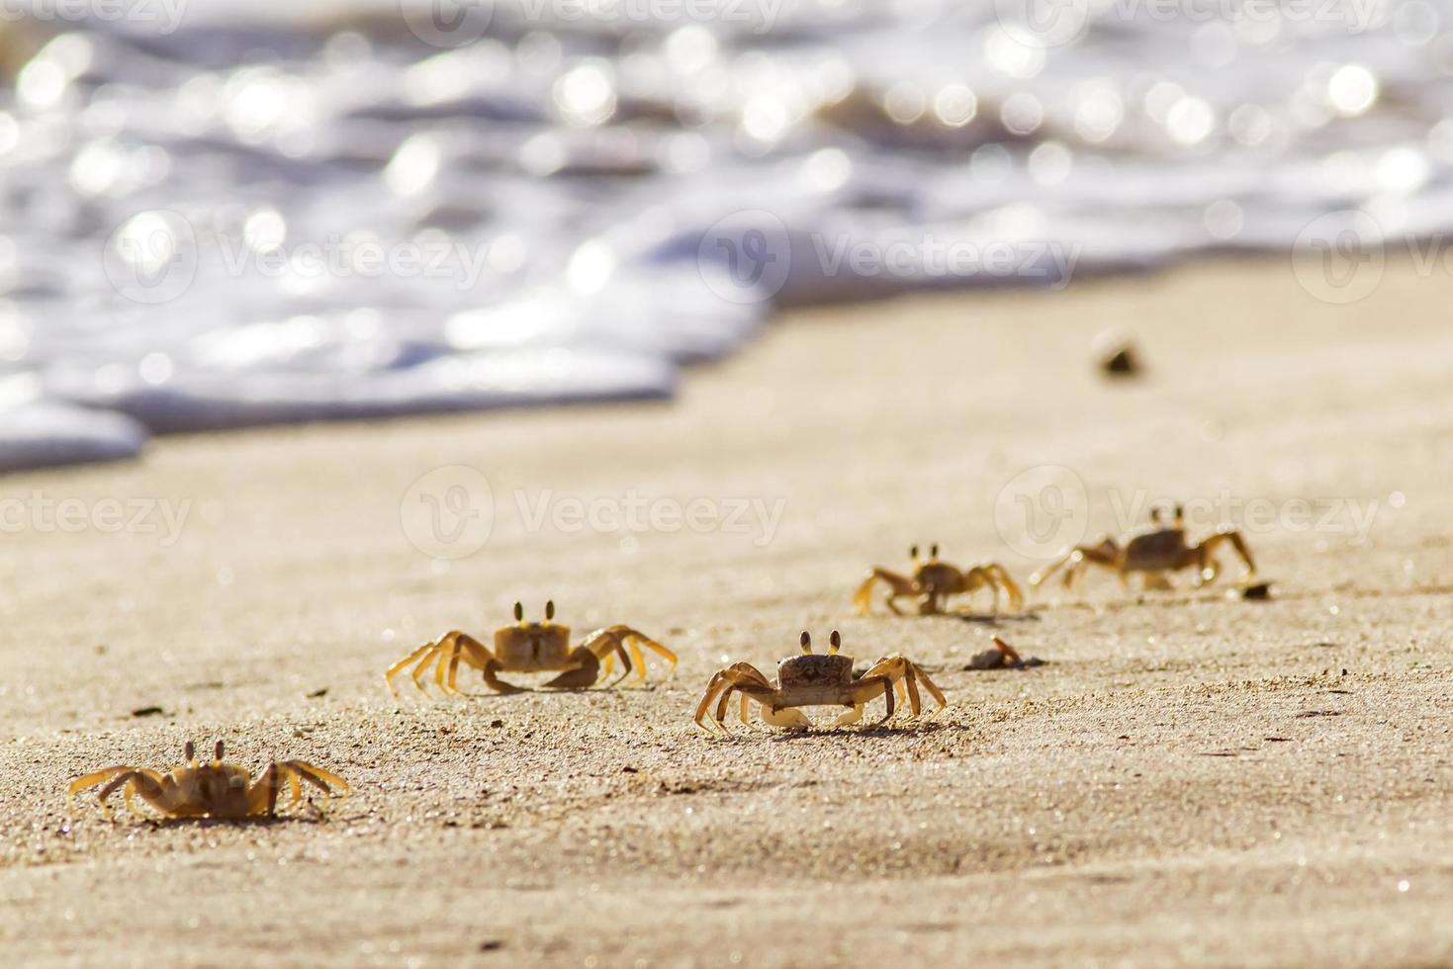

as part of the john muir award journey, i spent time observing the fascinating wildlife that calls to the beach. from the sand dunes to rockpools, at a low tide shallow pools of seawater became part of another discovery.
shore crabs- scuttling under rocks- hiding and curious
beadlet anemones like small blobs of jelly, their tentacles tucked in until the tide returns.
at first look the beach seemed calm and empty but become a rich and vibrant place. every visit brings new surprises. this experience taught me to be more observant and respectful. understanding that even the smallest creatures are part of the ecosystem.

seashells at the beach
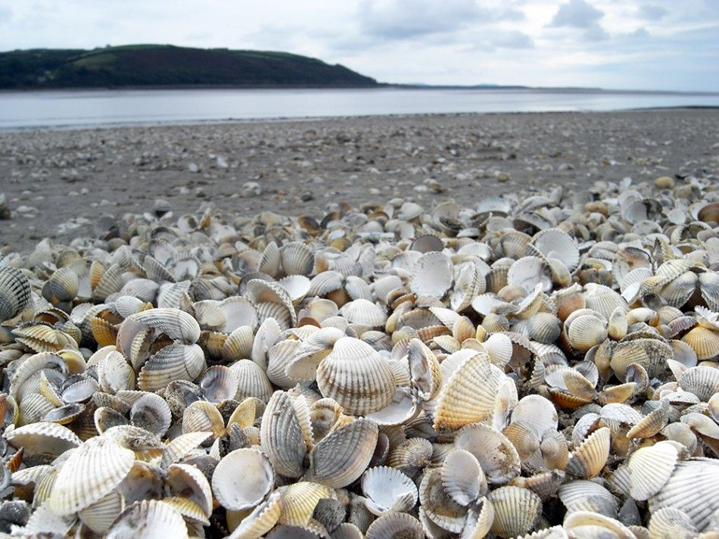
among the most familiar sights on the beach, seashells are scattered like treasures along the shoreline. at first, i saw them as pretty decorations but as part of my john muir award discovery i took a closer look and found that seashells have real ecological scientific and cultural importance. seashells are the hard protective outer layers left behind by sea creatures like –
molluscs, bevlaves and gastropods. though the animals inside are often long gone when we find them the shells reman as silent evidence of the life once lived beneath the waves.
why seashells matter- they are habitats for wildlife – empty shells become homes for creatures like hermit crabs, who rely on them protection as they grow.
coastal stability – shells can tell us about water quality , ocean temperature and even changes climate over time.
i learned that while its oaky to take a few shells as keepsakes its important not to over collect- shells serve purpose in the ecoystem even when empty, john muir believed in treading lightly in wild places.

littering at the beach
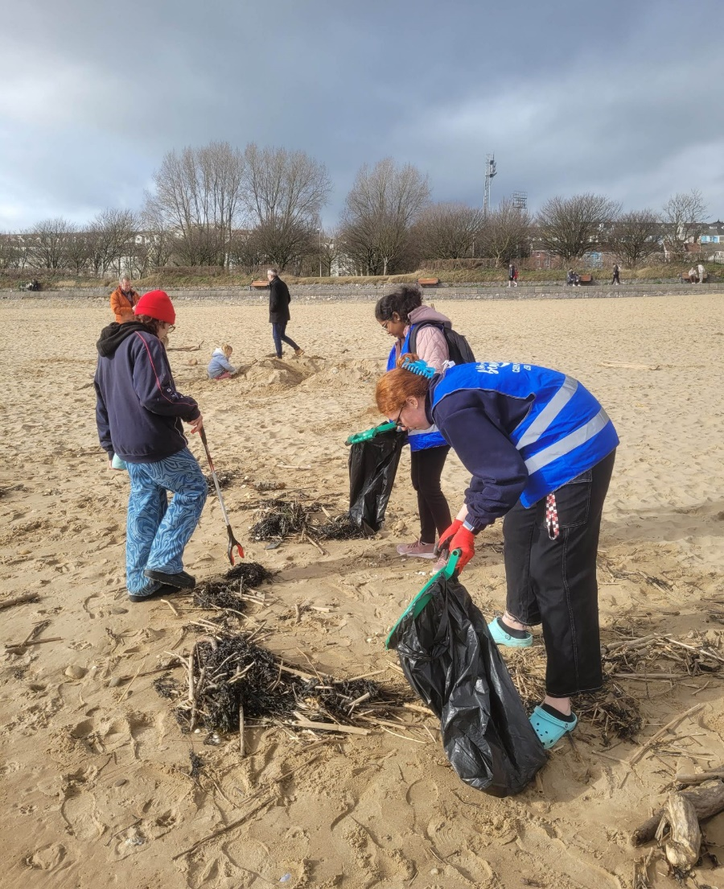
as i explored the beach for my john muir award, i discovered something that stood out in a negative way, litter. among the natural beauty of shells and seaweed wildlife there was also a lot of crisp packets, plastic bottles, fishing line etc.
the impact of litter- litter on the beach isnt just unsightly its dangerous, its harm to wildife- animals often mistake litter especially plastic for food. turtles and seabirds can die from eating it or getting tangled in it.
pollution in the food chain- microplastics which come from broken down plastic waste, are now found in fish even shellfish affecting the entire marine food wed.
environmental damage- litter can smother habitats, block waterways and take hundreds of years to breakdown.
inspired by the john muir award call for care to wildife places, i decided to take part in a beach clean up filling bags with rubbish and sorting recyclables. even a small action like picking up a bottle cap or reminding a friend to use a bin can help to make a difference.

john muir belives that places should be protected for future generations.

conclusion
throughout this journey along the beach i have discovered that nature isnt just something to look at- its something to connect with. to understand and to protect. what started as a simple walk along the beach became a experience of discovery. i learned how the beach is home to a rich variety of wildlife, each creature playing a role in a fragile ecosystem.
the john muir award helped guide me to not only notice these things but to care, it challenged me to reflect on my own actions and to speak up more for nature.
the beach is more than a destination it’s a living classroom for wildlife, where every creature and shell has a story.

