

Research Title
Food service Industry in during Pandemic and after Pandemic.

Supervisor Name: Dr Alex Bell

Submitted by
Name: Md Jahid Hossain
Id: 1811221
Submission Date:

Acknowledgement
I am grateful to my honorable supervisor. The reason is that without the support and valuable feedback of my supervisor, it was really tough for me to compete this research work. Then, I would like to thank my family member for supporting me to complete the research work. Besides, I would like to give my special thanks to the target participants, who provide reliable and valid information. Finally, I am grateful to almighty God to keep physically and mentally fit during the Covid-19 pandemic.

Abstract
Purpose: The purpose of this piece of research work is to investigate how businesses and clients of UK food service industry perceive the influence of covid-19.
Methodology: A qualitative research method was employed to collect data from 4 business participants using semi-structured interview, and 50 clients using structured interview. Data was processed and analyzing by using thematic analysis technique.
Finding: The results of the study say that covid-19 has had an adverse impact on small size fast food and restaurant chain in the UK. The closure of store and restaurant did not only lose customers, but also affect the logistics and supply chain negatively. This disruption has had a negative impact on workforce management, and Covid-19 negatively impacted the sales management and sales volume of the UK retail food business due to supply chain crisis, government restriction of customers’ movement, and maintaining social distance and fairness among customer for being infected by Covid-19. The result of structured interview from customer perspective showed that respondents (50%) were very likely to use takeaway services during pandemics. Even, they (45%) will be likely to use takeaway service after the pandemic. The prime reason of purchasing online was its convenient approach to delivering goods to the doorstep of customers (64%) followed by saving time (20%) and cost-effectiveness (6%). Savory and carbo-hydrate items were largely purchased by the survey participants (62%). Social distance (30%) and wearing masks (36%) were considered as the most preferable covid-19 preventive measures according to the majority of participants.
Recommendations: The research recommended that the businesses in the UK food industry should develop strategic partnership with suppliers and invest in developing supply chain and supplier’s capabilities. The study also recommended to the UK retail food businesses to develop sophisticated and interruption-free online delivery services.

Table of Contents
Acknowledgement 2
Abstract 3
Chapter One: Introduction 6
Background of the study 6
Aim and objective of this work 9
Research questions 9
Research rationale 10
Structure of this paper 11
Chapter Two: Literature Review 12
Introduction 12
The impact of the pandemic on the food industry 12
Entrepreneurial activity in the food sector during pandemic 15
Expected change of food service in pandemic 17
Expected change of food service after the pandemic 19
Business resilience 20
Gig economy 21
Online food service 22
Chapter Three: Methodology 24
Introduction 24
Philosophical considerations 24
Research paradigm: Constructivism 24
Ontology: what is reality? 26
Epistemology: How can the study know reality? 27
Research approach: Inductive 27
Research Method 28
Population, and sampling 30
Data collection instrument 31
Semi-structured interview 31
Structured interview 32
Data analysis: Thematic analysis 33
Ethical consideration 34
Conclusion 35
Chapter Four: Data Analysis 36
Sequential qualitative data analysis 37
Analysis of Semi-structured interview 37
Analysis of structured interview 44
Chapter Five: Conclusion and Recommendation 57
Conclusion 57
Recommendations 59
Developing strategic partnership with suppliers and investment in supply chain 59
Investment on developing skilled and talented human resources 59
Ensuring employees and customer health safety 60
Investment on developing sophisticated online delivery platform 60
Future research work 60
References 61
Appendices 66
Appndeix#1: Business Interview Questions with data collection 66
Business Perspective: Interview-1 66
Business Perspective: Interview-2 69
Business Perspective: Interview-3 72
Business Perspective: Interview-4 75
Appndeix#2: Customer Interview Questions with data collection 78
Customer Perspective: Interviews-1 78
Customer Perspective: Interviews-2 81
Customer Perspective: Interviews-3 84
Customer Perspective: Interviews-4 87
Customer Perspective: Interviews-5 90
Customer Perspective: Interviews-6 93
Customer Perspective: Interviews-7 96
Customer Perspective: Interviews-8 99

Chapter One: Introduction
This research work is vitally important for food businesses in the UK, because the covid-19 has had a significant influence on the value chain configuration system of fast-food chains such as logistics, operation, and supply chain management. This work is entitled as food service industry in during and after pandemic. In current business landscape, this title is valuable, because players of food service industry are searching for new means of gaining competitive advantage. This chapter covers some interesting aspects of this research that shape the foundation of this research study. First, it outlines the background and key problem statement. In addressing the problem, the study determines purpose and objectives of this research work. It also shows the rationale of doing this research work. Moreover, it writes up the structure of this work.

Background of the study
The covid-19 pandemic has posed tremendous challenges for the global food security, agriculture, and food system, which eventually shapes the architecture of the world food industry (Hassen et al., 2020; and Panzone et al., 2021). The food industry is made up of several sub-sectors including restaurants, and fast-food chains. The focus of this study is on the restaurant, and fast-food sectors (Aday & Aday, 2020; and Singh et al., 2021). At the very beginning of the pandemic, Deaton & Deaton (2020) did an empirical study where the authors highlighted the capability of some countries to supply food for the short-run, but the long-run ability to ensure food security was questioned. Because covid-19 has pressurized the global food supply chain system to supply those foods that increase or boost the immune system, the sustainable production or extraction of nutraceutical components from food waste, using emerging technology remains an interesting area of study (Deaton & Deaton, 2020; Panzone et al., 2021; and Power et al., 2020).

Most studies did 2020 onwards agreed that consumption patterns have also shifted from eating away from home to meals prepared and consumed at home (Reardon et al., 2020; Laborde et al., 2020; and Power et al., 2020). The world also saw the rising trend of panic buying and buying shocks, as well as hoarding of staple food items (Laborde et al., 2020). How the crisis adversely influences consumer behavior has been better manifested by panic buying behavior and hoarding of staple food (Panzone et al., 2021). Are customers rationale for purchasing goods in a pandemic? This question has been reflected by hoarding behavior (Brown et al., 2021). In addition to this, the disruption of the circulation of goods between countries, and the halt of import and export have had a detrimental impact on the food industry (Singh et al., 2021). More deeply, the pandemic has had a significant impact on altering trade restriction policies, food safety regulations, and protective measures from competing producers (Panzone et al., 2021; Power et al., 2020; and Siche, 2020).
Most recognized restaurant chains, and fast-food chains closed their traditional outlet-based operation (Goddard, 2021; Reardon et al., 2020). Companies that had reported the surge of above 40% sale growth and restaurant margin, experienced a fall in their EBITDA (Reardon et al., 2020). Examples are McDonald, Pizza Hurt, etc. In contrast, the food delivery and takeaway operators took the advantage of bolstering their financial statement, especially net profit margin, and retained earnings (Mitchell et al., 2020). Just Eat, Dominos, Uber Eats, and Deliveroo reported increasing profits, and key financial indicators (Mitchell et al., 2020). Doing a survey on 19th November 2020, Statista (2020) ranked Just Eat as the most popular food delivery and takeaway operator with 52% responses, followed by Dominos (28%), Uber Eat (26%), and Local Delivery Company (16%). The increasing popularity of food delivery and takeaway operator during covid-19 raised questions over the effectiveness of the distribution network of the most popular restaurant, and fast-food chains (Statista, 2020).

To quickly respond to customers’ demand, most recognized restaurants, and fast-food chains in the UK did a lot of change in their traditional supply chain, and business model (Mitchell et al., 2020; Brown et al., 2021; Panzone et al., 2021; and Power et al., 2020;). For example, KFC picks Flyt as its new delivery partner (Panzone et al., 2021). The impact of covid-19 on the delivery channel of fast-food chains have not only been reported by the mainstream media such as CNN (2020) but also been studied by academic scholars and researchers (Panzone et al., 2021; Power et al., 2020; and Brown et al., 2021). CNN (2020) captured that Pizza Hut plans to close 500 restaurants; Starbucks announced to strengthen its partnership with Uber Eats; McDonald plans to partner with several delivery aggregators to increase customer loyalty. Beyond the optimization of delivery channels, the food industry saw some interesting promotional campaigns from major fast-food chains to attract customers (Panzone et al., 2021). As an example, Burger King let its customers know about its strengthening partnership with DoorDash through a ‘taste test’ campaign (CNN, 2020).
A stream of recent research captured the impact of covid-19 on the delivery channel (Panzone et al., 2021), business model (Barman et al., 2021), marketing (Hobbs, 2021), supply chain (Mitchell et al., 2020), and customer relationship management. For instance, a narrative review by Hobbs (2021) argued that the shift of the business model caused by covid-19 is not just an immediate reaction, but it has a tremendous long-term impact on business (Panzone et al., 2021). Drawing these empirical findings, it is required to discover the answer to some interesting questions like what are the long-term impacts of covid-19 on the food industry. How do companies respond to the new trends?

Aim and objective of this work
The aim of this piece of research work is to investigate how businesses and clients of UK food service industry perceive the influence of covid-19. In addressing this aim, the following objectives must be met.
- To carry out literature review concerning the food service industry in during and after pandemic.
- To explore how UK small size fast-food and restaurant chains perceive the impact of covid-19 on their value chain configuration system.
- To identify key challenges and opportunities of UK food service industry caused by covid-19
- To interpret the cooking habit and purchase interest of clients in during and after pandemic.
- To provide suitable recommendations according to the findings of this study.

Research questions
- How do small size fast-food and restaurant chains perceive the impact of covid-19 on their value chain configuration system?
- What are key challenges and opportunities of UK food service industry caused by covid-19?
- How do clients perceive their cooking habit and purchase interest in during and after pandemic?

Research rationale
The current research is unique of its nature because no study qualitatively explores the food industry during and after pandemic in the perspective both business and customers in the UK context. For example, scholars write up a scientific paper on different interrelated topics including the impact of food supply chain disruption and its consequence on the food system (Galankais, 2020), how covid-19 affects the labor market (Haliu, 2020), the impact of the pandemic on workforce management in the food industry (McEwan et al., 2020), and how to maintain high-level food safety and consumer trust (Weerskin et al., 2020). However, the current research contributes in both academic and practical fields. In term of academic perspective, the current research work contributes to improving current literature in the field of Covid-19 and its impact on the UK food industry more especially the retail food sector. This means that academicians, young researchers, and scholars can gain insight understanding from this research paper. In addition, the research provides methodological justification of a qualitative research along with the sampling techniques, qualitative data collecting instruments, and data analysis techniques.
Besides, the research also provides practical contribution in the perspective of retail food business owners and customer in the UK food industry. For example, the study provides the impact of Covid-19 on business operation, sales management, and the importance of using digital technology in the UK’s retail food sector during and after Covid-19 pandemic. Further, the study examines the consumer purchase and cooking habit during and after Covid-19 pandemic that contributes to food business owners to understating the customer buying behavior, habits, and trends in the UK food industry during and after Covid-19 pandemic. Finally, the study provides suitable and effective recommendations for the food businesses so that they can confront the challenges to cope up with the post-pandemic business environment and address customer needs and demands.

Structure of this paper
The structure of the current research project is comprised of five important chapters. The first chapter is known as introduction chapter that incorporates the research background and problem statement, research aim, research objectives, research question, research rationale, and the structure of the current research project.
The second chapter is literature review chapter in which the researcher conducts an extensive literature review on previous studies to gain an understanding about the impact of Covid-19 on the food industry, entrepreneurial activity in the food sector during pandemic, expected change of food service in pandemic, expected change of food service after the pandemic, business resilience, gig economy, and online food service.
The third chapter is research methodology that aims to justify methodological tools and techniques derived from strong philosophical assumptions. In line with the justification of research philosophy and approach, it determines the best suitable research method, which subsequently creates pathway to analyze data collection instruments.
The fourth chapter is data analysis chapter that presents key results obtained from conducting structured, and semi-structured interviews with participants. Specifically, this research work undertook 4 semi-structured interviews with participants who run business, and carried out 8 structured interviews with clients who purchase fast food from business.
The final chapter is conclusion and recommendation chapter. In this chapter, the research presents the findings of both semi-structured interview data and structured interview data along with the suitable, effective, and valuable recommendations for the UK retail food businesses.

Chapter Two: Literature Review

Introduction
The covid-19 pandemic has had an unprecedented challenge on the UK food industry due to changing consumer purchasing behavior (Brown et al., 2021), transportation (Panzone et al., 2021), network disturbance (Power et al., 2020), closure of various food manufacturing industries (Singh et al., 2021), and labor absenteeism (Luckstead et al., 2021). Over the past few months, a growing body of literature examined the impact of pandemic on food industry from different aspects. Some interesting questions have been raised and discovered their answer within shortest possible times. How does covid-19 change consumer purchasing behavior (Panzone et al., 2021)? What is the impact of changing consumer purchasing behavior on food service (Mitchell et al., 2021)? How does network disturbance affect food service (Barman et al., 2021)? Does labor absenteeism affect food service (Luckestead et al., 2021)? What is the consequence of the closure of various food manufacturing industries (Panzone et al., 2021)? However, this literature review aims to discover the answer of some interesting questions (1) How does covid-19 affect the food industry, especially restaurants, and fast-food chains? (2) does pandemic create entrepreneurial opportunities for food service? (3) What are key changes of food service in pandemic and after pandemic? This literature review attempts to answer these three important questions.

The impact of the pandemic on the food industry
The covid-19 pandemic has posed tremendous challenges for the global food security, agriculture, and food system, which eventually shapes the architecture of the world food industry (Hassen et al., 2020; and Panzone et al., 2021). The food industry is made up of several sub-sectors including restaurants, and fast-food chains. The focus of this study is on the restaurant, and fast-food sectors (Aday & Aday, 2020; and Singh et al., 2021). At the very beginning of the pandemic, Deaton & Deaton (2020) did an empirical study where the authors highlighted the capability of some countries to supply food for the short-run, but the long-run ability to ensure food security was questioned. Because covid-19 has pressurized the global food supply chain system to supply those foods that increase or boost the immune system, the sustainable production or extraction of nutraceutical components from food waste, using emerging technology remains an interesting area of study (Deaton & Deaton, 2020; Panzone et al., 2021; and Power et al., 2020).
The pandemic has impacted the global food industry by shifting several influential factors including consumer purchasing behavior (Brown et al., 2021), transportation (Panzone et al., 2021), network disturbance (Power et al., 2020), closure of various food manufacturing industries (Singh et al., 2021), and labor absenteeism (Luckstead et al., 2021). These factors have a distinct impact on the food industry. How does covid-19 change consumer purchasing behavior (Panzone et al., 2021)? What is the impact of changing consumer purchasing behavior on food service (Mitchell et al., 2021)? How does network disturbance affect food service (Barman et al., 2021)? Does labor absenteeism affect food service (Luckestead et al., 2021)? What is the consequence of the closure of various food manufacturing industries (Panzone et al., 2021)?
These interesting questions have been partially resolved by some scholars because debate exists about their findings. For evidence, a recent study conducted by Panzone et al., (2021) and Thilmany et al., (2021) found that consumers tend to purchase immune-boosting food items amidst covid-19. They tend to purchase conveniently. Another interesting research showed the impact of job loss, and economic crisis on consumer purchase behavior (Singh et al., 2021; and Siche, 2020). Consumer purchase behavior in the pandemic is strongly influenced by health and safety, as well as hygiene (Panzone et al., 2021; and Hassen et al., 2020). In contrast, the loss of disposable income and consumer confidence index due to job loss has had a detrimental impact on food purchasing (Goddard, 2021; Hassen et al., 2020; and Siche, 2020). Another line of research tends to capture the influence of changing consumer behavior on the business model of food service (Aday & Aday, 2020; and Singh et al., 2021). For example, Aday & Aday (2020) found that customers tend to consume takeaway and delivery services. This has been endorsed by a market research firm (Statista, 2020). Despite these findings, it raises the question, whether the demand for takeaway and delivery services will remain high after the pandemic (Mitchell et al., 2021). Alternatively, the country-wide lockdown and international restriction of transportation caused supply chain disruption (Panzone et al., 2021; Barman et al., 2021; and Hobbs, 2021). For example, many companies went out of stock as reported by mainstream media like Guardian, BBC, and CNN.
Most studies did 2020 onwards agreed that consumption patterns have also shifted from eating away from home to meals prepared and consumed at home (Reardon et al., 2020; Laborde et al., 2020; and Power et al., 2020). The world also saw the rising trend of panic buying and buying shocks, as well as hoarding of staple food items (Laborde et al., 2020). How the crisis adversely influences consumer behavior has been better manifested by panic buying behavior and hoarding of staple food (Panzone et al., 2021). Are customers rationale for purchasing goods in a pandemic? This question has been reflected by hoarding behavior (Brown et al., 2021). In addition to this, the disruption of the circulation of goods between countries, and the halt of import and export have had a detrimental impact on the food industry (Singh et al., 2021). More deeply, the pandemic has had a significant impact on altering trade restriction policies, food safety regulations, and protective measures from competing producers (Panzone et al., 2021; Power et al., 2020; and Siche, 2020).
Some scholars (Power et al., 2020; Siche, 2020; Reardon et al., 2020; and Aday & Aday, 2020) claimed that some governments may intend to reverse the impacts of globalization on the food system, although there is strong debate about this claim. The impact of the pandemic on food service is mediated by the size and the type of productions (Power et al., 2020; and Siche, 2020). For example, in Canada, the fruit and vegetable sector were adversely impacted by the pandemic (Larue, 2020: Carnfield, 2020; and Barichello, 2020). The UK experienced the shortage of necessary food items (Power et al., 2020; and Siche, 2020). In the USA, the dairy, poultry, and egg sector were negatively influenced by the covid-19 pandemic (Laborde et al., 2020).
The impact of the pandemic on the UK food industry could be manifested by incorporating some important variables ranging from food safety (McEwan et al., 2020), guidance, occupation safety, and health and risk assessment (Galankais, 2020). CISA (2020) commented that food is a vitally important part of the UK’s critical infrastructure, followed by healthcare, the communication sector, and energy. Based on this premise, they called on maintaining the normal operation to feed the people during pandemics. Taking into consideration the impact of a pandemic, very quickly, scholars write up a scientific paper on different interrelated topics including the impact of food supply chain disruption and its consequence on the food system (Galankais, 2020), how covid-19 affects the labor market (Haliu, 2020), the impact of the pandemic on workforce management in the food industry (McEwan et al., 2020), and how to maintain high-level food safety and consumer trust (Weerskin et al., 2020).
More than dozens of researches are available at Google Scholar on the impact of the pandemic on the food industry (e.g., Brewin, 2020; Goddard, 2020; Hailu 2020; Ker and Cardwell 2020; Lawley 2020; McEwan et al., 2020; Richards 2020; Richard and Richard, 2020; Rude, 2020; Weerskin et al., 2020; Deaton and Deaton, 2020; Gray, 2020; Hobbs, 2020; Ker, 2020; Barichello, 2020; Larue 2020; and Cranfield, 2020). Drawing data from national economic statistics, Brewin (2020) reported that pandemic has a negative impact on the grains and oilseed sector. The logic behind this is that covid-19 disrupted the supply chain activities. A preliminary analysis done by Goddard (2020) concluded that the pandemic has adversely affected the food retail and food service in Canada, but the Government’s approach to dealing with the problem was acknowledged by the authors. Consistent with this study, Hailu (2020) added that the pandemic has had a detrimental impact on the Canadian Economy. Contrary to these common narratives, Ker & Cardwell (2020) opposed that the risk management in Canada’s agriculture sector was good. Studying the impact of the pandemic on fruit and vegetable markets in Canada, Richards & Richard (2020) revealed that the pandemic significantly impacted the Canadian fruit and vegetable markets. This has been endorsed by the closure of restaurants, bars, and schools, procedure growers, and distributors. The authors claimed that the pandemic altered the supply chain system of the food business in Canada. For example, the authors reported logistic constraints.

Entrepreneurial activity in the food sector during pandemic
Entrepreneurship could be described as a set of activities undertaken by entrepreneurs to create organization (Giones et al., 2020). This definition does not fully reflect upon the true meaning of entrepreneurship. According to Schumpeter’s theory of innovation, entrepreneurship is a philosophy designed to bring destructive innovation that destroys market equilibrium through creating entrepreneurial process, new commodity, technology, and market place (Mason & Hurskova, 2021). Innovation, and entrepreneurship are closely related to each other. Innovation is the introduction of new things, ideas, and concepts, that are protected in law, intellectual property (Brown et al., 2020). Entrepreneurship is a process of converting new ideas, concepts, and models into commercially feasible business (Linan & Jean, 2020).
Covid-19 pandemic has left millions of people out of job. Most companies in the UK joined the government furlough scheme (Block et al., 2021). Despite government initiatives, thousands of people were out of job (Maritz et al., 2020). According to McClelland’s theory of motivation, need for power, need for affiliation, and need for independence are influential motivations that pursue an individual to be entrepreneur (Brown et al., 2020). More than hundreds of empirical studies have been conducted to explore the negative impact of covid-19, but scant attention has been paid to exploring the positive aspect of covid-19 (Linan & Jean, 2020). Holistic research done by Brown et al., (2020) in the context of United Kingdom found that covid-19 creates market for entrepreneurial activities. This statement has been validated by some empirical research and practical initiatives. Foods delivered in 10 minutes, Mandira’s kitchen, and agile food delivery start-up are several topics that have been captured by mainstream media such as BBC (2020), the Guardian (2020), and the CNN (2020). This proves that covid-19 (Block et al., 2021) has promoted entrepreneurial activities in some of the extents.
Despite global economic downturn, the e-commerce platforms, and online based delivery platforms have experienced an increase of its market share and profitability (Maritz et al., 2020). For example, major fast-food chains, such as McDonald, Pizza Hut, Burger King, and Starbucks reported an increase of its online sales (Block et al., 2021). McDonald reported a surge of 40% online sales, followed by 56% of Burger King, and 35% of Pizza Hut. In addition to large fast-food brands, the small and medium restaurants have increased their sales through takeaway and online delivery. For example, a survey on 3oth March 2020, conducted by Statista (2020) reported an increase of profit margin of the local takeaway, and food delivery platforms.
It is true that covid-19 forces traditional high-street based food-chains, and restaurant chains to close their traditional operation, but they could offer takeaway and delivery options (Mason & Hruskova, 2021). Statistics also showed that 60% young people purchased online food delivery option, and the rest 40% old people had the biggest likelihood to use takeaway service (Statista, 2020). This encouraged new players to enter the food industry. When the UK prime minister warns against eating in restaurants, an increasing number of people begin to take online food delivery system (Maritz et al., 2020).

New start-up has taken the opportunity of increasing online food delivery demand. Evidence is the presence of Gorillas and Dija in the UK market. They declared 10-minute shopping considered as the new delivery battleground (Mason & Hruskova, 2021). This implies that covid-19 has fostered entrepreneurial activities. Many small and medium size supermarket chains invested in optimizing online delivery options such as optimizing website, and developing mobile application to reach towards customers (Bacq & Lumpkin, 2020). The current state of entrepreneurial activities in the UK food industry forces to remember the propositions of Schumpeter, who defined innovation as a process of destructive construction (Brown et al., 2020). This simply introduces innovation, and obsoletes old innovation. The proposition has been endorsed by several empirical research (Brown et al., 2020).

Expected change of food service in pandemic
The impact of covid-19 on food service could be described as a relative change of value chain configuration of restaurant chains, and fast-food companies (Goddard, 2021; and Hassen et al., 2020). This has been endorsed by some empirical studies done in the context of Canada, the USA, and the United Kingdom (Siche, 2020). As an example, Goddard (2021) and Aday & Aday (2020) reported that eating and drinking places were closed except for takeout or delivery options. This report (Goddard, 2021, and Aday & Aday, 2020) highlighted the impact of the pandemic on the distribution channel of traditional restaurants and fast-food chains. The demand for takeout or delivery options surged dramatically (Singh et al., 2021). A report published by the Research Department; Statista (2020) revealed some interesting facts. The survey was conducted on March 18, 2020. 60% respondents aged of 18-24 increased the frequency of using delivery service. The rest 40% of respondents commented that they had the biggest likelihood to increase frequency (Statista, 2020).
Most recognized restaurant chains, and fast-food chains closed their traditional outlet-based operation (Goddard, 2021; Reardon et al., 2020). Companies that had reported the surge of above 40% sale growth and restaurant margin, experienced a fall in their EBITDA (Reardon et al., 2020). Examples are McDonald, Pizza Hurt, etc. In contrast, the food delivery and takeaway operators took the advantage of bolstering their financial statement, especially net profit margin, and retained earnings (Mitchell et al., 2020). Just Eat, Dominos, Uber Eats, and Deliveroo reported increasing profits, and key financial indicators (Mitchell et al., 2020). Doing a survey on 19th November 2020, Statista (2020) ranked Just Eat as the most popular food delivery and takeaway operator with 52% responses, followed by Dominos (28%), Uber Eat (26%), and Local Delivery Company (16%). The increasing popularity of food delivery and takeaway operator during covid-19 raised questions over the effectiveness of the distribution network of the most popular restaurant, and fast-food chains (Statista, 2020).
To quickly respond to customers’ demand, most recognized restaurants, and fast-food chains in the UK did a lot of change in their traditional supply chain, and business model (Mitchell et al., 2020; Brown et al., 2021; Panzone et al., 2021; and Power et al., 2020;). For example, KFC picks Flyt as its new delivery partner (Panzone et al., 2021). The impact of covid-19 on the delivery channel of fast-food chains have not only been reported by the mainstream media such as CNN (2020) but also been studied by academic scholars and researchers (Panzone et al., 2021; Power et al., 2020; and Brown et al., 2021). CNN (2020) captured that Pizza Hut plans to close 500 restaurants; Starbucks announced to strengthen its partnership with Uber Eats; McDonald plans to partner with several delivery aggregators to increase customer loyalty. Beyond the optimization of delivery channels, the food industry saw some interesting promotional campaigns from major fast-food chains to attract customers (Panzone et al., 2021). As an example, Burger King let its customers know about its strengthening partnership with DoorDash through a ‘taste test’ campaign (CNN, 2020).
A stream of recent research captured the impact of covid-19 on the delivery channel (Panzone et al., 2021), business model (Barman et al., 2021), marketing (Hobbs, 2021), supply chain (Mitchell et al., 2020), and customer relationship management. For instance, a narrative review by Hobbs (2021) argued that the shift of the business model caused by covid-19 is not just an immediate reaction, but it has a tremendous long-term impact on business (Panzone et al., 2021). Drawing these empirical findings, it is required to discover the answer to some interesting questions like what are the long-term impacts of covid-19 on the food industry. How do companies respond to the new trends?

Expected change of food service after the pandemic
To what extent covid-19 has had a long-term impact on food service is an interesting question to be solved here. Focusing on an empirical study done by Hailu (2020); Weersink et al., (2020); and Brown et al., (2021), covid-19 does not only immediately change the business model of food service but also influence the companies to be agile, innovative, and to quickly respond to customers’ demand. As documented earlier, covid-19 has influenced major fast-food chains including Burger King, Pizza Hurt, Starbucks, McDonald, and KFC to strengthen their delivery network (CNN, 2020). Whether the change or update of the delivery network is adequate to satisfy the long-term impacts of covid-19 is an interesting question (Panzone et al., 2021). Brewin (2020) attempted to answer this question. The authors predicted that the covid-19 will cause a dramatic change in the global fast-food supply chain. For example, domestic production, and local supply chain resilience will take the position of outsourcing, and importing (Ker & Cardwell, 2020; Lawley, 2020; and Rude, 2020). The international food chains take advantage of globalization and internationalization, but covid-19 has encouraged country leaders to rethink about own food supply chains (Richards & Richards, 2020). For example, a study by Goddard (2021); Singh et al., (2021); and Reardon et al., (2020) said that supply chain resilience will play a critical role in tackling the challenges of post-covid hits. Critics (e.g., Laborde et al., 2020; Barman et al., 2021; and Luckstead et al., 2021), however, argued that at the age of globalization, and internationalization, companies pursue to gain competitive advantage, and therefore, the domestic supply chain may not be the ultimate solution.
The close association between the international food supply chain and the operating model of major fast-food, and restaurant brands is an important area of study to model the change of food service after the pandemic (power et al., 2020; and Panzone et al., 2021). Several projections have been done to model the impact of the pandemic on food change (Panzone et al., 2021), but there is not adequate data to accurately create a model. According to Hobbs (2021); Panzone et al., 2021; and Barman et al., (2021), to project the actual changes of food service after the pandemic, it needs to conduct a lot of empirical studies collecting data from various stakeholders, consumers, logistic suppliers, local community, and workplace. Beyond the supply chain, Mitchell et al., (2020) captured the impact of covid-19 on the marketing mix of major food chains, and restaurants. The use of social media marketing has increased dramatically amid the covid19 pandemic (Power et al., 2020; Reardon et al., 2020; and Singh et al., 2021). For example, companies are now investing a certain proportion of their revenue on social media marketing, and digital infrastructure (Power et al., 2020; and Brown et al., 2021).

Business resilience
The covid-19 pandemic has brought to light the fact that business resilience is vitally important in addressing situational demand. What business resilience means has been documented by some contemporary research, although there is no universal definition of business resilience. Business resilience is something that increases the ability of a firm to quickly meet situational demand (Dahles & Susilowati, 2015). For instance, a business has multiple suppliers or supply chain resilience to quickly meet customers’ demand. Here, supply chain resilience is the ability to quickly meet the changing situational demand (Avery & Bergsteiner, 2011). Looking at food delivery sector, the major brands such as Deliveroo, and Just Eat have increased their efficiency and effectiveness to meet the changing demand of customers. During covid-19 pandemic, major food delivery brands have made connection with renowned restaurant and fast-food chains (Power et al., 2020). For example, Pizza Hut has made contract with Just Eat to sell their products via the online delivery platform. This definition pays special attention to increase the ability of a business to quickly meet situational demand to outline business resilience.
The ability of quickly responding to customers’ demand could be earned by adopting different strategic, tactical, and operational activities (Kachgal, 2015). If so, what is the actual meaning of business resilience? Adopting a pragmatism theory, Avery & Bergsteiner (2011) tried to define supply chain resilience. In this study, the author defines supply chain resilience as the ability of a business to quickly meet customers’ demand. If international suppliers somehow fail to provide logistics, local suppliers serve for the crisis period. This is called supply chain resilience. The study, however, did not define business resilience. In illustration business resilience, Gomes (2015) outlined that business resilience could be something that strengthen the value chain configuration of a business to make difference from peers or competitive firms. This could be the ability to produce large number of items soon, to reduce the production error, to satisfy customers demand more profitably, and to take control over the whole business activities (Manning & Soon, 2016). The study seems this definition as the best suitable.
In summary, multiple studies shed light on describing business resilience. A group of thoughts define business resilience as the hidden capability of a business to meet situational demand. The gap of this group of thoughts is that they do not specify what actually causes business resilience. The remaining group of thoughts define business resilience as the internal or organic ability of a business to meet situational demand profitably. The organic ability could be the ability to produce large number of items soon, to reduce the production error, to satisfy customers demand more profitably, and to take control over the whole business activities.

Gig economy
There is no universal definition of gig economy. A standard definition of Gig economy is that a platform where employers hire employee on temporary basis without formal employment contract is known as gig economy (Tassinari & Maccarrone, 2020). For instance, Uber employed workers without formal employment contract. This concept is compatible with zero contract. The rising protest and strike of gig economy workers forced the California Government in the USA to create well documented principles of doing gig-economy activities. As a result, gig economy workers in the California, USA, now consume basic employment rights. However, the rights of gig economy workers are not well-established across the world (Wood et al., 2019). For example, food delivery workers at Deliveroo, and Uber Eat get payment based on transaction. They are paid against per delivery. In the UK, gig economy is a debated concept, and the debate began from Sports Direct. The retail company employed worker based on zero contract. That means they were not paid if they did not do job (Tassinari & Maccarrone, 2020). However, the food delivery service in the UK is a subject of gig economy, because employers hire employee to satisfy temporary demands. For example, many deliverymen in the UK joined the platform like Uber Eat, Just Eat, and Deliveroo to earn money. Gig economy is advantageous to give temporary earning opportunity (Jones, 2019). It provides you the opportunity to earn money.

An individual can earn money doing increasing amount of delivery. Critics, however, argue that gig economy workers are deprived of basic employment rights (Tassinari & Maccarrone, 2020). Contemporary research (Gross et al., 2018) has found that gig economy workers are more vulnerable to suffer from anxiety disorder, stress, and job burnout than permanent workers, because they feel job insecurity, which causes mental burnout. Gig economy is the product of technology. It is associated with freelancing. It is related to outsourcing. It is linked to increased competitive advantage. Business stresses that they are creatin employment, and contributing to society. In contrast, Gig economy workers are claiming that business takes advantage of their unemployment (Wood et al., 2019). If they have better opportunity, they did not do this job. This implies that debate is intensifying gradually around the gig economy.
In short, Gig economy is a concept associated with labor market where employers hire employee to get them do temporary job, and technology plays a pivotal role in connecting between employee and employer. Gig economy is creating employment, and contributing to society. In contrast, gig workers are suffering from psychological disorder. These two different and contradictory narrations have been turned to the policy makers so that they can do something that resolves the debate around Gig economy.

Online food service
What online food service means has multiple explanations of this question. Online food service is a platform where buyers or customers can place order electronically using internet to get delivery man reach the products to their doorstep (Li et al., 2020). This implies that online food service is operate out with the help of internet and digital device. For example, website, mobile phone, and social media are important platforms by which customers can connect with buyer to exchange between products and money (Hwang et al., 2020). Deliveroo, and Just Eat are two great examples of online food service. Customers can browse either website or smartphone app including both Android and iOS to exchange between food items, and money (Chen et al., 2020). Delivery man, third party courier service, or own delivery transportation are used to connect between seller and buyer, but to place order, there is no need to visit physical store (Li et al., 2020). Online food service is highly dependent on internet connection, and electronic gadget. Without internet connection, no business can connect with customer (Chen et al., 2020).
This statement can be questioned if considering the importance of cellular network such as 3G technology (Sidharta, 2021). However, SMS based delivery service is rare. So, internet is the most powerful tool to foster the growth of online food service. This is true. The increasing use of internet penetration has crated opportunity to grow online food service. The covid-19 pandemic has deepened and increased the demand of online food delivery service where contactless transaction has been the main slogan to prevent the covid-19 strain (Prasetyo et al., 2021). Contactless payment, contactless delivery, and contactless service have been increasing in the UK since the outbreak of covid-19. The major brands such as Uber Eat, Just Eat, and Deliveroo have reported the rise of market share, stock price, and business valuation due to increasing the number of customers. The covid-19 pandemic has forced food business to rethink about online food service. Major established brands are creating own online eco-system to gain competitive advantage, and to remain competitive in the marketplace (Chen et al., 2020).
It is projected that the online food service in the UK will grow at 5% CAGR within next 2030 (Prasetyo et al., 2021). In contrast, the increasing demand of online food service has inspired new entrants to enter the market, motivated supplier to rethink supply chain model, inspired customers to change their customers, and encouraged substitute providers to provide new substitute item (Chen et al., 2020). Ultimately, this increases competition. According to economic theory, this market still remains under perfect competition although few companies such as Deliveroo and Uber Eat dominate the market share. Innovation is vitally important in sustaining, and increasing the number of customers (Sidharta, 2021). Precisely, online food service connects between buyer and seller electronically with the help of internet to exchange between food products and services and money (Hwang et al., 2020). It is advantageous over traditional food service to facilitate convenience. It is cheap. It is reliable. It is more innovative than traditional food service. In contrast, online food service is at risk of information hazard due to increasing cyber-attack. It is a competitive sector where innovation is main tool to determine competitive advantage (Chen et al., 2020).

Chapter Three: Methodology

Introduction
This chapter aims to justify methodological tools and techniques derived from strong philosophical assumptions. Philosophy is of critical importance to set up research method, which subsequently determines data collection instrument, and data analysis technique. Given that this chapter is structured into philosophical consideration and practical implication of employing methodological tools and technique. It begins with illustrating the philosophical assumptions hold to carry out this unique piece of research. Here, the study covers ontological and epistemological concerns of doing this research work. Specifically, it justifies research philosophy and approach. In line with the justification of research philosophy and approach, it determines the best suitable research method, which subsequently creates pathway to analyze data collection instruments. As data collection depends on the individuals of interest, known as population, it is essential to justify appropriate sampling technique. Thus, it covers the analysis of sampling strategy. Followed by sampling strategy, data collection instrument is distributed to the participants. The collected data is analyzed using appropriate analytical model to be justified in this chapter. Finally, it shows the implication of ethics for doing this research work.

Philosophical considerations

Research paradigm: Constructivism
Positivism, constructivism/interpretivism, pragmatism, subjectivism, and critical are five important research paradigms (Bell et al., 2018; Zikmund et al., 2013; and Sekaran & Bougie, 2016). It shapes the foundation of ontology and epistemology. Prior to doing a research work, it is essential to gain a clear and concise knowledge of research paradigm. The nature, purpose, and objectives of a research shape the foundation of ontology, epistemology, approach, methodology, and method (Sekaran & Bougie, 2016). The purpose of this research work is to explore the food industry in during and after pandemic. To address this purpose, it is of critical importance in understanding the covid-19 and its impact from business and client perspective. Given that the study aims to perceive constructivism as the best research paradigm. The reason is that constructivism assumes that there is no single reality of truth, and reality is created by individuals in a group (Bryman & Bell, 2015). Therefore, it is important to interpret the underlying meaning of research phenomenon. The nature of the study does not comply with positivism pragmatism, because it focuses on a single reality of truth. It also believes that reality can be measured using valid tools such as survey method, and statistical analysis (Saunders et al., 2009). The foundation of pragmatism is that reality is constantly renegotiated, and therefore, it needs to use the best method for resolving research problems. Hence, it supports the application of mixed method research (Bernard, 2017).
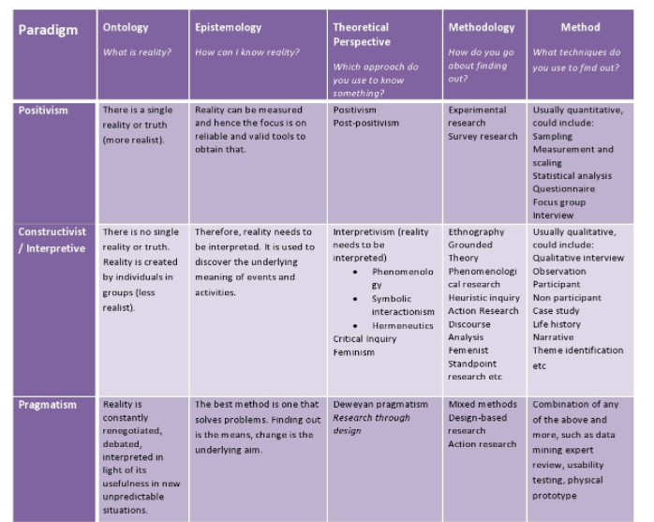
Figure 1 Key concept and foundation of research methodology (Bell et al., 2018).

Ontology: what is reality?
The foundation of business research methodology is comprised of ontology and epistemology (Sekaran & Bougie, 2016). Ontology studies the nature of reality, and it is vitally important to find out the truth for a research work. Ontology is made up of subjectivism, objectivism, and constructivism (Bell et al., 2018). The aim of this study is to investigate the food service industry in the UK in during and after pandemic. In doing so, it intends to explore the impact of covid-19 on food industry highlighting functional impacts such as sales management, operation management, and technology. It also searches for identifying key challenges and opportunities caused by covid-19 pandemic. In addition to theses, this research work focuses on understanding the purchasing and cooking habits of clients during and after pandemic.
Considering the aim and objectives of this research work, constructivism is employed because it helps extract opinion, views, experiences, and knowledge of both business participants, and client participants. As recommended by Eriksson & Kovalainen (2015), constructivism aims to closely study human participants to understand their thoughts, views, opinions, and understanding of the research phenomenon such as cooking habit and purchasing habit for clients, and covid-19’s impact on food business in terms of business perspective. In contrast, objectivism heavily depends on interconnection and inter-causality. It aims to study different variables, and to identify the relationship among them to give concrete conclusion. The study does not aim to produce specific facts. Instead, it aims to identify patterns of subjective information. Thus, constructivism is regarded as the best method for doing this research work (Creswell & Creswell, 2017). With the advancement of scholarly work, and knowledge of scholars, subjectivism is added as an important discipline of ontology. It deals with reality what we perceive to be real (Wilson, 2014).
Precisely, objectivism, subjectivism, and constructivism, constructivism is viewed as the most feasible, and realistic ontological consideration for this research work, because it enables to meet research purpose and objectives. It helps understand how businesses perceive the impact of covid-19 during and after pandemic. It also allows to understand key challenges and opportunities of covid-19 pandemic. Moreover, it sheds light on analyzing the cooking and purchasing habits of clients.

Epistemology: How can the study know reality?
Epistemology deals with the source of knowledge. It studies research method such as natural scientific method, and human perceived knowledge (Eriksson & Kovalainen, 2015). According to Neuman (2013), epistemologists study the origin, and scope of knowledge. How knowledge can be acquired is an important consideration of epistemology. Epistemologically, the core purpose of research is to discovery the underling meaning of events. The study employs interpretivism philosophy (Barnard & Barnard, 2012) because it aims to discover the underlying meaning of the covid-19 and its impact on the food industry.
The choice of interpretivism philosophy is derived from constructivism research paradigm. Positivism is not applicable because the study does not believe that there is a single reality of truth that can measured using valid statistical tool and technique (Eriksson & Kovalainen, 2015). The purpose and objectives of this research work do not comply with the philosophical assumptions of positivism and pragmatism.
To sum up, epistemologically, the study adopts interpretivism to interpret the research phenomenon to understand the underlying meaning of events and activities. The implication of interpretivism enables to employ qualitative method, which subsequently enables to employ qualitative method for collecting and analyzing subjective information.

Research approach: Inductive
As documented earlier, this research is based on constructivism paradigm, which aims to find out the truth based on discovering the underlying meaning of events and activities. This leads to adopt inductive approach (Zikmund et al., 2013). The core purpose of inductive approach is to employ qualitative method in terms of collecting and interpreting human views, opinion, and perception (Creswell & Creswell, 2017). The purpose of this research work is to investigate the food industry in during and after covid-19 pandemic. Here, inductive cycle is the best approach. As said earlier, this is not based on positivism paradigm, which believes the single reality of truth that can be measured using natural scientific method. Therefore, it is not applied in this research work. As the study is not based on pragmatism, it does not incorporate both inductive and deductive cycle into a single research work (Antwi & Hamza, 2015). In short, inductive cycle is the best approach for this research work, because it enables to interpret research phenomenon from both business and client perspectives.

Research Method
Followed by constructivism paradigm, interpretivism, and inductive approach, the study employs qualitative research method (Myers, 2013). The core purpose of qualitative research is to interpret events and activities to identify the underlying truth (Eriksson & Kovalainen, 2015). For example, the core purpose of the research is to understand the impact of covid-19 pandemic on the fast-food chains in the UK. In doing so, the study employs qualitative research method.
By the nature, the qualitative research method is vitally important to experiment and focus on capturing and understanding the core beliefs, views, values, and feelings of participants through conducting structured and semi-structured interviews, focus group discussion, and observation (Jamshed, 2014). For example, the qualitative research method allows the current research to understand the beliefs, views and feelings of the participant of business participants and customers about the impact of Covid-19 on the business operation, sales management, and customer habits through conducting structured and semi-structured interviews. However, first, advantage of qualitative research method is to understand the view, feelings, and values of participants through asking questions related to research aim and objectives (Merriam & Tisdell, 2015). Second, the qualitative research method contributes to computing the core belief of participants about their attitude, beliefs, and perception of a particular research problem (Marshall & Rossman, 2014). Third, qualitative research method is an open-ended process that allows participant to express their own opinions views from their own perspective (Eriksson & Kovalainen, 2015). Finally, qualitative method protects the potential bias of research data and result due to offering freedom of participants during collecting qualitative data from participants (Myers, 2013). Moreover, the study assumed that in order to gain indebt understanding of research phenomena and research aim and objective, qualitative research method allows research to experiment and focus on capturing and understanding the core beliefs, views, values, and feeling of participants.

In spite of having several advantages, the qualitative research method does not over the limitation. For example, the first limitation of this research method is that it is required more time to collect qualitative data from participant comparing with quantitative research method (Antwi & Hamza, 2015). Second, the finding of qualitative research work is qualitative by the nature, and so, it requires more time to understand, and make decision due to qualitative manner of research result (Bernard & Bernard, 2012). Third, qualitative research method does not support statistical data collection and measure the research result statistically, and researcher does not make decision based on statistical figures and facts in qualitative research work (Neuman, 2013). Finally, the qualitative research method does not support the hypothesis testing of scientific test of research result that may raise the question of the result of qualitative research work (Creswell & Creswell, 2017).
However, although there is some limitation of qualitative research method, the study employs the qualitative research method due to its advantages. The reason is that by employing the qualitative research method, the current study enables to understand the views, opinions, feeling, and core values of participants that was difficult for the quantitative research method (Eriksson & Kovalainen, 2015). Besides, the qualitative research method also contributes to generating qualitative result that help policy maker and business owner of the UK’s fast-food sector to develop new product, business model, process of delivering services as per the key requirement of customer as well as the industry trends (Bernard, 2017). Further, the application of qualitative research method in the current research work allows to interpret events and activities to identify the underlying truth (Bell et al., 2018). For example, the core purpose of the research is to understand the impact of covid-19 pandemic on the fast-food chains in the UK. That is why the current research work employs qualitative research method to conduct the valuable research work.

Population, and sampling
The individuals of interest are called population. The target population of this study is business operating in the UK food industry, and clients who purchase from food business. As it is difficult to study all population, statisticians suggest employing suitable sampling strategy (Bryman & Bell, 2015). As the study is not based on positivism, it overlooks the application of probability sampling strategy, because it aims to employ either descriptive or inferential statistics to find out the single truth. Instead, it adopts purposive sampling as suggested by Saunders et al., (2009).
The fast and foremost advantage of using purposive sampling is to select the sample size based on the key purpose of the research work (Gupta, 2011). The reason is that if the researchers fail to select the right sample size, they will fail to collect right research data and as well as generate inappropriate research work (Wilson, 2014). Further, the purposive sampling strategy is the family of non-random sampling techniques, and so, researcher does not enlist all popular of the study to select the sample size, rather researcher can choose sample size as per the key purpose of the research aim, and objectives. On the other hand, in random sampling techniques, researcher needs to enlist the all population, and then select randomly to collect research data (Zikmund et al., 2013). However, this process is time consuming and difficult to access the information of all population. In this case, Sekaran & Bougie (2016) argued that comparing with random sampling technique, the non-random sampling (purposive sampling) method is suitable to researcher to select sample size and collect relevant research data.
On the other hand, the main disadvantage of purposive sampling method is that it could be occurred bias of selecting sample size as well as data collection, if the researcher will not conscious during selecting sample size (Marshall & Rossman, 2014). In addition, Merriam & Tisdell (2015) stated that purposive sampling method is not suitable for employing large sample size to collect research data from participants because researcher selects sample size by considering the convenience issues. However, as the current research collects data from small sample size (e.g., 50 business clients) for structured interview, and 4 business clients for semi-structured interview) due to addressing the academic requirement of research work, the purposive sampling method is suitable for the current research work (Bell et al., 2018). Besides, researcher is also aware of the bias of sampling for the research work, and so, the purposive sampling method is suitable for the current research project.

Data collection instrument
As it is a pure qualitative research work, data is collected using interview method. The interview is carried out using two different formats of interview. They are semi-structured interview (Eriksson & Kovalainen, 2015) and structured interview (Creswell & Creswell, 2017).

Semi-structured interview
By the nature, the semi-structured interview questions are developed by considering both structured and open-ended characteristics that facilitate to collect data from participants by offering freedom of speech (Eriksson & Kovalainen, 2015). Besides, the semi-structured interview also advantages over the collection of data from participants through asking open-ended questions (Antwi & Hamza, 2015). The reason is that open-ended question gives opportunities for participants to provide their own experiences, thinking, views and feeling within any interruption of interviewer (Bernard & Bernard, 2012). For example, in this current research work, researcher gives opportunity for participants to express their opinions and views as their freedom through asking open-ended questions. In addition, the semi-structured interview also contributes to saves time of interview comparing with focus group discussion of excremental approach because researcher asks predetermined question to participants, and then, they provide answer from their own perspective, views, thinking, and experiences (Eriksson & Kovalainen, 2015). Moreover, the semi-structured interview contributes to exploring the beliefs and perception of participants, motivate them to pervades true information by ensuring the security of identity of participant, and address the lack of understating of interview question by explaining key purpose of every research question that help participant to provide relevant information according to the requirement of researcher as well as research aim and objectives (Newman, 2013).

The main disadvantage of semi-structured interview is that it is time consuming (Creswell & Creswell, 2017). The reason is the during conducting the semi-structured interview, both researcher and participant need to communicate face to face for asking question and recording the answer of participant (Bernard, 2017). In addition, the collecting of primary data through semi-structured interview is required to translate into text format to analyze and interpreted the result, and this process of more time consuming for researcher comparing with structure-interview (Eriksson & Kovalainen, 2015). However, although the semi-structured interview is time consuming research method, it effective for exploring the research phenomena through understanding the views, opinions, thinking, and feeling of participants, and so, the study employs semi-structured interview to collect qualitative data.

Structured interview
According to Saunders et al., (2009) structured interview is an approach to collect research data through asking structured questions of target participants. The primary advantage of structured interview is to collect research data within short time compared with the semi- structured interview (Creswell & Creswell, 2017). The reason is the in semi-structured interview both researcher and participant need to face to face communication to collect research data, whereas, participants can provide their valuable information through the structured interview by investing their convenience time because in this process researcher and participant do not present face to face during providing research data (Myers, 2013). In addition, structured interview provides opportunities for participants to give their answers within the particular option that contributes to saving their time to provide interview information (Jamshed, 2014). Moreover, structured interview is suitable to collect research data from large sample size by investing limited time and cost.
However, the core limitation of structured interview is that in some cases, it does not offer freedom of participants because participants are required to provide their answer with the certain option (Merriam & Tisdell, 2015). This means the participants do not get opportunity to provide their feeling, view, and thinking outside the structured answer option (Marshall & Rossman, 2014). In this case, research by Bell et al., (2028) stated that researchers can over the limitation of structured interview by developing research questionnaire based on the key information of current literature and the aim and objectives of the research question. The reason is that extensive literature review allows researcher to understand the research ground deeply that supports to develop effective structured interview questions.

Data analysis: Thematic analysis
First, it employs thematic analysis to present subjective information collated from business participants. As recommended by Saunders et al., (2009), thematic analysis is a robust qualitative data analysis tool, which provides insight of subjective information thematically. The purpose of this analysis technique is to identify themes. These themes are identified following a sequential process.
- The collected subjective information from 4 business participants was documented in Microsoft word (see appendix). Then, the information was manually read out several times to understand what participants actually wanted to say. This phase is vitally important to code important information.
- The second phase was coding. Here, the information was read out carefully for identifying some important codes (i.e., impact of covid-19 on supply chain). The codes were screened out carefully with the hope of identifying some important themes.
- Themes are vitally important because it indicates some patterns that help understand key research phenomenon (Bell et al., 2018). Followed by coding some important themes were identified to analyze the subjective information.
As stated by Bryman & Bell (2015) thematic analysis is a holistic approach to analyze qualitative research data through developing suitable theme in relation to the collected information as well as research objectives (Eriksson & Kovalainen, 2015). This means the thematic analysis contribute to gain an understanding of research problem and identify the effective solution through developing key theme and analyze the research data based on the identified themes (Jamshed, 2014). For example, ‘Covid-19 and its impact on operation management at Fast Food chain’ is an important them of the current research project that contributes to gaining understating of the impact of Covid-19 on the business operation of fast-food chain in the UK by exploring the research data that provide target participants. Moreover, thematic analysis is a flexible approach to analyzing qualitative data that allows researchers to analysis collected research data from different perspectives by developing different themes based on the research aim and objectives (Myers, 2013).
Although the thematic analysis is a flexible approach to analyzing qualitative data, the disadvantage of this approach is that it may generate inconsistency result due to lack of indebting knowledge of researcher (Eriksson & Kovalainen, 2015). The reason is that if the researcher fails to develop suitable themes, the research result will be failed to addressing the research aim and objectives (Antwi & Hamza, 2015). Moreover, researcher needs to gain an insight understating the ground of the research to employ thematic analysis as the key instrument of data analysis, otherwise, research fails to develop effective and suitable themes that mislead the research result to address research aim and objectives.

Ethical consideration
The ethical consideration of a research refers to following the rules and regulations of academic integrity, according to Saunders et al., (2009). The reason is that violating the rules of academic integrity leads students or researchers toward academic misconduct (Bell et al., 2018). However, the current research fully maintains the ethical issues of conducting research work. First, the research follows the academic rules and regulation that provided by the University. Second, the research work avoids any kind of personal information of participants that violates their personal interest, which is vitally important to motivate target participants (Bryman & Bell, 2015). Third, the current research work fully complied with the laws of GDPR act to ensure the security of research information (Nayak & Singh, 2021). Fourth, the study fully follows the laws of plagiarism, and uses proper citation for acknowledging the author (Sekaran & Bougie, 2016). The reason is that lack of appropriate referencing and citation may raise questions about the validity of a research work. Fifth, the study gets permission from the target participant through using the participant consent form because it is mandatory for researcher to get permission from the participant before collecting information and do not force to provide information (Wilson, 2014). Finally, the study does not use the research data for any other purpose except to address the aim and objectives of the current research project.

Conclusion
Objectivism, subjectivism, and constructivism, constructivism is viewed as the most feasible, and realistic ontological consideration for this research work, because it enables to meet research purpose and objectives. It helps understand how businesses perceive the impact of covid-19 during and after pandemic. It also allows understanding key challenges and opportunities of covid-19 pandemic. Moreover, it sheds light on analyzing the cooking and purchasing habits of clients. Inductive cycle is the best approach for this research work, because it enables to interpret research phenomenon from both business and client perspectives. As the study is not based on positivism, it overlooks the application of probability sampling strategy, because it aims to employ either descriptive or inferential statistics to find out the single truth. Instead, it adopts purposive sampling. As it is a pure qualitative research work, data is collected using interview method. The interview is carried out using two different formats of interview, including semi-structured interview and structured interview. The study employs thematic analysis to present subjective information collated from business participants. Moreover, the current research fully maintains the ethical issues of conducting research work.

Chapter Four: Data Analysis
This chapter is designed to present key results obtained from conducting structured, and semi-structured interviews with participants. Specifically, this research work undertook 4 semi-structured interviews with participants who run business, and carried out 50 structured interviews with clients who purchase fast food from business. The purpose of doing semi-structured interview with business is to understand their views regarding the impact of covid-19 pandemic on their value chain configuration system. Similarly, interviews with client were aimed to understanding their cooking and purchase habit. As this work contains two interviews with two different formats, it presents analysis sequentially. First, it employs thematic analysis to present subjective information collated from business participants. As recommended by Saunders et al., (2009), thematic analysis is a robust qualitative data analysis tool, which provides insight of subjective information thematically. The purpose of this analysis technique is to identify themes. These themes are identified following a sequential process.
- The collected subjective information from 4 business participants was documented in Microsoft word (see appendix). Then, the information was manually read out several times to understand what participants actually wanted to say. This phase is vitally important to code important information.
- The second phase was coding. Here, the information was read out carefully for identifying some important codes (i.e., impact of covid-19 on supply chain). The codes were screened out carefully with the hope of identifying some important themes.
- Themes are vitally important because it indicates some patterns that help understand key research phenomenon (Bell et al., 2018). Followed by coding some important themes were identified to analyze the subjective information.
The data collected from structured format was then illustrated statistically because it aims to generate some important facts to shed light on purchasing and cooking habits of general clients.

Sequential qualitative data analysis

Analysis of Semi-structured interview
Thematic analysis

Figure 2 Identified themes (Source: Author, n.d)
Theme 1: Covid-19 and its impact on operation management at Fast Food chain
An understanding of the impacts of covid-19 on operation management was a prime target of doing semi-structured interviews with 4 business participants. It is worth mentioning that the questions added in semi-structured interview were driven by conducting an extensive literature review. As an example, Singh et al., (2021) conducted a study to examine the influences of covid-19 on retail operation. Like this study, several studies were published highlighting the impact of covid-19. This analysis includes the views and opinions of 4 important participants. Their views were almost same because all of them were struggling to continue regular operation due to the restrictions undertaken by the UK government. A representative of business (age 33- and 8-years working experience named Little Italy) quoted that
[…Covid-19 changed our operational hour, cutting cost, and laying off unskilled and semi-skilled people. It has also disrupted the supply chain system. Moreover, it has been taught us about future action plan…]
This statement shows that covid-19 did not only affect the operating hour but also adversely affect the logistic and supply chain. The business laid of unskilled and semi-skilled people. This implies that the job of employee was under threat during covid-19. This has been evident in several academic studies. Power et al., (2020) said that covid-19 caused a loss of hundreds of thousands of jobs, and forced many employees to join the UK government furlough scheme. The covid-19 also restricted operating hour. At the same time, the operating cost of doing fast-food business was not stable. Instead, extra health and safety measures caused a rise of operating cost. In the meantime, the low sales volume has negative impact. Suppliers struggled to reach products due to covid-19 protocol (Laborde et al., 2020). This caused a tremendous loss for business. To end of this analysis, it needs to attach quote from the representative (age 21) of another business named the shed
[…Covid-19 negatively impacted our business because of decreasing operating hour. For example, before Covid-19 we served 10 hours but at present we serve only 6 hours…]
In summary, the results of semi-structured interview say that covid-19 has had an adverse impact on small size fast food and restaurant chain in the UK. The closure of store and restaurant did not only lose customers but also affect the logistics and supply chain negatively. This disruption has had a negative impact on workforce management. Many businesses were forced to cut off job or to join government furlough scheme.
Theme 2: Covid-19 and its impact on sales management
In terms of gaining insight understating the impact of the Covid-19 on the sales management of food business in the UK, the study conducted semi-structured interview with participants from 4 business. Therefore, the analysis of the interview that showed that all participant said that Covid-19 negatively influenced their sales management, more especially their in-stores selling. As the key reason of negative impact of Covid-19 on sale of the food business (Power et al., 2020), Participants said that supply chain crisis, government restriction of customers’ movement, and maintaining social distance and safety measure. For example, a participant of the business with 10-year business operation experiences said that
[…Due to Covid-19 outbreak, we failed to operate our in-store selling during lockdown that negatively reduces our customer confidence and supply chain relationship…]
This statement is supported by the other two business participant because that also said that due do C0vid-19 pandemic, customer was less likely to visit their outlet due to the fairness of infecting of Covid-19 that negatively influenced their sales volume in their physical outlets. This finding is supported by the previous study by Siche (2020), who noted that during the Covid-19 pandemic, the retail food business experienced negative sales growth due to shortage of customer visiting their stores.
On the other hand, although one business participant with 10-year business operation experience in the UK restaurant sector mentioned that Covid-19 negatively impacted their in-store selling, they experience high order in online platform. The statement of this participant is quoted that
[….Covid-19 negatively influence our sales volume because customer only orders in online platform due to maintaining social distance….]
This finding indicates that during the crisis time of Covid-19 in the UK, the customers of the retail food sector were more likely to purchase their necessary food item from online platform rather than in-store. This is supported by the primary research by Tassinari & Maccarrone (2020), who state that Covid-19 have changed the consumer buying pattern, and so they are purchasing their product from online platform due to maintaining social distance measures.
To the end, the analysis of interview data showed that Covid-19 negatively impacted the sales management and sales volume of the UK retail food business due to supply chain crisis, government restriction of customers’ movement, and maintaining social distance and fairness among customer for being infected by Covid-19. Besides, the study also found that although Covid-19 negatively impacted in-store selling retail food businesses in the UK, they experienced high order in online platform.

Theme 3: The use of digital technology to combat covid-19
One of the purposes of the study was to understand the use of digital technology in the UK retail food business to combat the crisis of Covid-19. In doing so, the study conducts the semi-structured interviews with the participants with four food business in the UK. However, the analysis of the interview that showed almost similar results. The reason is that all of the participant stated that employing digital technology is the key to success for the UK retail food business. For example, a participant with 10-year business operation experiences said that
[….The digital technology such as online selling platform has vital important to address customer convenience service in the future….]
This statement is fully supported by the participant of the business with less than 10 year business experiences and stated that…
[….Compared to the pre-Covid-19 period, I think that digital technology is vitally important to address customer convenience service such as online delivery service….]
This result indicated that digital technology such as online delivery platform will vitally contribute to increasing organizational sale in the UK retail food sector. The result is fully supported by the previous study by Aday & Aday (2020), who said that in the time of Covid-19 crisis more than 65% customer are purchasing food items from online platform that will be reached by 85% within the next two years.
On the other hand, rest of the two participants said that before Covid-19, they did not offer online selling but at present they offer online and takeaway services. For example, a participant said that
[….Prior to covid-19, we did not offer online sales. We had no takeaway service but we have now online and takeaway service….]
By supporting this result, Barman et al., (2021) argued that food retailer in the UK needs to use digital technology to server customer’s convenience services as well as compete with competitors in the post-pandemic business environment.
In short, the study found that the food retailer in the UK focused on using online selling platform due to addressing customer convenience services as well as gaining competitive advantage over the competitor during and post pandemic business environment through addressing customer needs and demands.
Theme 4: Opportunities amidst covid-19 pandemic
An important target of the current study was to know whether the Covid-19 create any opportunity for the UK fast food business or not, and so, the study conducted the semi-structured interview with the target participants. The reason is that the previous study by Brown et al., (2021) argued that Covid-19 forces businesses in the food sector to rethink their business model, promote innovation and creativity, and employ digital technology to address customer needs and demands. By linking this argument, the study developed interview question and asked participants whether their business found any opportunity amid Covid-19 pandemic. In this case, one participant with 10 years business operation experiences said that
[…I think online service is an opportunity for the exiting business…]
This indicates that offering online services to the target customer is one of the greatest opportunities for the food businesses in the UK, which contributes to responding towards customer new buying behavior, supported by Hwang et al., (2020),
In line with the opinion of the participant that mentioned above, rest of the three participants also provide all most similar views but one of the participants with 8 years business operation experience and 33 business size provided an interesting opinion that is quoted below,
[…An important opportunity is to rethink business model, and to add online sales where 4 billion people in the world spend at least one hour in a day online…]
The view of this participant indicates that businesses in the UK fast food chain must rethink their current business model and employ digital technology such as online selling services to harness the opportunities during and post pandemic environment. This statement is complied with the finding of the previous study by Luckstead et al., (2021), who claimed that Covid-19 pandemic contribute to rethinking business owner of the fast-food chain to develop new business model by incorporating digital technology such as online services.
In summary, the analysis of the interview data found that Covid-19 creates opportunities for the businesses of fast-food chain in the UK by developing new and innovative business model along with incorporating digital technology so that the businesses can maximize sales and profitability by offering online delivery services.
Theme 5: challenges of covid-19 pandemic
Along with understanding the key opportunities of Covid-19 for fast food chain in the UK, the study also wanted to know the key challenges that imposed by Covid-19 on the UK fast food business through conducting the semi-structured interview with business participants. However, the participant stated that decreasing in-store selling, inversing supply chain crisis, decreasing customer engagement are the most challenges issues that are imposed by Covid-19 on their businesses. For example, a participant with less than 10 years business experiences said that
[….Due to closing in-store selling, we have experienced less sales volume during covid-19 period than pre-covid-19 period….]
This means that the fast-food retail sector in the UK experienced negative in-store sales during the Covid-19 pandemic, compared with pre-Covid-19 situation. According to Mitchell et al., (2020), at the beginning stage of Covid-19 outbreak, the UK government-imposed lockdown, and so, the fast-food chains in the UK closed their in-store operation that negatively impact in-store selling.
Besides, one of the participants further claimed that offering professional online services is the great challenge for the fast-food chain. The participant said that
[….We face challenges to offer professional online service due to skills shortage of our employees…]
The reason is that fast food retail sector is operated by the semi-skilled and unskilled employees, but it is required skilled employees to offer professional online services, and so, the fast-food chain faced challenges to offer online services due to shortage of employees (Power et al., 2020). However, in line with the employees’ shortage, the fast-food chains in the UK also faced challenges to employee engagement during Covid-19 pandemic. For example, a participant said that
[….The main challenges of Covid-19 are to retain employee engagement due to increasing health and safety risks…]
The reason is that the employees of the fast-food sector are required to directly communicate with customer that would increase the possibility of infecting of Covid-19, and so, health safety is one of the key challenges of the sector to increase employee’s engagement.
Precisely, the analysis of interview that also showed that the fast-food retail sector in the UK experienced negative in-store sales during the Covid-19 pandemic, compared with pre-Covid-10 situation. Besides, the result showed that offering professional online services is the great challenge for the fast-food chain due to the shortage of skilled employees and the main challenges of Covid-19 are to retain employee engagement due to increasing health and safety risks.
Theme 6: Recommendation and future plan for business
The current research was also purposed to identify the key solution of the current challenges in the fast food chains in the through conducting semi-structured interview. Therefore, the participants provided their opinion to overcome the challenges of this sector. For example, a participant with ten year business experience said that
[….We are required to develop strong supply chain and online customer service….]
This is because the supply chain system in the UK food sector has been disrupted due covid-19 pandemic. This argument is supported by Tassinari & Maccarrone (2020), who noted that covid-19 adversely affected the food supply chain not of the UK but also the rest of the world, and so, the business owners are required to develop strategic partnership with supplier to address the crisis and create balance between demand and supply. However, this finding is also supported by the rest of the three participants.
On the other hand, one of the participants said that investment in digital technology will be the suitable solution to address the current challenges in the UK fast food retail sector. By supporting these views. Another participant stated that
[….We are trying to invest in digital infrastructure for the future….]
While at the same time, the participant with 10 years business experience said that
[…As Covid-19 positively influences our online selling, we have planned to investment on developing a sophisticated online platform….]
This means all the participants noted that investment in digital technology will be one of the key solutions of the current business challenges of the UK fast food retailer. In this case, research by Panzone et al., (2020) showed that as the Covid-19 changes consumer buying behavior from in-store purchasing to online purchasing, the investment in digital technology will be the key to gain competitive advantage in the future in the UK food sector.
In summary, the research found that the business owners are required to develop strategic partnership with supplier to address the crisis and create balance between demand and supply. Besides, the investment in digital technology will be the key to gain competitive advantage in the future in the UK food sector because Covid-19 changes consumer buying behavior from in-store purchasing to online purchasing.

Analysis of structured interview
Demographic analysis Q 1 to Q5
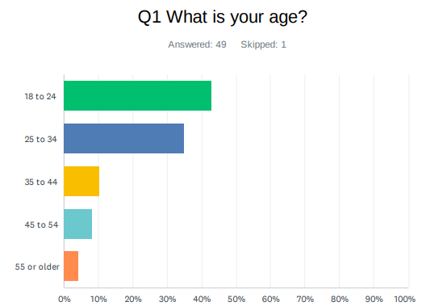 | 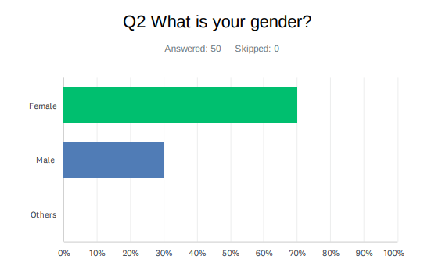
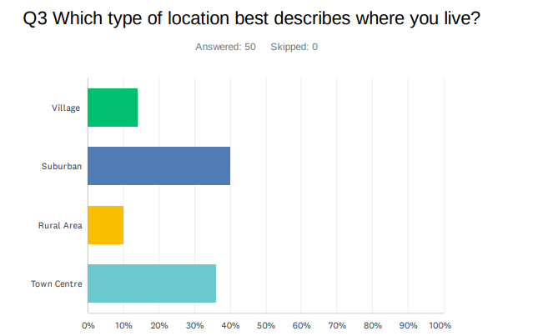 | 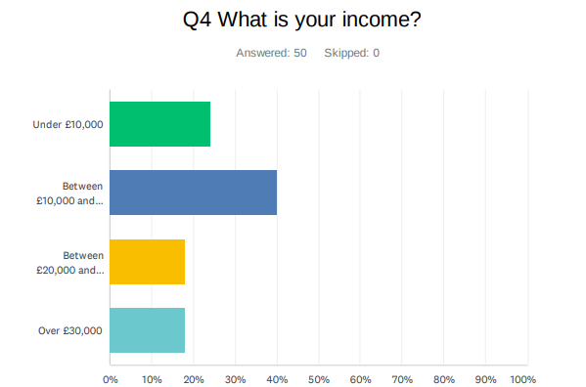
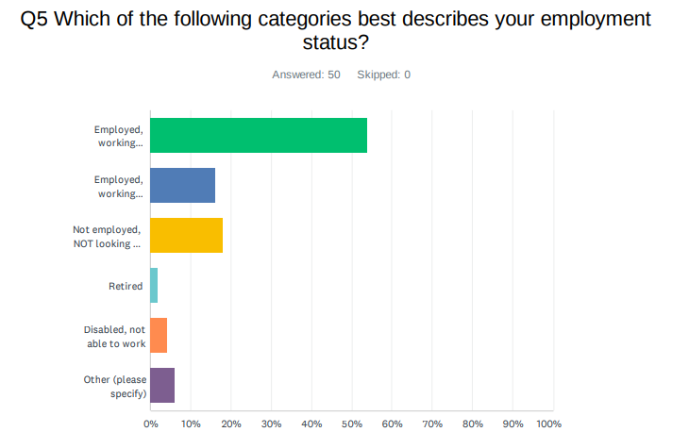
To uncover the impact of pandemic on purchasing habit, survey questionnaires were distributed to participants who would be characterized by age, gender, income, living regions, and employment status. Approximately 50 participants took part in this survey because there were some missing values. However, the majority of participants were female (70%) aged between 16 and 24 (43%) who lived in sub-urban areas (40%) and who were employed in working (54%). The income of large percentage of participants (40%) was between £10000 and £19999. As socio-demographic variables affect the responses (Panzone et al., 2021), the survey proclaimed that these demographic results would affect the way respondents think and behave in a certain manner.
Analysis of mode of purchasing during and after pandemic Q6, 8 and 9
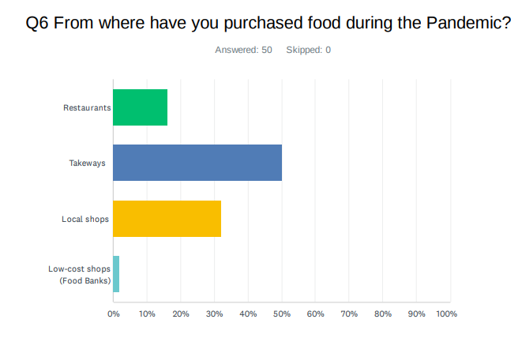 | 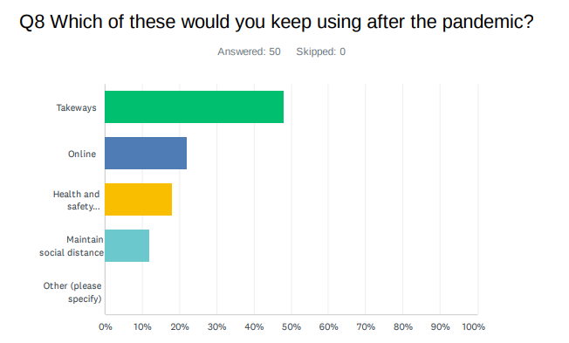
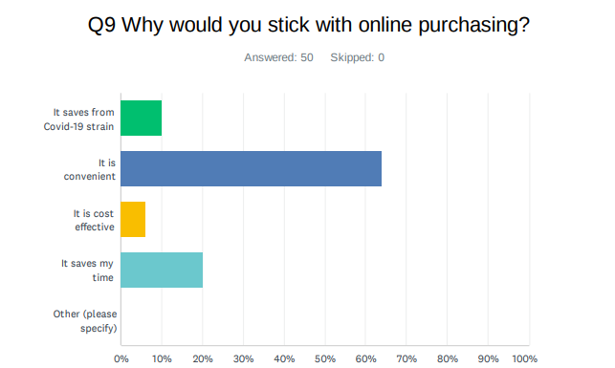
The study reveals that respondents (50%) were very likely to use takeaway services during pandemics. Even, they (45%) will be likely to use takeaway service after the pandemic. This implies that fast-food companies regardless of size such as micro, small, medium, and large have a great opportunity to add new and innovative initiatives in terms of takeaway service. This statement has been supported by the past studies dealing with the impact of pandemics on purchase habits of customers (Ogundijo et al., 2021). The prime reason of purchasing online was its convenient approach to delivering goods to the doorstep of customers (64%) followed by saving time (20%) and cost-effectiveness (6%).
Analysis of product type (Q7)
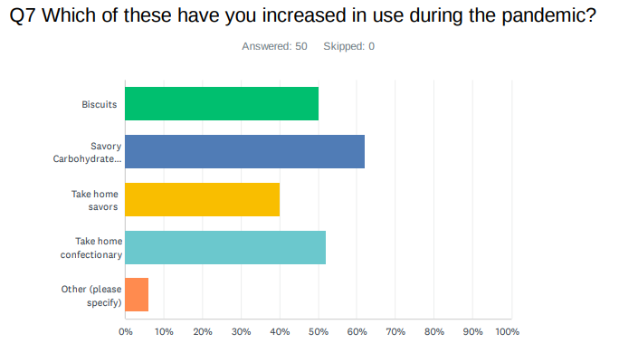
Savory and carbo-hydrate items were largely purchased by the survey participants (62%). These findings do not match with previous empirical works (e.g., Nakat & Bou-Mitri, 2021; and Boons et al., 2021) where plant-based food items, cereal items, and nutritional items were frequently purchased by Britons during pandemic. This gap might occur due to the socio-demographic variables. The survey is dominated by females who aged between 18 and 24 and who lived in suburban areas.
Analysis of covid-19 preventive measures (Q10)
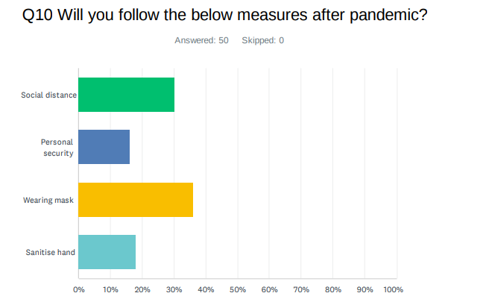
Social distance (30%) and wearing masks (36%) were considered as the most preferable covid-19 preventive measures according to the majority of participants. However, the mass-scale covid-19 vaccination program in the UK has affected the way people thought during this survey period.
Analysis of Likert scale questions (Q11-20)
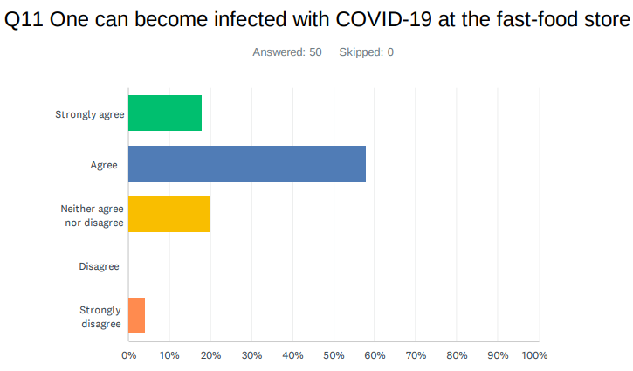 | 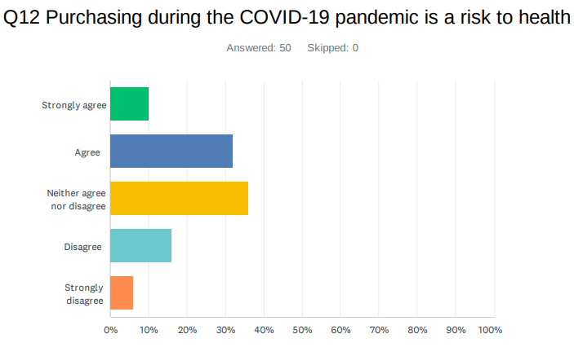
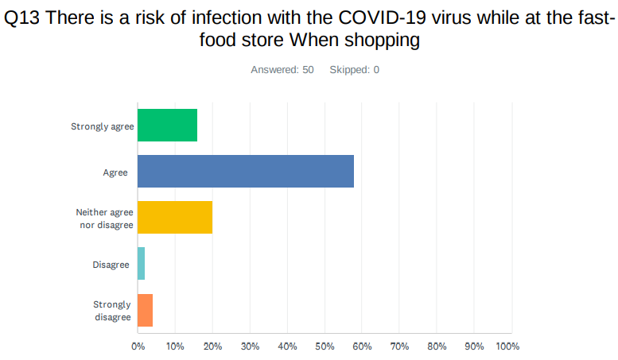 | 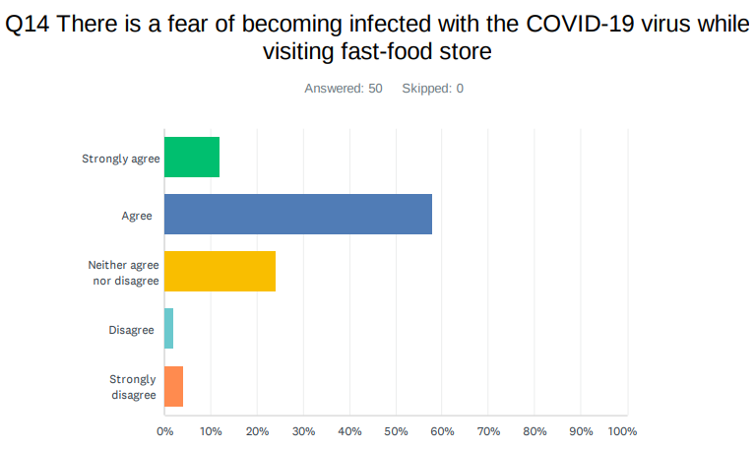

The survey found that the majority of the respondent (76%) agreed they could be infected by Covid-19 through purchasing fast-food from stores, followed by 42% agreeing with increase heath risk, 74% stated that visiting fast-food stores would increase fear of Covid-19 infection. But, the recent research by Boons et al., (2021) found that people are visiting fast-food to purchase their product after getting the Covid-19 vaccine. However, the possible reason for being differences between the survey result and empirical research is that when the respondent participated in the survey, they did not get the vaccine.
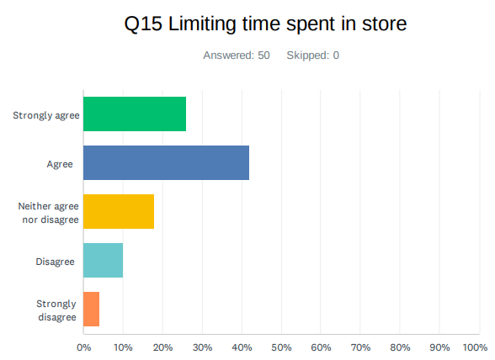 | 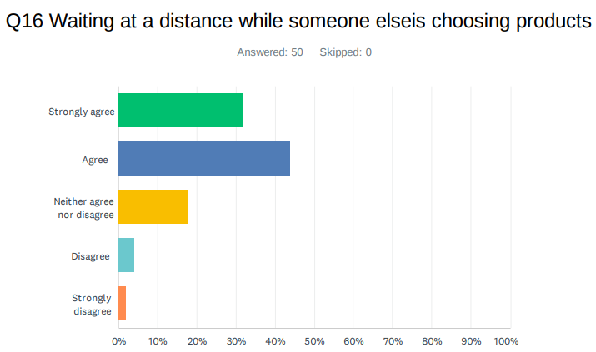
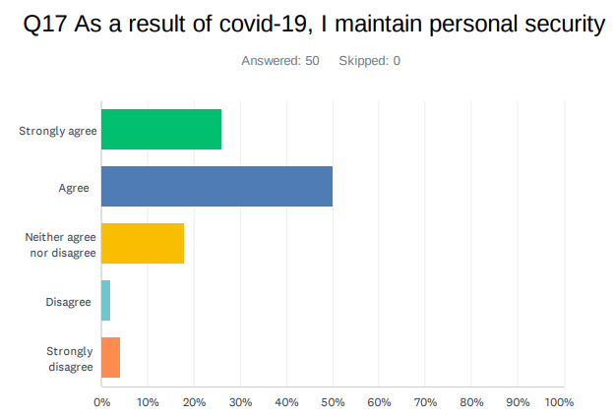 | 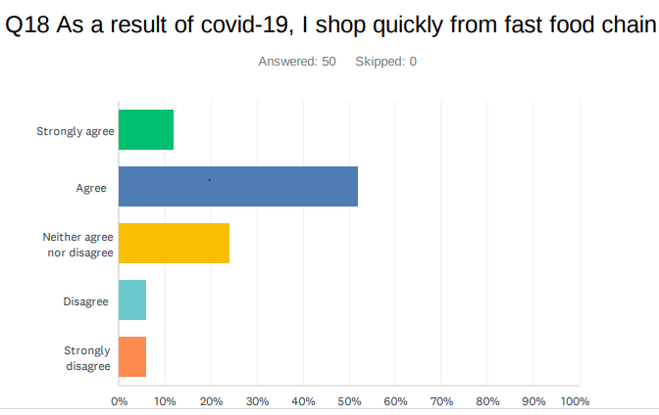

The study found that 68% respondents asserted that they spent limited time for purchasing food from retail stores, and 76% agreed that they maintained social distance. Besides, 76% respondents said that they maintained personal security, and 64% respondents said they shopped quickly from fast-food chains due to Covid-19 pandemic. This finding is strongly supported by Filimonau et al., ((2021), who stated that due to keeping safe from Covid-19 infection, customers are more likely to spend limited lime at stores, maintain social distance and personal security, and leave stores as soon as possible.
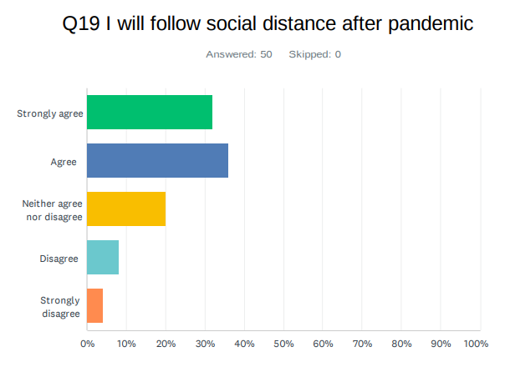 | 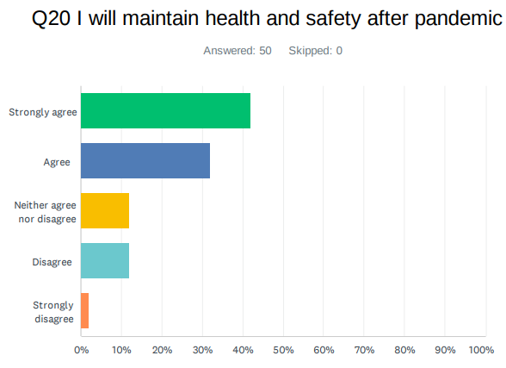

According to the survey result, 68% participants agreed that they will follow social distance, and 74% said they will maintain health and safety after pandemic. This possible reason of being this intend among customers would be due to increasing health and safety awareness during pandemics. In this case, Boyaci et al., (2021) argued that the outbreak of Covid-19 increases the health and safety awareness among general people.

Chapter Five: Conclusion and Recommendation

Conclusion
This research work aimed to explore the food industry during and after pandemic. To address this aim, it is of critical importance in understanding the covid-19 and its impact from business and client perspective. However, along with the aim of the study employed qualitative research method, characterized by interpretivism to interpret the research phenomenon to understand the underlying meaning of events and activities, and inductive cycle enables to interpret research phenomenon from both business and client perspectives to understand key challenges and opportunities of covid-19 pandemic, and to shed light on analyzing the cooking and purchasing habits of clients. Followed by constructivism paradigm, interpretivism, and inductive approach, the study employed qualitative research method, and purposive sampling techniques to select target sampling. Moreover, the semi-structured and structured interviews carried out to collect qualitative data from four business perspective participants and eight customer perspective participants. However, the findings of the current research were presented into two separate data analysis perspectives.
Finding of semi-structured interview data analysis: The results of semi-structured interview say that covid-19 has had an adverse impact on small size fast food and restaurant chain in the UK. The closure of store and restaurant did not only lose customers, but also affect the logistics and supply chain negatively. This disruption has had a negative impact on workforce management. Many businesses were forced to cut off job or to join government furlough scheme. The analysis of interview data showed that Covid-19 negatively impacted the sales management and sales volume of the UK retail food business due to supply chain crisis, government restriction of customers’ movement, and maintaining social distance and fairness among customer for being infected by Covid-19. Besides, the study also found that although Covid-19 negatively impacted in-store selling retail food businesses in the UK, they experienced high order in online platforms. The study found that the food retailer in the UK focused on using online selling platform due to addressing customer convenience services as well as gaining competitive advantage over the competitor during and post pandemic business environment through addressing customer needs and demands.
The analysis of the interview data found that Covid-19 creates opportunities for the businesses of fast-food chain in the UK by developing new and innovative business model along with incorporating digital technology so that the businesses can maximize sales and profitability by offering online delivery services. The result also showed that the fast-food retail sector in the UK experienced negative in-store sales during the Covid-19 pandemic, compared with pre-Covid-10 situation. Besides, the result showed that offering professional online services is the great challenge for the fast-food chain due to the shortage of skilled employees and the main challenge of Covid-19 is to retain employee engagement due to increasing health and safety risks. The research found that the business owners are required to develop strategic partnership with suppliers to address the crisis and create balance between demand and supply. Besides, the investment in digital technology will be the key to gain competitive advantage in the future in the UK food sector because Covid-19 changes consumer buying behavior from in-store purchasing to online purchasing.
Finding of structured interview data analysis: The study revealed that respondents (50%) were very likely to use takeaway services during pandemics. Even, they (45%) will be likely to use takeaway service after the pandemic. The prime reason of purchasing online was its convenient approach to delivering goods to the doorstep of customers (64%) followed by saving time (20%) and cost-effectiveness (6%). Savory and carbo-hydrate items were largely purchased by the survey participants (62%). Social distance (30%) and wearing masks (36%) were considered as the most preferable covid-19 preventive measures according to the majority of participants. The survey found that the majority of the respondent (76%) agreed they could be infected by Covid-19 through purchasing fast-food from stores, followed by 42% agreeing with increase heath risk, 74% stated that visiting fast-food stores would increase fear of Covid-19 infection. The study found that 68% respondents asserted that they spent limited time for purchasing food from retail stores, and 76% agreed that they maintained social distance. Besides, 76% respondents said that they maintained personal security, and 64% respondents said they shopped quickly from fast-food chains due to Covid-19 pandemic. Finally, 68% participants agreed that they will follow social distance, and 74% said they will maintain health and safety after pandemic.

Recommendations
Based on the finding of the research, more especially, the challenges that imposed on the business operation and sales management of the UK food industry, the research provides the following valuable, suitable, and effective recommendations.
Developing strategic partnership with suppliers and investment in supply chain: The thematic analysis result showed that supply chain crisis was one of the most impactful challenges in the UK food industry during the covid-19 pandemic than pre-Covid-19 situation. So, the study highly recommended that the businesses in the UK food industry should develop strategic partnership with suppliers and invest in developing supply chain and supplier’s capabilities. In this case, Mitchell et al., (2020) argued that the investment on suppliers contributes to developing the capabilities of supplier to supply required food items, and then, the food businesses will enable to maintain balance between demand and supply of customer requirements. In addition, Panzone et al., (2021) claimed that developing strategic partnership with supplier allows to develop strong relationship between suppliers and businesses that contribute to developing sustainable supply chain system within the UK food industry.
Investment on developing skilled and talented human resources: The result showed that offering professional online services is the great challenge for the fast-food chain due to the shortage of skilled employees. The reason is that the UK food industry is dominated by the semi-skilled and unskilled employees, and therefore, the sector faced challenges to offer professional services for target customer. By considering the finding, the study recommended that the food business in the UK is required to invest on developing skilled and talented human resources through offering effective and adequate training, learning and development opportunities because these are the key vehicles of improving employees’ skills, knowledge, competencies, and experiences within an particular industry (Power et al., 2020).
Ensuring employees and customer health safety: The research work found that engaging both employees and customers were the core challenges of the UK food business during the Covid-19 situation because it created health risk for both employees and customers. So, the research recommended that the food businesses in the UK food industry need to ensure health safety to increase both employees and customer engagement. The reason is the Covid-19 imposed high health risks on human life, and so, health safety is vitally important to protect against the outbreak of the Covid-19 (Panzone et al., 2021).
Investment on developing sophisticated online delivery platform: Moreover, the analysis of primary data showed that Covid-19 pandemic adversely affected in-store selling of the food businesses in the UK but it contributed to increasing online selling due to ensuring customer health safety. Besides, the study also found that due to lack of sophisticated online delivery services, the retail food businesses in the UK failed to offer professional online delivery services to target customers. In this situation, the study strongly recommended to the UK retail food businesses to develop sophisticated and interruption-free online delivery services. The reason is that customers are more likely to purchase from those businesses that offer professional and customer-friendly online delivery (Aday & Aday, 2020).

Future research work
The current research work was limited to explore the food industry in during and after pandemic by adopting only qualitative research methods. Besides, the study also limited to address the research aim and objectives by collecting primary data from small sample size (e.g. semi-structured interview with 4 business perspective participants, and structured interview with 8 customer perspective participants). Overall, the study employed only qualitative research method to explore the food industry during and after pandemic. However, in future, the research work will conduct on the same ground by involving large sample sizes. Moreover, the qualitative and quantitative methods as a means of mixed-method research work will be conducted in the future to explore the food industry during and after the pandemic.

References
Aday, S., & Aday, M. S. (2020) Impact of COVID-19 on the food supply chain. Food Quality and Safety, 4(4), 167-180.
Antwi, S. K., & Hamza, K. (2015) Qualitative and quantitative research paradigms in business research: A philosophical reflection. European Journal of Business and Management, 7(3), 217-225.
Avery, G. C., & Bergsteiner, H. (2011) Sustainable leadership practices for enhancing business resilience and performance. Strategy & Leadership.
Bacq, S., & Lumpkin, G. T. (2020) Social Entrepreneurship and COVID‐19. Journal of Management Studies.
Barichello, R. (2020) The COVID‐19 pandemic: Anticipating its effects on Canada's agricultural trade. Canadian Journal of Agricultural Economics/Revue canadienne d'agroeconomie, 68(2), 219-224.
Barman, A., Das, R., & De, P. K. (2021) Impact of COVID-19 in food supply chain: Disruptions and recovery strategy. Current Research in Behavioral Sciences, 2, 100017.
Bell, E., Bryman, A. and Harley, B. (2018) Business research methods. Oxford university press.
Bernard, H. R. (2017) Research methods in anthropology: Qualitative and quantitative approaches. Rowman & Littlefield.
Bernard, H. R., & Bernard, H. R. (2012) Social research methods: Qualitative and quantitative approaches. Sage.
Block, J. H., Fisch, C., & Hirschmann, M. (2021) The determinants of bootstrap financing in crises: evidence from entrepreneurial ventures in the COVID-19 pandemic. Small Business Economics, 1-19.
Boons, F., Doherty, B., Köhler, J., Papachristos, G., & Wells, P. (2021) Disrupting transitions: Qualitatively modelling the impact of Covid-19 on UK food and mobility provision. Environmental Innovation and Societal Transitions, 40, 1-19.
Boyacι, C. P., Ibrahim, S. A., Wei, O. C., & Galanakis, C. M. (2021) Transformation of the Food Sector: Security and Resilience during the COVID-19 Pandemic. Foods, 10(3), 497.
Brewin, D. G. (2020) The impact of COVID‐19 on the grains and oilseeds sector. Canadian Journal of Agricultural Economics/Revue canadienne d'agroeconomie, 68(2), 185-188.
Brown, R., Rocha, A., & Cowling, M. (2020) <? covid19?> Financing entrepreneurship in times of crisis: Exploring the impact of COVID-19 on the market for entrepreneurial finance in the United Kingdom. International Small Business Journal, 38(5), 380-390.
Brown, S., Opitz, M. C., Peebles, A. I., Sharpe, H., Duffy, F., & Newman, E. (2021) A qualitative exploration of the impact of COVID-19 on individuals with eating disorders in the UK. Appetite, 156, 104977.
Bryman, A., & Bell, E. (2015) Business research methods. Oxford University Press, USA.
Chen, H. S., Liang, C. H., Liao, S. Y., & Kuo, H. Y. (2020) Consumer Attitudes and Purchase Intentions toward Food Delivery Platform Services. Sustainability, 12(23), 10177.
CNN. (2020) Fast food companies are betting big on delivery. It might not pay off. [Online] Available at>https://edition.cnn.com/2019/08/19/business/fast-food-delivery/index.html [Accessed: 15th October 2021].
Cranfield, J. A. (2020) Framing consumer food demand responses in a viral pandemic. Canadian Journal of Agricultural Economics/Revue canadienne d'agroeconomie, 68(2), 151-156.
Creswell, J. W., & Creswell, J. D. (2017) Research design: Qualitative, quantitative, and mixed methods approaches. Sage publications.
Dahles, H., & Susilowati, T. P. (2015) Business resilience in times of growth and crisis. Annals of Tourism Research, 51, 34-50.
Deaton, B. J., & Deaton, B. J. (2020) Food security and Canada's agricultural system challenged by COVID‐19. Canadian Journal of Agricultural Economics/Revue canadienne d'agroeconomie, 68(2), 143-149.
Eriksson, P., & Kovalainen, A. (2015) Qualitative methods in business research: A practical guide to social research. Sage.
Filimonau, V., Beer, S., & Ermolaev, V. A. (2021) The Covid-19 pandemic and food consumption at home and away: An exploratory study of English households. Socio-Economic Planning Sciences, 101125.
Galanakis, C. M. (2012) Recovery of high added-value components from food wastes: conventional, emerging technologies and commercialized applications. Trends in Food Science & Technology, 26(2), 68-87.
Giones, F., Brem, A., Pollack, J. M., Michaelis, T. L., Klyver, K., & Brinckmann, J. (2020) Revising entrepreneurial action in response to exogenous shocks: Considering the COVID-19 pandemic. Journal of Business Venturing Insights, 14, e00186.
Goddard, E. (2020) The impact of COVID‐19 on food retail and food service in Canada: Preliminary assessment. Canadian Journal of Agricultural Economics/Revue canadienne d'agroeconomie. 68.
Goddard, E. (2021) The impact of COVID‐19 on food retail and food service in Canada: A second assessment. Canadian Journal of Agricultural Economics/Revue canadienne d'agroeconomie.
Gomes, R. (2015) Resilience and enterprise architecture in SMES. JISTEM-Journal of Information Systems and Technology Management, 12(3), 525-540.
Gray, R. S. (2020) Agriculture, transportation, and the COVID‐19 crisis. Canadian Journal of Agricultural Economics/Revue canadienne d'agroeconomie, 68(2), 239-243.
Gross, S. A., Musgrave, G., & Janciute, L. (2018) Well-Being and Mental Health in the Gig Economy. University of Westminster Press.
Gupta, N. (2011) Business Research Methodology. Abhigyan, 29(1), 57-58.
Hailu, G. (2020) Economic thoughts on COVID‐19 for Canadian food processors. Canadian Journal of Agricultural Economics/Revue canadienne d'agroeconomie, 68(2), 163-169.
Hassen, T. B., El Bilali, H., & Allahyari, M. S. (2020) Impact of covid-19 on food behavior and consumption in qatar. Sustainability, 12(17), 1-18.
Hobbs, J. E. (2020) Food supply chains during the COVID‐19 pandemic. Canadian Journal of Agricultural Economics/Revue canadienne d'agroeconomie, 68(2), 171-176.
Hobbs, J. E. (2021) Food supply chain resilience and the COVID‐19 pandemic: What have we learned?. Canadian Journal of Agricultural Economics/Revue canadienne d'agroeconomie.
Hwang, J., Kim, I., & Gulzar, M. A. (2020) Understanding the eco-friendly role of drone food delivery services: Deepening the theory of planned behavior. Sustainability, 12(4), 1440.
Jamshed, S. (2014) Qualitative research method-interviewing and observation. Journal of basic and clinical pharmacy, 5(4), 87.
Johnes, G. (2019) The gig economy in the UK: a regional perspective. Journal of Global Responsibility.
Kachgal, J. A. (2015) The synergy needed for business resilience. Journal of business continuity & emergency planning, 9(1), 10-17.
Ker, A. P. (2020) Risk management in Canada's agricultural sector in light of COVID‐19. Canadian Journal of Agricultural Economics/Revue canadienne d'agroeconomie, 68(2), 251-258.
Ker, A. P., & Cardwell, R. (2020) Introduction to the special issue on COVID‐19 and the Canadian agriculture and food sectors: Thoughts from the pandemic onset. Canadian Journal of Agricultural Economics/Revue canadienne d'agroeconomie, 68(2), 139-142.
Kuckertz, A., Brändle, L., Gaudig, A., Hinderer, S., Reyes, C. A. M., Prochotta, A., ... & Berger, E. S. (2020) Startups in times of crisis–A rapid response to the COVID-19 pandemic. Journal of Business Venturing Insights, 13, e00169.
Laborde, D., Martin, W., Swinnen, J., & Vos, R. (2020) COVID-19 risks to global food security. Science, 369(6503), 500-502.
Larue, B. (2020) Labor issues and COVID‐19. Canadian Journal of Agricultural Economics/Revue canadienne d'agroeconomie, 68(2), 231-237.
Lawley, C. (2020) Potential impacts of COVID‐19 on Canadian farmland markets. Canadian Journal of Agricultural Economics/Revue canadienne d'agroeconomie, 68(2), 245-250.
Li, C., Mirosa, M., & Bremer, P. (2020) Review of Online Food Delivery Platforms and their Impacts on Sustainability. Sustainability, 12(14), 5528.
Liñán, F., & Jaén, I. (2020) The Covid-19 pandemic and entrepreneurship: some reflections. International Journal of Emerging Markets.
Luckstead, J., Nayga Jr, R. M., & Snell, H. A. (2021) Labor issues in the food supply chain amid the COVID‐19 pandemic. Applied Economic Perspectives and Policy, 43(1), 382-400.
Manning, L., & Soon, J. M. (2016) Building strategic resilience in food supply chain. British Food Journal, 118(6), 1477-1493.
Maritz, A., Perenyi, A., de Waal, G., & Buck, C. (2020) Entrepreneurship as the unsung hero during the current COVID-19 economic crisis: Australian perspectives. Sustainability, 12(11), 4612.
Marshall, C., & Rossman, G. B. (2014) Designing qualitative research. Sage publications.
Mason, C., & Hruskova, M. (2021) The impact of Covid-19 on entrepreneurial ecosystems. In Productivity and the Pandemic. Edward Elgar Publishing.
McEwan, K., Marchand, L., Shang, M., & Bucknell, D. (2020) Potential implications of COVID‐19 on the Canadian pork industry. Canadian Journal of Agricultural Economics/Revue canadienne d'agroeconomie, 68(2), 201-206.
Merriam, S. B., & Tisdell, E. J. (2015) Qualitative research: A guide to design and implementation. John Wiley & Sons.
Mitchell, R., Maull, R., Pearson, S., Brewer, S., & Collison, M. (2020) The impact of COVID-19 on the UK fresh food supply chain. arXiv preprint arXiv:2006.00279.
Myers, M. D. (2013) Qualitative research in business and management. Sage.
Nakat, Z., & Bou-Mitri, C. (2021) COVID-19 and the food industry: Readiness assessment. Food control, 121, 107661.
Nayak, J. K., & Singh, P. (2021) Fundamentals of Research Methodology Problems and Prospects. SSDN Publishers & Distributors.
Neuman, W. L. (2013) Social research methods: Qualitative and quantitative approaches. Pearson education.
Ogundijo, D. A., Tas, A. A., & Onarinde, B. A. (2021) Exploring the impact of Covid-19 pandemic on eating and purchasing behaviours of people living in England. Nutrients, 13(5), 1499.
Panzone, L. A., Larcom, S., & She, P. W. (2021) Estimating the impact of the COVID-19 shock on UK food retailers and the restaurant sector. Global Food Security, 100495.
Power, M., Doherty, B., Pybus, K., & Pickett, K. (2020) How COVID-19 has exposed inequalities in the UK food system: The case of UK food and poverty. Emerald Open Research, 2.
Prasetyo, Y. T., Tanto, H., Mariyanto, M., Hanjaya, C., Young, M. N., Persada, S. F., ... & Redi, A. A. N. P. (2021) Factors affecting customer satisfaction and loyalty in online food delivery service during the covid-19 pandemic: Its relation with open innovation. Journal of Open Innovation: Technology, Market, and Complexity, 7(1), 76.
Reardon, T., Bellemare, M. F., & Zilberman, D. (2020) How COVID-19 may disrupt food supply chains in developing countries. IFPRI book chapters, 78-80.
Richards, T. J., & Rickard, B. (2020) COVID‐19 impact on fruit and vegetable markets. Canadian Journal of Agricultural Economics/Revue canadienne d'agroeconomie, 68(2), 189-194.
Richards, T. J., & Rickard, B. (2020) COVID‐19 impact on fruit and vegetable markets. Canadian Journal of Agricultural Economics/Revue canadienne d'agroeconomie, 68(2), 189-194.
Rude, J. (2020) COVID‐19 and the Canadian cattle/beef sector: Some preliminary analysis. Canadian Journal of Agricultural Economics/Revue canadienne d'agroeconomie, 68(2), 207-213.
Saunders, M., Lewis, P., & Thornhill, A. (2009) Research methods for business students. Pearson education.
Sekaran, U., & Bougie, R. (2016) Research methods for business: A skill building approach. John Wiley & Sons.
Siche, R. (2020) What is the impact of COVID-19 disease on agriculture?. Scientia Agropecuaria, 11(1), 3-6.
Sidharta, S. M. (2021) Customer Loyalty Analysis on Online Food Delivery Services. Turkish Journal of Computer and Mathematics Education (TURCOMAT), 12(3), 4003-4013.
Singh, S., Kumar, R., Panchal, R., & Tiwari, M. K. (2021) Impact of COVID-19 on logistics systems and disruptions in food supply chain. International Journal of Production Research, 59(7), 1993-2008.
Statista. (2020) Food delivery and takeaway operators consumers use or plan to use during coronavirus pandemic in Great Britain in 2020. [Online] Available at>https://www.statista.com/statistics/1107313/covid-19-food-delivery-companies-used-in-great-britain/ [Accessed: 10th May 2021].
Tassinari, A., & Maccarrone, V. (2020) Riders on the storm: Workplace solidarity among gig economy couriers in Italy and the UK. Work, Employment and Society, 34(1), 35-54.
Thilmany, D., Canales, E., Low, S. A., & Boys, K. (2021) Local Food Supply Chain Dynamics and Resilience during COVID‐19. Applied Economic Perspectives and Policy, 43(1), 86-104.
Weersink, A., von Massow, M., & McDougall, B. (2020) Economic thoughts on the potential implications of COVID‐19 on the Canadian dairy and poultry sectors. Canadian Journal of Agricultural Economics/Revue canadienne d'agroeconomie, 68(2), 195-200.
Wilson, J. (2014) Essentials of business research: A guide to doing your research project. Sage.
Wood, A. J., Graham, M., Lehdonvirta, V., & Hjorth, I. (2019) Good gig, bad gig: Autonomy and algorithmic control in the global gig economy. Work, Employment and Society, 33(1), 56-75.
Zikmund, W. G., Babin, B. J., Carr, J. C., & Griffin, M. (2013) Business research methods. Cengage Learning.

Appendices

Appndeix#1: Business Interview Questions with data collection

Business Perspective: Interview-1
Business Perspective: Interview
Name of Business: Little Italy
Business age: 8 years
Business Type: Restaurant
Business Size: 33
1. To what extent has Covid-19 changed operating hour of your business now relative to before the pandemic?
Huge impact! Before covid-19 pandemic, our restaurant was open for approximately 10 hours. Now, we operate for only 8 hours a day.
2. To what extent has Covid-19 affected the supply chain underway before Covid-19?
Covid-19 has had a direct impact on supply chain. During lockdown, our suppliers could no deliver materials because of the restaurant closure. Now, our supply chain is regular.
3. To what extent has Covid-19 affected the number of planned but not yet started sales?
Covid-19 adversely affected our sales. Customers who spent a good amount of time outside the home were staying at home. As a result, covid-19 resulted in poor sales performance.
4. To what extent has Covid-19 affected the sales management?
Badly
5. Compared to the pre-Covid-19 period, how has your view changed about the importance of digital technology for the future operations of your firm?
Prior to covid-19, we did not offer online sales. We had no takeaway service but we have now online and takeaway service. This is good for us.
6. To what extent has Covid-19 affected kitchen department?
The kitchen department of us is now run by 5 talented chefs.
7. To what extent has Covid-19 affected operational activities?
Covid-19 changed our operational hour, cutting cost, and laying off unskilled and semi-skilled people. It has also disrupted the supply chain system. Moreover, it has been taught us about future action plan.
8. As a result of Covid-19, what issues (opportunities and challenges) have your existing business encountered?
An important opportunity is to rethink business model, and to add online sales where 4 billion people in the world spend at least one hour in a day online. The challenge is underpinned by supply chain disruption, updating operating hour, job design and vice versa.
9. As a result of covid-19, What are key challenges and opportunities of Business volume?
Our volume is not up to the standard. In the early time, we served more than 150 customers a day. Now, we serve only 45 customers a day.
10. As a result of covid-19, What are key challenges and opportunities of customer engagement?
Our sales system is very good. We closely interact with customers. We try to build a good relationship with customers.
11. As a result of covid-19, What are key challenges and opportunities of model performance?
Retaining the brick and mortar-based business model is challenging, and the opportunity is to update the business model
12. As a result of covid-19, What are key challenges and opportunities of resourcing and staffing?
In line with the increasing online sales, our business has hired one chef. Now, the number of chefs is 5 in total.
13. As a result of covid-19, What are key challenges and opportunities of technology issues to virtual working?
Due to resource scarcity, it is a great challenge to invest in digital technology.
14. What about the online sales as a result of covid-19?
Yes, our online sale is good.
15.what have you learnt about resilience of your company during pandemic?
We need to build strong supply chain resilience
16. What sort of plan do you have for future?
We are trying to invest in digital infrastructure for the future.

Business Perspective: Interview-2
Business Perspective: Interview
Name of Business: Small & Beautiful
Business age: more than 10 years
Business Type: Restaurant
Business Size: 27
1. To what extent has Covid-19 changed operating hour of your business now relative to before the pandemic?
Soon after the declaration of national emergence, my business was shut down. During covid-19 pandemic, we open our restaurant from 8:00am to 5:00pm.
2. To what extent has Covid-19 affected the supply chain underway before Covid-19?
We stock items for production twice in a week before covid-19 pandemic. Now, we follow the same schedule. Therefore, there is no significant disruption of supply chain.
3. To what extent has Covid-19 affected the number of planned but not yet started sales?
To be honest, covid-19 is not blessing for us. Our supply chain was disrupted. Customers were forced to stay at home. Therefore, in-store sale performance was very low.
4. To what extent has Covid-19 affected the sales management?
The same answer as above
5. Compared to the pre-Covid-19 period, how has your view changed about the importance of digital technology for the future operations of your firm?
This is really a good question. Prior to covid-19, we did not offer online sales. We had no takeaway service but we have now online and takeaway service.
6. To what extent has Covid-19 affected kitchen department?
Our kitchen department is now run by three chefs. Before covid-19, four chefs worked on a roaster basis. One chef had been laid off to reduce the cost.
7. To what extent has Covid-19 affected operational activities?
Covid-19 caused decreasing operational hour, cutting cost, and laying off unskilled and semi-skilled people. It has also disrupted the supply chain system.
8. As a result of Covid-19, what issues (opportunities and challenges) have your existing business encountered?
Covid-19 has reduced offline or direct sales. This is a great challenge. On the other hand, it has increased the opportunity to increase online sales.
9. As a result of covid-19, What are key challenges and opportunities of Business volume?
Compared to 2019, our sales are very low.
10. As a result of covid-19, What are key challenges and opportunities of customer engagement?
We encourage customers to wear masks. We make them aware of using hand sanitizer.
11. As a result of covid-19, What are key challenges and opportunities of model performance?
The challenge is to retain the brick and mortar-based business model, and the opportunity is to update the business model.
12. As a result of covid-19, What are key challenges and opportunities of resourcing and staffing?
Our kitchen department is now run by three chefs. Before covid-19, four chefs worked on a roaster basis. One chef had been laid off to reduce the cost.
13. As a result of covid-19, What are key challenges and opportunities of technology issues to virtual working?
We invest in digital infrastructure to boost up sales performance.
14. What about the online sales as a result of covid-19?
Online sales have increased compared to covid-19.
15.what have you learnt about resilience of your company during pandemic?
Nothing is stable. It needs to earn business resilience.
16. What sort of plan do you have for future?
Investment in digital infrastructure
We are trying to invest in digital infrastructure for the future.

Business Perspective: Interview-3
Business Perspective: Interview
Name of Business: The Shed
Business age: more less 10 years
Business Type: Restaurant
Business Size: 21
1. To what extent has Covid-19 changed operating hour of your business now relative to before the pandemic?
Covid-19 negatively impacted our business because of decreasing operating hour. For example, before Covid-19 we served 10 hours but at present we serve only 6 hour.
2. To what extent has Covid-19 affected the supply chain underway before Covid-19?
Before covid-19, we did not face any supply chain crisis. But, due of Covid-19 pandemic, we face supply chain shortage due to lockdown.
3. To what extent has Covid-19 affected the number of planned but not yet started sales?
Due to Covid-19 outbreak, we failed to operate our in-store selling during lockdown that negatively reduces our customer confidence and supply chain relationship.
4. To what extent has Covid-19 affected the sales management?
Although we experience online selling at Covid-19, the in-store selling was negative.
5. Compared to the pre-Covid-19 period, how has your view changed about the importance of digital technology for the future operations of your firm?
Compared to the pre-Covid-19 period, I think that digital technology is vitally important to address customer convenience service such as online delivery service.
6. To what extent has Covid-19 affected kitchen department?
We experiences that Covid-19 creates staff shortage in our kitchen department because the absenteeism rate has been increased during covid-19 period.
7. To what extent has Covid-19 affected operational activities?
As earlier mentioned that Covid-19 creates supply chain crisis, we face shortage of food material during lockdown period that negatively impacted on our online sales and customer service.
8. As a result of Covid-19, what issues (opportunities and challenges) have your existing business encountered?
Covid-19 crates both opportunities and threats of our business. For example, it increases online selling but reduce in-store selling.
9. As a result of covid-19, what are key challenges and opportunities of Business volume?
Due to closing in-store selling, we have experienced less sales volume during covid-19 period than pre-covid-19 period.
10. As a result of covid-19, what are key challenges and opportunities of customer engagement?
Covid-19 increase health and safety risks among customer, and so, we experience less customer engagement in term of in-store selling.
11. As a result of covid-19, what are key challenges and opportunities of model performance?
I think, the Covid-19 has imposed main challenges on in-store restaurant service. As we have online service, we get opportunities in terms of online selling.
12. As a result of covid-19, what are key challenges and opportunities of resourcing and staffing?
The main challenges of Covid-19 is to retain employee engagement due to increasing health and safety risks.
13. As a result of covid-19, what are key challenges and opportunities of technology issues to virtual working?
Investing on digital technology is the main opportunities to increase sales during covid-19.
14. What about the online sales as a result of covid-19?
We experience 5% online selling during covid-19.
15. what have you learnt about resilience of your company during pandemic?
We learn positive experience of online customer service during covid-19.
16. What sort of plan do you have for future?
We have plan to invest on detrital technology in future.

Business Perspective: Interview-4
Business Perspective: Interview
Name of Business: The Little Square
Business age: 10 years
Business Type: Restaurant
Business Size: 25
1. To what extent has Covid-19 changed operating hour of your business now relative to before the pandemic?
Covid-19 has high impact on business operating hour because before Covid-19 we open restaurant more than 9 hour, but the operating hour is 6 hours due to covid-19.
2. To what extent has Covid-19 affected the supply chain underway before Covid-19?
Covid-19 has a great impact on supply chain because we face raw material shortage due to closing movement.
3. To what extent has Covid-19 affected the number of planned but not yet started sales?
Covid-19 negatively influence our sales volume because customer only order in online platform due to maintaining social distance.
4. To what extent has Covid-19 affected the sales management?
We experienced negative sales volume.
5. Compared to the pre-Covid-19 period, how has your view changed about the importance of digital technology for the future operations of your firm?
The digital technology such as online selling platform has vital important to address customer convenience service in the future.
6. To what extent has Covid-19 affected kitchen department?
Our kitchen department is run by 4 employees but we have 6 full time employees before covid-19.
7. To what extent has Covid-19 affected operational activities?
The business operating hour has been reduced during Covid-19 that negative influence our service time and sales volume.
8. As a result of Covid-19, what issues (opportunities and challenges) have your existing business encountered?
I think online service is an opportunity for the exiting business but increasing customer engagement in restaurant service is the key challenge.
9. As a result of covid-19, What are key challenges and opportunities of Business volume?
I think online service is an opportunity for the exiting business but increasing customer engagement in restaurant service is the key challenge.
10. As a result of covid-19, what are key challenges and opportunities of customer engagement?
We fail to increase customer engagement in restaurant service during covid-19.
11. As a result of covid-19, What are key challenges and opportunities of model performance?
We have opportunity to increase our sales by developing robust online selling platform but we need to invest large budget.
12. As a result of covid-19, what are key challenges and opportunities of resourcing and staffing?
The key challenges during covid-19 is to increase employee motivation and engagement.
13. As a result of covid-19, What are key challenges and opportunities of technology issues to virtual working?
Due to resource scarcity, it is a great challenge to invest in digital technology.
We face challenges to offer professional online service due to skills shortage of our employees.
14. What about the online sales as a result of covid-19?
The volume of online selling is higher in covid-19 than pre-covid-19.
15. What have you learnt about resilience of your company during pandemic?
We are required to develop strong supply chain and online customer service.
16. What sort of plan do you have for future?
As Covid-19 positively influences our online selling, we have planned to investment on developing a sophisticated online platform.

Appndeix#2: Customer Interview Questions with data collection

Data collection result of semi-structured interview
ANSWER CHOICES | RESPONSES
18 to 24 | 42.86% |  | 21
25 to 34 | 34.69% |  | 17
35 to 44 | 10.20% |  | 5
45 to 54 | 8.16% |  | 4
55 or older | 4.08% |  | 2
TOTAL |  |  | 49
Q1 What is your age?
Answered: 49 Skipped: 1
0
%
10
%
20
%
30
%
40
%
50
%
60
%
70
%
80
%
90
%
100
%
18
to
24
25
to
34
35
to
44
45
to
54
55
or older
Q2 What is your gender?
Answered: 50 Skipped: 0
ANSWER CHOICES | RESPONSES
Female | 70.00% |  | 35
Male | 30.00% |  | 15
Others | 0.00% |  | 0
TOTAL |  |  | 50
Female
Male
Others
0% 10% 20% 30% 40% 50% 60% 70% 80% 90% 100%
ANSWER CHOICES | RESPONSES
Village | 14.00% |  | 7
Suburban | 40.00% |  | 20
Rural Area | 10.00% |  | 5
Town Centre | 36.00% |  | 18
TOTAL |  |  | 50
Q3 Which type of location best describes where you live?
Answered: 50 Skipped: 0
0
%
10
%
20
%
30
%
40
%
50
%
60
%
70
%
80
%
90
%
100
%
Village
Suburban
Rural Area
Town Centre
ANSWER CHOICES | RESPONSES
Under £10,000 | 24.00% | 12
Between £10,000 and £19,999 | 40.00% | 20
Between £20,000 and £29,999 | 18.00% | 9
Over £30,000 | 18.00% | 9
TOTAL |  | 50
Q4 What is your income?
Answered: 50 Skipped: 0
0
%
10
%
20
%
30
%
40
%
50
%
60
%
70
%
80
%
90
%
100
%
Under £10,000
Between
£10,000 and...
Between
£20,000 and...
Over £30,000
ANSWER CHOICES | RESPONSES
Employed, working full-time | 54.00% | 27
Employed, working part-time | 16.00% | 8
Not employed, NOT looking for work | 18.00% | 9
Retired | 2.00% | 1
Disabled, not able to work | 4.00% | 2
Other (please specify) | 6.00% | 3
TOTAL |  | 50
Q5 Which of the following categories best describes your employment status?
Answered: 50 Skipped: 0
0
%
10
%
20
%
30
%
40
%
50
%
60
%
70
%
80
%
90
%
100
%
Employed,
working...
Employed,
working...
Not employed,
NOT looking ...
Retired
Disabled, not
able to work
Other (please
specify)
ANSWER CHOICES | RESPONSES
Restaurants | 16.00% | 8
Takeways | 50.00% | 25
Local shops | 32.00% | 16
Low-cost shops (Food Banks) | 2.00% | 1
TOTAL |  | 50
Q6 From where have you purchased food during the Pandemic?
Answered: 50 Skipped: 0
0
%
10
%
20
%
30
%
40
%
50
%
60
%
70
%
80
%
90
%
100
%
Restaurants
Takeways
Local shops
Low-cost shops
(
Food Banks
)
ANSWER CHOICES | RESPONSES
Biscuits | 50.00% | 25
Savory Carbohydrate + snacks | 62.00% | 31
Take home savors | 40.00% | 20
Take home confectionary | 52.00% | 26
Other (please specify) | 6.00% | 3
Total Respondents: 50
Q7 Which of these have you increased in use during the pandemic?
Answered: 50 Skipped: 0
0
%
10
%
20
%
30
%
40
%
50
%
60
%
70
%
80
%
90
%
100
%
Biscuits
Savory
Carbohydrate...
Take home
savors
Take home
confectionary
Other (please
specify)
ANSWER CHOICES | RESPONSES
Takeways | 48.00% | 24
Online | 22.00% | 11
Health and safety precaution | 18.00% | 9
Maintain social distance | 12.00% | 6
Other (please specify) | 0.00% | 0
TOTAL |  | 50
Q8 Which of these would you keep using after the pandemic?
Answered: 50 Skipped: 0
0
%
10
%
20
%
30
%
40
%
50
%
60
%
70
%
80
%
90
%
100
%
Takeways
Online
Health and
safety...
Maintain
social distance
Other (please
specify)
ANSWER CHOICES | RESPONSES
It saves from Covid-19 strain | 10.00% | 5
It is convenient | 64.00% | 32
It is cost effective | 6.00% | 3
It saves my time | 20.00% | 10
Other (please specify) | 0.00% | 0
TOTAL |  | 50
Q9 Why would you stick with online purchasing?
Answered: 50 Skipped: 0
0
%
10
%
20
%
30
%
40
%
50
%
60
%
70
%
80
%
90
%
100
%
It saves from
Covid-19 strain
It is
convenient
It is cost
effective
It saves my
time
Other (please
specify)
ANSWER CHOICES | RESPONSES
Social distance | 30.00% |  | 15
Personal security | 16.00% |  | 8
Wearing mask | 36.00% |  | 18
Sanitise hand | 18.00% |  | 9
TOTAL |  |  | 50
Q10 Will you follow the below measures after pandemic?
Answered: 50 Skipped: 0
0
%
10
%
20
%
30
%
40
%
50
%
60
%
70
%
80
%
90
%
100
%
Social distance
Personal
security
Wearing mask
Sanitise hand
ANSWER CHOICES | RESPONSES
Strongly agree | 18.00% | 9
Agree | 58.00% | 29
Neither agree nor disagree | 20.00% | 10
Disagree | 0.00% | 0
Strongly disagree | 4.00% | 2
TOTAL |  | 50

Q11 One can become infected with COVID-19 at the fast-food store
Answered: 50 Skipped: 0
0
%
10
%
20
%
30
%
40
%
50
%
60
%
70
%
80
%
90
%
100
%
Strongly agree
Agree
Neither agree
nor disagree
Disagree
Strongly
disagree
ANSWER CHOICES | RESPONSES
Strongly agree | 10.00% | 5
Agree | 32.00% | 16
Neither agree nor disagree | 36.00% | 18
Disagree | 16.00% | 8
Strongly disagree | 6.00% | 3
TOTAL |  | 50

Q12 Purchasing during the COVID-19 pandemic is a risk to health
Answered: 50 Skipped: 0
0
%
10
%
20
%
30
%
40
%
50
%
60
%
70
%
80
%
90
%
100
%
Strongly agree
Agree
Neither agree
nor disagree
Disagree
Strongly
disagree
ANSWER CHOICES | RESPONSES
Strongly agree | 16.00% | 8
Agree | 58.00% | 29
Neither agree nor disagree | 20.00% | 10
Disagree | 2.00% | 1
Strongly disagree | 4.00% | 2
TOTAL |  | 50
Q13 There is a risk of infection with the COVID-19 virus while at the fastfood store When shopping
Answered: 50 Skipped: 0
0
%
10
%
20
%
30
%
40
%
50
%
60
%
70
%
80
%
90
%
100
%
Strongly agree
Agree
Neither agree
nor disagree
Disagree
Strongly
disagree
ANSWER CHOICES | RESPONSES
Strongly agree | 12.00% | 6
Agree | 58.00% | 29
Neither agree nor disagree | 24.00% | 12
Disagree | 2.00% | 1
Strongly disagree | 4.00% | 2
TOTAL |  | 50
Q14 There is a fear of becoming infected with the COVID-19 virus while visiting fast-food store
Answered: 50 Skipped: 0
0
%
10
%
20
%
30
%
40
%
50
%
60
%
70
%
80
%
90
%
100
%
Strongly agree
Agree
Neither agree
nor disagree
Disagree
Strongly
disagree
ANSWER CHOICES | RESPONSES
Strongly agree | 26.00% | 13
Agree | 42.00% | 21
Neither agree nor disagree | 18.00% | 9
Disagree | 10.00% | 5
Strongly disagree | 4.00% | 2
TOTAL |  | 50

Q15 Limiting time spent in store
Answered: 50 Skipped: 0
0
%
10
%
20
%
30
%
40
%
50
%
60
%
70
%
80
%
90
%
100
%
Strongly agree
Agree
Neither agree
nor disagree
Disagree
Strongly
disagree
ANSWER CHOICES | RESPONSES
Strongly agree | 32.00% | 16
Agree | 44.00% | 22
Neither agree nor disagree | 18.00% | 9
Disagree | 4.00% | 2
Strongly disagree | 2.00% | 1
TOTAL |  | 50

Q16 Waiting at a distance while someone elseis choosing products
Answered: 50 Skipped: 0
0
%
10
%
20
%
30
%
40
%
50
%
60
%
70
%
80
%
90
%
100
%
Strongly agree
Agree
Neither agree
nor disagree
Disagree
Strongly
disagree
ANSWER CHOICES | RESPONSES
Strongly agree | 26.00% | 13
Agree | 50.00% | 25
Neither agree nor disagree | 18.00% | 9
Disagree | 2.00% | 1
Strongly disagree | 4.00% | 2
TOTAL |  | 50

Q17 As a result of covid-19, I maintain personal security
Answered: 50 Skipped: 0
0
%
10
%
20
%
30
%
40
%
50
%
60
%
70
%
80
%
90
%
100
%
Strongly agree
Agree
Neither agree
nor disagree
Disagree
Strongly
disagree
ANSWER CHOICES | RESPONSES
Strongly agree | 12.00% | 6
Agree | 52.00% | 26
Neither agree nor disagree | 24.00% | 12
Disagree | 6.00% | 3
Strongly disagree | 6.00% | 3
TOTAL |  | 50

Q18 As a result of covid-19, I shop quickly from fast food chain
Answered: 50 Skipped: 0
0
%
10
%
20
%
30
%
40
%
50
%
60
%
70
%
80
%
90
%
100
%
Strongly agree
Agree
Neither agree
nor disagree
Disagree
Strongly
disagree
ANSWER CHOICES | RESPONSES
Strongly agree | 32.00% | 16
Agree | 36.00% | 18
Neither agree nor disagree | 20.00% | 10
Disagree | 8.00% | 4
Strongly disagree | 4.00% | 2
TOTAL |  | 50

Q19 I will follow social distance after pandemic
Answered: 50 Skipped: 0
0
%
10
%
20
%
30
%
40
%
50
%
60
%
70
%
80
%
90
%
100
%
Strongly agree
Agree
Neither agree
nor disagree
Disagree
Strongly
disagree
ANSWER CHOICES | RESPONSES
Strongly agree | 42.00% | 21
Agree | 32.00% | 16
Neither agree nor disagree | 12.00% | 6
Disagree | 12.00% | 6
Strongly disagree | 2.00% | 1
TOTAL |  | 50

Q20 I will maintain health and safety after pandemic
Answered: 50 Skipped: 0
0
%
10
%
20
%
30
%
40
%
50
%
60
%
70
%
80
%
90
%
100
%
Strongly agree
Agree
Neither agree
nor disagree
Disagree
Strongly
disagree
0
%
10
%
20
%
30
%
40
%
50
%
60
%
70
%
80
%
90
%
100
%
<

18
18-29
30-44
45-60
>

60

