
Skills for the Workplace
Module Assignment Submission
Student Name: | R. O. BABACIU
Student Number: | 1808621
Module No: | BMSK4003_LON
Module Title: | Digital Skills and Research Methods
Lecturer: | Balendran Kandasamy

Statement of Confirmation of Authenticity
By the act of making this submission, the student declares that this is the work of the student named above. The work has not, in whole or in part, been knowingly presented elsewhere for assessment, or where assessment has been built on a previous assessment, this has been identified. Where materials have been used from other sources it has been properly acknowledged. If this statement is untrue, the student acknowledges that an assessment offence has been committed.
Attention is drawn to the plagiarism and unfair practice policies of both the University and of ILM.

Table of Contents
Introduction………………………………………………………….
Example of technologies and digital skills in business environment………………………………………………………….
Comparation of two technologies and providers………………………………………………………………
Conclusion……………………………………………………………
References……………………………………………………………

Introduction

The purpose of this report is to analyse digital skills and research method.
It is become harder to handle in our days without digital skills. Digital technology has been reformed into an integral part of everyday life for most people, from computers and mobile phones to televisions and games consoles. We are elaborated inter-connected global society, which makes it full integrated and understandable that digital skills are becoming more important in the workplace.
Digital skills and research method is used in the enterprise process to develop their business all over the world. It can be beneficial for business process to introduce new ideas in their growth and development by using digital technology. This assignment will discuss about the use of modern technology within the workplace.
There are different types of modern technologies implement in the business development process to increase their productivity and profitability.
Effectiveness of the use of modern technologies within the workplace.
Modern technology is main part of each organization that help for planning an effective strategy for balancing the business operation and function.
Technology can adopt the entire business and handle their complexity by using the new implementation (Anderson and jiang, 2018). The owner of business process can hire the efficient employee those who has ability to manage the business process in effective manner. There are different ways to effective the modern technology at the workplace.
Employee Monitoring- Business operation can manage the large team in the organization by using the modern technology. There are various type of application available to easily track all the activities of customers during service call (Komljenovic, Loiselle ND Kumral 2017). GPS tracking technology will help for monitoring the entire staff member of organization and identify their efficiency or performance towards the business goal and achievements.
Business security- Security is main concern about the organization to manage their business process and provide safety or security. Sometimes, it is the biggest issue in business because hackers and other thieve can easily stole the important information regarding the company and customers. There are also various technology that can protect the personal information of organization and always check and update the business benefits. Antivirus software and firewalls are the common security aspects that we use in the business when they are digitally linked with the security system of enterprise to protect against thieves.
Business efficiency- Business process is more effectively, operates by using the modern technology. Whereas it is easier for digitally customized the documents such as contracts copy and agreement to the users. The organization is using the communication medium to send details form one place to another by using Email technology. It is the ability to send the documentation with the full of security and safety.
There are online forms available and website to check any time and any place. Software programs always improve the data collection and interpretation the powerful (Zhang, Abound and Cobanoglu, 2017). CRM software is used in the firm to record all the details from the client. This software will follow-up calendars and propensity patterns. This is the main information that helps for sales, team to manage their business process and maintain the client relationship.
Automation of operations- Automation process is used in different areas of business such as tracking package of product delivery etc. For examples- fast food restaurants always try to implement new concept for providing the best quality of services to their customers. It is mainly focused on the resources that needed to provide the food services to the customers. Many organizations adopted training programs that implemented the automated web programs to explore their product and service in marketplace. In this way employee and other staff members can learn new things and expand the personal skill towards the development.
Social media is a tool for the purpose of marketing that gathered or collecting all the information and communication within the workplace.
Social media is generally interactive computerised technology that provide the better facilities such as creation, sharing the information, career interest and idea. Manny users can access the social media service with the help of web, technologies such as laptops and desktops to download the services in efficient ways. This service offering many functionalities in the smartphones (Viberg and Gronlund, 2017).
The user engaged with the electronic devices that is creating an interactive platform through communities, individuals and organization that can share and modify the user. Social media is the best approach that applicable in the business process for promoting their item and service in the world. The organizations need to do the new concept and adopt the latest trends for solving the issues and preferences to their competitors. Social media is the best platform that offers to improve their communication to support the process in proper way.
Modern technology is an advanced technology that implement the various technique for the business operation at workplace. These are important modern technologies that can be used in the organization as followings:
Cloud Computing- It is the service provider to deliver the data from one place to another. It useful for storage, networking, software and intelligence that can manage the entire process in proper way.
Advantages- The pros of cloud computing is visible and contrived. If your business is merchandising book or newspaper, why get involved in purchasing and maintaining a computer system. If you have a car rental office, your dealing agents losing time running antivirus software, move-up word-processor, or thinking about hard-drive smashing. Cloud computing is giving you the opportunity to purchase only the convenient deals that you want, when you want them, decrease the capital costs of computers. It is easy to add new applications or deals to your organization without waiting weeks or months for the new computer to come.
- Cloud computing is based on the specific design that allows transmitting the data in entire network
- Cloud service provide generally serve the data for multiple clients
- Cloud computing technology is used for the business process and organization
- This technology is high in performance to run on the wide areas network and it also offers various beneficial for single corporate detacenter.

Disadvantages
- Quality of connectivity-will need either WIFI connection or mobile network such as GPRS, 3G and in some countries even 4G.
- Security concerns- mobile VPNs are unsafe to connect to, and syncing devices that lead to security concerns.
- Low consumption- due to the use of batteries in these devices, these do not tend to last long.
Mobile Computing- mobile computing is basically related the emerge of new devices and their interfaces.
- This technology is usually performed different function by accessing the internet with the help of software application and browser.
- Mobile technology is beneficial for consumer facing service provider.
- This technology is the less fast than the cloud computing technologies.
Both cloud computing and mobile computing have to do with using wireless systems to transmit data. Cloud service providers serve multiple clients. They arrange access between the clients local or closed networks, and their own data backup systems.
However the difference between this two is that the Cloud computing is based to the specific design of new technologies and services that allow data to be sent over networks, through wireless connections, to a secure location and that means that they can intake data that is sent to them and store it securely, while delivering, services back to a client through these carefully maintained connections. And Mobile computing is based to realise new devices and interfaces. Smartphones and tablets are mobile devices that can do a lot of what traditional technologies does. It is also include accessing the internet through browsers, supporting multiple software application with a core operating system and sending and receiving different types of data. However my opinion Cloud computing is better because is not that expensive in comparison to traditional computing. One main reason for this is that the the running servers is dividing between different parts, which is low costs and the company is also able to spare, as it does not have to purchase high-priced hardware. As well because takes place on the internet, it is fundamental that it is utilize in a continuative, reliable and fast internet connection to be on top of it. As long this connection is present, then the data is accessible anywhere, and c.an be very good for business environment.

Conclusion

As per discussion, it concluded that digital skills and research method is used in the enterprise process to develop their business all over the world. It can be beneficial for business process to implements new ideas in their growth and development by using digital technology, and it is important that organizations give training for the staff and improve their career prospects in the future, and for the benefits that is been improved digital skills can offer in today’s fast paced digital world. However, digital skills make the workplace a freer and simpler place to navigate an all your work can now be done from home, or on the move. Digital skills are important if you don’t have them you must learn, understand and try to develop them so you can achieve your goals and objectives.

REFERENCES

Anderson, M. and Jiang, J., 2018. Teens, social media & technology 2018. Washington, DC: Pew Internet & American Life Project. Retrieved June,3. P.2018.
Felix, R., Rauschnabel, P.A. and Hinsch, C., 2017. Elements of strategic social media marketing: A holistic framework. Journal of Business Research, 70. pp. 118-126.
Zhang, T., Abound Omran, B. and Cobanoglu, C., 2017. Generation Y’s positive and negative eWOM: use of social media and mobile technology. International Journal of Contemporary Hospitality Management, 29(2). Pp.732-761.
Viberg, O. and Gronlund, A., 2017. Understanding students’ learning practices: challenges for design and integration of mobile technology into distance education. Learning, Media and Tchnology, 42(3). Pp.357-377.
Komljenovic, D., Loiselle, G. and Kumral, M., 2017. Organization: A new focus on mine safety improvement in a complex operational and business environment. International Journal of Mining Science and Technology, 27(4). Pp.617-625.

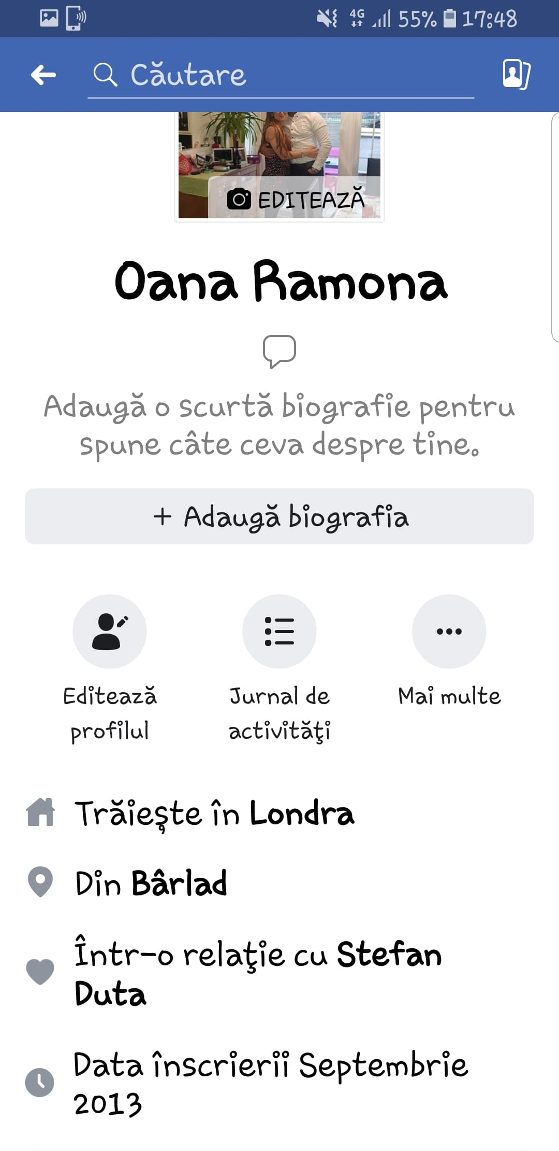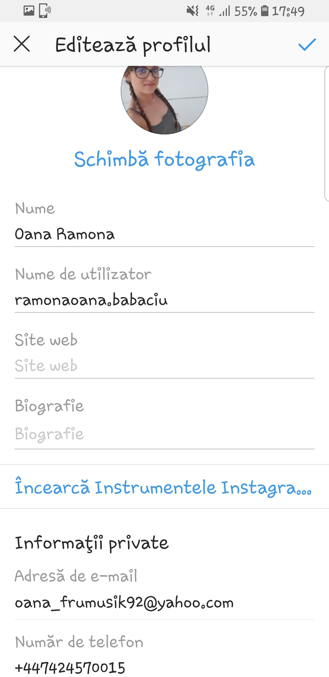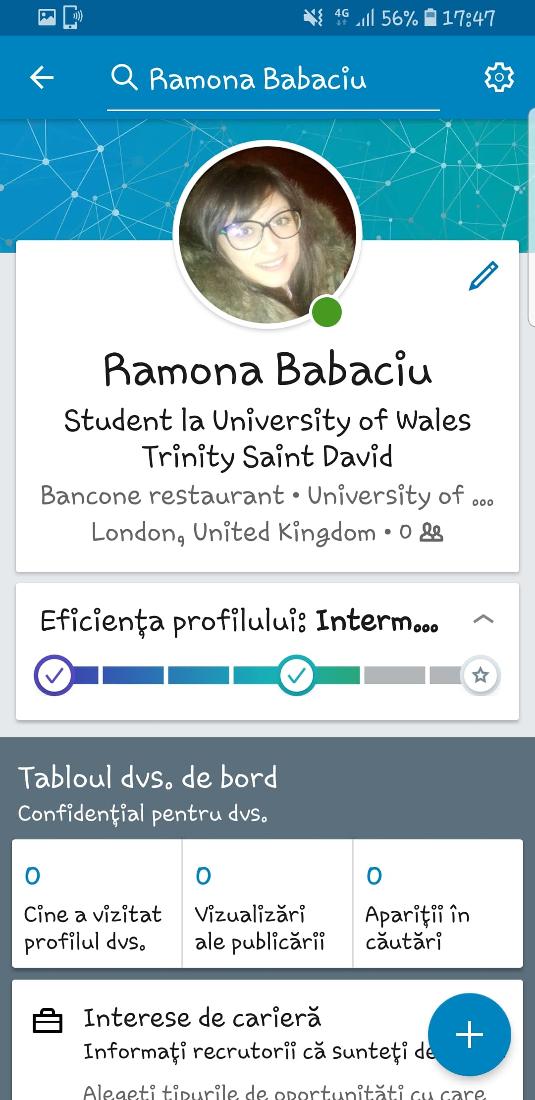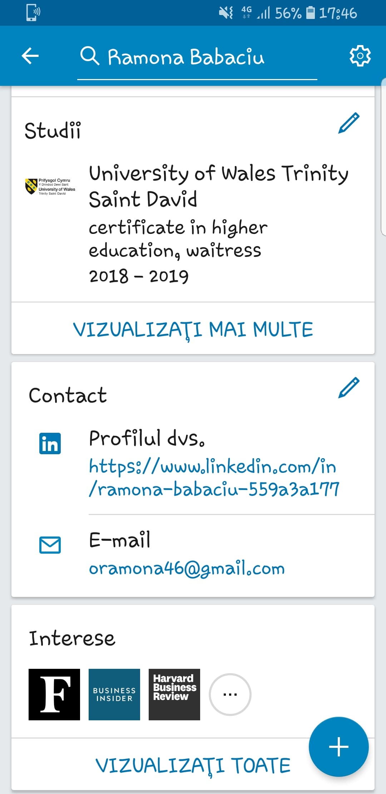

Appendix 1

Appendix 2

