Name: Emma Carrington

Student Number: 1910725

CIPD Membership Number: 55478700

Qualification: CIPD Diploma in Applied Human Resources (CIPDL5)

Module: Employee Engagement

On the Job Training Activity 1

Word Count: 770

By signing below, I confirm that the work/evidence presented is my own, unaided work. I understand the regulations pertaining to candidate malpractice and the action that may be taken as a result.

Signed: Emma Carrington

Date: October 2020

HEIW focus on employee experience which creates a holistic approach around engagement and wellbeing which enables employees to have a voice and be their best (CIPD, 2017; 2018; Peakon, 2020; Gallup, 2020; Mercer, 2019; People Insight, 2020; Sage, 2020). Culture is based on a strongly held and widely shared set of beliefs’ that are supported by strategy and culture (Wilkinson & Taylor, 2016; Bersin, 2015). This is reflected in the Communication and Engagement Strategy which is based on the organisation’s IMTP (business case), vision, purpose, strategic objectives, values and behaviours, plus feedback from staff and stakeholders. It recapitulates how HEIW communicate and engage effectively with staff, stakeholders and partners to build on existing and establish new working relationships, and outlines HEIWs approach to communications and engagement, and how this will align with the organisation’s vision, purpose, strategic objectives, values and behaviours (Taylor, 2016; CIPD, 2019; 2020 MacLeod and Clarke 2009, p33; Holbeche and Matthews (2012).
Through responsive communications and engagement HEIW supports the achievement of the organisation’s corporate objectives and is underpinned by the 10 pillars of EE (Shriar, 2015; Mansfield, 2018; Deloitte, 2015 ); by creating an inclusive and respectful working environment where staff are valued and informed, ensuring the workforce are confident to have a voice and share ideas in the knowledge this will inform organisational decisions (CIPD, 2020; Sharp, 2018; Engage for Success, 2020; ACAS 2016, 2020). Employees are encouraged and supported to build on existing and develop new effective working relationships with key stakeholders and partner organisations, understanding each other’s needs, and work together to build a sustainable and flexible health and care workforce in Wales (NLIAH, 2010; NHS Wales; Malhotra, G, 2006; Nuffield Trust, 2016; CIPD 2012).

HEIW recognise the importance of a bottom up leadership approach which encourages employees to have autonomy and respond to organisational and partner need, as top-down approaches do not benefit customer/stakeholder experience (Hutchinson & Purcell, 2003; Gallup Q12;SHRM, 2010).HEIW furthermore recognise the expertise of staff and celebrate their successes through raising profiles of both HEIW in Wales and further afield. HEIW promote awareness and understanding of the breadth of employees role including education and training, leadership, workforce planning and digitalisation whilst furthermore promoting, raising awareness of and increasing participation in HEIW educational and training services and programmes i.e. HEIW ensure that formal agreements and understandings underpin key partnerships. HEIW furthermore commit to visiting NHS sites across Wales as part of the HEIW Roadshow to meet and engage with students, trainees, trainers, mentors and those responsible for healthcare education (CIPD, 2019).

HEIW gather, share and act on best practice intelligence, evidence, feedback, lessons learnt and insights into the needs of patients, healthcare organisations and their workforces in all parts of Wales (CIPD, 2019;2020; Pezzo,2019; Peakon, 2020; Mercer, 2019).

HEIW recognise that stakeholders and partners vary depending on the nature of communication which is refined depending on the subject for communication or engagement (appendix 1):
A key priority for HEIW is understanding what stakeholders, partners and service-users require, and how the organisation can support them. To achieve this HEIW ensure they communicate with them all on a regular basis, through various channels. Stakeholders have been consulted and have informed HEIW of the preferred communication and engagement mechanisms (appendix 2) (CIPD, 2013; Silverman, 2014; Engage for Success, 2020).
HEIW ensure that CEO stakeholder bulletins are circulated on a regular basis to inform and update on progress. Staff open forums and communication updates via the intranet are shared with all employees (appendix 3).
Social Media is influential compared to traditional methods of engagement which offers organisational opportunity to gain insight in a more open and transparent manner (Silverman, 2014).
HEIW hold National Stakeholder Events and Working groups on key topics (e.g. workforce strategy) to inform and update everyone on future work. The Executive team and senior managers furthermore commit to attending and taking part in key mechanisms such as CEOs meetings, all peer group meetings, the Welsh Partnership Forum and maintain links to the Welsh Government Advisory Machinery. Additionally, HEIW continue to involve stakeholders and partners in development of the annual work programme/plan, using various engagement methods (HEIW, 2018; Electric, 2019).
HEIW ensure that formal agreements and understandings underpin key partnerships. HEIW furthermore commit to visiting NHS sites across Wales as part of the HEIW Roadshow to meet and engage with students, trainees, trainers, mentors and those responsible for healthcare education (Engage for Success, 2020).
HEIW advocate learning and development. Each directorate has a specific target to achieve within the IMTP. Managers are ultimately accountable for the team achieving these goals however, advocate enriching employees learning and development with a complete unit of work to become experts in their field which aid self-development (Herzberg, 1959, 1968; Pink, 2009; Keating, 2015).
HEIW constantly recognise the link between high engagement and high Performance (Towers Perrin, 2007 /8; Harter et al 2002; Saks, 2006).). Nevertheless, HEIW believe successful communication and engagement rely on everyone proactively taking part. On the one hand it is the responsibility of the message / information creator to ensure content is relevant and accessible to their audience. On the other hand, HEIW rely on the audience to proactively seek out information / messages and read them. The same applies when engaging, both parties must be proactive and participate. HEIW are therefore aware of the importance of engagement and understand the importance of being realistic when evaluating the communication and engagement tools. HEIW partake in the traditional NHS Wales national survey. Overall, the engagement index scores for NHS Wales improved from 3.43 in 2013, 3.65 in 2016 and 3.82 2018 (NHS Wales; Frampton, 2016) showing improvement in all three themes making up the score (appendix 4). However, there were some significant variances between the ten organisations in NHS Wales yet, all organisations saw an improvement in their overall score since 2013. A further staff survey is due to take place at the end of October 2020. However, HEIW constantly monitor and evaluate communications and engagement through real time surveys i.e. COVID-19 staff survey and use this information to inform appropriate developments and future improvements (Clearview, 2020; Frampton et al 2016; BMJ).

Engaged colleagues typically experience greater job satisfaction and greater wellbeing. HEIW’s sickness rate has improved since the start of the pandemic (2.1% compared with 4.1% of wider NHS Wales). Demonstrating engagement activities within HEIW are universally beneficial to an employee at work and the organisational brand (MacLeod, 2009, p6; Schaufeli et al 2008, 2010; Alfes et al, 2010). However, there may be a risk of presenteeism (Simpson, 2019; Hemp, 2004; Garrow, 2016; Baker, 2020; Briggs 2020). It’s therefore important HEIW maintain engagement activities (CIPD, 2014).

References
ACAS (2020) Building productivity: Employee voice. Available at: https://archive.acas.org.uk/index.aspx?articleid=5494 [accessed 01.09.20].
ACAS (2016) Employee voice is the key to better productivity. Available at: https://archive.acas.org.uk/index.aspx?articleid=5640 [accessed 01.09.20].
Alfes, K., Truss, C., Soane, E. C., Rees, C. I. and Gatenby, M. (2010) Creating an Engaged Workforce. London. Chartered Institute of Personnel and Development. [accessed 01.09.20].
Baker, L (2020) Why presenteeism is of extra concern during Covid-19 epidemic. Available at: https://employernews.co.uk/absence-management/presenteeism-covid-19/ [accessed 01.09.20].

Bursin, J (2015) Becoming irresistible: A new model for employee engagement Deloitte Review Issue 16. Available at: https://www2.deloitte.com/us/en/insights/deloitte-review/issue-16/employee-engagement-strategies .html [accessed 29.09.20].

Briggs, M (2020) Presenteeism. Through COVID & beyond. Available at: https://www.shoosmiths.co.uk/insights/articles/covid19/presenteeism-through-covid-and-beyond [accessed 13.10.20].
CIPD (2012) Managing for sustainable employee engagement. Available at: https://www.cipd.co.uk/knowledge/fundamentals/relations/engagement/management-guide [accessed 01.09.20].
CIPD (2013) Social media and employee voice. Available at: https://www.cipd.co.uk/knowledge/work/technology/employee-voice-report#_ga=2.55391912.2076890705.1602861887-129707373.1602000613 [accessed 01.09.20].
CIPD (2014) The future of engagement,: https://www.cipd.co.uk/knowledge/fundamentals/relations/engagement/future-report [accessed 01.09.20].
CIPD (2017) Developing managers for engagement and well-being. Available at: https://www.cipd.co.uk/knowledge/culture/well-being/developing-managers-report#_ga=2.154677947.2076890705.1602861887-129707373.1602000613
CIPD Professional Areas report. Available at: https://www.cipd.co.uk/learn/profession-map/2013-profession-map/professional-areas [accessed 01.09.20].
https://www.cipd.co.uk/Images/Employee-Engagement_tcm18-9655.pdf
CIPD (2018) Professional Map. Available at: https://peopleprofession.cipd.org/profession-map?gclid=EAIaIQobChMIwZrCj7i57AIVELh3Ch0MaAGDEAAYASAAEgLhBfD_BwE [accessed 01.09.20].
CIPD (2019) Employee engagement and motivation. Available at: https://www.cipd.co.uk/knowledge/fundamentals/relations/engagement/factsheet [accessed 01.09.20].
CIPD FACTSHEET (2020) Employee Voice. Available at: https://www.cipd.co.uk/knowledge/fundamentals/relations/communication/voice-factsheet [accessed 01.09.20].
CIPD (2020) Evidence-based practice for effective decision-making. Available at: https://www.cipd.co.uk/knowledge/strategy/analytics/evidence-based-practice-factsheet [accessed 01.09.20].
CIPD (2020) Best to good practice HR: developing the principles Available at: https://www.cipd.co.uk/knowledge/strategy/hr/good-practice-report [accessed 01.09.20].
Deloitte (2014) Big Demands and High expectations: The Deloitte Millennial Survey. London. Deloitte. Available at: http://www2.deloitte.com/al/en/pages/about-deloitte/articles/2014-millennial-survey-positive-impact.html [Accessed 06/03/20].

Deloitte (2019): The Deloitte Global Millennial Survey. Available at:
https://www2.deloitte.com/global/en/pages/about-deloitte/articles/millennialsurvey.html [Accessed 06/03/20].

Electric, S (2019) 4 Steps to Include Stakeholders on Your Sustainability Journey. Available at: https://gresb.com/4-steps-include-stakeholders-sustainability-journey/ [accessed 01.09.20].
Engage for Success (2020) Employee Voice. Available at: https://engageforsuccess.org/employee-voice [accessed 01.09.20].
Frampton, A., Fox, F., Hollowood, A., Northstone, K., Margelyte., Smith-Clark, S., Redwood, Sabi (2016) Using real-time, anonymous staff feedback to improve staff experience and engagement. BMJ. Vol 6, Issue 1. Available at: https://bmjopenquality.bmj.com/content/6/1/u220946.w7041 [accessed 25.08.20].

Garrow, V (2016) Presenteeism: A review of current thinking. Available at: https://www.employment-studies.co.uk/system/files/resources/files/507_0.pdf [accessed 26.08.20].

Gallup (2020) Employee Experience (2020) Available at: https://www.gallup.com/workplace/242252/employee-experience.aspx [accessed 20.08.20].
Gallup Q12: No. 1 employee engagement survey and all the strategic advice that goes with it. Available at: https://www.gallup.com/access/239210/employee-engagement-survey.aspx [accessed 20.08.20].
Gallup Q12: Fortune 500 Employee Engagement Tools for Your Size Company. Available at: https://q12.gallup.com/ [accessed 20.08.20].
Harter, J.K., Schmidt, F. L and Hayes, T. L. (2002) Business-unit level relationship between employee satisfaction, employee engagement and business outcomes: a meta-analysis. Journal of applied Psychology. Vol 87. Pp268-79.

Herzberg, F. (1968) One more time: how do you motivate your employees? Harvard Business Review. January-February. Pp109-120.

Hemp, P (2004) Presenteeism: At Work—But Out of It. Harvard Business Review. Available at: https://hbr.org/2004/10/presenteeism-at-work-but-out-of-it [accessed 22.08.20].

Hutchinson, S. and Purcell, J. (2003) Bringing policies to life: the vital role of front-line managers in people management. London: Chartered Institute of Personnel and Development.

Holbeche, L. and Matthews, G. (2012) Engaged: Unleashing your Organisation’s potential through employee engagement. Chichester: Wiley/Josey Bass.

Macleod, D. and Clarke, N. (2009) Engage for Success: enhancing performance through employee engagement. A report to government. London: Department for Business, Innovation and Skills.

Malhotra, G (2006) Grow your own creating the conditions for sustainable
workforce development Kings Fund. Available at: https://www.kingsfund.org.uk/sites/default/files/field/field_publication_file/grow-your-own-creating-conditions-sustainable-workforce-development-gita-malhotra-kings-fund-3-august-2006.pdf [accessed 01.09.20].
Mansfield, T (2018) The 10 Pillars Of Employee Engagement. Zest. Available at: https://zestmeup.com/blog/the-10-pillars-of-employee-engagement/ [accessed 01.09.20].
Mercer (2019) Building a better employee experience. Available at: https://www.mercer.com/our-thinking/career/voice-on-talent/building-a-better-employee-experience.html [accessed 01.09.20].
Nuffield Trust (2016) Creating a sustainable workforce: The long-term sustainability of the NHS. Available at: https://www.nuffieldtrust.org.uk/resource/creating-a-sustainable-workforce [accessed 01.09.20].
NLIAH (NHS Wales). Available at: http://www.wales.nhs.uk/sitesplus/documents/1002/Flexible%20%20Sustainable%20Workforce.pdf [accessed 01.09.20].
Peakon (2020) The Four Phases of Employee Experience. Available at: https://peakon.com/resources/library/the-four-phases-of-employee-experience/ [accessed 22.09.20].
Pezzo, E (2019) 7 Tips to Maximize the New Employee Experience. HR Daily Advisor. Available at: https://hrdailyadvisor.blr.com/2019/02/19/7-tips-to-maximize-the-new-employee-experience/ [accessed 22.09.20].
People Insight (2020) Employee Experience vs Employee Engagement: What’s the Difference? Available at: https://peopleinsight.co.uk/employee-experience-vs-engagement/ [accessed 01.09.20].
Pink, D (2009). TED Global. The Puzzle of Motivation Available at https://www.ted.com/talks/dan_pink_the_puzzle_of_motivation [Accessed 5 August, 2020]

Sage (2020) The importance of employee experiences in HR tech selection. Available at:https://www.sagepeople.com/Ventana2020-employee-experience/?gclid=EAIaIQobChMIoszD0bO57AIVS9iyCh2cMwr9EAMYAiAAEgJcMPD_BwE[accessed 21.09.20].
Saks, A.M (2006) The antecedents and consequences of employee engagement. Journal of Managerial Psychology. Vol 21, No 7. PP600-19.
Schaufeli, W.B. and Bakker, A. B. (2010) The conceptualization and measurement of work engagement. In Bakker, W.B.and Leiter, M.P. (eds). Work engagement: a handbook of essential theory and research. New York: Psychology Press.
Schaufeli, W.B., Taris, T. W. and Van Rhenen, W, (2008) Alcoholism, burnout and engagement: three of a kind or three different kinds of employee wellbeing. Applied Psychology. An International Review. Vol 57. Pp173-203.
Sharp, R (2018) Breaking the silence: Employee voice. Available at: https://www.hrmagazine.co.uk/article-details/breaking-the-silence-employee-voice[accessed 20.09.20].
SHRM (2010) The Gallup Q12 Employee Engagement Questionnaire. Available at: https://www.shrm.org/hr-today/news/hr-magazine/pages/0510fox3.aspx [accessed 01.09.20].
Silverman, D. (2014) The Future of Engagement. Research Report. CIPD. Available at: www.cipd.co.uk/hr-resources/research/future-engagement.aspx [accessed 10.08.20].

Simpson, E (2019) The rise of 'presenteeism' in the workplace. BBC News. Available at: https://www.bbc.co.uk/news/business-47911210 [accessed 20.09.20].
Taylor, S. (2016) Improving Organisational Performance in Taylor and Woodham (2nd Edition) Studying Human Resource Management. London: CIPD.

Towers Perrin (2009) Global Workforce study 2007/2009: closing the engagement gap- a road map for driving superior business performance. London. Towers Watson.

Appendix 1
• HEIW workforce
• Health and care students and trainees including nurses, medics, allied health professionals,
healthcare support workers, pharmacists
• Service users – including trainees and students
• Health and care workforce - current and future
• Education providers including Universities, trainers and mentors
• Health Boards and Trusts
• Professional bodies
• Regulators
• Trade Unions
• Social Care Wales
• Welsh Government
• Partnership boards
• Academi Wales
• Media – specialist publications and main stream media
• Patients / carers
• Public
• Third sector
• Career organisations
• Schools

Appendix 2
Communication | Engagement
  Open
  Transparent
  Inclusive
  Not divided (e.g. into clinical and non-clinical)
  Clear
  Positive
  Dynamic and proactive
  Consistent
  Inspired
  Exciting
  Influence
  Collaborative
  Innovative/encouraging
  Representative
  Giving feedback/results
  Responsive to audiences
  Stakeholder mapping to inform framework
  Different levels of relationship and priorities
  Managing expectations
  Listening
  Two-way
  Appropriate messages for specific audiences

Appendix 3
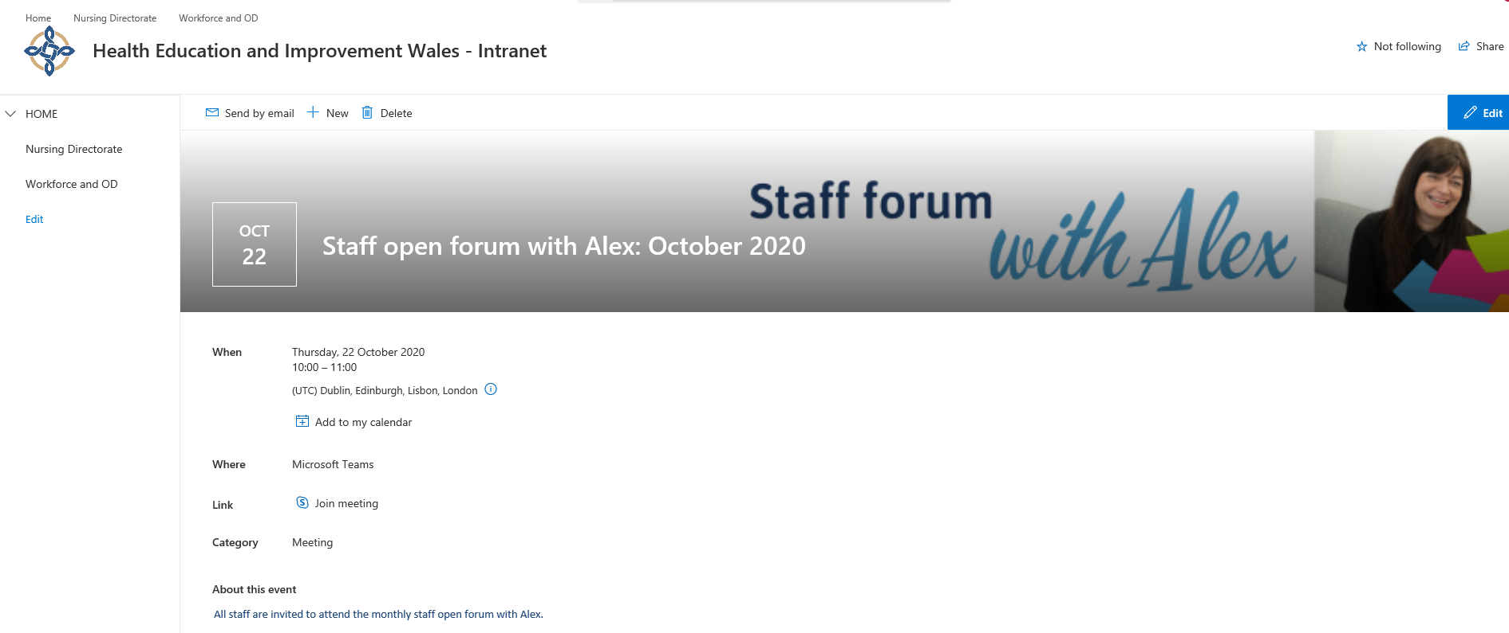

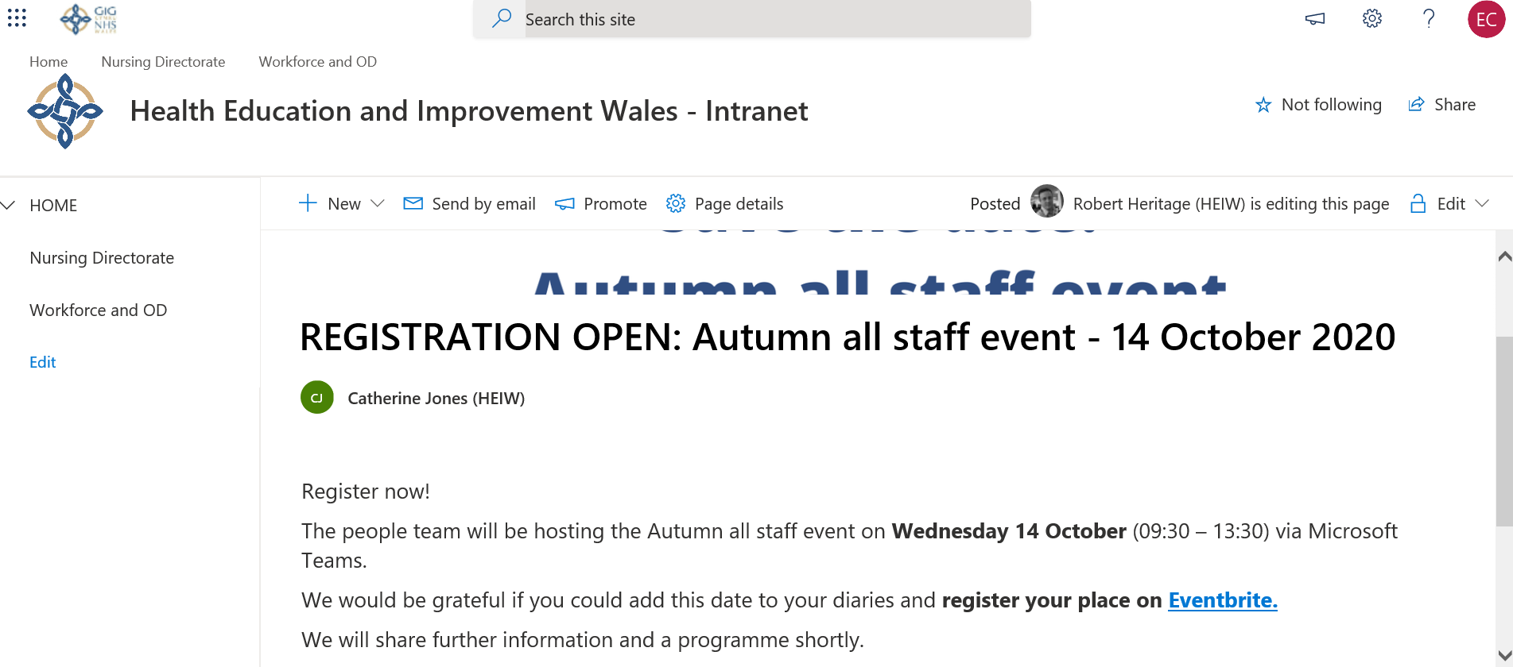

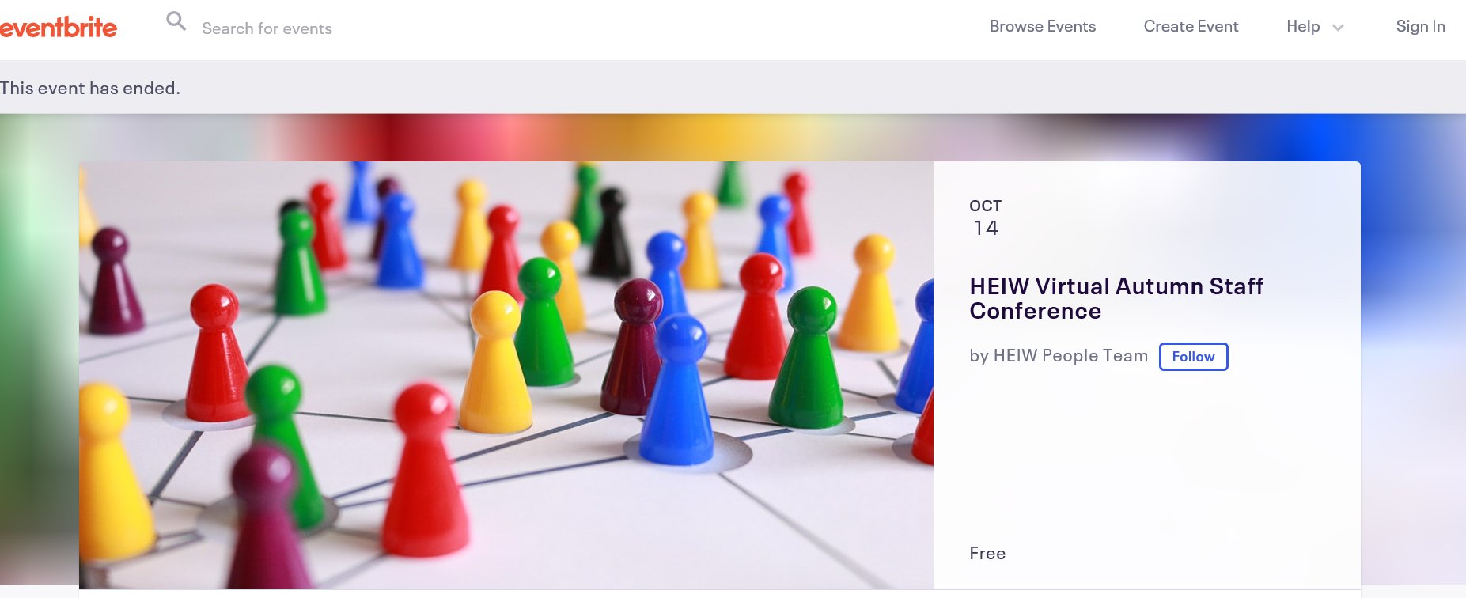

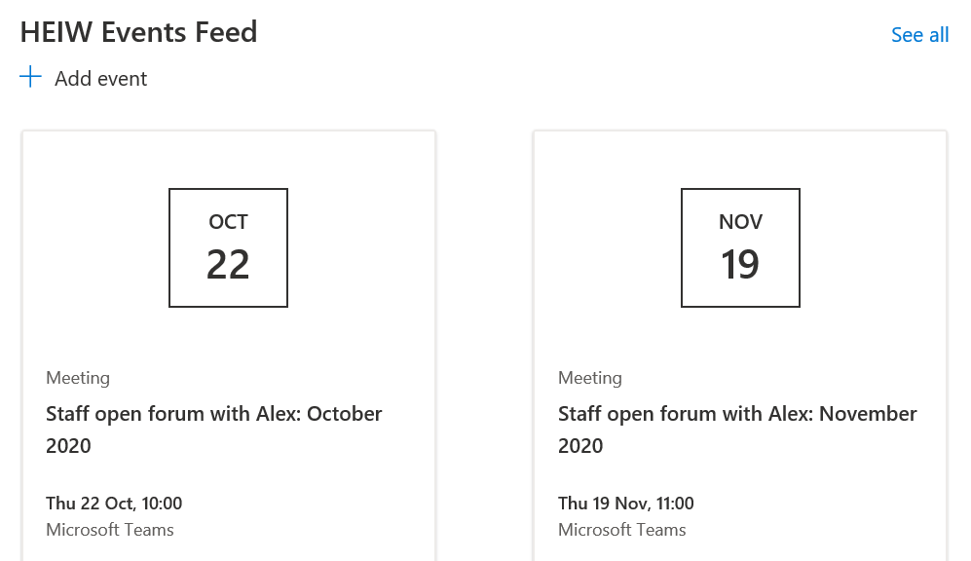

Appendix 4
NHS Wales Engagement Index
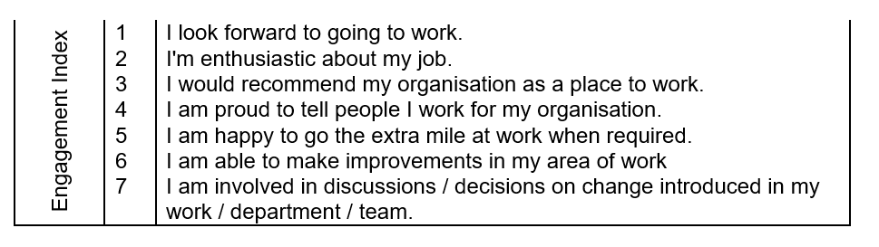

Name: Emma Carrington

Student Number: 1910725

CIPD Membership Number: 55478700

Qualification: CIPD Diploma in Applied Human Resources (CIPDL5)

Module: Employee Engagement

On the Job Training Activity 2

Word Count: 500

By signing below, I confirm that the work/evidence presented is my own, unaided work. I understand the regulations pertaining to candidate malpractice and the action that may be taken as a result.

Signed: Emma Carrington

Date: October 2020

A communication bulletin is a powerful communication tool, when properly designed. Employee newsletters are crucial to measuring EE so areas of organisational improvement can be pinpointed and building a consistent and trusted voice within an organisation such as HEIW. A communication bulletin is an opportunity to keep everyone in sync, and to keep employee engagement. According to Retrospectively, Inc., employee productivity increases anywhere from 20-25% when employees feel connected to the company. However, only 13% of employees reported participating in their intranet daily 31% said they never do (Smith, 2020)

Healthy communication lines between management and staff and within the departments in the organisation are crucial to the success of every organisation. Within HEIW an organisational internal newsletter supports the achievement of this goal. The well-designed updates help improve the performance of the workforce as it keeps employees informed regarding on the organisations policies, activities, services, social events, and other company news.
The content of each HEIW Communication update encompasses HEIWs valued and behaviours which is reflected in each internal newsletter; Respect for all: in every contact we have with others; Together as a team: we will work with colleagues across NHS Wales and with partner organisations; Ideas that improve: harnessing creativity, and continuously innovating and evaluating (HEIW, 2018). It engages with colleagues at all levels and acknowledges the current pandemic along with the impact of lockdown on employees. They aim to get everyone in sync with the organisations top messages so that they can communicate and increase reach across NHS Wales.
It recognises the current situation, and communicates the importance of employees looking after their Health and Wellbeing and others (West 2012, 2018; McDonald et al 2005; CIPD 2016, 2020; NHS Workforce Trends 2017, 2019; Mercer, 2016; NBT, 2020; Rees et al, 2013; CIPD, 2017; Public Health Wales, 2020). The bulletin also acknowledges the impact of working from home and reassures employees regarding the opening of the building, which employees valued before local lockdown (Staglin, 2020; Mental Health.org, 2020;Nuffield Health, 2020)
The tone of the communication helps to build trust as readers can identify with the CEOs personality. The tone also develops a consistent tone of voice across all stakeholder connections to HEIWs brand, including all social media channels, which makes them seem genuine and employees and stakeholders feel at ease (CIPD, 2020; Whitehouse, 2018; Imperial College London, 2020).
HEIW’s communication updates incorporates employee recognition section, which is inclusive and open to all employees i.e. recognition of work achieved and an engaging warm welcome to new employees, with a reference to their name and new job role which makes them feel valued. It also acknowledges and thanks those employees departing from the organisation (Wright, 2018; Sivasubramaniam, 2019; SHRM, 2020).
Health and Safety (i.e. flue vaccination) (HSE, 2020) and learning and development (Herzberg, 1959, 1968; Pink, 2009; Keating, 2015) updates are also incorporated, which demonstrates employees’ views are considered and acted on.
Executive updates allow employees to feel connected to the organisation, especially during the pandemic. CEO Bulletins are also circulated monthly and since the start of the start of the pandemic a monthly COVID-19 update has been circulated to employees to ensure employees feel connected and they are informed of development i.e. working from home etc.
HEIW have developed communications updates which include:

- Regular updates from senior leaders to reinforce the importance of staff wellbeing during these difficult times along with the provision of a free NHS COVID-19 platform which includes free advice and services;
- Business updates and changes in policy e.g. changes in financial or IT policies to reflect new working practises;
- Regular updates on the support available from managers, staff networks, HR, EAPs and other external providers.

HEIW encourage employee feedback and embed employee voice within communications methods for obtaining feedback via (CIPD, 2013; Silverman, 2014; Engage for Success, 2020):
- Online communication tools such as Microsoft Teams
- A dedicated email address with a mailbox for employees to send any questions or concerns
- An already established staff forum or newly set-up forum which represents employee voice during the current situation;
- Digital area such as a staff intranet.

References
CIPD (2020) House Style. Available at: https://www.cipd.co.uk/house-style [ Accessed 10/10/ 20]

CIPD (2020) Employee Communication. Available at: https://www.cipd.co.uk/knowledge/fundamentals/relations/communication/factsheet [Accessed 09/10/ 20]

CIPD (2016) Employee Outlook: Employees views on working lives. Available at:
https://www.cipd.co.uk/Images/employee-outlook-focus-on-skills-and-careers_tcm18-10995.pdf [Accessed 10/10/ 20]

CIPD (2016) How should we respond to the gig economy? Available at:
https://www.cipd.co.uk/news-views/cipd-voice/issue-6/gig-economy-response[Accessed 08/10/ 20]

CIPD (2016) Moving the employee agenda forward. Available at:
https://www.cipd.co.uk/Images/moving-employee-well-being-agenda-forward_2016_tcm18-15556.pdf [ Accessed 07/10/ 20]

Engage for Success (2020) Employee Voice. Available at: https://engageforsuccess.org/employee-voice [ Accessed 10/09/ 20]

Herzberg, F. (1968) One more time: how do you motivate your employees? Harvard Business Review. January-February. Pp109-120.

HEIW (2018) Values and behaviours. Available at: https://heiw.nhs.wales/about-us1/values-and-behaviours/ [ Accessed 20/09/ 20]

HSE (2020) Coronavirus (COVID-19): working Safelyhttps://www.hse.gov.uk/coronavirus/index.htm?utm_source=hse.gov.uk&utm_medium=refferal&utm_campaign=coronavirus&utm_term=banner-2&utm_content=home-page-banner [ Accessed 21/09/ 20]

Imperial College London (2020) Tone of voice guidance for internal communications. Available at: https://www.imperial.ac.uk/brand-style-guide/writing/tone-of-voice-guidance/ [ Accessed 10/10/ 20]

Mental Health.org (2020) Looking after your mental health while working during coronavirus. Available at: https://www.mentalhealth.org.uk/coronavirus/looking-after-your-mental-health-while-working-during-coronavirus[ Accessed 21/09/ 20]

NHS Wales’ Workforce Trends Report. Available at:
https://weds.heiw.wales/assets/Uploads/a8c0b0c31d/NHS-Wales-Workforce-Trends-as-at-31-March-2017-v2.pdf [Accessed 21/09/ 20].

Public Health Wales (2020) COVID-19. Available at: https://phw.nhs.wales/topics/latest-information-on-novel-coronavirus-covid-19/ [ Accessed 23/09/ 20]
SHRM (2020) Managing Employee Recognition Programs. Available at: https://www.shrm.org/resourcesandtools/tools-and-samples/toolkits/pages/employeerecognitionprograms.aspx [ Accessed 23/09/ 20]
Sivasubramaniam, K (2019) EXCLUSIVE: Boost employee engagement through recognition. Employee Benefits. Available at: https://employeebenefits.co.uk/boost-employee-engagement-recognition/ [ Accessed 24/09/ 20]
Silverman, D. (2014) The Future of Engagement. Research Report. CIPD. Available at: www.cipd.co.uk/hr-resources/research/future-engagement.aspx[ Accessed 21/09/ 20]

Smith (2020) Why Your Organization Needs an Internal Newsletter. Meltwater. Available at: https://www.meltwater.com/en/blog/11-reasons-your-organization-needs-an-internal-newsletter [ Accessed 25/09/ 20]
Staglin, G (2020) When Home Becomes the Workplace: Mental Health And Remote Work. Forbes. Available at: https://www.forbes.com/sites/onemind/2020/03/17/when-home-becomes-the-workplace-mental-health-and-remote-work/ [ Accessed 24/09/ 20]

West, M. A. Dawson, J.F. (2012) Employee Engagement and NHS performance: Lancaster University & University of Sheffield. The Kings Fund. Available at:
https://www.kingsfund.org.uk/sites/default/files/employee-engagement-nhs-performance-west-dawson-leadership-review2012-paper.pdf [ Accessed 21/09/ 20] ].

West, M. A. Dawson, J.F. (2018) “Employee engagement, sickness absence and agency spend in NHS trusts”. The King’s Fund. Available at: https://www.england.nhs.uk/wp-content/uploads/2018/03/wres-engagement-absence-agency-spend.pdf [Accessed 25/09/ 20].

Whitehouse, E (2018) How to be a better communicator. People Management. Available at: https://www.peoplemanagement.co.uk/long-reads/articles/how-better-communicator [ Accessed 21/09/ 20]
Wright (2018) How to use recognition to boost employee engagement. Available at: https://www.sagepeople.com/about-us/news-hub/how-to-use-employee-recognition-to-drive-engagement/ [ Accessed 21/09/ 20]
Nuffield Health (2020) Working from home taking its toll on the mental health & relationships of the nation. Available at: https://www.nuffieldhealth.com/article/working-from-home-taking-its-toll-on-the-mental-health-relationships-of-the-nation
Pink, D (2009). TED Global. The Puzzle of Motivation Available at https://www.ted.com/talks/dan_pink_the_puzzle_of_motivation [Accessed 5 August, 2020]

Name: Emma Carrington

Student Number: 1910725

CIPD Membership Number: 55478700

Qualification: CIPD Diploma in Applied Human Resources (CIPDL5)

Module: Employee Engagement

On the Job Training Activity 3

Word Count: 300

By signing below, I confirm that the work/evidence presented is my own, unaided work. I understand the regulations pertaining to candidate malpractice and the action that may be taken as a result.

Signed: Emma Carrington

Date: October 2020

Purpose

The CIPD Professional Map aims to add sustained value to an organisation (CIPD 2009, 2012). On Monday 28/09/20 I met with my line manager to discuss my Employee Engagement development needs. We used the CIPD Profession Map as a basis for our discussion.
We discussed my development needs in relation to EE within my current role and linked them to HEIW 3-year Integrated Medium Long-Term Plan (IMTP) through Identifying organisational and individual capability requirements and aligning strategy, people and processes to optimise effectiveness and achieve the organisational goals.

Employee Engagement
I need to continue demonstrating that I am working to strengthen the connection that all employees have with their work, colleagues and to their organisations so that employees are more fulfilled by their work and make greater contribution towards organisational objectives: give attention to good leaderships and management.
Develop employee relations strategy, policy and practice
I intend to spend time with the people team to assess my level of awareness, understanding and interpretation of current policies i.e. the development and consultation of the People and OD strategy and the Mental Health Policy. I intend to apply this learning within the development of the planned HEIW Health and Wellbeing Strategy.
Embed employee relations strategy, policy and practice
I will use my professional network to provide opportunities to discuss specific employee relations issues and the full range of strategies and solutions available within HEIW. I have been asked to represent HEIW on the National Health and Wellbeing Group.
Research and Measure employee engagement.
As a member of the Employee Assistance Programme task and finish group I intend to undertake further benchmarking exercises to of Health Boards/Trusts in NHS Wales and the intervention and prevention services they provide to their employees.
I will increase my employer brand knowledge by linking with HEIWs expanding talent Management team to gain knowledge and experience in HEIWs employer brand. I intend to study its direction, development process and track its effectiveness in attracting and retaining key talent
It is my intention to attend external networking events and workshops including those organised by my local CIPD Branch as well as Employment Law updates and learning seminars. I will prioritise those run for my industry / sector and area of interest.
Role Model Behaviour
To build knowledge, experience, confidence and self-review processes I intend to link with a mentor and coach.
I am currently working proficiently between a Band 1 & 2 within Health Education and Improvement Wales (HEIW) however, I would like to work proficiently at Band 2 at the end of this course in May 2021. In order to reach this aspiration, I need to increase and widen my HR knowledge experience by obtaining management experience individually or within a HR team, linking it to HR strategy and policies.
I will build on my current knowledge and skills and continue to use the professional map as a developmental self-assessment tool whilst undertaking this course and during by future career within HR. The map has helped me to recognise my professional areas for development and allow me to plan my own learning. I plan to continuously undertake and seek new learning opportunities and assess my level of knowledge in relation to practices and behaviours that will make me more effective within my role. I will always adhere to the CIPD Codes of Practice and work ethically.
I will continue to use the 2013 Professional Map in conjunction with the 2015 map to keep up with my professional development. If HR professional develop these skills and demonstrate that they can apply their understanding of an organisations business and context, they will have the ability to meet organisational need tailor its current and future strategies (Perkins et al 2016; CIPD, 2019).

Appendix 1 - Employee Engagement
Assessment Summary
“When you work in Employee Engagement, I’m working to strengthen the connection that all employees feel with their work, their colleagues and with the organisation, increasing the level of contribution they make by improving the fulfilment they get from their work. At my level the assessment indicates that I typically need to gather and analyse engagement data from employee surveys and other data sources. From this, will be able to create reports and presentations on engagement levels, and will support the rollout of engagement initiatives. My role will allow me to also be involved in developing communications around brand, values and behaviours”.

How prepared am I?

The assessment indicates that my knowledge and skills in this area are meeting expectations. This would be typical of someone who has strong experience in HR and Employee Engagement at this level.

Within this area I have demonstrated areas where I’m particularly strong, areas where I’m competent and areas where I have skill and knowledge gaps. To increase my knowledge and improve your skills in Employee Engagement, I need to consider the courses, reading materials and practical development actions, such as attending an employee engagement course, read literature on employee engagement. My assessment score suggests that I may be ready to assess myself against the next level up, or in a different area of HR however, In order to be able to work at the next level up within Employee Engagement, I typically need to help the organisation research and identify the key drivers for employee engagement and support the implementation of engagement plans at a local level. I intend to work with managers and their staff to improve engagement by enabling employees to increase their contribution to the organisation to build my development within employee engagement.

My strengths
- Administering the roll out of regular employee engagement initiatives

Where I am competent
- Assisting in designing and conducting surveys and other employee research
- Collating data regarding employee engagement from a variety of sources (such as employee surveys, benchmarking data, focus groups etc)
- Analysing employee engagement data using a variety of techniques
- Designing and developing reports and presentations to feedback employee engagement data
- Encouraging employees to get involved in resolving engagement issues
- The main factors which influence people’s behaviour at work
- Different research methods
Evidence and areas for development
Activity | Evidence (how I demonstrate this) | Area for Development
Research and Measure employee engagement.  Activity | As an official member of the HEIW Health and Wellbeing Network my role requires me to research and reviewing health and wellbeing initiatives – the success of which has resulted in the partnership with external providers of financial support services counselling support services for staff.  I was involved in the HEIW Health Needs Assessment where employee engagement was key. I undertook research in readiness and held an employee focus groups to ensure employee engagement. All the results were analysed and as an outcome my research project for this course will be focused on work life balance.  As a member of the Employee Assistance Programme (EAP) task and finish group I was involved in a benchmarking exercise of Health Boards/Trusts in NHS Wales and the intervention and prevention services they provide to their employees. The task and finish discussed the relevance of the services  Evidence (how I demonstrated this) | - Look back on previous benchmarking exercises and outcomes and consider how the organisation can improve its engagement research.  Area for Development
Research and Measure employee engagement. | to HEIW and themed them into 5 groups;  Health Promotion, People Team, Health and Wellbeing, Employee Assistance Programme and Education and Development.
Develop employee engagement proposals and plans. | The EAP Task and Finish Group all met on 24th October 2019, to compare the outcomes of the benchmarking exercise and literature review against ‘A Buyer's Guide to Employee Assistance Programmes, published by UL EAPA, 2019’, and developed a proposal table. | - During my development I will experiment with a variety of formats and styles to present and report employee engagement results and seek feedback on which is the most clear and impactful.  - I intend to build relationships with consultancies that specialise in employee engagement. Discuss case studies and strategies that have been developed to drive greater engagement within HEIW.
Embedded employee interventions | I have research and reviewed and promoted health and wellbeing initiatives that embed employee engagement within HEIW such as, EAP, HNA, Staff Survey, Corporate Health Standards (CHS) and Mindful Menopause sessions with an Occupational Therapist within HEIW.  I currently provide updates reports to the Senior Leadership Team (SLT). | - I would like to develop processes to generate ideas and solutions to address issues identified in employee engagement surveys an encourage participation from a broad cross-section of the organisation.
Employer brand  Activity | Ensure that HEIW colleagues are always living our values and promote and encourage our values.  Evidence (how I demonstrated this) | - I will increase my employer brand knowledge by Identifying and study high-profile case studies of organisations that have successfully developed an employer brand that has transformed their ability to attract and retain talent and discuss with my manager.  - Area for Development
- Become an expert in my organisations employer brand. I will link with HEIWs talent Management team to gain knowledge and experience in HEIWs employer brand; I intend to study its direction, development process and track its effectiveness in attracting and retaining key talent.

- Increase my confidence in the advice that I am providing to stakeholders, manager and employees.
Knowledge | Use the HEIW values to influence behaviour and promote initiatives.  Build relationships and trust with employees so they can come to me living the values.  Stay professional at all times and be a role model. | I will research and deepen my understanding of HEIWs values and behaviours so that I can work with managers and employees in adhering to them.  I intend to study Employee Engagement case studies to learn how different drivers of engagement apply in different organisations and by different groups of employees.

