HNC Plant operations and Performance
Plant flow diagrams and PID’s

HNC Plant operations and Performance

Plant flow diagrams and PID’s
Hand out date: 1st November 2019
Submission Date : 24th January 2020
Contents
Plant flow diagrams and PID’s 1
My Chosen Plant: BOS Plant 1
Natural Gas System 3
COSHH - The Control of Substances Hazardous to Health. 4
COMAH – The Control of Major Accident Hazards 5
Conclusion 5
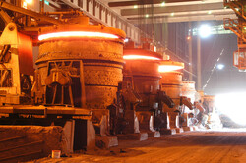
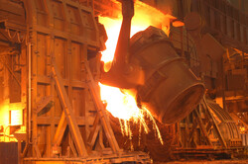

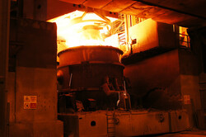
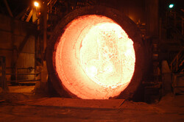

My Chosen Plant: BOS Plant
I work in the BOS plant of TATA Steel ( Basic Oxygen Engineering) this is where molten iron is delivered to the plant via torpedoes and made into steel through a large amount of processes, to carry out these processes lots of gas, air electricity and water is needed. A part of Steel and Slab is the Concast this is where the molten steel is casted into long metal blocks this is a heavy and intensive process and lots of liquids and gasses are needed to carry it out. The product is then transferred onto the hot mill for rolling.
Equipment
Here is the diagram showing the natural gas flow under and into the casters and local area. In this process lots of service requirements are needed.
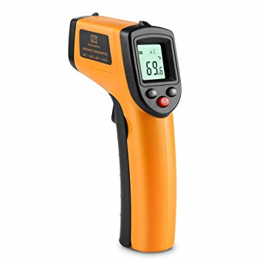
Forms of thermometers are used to check the temperature of the steel and maintain a constant state. They are also used to check the temperature of other products such as gasses and water. This is to insure that no parts of the plant are over or under heating, if they are this causes issues. An example is when the slabs of steel are cut if the water in the jets are no the correct temperature they will not cut the steel effectively.
Contactless temperature measurement on metal surfaces, Optris.co.uk, https://www.optris.co.uk/temperature-measurement-metal 1

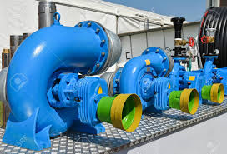
Water pumps are used to pump water around the plant this is done on a massive scale and is heavily monitored due to the risks that are made when water is close to molten metal. We used the pumps a lot on my site due to the need of water to supply 3 water treatments areas

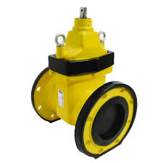
Valves are used to constrict and dilate flow to the needed area for example if too much water was being pumped into the sprayers a valve would be closed to stop or restrict the flow. Pressure gages are used on these valves to maintain the correct pressure if the pressure is incorrect a system alert will occur

Types of Industrial Valves - Applications, Advantages, and Disadvantages | Plant Automation Technology, Plantautomation-technology.com, https://www.plantautomation-technology.com/articles/types-of-industrial-valves-applications-advantages-and-disadvantages 2

Natural Gas System
This is flow chart it also shows areas where other gasses join the system such as nitrogen, this does not harm the system due to nitrogen being a neutral gas, the flow chart also shows who is responsible for the gas this is because different parts of the plant are reasonable for different gas points. This makes it easy to control the gas throughout the plant and to identify where problems went wrong the key also shows what each symbol means this makes it easy to identify what gate is used to stop or restrict the flow or what is being measured at that point.
An example of a process flow is close to the caster 3 area. Nitrogen is added to the gas before entering the caster, there is a manual operated gate valve at the caster to stop or restrict the gas flow going into the caster, the gas is needed in the caster to aid with the casting process. Any unused gas will go to the gas flares this is the flare stack that you see which has the flame. The gas is burned off at this process. Before entering the flare stack another manually operated gate valve is used to stop flow if it is unneeded. There is also a natural gas transmitter at this point this is used to detect toxic gases we do this because we do not want toxic gasses being released into the atmosphere.
When starting the company I found it hard to understand the flow diagrams, my colleges pointed out all the helpful information the diagram gives such as keys and area information. each section of the chart has a Section ladled by letter, there is a description of that area to help you understand the area. Even though this flow chart shows a map of natural gas flow under steel and slab different sections have different plant areas in charge such as SWEB, energy and BOS plant these are all colour coded in a key to help you understand the responsibility. For example the ladles need to be as dry as possible to transport molten iron because water and iron do not mix well, the natural gas (nitrogen), goes through a multitude of valves and filtering system before getting to the driers this is to insure the flow is safe and the gas is filtered correctly, this area of natural gas is owned by the BOS plant and highlighted green on the flow chart. The torpedoes also need to be dry to move molten iron from the blast furnace to the BOS plant, much like the lades the torpedoes need to go through a drying process to insure they are fit for purpose the only difference is that this area is owned by SWEB so any incidence that occur is there responsibility.
Wells, DW. 1995 Schematic of natural gas system. 1st edition. Port Talbot: British Steel 3

COSHH - The Control of Substances Hazardous to Health.
Where I work there are lots of substances that fall under the COSHH regulations, at TATA steel we do everything we can to control these substances. We deal with lots of hazardous chemicals and material. We do the most we can to protect staff from these substances. For example there are parts of old builds that have asbestos imbedded in the walls. If asbestos is found it is dealt with in the most professional manor. The building will be air sealed. And only professions or trained personnel will enter the building it will then be checked over to insure the building is safe to use. In the BOS there are hundreds of tons of molten metal being carried around at one time this is a huge substances that is hazardous to health, TATA put many preciouses into place so that all employees are safe and do not get close to the molten metal.
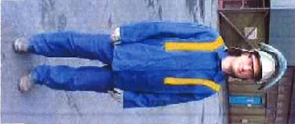
Incise of an emergency such as lose of containment all employees are protected with specialised PPE (personal protective equipment). This consists of fire resistance material covering you from head to toe. This is used to insure all employees are safe from these types of substances. This is the PPE that we use at Steel and Slab
Everyone who starts to work for the business will also be assigned a COSSH awareness course, this is a day course where you will become more aware of the hazards around you. There are also articles and booklets to access 24/7 regarding COSHH.
On site we have chemical labs which is where a lot of substances hazardous to health are held. All chemicals held in the lab stick to the COSHH regulation. All chemicals have the correct labels and information that follows. Everyone who deals with them chemical are trained to do so. This insure all users are competent to work in this area, all employees are also made to wear the correct ppe to protect them from negative exposure.
Johns, SJ, 2013, 5nd edn, London, Health & Safety Executive. 4

COMAH – The Control of Major Accident Hazards
TATA Steel strip products is a COHAM tier one site meaning that the sight is a very dangerous site to those who are not trained or warned on the events in the plant.
A good example on how we control these hazards is the way we report them, we have a near miss system which is accessible for all tata employees, in these system any issues on plant are recorded and acted upon, they are ranked in a high medium low risk, some high risk issues are put forward into an investigation, this is where the problem is raised with heads of departments and are strategies o overcome this problem are discussed. And acted upon.
If we do have a major accident on site a MI is launched this is major investigation, root causes analysis is done in these meetings and a method to over come the issue in implemented. An example of this is the hook spotting project, we had a large loss of containment due to the hooks not properly being engaged, the ladle slipped off the hook and molten iron was spilt on the floor, no one was injured but this could of resulted in a fatality if someone was in the wrong area. The method that was put in place was to have someone physically check that the hooks were engaged this has resulted in no issues in the last 6 months.
Being a COMAH tier one TATA have to abide by rules set by the HSE to keep all employees and contractors safe. When starting work for TATA steel you will have to complete E learning on COMAH this informs you of what it is and what it involves. By completing this you will be more aware of the dangers on site and how to deal with them.
To prevent accidents occurring we have a well-used near miss system. This allows all employees of TATA steel to report an accident or a problem this can then be acted upon and amended. This makes the site a safer place for all workers. Near miss report are not reports where someone has been injured but reports where someone could be injured. This system prevent future injuries happening.
HSE Books, 2015, 3rd edn, London, Health & Safety Executive. 5

Conclusion
In the TATA Steel Bos Plant there are lots of areas which require mass amounts of gas, water and other substances. These are all controlled by pipeline systems which run through and under the plant, all areas have relevant safety precious’s put in place in case of accidents. The pipeline are controlled by various valves which are suited to the area. Attached to all gas or liquid systems we have the correct safety equipment’s to insure the system is running correctly, we do this through thermometers and pressure gages, if one of these precious are wrong an alert is raised and dealt with as quickly and professionally as possible. We abide by all COSHH and COMAH regulations to insure are plant in safe for all employees and contractors. We have strong reporting systems that help us be more aware of the issues on plant and these issues are raised and dealt with in an professional manor. This helps us reduce the amount of accident that occur and make TATA Steel Strip products a safer place.
Refences
Source | In text (rewriting the topic) | Owner | Reference number
Website | Forms of thermometers are used to check the temperature of the steel and maintain a constant state. | Optris | 1
Website | Valves are used to constrict and dilate flow to the needed area | Plantautomation | 2
Flow Diagram | This is flow chart it also shows areas where other gasses join the system such as nitrogen | TATA Steel | 3
Regulation Report | Where I work there are lots of substances that fall under the COSHH regulations | HSE | 4
Regulation Report | TATA Steel strip products is a COHAM tier one site meaning that the sight is a very dangerous site to those who are not trained or warned on the events in the plant. | HSE | 5

