Programme Name: BA (Hons) Leadership and Management Skills in the Workplace
Module Name (and Part if applicable): Project Management
(LCLM5003)
Assessment Title: A Project Portfolio – Parts A, B and C
Student Name: Sinde Franklin Woppiwo
Student Number: 2414246
Tutor / Module Leaders: Samson Oladejo and Dr Xavier Matieni
Word Count: 3670

Table of Contents
PART A: Project Proposal Poster 3
PART B: Critical Reflection on Tutor and Peer Feedback 6
Strengths retained 7
Areas for improvement 7
How the feedback informed Part C 7
Part C: Project Management Plan: Redevelopment of the Central Transport Hub 9
1. Introduction 10
2. Project description 10
3. Scope 12
4. Work breakdown structure 12
5. Quad chart 13
6. Gantt chart and time plan 14
7. Stakeholder involvement 15
8. Allocation of resources, cost and funding 16
9. Risk analysis 18
10. Conclusion 21
References 22

PART A: Project Proposal Poster

Redevelopment of the Central Transport Hub
Part A Project Proposal Poster | LCLM5003 Project Management | Topic 1 | Student Name: Sefat Franklin
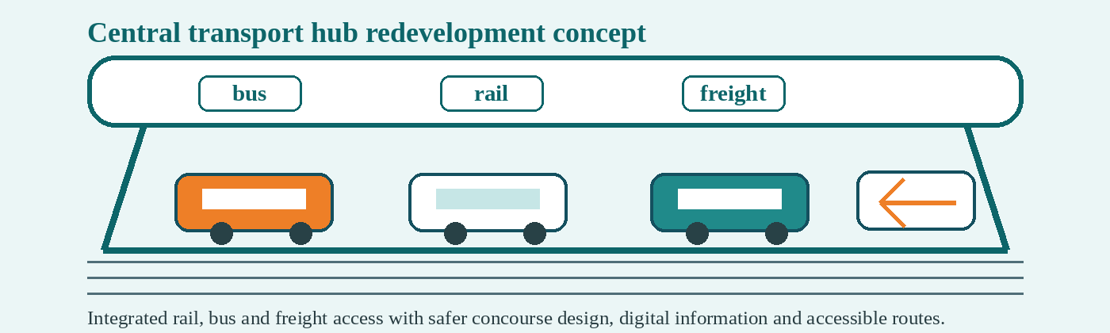  Figure 1: Central transport hub redevelopment concept.  Source: Author. | 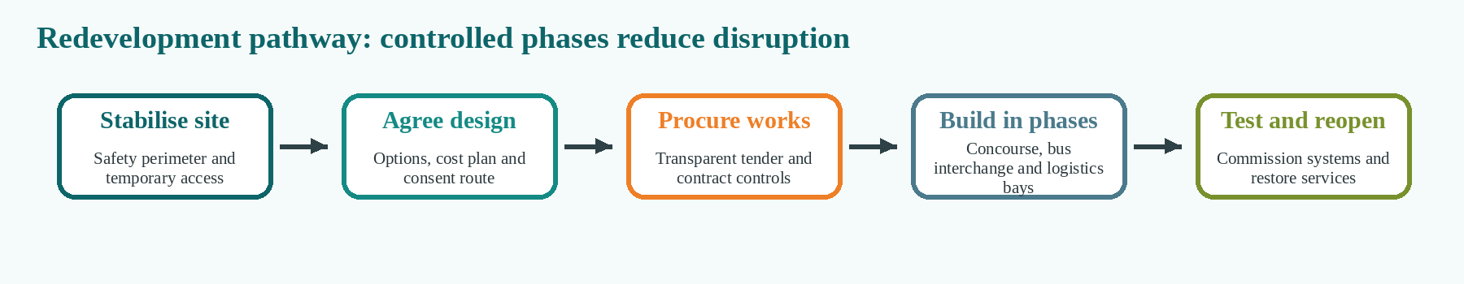  Figure 2: Redevelopment pathway.  Source: Author.
1. Project background and rationale  The project is a solution to the need to close a 40-year-old metro transport hub that is no longer safe and accessible. The former hub was a railway, bus and freight exchange and closure has resulted in delays to commuters, strain on supply chains, business losses and loss of public confidence. A temporary or digital-only solution is chosen because it would alleviate symptoms, but not resolve the unsafe asset condition and is therefore not the preferred solution. The scope, interfaces, stakeholder expectations and risk controls have to be defined early in the proposal, as the hub is a complex public infrastructure project (PMI, 2021; Kerzner, 2022).  2. Project aim and objectives  Aim: to reopen a safe, accessible, digitally coordinated and lower-carbon central transport hub that restores transport capacity and supports long-term social and economic value.  • Completed concept design, consents, procurement and phased construction/commissioning within 30 months.  • Restore interchange capacity for rail, bus and freight operations to at least pre-closure levels with temporary continuity for passengers.  • Ensure safety, fire, accessibility and inclusive design requirements are met, via early assurance reviews.  • Ensure that real-time passenger information, CCTV, wayfinding and freight coordination information are integrated at handover.  • Minimize carbon footprint during operations by utilizing efficient systems, active travel connections and responsible material selection.  3. Scope and boundaries  Agreed deliverables and exclusions limit scope in infrastructure megaprojects as scope that is not clearly defined can cause increase in costs (He et al., 2015).  Table 1: Scope and boundaries.  Source: Author  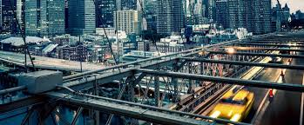 |  | 4. Key stakeholders  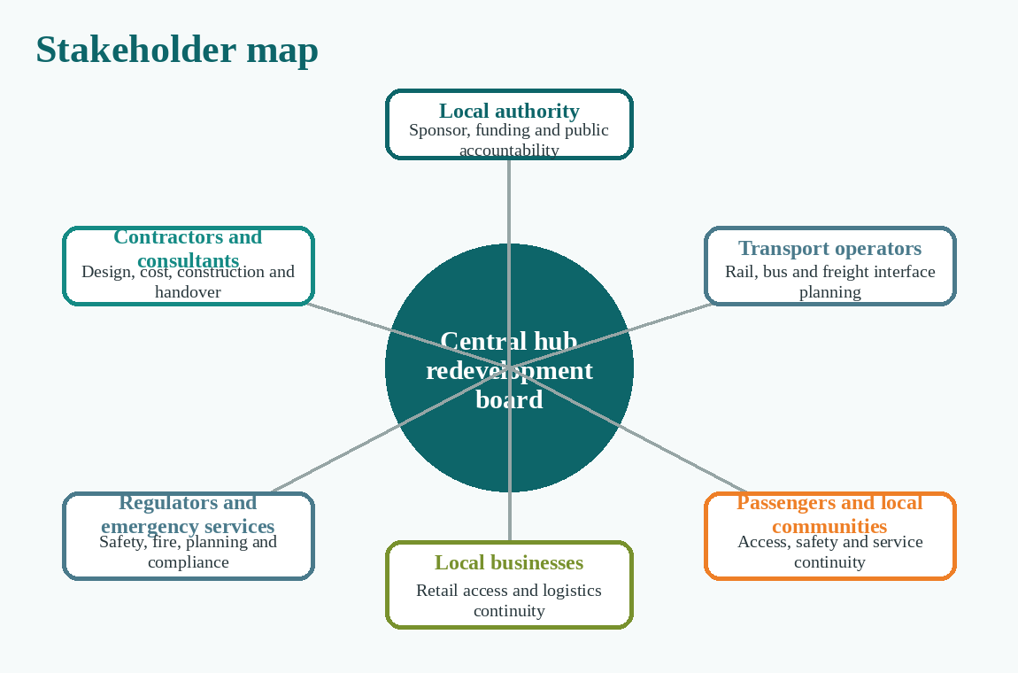  Figure 3: Key stakeholders.  Source: Author.  Local authority is the sponsor and client. Key stakeholders include transport operators, passengers, disabled-user-groups, businesses, logistics companies, safety regulators, emergency services, contractors and consultants. Stakeholder management has to be an ongoing process as competing claims, approvals and public acceptability will impact on the performance of the megaproject (Mok, Shen and Yang, 2015). Engagement will be achieved via a monthly project board, public accessibility forum, operator interface meetings, business liaison group and frequent disruption notices.  5. High-level risks and trade-offs  Table 2: Risk and trade-off overview.  Source: Author. | The trade-off that's crucial is speed versus assurance. A fast rebuild could achieve the restoration of capacity earlier, but poor design review or a lack of scrutiny in procurement could lead to higher legal, safety and cost risk. Therefore, it is important to have transparent reporting, independent review and clear decision records as public controls (Locatelli et al., 2017).  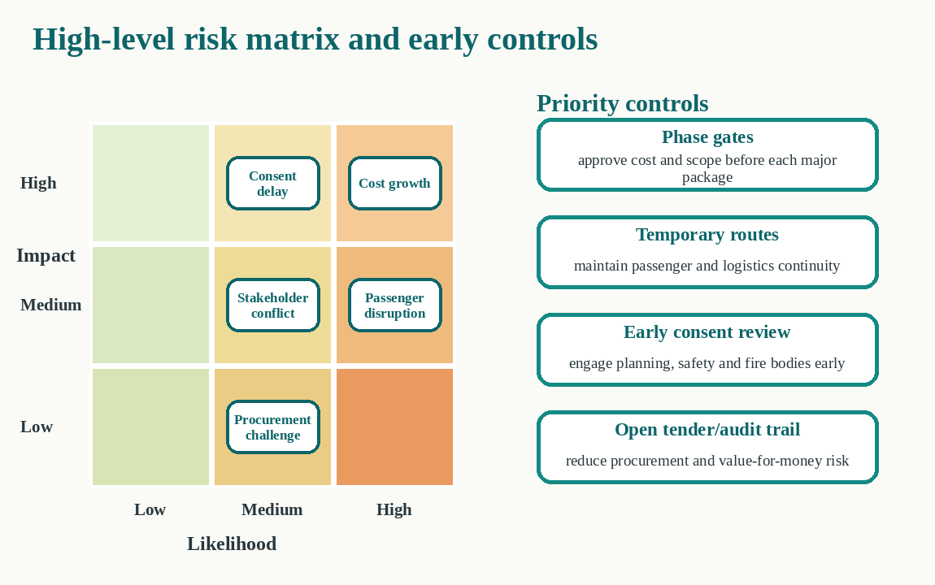  Figure 4: High-level risk matrix and controls.  Source: Author.  6. Strategic value of the project  The strategic value is highest as redevelopment addresses the asset failure and safeguards future mobility. The project revitalizes the city's primary interchange, enhances safety for passengers, ensures reliability for freight and provides a viable recovery plan for local businesses. Lower carbon operations, and accessible urban design and digital coordination also provide a long-term value. Success will be assessed by the positive outcomes of safe handover, re-opened capacity, satisfaction of stakeholders, budget management, reduced disruption complaints and the achievement of agreed accessibility and environmental targets.  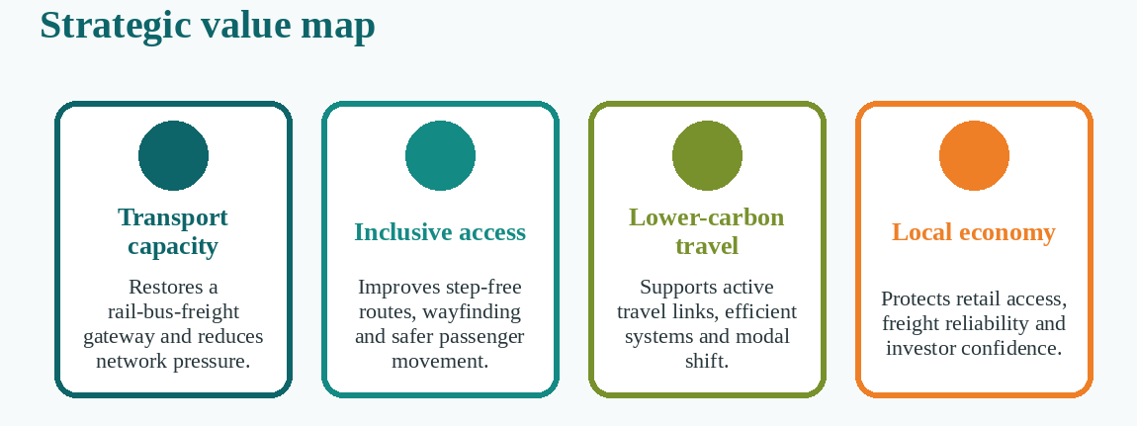  Figure 5: Strategic value map.  Source: Author.
  In scope | Out of scope
  Site stabilisation; demolition; concourse; bus interchange; freight access; utilities; digital systems; testing and handover. | City-wide rail upgrades; private commercial redevelopment beyond agreed retail units; long-term timetable reform; housing renewal.
  Boundary: restores the hub and immediate access routes. | Boundary: wider regeneration remains separate.
  Risk | Control | Trade-off
  Cost growth | Phase gates, cost plan, change control | Some features deferred
  Passenger disruption | Temporary routes, night works, logistics plan | Higher enabling cost
  Consent delay | Early regulator and fire review | More design iterations
  Stakeholder conflict | Consultation and benefits map | Slower decisions
  Procurement challenge | Open tender and audit trails | More assurance time

He, Q., Luo, L., Hu, Y. and Chan, A.P.C. (2015) ‘Measuring the complexity of mega construction projects in China: A fuzzy analytic network process analysis’, International Journal of Project Management, 33(3), pp. 549–563. Available at: https://doi.org/10.1016/j.ijproman.2014.07.009.  Kerzner, H. (2022) Project management: A systems approach to planning, scheduling, and controlling. 13th edn. Hoboken, NJ: Wiley. | Locatelli, G., Mariani, G., Sainati, T. and Greco, M. (2017) ‘Corruption in public projects and megaprojects: There is an elephant in the room!’, International Journal of Project Management, 35(3), pp. 252–268. Available at: https://doi.org/10.1016/j.ijproman.2016.09.010.  Mok, K.Y., Shen, G.Q. and Yang, J. (2015) ‘Stakeholder management studies in mega construction projects: A review and future directions’, International Journal of Project Management, 33(2), pp. 446–457. Available at: https://doi.org/10.1016/j.ijproman.2014.08.007. | Project Management Institute (2021) A guide to the project management body of knowledge (PMBOK Guide). 7th edn. Newtown Square, PA: Project Management Institute.

PART B: Critical Reflection on Tutor and Peer Feedback

Strengths retained
The comments on the Poster for Part A were constructive and actionable. It requested the total project cost, a breakdown of the costs, their proposed sources of funding, their SMART objectives, a Gantt chart and further clarity on the timing of the redevelopment. The comments did not question the selected option, the rationale for the rebuilding of the hub, the scope, the stakeholder map, the risk and trade-off discussion nor the strategic value map. This indicates that the problem statement and the suggested solution was clearly expressed. The poster also presented a logical redevelopment pathway and the presentation of the complex infrastructure proposal, using visual material to make it accessible to non-specialist stakeholders. These are significant assets as reflection needs to recognise what works and what does not (Bassot, 2016).

Areas for improvement
The main problem was the poster did not make sufficient demonstration that the project was financially and time wise deliverable and was a strategic pitch level. The project was time-bound with the goal to finish the project in 30 months, while other objectives were not necessarily specific and measurable. For instance, the goal to "restore capacity" and "minimise carbon" did not specify capacity or a baseline or performance threshold. There was also no budget or funding plan that was quantified, this hindered stakeholders from making judgements on affordability, value for money and exposure to cost escalation. This is important as early cost estimates are prone to scope problems, optimism bias, and/or political pressures in major transport projects (Flyvbjerg, 2021; Chen et al., 2023). The poster also did not include the major phases, even though the duration was shown, there was no indication of the over-lap, dependency or decision gates. As a result, the 30 month guarantee couldn't be evaluated against a realistic delivery order.

How the feedback informed Part C
The original goals are thus translated into the six SMART goals in the final project management plan. These include reopening by Month 30, restoring at least 100% of pre-closure peak capacity, ensuring full safety and accessibility compliance, the project's expenditure to be capped at an indicative £650 million approved budget, and the project's forecast operational carbon to be reduced by at least 30% compared to the pre-closure baseline of the former hub. The plan also clarifies that the targets will be based on surveys and concept designs and are not considered facts until these are completed.
The financial section now includes an indicative breakdown of the cost at 2026 price levels including a 15% risk and inflation allowance as well as a proposed funding mix of central government, local authority, transport operators, green infrastructure funds and commercial contributions. This is based on the approach of evidence-based, transparent and progressively assured (Infrastructure and Projects Authority, 2021) estimates of infrastructure.
Last, but not least, a detailed 30-month Gantt chart, Milestone Gates and a Work Breakdown Structure have been added. Physical works are tested in a controlled predictive sequence and passenger-information and logistics systems are tested through iterative testing. This hybrid approach is an answer to the different degrees of uncertainty in the project (Gemino et al., 2021). Overall, the feedback has transformed the proposal from a good idea to a more responsible and actionable program with identified dependencies and controls, and measurable outcomes.

Part C: Project Management Plan: Redevelopment of the Central Transport Hub

1. Introduction
The central transport hub has been closed, eliminating a key hub for the rail, bus and freight transport system, which has caused safety, mobility and economic challenges. Full redevelopment is the preferred solution as temporary and digital solutions would just cover up the failure of the asset. The project is considered as a multifaceted public infrastructure project with several technical interfaces, regulatory interdependencies and conflicting priorities from the stakeholders. The more complex the knowledge and the less coordinated, the more time and money will be spent, while resulting in delay (Bjorvatn and Wald, 2018; Denicol et al., 2020). This plan therefore will incorporate scope, schedule and cost, stakeholder, resource and risk controls. The planning basis is that the school will open in September 2026 and re-open in stages in February 2029. All figures are indicative as there is no site survey, design, demand and tender data provided in the scenario and will be validated at the first gates of the project.

2. Project description
The project will involve stabilisation and clearance of the existing site, temporary passenger facilities and logistics, a new concourse and modal interfaces, and the upgrading of utilities and installation of safety, accessibility and digital systems. It's not just about the finished building; it's about the business result. Restored capacity, safe and inclusive mobility, resilient freight connectivity, reduced whole-life environmental impacts and re-gained business and passenger confidence are all part of the recipe for success.
Decision is made to use a hybrid delivery model.A hybrid delivery model is decided. The lifecycle for civil, structural and safety-critical works is a predictive stage-gate process due to the strong dependencies between design assurance, statutory consent, procurement and construction. Short iterative cycle of operator / user testing for digital passenger information, CCTV integration, wayfinding and freight coordination. There is evidence that hybrid models can help maintain schedule and budget control and deliver better stakeholder results, but require good interface control (Gemino et al., 2021). Governance is sponsor-led with a project board, a Senior Responsible Owner, an integrated project management office and independent technical, commercial and safety assurance, in line with professional guidance on governance and accountability for the lifecycle of projects (Association for Project Management, 2019; PMI, 2021). Decision gates are at the business case approval, design freeze, contract award, commissioning readiness and final handover. This helps to hold people accountable and prevents the optimism and escalation bias that is often found in large-scale projects (Flyvbjerg, 2021) and uniqueness bias that is often found in small-scale projects.
The quality management is not only checked at the end, but also integrated. Design reviews assess the constructability, accessibility, fire strategy, maintainability and whole-life carbon of the design prior to design freeze. Contractors then execute to the approved inspection and test plan, noting any non-conformance in the common data environment and closing the non-conformance prior to the payment milestones. Benefits are given to operational owners prior to handover. At opening, 6 months and twelve months capacity, reliability, user satisfaction, complaints are measured, and carbon indicators and local-business indicators are measured at 6 months and twelve months. This avoids a very narrow view of success, which is limited to the time, cost and scope of the investment, and keeps focus on the public value created, which was the reason for investing.
The original poster aims have been converted to SMART objectives in Table 3. Baselines for capacity and carbon will be determined in Months 1-4 and may only be changed following documented impact assessment and project board approval.
ID | SMART objective | Measure / acceptance evidence
O1 | Reopen the hub by Month 30 (February 2029). | Safety certificate, operational readiness and phased opening completed.
O2 | Restore at least 100% of pre-closure peak rail, bus and freight interchange capacity by handover. | Capacity model and 30-day operational trial.
O3 | Achieve full applicable safety, fire and accessibility compliance with zero unresolved category-A defects. | Independent assurance and regulator sign-off.
O4 | Commission passenger information, CCTV, wayfinding and freight coordination by Month 27 with at least 99.5% availability during a 30-day trial. | System availability and user-acceptance records.
O5 | Deliver within the £650 million approved baseline and keep unapproved schedule or cost variance within 5%. | Monthly earned-value and forecast-at-completion reports.
O6 | Reduce forecast operational carbon by at least 30% against the former hub baseline and divert at least 90% of construction waste from landfill. | Whole-life carbon model and verified waste data.
Table 3: SMART project objectives
Source: Author

3. Scope
The scope baseline includes the central hub and access routes to this area. In-scope deliverables include: structural stabilisation, demolition and remediation, temporary passenger and freight arrangements, a new concourse, rail, bus and freight interfaces, utilities and building services, fire and security systems, step-free routes, accessible toilets, tactile navigation and inclusive wayfinding, passenger information, CCTV, and logistics coordination systems, public-realm connections, testing, training and handover. Out of scope work is outside of the scope of the agreement, for example city-wide rail enhancements, long term timetable reform, housing renewal and commercial development outside agreed retail units (Gemino et al., 2021).
To be accepted, the design certificates must be approved, inspection and test plans must be completed, all category-A defects must be resolved, the accessibility must be signed off, emergency exercises must be successful and a 30-day operational trial must have been completed. The constraints are the need for continued service continuity, limited urban space, live utilities, rail possessions, regulatory approvals and a funding limit of £650m. The key assumptions are: when the land is available, no significant contamination present other than what is allowed, and the operators participation and funding approvals at each gate.
The baseline is safeguarded by a formal change-control process. All requests are recorded, vetted for necessity and cost, time, carbon, safety, benefits and stakeholder impact. Any changes within delegated tolerance will be approved by the Change Control Board, larger changes will be referred back to the project board and funders. This is because scope ambiguity will create scope complexity and scope exposure (He et al., 2015; ISO, 2020).

4. Work breakdown structure
The work breakdown structure breaks down the end product into smaller and more manageable work packages, which are also accountable. There are six control accounts, as illustrated in Figure 6, which are governance and assurance, design and approvals, temporary operations and enabling works, core construction, systems and digital integration and commissioning and benefits transition. Each package is owned by a name, has a budget, activities that need to be scheduled, acceptance criteria and risk allocation. The WBS is used for estimating, procurement, and responsibility assignment and earned value reporting, but it doesn't contain sequence. Dependencies are then passed on to the integrated Gantt baseline. The decomposition is deliverable oriented to minimize duplication of effort, and to track changes from the approved scope to a specific control account (PMI, 2021; ISO, 2018).
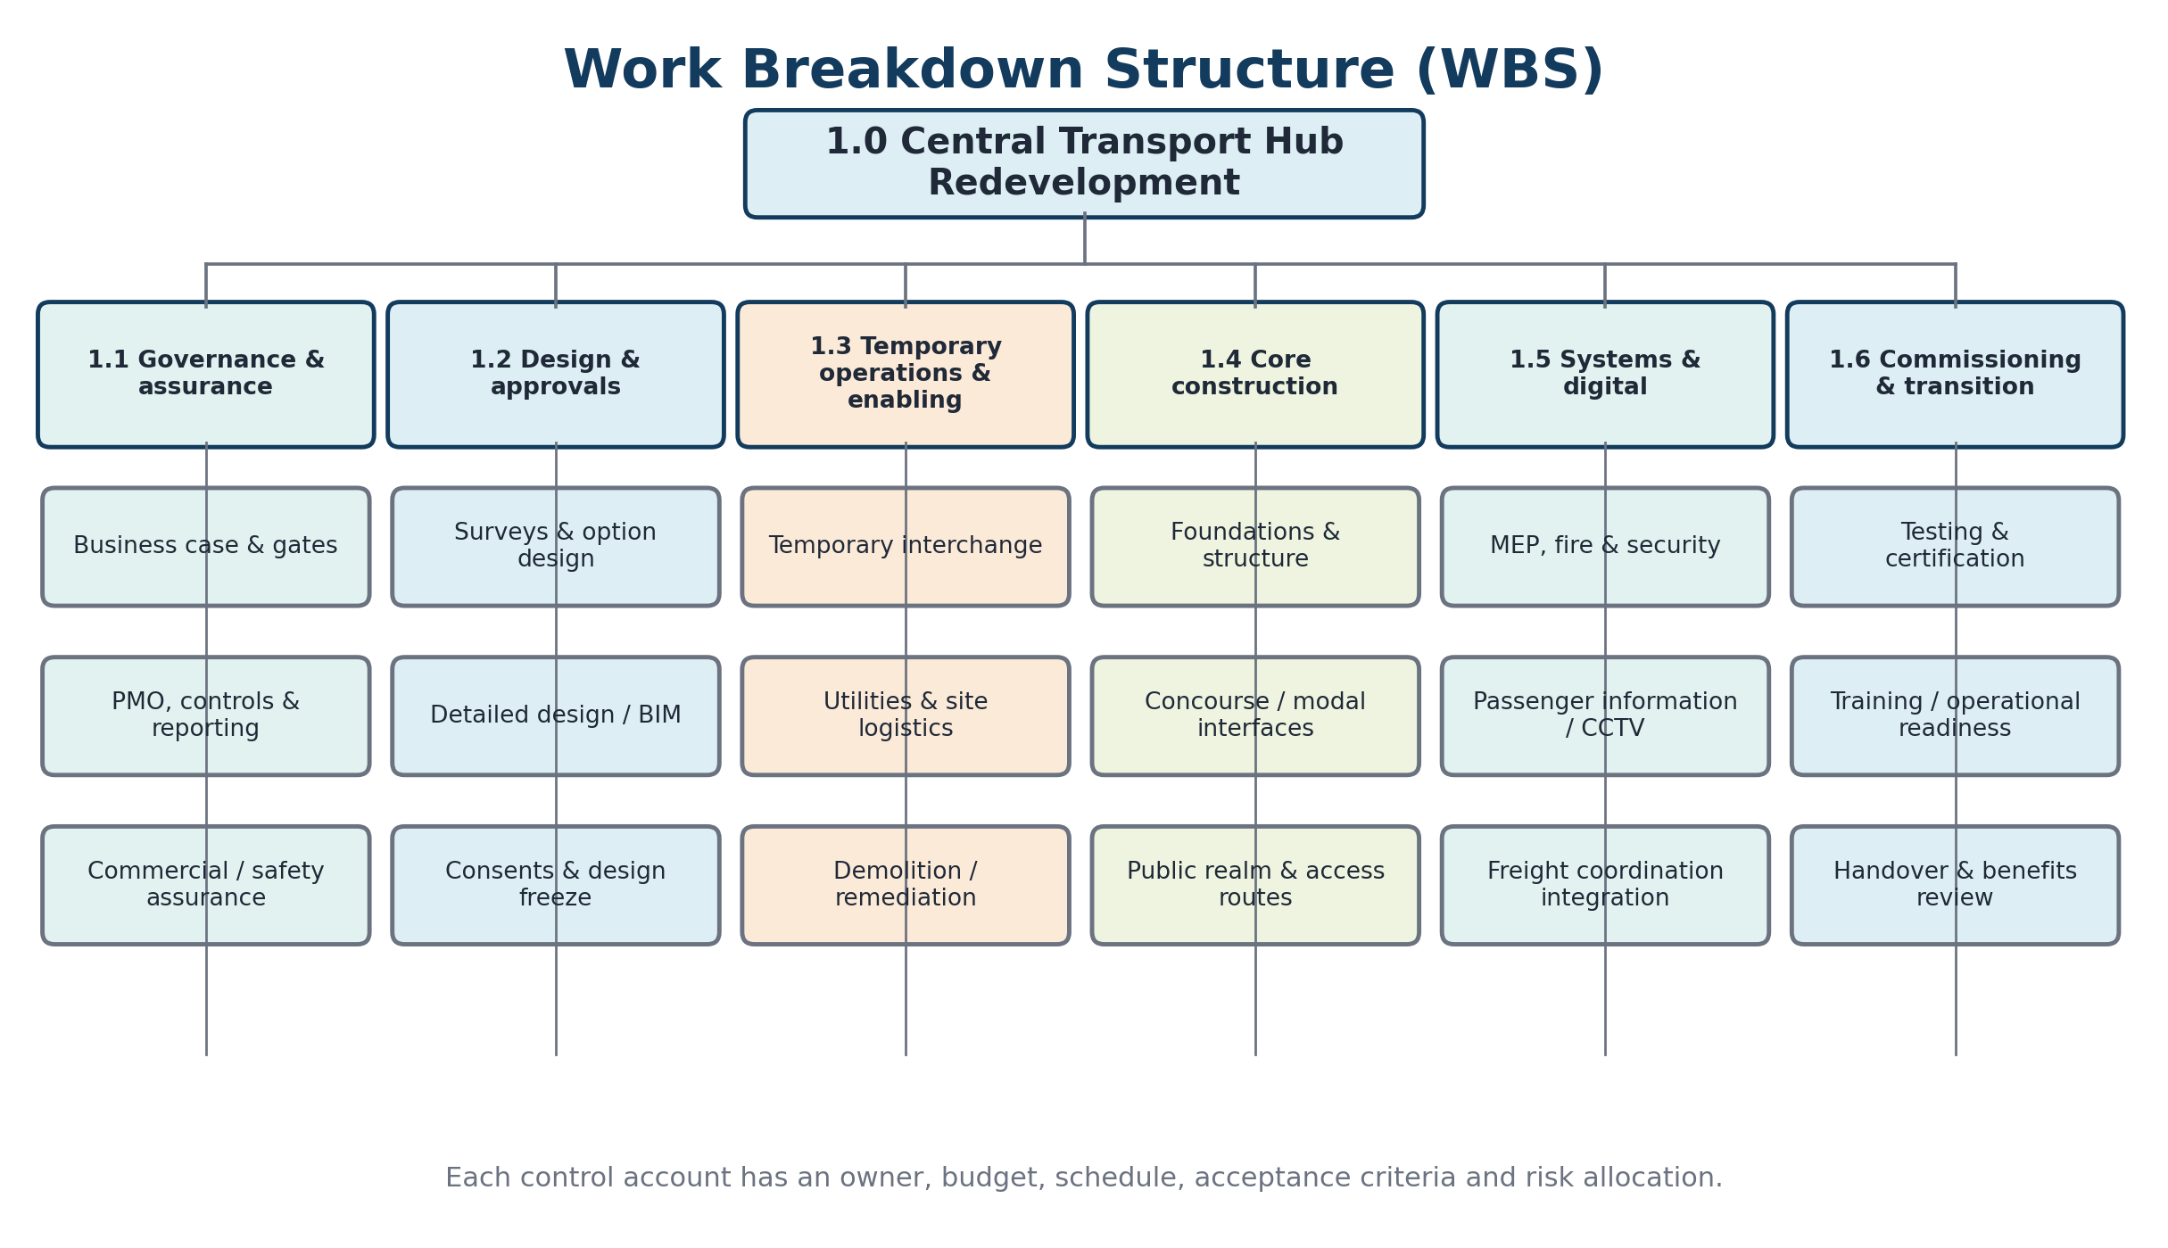
Figure 6: Work breakdown structure for the redevelopment project.
Source: Author.

5. Quad chart
The one page executive view of purpose, deliverables, schedule, cost, governance and the key risks is illustrated in Figure 7. The quad chart is provided at project-board meetings at monthly intervals to keep decisionmakers up to date on the project without having to read through individual technical reports. It is limited in compression: new problems are suppressed by summary indicators. The chart will then be connected to the real-time schedule, cost report, risk register and decision log of the project management office.
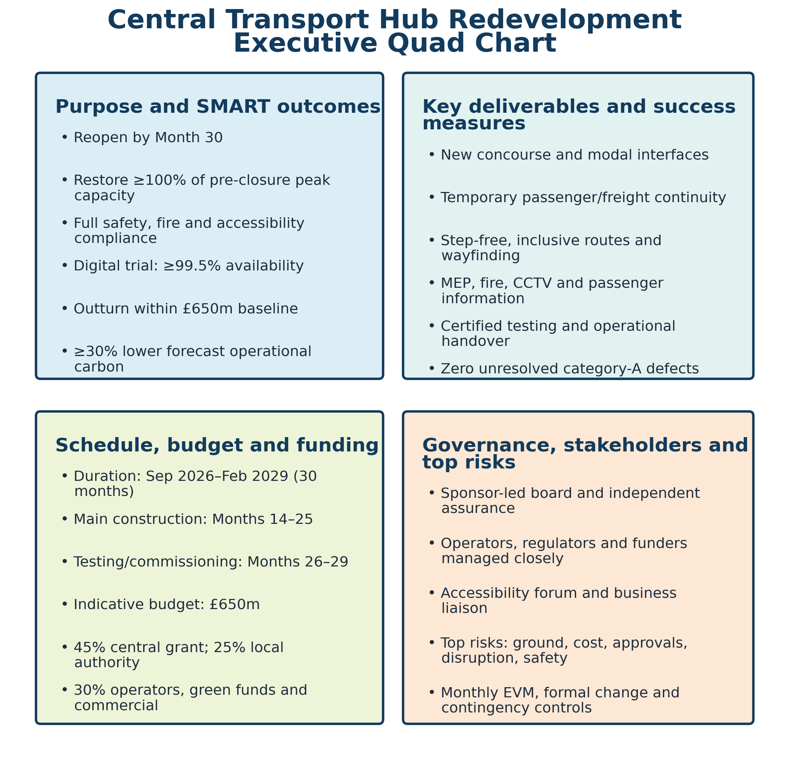
Figure 7: Executive quad chart summarising project purpose, deliverables, schedule, cost, governance and risks. Source: Author.

6. Gantt chart and time plan
The 30-month Integrated Schedule September 2026 – February 2029 is shown in Figure 8. To minimize elapsed time, early surveys, temporary operations, design and consultation are interwoven. Enabling works can commence prior to the start of procurement, which commences once a good level of design maturity has been achieved. Core construction takes place from Month 14 to Month 25 and building services/digital integration overlaps from Month 20. The testing phase, emergency exercises and operational readiness are Months 26-29, while the phased reopening is Month 30.
The key phases anticipated to be on the critical path are surveys, design approval, main procurement, structural completion, systems integration and safety certification. Indiscriminate parallel working is not a way to control schedule compression but rather to achieve it. A 6 week look-ahead plan, interface milestones and possession calendar will ensure coordination of contractors and operators. Monthly EA will be performed and input into the comparison of planned value, earned value and actual cost; if the variance exceeds 5% a recovery plan and escalation will be performed (Kerzner, 2022). Non-critical public-realm and retail fit-out work is retained on float and long lead equipment is released early once design assurance has been met.

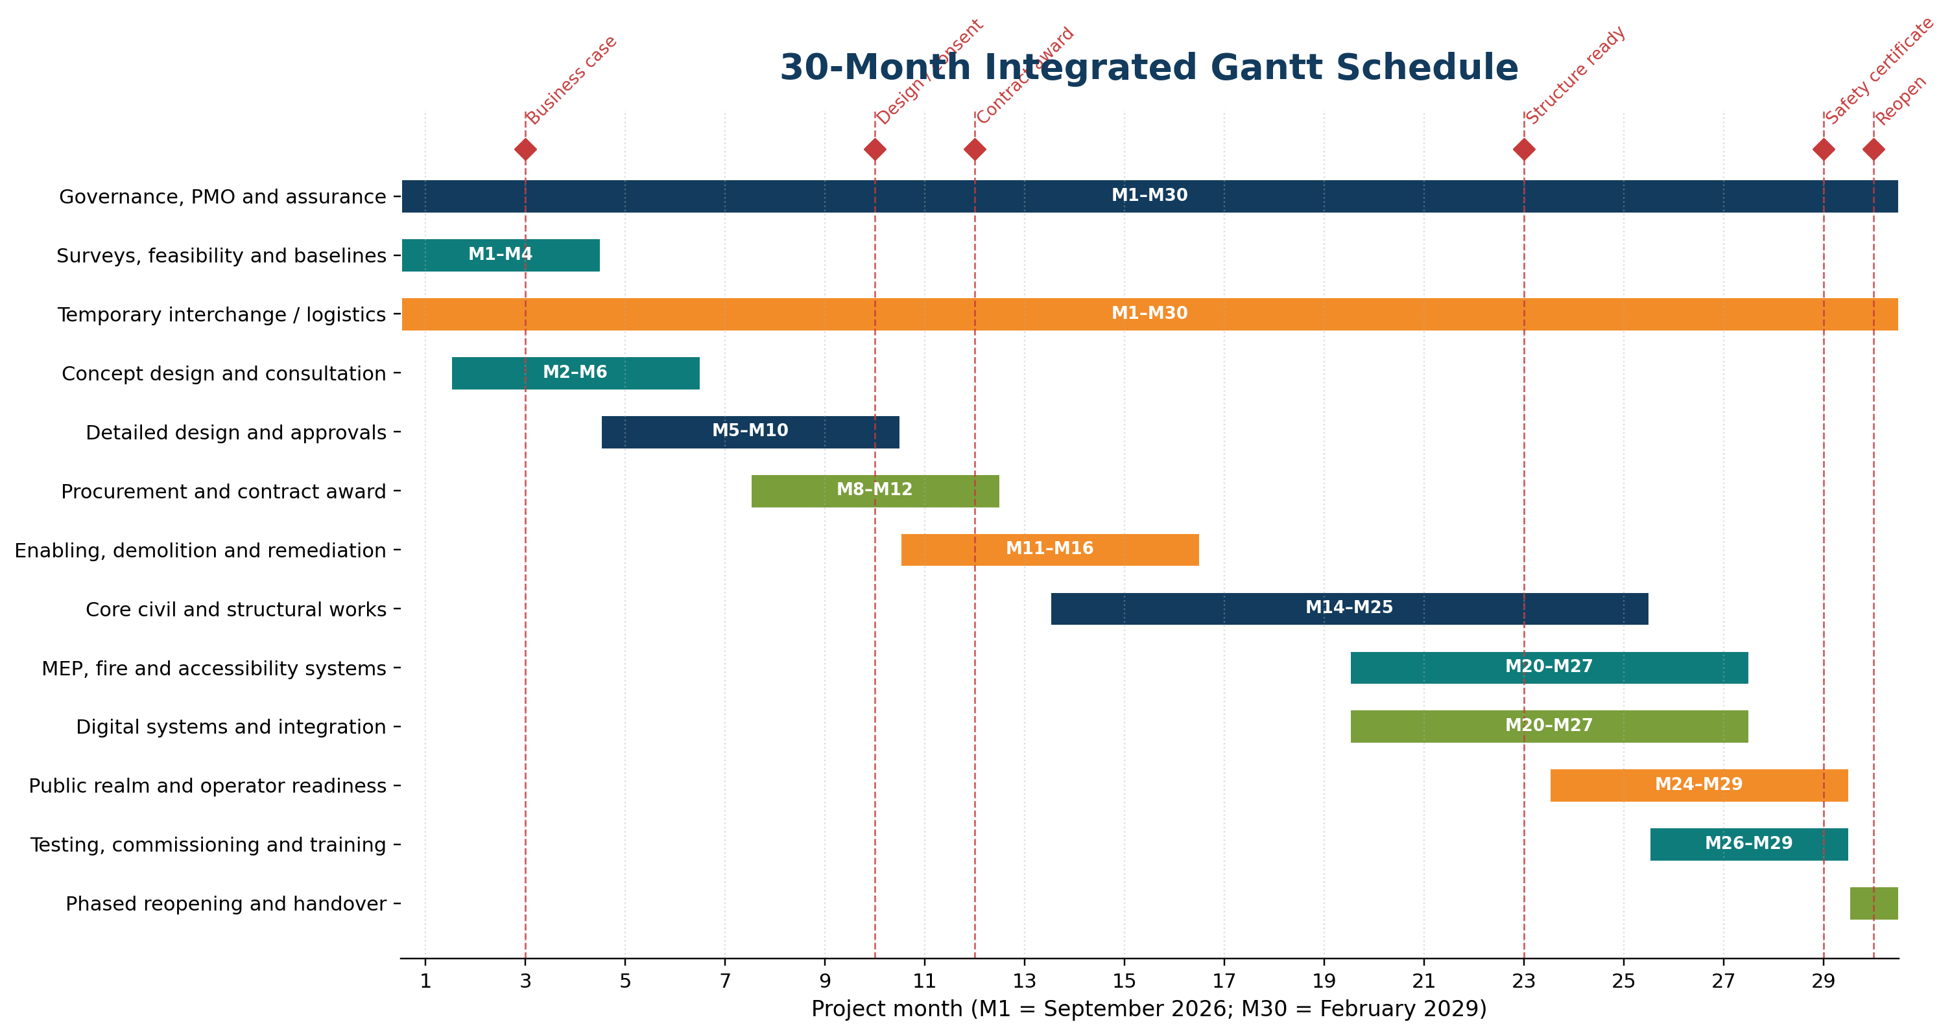
Figure 8: Thirty-month integrated Gantt schedule and milestone gates. Source: Author.

7. Stakeholder involvement
The involvement of stakeholders is based on the principles of stakeholder power, interest and exposure to disruption. The sponsor, the funders, the transport operators and the safety regulators are grouped in the manage-closely group in figure 9, as well as the main contractor. Formal authority is low but interest and exposure high, so they need to be kept well informed and actively engaged in the design and the planning of services. Structured technical engagement maintains satisfaction of emergency services, utilities and planning bodies.
The project board is made up of the Senior Responsible Owner, operator representatives, commercial lead, design lead and project director and meets monthly. For each fortnight, a possession operator interface group is responsible for the possessions, temporary routes and operational risk. Layouts, prototypes and trial operations are considered at concept, detailed design and commissioning stages at an accessibility forum. Logistics briefings are issued to businesses and freight users on a monthly basis and notices are issued to passengers via the stations, websites, social media and accessible formats. Complaints are recorded, classified and reported and timescales are adhered to for response.
This way of doing things does not see stakeholder concerns as communication issues but rather a source of knowledge and a risk for the project. Stakeholder and risk management can be integrated to reduce the objective conflict and enhance the decisions on resource use (Xia et al., 2018). In addition, it is essential to involve external actors in governance as internal formal structures alone do not convey legitimacy, ethics and community impacts (Derakhshan et al., 2019). The Consultation process does not take away the sponsor's responsibility; alternatives considered and rejected, and trade-offs, are documented in an open and transparent decision log.
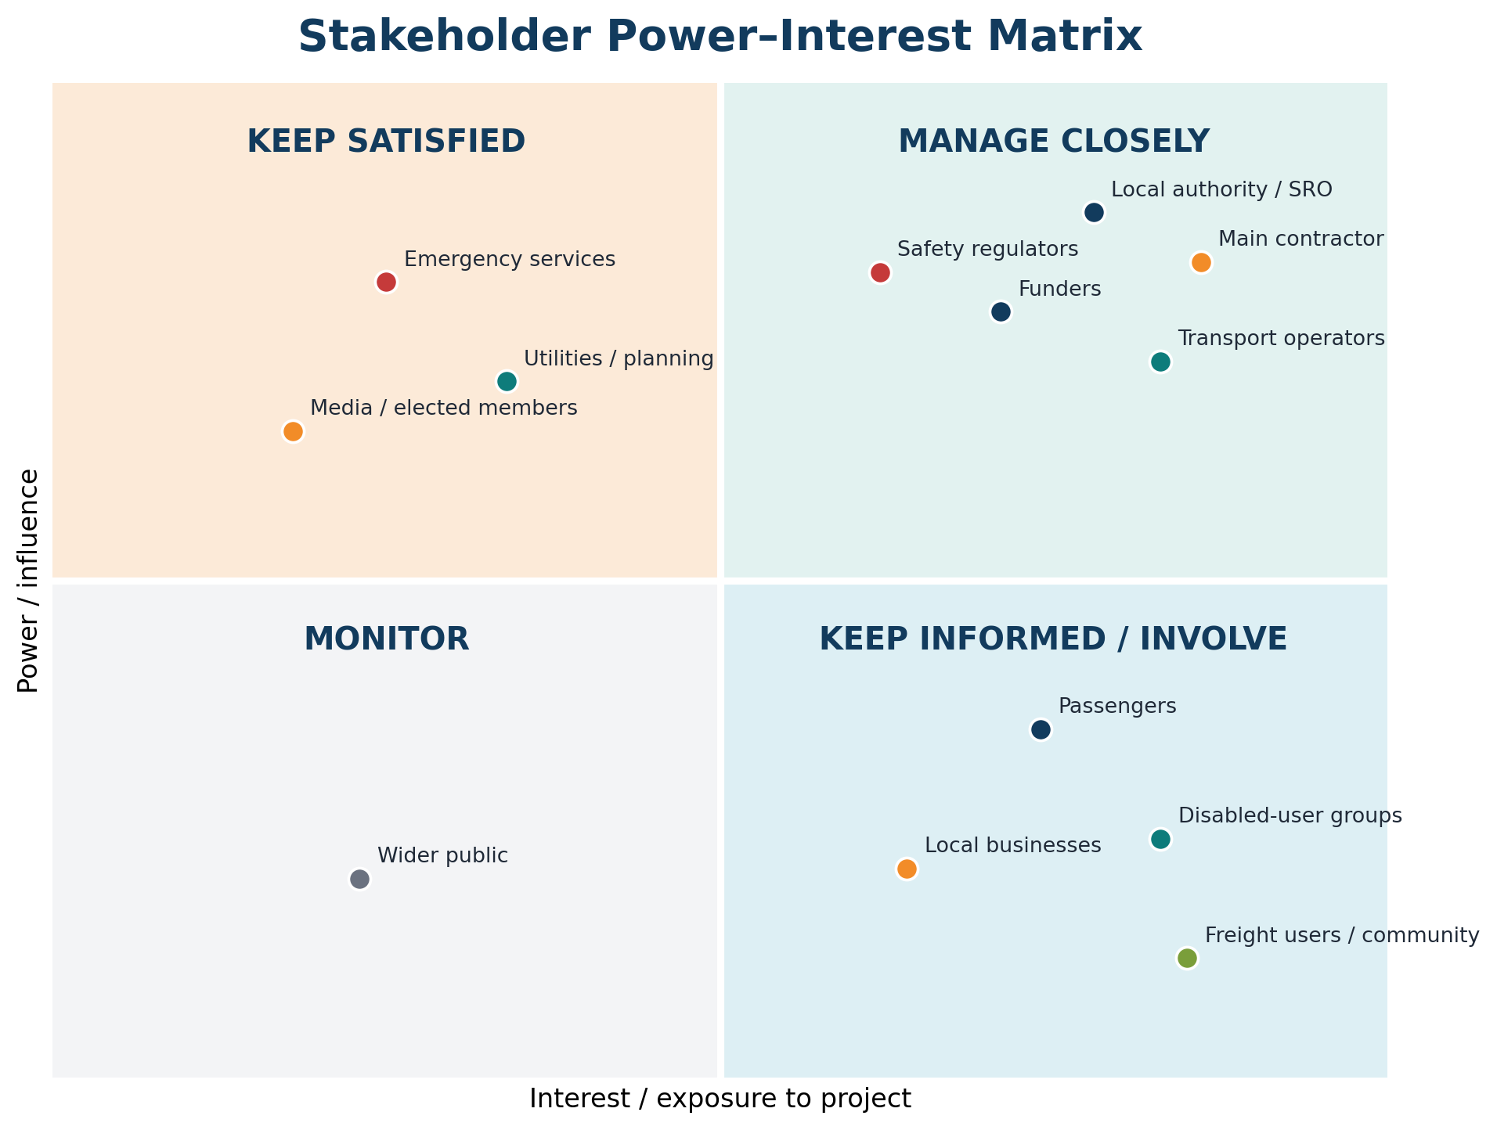
Figure 9: Stakeholder power–interest matrix for engagement prioritisation. Source: Author.

8. Allocation of resources, cost and funding
Resources, as shown in Table 4 are allocated using the WBS and responsibility matrix. The core client team consists of the Senior Responsible Owner, project director, project manager, project management office, commercial manager, design manager, construction manager, safety assurance manager, digital lead, sustainability lead and stakeholder/accessibility lead. The team is augmented during design, construction and commissioning by specialist designers, contractors and operators. A controlled drawing environment is a common data environment which is used to store controlled drawings, schedules, cost information, risks, requests for information and assurance evidence. Workforce planning, welfare, logistics and competence checks are related to the construction sequence because of the expected high number of peak site labour requirements during Months 16-24.
Workstream | SRO | Project manager | Design lead | Commercial lead | Construction lead | Operations / digital
Business case and gates | A | R | C | C | C | C
Design and approvals | A | C | R | C | C | C
Procurement and cost control | A | C | C | R | C | I
Enabling and core construction | I | A | C | C | R | C
Digital and operational integration | I | A | C | C | C | R
Testing, handover and benefits | A | R | C | C | C | R
Table 4: High-level responsibility assignment (RACI) (Key: A = Accountable; R = Responsible; C = Consulted; I = Informed.)
Source: Author.
The indicative budget for prices at 2026 level is £650m. The cost breakdown is shown in figure 10, which includes £52 million for surveys, design, consents and project management; £65 million for enabling, demolition and remediation; £182 million for civil and structural works; £91 million for rail, bus and freight interfaces; £71.5 million for mechanical, electrical, fire and accessibility systems; £39 million for testing and training; £32.5 million for temporary transport and disruption management; and £97.5 million for risk and inflation allowance. This is an estimate and not a tender price. It will be benchmarked, risk adjusted and independently assured at each stage of the business case following the guidance on Infrastructure and Projects Authority cost-estimating for projects in the UK (Infrastructure and Projects Authority, 2021).
The proposed split of funding is: 45% transport-related grant from the central government (£292.5m), 25% capital funding from local government (£162.5m), 15% operator contributions (£97.5m), 10% green-transport funding (£65m) and 5% commercial or developer contributions (£32.5m). Funding agreements will be put in place in stages with gates to ensure that expenditure is approved in line with evidence of scope, cost and benefits in line with the public-sector Five Case Model and value-for-money principles (HM Treasury and Government Finance Function, 2026). Commitment tracking, forecast-at-completion, and contingency drawdown approval and earned-value indicators are used for monthly cost control. The reduction of optimism bias is achieved by reference class evidence and independent challenge; these are used in addition to project-specific risk analysis (Chen et al., 2023).
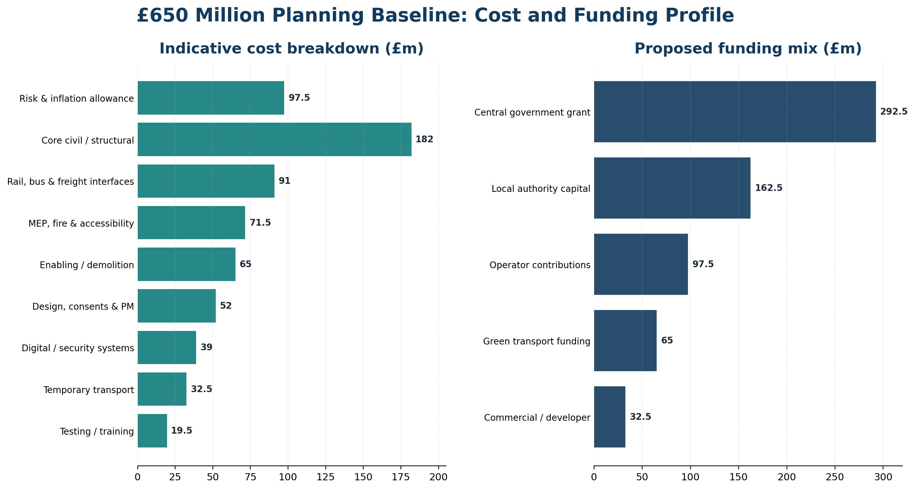
Figure 10: Indicative £650 million cost breakdown and proposed funding mix. Source: Author.

9. Risk analysis
Risk management is an ongoing process of identify, assess, respond and monitor and covers threats and opportunities. Probability & impact range from 1 to 5; with 15-25 being high, 8-14 medium and 1-7 low. The key risks, owners and responses are shown in Table 5 and inherent exposure is shown in Figure 11. Triggers and response actions are monitored fortnightly by risk owners and high risks are monitored monthly by the project board. Only exposure quantifications and approved response plans will result in a release of contingency.
The greatest dangers are structural or ground conditions that are unknown, escalating costs, disruption of passengers and freight, approval delay and safety incidents. The uncertainty is minimized before the main contract by conducting early intrusive surveys and by having the utility mapping and design maturity. Transparent assumptions, market testing, package benchmarking and open-book reporting and controlled contingency are all ways of managing cost exposure. A temporary interchange is used to minimise service disruption, night or weekend possessions, and segregated routes and coordinated passenger communication. Safety is controlled by construction design and management responsibilities, permit to work systems, independent assurance and rehearsed emergency systems.
Digital integration, capacity of supply chain, accessibility and carbon outcomes are not considered as secondary workstreams, but as interface risks. Passenger Information and Freight systems are put to the test in a sandbox and in a staged way, through user acceptance. During design, suppliers for long-lead components are identified and alternative suppliers are provided. Disabled-user organisations are involved in design reviews and in operational trials. Embodied and operational carbon and responsible material selection and waste diversion are captured in a project carbon budget. Environmental and social indicators need to be combined with traditional time and cost controls in the implementation of sustainable control (Kivilä et al., 2017; Sabini et al., 2019).
Risk management is only valuable when the measures taken in response to the risks are in line with the interests of stakeholders and decisions made, not when the register is used as a compliance document (Willumsen et al., 2019). Risks that remain after the project is finished, as well as assumptions and accepted trade-offs are therefore described in board papers, and escalation thresholds are related to delegated authority.
ID | Risk / trigger | P | I | Score | Primary response | Owner
R1 | Unknown structural, utility or ground conditions | 4 | 5 | 20 | Intrusive surveys, utility mapping, early contractor input | Design manager
R2 | Inflation, design growth or weak cost control | 4 | 4 | 16 | Benchmarking, open-book reporting, 15% allowance, change control | Commercial manager
R3 | Planning, fire or safety approval delay | 3 | 5 | 15 | Regulator workshops, staged submissions, assurance hold points | Design manager
R4 | Passenger or freight disruption exceeds tolerance | 4 | 4 | 16 | Temporary interchange, possessions plan, night works, accessible communications | Operations lead
R5 | Construction safety incident | 3 | 5 | 15 | CDM controls, segregation, permits, independent audits and drills | Safety manager
R6 | Long-lead item or supplier failure | 3 | 4 | 12 | Early market engagement, dual sourcing and procurement schedule | Commercial manager
R7 | Digital systems fail to integrate | 3 | 4 | 12 | Interface control, sandbox testing and staged user acceptance | Digital lead
R8 | Accessibility or community requirements are missed | 3 | 4 | 12 | Co-design, prototype reviews, grievance log and operational trials | Stakeholder lead
R9 | Carbon and waste targets are not achieved | 3 | 3 | 9 | Carbon budget, responsible materials, waste tracking and design reviews | Sustainability lead
R10 | Funding shortfall or political reprioritisation | 2 | 5 | 10 | Staged agreements, gate-linked approvals and scope prioritisation | SRO
Table 5: Principal project risk register
Source: Author
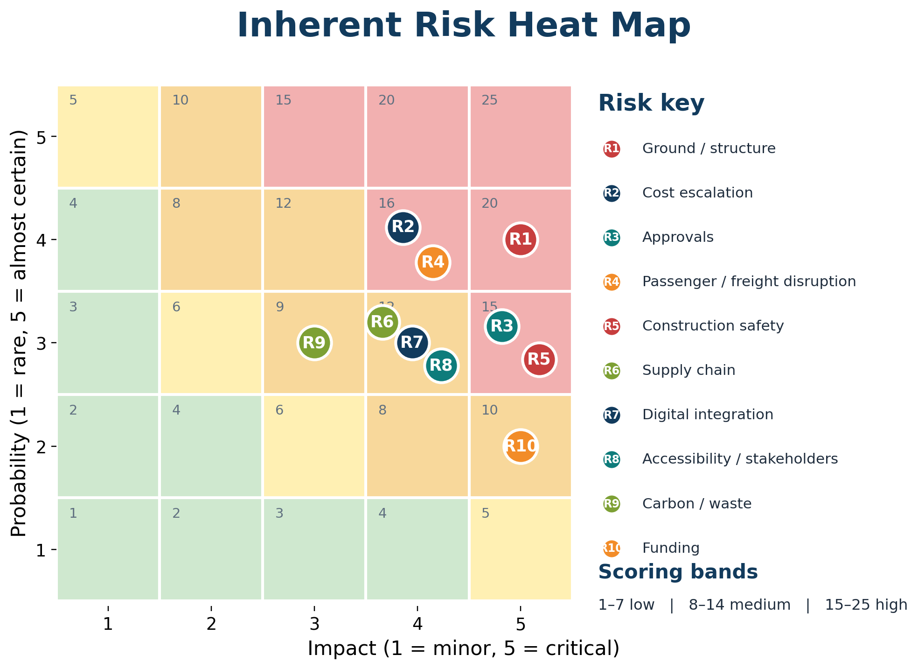
Figure 11: Inherent risk heat map before planned responses.
Source: Author.

10. Conclusion
The redevelopment plan is the process of developing the Part A proposal into a comprehensive, viable and practical delivery baseline. A hybrid lifecycle offers safety-critical construction with predictable control, and iterative learning for digital systems. The WBS, the quad chart and the Gantt chart make deliverables, decisions and timing visible, and the stakeholder governance, allocation of resources and controls of risks make accountability visible. The budget of £650m and funding mix is in direct response to the feedback received but is subject to change until surveys and design and market evidence is complete. Disciplined phase gates, change and contingency control that are transparent, and meaningful accessibility engagement and early management of interfaces are key to success. This will allow for the project to restore transport capacity by Month 30, whilst maintaining safety, value for money, inclusion and long-term environmental performance.

References
Association for Project Management (2019) APM Body of Knowledge. 7th edn. Princes Risborough: Association for Project Management.
Bassot, B. (2016) The Reflective Practice Guide: An Interdisciplinary Approach to Critical Reflection. Abingdon: Routledge.
Bjorvatn, T. and Wald, A. (2018) ‘Project complexity and team-level absorptive capacity as drivers of project management performance’, International Journal of Project Management, 36(6), pp. 876–888. https://doi.org/10.1016/j.ijproman.2018.05.003.
Chen, Y., Ahiaga-Dagbui, D.D., Thaheem, M.J. and Shrestha, A. (2023) ‘Toward a deeper understanding of optimism bias and transport project cost overrun’, Project Management Journal, 54(5), pp. 561–578. https://doi.org/10.1177/87569728231180268.
Denicol, J., Davies, A. and Krystallis, I. (2020) ‘What are the causes and cures of poor megaproject performance? A systematic literature review and research agenda’, Project Management Journal, 51(3), pp. 328–345. https://doi.org/10.1177/8756972819896113.
Derakhshan, R., Turner, R. and Mancini, M. (2019) ‘Project governance and stakeholders: a literature review’, International Journal of Project Management, 37(1), pp. 98–116. https://doi.org/10.1016/j.ijproman.2018.10.007.
Flyvbjerg, B. (2021) ‘Top ten behavioral biases in project management: an overview’, Project Management Journal, 52(6), pp. 531–546. https://doi.org/10.1177/87569728211049046.
Gemino, A., Horner Reich, B. and Serrador, P.M. (2021) ‘Agile, traditional, and hybrid approaches to project success: is hybrid a poor second choice?’, Project Management Journal, 52(2), pp. 161–175. https://doi.org/10.1177/8756972820973082.
He, Q., Luo, L., Hu, Y. and Chan, A.P.C. (2015) ‘Measuring the complexity of mega construction projects in China: a fuzzy analytic network process analysis’, International Journal of Project Management, 33(3), pp. 549–563. https://doi.org/10.1016/j.ijproman.2014.07.009.
HM Treasury and Government Finance Function (2026) The Green Book. London: HM Treasury. Available at: https://www.gov.uk/government/publications/the-green-book-appraisal-and-evaluation-in-central-government (Accessed: 24 July 2026).
Infrastructure and Projects Authority (2021) Cost Estimating Guidance: A Best Practice Approach for Infrastructure Projects and Programmes. London: Cabinet Office. Available at: https://www.gov.uk/government/publications/cost-estimating-guidance (Accessed: 24 July 2026).
International Organization for Standardization (2018) ISO 21511:2018 Project, Programme and Portfolio Management – Work Breakdown Structures. Geneva: ISO.
International Organization for Standardization (2020) ISO 21502:2020 Project, Programme and Portfolio Management – Guidance on Project Management. Geneva: ISO.
Kerzner, H. (2022) Project Management: A Systems Approach to Planning, Scheduling, and Controlling. 13th edn. Hoboken, NJ: Wiley.
Kivilä, J., Martinsuo, M. and Vuorinen, L. (2017) ‘Sustainable project management through project control in infrastructure projects’, International Journal of Project Management, 35(6), pp. 1167–1183. https://doi.org/10.1016/j.ijproman.2017.02.009.
Project Management Institute (2021) A Guide to the Project Management Body of Knowledge (PMBOK Guide). 7th edn. Newtown Square, PA: Project Management Institute.
Sabini, L., Muzio, D. and Alderman, N. (2019) ‘25 years of sustainable projects: what we know and what the literature says’, International Journal of Project Management, 37(6), pp. 820–838. https://doi.org/10.1016/j.ijproman.2019.05.002.
Willumsen, P., Oehmen, J., Stingl, V. and Geraldi, J. (2019) ‘Value creation through project risk management’, International Journal of Project Management, 37(5), pp. 731–749. https://doi.org/10.1016/j.ijproman.2019.01.007.
Xia, N., Zou, P.X.W., Griffin, M.A., Wang, X. and Zhong, R. (2018) ‘Towards integrating construction risk management and stakeholder management: a systematic literature review and future research agendas’, International Journal of Project Management, 36(5), pp. 701–715. https://doi.org/10.1016/j.ijproman.2018.03.006.

