Material Science and Building Services

Assignment 1 - Construction Materials

Steffan Dancey

Student No: 2014079

Table of Contents

1. Introduction 3
2. Likely durability and climatic resistance, given the environmental conditions the site is exposed to 3
Steel 3
Concrete 4
3. Impact the framing material's original production process on the environment, with reference to resource use in manufacture and in biproducts produced 5
Steel 6
Concrete 6
4. Ease of assembly, potential ease of adaptation to a shape and use, within the total life cycle of the building 8
Steel 8
Concrete 9
5. Conclusion 10
6. References 11

Introduction

In this assignment I will investigate and evaluate the characteristics and properties of construction materials. I will choose two existing habitable buildings from around the world, one with a Concrete frame, and another with a steel frame. I will report on the details of their original design planning, construction method and potential impact in consideration of social and environmental sustainability.

Likely durability and climatic resistance, given the environmental conditions the site is exposed to

Steel
The Empire State Building was constructed mainly of steel beams and towers over the 107 stories. Steel structures like the Empire State are exceptionally durable, even with very little maintenance they can last generations with ease. While materials such as concrete and wood do not cope with extreme weather well, steel is known to resist extreme weather such as snow loads and strong winds and are guaranteed against rust, warps or shrinkage. Depending on carbon content, a steel frame will also have very good moisture resistance properties, treatments can also be used to enhance the steels resistance against rust. This will eliminate any corrosion of steel if exposed to water.
Early types of steel high rise buildings “like the Empire State Building, that date from the 1930s are least likely to remain standing in 7,000 years” - Punctual Abstract, https://www.punctualabstract.com/2018/11/14/skyscraper/ (accessed 14/02/21). This is due to the fact they are built practically entirely of steel, this means they have excellent tensile strength but tend to be inflexible and fairly rigid.
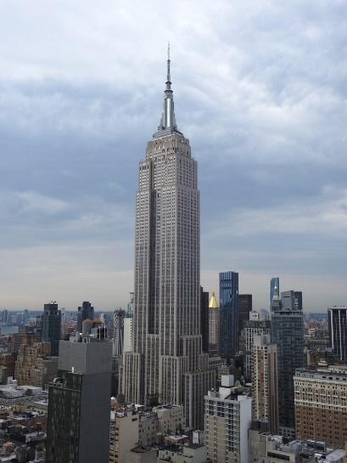
Image from: Vanessa Londono, September 2020. New York YIMB. https://newyorkyimby.com/2020/09/empire-state-building-restoration-nearly-complete.html. (Accessed 15/02/2021)
Due to the nature of the building, the Empire State Building is exposed to high levels of wind and under the city of New York’s building code, the building was made to withstand 20 lbs per square foot above the 6th level. The building code does not require wind pressures below the 100-foot threshold to be calculated. To resist the possible strong winds and extreme weather conditions shear walls were implemented into the buildings design. Belt trusses were also used to evenly distribute the compressive and tensile force acting on the large number of exterior trusses. Information from: Click Americana. https://clickamericana.com/topics/places/safe-skyscrapers-like-empire-state-building-1931 (accessed 17/02/21)
The structure of this building is a centre single core within short columns, these bear the floor with the central part of the building. The core holds the vertical load and is impeded with a horizontal force due to earthquakes and wind. The windows on all sides of the building also allow great lighting and views. The towers’ structure is braced steel with semi rigid connections and covered with heavy cladding designed to stiffen the structure, this makes the building one of the stiffest towers of its height.

Concrete
The Ingalls Building is a concrete framed high rise building in Cincinnati, Ohio and was constructed in 1903. The building consists of 16 stories and peaks at 210 feet tall. It was designed to be a commercial property holding stores a bank and offices used the remaining space. the building was completed from start to finish in approximately 8 months and was the tallest concrete framed building in the world until 1923 when the Medical Arts Building in Dallas, Texas was built at 281-foot tall.
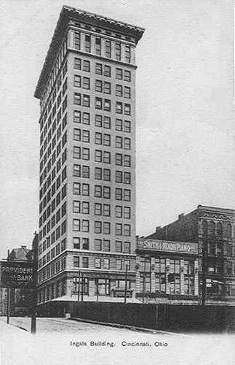
Historic Concrete Contractor Projects - Ingalls Building - Cincinnati, Ohio. http://www.concretecontractor.com/concrete-construction-projects/ingalls-building/ (accessed 15/02/21).
It took two years from when the building was first proposed to satisfy the authorities that the structure would be viable as scepticism was high, it was thought by many engineers that the building would develop cracks and be unsafe or even collapse beneath its own weight. As this building was the first high rise concrete frame building there was also concern about the stability during high winds.
Unlike steel, concrete does not require coatings or paint to defend the steel against corrosion. A well-designed concrete mix proves to be maintenance free.
One of the main reasons concrete was chosen as the structural frame was due to its great load bearing capacity and it's cost of construction compared to a similar steel structure. Using steel would prove costly due to transportation, where concrete could be made using materials and labour on site. As large steel beams girders and columns did not need to be hoisted or stored on site this greatly decreased the need of on-site storage and hoists, saving on costs yet again.

Impact the framing material's original production process on the environment, with reference to resource use in manufacture and in biproducts produced

Concrete is a widely used material in construction and even though steel is becoming popular due to its reduced construction time and flexibility. Concrete and steel framed buildings do have their environmental benefits and drawbacks.

Steel
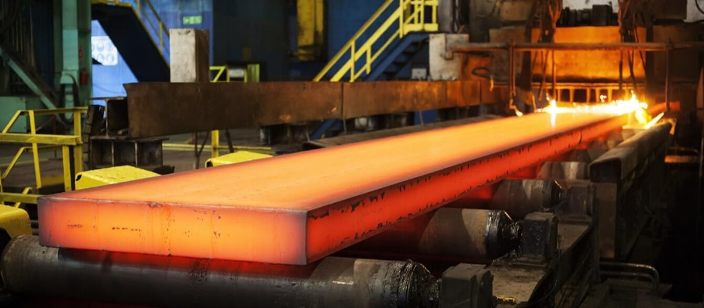
Image from: en-former “How hydrogen could change the face of steel production as we know it” https://www.en-former.com/en/hydrogen-revolution-steel-production/ (accessed 18/02/21).
When constructing a steel framed building such as The Empire State Building, all elements are accurately fabricated to the required tolerances prior to delivery, this ensures waste is at a minimum and assembly is swift. Erection procedures are designed in detail using 3D models in the modern day, for the most complex structures, trial assemblies can be staged to ensure everyone understands the required procedure. Since the Empire State was constructed in the 1930’s the design was completed in the style called Art Deco.
Steel is a 100% recyclable material and has good scrap value, therefore does not require encouragement to be recycled and not left in landfill. With steel’s magnetic properties, it can be taken from waste and diverted back to be melted down and used again. Steel could last forever as it keeps its strength in every part of each use cycle.
Steel is a highly ductile material, this means it can be moulded and reshaped many times to suit different designs without any significant effect on its strength properties. In the production of steel by products are created, but even these are highly recyclable too, as they’re used in plastics and fertilisers etc.
The production of coke is likely the primary sources of contamination in the industry. Air pollutants for instance oven gas, naphthalene, ammonium compounds, sulphur and coke dust are emitted from the coke ovens. The water contamination is due to the water used to cool the coke after the baking is complete, the contamination is caused by compounds such as coke breezes. The contaminated water can be easily reused, by using filtration processes methods.

Concrete
Constructing a building out of concrete such as the Ingalls Building can prove very environmentally friendly. For the most part, the major material to produce cement is limestone, limestone is the most plentiful material on the planet. Slag cement and silica can be used to make concrete, these are by-products from power plants other types of manufacturing services.
Concrete has great durability, for a structure like the Ingalls Building this is imperative. Concrete will not rust, burn or rot and can have a life up to three times longer than other traditional methods of Construction.
The concrete walls, foundations, and floors are highly energy efficient as they take advantage of concretes thermal properties to draw in and keep hold of heat. This significantly reduces the amount energy required to heat the building.
The amount of concrete required for this project would have been calculated prior to commencement of the work, this ensures there is minimal waste. After being used for its intended purpose, it can even be crushed and recycled and used in aggregate or new concrete mixes.
https://www.concretenetwork.com/concrete/greenbuildinginformation/
https://www.irishconcrete.ie/concretes-multiple-benefits/flexibility-adaptability/
Below is a diagram that shows life cycle and processes of concrete.
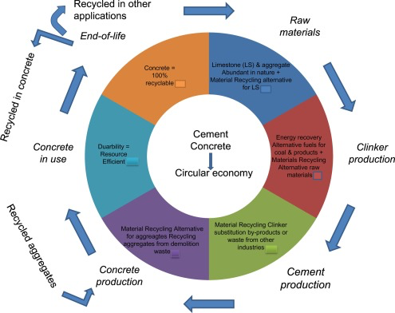
Concrete Production - an overview | ScienceDirect https://www.sciencedirect.com/topics/engineering/concrete-production (accessed 18/02/21).
Sulfur dioxide, nitrogen oxide and carbon monoxide are caused in the production of cement. Listed below are environmental impacts that occur from the production of cement.
Nitrogen oxide can cause and contribute to numerous health problems, and environmental effects. It can cause acid rain, global warming and deterioration of water quality. People affected include children, people with respiratory problems.
Sulfur Dioxide can affect breathing and existing cardiovascular and respiratory problems. The elderly, children and Individuals with asthma, bronchitis or emphysema are at risk.
Carbon monoxide can also cause harmful health impacts and can shorten the delivery of oxygen to tissues and vital organs. The insufficient supply of oxygen can further have negative effects on the central nervous systems and cardiovascular. The formation of smog is also caused by Carbon Monoxide.

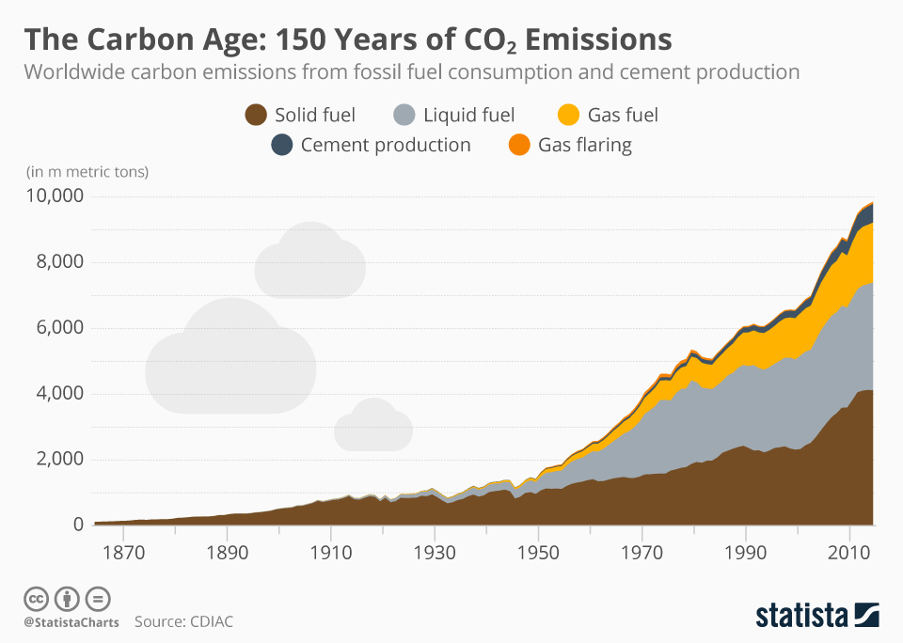
Dyfed Loesche. Infographic: The Carbon Age: 150 Years of CO2 Emissions. Statista Infographics https://www.statista.com/chart/13584/worldwide-carbon-emissions-from-fossil-fuel-consumption-and-cement-production/ (accessed 19/02/21).
The graph above displays the worldwide carbon production between the years of 1870 and 2010. The graph clearly shows the rapid increase of carbon emissions produced between the years of 1950 and 2010. According to the graph, cement production has been the second highest source carbon emissions since the early 1900’s. We are mainly concerned about the affect the cement production had on the environment around the time the Ingalls Building was constructed. The building was constructed in 1903, and there is no substantial amount of carbon emissions recorded. This tells us concrete construction was not yet affecting the environment as much as it is today.

Ease of assembly, potential ease of adaptation to a shape and use, within the total life cycle of the building

Steel
Steel framed structures can be built quickly and efficiently, the accuracy of steel sections especially aids the process and allows other trades to start and finish their works sooner. This provides a shorter programme of works.
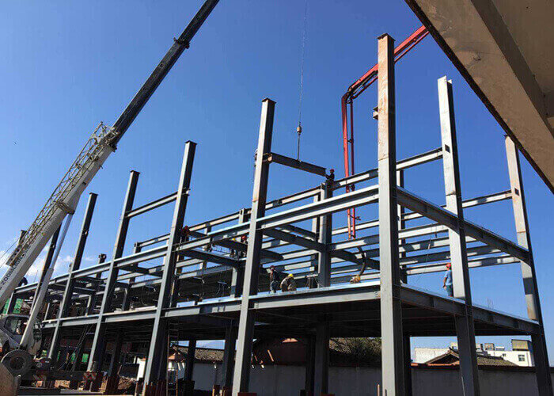
Image from havitsteelstructure, https://havitsteelstructure.com/prefab-steel-building/ (accessed 21/02/21).
Steel framed buildings can be very easily adapted to different shapes and uses, attention must be made to the current condition of the building prior to work. The ease of adaption is down to how a steel framed building is constructed, Steel buildings are either held together with welds, bolts or rivets. This makes cutting and adding in new sections of steel a lot simpler than a new concrete frame to a concrete building.
work compared to a similar sized concrete frame structure. By having a shorter programme of work, it reduces disruption in inner city projects, and cuts costs of on-site preliminaries as there is less time spent on site.
It can easily be fabricated into many shapes and sizes. it can be shaped into many different design applications these include structural practicality, some for the aesthetic, and some for both these purposes.

Concrete

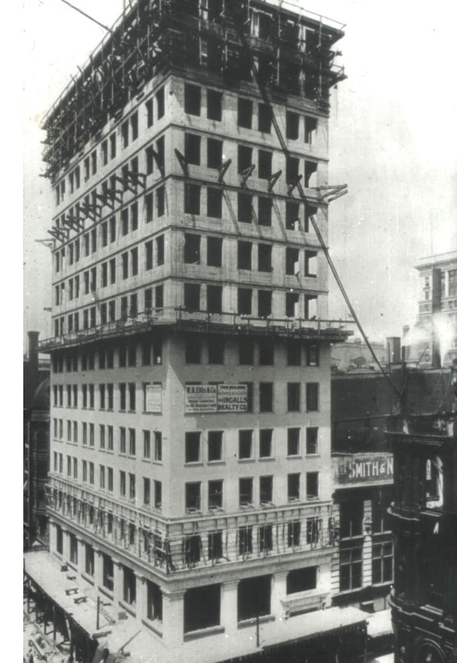
Suzanne Morris. The Making of Brooklyn: Reinforced Concrete and Turner Construction https://www.brownstoner.com/history/brooklyn-architecture-reinforced-concrete-henry-c-turner-construction-ransome-coignet/ (accessed 23/02/2021)
As the Ingalls Building ages the structure will outgrow the original plans. With Construction, design and technology construction constantly evolves to meet the modern-day demand. By adapting the current building, it avoids the need of demolition and reconstruction of a new building. This proves to be environmentally friendly, combined with energy savings and the benefit of adapting a current valued building to its former glory. Holes can be cut through slabs and walls can have holes cut through reasonably easily, while there are methods to strengthen the frame if required.
A concrete frame can be relatively easy to modify for other uses. Whilst additional strength and support may be required, holes can be cut through walls and slabs.

Conclusion

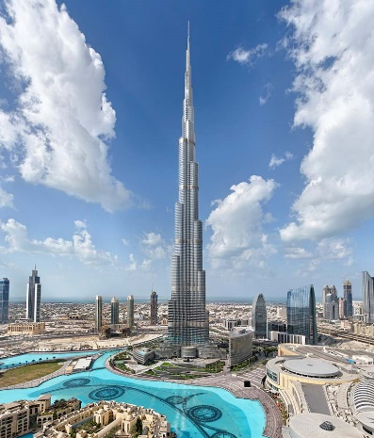
Through researching the characteristics and properties of steel and concrete framed structures both methods are proven to be successful and effective. The Empire state building proved to be a great success. The building is exceptionally durable, while concrete would not cope as well with the cold winters New York experience. Steel is renown to resist extreme weather such as snow loads and strong winds and is guaranteed against rust, warps or shrinkage which is why most high-rise buildings use a steel frame structure.
The Ingalls building was constructed in 1903, there was great scepticism regarding the strength of the concrete frame as, traditionally high-rise structures were constructed mainly of steel. The success of the Ingalls Building proved that the method of concrete framed construction in high rise buildings was worthwhile, and this method is still used today and found in modern day high rise like the Burj Khalifa (pictured).
Burj Khalifa: The tallest building in the world. Guinness World Records https://www.guinnessworldrecords.com/records/hall-of-fame/burj-khalifa-tallest-building-in-the-world (accessed 27/02/21)
Through investigating the sustainability of both materials, steel is certainly the more sustainable material, this is mainly due to the fact it is 100% recyclable.
End of life scenarios for Steel and Concrete below:
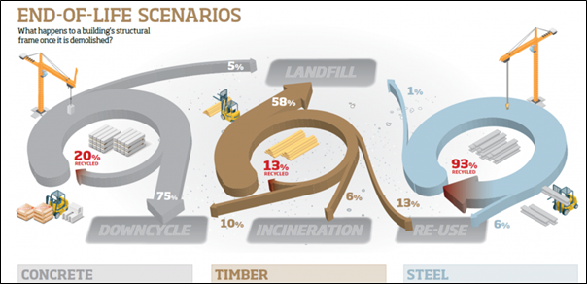
Steelconstruction.info. https://www.steelconstruction.info/images/4/47/CE_07.png (accessed 24/02/2021)
The graph above clearly illustrates how sustainable Steel is, with 93% of waste being recycled compared to concrete at 20%. As concrete is difficult to recycle ¾ of the waste is downcycled, as aggregates from demolition may be used as subbase or fill. The aggregates from demolition may also be used in concrete production, but this is limited by the percentage permitted and the amount attainable. Even if aggregates were to be re used new cement must be manufactured, and this is the biggest source of Carbon Dioxide in the production of concrete. In addition to the 93% of steel recycled a further 6% is also re used, only leaving 1% to go to landfill. Structural steel and steel cladding components are often reused in the agricultural industry. Steel structures are designed with reuse in mind, components are often bolted and not welded as well as connection details being standard sizes. All of which increase the chance of re use.

References

Punctual Abstract, https://www.punctualabstract.com/2018/11/14/skyscraper/ (accessed 14/02/21).
Vanessa Londono, September 2020. New York YIMB. https://newyorkyimby.com/2020/09/empire-state-building-restoration-nearly-complete.html. Accessed 15/02/2021
Click Americana. https://clickamericana.com/topics/places/safe-skyscrapers-like-empire-state-building-1931 (accessed 17/02/21)
the world counts. https://www.theworldcounts.com/challenges/planet-earth/mining/environmental-impact-of-steel-production/story (accessed 20/02/2021)
Historic Concrete Contractor Projects - Ingalls Building - Cincinnati, Ohio. http://www.concretecontractor.com/concrete-construction-projects/ingalls-building/ (accessed 15/02/21).
en-former “How hydrogen could change the face of steel production as we know it” https://www.en-former.com/en/hydrogen-revolution-steel-production/ (accessed 18/02/21).
Concrete Production - an overview | ScienceDirect https://www.sciencedirect.com/topics/engineering/concrete-production (accessed 18/02/21).
Dyfed Loesche. Infographic: The Carbon Age: 150 Years of CO2 Emissions. Statista Infographics https://www.statista.com/chart/13584/worldwide-carbon-emissions-from-fossil-fuel-consumption-and-cement-production/ (accessed 19/02/21).
havitsteelstructure, https://havitsteelstructure.com/prefab-steel-building/ (accessed 21/02/21).
Suzanne Morris. The Making of Brooklyn: Reinforced Concrete and Turner Construction https://www.brownstoner.com/history/brooklyn-architecture-reinforced-concrete-henry-c-turner-construction-ransome-coignet/ (accessed 23/02/2021)
Steelconstruction.info. https://www.steelconstruction.info/images/4/47/CE_07.png (accessed24/02/2021)
Burj Khalifa: The tallest building in the world. Guinness World Records https://www.guinnessworldrecords.com/records/hall-of-fame/burj-khalifa-tallest-building-in-the-world (accessed 27/02/21)

