

Assessment 1 – Reading Task Template
PART 1: Upload your photo of your A3 in-class notes here:
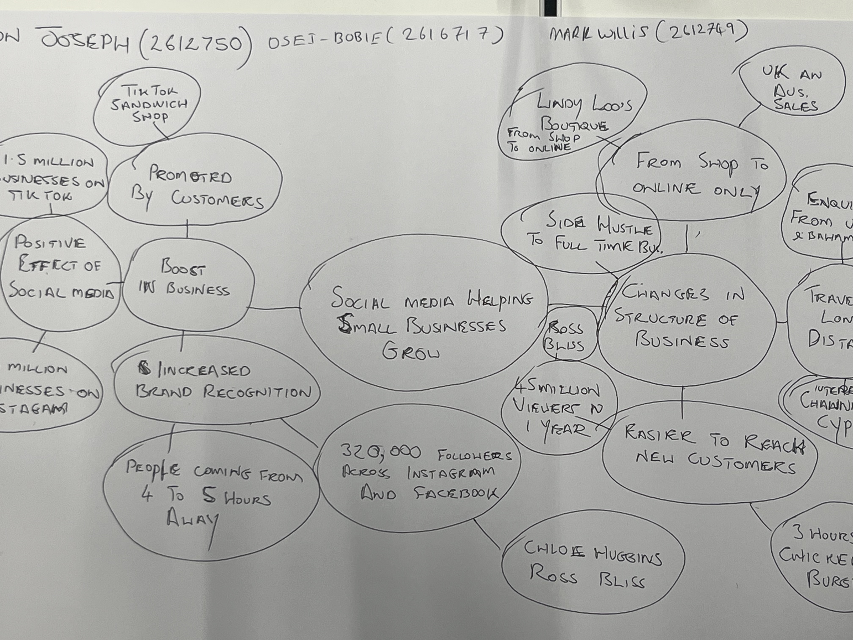

PART 2:
- Answer every question below in 1-3 full sentences.
- Use your own words. Do not use generative AI to answer these questions.
- Include a specific detail from the text when asked.
REMINDER
- The main idea is the overall message of the whole text.
- A key point helps to explain the main idea.
- A specific detail or example from the text shows that the key point is true.

- What is the main idea of the whole text?
How social media has changed the lives of business owners across the UK by driving higher growth in business and sales volume, and by extending their customer base beyond their local area.

- What is one key point that supports the main idea, and which specific example from the text shows this?
In a BBC news article published in 2026, a Business owner, Murat Mutlu, from Essex, who owns a sandwich shop, started to experience a rush of customers after another customer posted about eating a sandwich from that establishment, and others also followed suit. This has tempted people from afar to come to try their food and give a testimonial on TikTok.

- What is a different key point that supports the main idea, and which specific example from the text shows this?
Another key point to mention is that some business owners have had to change their business model to accommodate the influx of customers from home and afar. An example of this is quoted in the BBC article of 2026, Linda Hunter (aka Lindy loo) now runs an online Boutique from an industrial estate near Epping. Previously, she ran a clothing stall at markets in Essex, Kent, and London, but because of the COVID pandemic, she switched to online selling, now has a larger customer base in the UK, and ships items to Australia.

- Which part of the text do you think is most important, and why?
The most important part of the text is how Social Media has influenced how customers can be aware of what is available with the click of a button and by seeing testimonials from customers posting on social media, which evidently can convert brand awareness and curiosity into venturing as a customer or perhaps your own business ideas.

Reflection:
- What did you find difficult in this task (including in-class components), and why was it difficult?
I had to tentatively read the source and take into account other people's perceptions of the article (group mapping) before drawing my own judgement as to how I tackle the questions in the assessment

- What helped you with this difficulty, and how did it help you?

I had to patiently read the article and take into account the class discussion to evaluate my thoughts in answering the question and then decide what best conveys and expresses my thoughts correctly.

