Shelina Begum (1704954)

University of Wales Trinity Saint David
Published on 20th April 2018

An analysis of the current situation in the nhs.
Problem Solving and Decision Making (BMSK4004) Lecturer: Lianne Cuke

Executive Summary

The purpose of this report is to investigate the current situation of the National Health Service (NHS) and the impact that it is having on its stakeholders. The report will discuss the process of decision making and problem solving by using tools and techniques. A number of models will be used to aid analysis, including the PESTLE analysis, five why and the fishbone to explain the cause of the NHS problems. By using the five why model and the fishbone, it will breakdown the two problems to explain in more details. It will also contain a SWOT analysis to discover the strengths, weaknesses, opportunities, and threats the NHS is having.

The report will also contain details of who the stakeholders are and the impact that is causing to its stakeholders. To identify the stakeholders of the NHS, it is required to use the brainstorming process. The report will contain a table explaining who the internal, external and connected stakeholders are. Also, it will explain how much power and the interest the stakeholders have by using a Mendelow’s (1991) matrix.

At the end of the report, it contains the conclusion explaining what has been covered and, in the recommendation, it contains suggestions to solve the problems.

Contents
Executive Summary 1
1.0 Introduction 3
2.0 Main Body 4-20
2.1 Current Problems 4-5
2.1.1 Ageing Population 4
2.1.2 Lifestyle Factors 4
2.1.3 Change in Public Expectations 5
2.1.4 A&E Departments 5
2.1.5 Rising Costs 5
2.2 Stakeholder Analysis 6-9
2.2.1 Stakeholders Impact 9
2.3 PESTLE Analysis 9-13
2.3.1 Political Impact on the NHS 10
2.3.2 Economic Impact of the NHS 10
2.3.3 Social Impact of the NHS 11
2.3.4 Technological Impact of the NHS 11
2.3.5 Legal Impact of the NHS 12
2.3.6 Environmental Impact of the NHS 13
2.4 Problem Solving and Decision Making 13-19
2.4.1 Problem One: Shortage of Staff 14
The Five Why 14
2.4.2 Problem Two: The A&E Waiting Time 16
The Fishbone 16
2.5 The SWOT Analysis of the NHS 19-20
3.0 Conclusion 21
4.0 Recommendations 22
Reference List 23-26

1.0 Introduction

In 1948, Aneurin Bevan launched National Health Service (NHS) for everyone to have best possible medical care, notwithstanding prosperity (NHS choices, 2016). The main reason the NHS was open for everyone was that they can have free treatment for the diseases. It is seventy years this year since the NHS was launched. The NHS is a public-sector organisation which is funded by the government, most of the money is from the UK tax payer. The first NHS hospital was opened in Manchester which is now known as Trafford General Hospital. The NHS was opened so the “hospitals, doctors, nurses, pharmacists, opticians and dentists” to be available in one organisation and in one place, to make the public easy and convenient to access (NHS, 2015).

The services NHS provides are urgent and emergency care, walk in clinics, pharmacy, General Practitioner (GP), dental, mental health, hospital, eye care, sexual health, and pathology services (NHS choice, 2015). According to NHS (2018), the current situation of the healthcare is that they are facing the biggest challenge due to the ageing population, lifestyle factor, the change in public expectation, more people are going to Accident and Emergency (A&E) departments and the rising costs.

2.0 Main Body

2.1 Current Problems

2.1.1 Ageing Population

The ageing population is increasing every year. The diseases which would have killed a huge number of individuals have been treated, so this means more individuals have a longer life span. There may be some individuals living with long term illnesses such as diabetes, kidney and heart diseases which means they will need regular treatment and professional care (NHS, 2018). The Department of Health calculated that the standard budget of running the hospital and community health services for an individual over eighty-five years old will be approximately three times more than an individual aged sixty-five to seventy-four years old (UK Parliament, 2015).

2.1.2 Lifestyle Factors

The way people are living is the negative impact on the NHS. More people are visiting the NHS as they are getting ill because of smoking, consuming too much alcohol, poor diet and not exercising enough. Also, there is a rise in children being overweight which means the problem is ongoing (NHS, 2018). There has been an increase in obesity as in 2016/17 617 thousand people was admitted in the hospitals which was due to obesity factor that was a rise of eighteen percent from previous year (NHS Digital, 2018). Due to smoking it was identified that in 2015/16 474 thousand were admitted to hospitals which was a rise from 458 thousand in 2005/06. Also, approximately seventy-four thousand deaths were identified in 2015 which was caused because of smoking (NHS Digital, 2017).

2.1.3 Change in Public Expectations

Due to growing population, people are expecting more from the NHS. The NHS main aim was to treat diseases, now people want more such as advice on healthcare management, mental health and social care, vaccination programme, contraception, antenatal and maternity services. Also, they want the active handling of medication and appointments (NHS, 2018).

2.1.4 A&E Departments

There are many people going to the A&E departments and the minor injury units which is causing the departments to cope. Most of the people visiting are necessary but some are going to A&E department because they could not get the appointment at their GP or because of the irregular management of their long-term health conditions. During the winter, more people are visiting the A&E departments because of flu and cold weather which is making the NHS hard to cope (NHS, 2018).

2.1.5 Rising Costs

The NHS is facing the financial crisis because of the rising costs of services, energy and supplies, as the demand increases also the cost increases. The change and development in technology need more funding. Also, there is a rise in patients in hospitals which requires more food to be provided therefore more money is needed for catering (NHS, 2018). The cost of £2,160 is spent per individual yearly on healthcare (Dolton, 2017). The financial spending is rising every year which NHS is finding hard to cope due to less government funding. In 2006/07 the spending was £77.881 billion which has raised to £120.512 billion in 2016/17, £123.817 billion in 2017/18 and the following year it will rise to £126.269 billion in 2018/19 (NHS Confederation, 2017).

2.2 Stakeholder Analysis

A stakeholder is a person that has a specific interest or concern in any perspective of the organisation (Pettinger, 2012). According to Professional Academy (2018) business person uses stakeholder mapping to group all their stakeholders of their organisation into three categories which are internal (for example employees and managers), connected (for example suppliers, customers, distributers, financier, shareholders and retailers) and external (for example local communities, government, media, professional bodies, and society). Stakeholder mapping allows the merchant to understand better who the stakeholders are for the organisation. To identify the stakeholders of the NHS, it is required to use the brainstorming process. Brainstorming is the procedure to find a solution to problems and for producing creative idea (Doyle, 2011).

First, it is required to identify the stakeholders of the NHS by using the three categories internal, external and connected.
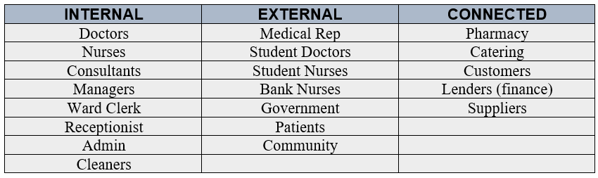

It is identified the internal stakeholders for NHS are employees such as managers, doctors, nurses, consultants, receptionist, administrators, ward clerk and cleaners. External stakeholders are government, patients, community, medical rep, student doctors, student nurses and bank nurses. Connected stakeholders are the suppliers, catering, pharmacy, customers, and lenders.

Now, it is required to work out how important the stakeholders are to the NHS. Mendelow's Matrix is an implement that might be utilized by a business to consider the state of mind of their stakeholders toward the beginning of a task or when they are setting out vital goals. Mendelow’s (1991) matrix is used in most organisations to identify their stakeholders (Business Information Resources, 2018). Below is the Mendelow’s matrix diagram which will be used to identify the power and interest of the stakeholders.

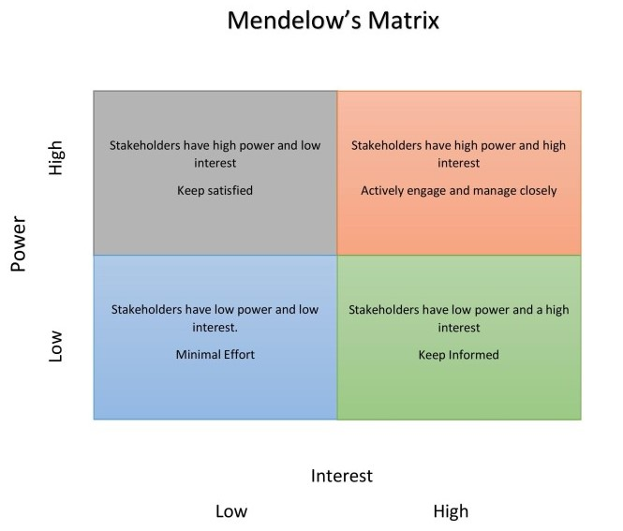

By using the Mendelow’s matrix it is required to work out the power and the interest of the stakeholders in the NHS.
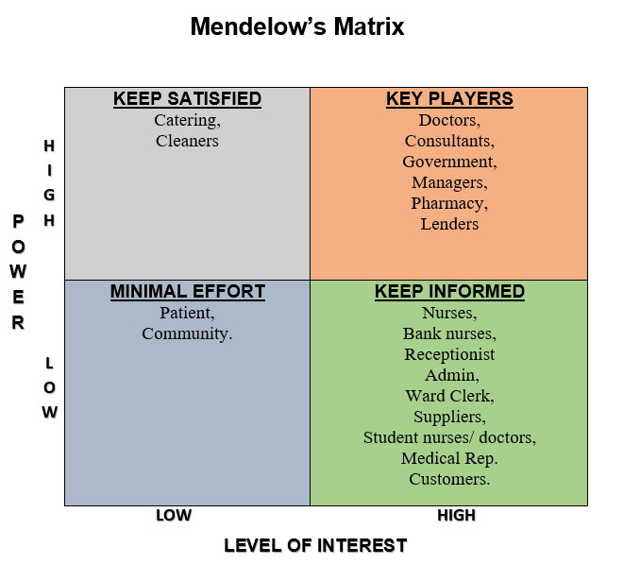

By completing the Mendelow’s matrix it is identified that doctors, consultants, government, lenders, pharmacy, and managers are the main key players without them the hospital will not run properly, they are the most important stakeholders for the NHS. The government looks after the society and gives funding to the hospitals and the lenders provide finance. The pharmacy needs to dispense medication which is needed for the patients without them there will be no treatment. Nurses, bank nurses, receptionist, admin, ward clerk, suppliers, student nurses/ doctors, medical rep, and customers have low power but high interest as they are the one who maintains the hospital and keeps the key players informed. Catering and cleaners have high power and low interest, the cleaners need to keep the hospital clean and catering needs to provide foods for the whole hospital without them the hospital will not run properly. Patient and the community has low power and low interest.

2.2.1 Stakeholders Impact

Patients want a high quality of care which the NHS is not giving them, currently, the waiting time is longer at the A&E and there are long waiting lists for surgery and appointments which is affecting them (NHS Provider, 2018). Shortage of staff is affecting the employees as there is high pressure on them which could increase illnesses (Murray, 2017) and, they want improved working condition. Suppliers want regular orders and immediate payments, if the NHS does not order and provide their payment on time it will affect the suppliers. The government provides funding for the hospital, they look after the NHS and make sure it is running properly so it is necessary for the NHS to run properly for the society and if it does not run properly it will affect the government and all the stakeholders.

2.3 PESTLE Analysis

The PESTLE analysis will be used to discover the problems of the NHS. PESTLE analysis is a useful implement to recognise the external factor that affects the organisations (Newton and Bristoll, 2013). Pettinger (2012) stated that it helps the organisation to understand the environment and the strategic situation. PESTLE analysis lets the organisation understand the political, economic, social, technological, legal and environmental situation.

2.3.1 Political Impact on the NHS

The political impact the NHS is having is because of the government as they are not funding enough money. The government is run by the Prime Minister Theresa May who is the leader of the conservative party, it is assisted by the cabinet and ministers to run the government. The Secretary of State, Jeremy Hunt who works in the department of health and social care is responsible for the NHS, his responsibility is to keep an eye on the financial and performance of NHS (GOV.UK, 2018). The opposition party of the government is the labour party which is run by Jeremy Corbyn, he is the leader of the opposition party. The labour party leader chooses “ a shadow cabinet to follow the work of government departments” (UK Parliament, 2018). According to Ham (2017) “the real NHS crisis is political not humanitarian.” Ham (2017) stated that all politician parties have not provided enough funding for the health and social care. As stated by McKenna (2016) that Brexit is the political impact, due to Brexit there will be many problems. Rushforth (2016) stated the political leader is weak, and the NHS needs a strong leadership to sort out the NHS issues.

2.3.2 Economic Impact of the NHS

The NHS is not receiving enough funding due to the cut which impacting on the economic (Hunt, 2016). As mentioned by the NHS England (2018), since the recession of 2008, the NHS funding has gone slower and they are not receiving enough funding from the government. According to Blackburn (2018) since the United Kingdom (UK) austerity started more people are waiting on trolleys because of a shortage of beds and staffs. Less funding is being made to the mental health and acute hospitals, because of that the shortage of staff has increased which has impacted on the standard and safety of care (The King's Fund, 2018). The Guardian Newspaper has stated the coroners have found in the last six years that there were forty-five cases in England and Wales which were affected due to less funding and shortage of beds, shortage of staff and consultants for the mental health treatments which also may have caused deaths (Duncan, Bawden and Campbell, 2018). The BBC News (2018) stated that missed appointments are costing the NHS, the cause of the missed appointment could be because patients are forgetting about it or they are ill on that day. The A&E is not meeting the target of fours wait, people are waiting than four hours. This has mainly affected the economic, according to the Guardian Newspaper (Campbell, Marsh and Duncan, 2018) the NHS performance for this year was 77.3%, it is worse than the previous year which was 77.6%. The A&E department of the NHS is not meeting the 95% target.

2.3.3 Social Impact of the NHS

The social impact the NHS is having is that the public is making more demands on health professionals and people spending more time on making decisions and finding about their health and care, due to the rising demand it is causing the patient to wait longer (Robertson, 2016). The patient expectation of high quality care is increasing (Dixon, 2015). According to Roberts and Charlesworth (2014), the ageing population is causing more people being admitted to hospital because of chronic disease. Also, stated by Thompson (2015) more people are living longer and as they get old they are at high risk of having a fall, disability and being admitted to the hospital, also they need long-term care. Another social impact the NHS is having is that there is a rise in obesity, according to NHS Digital (2017) in 2015, fifty-eight percent women and sixty-eight percent men were obese or overweight, because of obesity more people are being admitted to the hospital.

2.3.4 Technological Impact of the NHS

The technological impact the NHS is having is that the NHS is slow in accepting the latest technology. The latest technology will help the healthcare to deliver information such as patients information, booking appointments, getting the diagnostic technology available to consumer, monitoring and improving communication between patients, carers and professional (The King’s Fund, 2018). Also, technology can cause many failures as mentioned by Donnelly (2018), the poor computer system may have caused up to 900 deaths yearly and the cyber security of information technology (I.T.) system is not up to date. Also, stated by Smith (2018) due to I.T. failure, the doctors could not access to patient records. Therefore, the I.T. system needs to be up to date.

2.3.5 Legal Impact of the NHS

The legal impact of the NHS is the European working time directive which was launched to help staffs “by limiting the maximum amount of 48 hours each week, as well as setting minimum requirements for rest periods and annual leave,” if the UK amend the working hours then the contracts and the wages will be affected (McKenna, 2016). Also according to McKenna (2016), due to Brexit, there will be problem getting staffs into the hospitals from other countries because of the European Union’s policy freedom of movement, as most of the staff are from European Union (EU) countries, the staff are leaving the UK to work in other countries until something is not done about it there will be problems having permanent staff in the NHS. Also, Zanon (2018) stated that the NHS relies on EU workers as ten per cent of doctors and five per cent of nurses presently are from the EU, there are over 160,000 EU/EEA nationals are working in the health and social sector. There will be problems with access to medicines as at present the UK is part of the European Medicines Agency which controls the permission for medicines to be established on the EU market. The UK relies on the international supply chain for pharmaceutical and medical devices. Also, Zanon (2018) mentioned the collaborative research will be affected as UK organisations benefit large amount from the EU health research funds. Also, due to Brexit, the clinical trials will be affected, the UK is unsure if they will have access to the EU portal and database.

2.3.6 Environmental Impact of the NHS

The NHS has focussed to save money by decreasing the carbon emission which will benefit people’s health, they have decided to motivate staff to walk or travel by bike to work. Also, they have decided to increase the use of technology for communication between staff and patients who have long-term health conditions, and by supplying mental health services for people who attend for physical health needs in hospitals (NHS England, 2016). Also, according to the sustainability strategy the NHS is required to reduce the carbon emission, needs to save water and electricity so it will help the NHS financial crisis, the NHS is requiring staffs to recycle waste which will help the environment (Fenwick, 2016). As from the researcher's experience, there is a crisis in parking for visitors and staffs, the staff and patients are finding it hard to find any parking spaces when they go for appointments or work.

2.4 Problem Solving and Decision Making

By completing the PESTLE, it was identified that there are many problems in the NHS. A problem is a situation considered as uninvited or dangerous which needs to be sorted (Oxford dictionaries, 2018). It was also identified that many problems are linked to each, for example, Brexit is the political, economic, social and legal problem.

Two problems will be chosen and will be discussed in detail by using decision making models. There are many models used for decision making such as PMI, grid analysis, Edward de Bono six thinking hats, the Five Why and the Fishbone. The Five Why and the Fishbone has been chosen to be used to discuss in more detail.

2.4.1 Problem One: Shortage of Staff

For the first problem, an economic problem will be investigated which is a shortage of staff. The five why will be used to find out the cause of the problem.

The Five Why

The Five Whys is used to find out the root cause of a problem by asking why until they get the answer. It enables the person to decide the connection between various root causes of an issue. The Five Whys is a straightforward and easy tool to use. The tool could be used separately or in addition to a root cause analysis. The tool rapidly helps any person to recognise the cause of the issue (NHS Improvement, 2017).
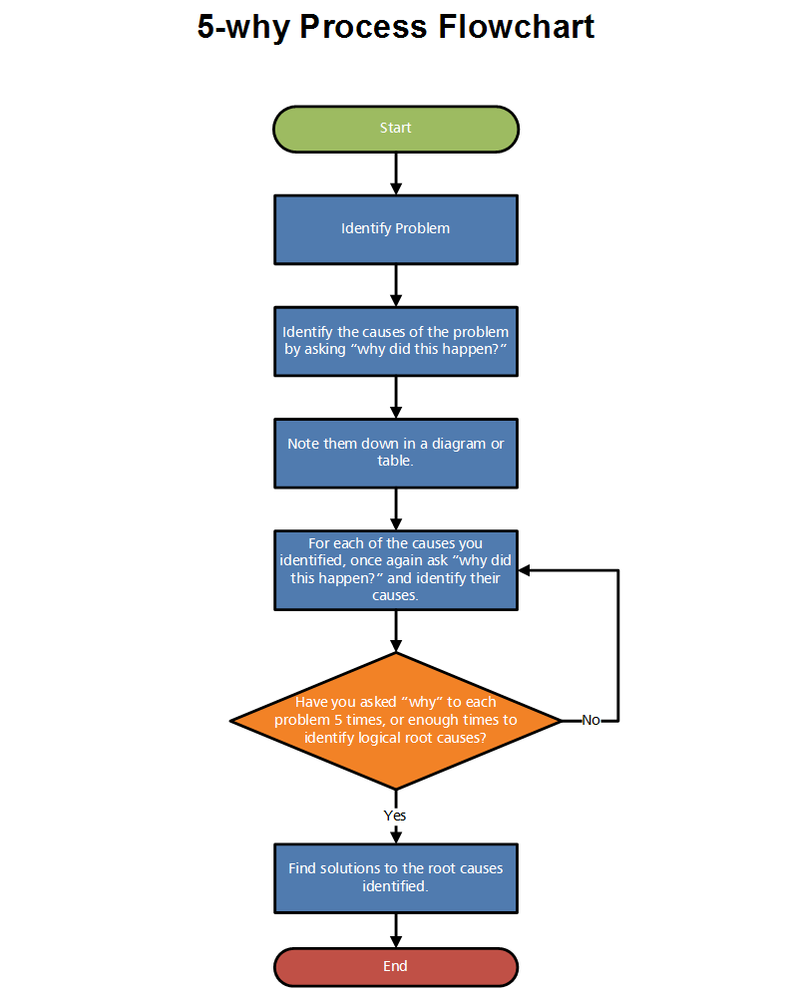
(Seiter, 2014)
To use the five why process, it is necessary to write down a problem. Then it is required to ask why the problem is occurring until the person gets the right answer. Sometimes the person will get the answer after few whys but sometimes it is required to answer full five why until they get the actual right answer.

The Five Why of Shortage of Staff

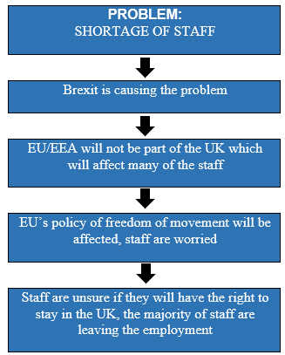

By using the five why the researcher has identified the issues. The cause of the problem is that the staff are leaving the UK employment in the NHS as the staff unaware if they will have the right to stay in the UK. The staff are thinking they might be asked to leave the UK. Due to Brexit the EU’s policy freedom of movement which will affect the policy, it might stop people having the right to work in the UK. People are afraid, so they decided to leave employment in the UK. As the researcher has explained in the PESTLE that the NHS relies on the EU workers as many workers are from the EU working in the NHS. Since the Brexit started the NHS started to get worse as there are many staff leaving the employment and due to that the NHS suffering getting doctors and nurses. Therefore, shortage of staff is a big impact on the NHS, it needs to be sorted out, and so the NHS can run properly. To solve this problem, it is required to find a way to solve the staff problem and to stop them from leaving the employment.

2.4.2 Problem Two: The A&E Waiting Time

Another economic problem is the A&E waiting time, the A&E department has the worst waiting time ever. The Fishbone analysis will be used to investigate the cause of the problem.

The Fishbone

The Fishbone is a cause and effect analysis which allows anyone to thoroughly consider the reasons and what main issues affecting the problem before finding any answers or solutions. By finding the main issues the person can start erasing the problem. The Fishbone tool should be used when someone wants to know or decide why a specific problem is happening. This tool will help anyone thoroughly recognise the issue and all the potential cause. The fishbone diagram is also called the Ishikawa diagram, it was created by Professor Kaoru Ishikawa in 1968 (NHS Improvement, 2017).

Example of a Fishbone diagram:
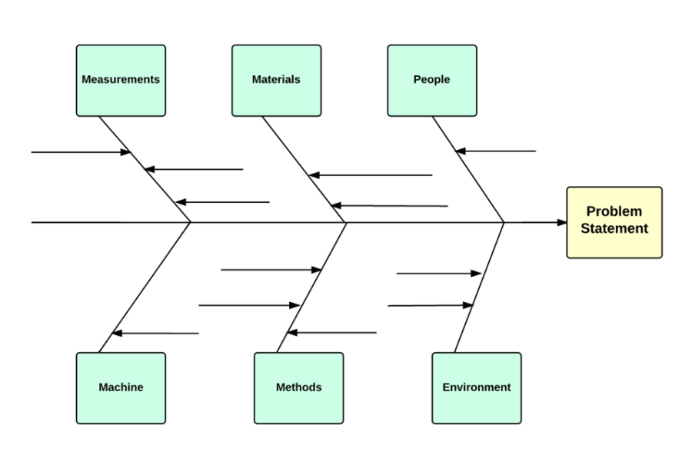
(Lucidchart, 2018)

To use the fishbone, it is required to recognise an issue then think about it in detail, it is required to find out “who is involved, when and where it occurs” (NHS Improvement, 2017). It is required to put the issue in the problem statement box, then draw the long arrow line pointing the problem box. After it is required to recognise the vital elements and it is required to draw four or more lines from the long arrow and make boxes, then it is required to brainstorm the causes by drawing small arrows.

The NHS has mentioned the fishbone has been used in their hospitals to identify the problems and to find solutions. By using the diagram above, it will be used to identify the causes of the A&E waiting time.

The Fishbone of the A&E Waiting Time

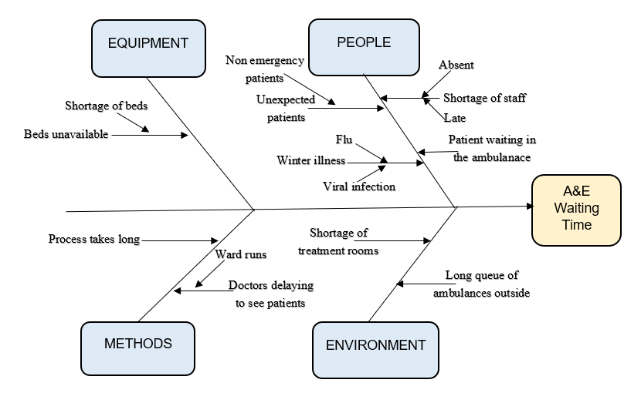

The fishbone diagram shows the issues which are affecting the A&E waiting time. The A&E department is affected by the shortage of staff, the reason could be that the staff is absent due to illness or the staff coming late. There are unexpected patients going to A&E, for example, a non-emergency patient who could have waited to see a GP next day is attending the A&E. During the winter, more and more people gets ill with flu or viral infection due to this people are attending the A&E. The A&E process takes longer such as discharging patients which always gets delayed due to that many patients are waiting in the ambulance and in the waiting area. Also, there are beds unavailable for the patients and the nurses are taking long to treat patients or to see them. The doctors are delaying seeing the patients as there are not many doctors available, the doctors also must do ward runs before seeing the patients in the A&E. There is a shortage of treatment rooms, the nurses are unable to empty treatment rooms quickly because all this process is very slow.

To solve this problem, it is required to sort out the shortage of staff, unexpected patients who are attending the A&E, the winter illnesses, shortage of treatment rooms, the process which is taking long, doctors delaying seeing the patients and the shortage of beds. If these issues are solved, then the waiting time in the A&E will reduce and improve.

2.5 The SWOT Analysis of the NHS

The SWOT analysis is a business investigation method which helps the company to find out how their market, products, and services are performing before choosing the ideal approach to accomplish future development. The procedure includes recognising the strengths and weaknesses of the company, the opportunities, and threats being in the market that it works in. The principal letter of four elements makes the acronym SWOT (Newton and Bristoll, 2013).
Below is the table the most companies use:
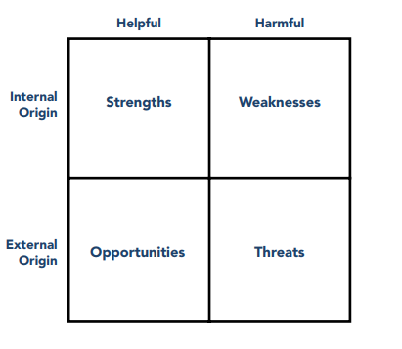

Swot Analysis – NHS

The SWOT analysis of the NHS:
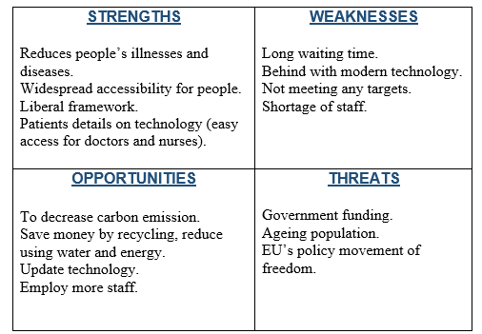

By completing the SWOT analysis, it is identified that the strengths of the NHS are that they can reduce people’s illnesses and diseases, they have widespread accessibility for people as NHS is available in every city in UK, liberal framework, patients’ details are available through technology which makes the doctors and nurses access quickly. The weaknesses are that the waiting time is long, they are backdated with technology, they are not meeting the targets and shortage of staff. The opportunities they have are they can decrease carbon emission, save money by recycling, reducing water and energy, they could update to latest modern technology and employ more staff. The threats they are having are because of the ageing population, the change of the EU’s policy movement of freedom which will affect the EU staff who are working in the NHS and the government funding as they are not receiving enough funding to cope with the crisis.

3.0 Conclusion

To conclude, it was possible to identify the internal, external and connected stakeholders by brainstorming. By using the Mendelow’s matrix it was possible to discover the power and interest level of the stakeholder in the NHS and the stakeholder’s impact. By utilising the PESTLE analysis, it was possible to discover the political, economic, social, technological and environmental situation. The SWOT analysis was applied to discover the strengths, weaknesses, opportunities, and threats in the NHS. The two economic problems were investigated by using the decision-making tools which are the five why and the fishbone models. The five why was used to discover the shortage of staff problem and the fishbone diagram was used to discover the causes of the A&E waiting time problem. By using the five why and the fishbone models it was possible to locate the causes of the problem and what is causing it.

By completing the five why for the problem of shortage of staff, it was discovered that the staff from the EU are leaving because of the Brexit which will affect the EU’s policy freedom of movement. Therefore, the staff are unsure if they will have the right to work and stay in the UK. Due to all these issues, the NHS is short of staff. Also, by completing the fishbone diagram for the problem of the A&E waiting time, it was discovered that the A&E process is taking too long, there are non-emergency patients attending the A&E, there is shortage of treatment rooms, doctors are delaying to see patients in the A&E, there are more people getting ill because of the winter and also there is shortage of beds.

4.0 Recommendations

Below are the recommendations which are required to solve the problems:

4.1 Problem One: Shortage of staffs
It is recommended for the government to sort out the EU’s policy freedom of movement, so the EU staff could work in the UK. The staff should have the permit to stay in the UK until they have the employment, this will sort the problem the NHS is having a shortage of staff.

4.2 Problem Two: A&E Waiting Time
It is recommended to employ more doctors and nurses to make the process fast. During the winter, the patients should be encouraged to use the non-emergency number, many of the problems could be sorted out by calling the non-emergency number as the nurses and doctors could advice and give prescriptions, this will save many people going to the A&E department. The government should fund more money for treatment room, so the A&E could have extra treatment rooms. If all these problems get sorted then the process will be quicker, and the beds will be available, there should not be any patients waiting in the ambulance.

4.3 SWOT Analysis of the NHS
It is recommended to change the weaknesses which are the long waiting times, behind with the technology, not meeting any targets of the NHS and shortage of staff to the strengths. It is also required to complete the opportunities of decreasing the carbon emission, save money by recycling, by reducing use of water and energy, employing more staff and by updating the technology to gain success and it is necessary to tackle the threats, so the NHS can run properly.

Reference List

BBC News. (2018). Missed NHS appointments 'infuriating'. [online] Available at: http://www.bbc.co.uk/news/av/uk-wales-43001269/missed-nhs-appointments-infuriating-for-doctors [Accessed: 10th March, 2018].
Blackburn, P. (2018). Emergency waiting times worst since records began. [online] Available at: https://www.bma.org.uk/news/2018/march/emergency-waiting-times-worst-since-records-began [Accessed: 9th March, 2018].
Business Information Resources, (2018). Mendelow's Matrix. [online] Available at: https://bizzledizzle.com/strategy/mendelow-matrix/ [Accessed: 18th February, 2018].
Campbell, D., Marsh, S. and Duncan, P. (2018). Percentage of A&E patients treated within four hours at lowest ever level. [online] Available at: https://www.theguardian.com/society/2018/jan/11/number-of-a-and-e-patients-treated-within-four-hours-at-lowest-ever-level [Accessed: 23rd March, 2018].
Dixon, J. (2015). The NHS has social objectives as well as economic ones. Can we reconcile them? [online] Available at: https://www.theguardian.com/commentisfree/2015/nov/08/national-health-service-deficit-junior-doctors [Accessed: 6th March, 2018].
Dolton, P. (2017). Is NHS Funding in crisis? [PDF] London: National Institute of Economic and Social Research. Available at: https://www.niesr.ac.uk/sites/default/files/publications/NIESR%20Briefing%20Paper%20No5%20-%20Is%20NHS%20Funding%20In%20Crisis.pdf [Accessed: 12th April, 2018].
Donnelly, L. (2018). More than 900 NHS deaths yearly may be caused by IT failings. [online] Available at: http://www.telegraph.co.uk/news/2018/02/06/900-nhs-deaths-yearly-may-caused-failings/ [Accessed: 7th February, 2018].
Doyle, C. (2011). Brainstorming. In A Dictionary of Marketing. (Third edition). Oxford University Press. Retrieved: 18th February, 2018, from http://www.oxfordreference.com.ezproxy.uwtsd.ac.uk/view/10.1093/acref/9780199590230.001.0001/acref-9780199590230-e-0192.
Duncan, P., Bawden, A. and Campbell, D. (2018). NHS shortfalls affected dozens of mental health patients who later died. [online] Available at: https://www.theguardian.com/society/2018/mar/06/lack-of-beds-and-staff-for-mental-health-patients-crucial-failings [Accessed: 20th March, 2018].
Fenwick, S. (2016). Sustainable Healthcare Strategy 2016-2020. [PDF] Newcastle: NHS Foundation Trust, pp.3-5. Available at: http://www.newcastle-hospitals.org.uk/downloads/About%20us%20pages/Sustainability_Strategy.pdf [Accessed: 10th March, 2018].
GOV.UK, (2018). How government works. [online] Available at: https://www.gov.uk/government/how-government-works#who-runs-government [Accessed: 13th March, 2018].
GOV.UK, (2018). Secretary of State for Health and Social Care. [online] Available at: https://www.gov.uk/government/ministers/secretary-of-state-for-health-and-social-care [Accessed: 13th March, 2018].
Ham, C. (2017). Political crisis in the NHS. [online] Available at: https://www.kingsfund.org.uk/publications/articles/political-crisis-nhs [Accessed: 27th February, 2018].
Hunt, J. (2016). A strong NHS needs a strong economy. [online] Available at: https://www.gov.uk/government/speeches/a-strong-nhs-needs-a-strong-economy [Accessed: 6th March, 2018].
McKenna, H. (2016). Five big issues for health and social care after the Brexit vote. [online] Available at: https://www.kingsfund.org.uk/publications/articles/brexit-and-nhs [Accessed: 3rd March, 2018].
Murray, R. (2017). Falling number of nurses in the NHS paints a worrying picture. [online] Available at: https://www.kingsfund.org.uk/blog/2017/10/falling-number-nurses-nhs-paints-worrying-picture [Accessed: 14th March, 2018].
Newton, P. and Bristoll, H. (2013). PESTLE Analysis. [eBook] Available at: http://www.free-management-ebooks.com/dldebk-pdf/fme-pestle-analysis.pdf [Accessed: 2nd February, 2018].
Newton, P. and Bristoll, H. (2013). SWOT Analysis. [eBook] Available at: http://www.free-management-ebooks.com/dldebk-pdf/fme-swot-analysis.pdf [Accessed: 28th March, 2018].
NHS, (2015). The NHS history (1948-1959) - NHS England - NHS Choices. [online] Available at: https://www.nhs.uk/NHSEngland/thenhs/nhshistory/Pages/NHShistory1948.aspx [Accessed: 20th March, 2018].
NHS, (2018). Today's NHS - our current challenges. [online] Available at: https://www.myhealth.london.nhs.uk/help/nhs-today [Accessed: 26th January 2018].
NHS choices, (2015). NHS services explained - The NHS in England. [online] Available at: https://www.nhs.uk/NHSEngland/AboutNHSservices/Pages/NHSServices.aspx [Accessed: 17th February, 2018].
NHS choices, (2016). About the National Health Service (NHS) in England. [online] Available at: https://www.nhs.uk/NHSEngland/thenhs/about/Pages/overview.aspx [Accessed: 11th February, 2018].
NHS Confederation, (2017). NHS statistics, facts and figures. [online] Available at: http://www.nhsconfed.org/resources/key-statistics-on-the-nhshttp://www.nhsconfed.org/resources/key-statistics-on-the-nhs [Accessed: 12th April, 2018].
NHS Digital, (2017). Statistics on Obesity, Physical Activity and Diet. [online] Available at: http://digital.nhs.uk/catalogue/PUB23742 [Accessed: 13th March, 2018].
NHS Digital, (2017). Statistics on Smoking, England - 2017 [PAS]. [online] Available at: http://digital.nhs.uk/catalogue/PUB24228 [Accessed: 12th April, 2018].
NHS Digital, (2018). Statistics on Obesity, Physical Activity and Diet - England, 2018. [online] Available at: https://digital.nhs.uk/catalogue/PUB30258 [Accessed: 12th April, 2018].
NHS England, (2016). NHS England » The Sustainable Development Unit for NHS England and Public Health England. [online] Available at: https://www.england.nhs.uk/2016/06/sustainable-development/ [Accessed: 13th March, 2018].
NHS England, (2018). NHS England » Funding and efficiency. [online] Available at: https://www.england.nhs.uk/five-year-forward-view/next-steps-on-the-nhs-five-year-forward-view/funding-and-efficiency/ [Accessed: 13th March, 2018].
NHS Improvement, (2017). Cause and effect (fishbone). [PDF] NHS. Available at: https://improvement.nhs.uk/resources/cause-and-effect-fishbone-diagram/ [Accessed: 23rd March, 2018].
NHS Improvement, (2017). Root cause analysis using five whys. [PDF] NHS. Available at: https://improvement.nhs.uk/resources/root-cause-analysis-using-five-whys/ [Accessed: 21st March, 2018].
NHS Providers, (2018). Impact on patients and staff. [online] Available at: https://nhsproviders.org/mission-impossible/5-impact-on-patients-and-staff [Accessed: 14th March, 2018].
Oxford Dictionaries, (2018). Problem | Definition of problem in English by Oxford Dictionaries. [online] Available at: https://en.oxforddictionaries.com/definition/problem [Accessed: 4th February, 2018].
Pettinger, R. (2012), Management a concise introduction, Hampshire: Palgrave Macmillan.
Professional Academy (2018). Marketing Theories - Stakeholder Mapping. [online] Available at: https://www.professionalacademy.com/blogs-and-advice/stakeholder-mapping---marketing-theories [Accessed: 11th February, 2018].
Roberts, A. and Charlesworth, A. (2014). A decade of austerity in Wales? The funding pressures facing the NHS in Wales to 2025/26. [online] Available at: https://www.nuffieldtrust.org.uk/research/a-decade-of-austerity-in-wales-the-funding-pressures-facing-the-nhs-in-wales-to-2025-26 [Accessed: 6th March, 2018].
Robertson, R. (2016). Six ways in which NHS financial pressures can affect patient care. [online] Available at: https://www.kingsfund.org.uk/publications/six-ways [Accessed: 6th March, 2018].
Rushforth, J. (2016). New analysis from the Health Foundation shows economic fallout from leaving the EU poses serious risks to NHS finances. [online] Available at: http://www.health.org.uk/news/new-analysis-health-foundation-shows-economic-fallout-leaving-eu-poses-serious-risks-nhs [Accessed: 6th March, 2018].
Seiter, C. (2014). The 5 Whys: A Simple Process to Understand Any Problem. [online] Available at: https://open.buffer.com/5-whys-process/ [Accessed: 23rd March, 2018].
Smith, M. (2018). 'Major incident' affects NHS Wales' IT system. [online] Available at: https://www.walesonline.co.uk/news/health/doctors-cant-access-patient-details-14197886#ICID=FB-Wales-main [Accessed 10th March, 2018].
The King's Fund, (2018). Mental health funding gap widens further. [online] Available at: https://www.kingsfund.org.uk/press/press-releases/mental-health-funding-gap-widens-further [Accessed: 13th March, 2018].
The King's Fund, (2018). Technology in the NHS. [online] Available at: https://www.kingsfund.org.uk/projects/technology-nhs [Accessed: 13th March, 2018].
Thompson, C. (2015). NHS England » Meeting the challenges of an ageing population. [online] Available at: https://www.england.nhs.uk/blog/catherine-thompson/ [Accessed: 13th March, 2018].
UK Parliament, (2015). Challenges of an ageing population: Key issues for the 2015 Parliament. [online] Available at: https://www.parliament.uk/business/publications/research/key-issues-parliament-2015/social-change/ageing-population/ [Accessed: 12th April, 2018].
UK Parliament, (2018). Government and Opposition roles. [online] Available at: http://www.parliament.uk/about/mps-and-lords/principal/government-opposition/ [Accessed: 15th March, 2018].
Zanon, E. (2018). Brexit: what are the potential impacts on the NHS? [online] Available at: http://ukandeu.ac.uk/brexit-what-are-the-potential-impacts-on-the-nhs/ [Accessed: 22nd March, 2018].

