

Managing Enterprise in the 21st Century

Business Plan

SmartCost
(Financial Protection and Expense Control Application)
Company Name: SmartCost

Student: Mariana Priscila Castro Nogueira
Student Number: 2439864
Lecturer: Konstantina Mari

Table of Contents

Executive Summary ............................................. 4
Business Concept ............................................... 4
Product Description ............................................ 5
Business Objectives (SMART Objectives) ......................... 5
4.1 Short-Term Objectives ......................................... 5
4.2 Long-Term Objectives .......................................... 6
Target Market and Main Advantage ............................... 7
Marketing Strategies ........................................... 8
6.1 Digital Marketing ............................................. 8
6.2 Partnership Marketing ......................................... 9
Market Analysis and Marketing Plan ............................. 10
7.1 Competitors ................................................... 10
7.2 Customers ..................................................... 11
7.3 Target Groups ................................................. 12
Funding Requirements and Allocation ............................ 13
Financial Estimate ............................................. 14
PESTEL Analysis ............................................... 15
10.1 Political Factors ............................................ 15
10.2 Economic Factors ............................................. 16
10.3 Social Factors ............................................... 17
10.4 Technological Factors ........................................ 18
10.5 Environmental Factors ........................................ 19
10.6 Legal Factors ................................................ 20
SWOT Analysis ................................................. 21
11.1 Strengths .................................................... 21
11.2 Weaknesses ................................................... 22
11.3 Opportunities ................................................ 23
Management Team & Organisational Chart ........................ 24
12.1 Management Team .............................................. 24
12.2 Roles and Responsibilities ................................... 25
Marketing Mix (4Ps) ........................................... 26
13.1 Product ...................................................... 26
13.2 Price ........................................................ 27
13.3 Place ........................................................ 28
13.4 Promotion .................................................... 29
Key Milestones ................................................ 30
Financial Plan (One Year) ..................................... 31
15.1 Sources of Finance ........................................... 31
15.2 Cash Flow Forecast ........................................... 32
15.3 Sales Forecast ............................................... 33
15.4 Cost of Production Forecast ................................. 34
15.5 Break Even Analysis .......................................... 35
Operations and Management Plan ................................. 36
Production of Good and Service ................................ 37
Technology Plan ............................................... 38
Human Resource Plan ........................................... 39
Expansion Plan ................................................ 40
Reference List ................................................ 41
Appendices .................................................... 42

Executive Summary

Business Plan – SmartCost

SmartCost is a digital financial management app designed to help small and medium-sized businesses manage expenses and improve financial stability.
Many businesses face financial problems not because they lack customers, but because they do not manage spending and cash flow properly.
The app automatically records a company’s income and expenses in real time. Every transaction updates the business balance immediately, allowing owners to see their financial situation at any moment.
SmartCost also analyses spending patterns and highlights areas where businesses may be overspending, such as inventory, logistics, utilities, or operational supplies. This helps owners make better financial decisions and control costs more effectively.
Another key feature is supplier comparison. SmartCost can suggest lower-cost suppliers by comparing market prices, helping businesses reduce expenses without compromising quality.
The business will run on a monthly subscription model, charging £15 per month. This affordable price makes it accessible for startups and small businesses.

Business Concept

SmartCost is a SaaS (Software as a Service) platform designed for small businesses, startups, retail shops, restaurants, and service companies.
The company will be registered as a Limited Company in the United Kingdom, offering legal protection for the owner and opportunities for future growth.
The main goal of SmartCost is to simplify financial management for businesses that do not have accounting expertise.

I think the most important part of the concept is simplicity. Small business owners often don’t have time to learn complex systems. By making the platform easy to use, SmartCost can be part of their daily routine without causing stress. In my opinion, this approach will make the app more appealing than other expensive or complicated tools on the market. The company can also add extra features in the future based on real user needs.

Product Description

Key functions of SmartCost include:

🔘 Automatic expense tracking
🔘 Income recording
🔘 Monthly financial reports
🔘 Profit analysis
🔘 Supplier comparison
🔘 Cost alerts

The system is simple and easy to use, especially for business owners without accounting experience.
The interface is designed to be clear and quite easy to understand, so users do not really need much training. I think this is important because many small business owners do not have time to learn complicated systems. The app also works in real time, which helps users quickly notice if something is not right with their spending. Over time, it can also help people improve how they manage their finances, not just track numbers.

Business Objectives (SMART Objectives)

- Short-Term Objectives (less than one year)

🔘 Attract 100 paying customers within the first 6 months
🔘 Launch the full mobile version
🔘 Build a strong social media presence
🔘 Establish partnerships with accountants

These short-term goals are mainly to help the business start in a stable way. In my opinion, at the beginning the focus should be more on getting users and making the brand known, not really on high profit. Also, building trust early can make a big difference later.

- Long-Term Objectives (more than one year)

🔘 Reach over 500 customers
🔘 Expand into European markets
🔘 Introduce AI-based cost prediction
🔘 Develop a multilingual version

In the long term, the idea is to grow step by step and reach more customers. Expanding into other countries might take time, but it can help increase revenue. I think adding features like AI can also make the product more attractive compared to others in the market.

SmartCost Target Market and Main Advantage

SmartCost is made for small and medium businesses that need a simple way to manage their money. The main target customers are startups, small shops, restaurants, freelancers, and service businesses.

Startups are one of the main groups because they usually don’t have much money at the start. Because of that, they need to control their spending more carefully. Sometimes they are still learning how to manage a business, so having something simple like SmartCost can really help them stay organised and avoid bigger problems later.

Small shops also deal with many daily expenses like buying products, paying bills, and working with suppliers. It is not always easy to keep track of everything, especially when the business is busy. In some cases, the owner might not even notice where money is being lost. SmartCost helps by showing all this information in a clearer way.

Restaurants are also a good example because they spend money almost every day on food, staff, and other things. If they don’t pay attention to these costs, they can lose money without realising. With the app, they can check their spending more often and try to control it better.

Freelancers and service businesses are part of this target market too. Many of them work alone or in small teams, and they usually don’t want to use complicated systems. In my opinion, they prefer something quick and easy that doesn’t take too much time. That’s why SmartCost can be useful for them.

The main advantage of SmartCost is its simplicity and focus on reducing costs. The app is easy to use and does not require a lot of training. Users can understand it quickly and include it in their daily routine without too much effort.

I think this is important because when something is too complicated, people stop using it after some time. SmartCost is more practical and feels more adapted to small businesses, not big companies.

Another point is that the app doesn’t only show numbers. It also helps users understand their spending better. Over time, they can see patterns and try to improve how they manage their money. This can help the business become more stable and avoid financial problems in the future.

Short-Term Objectives (less than a year)

In the first year, SmartCost will focus on starting the business in a stable way and understanding how users react to the app. One of the main goals is to reach around 100 paying customers within the first six months. This is important because it helps show if the idea is working in real situations.

Another objective is to launch the full mobile version, so users can access the app more easily in their daily routine. The company will also work on building a social media presence to make the brand more known and explain the benefits in a simple way.

SmartCost will also try to create partnerships with accountants, since they can recommend the app to small businesses. I think this can help build trust faster. At this stage, the focus is more on getting users and improving the product, not really on making high profits.

Long-Term Objectives (More than a year)

In the long term, SmartCost plans to grow step by step and become more stable. One of the main goals is to reach over 500 customers, which can help the business have a more regular income.

Another objective is to expand into European markets. This may take time, but it can help the company grow and reach more people. To support this, SmartCost plans to create a multilingual version of the app.

The company also wants to add new features, such as AI-based cost prediction, to make the platform more useful. I think this can make SmartCost more attractive compared to other apps.

Overall, the long-term focus is on gradual growth, improving the app, and keeping it simple and practical for small businesses.

Marketing Strategies

SmartCost’s main advantage lies in its ability to bring together real-time expense tracking, supplier price comparison, and basic financial management within a single platform. It is designed specifically for small businesses, allowing owners to better understand their spending, make more informed decisions, and reduce unnecessary costs.
Marketing Strategy 1: Digital Marketing

SmartCost will mainly rely on digital marketing to reach its target audience. Social media platforms such as Instagram, Facebook, and LinkedIn will be used to connect with small business owners. By sharing short videos, simple tutorials, and some paid advertisements, the company can explain how the platform works and show its practical value in day-to-day business activities.

Marketing Strategy 2: Partnership Marketing

Another key strategy is to develop partnerships with accountants, business advisors, and local small business networks. These partnerships can help introduce SmartCost to entrepreneurs who are already looking for ways to improve their financial management, making the promotion more direct and relevant.

Market Analysis and Marketing Plan

🔹 Competitors:
SmartCost competes with well-known platforms like QuickBooks, Xero, and FreshBooks. These apps have many features, but sometimes they feel too complicated for small business owners who don’t have accounting experience. Some users might get confused by all the options, which can make the software harder to use. It seems that focusing on simple and practical solutions could be a real advantage for SmartCost.

🔹 Customers:
The main customers are startups, small retail shops, restaurants, freelancers, and service businesses. These business owners usually want tools that are fast, easy to understand, and useful for daily tasks. Many do not have time to learn complicated software or do detailed accounting, so they value systems that give quick answers about their finances.

🔹 Target Groups:
SmartCost focuses on business owners who want clear insights and practical advice. For example, the app not only tracks expenses but also helps users notice overspending and suggest cheaper suppliers. Unlike traditional spreadsheets, it reduces stress and makes financial management more approachable. I think this kind of guidance is something small businesses really need because mistakes can cost them a lot.

Funding Requirements and Allocation

To successfully launch the business, an initial investment of £10,000 will be required. This funding will be used across several key areas to ensure the platform is fully operational and ready for users.

Approximately £4,000 will be allocated to app development and software design, as this is a core part of the business. A further £2,500 will be used for digital marketing and promotional activities to help attract early users. Around £2,000 will cover cloud storage and other technical systems needed to support the platform, while the remaining £1,500 will be set aside for customer support and administrative costs.

The initial capital is expected to come from a combination of the founder’s personal savings, a small bank loan, and potentially some small business grants.

Financial Estimate

If SmartCost manages to reach around 100 users paying £15 per month, it could generate approximately £1,500 in monthly revenue. This would offer a reasonable starting point to help cover ongoing operational costs and gradually move the business towards breaking even within the first year.

PESTEL Analysis SmartCost

Political Factors
🔘 Government support for digital innovation in the United Kingdom gives good opportunities for startup businesses like SmartCost. Public policies that support technology and small businesses can help digital companies grow faster. Also, government funding programmes and innovation grants may help new digital services develop more in the market.
🔘 Opportunity: access to government support for digital startups.
🔘 Threat: changes in government policy or less support for technology businesses in the future.
🔘 Impact on business: medium impact because political decisions can affect business growth over time.
🔘 Strategy: SmartCost should follow government programmes and apply for support if possible.

Economic Factors
🔘 During inflation or economic uncertainty, many companies try to reduce unnecessary costs and control spending more carefully. Because of this, tools like SmartCost can become more useful since businesses need affordable ways to manage expenses.
🔘 Opportunity: more demand for cost management solutions during difficult economic periods.
🔘 Threat: some businesses may avoid paying for extra software subscriptions.
🔘 Impact on business: high impact because economic conditions influence customer decisions directly.
🔘 Strategy: SmartCost should keep the monthly price affordable and show customers clear financial benefits.

Social Factors
🔘 Today, many entrepreneurs need simple financial tools because not all small business owners have accounting knowledge. Most users prefer systems that are easy to use and save time in daily business tasks.
🔘 Opportunity: growing demand for simple and practical financial tools.
🔘 Threat: some people may still prefer traditional methods like spreadsheets.
🔘 Impact on business: high impact because customer acceptance is important for business success.
🔘 Strategy: SmartCost should focus on simple design and easy use for customers.

Technological Factors
🔘 Cloud systems and mobile apps allow businesses to check finances anywhere and at any time. Technology also changes quickly, which creates opportunities to improve the system with automation and artificial intelligence.
🔘 Opportunity: use of cloud systems and future AI development.
🔘 Threat: cyber security risks and fast changes in technology.
🔘 Impact on business: high impact because SmartCost depends fully on digital systems.
🔘 Strategy: SmartCost should invest in security and update the software regularly.

Environmental Factors
🔘 Digital financial systems reduce paper use because reports and records are stored electronically. This can support environmentally friendly business practices and also improve company image.
🔘 Opportunity: SmartCost can be presented as an environmentally friendly solution.
🔘 Threat: digital systems still need energy for servers and data storage.
🔘 Impact on business: medium impact because sustainability is becoming more important for many businesses.
🔘 Strategy: SmartCost should use efficient digital systems and explain environmental benefits.

Legal Factors
🔘 SmartCost must comply with UK General Data Protection Regulation because it handles sensitive financial data. Legal compliance is important to protect customer information and keep trust.
🔘 Opportunity: legal compliance can improve customer confidence.
🔘 Threat: legal penalties if data protection rules are not followed correctly.
🔘 Impact on business: high impact because legal problems could damage the business.
🔘 Strategy: SmartCost should use secure data protection systems and follow legal rules carefully.

SWOT Analysis

Strengths

🔘 Simple and user-friendly platform, easy for business owners without accounting knowledge
🔘 Affordable monthly subscription makes it accessible for startups and small businesses
🔘 Supplier comparison feature that helps reduce costs without sacrificing quality
🔘 Real-time tracking of income and expenses for better financial awareness

These strengths make the product more attractive for small businesses that prefer something simple and affordable. I think ease of use can be a strong advantage compared to more complex systems.

Weaknesses

🔘 New brand with limited recognition in the market
🔘 Initial trust from potential customers may be low
🔘 Small team initially, which may affect rapid customer support or development

At the beginning, it may be a bit difficult to gain customer trust. The company will probably need some time to build a good reputation and show that the system works well.

Opportunities

🔘 Growth of startups and small businesses in the UK and Europe
🔘 Increasing digitalisation and adoption of cloud-based financial tools
🔘 Potential partnerships with accountants or financial advisors

There is also a good opportunity to grow through partnerships and recommendations. As more businesses start using digital tools, solutions like SmartCost can become more common.

Management Team & Organisational Chart
Management Team and Their Background

Founder
🔘 Responsible for business strategy, financial planning, and overall operations.
🔘 Holds experience in small business management and digital solutions, ensuring practical decisions for users.

The founder will also be involved in important decisions, especially in the early stages when the team is still small. In my opinion, being flexible and adapting to changes will be very important for the success of the business.
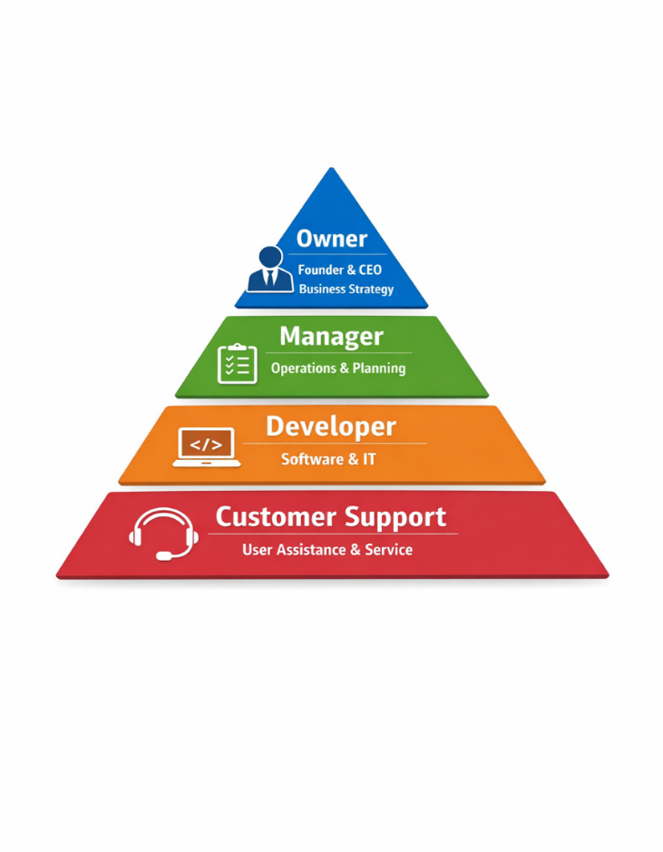
Software Developer
🔘 Develops and maintains platform security, user interface, and new features.
🔘 Focused on cloud-based solutions and mobile application optimization.

The developer will also be responsible for fixing problems and improving the system based on user feedback. This role is very important to keep everything running properly.

Marketing Manager
🔘 Leads digital marketing campaigns, social media strategy, and content creation.
🔘 Monitors customer acquisition and retention to ensure sustainable growth.

The marketing manager needs to understand the target audience and create simple but effective campaigns. I think it is more important to reach the right people than to create something too complex.

Customer Support
🔘 Provides guidance to users, resolves technical issues, and ensures smooth onboarding.
🔘 Collects feedback from users to help improve product features.

Good customer support can make a big difference, especially for new users. Even simple and quick help can improve the experience and make customers continue using the app.

Marketing Mix (4Ps)

🔹 Product:
SmartCost is a cloud-based platform that tracks income, expenses, and profits in real time. It also gives practical suggestions, like alerting users about unusual spending or comparing supplier costs. The interface is clean and easy to understand, so users can focus on their business rather than learning the software. From my perspective, small business owners will stick with it if it actually helps them every day, instead of being just another tool.

🔹 Price:
The app costs £15 per month, which is affordable for startups and very small businesses. This price makes it easy for early adopters to try the platform without worrying too much about cost. I think the key is that users should feel they are getting more value than what they pay for, otherwise it could be hard to keep them as customers.

🔹 Place:
SmartCost is fully online and mobile-friendly, so business owners can access it anywhere, anytime. This is especially important for entrepreneurs who work outside of an office. The digital-only delivery also helps the company expand easily to new regions, like other parts of Europe.

🔹 Promotion:
Promotion will focus on digital marketing and partnerships with accountants or advisors. Educational content such as tutorials, simple guides, and real-life examples will show practical benefits instead of just listing features. Promotions will emphasize that SmartCost helps users save time, avoid mistakes, and make better financial decisions, not just track income and expenses. In my opinion, showing practical results will make it more convincing than just explaining technical features.

Management Team

The management team will be small at the start but will cover key areas: development, marketing, and customer support. Each member will have clear responsibilities, so tasks stay organized. Small teams can work well because everyone knows what is happening and can help each other. The team will also meet regularly to discuss ideas and solve problems. This approach keeps the company flexible and allows improvements faster.

Management Team and Their Background

The team includes people with experience in business, technology, and marketing. The founder knows small business management and digital solutions. The developer focuses on app features, security, and stability. The marketing manager handles campaigns and social media, while customer support helps users understand the app and solve problems. Having a mix of skills is important because it allows the business to work efficiently, improve the app, and give good service to users.

Organisational Chart
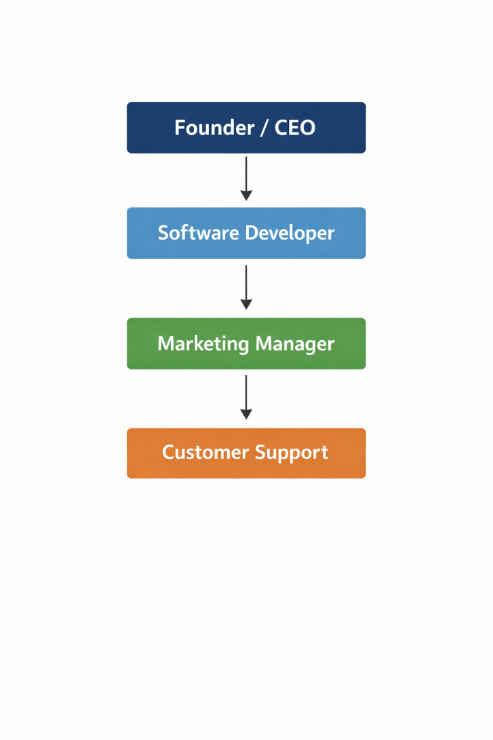

Key Milestones

First version of the app completed
🔹 Official launch for users
🔹 First paying customers
🔹 Mobile version released
🔹 Add new features based on user feedback

Milestones help the team track progress and stay motivated. Achieving small goals encourages everyone and shows the business is improving step by step.

Financial Plan (One Year)

The first year will focus on keeping costs low and attracting new users. Making profit is not the main goal at the start. The priority is to make the app work well, understand users, and build trust. Once the app is stable and has enough users, the company can focus on increasing revenue and long-term growth.

Sources of Finance

🔹 Founder’s savings
🔹 Small bank loan
🔹 Possible government grants

At the start, the business will mostly rely on internal money. Other financing options can be considered later if the company needs more funds. Using internal funds first gives more control over the business.

Cash Flow Forecast

In the beginning, expenses may be higher than income because of development, marketing, and server costs. Over time, as more users subscribe, income should become higher than costs. Checking cash flow every month helps understand where money is going and avoids surprises. It also helps plan future spending and improvements.

Sales Forecast

Sales are expected to grow slowly at first. At the start, there may be only a few customers, but the number should increase as the app becomes more known. Steady growth is more realistic than expecting too many users too quickly and makes planning easier.

Cost of Production Forecast

Main costs:
🔹 Development and updates of the app
🔹 Marketing campaigns
🔹 Cloud servers and storage
🔹 Customer support

These costs are necessary to keep the service working well. Careful planning is important to avoid spending too much while maintaining quality and user satisfaction.

Break Even Analysis

SmartCost needs a certain number of paying customers to cover monthly costs. For example, if monthly costs are £1,500, about 100 paying users are needed to break even. After this, the business can start earning profit. Knowing the break-even point helps plan growth and shows when the business starts to succeed

Operations and Management Plan

SmartCost will be mostly online, so users can access it anywhere and anytime. The team will check the app every day to make sure it works correctly, fix small issues, and update features when needed. Daily operations will also include reviewing user feedback to see what works well and what can be improved. Listening to users at the start is very important because it helps make the app more practical and prevents mistakes. Planning small improvements regularly will keep the app reliable and increase trust. Overall, the goal is to make the app smooth, fast, and easy for business owners.

Production of Good and Service

SmartCost doesn’t produce physical products. Everything is digital and available through the app. Users can track expenses, compare suppliers, and view monthly reports quickly. This is much easier than using spreadsheets or doing accounting by hand. The digital nature of SmartCost is helpful because it allows the company to grow without extra costs. Later, new features can be added depending on what users really need, like suggestions for reducing costs or alerts about unusual spending. The service is designed to make daily financial management simpler and more practical.

Technology Plan

The app will use cloud technology so users can check their finances at any time and from any device. Data will be stored securely to prevent problems or unauthorized access. The system will receive updates regularly to fix bugs, improve speed, and add small improvements. Technology should work well but also stay simple, because business owners usually don’t have technical knowledge. A reliable, fast, and easy-to-use system is important so people continue using the app over time. The company can also explore new technologies later, like AI-based cost suggestions, to improve the app.

Human Resource Plan

At first, the team will be small and flexible. People may perform more than one role, for example helping with development and customer support if needed. As more users join, the company can hire extra staff, especially for technical and support roles. Starting with a small team allows faster decisions and easier communication. Each member will be involved in the business and understand the needs of users. Later, the team can grow gradually as the business expands while keeping quality high.

Expansion Plan

SmartCost plans to expand slowly and carefully into other markets, especially Europe. First, the company will focus on countries with business systems similar to the UK. After building a strong base, new features can be added depending on user requests, like advanced reports, AI suggestions, or multilingual support. Gradual growth is better than expanding too fast because it maintains quality and keeps users happy. Slow expansion also gives the team time to adapt to new markets and learn what users really need.

Reference List

Acs, Z.J., Stam, E. and Szerb, L., 2021. The Global Entrepreneurship and Development Index 2021. Springer, Cham.

Blank, S. and Dorf, B., 2020. The Startup Owner’s Manual: The Step‑by‑Step Guide for Building a Great Company. 4th ed. Wiley.

Brynjolfsson, E. and McAfee, A., 2014. The Second Machine Age: Work, Progress, and Prosperity in a Time of Brilliant Technologies. W.W. Norton & Company, New York.

Byers, T., Dorf, R.C. and Nelson, A.J., 2014. Technology Ventures: From Idea to Enterprise. 4th ed. McGraw‑Hill Education, New York.

Haines, S.G., 2014. Successful Business Plan: Secrets & Strategies. 6th ed. The Planning Shop, Inc., Palo Alto, CA.

Ries, E., 2011. The Lean Startup: How Today’s Entrepreneurs Use Continuous Innovation to Create Radically Successful Businesses. Crown Business, New York.

Teece, D.J., 2010. Business Models, Business Strategy and Innovation, Long Range Planning, 43(2‑3), pp.172–194.

Wernerfelt, B., 1984. A Resource‑Based View of the Firm, Strategic Management Journal, 5(2), pp.171–180.

Zott, C., Amit, R. and Massa, L., 2011. The Business Model: Recent Developments and Future Research, Journal of Management, 37(4), pp.1019–1042.

Appendices:

This section includes extra documents that support the SmartCost business plan and give more detail about how the idea was developed.

The appendices include:

🔘 Market research, such as survey results and feedback from potential users
🔘 Financial estimates, including basic cost calculations, pricing decisions, and expected sales
🔘 Early app designs or interface examples to show how the platform will look and work
🔘 Notes and planning documents used during the development process

These materials help show why certain decisions were made, for example choosing the subscription price or deciding which features are most important for users. They also show that the idea was carefully planned and based on research, not just guesses.

The appendices can also include extra details that were not in the main sections, which helps keep the business plan clear and easy to read. This way, anyone who wants more information can understand the project better without making the main text too long.

Overall, this section supports the main parts of the business plan and gives a clear view of all the work behind SmartCost.

