Effective Team Working and Communication BMSW4002

Dr Nandish Patel

Aziza Nassir

2018580

Table of Contents
Introduction 1
Importance of communicational skills and its models in building an effective team 2
Significance of communication and communicational skills in effective team 2
Significant theoretical modes for effective communication and communication skills 3
Berlo’s SMCR Model of Communication 3
Shannon Weaver Model of Communication 5
Explanation of the understandings of communication by a case study 7
Impacts of poor communication in a workplace 8
Conclusion 9
References 10

Introduction
At present, all the world’s top business industries are actively working with a dynamic range of workforces from different backgrounds of culture, religion and ethical beliefs. However, despite these differences, they can effectively work together in teams which lead the organisations for becoming successful (Bell, 1981). Though the effectiveness cannot be built up that easily as it requires the team members to give effort and to regularly practice for maintaining good communications by using various theoretical models. Thus this report will discuss how a team in a company can improve their performance by using the models of commination and communicational skills.

Importance of communicational skills and its models in building an effective team

Significance of communication and communicational skills in effective team
An effective and productive team is the foundation of any high performing workplace. Even though the teams in an organisation are seen from the outside they look almost similar. But by observing the team’s performance and characteristics a person can identify between a good or bad team. A team can be distinguished by interactions, behaviours, productivity and capabilities to handle different challenges. Research has shown an effective team is built up by six constituent factors which are communication, leadership trust and respect, clear goals, diversity and ability to manage conflicts. And among these six factors communication is considered the most important component (Conway et al., 2001).
Communication is the action of receiving and sharing information from one place, person or team to another and effective communication is a method of interchanging knowledge, ideas, perspectives and information for the intention of fulfilling a significant goal. In today's business industries effective communication is considered central to every facet of organisational behaviour. Like in a workplace the employees will be able to have open honest discussions through sharing their opinions, thoughts and ideas if they have the skills of effective communication. Also, a team with good communication skills hills the function of coordination, interchange of information and the ability to share their emotions and feelings. Some of the significance of good communicational skills in an effective team are mentioned below:
Understanding their roles in a team:
In a team, each member has certain roles and responsibilities to fulfil which leads them to accomplish a significant goal. So by good communication skills, they can interact with one another when they face problems in understanding their task and responsibilities of group activity (Eliassen & Sitter, 2008).
Enhance Productivity:
A person might not feel confident and determined if he or she works by himself in a team. But maintaining communication will make them comfortable and engaged with the team members which will lead them to boost up the productivity in their performance.
Idea Generation:
Generally, managers tend to create a team with different skilled employees in each subject so by discussing among themselves through communication they can come up with new ideas which can overcome the challenges of an organisation. Additionally, each team member can learn a lot by sharing their thoughts ideas and opinions through effective communication.
Minimises Conflicts:
If a team can maintain good communication with one another then the possibility of any sort of confusion or misunderstanding will reduce as they will be able to convey their messages appropriately and clearly. As a result, there will be less chance of conflict between the members of our team.

Significant theoretical modes for effective communication and communication skills
Only delivering information to one person in a team is not enough as there is some sort of the purpose of transferring the information. In almost every organisation it can be seen that the managers spend around 90% to 50% time communicating with the other employees in the workplace. Moreover, communication can also help to develop a good professional relationship with the supervisors and the co-workers which can help a person to build trust and organisational support while working in a team (Grensing-Pophal, 2012). Many researchers have identified that good communication has shown to be significant in bringing success to a company. For these reasons, they have developed theoretical models for maintaining effective communication in the workplace. Some of these models are mentioned below:

Berlo’s SMCR Model of Communication
Berlo's SCMR model represents one of the simplest forms of the communication process. This model of communication mainly focuses on the emotional aspect of the message which is required to be transferred. This model was mainly created for improving technical communication which was related to using in team development. The acronym of SCMR model stands for the sender, message, channel and receiver which factors are briefly discussed below:
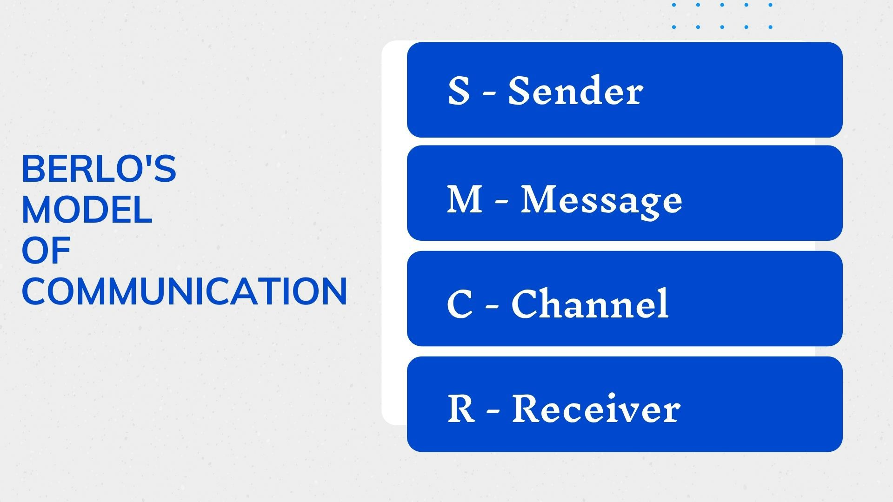
Figure 1: Berlo’s SMCR Model of Communication (Hutchinson, 2018)
Sender:
Generally, the initial sender of the message is known as the source or sender who creates the message and then passes it to the receiver. The source is also known as the starter or encoder of the communication process.
Message:
The message is the collection or package of the information for data that is transferred from the source to the receiver. This message can be passed on through various forms such as a written report, speech, audio recording, video or documents file.
Channel:
Channel is known as the medium through which the message is transferred from one person to another. The channel can be a person or system which can transmit the information in the property that can later be assimilated through sound, vision or both.
Receiver:
The receiver is known as the last person in the model who receives and can decode the messages which were passed on to him or her (Hutchinson, 2018). Also, the person should have the capability to understand what the source or the sender wants to convey and then respond accordingly.
Shannon Weaver Model of Communication
The model of communication by Shannon and weaver is one of the most popular frameworks of communication skills which is widely accepted worldwide. Many also called it 'mother of all models' because it is so widely used in many organisations today. It is a linear model of communication that provides a rigid framework for analysing the process of sending and receiving messages. Generally, this framework of communication is used for face to face discussion in the workplace (McIntosh, 1984). Here the creators of the model state that the human communication process can be broken down into 7 factors. And the seven factors of briefly discussed below:
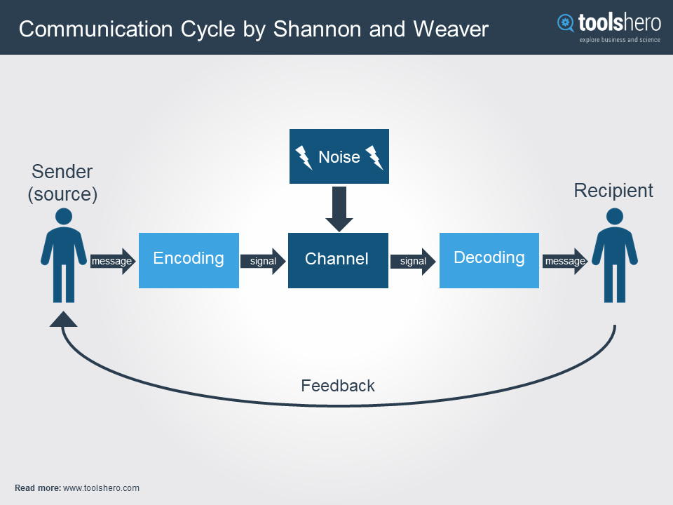
Figure 2: Shannon Weaver Model of Communication (Tyson, 1997).
Sender:
This framework also starts with the sender who is known as the information source. The communication process starts with the information source where the sender chooses a message to transfer it to the receiver for a significant purpose.
Encoder:
The next step of the framework is the person or a device that converts the information of the sender into complex forms or intelligible words and sentences for transmission. Even in companies on credit and also with the person that turns the spoken, written, sign language, or different language information for the transmission process.
Channel:
Here the channel is the media or infrastructure that takes the information from the sender and transmits it to the decoder or receiver. Like for sending a presentation to another person, email can be the channel of transmission.
Noise:
There are many sorts of factors that can obstruct the channel in sending the information properly to the decoder. Like if there is a loss of internet connection then the mail will be obstructed for the decoder or receiver to get it in time.
Decoder:
The role of a decoder is to receive the message and convert it into simpler words or language for the receiver to understand it properly. For instance, if the message is in a different language that the receiver does not understand then it is the job of the decoder to translate for him or her.
Receiver:
The receiver is considered as the endpoint in this communication model who was the main focus for the sender to pass it on. Here the receiver's job is to hear or read the decoded message and interpret or understand it accordingly (Mullins & Christy, 2015).
Feedback:
Lastly, after properly understanding and interpreting the information sent by a sender the receiver is required to respond based on his or her understanding.

Explanation of the understandings of communication by a case study
In the given third case study by Last, 2016 in Pressbooks it is seen that how the making a complex instruction manual in Sagatec Software, Inc. made the customers lose interest in the company’s market product. Even it cost the company $350,000 to rewrite the journal again along with losing its reputation in the eyes of the customers.
It is known that along with maintaining good communication within the organisation it is also necessary for the business companies to establish good communication with their customers as well. It helps them by converting them into loyal and regular customers along with increasing the sales by their good feedback to others. Poor communication can also cost a lot of money and waste the significant time of a company. So it is necessary for the organisation to properly represent its information and guidelines for the customers so they can easily understand it (Last, 2016). Like writing, instructions in manuals as mentioned in the case study should be written in simple words and sentences customers can understand.
Here according to the Shannon framework of communication the company Sagatec Software had internal noise where there was a mistake in encoding the message that was required to be written in the instruction manual. The message which was given in the manual was not properly encoded as the customers were confused to find out how to get started by reading it.
Thus going through this case study it can be understood that due to lack of proper conversation of information the company had lost its customers and had to spend a huge sum of money for redoing it again.

Impacts of poor communication in a workplace
Samsung is known as one of the most influential tech companies around the world. The company strives in the tech industry by introducing new devices like smartphones, laptops and tablets every year. At present, their appliances and electronic devices can be seen in almost every country around the world. Its revenue has risen to $211.2 billion until 2017. The company is also known to have one the most modernized and effective workplaces where the employees from different backgrounds tend to work productively by mail effective communication. However, back in 2016, the company had to go through a huge crisis due to poor communication.
A study has shown that in the UK 14% of the workweek is wasted for poor communication. Moreover, according to research from Harvard University, lack of interpersonal communication has resulted in 70% to 80% of accidents in business operations over the last 20 years. Besides throughout the years, many large organisations had to face lawsuits due to poor communication (Roche et al., 1998). For instance, even though the company Samsung is committed to producing high-quality products, the company had to face serious issues in reported cases of their Galaxy Note 7 catching on fire due to some battery cell is Issues that were caused by miscommunication between the tech developers and producers of the company. And for these cases with their smartphones the company didn't properly state the reason for these incidents which lead them to establish Paul communication with its customers. This has resulted in its market price falling drastically in 2016.
Hence, in this example, the consequence of poor communication in the workplace can be observed which can be improved by practising in uses effective models of communication among the workforces of the company.

Conclusion
In almost every aspect of life, different teams are developed for accomplishing various tasks for overcoming different challenges (Pilbeam & Corbridge, 2006). And among those teams communication is considered as the most crucial factor regardless of the role each team members are responsible for. Large companies like Samsung, Nike and Unilever shoot give more emphasis on establishing effective communication in the workplace. Otherwise, they might have to face bad consequences and loss in business.

References
Bell, J. (1981). An employee management handbook. Engineering Industry Training Board.
Conway, S., Jones, O., & Steward, F. (2001). Social interaction and organisational change. ICP.
Eliassen, K., & Sitter, N. (2008). Understanding public management and administration. SAGE.
Grensing-Pophal, L. (2012). Employee Management for Small Business. Self-Counsel Press.
Hutchinson, S. (2018). Performance management.
Last, S. (2016). 1.4 Case Study: The Cost of Poor Communication. Pressbooks.bccampus.ca. Retrieved 22 August 2021, from https://pressbooks.bccampus.ca/technicalwriting/chapter/casestudy-costpoorcommunication/.
McIntosh, R. (1984). Employee management standards. AVI Pub. Co.
Mullins, L., & Christy, G. (2015). Management and Organisational Behaviour.
Pilbeam, S., & Corbridge, M. (2006). People resourcing. Financial Times Prentice Hall.
Roche, W., Monks, K., & Walsh, J. (1998). Human resource strategies. Oak Tree Press in association with Graduate School of Business, University College Dublin.
Tyson, S. (1997). The practice of human resource strategy. Pitman Pub.

