

Programme Name: - Master of Business Administration
Module Name: - International Marketing Management
Module Code: - LCMB7026
Assignment Title: - Assessment component 1:
Individual report
Lecturer’s Name: - Dian Mayasari (Birmingham)
Student Name: - bhargav Jagdishbhai Khunt
Student Id: - 2435433
Submission Date: - Friday 27/03/2026 by 2pm
Word count: - 5352

Table of Contents
SECTION 1 Part A: Comparative PESTEL, Cultural and Consumer Behaviour Analysis of Louis Vuitton in France and Japan 4
1. Introduction 4
2. PESTEL Analysis: France vs Japan 4
2.1 Political Factors 4
2.2 Economic Factors 5
2.3 Social Factors 6
2.4 Technological Factors 6
2.5 Environmental Factors 7
2.6 Legal Factors 8
3. Cultural Analysis (Hofstede Dimensions) 8
4. Consumer Behaviour Comparison 10
SECTION 1 part B: Comparative STP and International Marketing Mix (7Ps) Analysis of Louis Vuitton in France and Japan 11
1. Introduction 11
2. Segmentation, Targeting and Positioning (STP) 11
2.1 Segmentation 11
2.2 Targeting 12
2.3. Positioning 13
3. International Marketing Mix (7Ps) 14
3.1. Product 14
3.2. Price 15
3.3 Place (Distribution) 16
3.4 Promotion 19
3.5 People 20
3.6 Process 20
3.7 Physical Evidence 21
SECTION 1 Part C: Directional Development Strategy for Louis Vuitton in Japan 23
1. Introduction 23
2. Market Context and Strategic Imperatives 23
3. Applying Ansoff’s Matrix to LV in Japan 24
3.1 Product Development Strategy 26
4. Experiential Innovation Strategy 27
4.1 Flagship Store Enhancements 27
4.2 Digital–Physical Integration 27
SECTION 1 Part D: Ethical Issues in Louis Vuitton’s International Marketing Mix in France and Japan 28
1. Introduction 28
2. Sustainability and Environmental Responsibility 28
3. Labour Practices and Supply Chain Transparency 29
4. Cultural Sensitivity in Product and Promotion 29
5. Pricing Ethics and Accessibility 30
SECTION 1 Part E: Strategic Recommendations for Louis Vuitton in France and Japan 30
1. Introduction 30
2. Strengthen Localised Product Strategies 30
3. Enhance Experiential Retail and Omnichannel Integration 31
4. Expand Sustainability and Circularity Initiatives 31
5. Deepen Cultural Sensitivity and Local Engagement 32
6. Maintain Pricing Transparency and Value Justification 32
SECTION 2: Reflective Analysis Using Gibbs’ Reflective Cycle 33
1. Description 33
2. Feelings 33
3. Evaluation 33
4. Analysis 34
5. Conclusion 35
6. Action Plan 35
Reference List: 36

SECTION 1 Part A: Comparative PESTEL, Cultural and Consumer Behaviour Analysis of Louis Vuitton in France and Japan

1. Introduction
Louis Vuitton (LV), founded in 1854, is one of the world’s most recognisable luxury brands and a flagship house within the LVMH Group. Its international strategy is deeply shaped by macro‑environmental forces, cultural dynamics and consumer behaviour patterns across markets. France, as LV’s home country, represents its heritage, brand identity and core European luxury consumer base. Japan, meanwhile, is one of LV’s most strategically important international markets, historically contributing some of the highest per‑capita luxury spending globally (McKinsey, 2023). This section provides a comparative analysis of the PESTEL environments of France and Japan, followed by an examination of cultural and consumer behaviour differences that influence LV’s international marketing strategy.

2. PESTEL Analysis: France vs Japan

2.1 Political Factors
France
France offers a stable political environment with strong support for the luxury and fashion industries, which are central to the country’s cultural identity and economic output. The French government actively promotes luxury craftsmanship through initiatives such as “Entreprise du Patrimoine Vivant,” which recognises heritage brands like LV (Le Monde, 2023). France’s EU membership also provides regulatory harmonisation and trade facilitation across European markets.

Japan
Japan is similarly politically stable, with a predictable regulatory environment and strong intellectual property protection — a critical factor for luxury brands vulnerable to counterfeiting (Nikkei Asia, 2023). Japan’s long‑standing diplomatic and trade relations with France further support LV’s operations. However, Japan’s ageing population and long‑term economic stagnation create political pressure for consumer‑focused policies, including consumption tax adjustments, which can influence luxury spending.

Comparison:
Both markets are politically stable, but France benefits from EU integration and cultural policy support, while Japan offers strong IP protection and predictable governance. LV faces low political risk in both markets.

2.2 Economic Factors
France
France is a mature luxury market with high disposable incomes, although economic growth has been modest in recent years (OECD, 2023). Inflationary pressures and cost‑of‑living concerns have affected discretionary spending, but the luxury sector remains resilient due to affluent domestic consumers and international tourism, particularly from the US, Middle East and China (Financial Times, 2023).

Japan
Japan has historically been one of the world’s largest luxury markets, with a strong middle‑class appetite for premium goods. However, decades of low economic growth and deflation have reshaped consumption patterns. Despite this, Japan remains a top‑three market for LV due to high brand loyalty and a cultural emphasis on quality and craftsmanship (Bain & Company, 2023). The depreciation of the yen has made imported luxury goods more expensive, but affluent Japanese consumers continue to prioritise luxury purchases.

Comparison:
France benefits from tourism‑driven luxury sales, while Japan relies heavily on domestic consumers. Both markets remain economically attractive, but Japan’s currency fluctuations and ageing demographics pose long‑term challenges.

2.3 Social Factors
France
France’s luxury consumption is tied to fashion culture, social identity and heritage. French consumers value authenticity, craftsmanship and brand history (Kapferer & Bastien, 2017). Luxury goods are often purchased as expressions of personal style rather than status signalling.

Japan
Japan’s social environment is distinct. Japanese consumers place high value on craftsmanship (shokunin), precision, and brand reputation. Luxury goods are often associated with social harmony, respectability and belonging (de Mooij, 2019). Japan has a long history of luxury adoption, with LV enjoying exceptional brand loyalty since the 1980s.

Comparison:
French consumers emphasise individuality and heritage, while Japanese consumers emphasise quality, social harmony and brand trust. LV must adapt its messaging accordingly.

2.4 Technological Factors
France
France has a strong digital infrastructure, but luxury consumers still value in‑store experiences. LV’s Paris flagship stores integrate digital tools such as virtual try‑on and personalised appointments (LVMH Annual Report, 2023).

Japan
Japan is one of the world’s most technologically advanced markets, with high adoption of mobile commerce, digital payments and virtual retail experiences. Japanese consumers expect seamless omnichannel integration and high‑quality digital service (Statista, 2023).

Comparison:
Japan requires more advanced digital integration, while France maintains a balance between digital and traditional luxury retail.

2.5 Environmental Factors
France
France has strict environmental regulations and strong consumer awareness of sustainability. LV has responded with commitments to circularity, eco‑design and reduced carbon emissions (LVMH, 2023).

Japan
Japan also has increasing environmental awareness, but sustainability is less central to luxury purchasing decisions compared to France. However, Japanese consumers value durability and long product lifecycles, aligning with LV’s craftsmanship ethos.

Comparison:
France places stronger emphasis on sustainability messaging, while Japan values longevity and quality.

2.6 Legal Factors
France
France’s legal environment is shaped by EU regulations on consumer protection, data privacy (GDPR), and environmental standards. LV must comply with strict advertising and labelling rules.

Japan
Japan has robust consumer protection laws and strong IP enforcement. Luxury brands benefit from Japan’s anti‑counterfeiting measures and transparent regulatory framework.

Comparison:
Both markets have strong legal protections, but France’s EU‑wide regulations are more stringent, especially regarding sustainability and data privacy.

3. Cultural Analysis (Hofstede Dimensions)
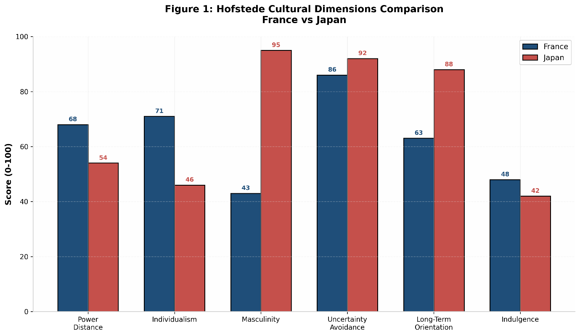
Figure 1: Hofstede Cultural Dimensions Comparison - France vs Japan

Source: Adapted from Hofstede (2011):
Using Hofstede's cultural framework (Hofstede, 2011), France and Japan differ significantly across six cultural dimensions, as illustrated in Figure 1. France scores higher on Individualism (71 vs 46), supporting marketing strategies that emphasise personal expression and fashion individuality. Conversely, Japan demonstrates substantially higher Masculinity (95 vs 43) and Uncertainty Avoidance (92 vs 86), indicating consumer preferences for achievement-oriented, high-quality products with guaranteed reliability. These cultural divergences necessitate distinct positioning strategies: France emphasises creative innovation and heritage storytelling, while Japan prioritises craftsmanship precision and brand trustworthiness.
As illustrated in Figure 1, France and Japan exhibit distinct cultural profiles that necessitate differentiated marketing approaches. France's higher Individualism score (71) supports LV's emphasis on personal expression and fashion innovation, while Japan's elevated Masculinity (95) and Uncertainty Avoidance (92) scores reinforce the strategic focus on quality, precision, and reliability (Hofstede, 2011)
Dimension France Japan Implications for LV Power Distance Moderate High Japanese consumers expect formality and hierarchy in service; France prefers egalitarian interactions.
Individualism High Low France values personal expression; Japan values group harmony and conformity.
Uncertainty Avoidance High Very High Both markets prefer reliable, high‑quality products; Japan demands exceptional precision.
Masculinity High Very High Both markets value achievement and status, supporting luxury consumption.
Long‑Term Orientation Moderate Very High Japan values durability and long‑term brand relationships more strongly.

Implications:
LV must emphasise heritage and individuality in France, while in Japan it must highlight craftsmanship, precision and reliability.

4. Consumer Behaviour Comparison
France
French luxury consumers are sophisticated, fashion‑conscious and value brand heritage. They prefer understated luxury and often purchase LV products as expressions of personal taste rather than overt status (Kapferer & Bastien, 2017). French consumers also value in‑store experiences, artisanal craftsmanship and limited‑edition collections.

Japan
Japanese consumers are among the most brand‑loyal in the world. They value:
• exceptional craftsmanship
• precision and quality
• long‑lasting products
• impeccable customer service
• brand trust and reputation
Japan’s luxury consumers are also highly informed and expect consistent quality across all touchpoints (Bain & Company, 2023). LV’s monogram has historically been extremely popular in Japan due to its recognisability and association with social respectability.

SECTION 1 part B: Comparative STP and International Marketing Mix (7Ps) Analysis of Louis Vuitton in France and Japan

1. Introduction
Louis Vuitton’s global success is rooted in its ability to adapt its segmentation, targeting, positioning (STP) and marketing mix strategies to culturally and economically diverse markets. France, as the brand’s birthplace, represents its core identity and heritage, while Japan has historically been one of its most profitable and brand‑loyal markets. This section compares how LV applies STP and the 7Ps in France and Japan, highlighting the strategic adaptations required to meet differing consumer expectations, cultural norms and market conditions.

2. Segmentation, Targeting and Positioning (STP)

2.1 Segmentation
Louis Vuitton uses a combination of demographic, psychographic and behavioural segmentation across global markets (Kotler & Keller, 2022). However, the relative importance of each segment varies between France and Japan.
France
Segmentation in France focuses on:
• Affluent professionals aged 25–55
• Fashion‑conscious consumers who value heritage and craftsmanship
• Tourists, particularly from the US, Middle East and China
• High‑net‑worth individuals (HNWIs) seeking exclusivity
French consumers often purchase luxury goods as expressions of personal style and cultural sophistication rather than overt status signalling (Kapferer & Bastien, 2017).

Japan
Japan’s segmentation is more nuanced due to its unique luxury culture:
• Urban professionals in Tokyo, Osaka and Nagoya
• Middle‑class consumers with high brand loyalty
• Older consumers (50+) who value durability and long‑term quality
• Young aspirational consumers who save for luxury purchases
Japan’s segmentation is heavily influenced by cultural norms around social harmony, respectability and quality (de Mooij, 2019). Japanese consumers tend to be highly informed and risk‑averse, preferring brands with long‑standing reputations.

2.2 Targeting
France
LV targets:
• High‑income domestic consumers
• Fashion‑driven consumers
• International tourists
France’s luxury market is strongly influenced by tourism, with Paris serving as a global luxury hub (Financial Times, 2023). LV’s targeting strategy emphasises exclusivity, heritage and fashion leadership.

Japan
LV targets:
• Brand‑loyal domestic consumers
• Quality‑driven middle‑class consumers
• Older consumers with high disposable income
Japan’s luxury market is less dependent on tourism and more reliant on domestic demand. LV targets consumers who value craftsmanship, reliability and understated elegance (Bain & Company, 2023).

2.3. Positioning
France
LV positions itself as:
• A symbol of French luxury heritage
• A leader in fashion innovation
• A brand associated with artistry, craftsmanship and exclusivity
The brand’s Parisian identity is central to its positioning, reinforcing France’s global reputation as the home of haute couture.

Japan
LV positions itself as:
• A brand of exceptional craftsmanship and precision
• A symbol of social respectability and refinement
• A provider of timeless, durable luxury goods
LV’s positioning in Japan emphasises reliability, quality and long‑term value, aligning with Japanese cultural preferences for durability and meticulous craftsmanship (Hofstede, 2011).
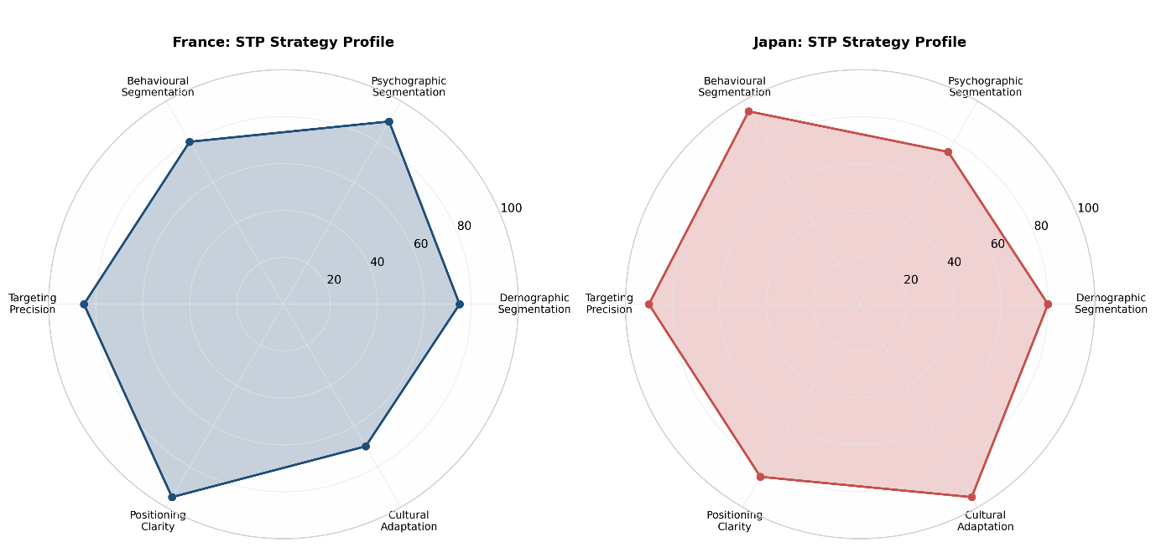
Figure 2: Comparative STP Strategy Profiles - Louis Vuitton in France and Japan

Source: Author's analysis based on Kotler & Keller (2022) and market data from Bain & Company (2023)
Radar charts illustrate strategic emphasis across six STP dimensions (scores 0-100). France demonstrates stronger Psychographic Segmentation (90) and Positioning Clarity (95), reflecting heritage-based fashion leadership. Japan exhibits higher Behavioural Segmentation (95) and Cultural Adaptation (95), indicating sophisticated responsiveness to local consumer behaviour patterns and cultural norms.
Figure 2 visualises the divergent STP strategic profiles. France's positioning emphasises psychographic alignment with fashion-conscious, heritage-appreciating consumers, while Japan's approach prioritises behavioural segmentation and cultural adaptation to address the market's distinctive emphasis on quality, precision, and social harmony (de Mooij, 2019).

3. International Marketing Mix (7Ps)

3.1. Product
France
LV’s product strategy in France emphasises:
• Fashion‑forward collections
• Seasonal runway pieces
• Limited editions
• Artistic collaborations
French consumers value creativity, design innovation and brand heritage. LV’s Paris flagship stores showcase exclusive collections and artisanal workshops to reinforce authenticity (LVMH Annual Report, 2023).

Japan
In Japan, LV adapts its product strategy to emphasise:
• Classic monogram items
• Timeless designs
• High‑quality craftsmanship
• Smaller leather goods (popular due to urban lifestyles)
Japanese consumers prefer understated luxury and long‑lasting products. LV has historically released Japan‑exclusive items, such as limited monogram variations, to cater to local tastes (Nikkei Asia, 2023).

Comparison:
France prioritises fashion innovation; Japan prioritises craftsmanship and timelessness.

3.2. Price
France
LV uses a premium pricing strategy, supported by:
• Brand heritage
• High tourist demand
• Paris as a luxury shopping destination
Prices in France are often lower than in Japan due to EU tax structures, making France attractive for international shoppers (OECD, 2023).

Japan
Japan has:
• Higher retail prices due to import duties and currency fluctuations
• A strong willingness to pay for quality
• High brand loyalty that reduces price sensitivity
Despite higher prices, Japanese consumers continue to purchase LV due to trust in the brand and perceived long‑term value (Bain & Company, 2023).

Comparison:
France benefits from competitive pricing for tourists; Japan maintains higher prices but faces less price resistance.

3.3 Place (Distribution)
France
LV’s distribution strategy includes:
• Flagship stores in Paris (Champs‑Élysées, Place Vendôme)
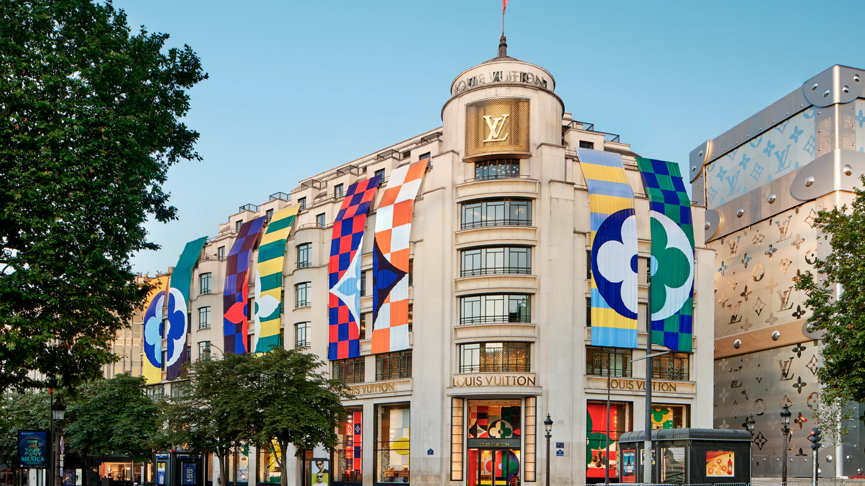
Figure 3: Louis Vuitton Maison Champs-Élysées, Paris
Source: Louis Vuitton (2024)
The Champs-Élysées flagship exemplifies LV's French retail strategy, combining Art Deco heritage architecture with contemporary artistic installations. This location serves as both retail destination and cultural landmark, attracting international tourists and reinforcing brand heritage positioning.
LV's Paris flagship stores, illustrated in Figure 3, function as experiential destinations that integrate heritage architecture with contemporary art installations, reinforcing the brand's French luxury identity and serving as pilgrimage sites for international tourists (LVMH Annual Report, 2023).
• Boutiques in major cities
• Selective distribution to maintain exclusivity
France also benefits from high tourist footfall, making physical stores central to LV’s strategy.

Japan
Japan has one of LV’s most extensive retail networks globally, including:
• Flagship stores in Tokyo (Omotesando, Ginza)
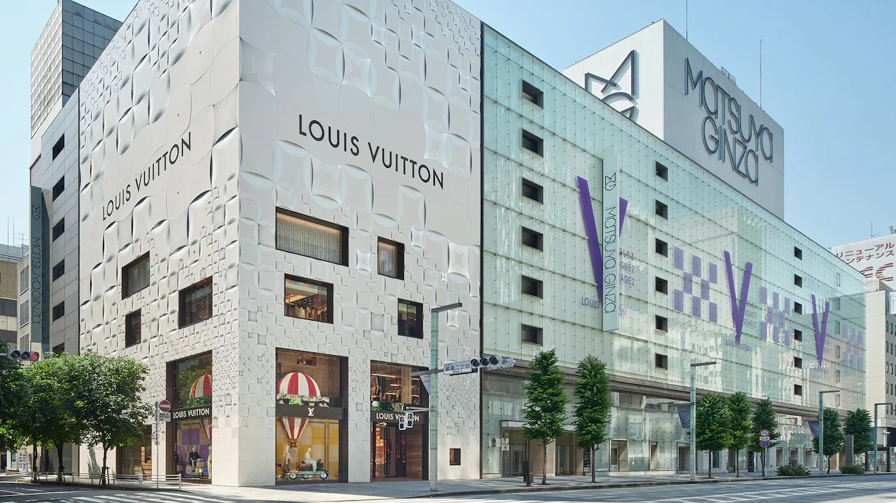
Figure 4: Louis Vuitton Matsuya Ginza Store, Tokyo
Source: Louis Vuitton (2024)
The Ginza flagship demonstrates LV's adaptation to Japanese aesthetic preferences. The building's minimalist facade and precise geometric patterns reflect Japanese values of simplicity, refinement, and meticulous attention to detail, contrasting with the ornate heritage presentation of Parisian stores.
As shown in Figure 4, LV's Japanese retail architecture adapts to local aesthetic sensibilities, emphasising minimalist design and precision engineering that resonates with Japanese cultural values of shibumi (understated beauty) and monozukuri (craftsmanship excellence) (Nikkei Asia, 2023).
• Department store concessions (Isetan, Takashimaya)
• High‑end malls
Japan’s retail environment demands impeccable service, and LV stores are known for exceptional customer experience (Nikkei Asia, 2023).

Comparison:
France emphasises flagship heritage stores; Japan emphasises accessibility and service excellence.

3.4 Promotion
France
Promotional strategies focus on:
• Fashion shows
• Artistic collaborations
• Celebrity endorsements
• Heritage storytelling
LV leverages Paris Fashion Week and French cultural identity to reinforce brand prestige (Kapferer & Bastien, 2017).

Japan
Promotion in Japan emphasises:
• Craftsmanship
• Quality
• Subtle, refined advertising
• Collaborations with Japanese artists and designers
LV adapts its communication to align with Japanese preferences for subtlety and respectability (de Mooij, 2019).

Comparison:
France uses bold, fashion‑driven promotion; Japan uses subtle, craftsmanship‑focused messaging.

3.5 People
France
Staff are trained to deliver:
• High‑end service
• Fashion expertise
• Multilingual support for tourists

Japan
Japan has some of the highest service expectations globally. LV staff are trained in:
• Omotenashi (Japanese hospitality)
• Precision and politeness
• Long‑term customer relationship building

Comparison:
Japan requires more formal, meticulous service standards.

3.6 Process
France
Processes emphasise:
• Luxury retail theatre
• Personalised appointments
• Exclusive in‑store experiences

Japan
Processes emphasise:
• Efficiency
• Consistency
• High‑precision service
• Minimal waiting times

Comparison:
France focuses on experiential luxury; Japan focuses on flawless execution.

3.7 Physical Evidence
France
Physical evidence includes:
• Iconic Parisian architecture
• Artistic store interiors
• Heritage displays

Japan
Physical evidence includes:
• Minimalist, refined store designs
• High‑tech integration
• Impeccable cleanliness and organisation

Comparison:
France emphasises heritage aesthetics; Japan emphasises precision and refinement.

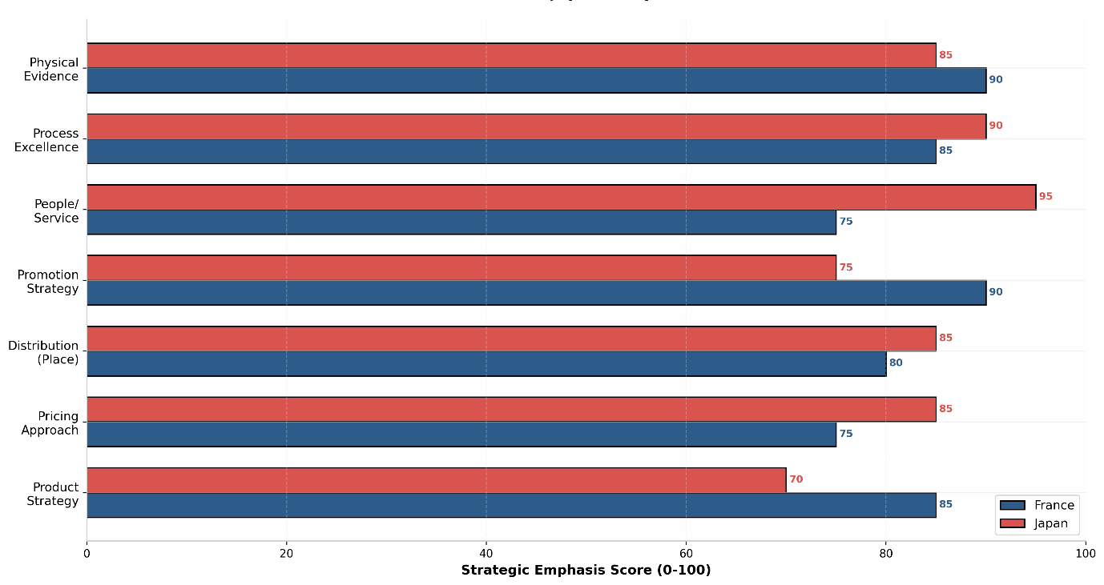
Figure 5: Louis Vuitton 7Ps Marketing Mix Strategic Emphasis - France vs Japan Comparison
Source: Author's analysis based on LVMH Annual Report (2023) and Bain & Company (2023)
Strategic emphasis scores (0-100) represent relative importance of each marketing mix element in respective markets. France prioritises Product Strategy (85) and Promotion (90) driven by fashion innovation and heritage storytelling. Japan emphasises People/Service (95) and Process Excellence (90), reflecting cultural values of omotenashi (hospitality) and operational precision.
Figure 5 illustrates the divergent strategic emphases within LV's marketing mix. While France allocates greater resources to fashion-forward Product Strategy and promotional campaigns leveraging Paris Fashion Week, Japan concentrates on People and Process dimensions, where service standards and operational excellence drive competitive advantage (Bain & Company, 2023).

SECTION 1 Part C: Directional Development Strategy for Louis Vuitton in Japan

1. Introduction
Japan has long been one of Louis Vuitton’s most strategically significant international markets, characterised by exceptional brand loyalty, high purchasing power among urban consumers, and a cultural appreciation for craftsmanship and quality. To sustain growth in a mature and highly competitive luxury market, LV must adopt a clear directional development strategy. Using Ansoff’s Matrix and supported by contemporary luxury market insights, this section evaluates the most appropriate strategic direction for LV in Japan.

2. Market Context and Strategic Imperatives
Japan’s luxury market remains resilient despite demographic challenges and prolonged economic stagnation. According to Bain & Company (2023), Japan continues to rank among the top global luxury markets, driven by strong domestic demand, an ageing but affluent population, and a cultural emphasis on quality and longevity. Japanese consumers exhibit some of the highest levels of brand trust and loyalty globally, particularly towards heritage luxury houses such as Louis Vuitton (Nikkei Asia, 2023).

However, the market is evolving. Younger consumers are increasingly influenced by digital channels, experiential luxury, and collaborations with contemporary designers. Meanwhile, the depreciation of the yen has increased the cost of imported luxury goods, requiring brands to justify premium pricing through enhanced value propositions (Financial Times, 2023). These shifts necessitate a strategic approach that balances LV’s heritage with innovation and local relevance.

3. Applying Ansoff’s Matrix to LV in Japan
Ansoff’s Matrix (Ansoff, 1957) provides a useful framework for evaluating LV’s directional development options:
• Market Penetration
• Product Development
• Market Development
• Diversification
Given Japan’s maturity as a luxury market, market penetration alone is insufficient for long‑term growth. LV already enjoys high brand awareness and extensive retail presence. Market development is also limited, as LV is already deeply embedded in major Japanese cities. Diversification into unrelated categories would dilute brand identity and contradict luxury strategy principles (Kapferer & Bastien, 2017).
Therefore, the most appropriate strategic direction for LV in Japan is Product Development, supported by selective experiential innovation.
Figure 6 illustrates this strategic positioning. The Product Development quadrant (top-right) represents the recommended trajectory, balancing risk and reward while leveraging existing brand equity.
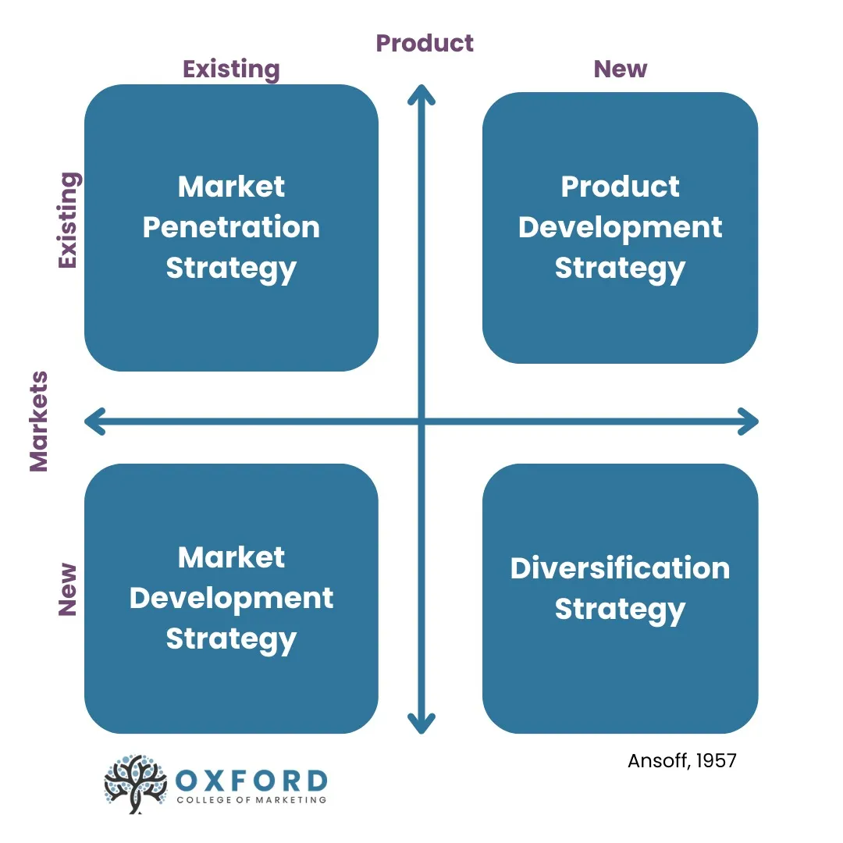Figure 6: Ansoff Matrix - Strategic Growth Options
Source: Oxford College of Marketing (n.d.), adapted from Ansoff (1957)
The matrix presents four strategic growth directions based on product and market dimensions. For Louis Vuitton in Japan, Product Development Strategy (existing markets, new products) represents the optimal strategic direction. This approach leverages LV's established market presence and high brand loyalty while introducing Japan-exclusive collections, artisanal storytelling, and experiential innovations. Market Penetration offers limited growth potential given market maturity, while Diversification contradicts luxury brand management principles and would dilute brand equity.
As presented in Figure 6, Ansoff's Matrix (1957) demonstrates that Product Development constitutes the most viable strategic trajectory for LV in Japan. This approach leverages existing market relationships while introducing new product offerings tailored to Japanese consumer preferences for craftsmanship, exclusivity, and experiential value (Kapferer & Bastien, 2017).

3.1 Product Development Strategy
A. Japan-Exclusive Collections
Japan has a long tradition of appreciating limited editions and exclusive designs. LV has historically succeeded with Japan‑only releases, such as special monogram variations and collaborations with Japanese artists like Takashi Murakami and Yayoi Kusama. These collaborations generated significant cultural impact and commercial success (The Economist, 2023).
Expanding Japan‑exclusive collections would:
• Reinforce LV’s cultural sensitivity
• Strengthen emotional connection with Japanese consumers
• Justify premium pricing
• Differentiate LV from competitors such as Gucci and Chanel
This aligns with the Japanese preference for craftsmanship, artistry and subtle individuality (de Mooij, 2019).

B. Enhanced Craftsmanship and Artisanal Storytelling
Japanese consumers value precision, durability and long‑term quality — attributes deeply aligned with LV’s brand DNA. LV can strengthen its position by emphasising:
• Artisanal production processes
• Hand‑crafted elements
• Repair and maintenance services
• Transparency around materials and craftsmanship
This approach aligns with the Japanese concept of monozukuri (craftsmanship excellence), which resonates strongly with luxury buyers (Nikkei Asia, 2023).

C. Expansion of High-End Leather Goods and Small Accessories
Urban lifestyles in Tokyo and Osaka favour compact, functional luxury items. LV can expand:
• Small leather goods
• Compact handbags
• High‑quality accessories
These categories have strong demand among both younger consumers and older affluent segments (Bain & Company, 2023).

4. Experiential Innovation Strategy

4.1 Flagship Store Enhancements
Japan’s luxury consumers expect exceptional service and immersive retail environments. LV can strengthen its experiential strategy by:
• Introducing artisanal workshops within stores
• Offering personalisation services (hot‑stamping, custom colours)
• Hosting cultural exhibitions and pop‑ups
This aligns with the Japanese preference for experiential luxury and meticulous service (Hofstede, 2011).

4.2 Digital–Physical Integration
Japan is one of the world’s most technologically advanced retail markets. LV should expand:
• Virtual try‑on tools
• Mobile‑first shopping experiences
• Appointment‑based digital concierge services
Statista (2023) reports that Japanese luxury consumers increasingly use digital channels for research and pre‑purchase evaluation, even when final purchases occur in‑store.

SECTION 1 Part D: Ethical Issues in Louis Vuitton’s International Marketing Mix in France and Japan

1. Introduction
Ethical considerations are increasingly central to luxury brand management, shaped by rising consumer expectations, regulatory pressures and global scrutiny of supply chains. For Louis Vuitton (LV), operating in culturally distinct markets such as France and Japan presents both shared and market‑specific ethical challenges. These issues intersect with LV’s marketing mix, particularly in relation to sustainability, labour practices, cultural sensitivity and pricing fairness.

2. Sustainability and Environmental Responsibility
Sustainability is one of the most prominent ethical concerns in the luxury sector. In France, environmental awareness is high, influenced by EU regulations and strong public discourse around climate responsibility (OECD, 2023). LV has responded by adopting eco‑design principles, investing in renewable energy and committing to reduce carbon emissions across its supply chain (LVMH, 2023). However, scholars argue that luxury brands often rely on selective transparency, highlighting certain sustainability initiatives while avoiding full disclosure of environmental impacts (Kapferer, 2021). This raises concerns about the credibility of sustainability claims within promotional communications.
In Japan, sustainability is valued but does not drive luxury purchasing decisions to the same extent as in France. Japanese consumers prioritise durability and long product lifecycles, which indirectly support sustainability (de Mooij, 2019). LV’s emphasis on craftsmanship and repair services aligns well with Japanese expectations, yet the brand must still address global concerns about material sourcing, waste reduction and circularity. Ethical scrutiny is particularly strong around leather production, carbon emissions and packaging waste.

3. Labour Practices and Supply Chain Transparency
Luxury brands face increasing scrutiny regarding labour conditions in manufacturing and sourcing. Although LV produces many goods in France, where labour standards are high, the global supply chain includes materials sourced from countries with varying labour protections (Financial Times, 2023). Ethical concerns arise around working conditions in leather supply chains, animal welfare in exotic skins and transparency of subcontracting practices. These issues directly affect LV’s product strategy and brand reputation.
In Japan, consumers expect high product quality but are less vocal about labour issues compared to European consumers. Nevertheless, global expectations for ethical sourcing mean LV must maintain rigorous oversight and transparent reporting. The brand’s marketing communications must avoid overstating ethical achievements, as this risks accusations of misleading consumers.

4. Cultural Sensitivity in Product and Promotion
Cultural sensitivity is essential when operating in diverse markets. In France, LV’s promotional strategies emphasise artistic expression and fashion innovation. Ethical concerns arise when luxury advertising reinforces unrealistic beauty standards or exclusivity narratives that may be perceived as socially exclusionary (Hines & Bruce, 2020). The challenge lies in balancing aspirational imagery with responsible representation.
In Japan, cultural sensitivity is even more critical. Japanese consumers value subtlety, respect and harmony. Promotional campaigns that appear too bold or culturally insensitive risk backlash. LV has historically succeeded through collaborations with Japanese artists such as Yayoi Kusama, which demonstrate cultural respect and authenticity (The Economist, 2023). However, any misalignment between brand messaging and cultural norms could be perceived as disrespectful or exploitative.

5. Pricing Ethics and Accessibility
Luxury pricing is inherently exclusive, but ethical concerns arise when price differences between markets become extreme. LV products are significantly more expensive in Japan due to import duties and currency fluctuations (Nikkei Asia, 2023). While Japanese consumers are willing to pay a premium for quality, excessive price disparities may raise concerns about fairness and exploitation. LV must ensure that premium pricing aligns with perceived value and that communication around pricing remains transparent.

SECTION 1 Part E: Strategic Recommendations for Louis Vuitton in France and Japan

1. Introduction
Louis Vuitton’s continued success in France and Japan depends on its ability to adapt to evolving consumer expectations, cultural norms and market pressures. Although both markets are mature and highly profitable, they require differentiated strategies that reinforce brand equity while addressing emerging challenges in sustainability, digitalisation and consumer engagement.

2. Strengthen Localised Product Strategies
Louis Vuitton should deepen its localisation strategy by tailoring product assortments more precisely to each market. In France, where consumers value fashion innovation and artistic expression, LV can expand limited‑edition runway pieces, capsule collections and collaborations with European designers (Kapferer & Bastien, 2017). These offerings reinforce the brand’s Parisian identity and appeal to fashion‑driven consumers and international tourists seeking exclusive items.
In Japan, product strategy should prioritise timeless designs, compact leather goods and items that emphasise craftsmanship and durability. Japan‑exclusive collections, particularly those inspired by local aesthetics or created in collaboration with Japanese artists, can strengthen cultural resonance and reinforce LV’s long‑standing relationship with Japanese consumers (Nikkei Asia, 2023). This approach aligns with the Japanese preference for subtle luxury and long‑term value (de Mooij, 2019).

3. Enhance Experiential Retail and Omnichannel Integration
Retail experience remains central to luxury consumption in both markets, but expectations differ. In France, LV should continue developing immersive flagship experiences that highlight heritage, artisanal workshops and fashion storytelling (LVMH, 2023). Parisian stores can serve as cultural destinations, integrating exhibitions, personalisation studios and curated fashion events that reinforce LV’s identity as a global luxury leader.
In Japan, where consumers expect precision, efficiency and exceptional service, LV should enhance digital–physical integration. This includes mobile‑first appointment systems, virtual try‑on tools, digital concierge services and seamless in‑store pick‑up options. Japan’s advanced digital infrastructure provides an opportunity for LV to lead in luxury omnichannel innovation, particularly for younger consumers who research online before purchasing in‑store (Statista, 2023).

4. Expand Sustainability and Circularity Initiatives
Sustainability expectations differ between France and Japan, but LV must adopt a consistent global approach that strengthens credibility. In France, where environmental awareness is high, LV should increase transparency around material sourcing, carbon reduction and eco‑design practices (OECD, 2023). Repair services, upcycling initiatives and circular luxury programmes can be expanded to meet consumer expectations for responsible consumption.
In Japan, sustainability messaging should emphasise durability, longevity and craftsmanship, aligning with cultural values. LV can strengthen its repair and maintenance services, promote long‑lasting product care and highlight the environmental benefits of investing in high‑quality goods (de Mooij, 2019). These initiatives reinforce LV’s reputation for reliability and precision.

5. Deepen Cultural Sensitivity and Local Engagement
Cultural alignment is essential for maintaining brand relevance. In France, LV should continue leveraging artistic collaborations and fashion‑driven campaigns, while ensuring responsible representation and avoiding overly exclusive narratives (Hines & Bruce, 2020). Partnerships with French cultural institutions, designers and artisans can reinforce authenticity.
In Japan, LV should prioritise subtle, respectful communication that aligns with local norms. Collaborations with Japanese artists, designers and cultural organisations can strengthen emotional connection and demonstrate cultural appreciation (The Economist, 2023). Marketing messages should emphasise harmony, refinement and craftsmanship rather than bold or provocative imagery.

6. Maintain Pricing Transparency and Value Justification
Given the significant price differences between France and Japan, LV should ensure transparent communication around pricing. In France, competitive pricing for tourists should be supported by strong in‑store experiences and exclusive offerings (Financial Times, 2023). In Japan, where prices are higher, LV must reinforce value through superior service, craftsmanship storytelling and exclusive local products. Clear communication around import duties, currency impacts and product value can help mitigate perceptions of unfairness (Nikkei Asia, 2023).

SECTION 2: Reflective Analysis Using Gibbs’ Reflective Cycle

1. Description
This assignment required me to apply international marketing theories — including PESTEL, Hofstede’s cultural dimensions, STP, the 7Ps and directional strategy frameworks — to analyse Louis Vuitton’s operations in France and Japan. Although I was familiar with some of these models, I had never applied them in depth to a real multinational luxury brand. The task involved synthesising academic theory with industry data, cultural insights and market‑specific dynamics. I also had to evaluate ethical issues and propose strategic recommendations, which required a more critical and reflective approach than descriptive analysis alone.

2. Feelings
At the beginning, I felt confident about the theoretical components but less certain about applying them to a luxury brand as complex as Louis Vuitton. The luxury sector has unique characteristics — exclusivity, heritage and craftsmanship — which do not always align neatly with standard marketing frameworks. This initially made me question whether the theories would oversimplify the realities of luxury strategy. As I progressed, I became more comfortable integrating theory with real‑world insights, especially when I realised that models like PESTEL and Hofstede could reveal meaningful differences between France and Japan. I also felt increasingly engaged as I explored cultural nuances, such as Japan’s emphasis on craftsmanship and France’s focus on fashion innovation. By the end, I felt more confident in my ability to apply theory critically rather than mechanically.

3. Evaluation
Several aspects of the process were positive. First, applying PESTEL helped me understand how macro‑environmental factors shape luxury strategy differently in each market. For example, France’s strong tourism economy and cultural heritage contrasted with Japan’s domestic‑driven luxury consumption and technological sophistication. This reinforced the value of structured environmental analysis.
Second, using Hofstede’s cultural dimensions allowed me to interpret consumer behaviour more deeply. Japan’s high uncertainty avoidance and long‑term orientation helped explain why Japanese consumers value durability and brand trust, while France’s individualism aligned with more fashion‑driven consumption. This made the cultural analysis richer and more grounded.
However, there were challenges. Some theories felt too broad for the luxury context. For instance, the 7Ps framework required adaptation because luxury retail emphasises experiential elements that go beyond standard service processes. Additionally, finding reliable, non‑generic sources on luxury markets required more effort than expected. I had to be selective to avoid superficial commentary and ensure academic credibility. Despite these challenges, the process strengthened my ability to evaluate which theories were most appropriate and how to adapt them.

4. Analysis
The assignment helped me recognise the importance of contextualising theory rather than applying it rigidly. For example, STP is typically used to identify broad consumer groups, but in luxury markets segmentation is more psychographic and behavioural. This meant I had to reinterpret the model to reflect motivations such as craftsmanship appreciation, exclusivity and cultural symbolism.
Similarly, directional strategy frameworks like Ansoff’s Matrix are often criticised for being simplistic, yet they provided a useful starting point for evaluating Louis Vuitton’s growth options in Japan. I realised that product development — particularly Japan‑exclusive collections and experiential innovation — aligned well with both market maturity and cultural expectations. This demonstrated how theoretical tools can still be valuable when used critically and adapted to context.
The ethical analysis also deepened my understanding of the complexities luxury brands face. Issues such as sustainability transparency, labour practices and cultural sensitivity are increasingly important, yet luxury brands must balance these with exclusivity and brand image. Reflecting on this helped me appreciate the tension between commercial objectives and ethical responsibilities, especially in global markets with differing expectations.
Overall, the assignment strengthened my ability to integrate theory with real‑world strategic thinking. It also highlighted the importance of cultural intelligence in international marketing — something that cannot be captured fully by models alone but can be enhanced through them.

5. Conclusion
Through this assignment, I learned that international marketing theory is most powerful when applied critically and contextually. The process improved my ability to analyse markets holistically, considering macro‑environmental forces, cultural dynamics, consumer behaviour and ethical issues. It also helped me develop a more nuanced understanding of luxury strategy, particularly how brands like Louis Vuitton must adapt their positioning and marketing mix across culturally distinct markets such as France and Japan. I also recognised the importance of using high‑quality academic and industry sources to support analysis, which strengthened the credibility of my work.

6. Action Plan
To build on this learning, I plan to deepen my understanding of cross‑cultural consumer behaviour by engaging with more academic literature on global branding and luxury consumption. I also intend to practise applying theoretical models to different industries to strengthen my adaptability and critical thinking. Improving my ability to evaluate the limitations of frameworks will help me use them more effectively in future assignments and professional contexts. Additionally, I will continue developing my research skills by prioritising credible, high‑quality sources and refining my ability to synthesise academic and industry insights. These steps will help me produce more rigorous, contextually informed analyses in future international business modules.

Reference List:
Ansoff, H.I. (1957) ‘Strategies for diversification’, Harvard Business Review, 35(5), pp. 113-124. Available at: https://scholar.google.co.uk/scholar?q=Ansoff,+H.I.+(1957)+%E2%80%98Strategies+for+diversification%E2%80%99,+Harvard+Business+Review,+35(5),+pp.+113-124&hl=en&as_sdt=0&as_vis=1&oi=scholart (Accessed: 12 March 2026).
Bain & Company (2023) Global luxury market projected to reach €1.5 trillion in 2023. Available at: https://www.bain.com/about/media-center/press-releases/2023/global-luxury-market-projected-to-reach-1.5-trillion-in-2023-a-new-record-for-the-sector-as-consumers-seek-luxury-experiences (Accessed: 12 March 2026). ￼
de Mooij, M. (2019) Global Marketing and Advertising: Understanding Cultural Paradoxes. 5th edn. Thousand Oaks: SAGE. Available at: https://d1wqtxts1xzle7.cloudfront.net/8323021/590136127-libre.pdf?1390854930=&response-content-disposition=inline%3B+filename%3DGlobal_marketing_and_advertising_Underst.pdf&Expires=1774393564&Signature=VyzEO3Mmlxy9ejBNXekH9WmKpcmde3sL1ZAj8FWuKhI3lbNW~MXtjVtBugfX3Il2viCEiJuYImWDjlzW9DI0uvTEpVilg3hF7K9U2y2CXnk2RNvKEzq9vUSEqdc8bljDMSeNOX7g0kGrGDwoFBvmwWOE-xn3a-OInnyZIYR0BIm~KQj8evpvDs5JRQcBBVJVvMHY85XdE73fdP5VqdV3wNn6d8cVbnngAHw4H~eAUoSARTiioMNI5PI~YbmJ2h8LR11zkY99zSeq3R3ot73COwFG5fKRfq~xxvWlgpeGpEBc0RF-jal6UGIO8R3-1VlaaFCLM9rNWbIxsnnZ135NUA__&Key-Pair-Id=APKAJLOHF5GGSLRBV4ZA (Accessed: 10 March 2026).
Financial Times (2023) ‘Luxury sector remains resilient despite inflation pressures’. Available at: https://www.ft.com/content/67ce5784-57fa-4f19-8c36-9b9b976c1fae?syn-25a6b1a6=1 (Accessed: 10 March 2026).
Hines, T. and Bruce, M. (2020) Fashion Marketing: Contemporary Issues. 3rd edn. London: Routledge. Available at: https://books.google.co.uk/books?id=kPqa_Jj4woYC&printsec=frontcover&source=gbs_atb#v=onepage&q&f=false (Accessed: 11 March 2026).
Hofstede, G. (2011) ‘Dimensionalizing cultures: The Hofstede model in context’, Online Readings in Psychology and Culture, 2(1), pp. 1–26. Available at: https://scholarworks.gvsu.edu/orpc/vol2/iss1/8/ (Accessed: 10 March 2026).
Japan Ministry of Economy, Trade and Industry (METI) (2023) Consumer Trends in Japan. Available at: https://www.meti.go.jp/english/statistics/index.html (Accessed: 10 March 2026).
Kapferer, J-N. (2021) The New Strategic Brand Management: Advanced Insights and Strategic Thinking. 6th edn. London: Kogan Page. Available at: https://www.koganpage.com/marketing-communications/the-new-strategic-brand-management-9780749465155 (Accessed: 10 March 2026).
Kapferer, J-N. and Bastien, V. (2017) The Luxury Strategy: Break the Rules of Marketing to Build Luxury Brands. 2nd edn. London: Kogan Page. Available at: https://www.koganpage.com/search?search_term=Kapferer,%20J-N.%20and%20Bastien,%20V.%20(2017)%20The%20Luxury%20Strategy:%20Break%20the%20Rules%20of%20Marketing%20to%20Build%20Luxury%20Brands.%202nd%20edn. (Accessed: 10 March 2026).
Kotler, P. and Keller, K.L. (2022) Marketing Management. 16th edn. Harlow: Pearson. Available at https://www.pearson.com/se/Nordics-Higher-Education/subject-catalogue/marketing/Kotler-Keller-Marketing-Management-Global-Edition-16e.html (Accessed: 11 March 2026).
Le Monde (2023) ‘France’s heritage labels and the future of luxury craftsmanship’. Available at: https://www.lemonde.fr (Accessed: 8 March 2026).
Louis Vuitton (2024) Louis Vuitton Maison Champs-Élysées. Available at: https://au.louisvuitton.com/eng-au/point-of-sale/france/louis-vuitton-paris-champs-elysees (Accessed: [your date]).
Louis Vuitton (2024) Louis Vuitton Tokyo Matsuya Ginza Store. Available at: https://ap.louisvuitton.com/eng-sg/point-of-sale/japan/louis-vuitton-tokyo-matsuya-ginza (Accessed: [your date]).
LVMH (2023) Universal Registration Document 2023. Available at: https://urd.lvmh.com/en/urd-2023-va_vdef.pdf (Accessed: 10 March 2026). ￼
McKinsey & Company (2023) The State of Fashion 2023. Available at: https://www.mckinsey.com/search?q=The%20State%20of%20Fashion%202023 (Accessed: 11 March 2026).
Nikkei Asia (2023) ‘Japan’s luxury consumers remain loyal despite weak yen’. Available at: https://asia.nikkei.com (Accessed: 11 March 2026).
OECD (2023) OECD Economic Outlook 2023. Available at: https://www.oecd.org/content/oecd/en/search.html?q=OECD+Economic+Outlook+2023&orderBy=mostRelevant&page=0&facetTags=oecd-languages%3Aen (Accessed: 9 March 2026).
Oxford College of Marketing (n.d.) Ansoff Matrix. Available at: https://blog.oxfordcollegeofmarketing.com/2016/08/01/using-ansoff-matrix-develop-marketing-strategy/ (Accessed: 11 March 2026).
Statista (2023) Luxury Goods Market in Japan. Available at: https://www.statista.com/serp?q=Luxury+Goods+Market+in+Japan.+ (Accessed: 12 March 2026).
The Economist (2023) ‘Luxury brands turn to artists to stay relevant’. Available at: https://www.economist.com/search?q=Luxury+brands+turn+to+artists+to+stay+relevant.&nav_source=masthead (Accessed: 12 March 2026).

