

School of Engineering

The Ford 1.0l Ecoboost Investigations:
A Cyclic Combustion Analysis to Better Aid Component Design
&
The Development of a low NVH Hybrid Variant based on Crankshaft Design

Carl P. Engelbrecht
P150898

M6X00147
BEng Motorsport Engineering
03 May 2020

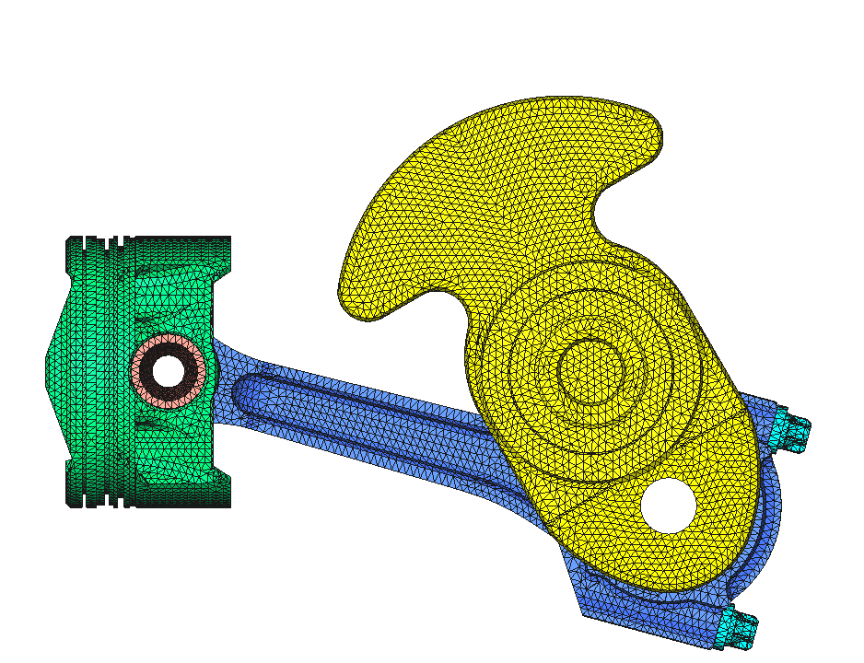

‘This thesis is the result of the author’s original research. It has been composed by the author and has not been previously submitted for examination which has led to the award of a degree.’

Signed: Carl P. Engelbrecht Date: 03/05/2020

This project is dedicated to my mother and father Karin and Carl Engelbrecht
who made all of this possible, my family and my wife Beth
who supported me through all my efforts in this challenging endeavour.
And also, Malcolm my supervisor for all of his insightful guidance.
I am truly grateful.

“I find it better to improve things than to be constantly forced to come up with something new, which is often not new but is formalistically super imposed. If I start with the outside then it will always be formalistic. And that is why I prefer the term re-engineering. I want to start with the inside. Always from the inside to outside.
- Dieter Rams, 2019

Contents
Abstract 4
Ford 1.0-litre Ecoboost and Development for Hybridisation 5
1.1 Timing Plan 6
Cyclic Combustion Analysis 7
1.2 Combustion Analysis Program Development 7
1.2.1 Cylinder Pressures & P-V Diagrams 8
1.2.2 Polytropic Index 9
1.2.3 Start and End of Combustion from Extra Combustion Pressure 11
1.2.4 Mass Fraction Burned 13
1.3 Cyclic Variation Analysis 14
Hybrid Crankshaft Design Investigation 17
1.4 Literature Review: Crankshaft Design for Hybrid Vehicles 17
1.4.1 The Hybrid Vehicle and Characteristics of the ICE 17
1.4.2 NVH and Engine Configurations 19
1.4.3 In-line Twin Balancing Method 20
1.5 The Balanced Even-firing Inline Twin Crankshaft Design 23
1.5.1 Cylinder Components 23
1.5.2 Initial Design 32
1.5.3 Under-Balancing Study 32
1.5.4 FEA Testing 38
1.5.5 Modal Analysis 44
1.5.6 Torsional Vibration Damper Design 47
1.5.7 Final Design and Considerations 49
Conclusion 51
1.6 Recommended Further Work 52
1.7 Pandemic Impact 52
References 53
Appendix 56

Abstract
The Ford 1.0l Ecoboost has been proven to be an exeptional IC engine meeting stringent modern requirements. Two topics are investigated stemming from this engine. The first is the study of cyclic variation present in the effort of identifying faster cycles responsible for peak cylinder pressures. This hopes to better inform cylinder component development particularly concerning optimised loading conditions. The second investigation aims to develop a variant of the engine platform for use in a hybrid vehicle application through a focus on the crankshaft and the goal of low NVH properties.
A script was written within MATLAB to analyse existing cylinder pressure data. The script uses a difference in combustion pressure added method to aid start and end of combustion identification. This allows for the production of a cummulative mass fraction burn curve. The refined script is utalised to analyse the cyclic differnce in 3 cycles among 500. A pressure based method is also implimented. The crankshaft is under-balanced through a compuational motion analysis within Solidworks based on manual methods. While a finite element methods follows to validate the new design against the original 3-cylinder crankshaft. A modal analysis process is used to identify the dynamic characteristics of the former while the same method is used to specify a torsional vibration damper.
The pressure based method is superior in identifying faster burn cycles, containing pressure and crank angle of occurance data, compared to a burn angle method for the purpose of an informed design process. The design of a series hybrid crankshaft has proven successful, retaining the force in the direction of the cylinder axis for a horizontally mounted engine while meeting the fatigue life of the original at a lightened mass. The usage case avoids critical resonance and an accurately simulated TV damper improves power-take-off vibrations.

Ford 1.0-litre Ecoboost and Development for Hybridisation
In 2017 the Ford 1.0 litre Ecoboost was voted as the 2019 engine of the year in the Sub-150 PS category, the 11th award given to the engine (The Ford Motor Company, 2019). Comprised of three cylinders and delivering 140 PS through various innovations such as direct injection, cast-in-head exhaust manifold, twin independent variable cams and now cylinder deactivation. Packed with innovation, the powerplant has responded to the requirements set out by the changing global conditions and the new WLTP targets. It has also been stated that The Ford Motor company plan to use the 1.0l Ecoboost as the basis of their hybrid powertrain.
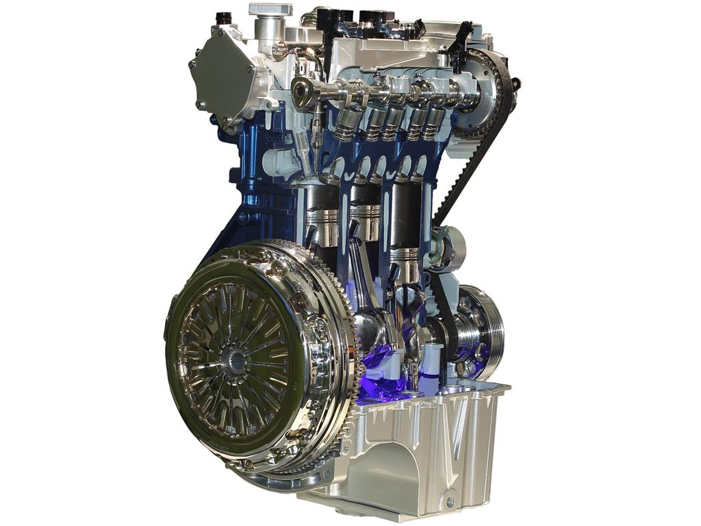
Figure 1 - Ford 1.0-litre Ecoboost. (Metro News, 2019)
Therefore, examining the future of transport the uptake of hybridisation has been identified, notably Toyota’s Deeside engine plant has shifted to producing 70% hybrid powerplants. Showing a global increase, the development and production of a hybrid powerplant is well warranted. Although the opinions on hybrid modes of transportation have been unfavourable in recent times (Brooke, 2020) argues with all electric vehicles (BEVs) being too expensive for consumers and low emission achievements of newly developed IC-engines the most effective strategy to zero-emissions include hybrid vehicles.
Thus, based on the foundation’s innovation and technology present within the Ecoboost engine the project will aim to develop a variant of the three-cylinder engine to be used within a hybrid vehicle. This will possibly also pave the way for the adaptation of a highly efficient four stroke engine in other small capacity engine applications, such as a ride-on lawnmower.
The investigation is broken up into two components. The first is a study into the combustion characteristics of the Ecoboost 1.0l engine, specifically looking at the cyclic variability present within 500 cycles of data. Developing a computer script to quantify the data into useable figures will aid in the understanding of the real combustion characteristics present and aid insight into the location of peak pressures at specific crank angles in hopes to better inform the loading conditions present in the development of cylinder components.
The second objective of the project is to develop a crankshaft for the new variant of the engine. It is commonly seen during development of engines for high performance applications that cylinder components are removed in all but one cylinder and a single cylinder engine is created. In a real-world application, the engine can operate with the same reciprocating and cylinder head assembly but will require a redesigned and balanced crankshaft hence the reason the crankshaft is focused upon. The crankshaft is responsible for converting gas force from combustion acting through the piston and connecting rod into useable torque the design of the crankshaft encompasses many design elements and is far from simple. One such consideration is the vibrations that are produced within the vehicle and are experienced by the passengers, an important aspect in a modern vehicle, especially when decreasing the number of cylinders. Low frequency vibrations seen in generator engines are not acceptable in a modern hybrid vehicle and thus removal thereof will be critical. The redesigned crankshaft will need to meet the original fatigue life of the original to ensure longevity. Geometric limitations will also have to be overcome when designing the new balancing weights. The final design will aim to produce a well-designed crankshaft with characteristic suited for use with a hybrid powertrain to power the future.

Timing Plan
The initial beginnings of the project began with the investigation into in-cylinder pressure analysis of all three of the Ford Ecoboost engine range, the 1.6, 1.5 and 1 litre. However, after the midway point a discussion was had on further progression and interests. This led into the development and modelling of the cylinder components of the Ford 1.0 Ecoboost, which further led to the development and design of an in-line twin hybrid variant crank train for future road use.
The development of the project and changes are illustrated in the timing plan below.
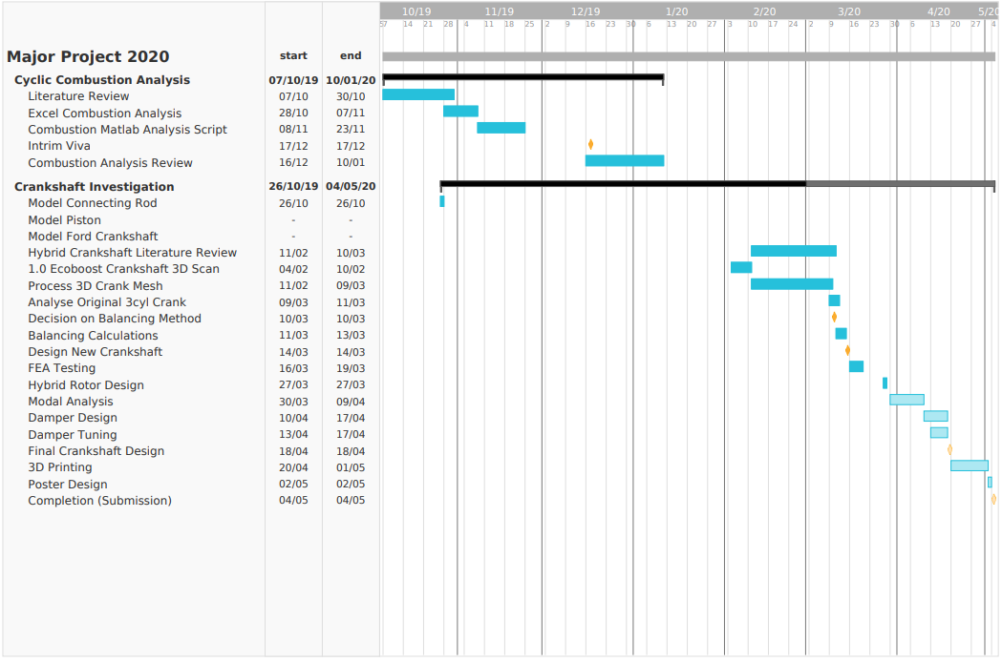
Figure 2 - Timing Plan.

Cyclic Combustion Analysis
The initial investigation conducted was on the combustion characteristics of the Ford 1.0 Ecoboost engine with the outcome of understanding various phenomenon occurring during operation, cyclic variation in particular. Two predominant factors lead to this research piece which were ultimately superseded in the later phase of the report, the first being in the interest of understanding the impact that cyclic variations would have on the fatigue life of a connecting rod and if it would be possible to reduce mass in areas where excess material is present. Secondly, to build upon the combustion analysis understanding of previous projects. Therefore, in light of these two factors, an initial combustion analysis platform was built to understand the combustion process followed by a study looking at the cyclic variations present in 300 cycles. The backbone of understanding for the relevant topics are formed through research in the following segment.

Combustion Analysis Program Development
Before cyclic variations can be discussed the study of combustion must be understood. One of the first areas extensively investigated was the ignition of fuel within the confined cylinder, as the products of the reaction were solely responsible for the work output of the IC engine as discussed by (Amann, 1985). Initial mechanical methods of measurements were quickly superseded by electronic pressure transducers. Most modern measurement systems use piezoelectric transducers which measure the changes in pressure at each degree of the crank angle (or more if greater detail is required), however not the absolute pressure. (Brunt and Pond, 1997) discussed the use of pressure referencing methods to improve upon the absolute pressure data utilised, stating minor inaccuracies within absolute pressure negatively impact critical parts of various analysis processes, particularly polytropic index results. Experimental methods can be used to improve accuracy, such as pressure measurements taken within the intake manifold which provides referencing points and is the preferred method. More applicable to already recorded data (in the case of this investigation) is to use polytropic index pressure referencing, which is discussed in 1.2.2.
In order to study the combustion process and subsequent cyclic conditions an initial calculation spreadsheet was developed. This was superseded by a MATLAB script capable of greater data processing essential in the later cyclic analysis data channels.
The Ford 1.0 Ecoboost was the main subject of study however data was available for the remaining Ecoboost engines (1.5 and 1.6) as well as the naturally aspirated 1.6 sigma engine. Therefore, comparisons are made throughout in order to further test the method and possibly establish how different cylinder configurations affect the combustion characteristics. Cyclic studies were only conducted on the 1.0l Ecoboost as this was the only cyclic data available, other sets of data are averages of 500 cycles in each cylinder which is further averaged over all cylinder for one-cylinder pressure data channel, which removes any variation and ‘smooths’ any errors.
The following demonstrates the development and findings of the combustion analysis script.

Cylinder Pressures & P-V Diagrams
The pressure-volume (P-V) diagram is particularly useful when evaluating the combustion characteristics of an engine. Figure 3 showcases the process which make up the SI or internal combustion engine operating cycle. The compression and expansion stage are adiabatic and isentropic (reversible), combustion is adiabatic however (Morishita and Kushiyama, 1997) notes the possibility of sonic fluid exchanges and that the term near adiabatic would be better suited. Combustion is also a combination of the ideal constant pressure and constant volume cycle. Exhaust and intake stages are also both adiabatic. The P-V diagram allows indicated and pumping work to be calculated through integration, hence the effect of valve timing on pumping work can be evaluated. Pumping work in a naturally aspirated engine is found in the combustion and expansion loop while in a turbocharged variant it is found in the whole system under high loading. (Heywood, 2018)
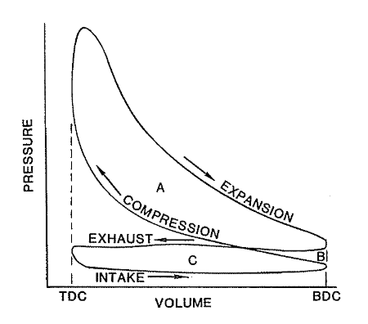
Figure 3 - Internal combustion engine operating cycles. (Amann, 1985)

Figure 4 shows all studied engine data plotted at 6000rpm full load. Peak power is found at various rpm points for each engine and ideal comparison would require more tests, however that is not the aim of this paper. Peak pressure of the 1.0 Ecoboost is found at 3500rpm. A single rpm does provide a basis do examine difference in the engine operation at this speed, for instance the 1500 Ecoboost shows a greater increase in pressure within a smaller volume. This is more efficient as less heat is lost to the cylinder lining. A sharp point is evident within the 1.0 and 1600 Ecoboost data as peak pressure occurs much later (33º ATDC), during expansion. The motored pressure increase without combustion is evident in both cases and would prove the best area to acquire the polytropic index.
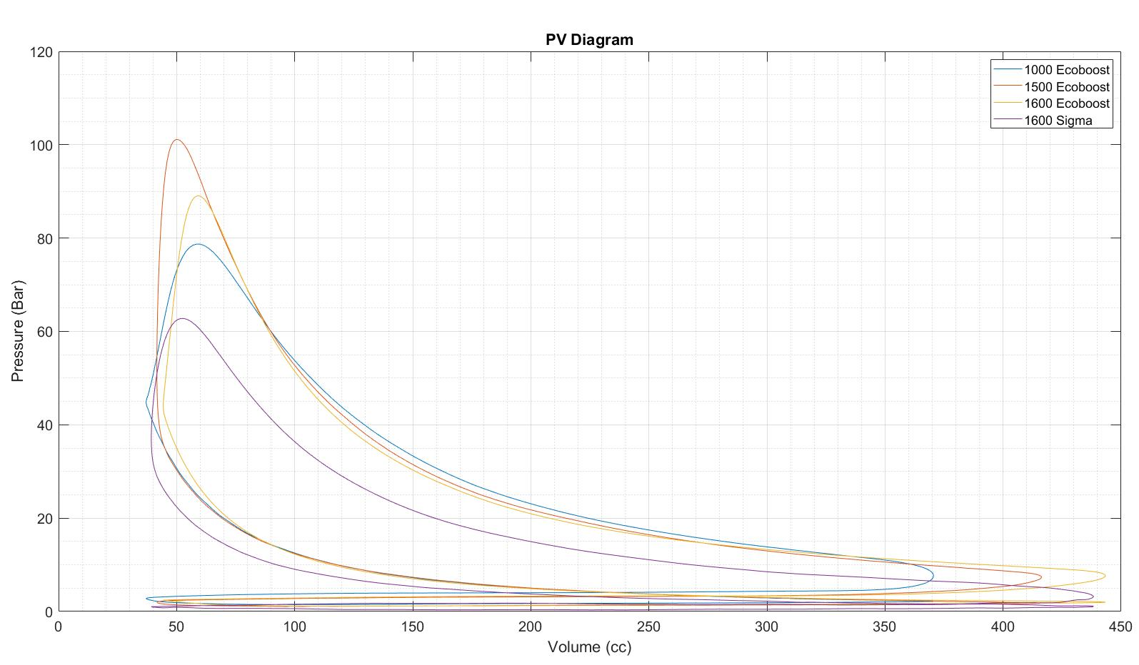
Figure 4 - Pressure-Volume diagram of all four ford engine models at 6000rpm full load.

Polytropic Index
Knowing the adiabatic nature of the mixture during compression and expansion the relationship expressed in Equation 1 can be used to find the polytropic index. Based on the ideal gas law, mass, gas constant and temperature remain constant ‘C’. The index value in an ideal Otto cycle would be that of 1.4 (the isentropic value of air), (Amann, 1985; Neo and Collings, 1997; Heywood, 2018) All report findings in the range of 1.25 to 1.4. While (Blair, 1999) specifies the general value of 1.25 for expansion and 1.35 for compression, illustrated in Figure 5. The value of 1.4 is not normally achieved due to the delay in chemical reactions and oxidations from unburnt fuel.

$${PV}^{n}=C$$
Equation 1 - Polytropic Exponent.
$$n =\frac{Log(P2-P1)}{Log(V2-V1)}$$
Equation 2 - Index value at each degree of crank angle.
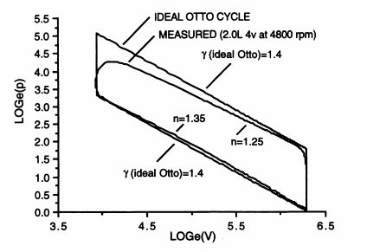
Figure 5 - Logarithmic pressure volume graph of the ideal Otto cycle compared to normal combustion. (Blair, 1999)

Polytropic pressure referencing was considered based on the methods described by (Brunt and Pond, 1997) and are considered necessary to achieve satisfactory mass fraction burned results. A fixed polytropic method is preferred and produces a pressure offset factor whereby the absolute pressure is modified, the formula is detailed in Equation 3. A polytropic index value of 1.32 is used and pressures between 100 and 65 BTDC, after the inlet valve closes, are recommended. This method is more susceptible to noise than intake manifold pressure referencing.

$$P_{off}=\frac{P1-\left(P2-P1\right)}{{\left(\frac{V1}{V2}\right)}^{n}-1}$$
Equation 3 - Pressure offset used in the polytropic pressure referencing method.

Using a logarithmic function, the index is isolated, in practise this is done through plotting a logarithmic P-V diagram. Initially efforts were made to obtain an averaged value through smoothing functions to pin-point the crank angle degree where combustion obscures the value. This however did not prove viable, instead a linear least squares regression method is used, a straight line was fit to the compression and expansion segments. The method produced good results. Each engine exhibited good linearity, especially the 1.0l due to the retarded ignition as discussed previously. Variations in the polytropic index of each engine is shown in Table 1.
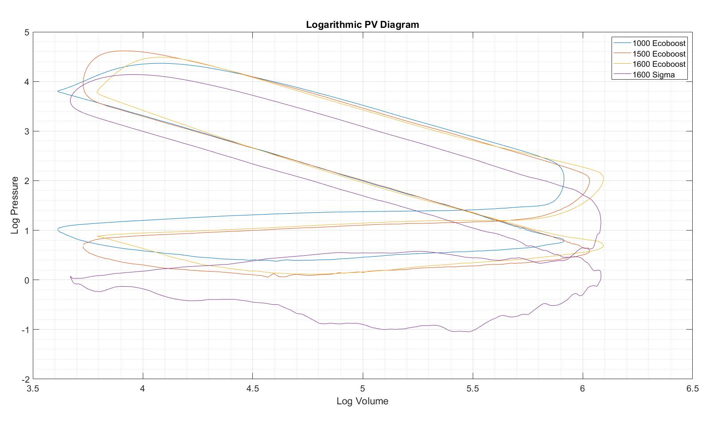
Equation 4 - Logarithmic P-V graph of all four engine types. Very similar gradients on both compression and expansion can be observed.

Start and End of Combustion from Extra Combustion Pressure
The identification of start and end of combustion is necessary in calculating the mass fraction burned. The identification thereof has been done through graphical analysis unless a complex pressure difference script was to be created. This leaves two methods, the first looking at the difference in pressure plot (P2-P1) and the second preferred method, difference in combustion pressure added. The later method is gathered from (Blair, 1999) which is represented by Equation 5. The result assumes a constant value for ‘n’ during the compression and expansion phase, transitioning at TDC.
$$P2a=P1{\left(\frac{V1}{V2}\right)}^{n}$$
$$P \left(bar\right), V1 and V2 \left(cc\right), n=Polytropic index for compression or expansion, respectively.$$
Equation 5 - Additional pressure from combustion.
The result is plotted against crank angle, shown in Figure 6, where a sudden increase in pressure difference signifies the start of combustion. The return to semi-linear values along the x-axis signifies the end of combustion. Difficulty arises in the main selection method when large variations exist. Judgement was used to select an appropriate SOC and EOC however further development in smoothing would largely benefit the accuracy, if a plausible endeavour. Preliminary attempts of such a method was out of reach for this investigation.
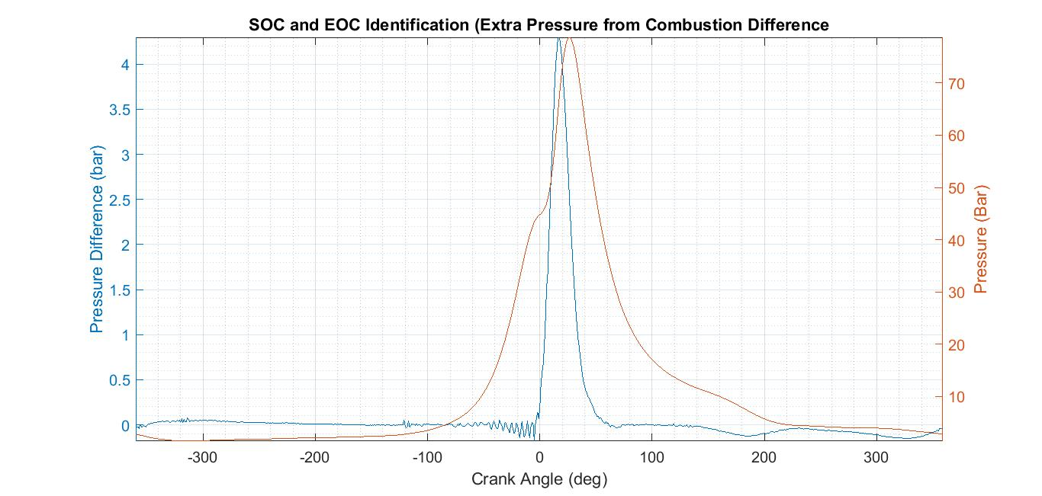
Figure 6 - Extra pressure difference graphed with absolute combustion pressure.

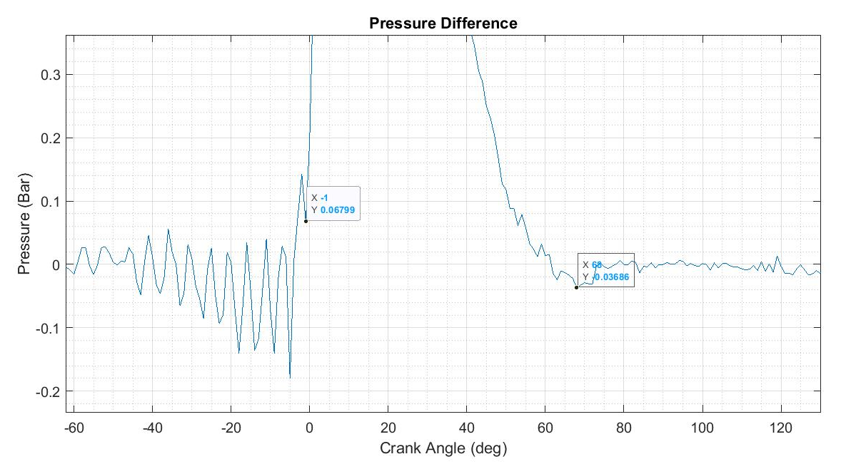
Figure 7 - Identification of SOC and EOC.

Mass Fraction Burned
The mass fraction burned (MFB) is the final element to be calculated in the combustion analysis method. Calculations are based off of the method described by (Heywood, 2018) and the formula featured below. Being a simplified method various assumptions are made, heat-transfer is only represented by the polytopic index value ‘n’ and lend to the importance of an accurate representation.
$$MFB= \frac{P^{1/n}V-P_{0}^{1/n}V_{0} }{P_{f}^{1/n}V_{f}-P_{0}^{1/n}V_{0}}$$
Equation 6 - Mass fraction burnt.

Data gathered from SOC and EOC is used to specify the start and end limits of the burn duration. The user input script is featured in appendix Figure 52. Taking into account the change in pressure at each degree of crank angle a cumulative summary is used to produce the MFB curve in Figure 8. ‘1’ is complete burn, however under normal operation there is normally unburned fuel. To identify 5%, 10%, 50% and 90% a curve fit function to the 9th polynomial was utilised to extrapolate the data.

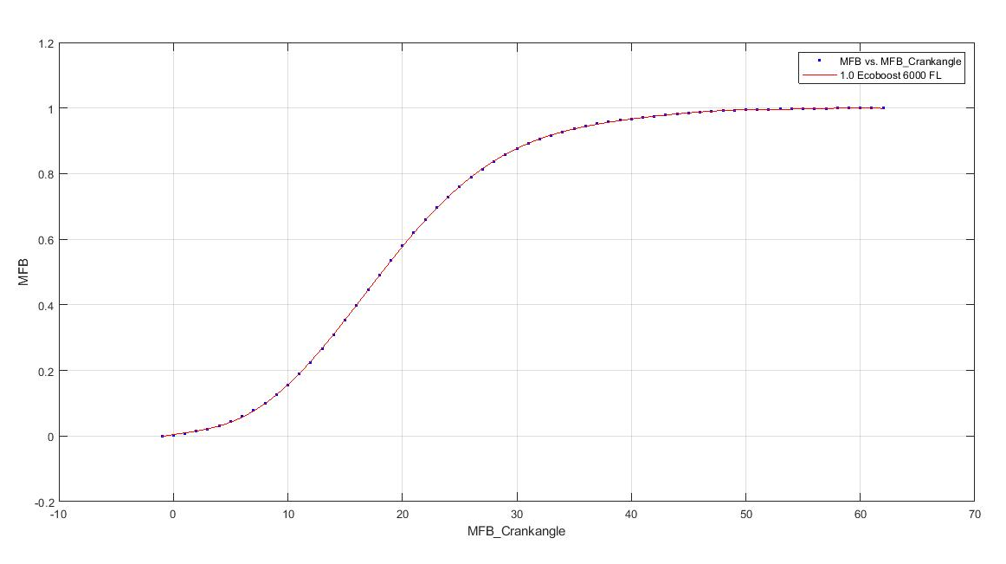
Figure 8 - Resultant mass fraction burn curve for the Ford 1.0 Ecoboost.

The results from all four engine variants studied are featured in Table 1. The polytropic index value is in the range of recommended findings while burn profiles is an accurate representation of the characteristics witnessed in the P-V diagram.

Table 1 - Combustion analysis results from MATLAB script for all engine variants studied.
Engine Variant | nEXP | nCOMP | SOC | EOC | 10% Burn | 50% Burn | 90% Burn
1000 Ecoboost | 1.25 | 1.32 | -1 | 62 | 8 | 18 | 31
1500 Ecoboost | 1.27 | 1.30 | -10 | 37 | -2 | 7 | 19
1600 Ecoboost | 1.30 | 1.32 | -6 | 42 | 5 | 13 | 23
1600 Sigma | 1.28 | 1.29 | -15 | 50 | -1 | 10 | 23

Cyclic Variation Analysis
Combustion is not identical from one cycle to the next although this would ideally be the case and thus the conversion of chemical energy into mechanical occurs cyclically. Many methods have been utilised in order to gain better control of combustions repeatability such as direct injection, dual spark plugs and real time onboard monitoring systems to name a few. The predictability and lack of variation allows the boundaries of performance to be pushed closer to the knock limit allowing for greater performance while maintaining reliability, if performance is adequate however components can be made lighter under the same loading conditions. This is the motivation behind the need to decrease cyclic variation in the interest of production vehicles.
Cyclic variations are understood to be caused by fluctuations in air-fuel ratios and turbulent fluid mixing before and within the combustion chamber. Thus, with the dependence on mixing quality caused by turbulent air it is logical to expect variations. It is also believed to be caused by exhaust gas recirculation from previous combustion occurrences left in the chamber, as well as an observed dependence on peak temperatures (Heywood, 2018; Daily, 2019).
The importance of cycle-to-cycle variation lies in the extremes, as fasters cycles are essentially advancing ignition burning close to TDC while slower cycles while slower cycles are retarding the ignition and burning within a greater volume. The later reduces the overall torque and efficiency of the engine while the former runs the risk of knock and stipulates the octane rating. Therefore, a compromise on spark timing and air/fuel ratios are the rest. A faster cycle is normally denoted by a higher peak cylinder pressure, causing increased risk closer to TDC. Slower cycles produce lower peak pressures and result in partial burning effecting following cycles and may lead to misfire. (Heywood, 2018)
(Tang et al., 2014) Showcased the greatest degree of cyclic variations during cold start within a GDI engine, stating the 10%-90% burn rate is the most affected. Variations tend to slow cycles rather faster ones from greater heat transfer and sub-optimal burning.
The cyclic study is done as an investigation into two elements, first to study the variation in peak gas force and second to compare the results of three cycles to that of the formula one engine evaluated by (Neo and Collings, 1997). The engine is assumed to be within operational temperatures when readings were taken.
The peak pressures across the 500 cycles were examined for cylinder 1, Figure 9. Using maximum pressure data and corresponding burn angle, faster and slower cycles has been identified. A clear drop in pressure is apparent the later the peak pressure occurs in crank angle degree. A general central clumping can be observed, but more importantly there are a few instances of the highest-pressure readings occurring at 20º, this is the area of interest. Understanding this a firm basis could be made for stress testing limits and as such the maximum connecting rod stresses and angle of force can be used instead of the widely utilised worst-case scenario of peak pressure at TDC.
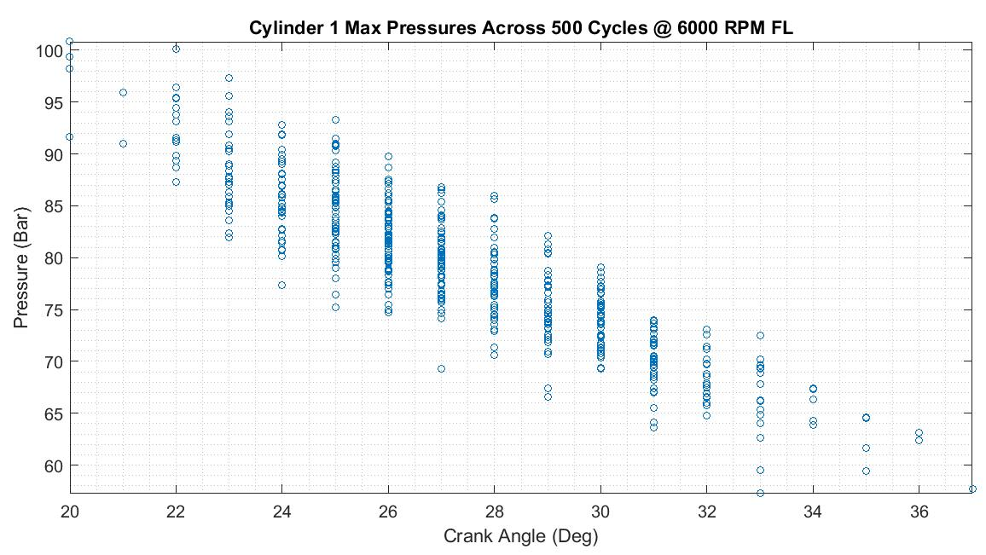
Figure 9 - Maximum cylinder pressure reading of 500 cycles in cylinder 1 of 1.0 Ecoboost.

Further analysis was carried out into cyclic occurrences with the aim of using the burn-rate-related measurement approach as discussed by (Heywood, 2018), in order to compare findings by (Neo and Collings, 1997). Using the analysis script built in the preceding three engine cycles were processed from the 500 cycles of data and results display in Table 2. The shortcomings of the manual SOC and EOC identification became apparent when using unfiltered or non-averaged data, large elements of noise is present (appendix Figure 56) and causes large discrepancies in data selection, invalidating the results of this study to some degree as speculative. If further development were planned for this segment a heat release analysis would be recommended. The burn angle results of the three cycles are inline of that seen in the P-V diagram with 90% burn achieved at an earlier crank angle while the results for 1 & 2 are similar. From this finding however it is clear that the results from a peak pressure-based analysis are more sound and of greater use if the intention is to specify design limits for a design study.
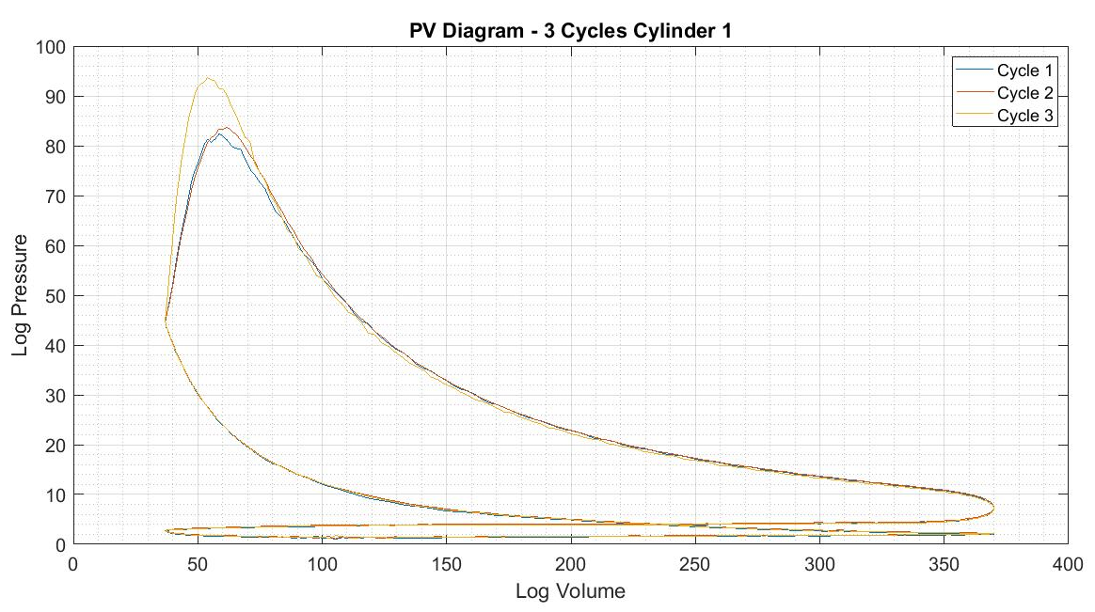
Figure 10 - P-V diagram of 3 cycles of 500 from cylinder 1.

Table 2 - Burn angle results from 3 cycles studied of the 500 cycles.
Engine Cycles | 1 | 2 | 3 | aver.
N_{COMP} | 1.35 | 1.32 | 1.33 | 1.32
N_{EXP} | 1.27 | 1.26 | 1.27 | 1.25
SOC | -4º | -5º | -5º | -1
EOC | 68º | 67º | 61º | 62
5% Burn | 5º | 5º | 3º | 6º
10% Burn | 7º | 8º | 5º | 8º
50% Burn | 18º | 18º | 15º | 18º
90% Burn | 30º | 29º | 25º | 32º

Hybrid Crankshaft Design Investigation
The conclusion of the cyclic variation study has led to a further investigation into the design of a crankshaft for a variant of the Ford 1.0 Ecoboost to be used within a hybrid vehicle. The difference in engine requirements for a series and parallel hybrid are discussed as well as design considerations specific to the range extender engine. NVH makes up a large factor in all the design considerations at each stage, the source of vibration within a crankshaft is discussed and ways to minimise it in order to meet modern consumer expectations.
This initial literature review paves the way for the final design of a suitable range extender crankshaft design.

Literature Review: Crankshaft Design for Hybrid Vehicles
The design of a Hybrid series SI engine is largely tied into the NVH outcomes as well as packaging constraints. A hybrid vehicle under the umbrella of modern transportation is viewed in the same light as an electric vehicle, silent. Noise and vibrations couple the vehicle to the thought of emissions and ‘dirty’ transportation. Therefore, each design element from the number of cylinders, orientation to the balancing methods must be considered in terms of the vibrations it will produce within the vehicle and subsequent cabin. Hence, each of these will be investigated to understand which will be the best option available for the redesign of the Ford 1.0 engine. As mentioned before, the crankshaft will be focused upon as this is the primary source of vibration and largely the main component which will need to be redesigned for a new engine to be developed.

The Hybrid Vehicle and Characteristics of the ICE
Firstly, the use of the powertrain needs to be understood within a hybrid vehicle. A hybrid is defined as a vehicle that features different forms of propulsion or power generation, in this case, electric motors and an IC engine. The benefit over pure electric propulsion is the additional engine is used as a range extender to dispel ‘range anxiety’ experienced with the former.
There are two main types of hybrid configurations present on the market, as discussed by (Burke, 1992), series and parallel systems. A series hybrid, detailed in Figure 11 on the left, uses an IC engine as a generator to charge the battery systems which in turn power the electric motor to deliver torque to the driving wheels. The engine is disconnected from the wheels and therefore a stepped gearbox is not present. The advantage of this system as discussed by (Turner et al., 2010) is that the ‘Tank-to-Wheel’ efficiencies are much greater than that of an IC engine utilising a stepped gearbox.
A parallel hybrid system on the other hand, as the name suggests, takes driving torque from both the electric motor and the ICE. The electric motor operates at low speed and low load, and as this demand is increased the engine takes over. A complex calibration system is present to facilitate the balance.

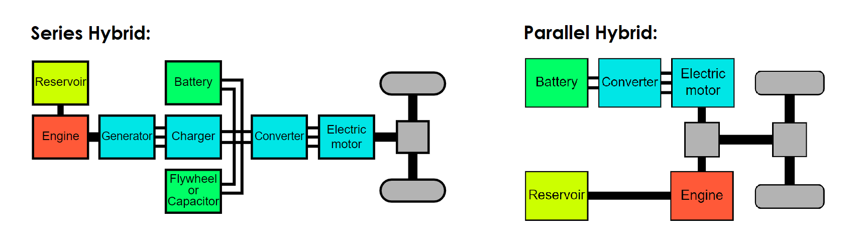
Figure 11 - Two most common hybrid systems. Series and parallel

The choice of either system is largely dependent on numerous factors which need to be taken into consideration meaning no clear distinction can be made before development has already commenced. However, as discussed by (Burke, 1992) a series configurations may prove more beneficial than its counterpart. Firstly, it requires less calibration than a Parallel system, making for a less complex system and lowering development costs, this is an important factor to consider when driving down the cost of the final vehicle. The lack of transient operation also means further simplicity and optimisation with regards to the ICE lowering emissions production. A drawback however is packaging constraints and it is the reason the majority of hybrids operating on the road are parallel hybrids. However, on the basis of the FIAT 500, (Pischinger et al., 2012) showcases the feasibility of packaging a series hybrid system within the vehicle.
It is important to understand that the ICE within a parallel hybrid is in most cases the same as the non-hybrid variant in the manufacturers line-up with little change. Therefore, in this paper a range extender engine will be developed for the use in a series hybrid.
Once established the engine characteristics and requirements of a series hybrid range extender engine must be understood. Reviewing papers by (Burke, 1992; Turner et al., 2010; Pischinger et al., 2012) it is found that at a Vmax (the maximum speed the vehicle can travel while being able to charge the batteries) of ~120km/h the power requirement from the SI engine should be no less than 30kW and more realistically 35kW considering road gradients and vehicle mass as well as electronic systems. The Ford 1.0 engine studied outputs 67.96kw at 3500rpm (full load), assuming the engine is reduced by one cylinder, it would ideally produce 2/3 of the power which comes out at 45.30kW. Retaining the cylinder geometry, a two-cylinder variant would have a capacity of 666cc. This rough estimation is validated by comparison of the FIAT 500 Air Twin, a similar two-cylinder turbocharged engine with a capacity of 875cc, produces 52.2kW at 3500rpm (assumed full load) according to (Zal, 2020). Therefore, a two cylinder variant of the 1.0 Eco boost meets the power output required. (Turner et al., 2010) have done a parametric study concluding that a three-cylinder engine of a 1200cc capacity shown the most benefits of a two-cylinder variant of the same capacity, but however noted that a downsized two-cylinder variant was a plausible solution. It must be noted the engine discussed in that paper is naturally aspirated and a turbocharged two-cylinder variant would meet the same power requirement. This is however not including the NVH implications which will be discussed in the following segment. Another difference apparent within a range extender engine is the lack of a flywheel.
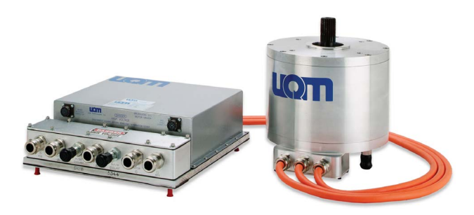
Figure 12 - Typical hybrid generator, with a direct splined connection to the engine output. Pictured is the UQM PowerPhase 75. (UQM, 2020)

NVH and Engine Configurations
The vibration and subsequent noise caused by an SI engine stems from its fundamental operation, turning a linear oscillation into a rotational torque through the crankshaft. The motion of the reciprocating linear masses produces a reciprocating force, while the lower rotational mass produce a rotational force. The reciprocating force at TDC is greater than that of BDC therefore a simple harmonic motion is created. This is divided into a primary and secondary harmonic motion, the first being greater than the second. The second harmonic motion occurs at twice the speed of the first. The act of balancing these two forces influences the refinement of the engine and therefore is directly connected to the NVH. It is important to understand that the balancing of both forces, as well as possible moments, is dependent on cylinder count, engine configuration (vee, straight, boxer) and firing order. (Manning, 2012)
When discussing the number of cylinders and configuration of a four-stroke engine (important to clarify as other engine types such as a two stoke, Wankel and gas turbine with more development may prove a better solution) two papers discuss two applicable concepts. The first as featured in the proceeding discussions is the investigation by (Turner et al., 2010) proving that a NA three cylinder engine is a feasible range extender configuration because of lower frictional losses and ideal cylinder geometry compared to a two cylinder inline variant of the same capacity. The paper concludes on the possibility of further development of a two-cylinder variant downsized, with no alteration to the cylinder geometry. It is specified that this will require a balance shaft.
The second paper by (Pischinger et al., 2012) investigates the use of a two cylinder 90º Vee engine configuration with two alternator generators either side of the cylinder banks for an overall compact package capable of fitment within modern A and B segment vehicle. An area not thoroughly discussed within the previous paper, the positioning of the range extender within the vehicle is defined to be optimum under the rear luggage compartment as illustrated below in a fiat 500. This is also the case in the BMW I3. This requires the cylinder axis to lay horizontally along the vehicle.
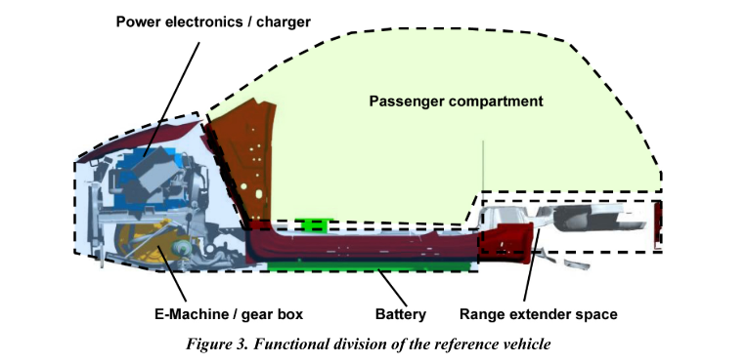
Figure 13 - Allocated space for a range extender engine within a proposed series hybrid A segment vehicle by (Pischinger et al., 2012).
In conclusion the research papers bring to light various important aspects to consider when moving forward with the ideal design for the Ford 1.0 Ecoboost range extender concept. It is decided that a two-cylinder turbocharged variant would prove a feasible undertaking providing the required power output for optimal battery state of charge under Vmax. Minimal alteration to the original architecture of the engine rules out the use of a Vee configuration, despite its obvious benefits, however this may be an area for future investigation. This decision will require the use of a second order balance shaft. A flat laying engine will be the most beneficial to packaging as it was found to be safer in a collision and causing minimum changes to useable interior space. The idea of using two alternators to better package the engine and to be used as balancing shafts is worth considering in the design.

In-line Twin Balancing Method
It is understood that from the previous findings the most feasible solution moving forward is a two-cylinder variant based on the inline architecture of the original engine. From what was discussed previously, mounting the engine horizontally is most beneficial for cabin space. Thus, the final engine will take the shape of a horizontally mounted even firing inline twin. Even firing due to the frequency of the audible noise being more pleasant than that of a 180º firing configuration, described by (Hubmann et al., 2012) as “The 360° design gives the impression of a calm and smooth engine whereas the 270° which has the same firing order as a 90° V2 engine, sounds quite rough and sporty. … For stationary or automotive applications, the more regular sound impression of the 360° design might be more appropriate”. A viable solution with fundamentally poor engine balance. An inline twin has the same balance characteristics of a single cylinder, having unbalanced forces in both the primary and secondary harmonic. However, benefiting from balanced couples, a beneficial attribute in reducing external balancing methods and final packaging size.
In order to achieve low vibrations in the engine a balancing strategy must be implemented. A 100% locally balanced crankshaft an inline even firing engine produces excessive vibrations due to rotational inertia not counterbalanced by an alternative piston, illustrated in Figure 14.
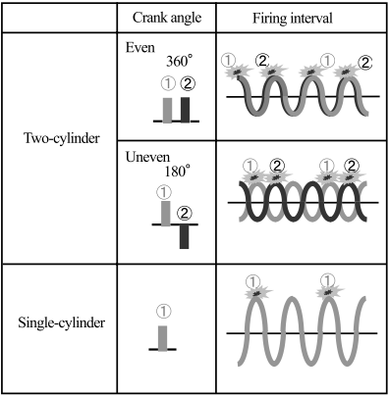
Figure 14 - Firing interval for an even and uneven firing two cylinder engine. (Okano et al., 2002)
A multitude of methods have been explored in order to balance a single and twin cylinder engine. (Harkness, 1968) and (Hazzard, 2020) implemented the use of a counterbalance in the form of a dummy weight acting in the same manner as an uneven firing engine’s opposing piston function. This was mounted on either side of the crankshaft, illustrated in Figure 15. This method was also patented by Yamaha for an outboard boat engine (see below), in order to reduce vibration along the x axis into the boat. A ~81% decrease in vertical vibration velocity was experienced in the case of (Harkness, 1968). In all cases it showed a significant decrease in vibration. However, it is not a method commonly seen in automotive applications and is assumed to be due to the added reciprocating mass and loss in output power thereof, a point not explicitly discussed in either paper. Interestingly (Harkness, 1968) opted for the use of a balancing shaft in their larger 12hp production engine and used the former method as a low cost solution for the 5hp motor. Similarly (Hazzard, 2020) used the technology in a two stroke engine where the counterbalance piston was used to charge the air fuel mixture into the chamber compensating for the loss in power. The Yamaha patent has not been used in production.
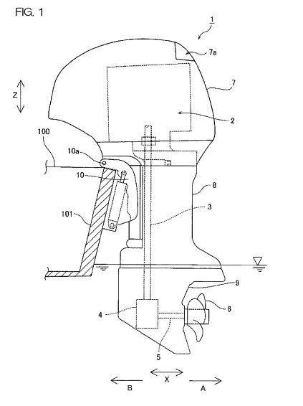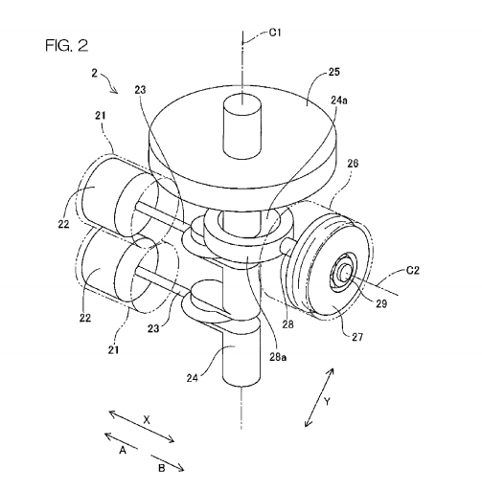
Figure 15 - Yamaha counterbalance outboard motor design. (Karaki and Mitani, 2010)
More common in automotive vehicles, a balancing shaft is used as the main source of engine balancing. A higher cost powerplant warrants the extra cost in development and manufacture as discussed previously in the development of the 12hp engine. A balancing shaft is similar to a crankshaft in construction, asymmetrical masses are attached to a shaft which rotates in order to counteract the forces produced at the crankshaft. An even-firing in-line twin requires primary and secondary balancing shafts to be fully balanced. A primary balance shaft rotates at engine speed in the reverse direction of the crankshaft, while secondary balance shaft is at twice engine speed rotating in both directions, (Manning, 2012). The use of two primary balance shafts are illustrated in the diagram below. What could be a singular shaft is split into two equidistant shafts in order to remove any moments produced.
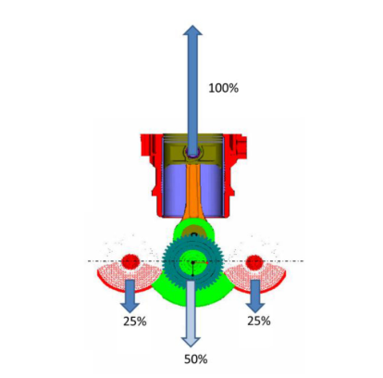
Figure 16 - Example use of two primary balancing shafts mitigating any moments produced by a single balancing shaft. (Hubmann et al., 2012)
As with reciprocating counter balancing masses, balancing shafts introduce frictional losses, mass and extra cost to the system. (Harkness, 1968) saw a 0.4hp decrease in output power through the addition of a single shaft. A split shaft however will not have double the frictional losses due to smaller bearing sizing etc. The addition of each balancing shaft, such as to counteract secondary forces, adds a loss in power and increases mass, unit size, complexity and cost, all of which need to be minimized for a hybrid series engine.
Under-balancing, on the other-hand, is a method mainly seen used in horizontally mounted engines where the cylinder axis is parallel to the application axis. (Hazzard, 2020) describes the use of a 30% balanced crankshaft in a chainsaw where the cylinder axis is parallel to the bar. This leaves 70% of the reciprocating mass in the axis direction and introduces only perpendicular mass of 30%, thus leaving the vibrations in the least disturbing direction.
Reviewing the balancing methods, it would be most appropriate to investigate the use of an under-balanced crankshaft in order to minimize the aforementioned attributes of both a reciprocating counterbalance and balance shaft system.

The Balanced Even-firing Inline Twin Crankshaft Design
Following the findings from the literature review a few key aspects of the final design has been defined,
- The range extender will be a two-cylinder variant of the existing Ford 1.0 Ecoboost. The cylinder geometry will remain the same and final capacity will be brought down to 665.9cc.
- Maximum RPM will be limited to 4000rpm with expected operation at 3500rpm, the optimal BSFC of existing engine. The direct attachment to the generator and lack of gearbox removes any chance of over-revving and removes the need to compensate for this.
- The engine will be positioned horizontally in order to have minimum impact on cabin space.
- A fully balanced engine would require multiple balancing shafts for first and second order balancing plus additional gearing. This adds greater mass and complexity to the unit as well as negatively impact noise with gear contact noise. Overall cost of the unit will also increase. Therefore, it has been decided developed an underbalanced crankshaft.
The crankshaft and subsequent engine will be modelled in Solidworks and FEA tested in Design Studio. The following is the process taken to achieve the final outcome.

Cylinder Components
All the crank train components of the Ford 1.0 Ecoboost were modelled in Solidworks as accurately as possible using a multitude of techniques.

Modelling Techniques
The aim of modelling a component from a physical variant is to retain as much detail as possible within the computationally designed component in order to achieve an accurate representation within further stress analysis investigations of motion analysis studies.
The following are the various methods used to achieve accurate modelling of the components critical to the investigation.

Physical Measurement
The primary method of accurate modelling of the components is to take physical measurements. This is especially important to define essential geometry of the components such as crankshaft bearing journal diameters, seen in the figure below. The equipment mainly used is a micrometre, flat-table, height gauge and Vernier calliper.
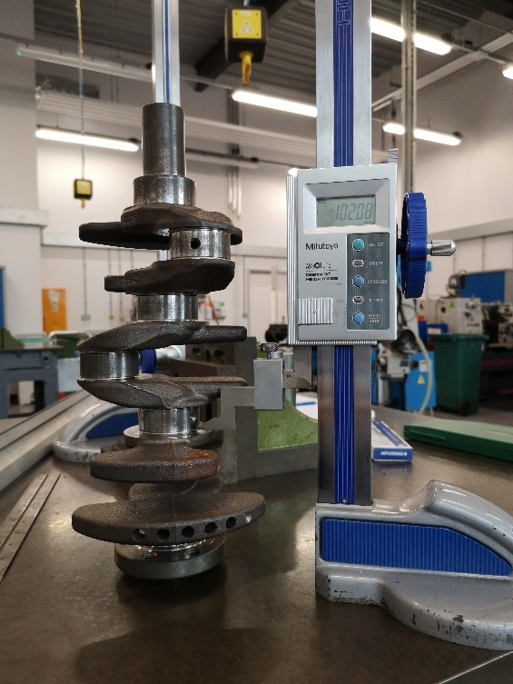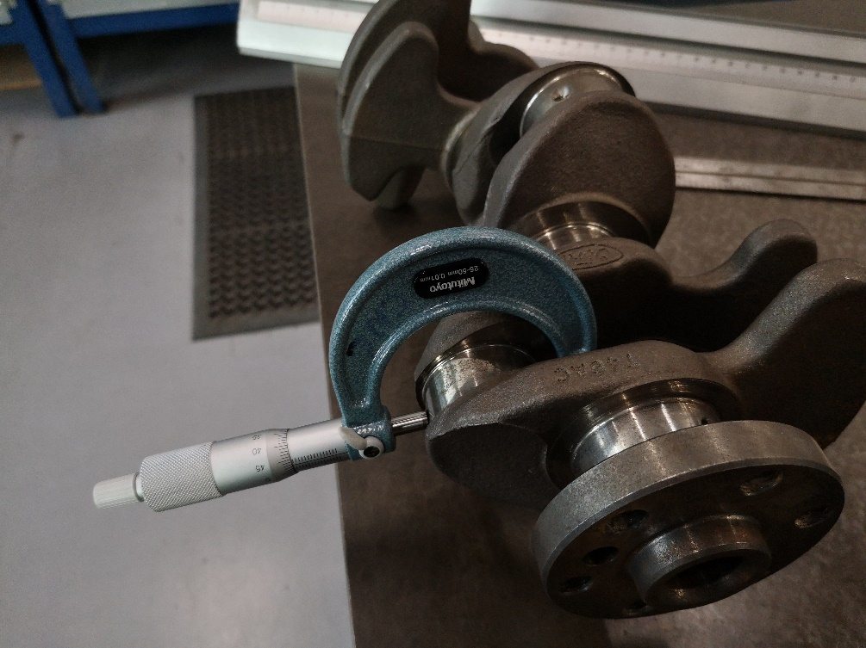
Figure 17 - Measurements methods used to accurately define the crank journal diameters. Height gauge used on the left and micrometre used on the right.

The shape of the connecting rod beam was accurately modelled using as set of X and Y co-ordinates measured using the height gauge and a set of callipers.
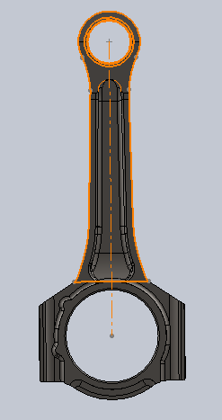
Point | X | Y | Z
 | 18.14 | 36.60 | 0
 | 18.31 | 45.00 | 0
 | 18.65 | 55.00 | 0
 | 18.96 | 65.00 | 0
 | 19.31 | 75.00 | 0
 | 19.68 | 85.00 | 0
 | 20.06 | 95.00 | 0
 | 21.19 | 105.00 | 0
 | 25.32 | 115.00 | 0
 | 26.83 | 117.00 | 0
 | 28.43 | 120.00 | 0
 | 30.09 | 122.50 | 0
 | 32.06 | 124.98 | 0
 | 34.02 | 126.17 | 0
Figure 18 - The use of measured co-ordinate geometry to accurate replicate the curve in a connecting rod.
The following two methods also rely on accurate measurements to either scale the image in the case of two-dimensional scanning method or to model areas of desired accuracy such as the aforementioned bearing diameters in the case of the three-dimensional scan.

2-Dimensional Scanning
Another process used to aid the modelling process, particularly of the connecting rod, was the use of two-dimensional scanning techniques in the form a flatbed scanner. The object was laid upon the glass bed and backed with a white sheet of paper to improve contrast. This allows the scan to be imported into a Solidworks sketch and accurately dimensioned. The accuracy of a completely flat scan as opposed a camera mitigates any lens warping and thus the scan can be considered dimensionally accurate.
From scanning the connecting rod, a press fit bushing was identified in the figure below.

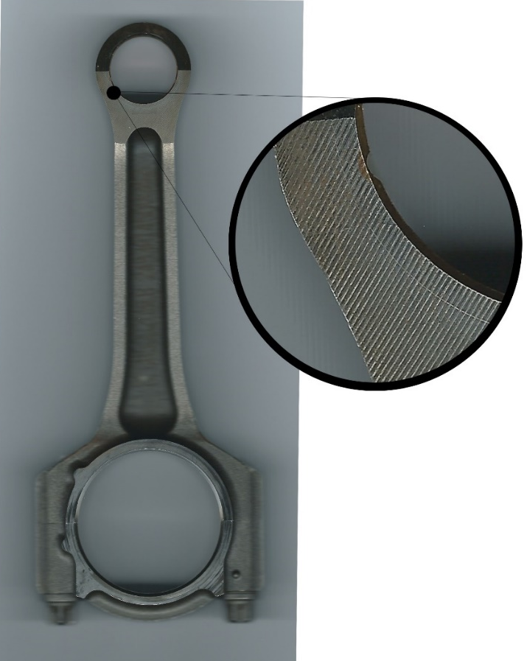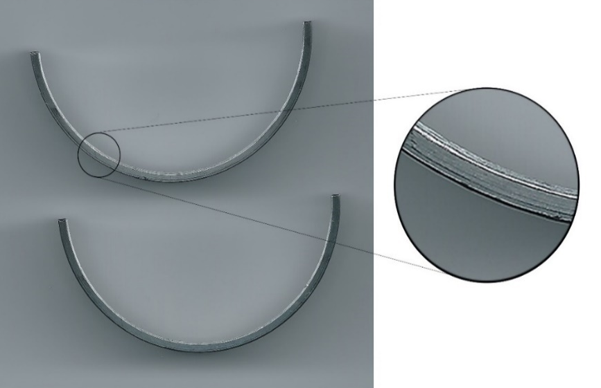
Figure 19 - Connecting rod two-dimensional scan. High resolution of the scanned image identified the small end of the connecting rod as a press fit bushing. Scan of connecting rod bearing shell identifies split line between Babbitt component and steel backing plate.

3-Dimensional Scanning
A third method of modelling aid is used, three-dimensional scanning. This method is particularly useful when modelling components which have been cast and exhibit organic shapes which are difficult to measure using traditional methods, in this case the crank shaft and piston. This method although useful has proven to be very time consuming. Initially the piston was modelled through Solidworks meshing and completed through a single software package, however due to the scale and complexity of the crankshaft processing was moved to Geomagic Design Studio X.
Achieving a final accurate model begins with preparing the model for scanning. This is done by coating the item in grey primer to remove any lustre from the surface, which causes the surface to be undetectable and produces ‘holes’ in the final scan. The surface is then doted to provide reference points for the machine.

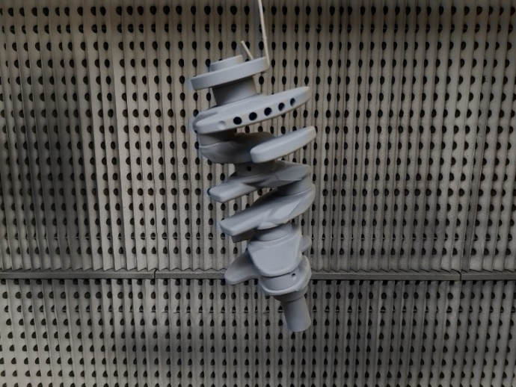
Figure 20 - Crankshaft sprayed in grey primer in preparation for 3-dimeniosnal scanning.

Once the crankshaft is scanned a point cloud is created, as the name implies it is a system of points with x-y-z coordinates which can be read and imported by the software package. The point cloud is converted into a surface mesh by the software. Irregularities and subsequent ‘holes’ in the scan data are mended following the contours and shapes of the surrounding geometry, automatically processed through a feature within the software package and produces approximations which resulted in large variations, hinder later modelling stages. Once completely surfaced sketches can be drawn from each mesh segment. Initial solid bodies are created from reference measurements taken of the journal bearing diameters and widths. This is followed by more modelling more complex and time-consuming areas such as the webbing and counter-masses. Each segment is modelled using a multitude of features until a final accurate model is created. The process is illustrated in figure bellow.
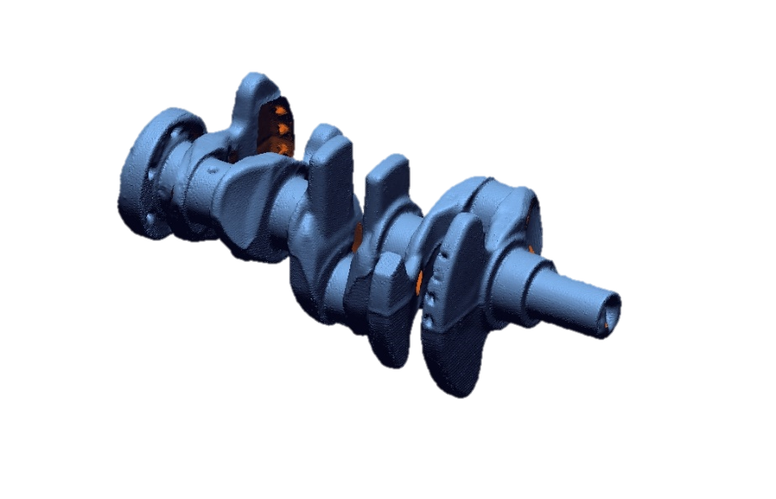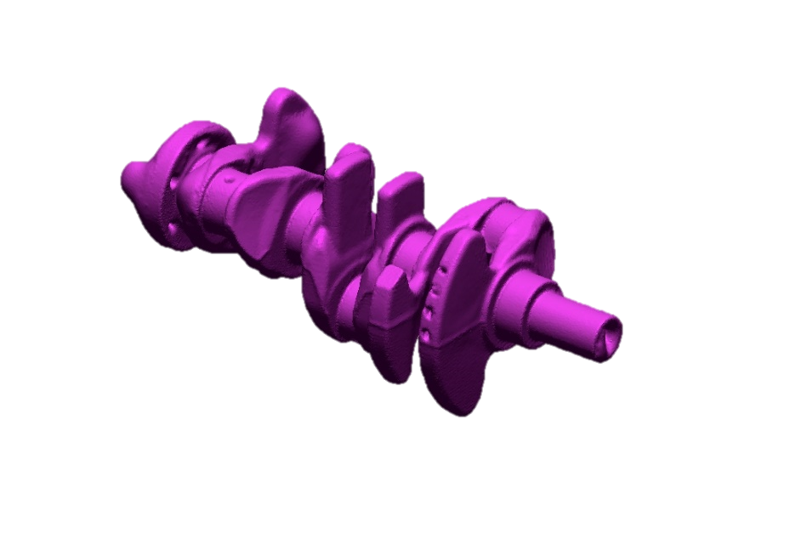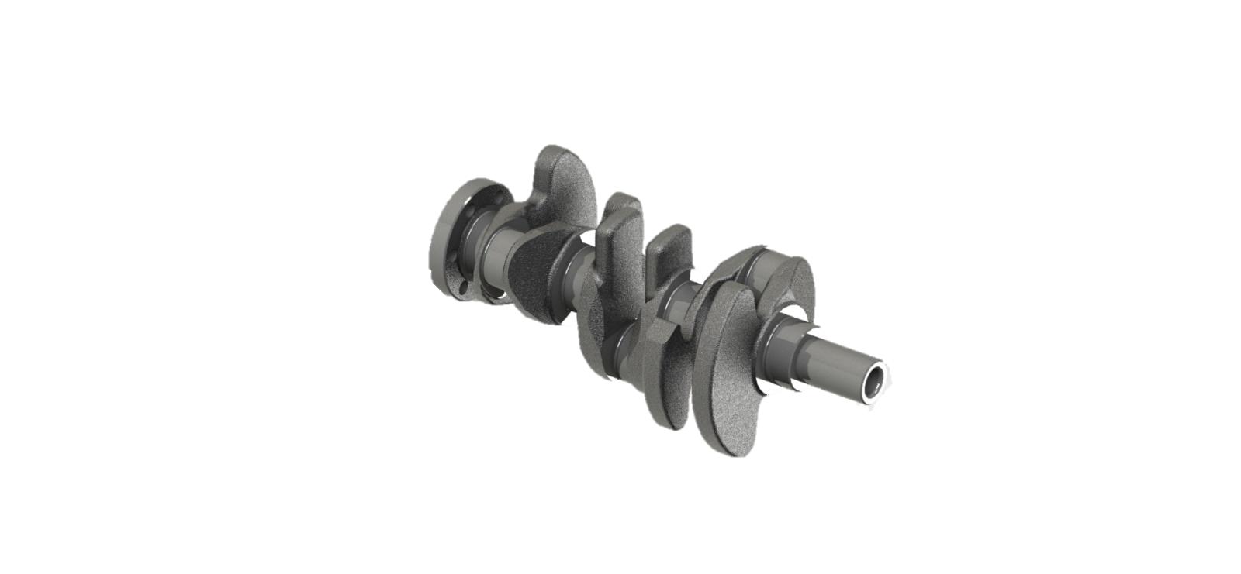

Point Cloud
Processed Mesh
Solid Body Model
Figure 21 - Three-dimensional modelling process from scan data done on the Ford 1.0 Ecoboost crankshaft.
It must be noted that the final fillets and operations (oil gallery holes, balancing webbing holes) are done in Solidworks, via a process of exporting the model bodies from the Geomagic Software. The accuracy of the final model is estimated at 90% of the original due to modelling limitations and non-correctable 3-dimensional scan errors. The piston was modelled from a three-dimensional scan of the Ford 1.5 Ecoboost engine completed before it was decided upon the 1.0L, both pistons are an EVOTEC Mahle design and exhibit similar geometric shapes. The modelled piston was scaled to the bore diameter.

Models
Using the techniques described in the previous section the final model of each component is featured below.

Table 3 - Solidworks models of the Ford 1.0 Ecoboost.
 | Original Component | Solidworks Model
Piston | 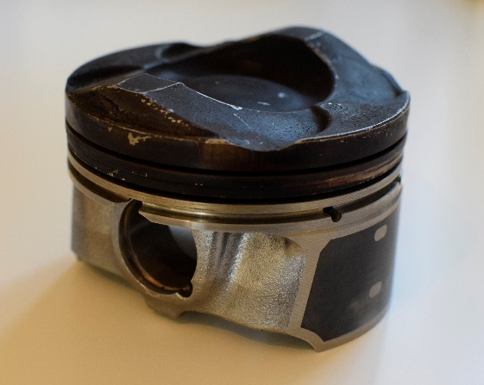 | 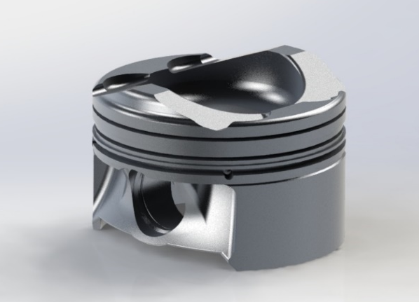
Gudgeon Pin | 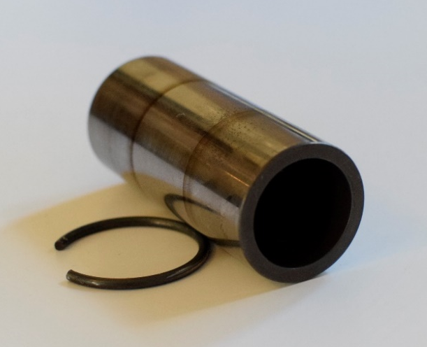  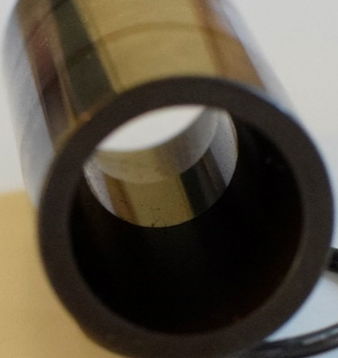 | 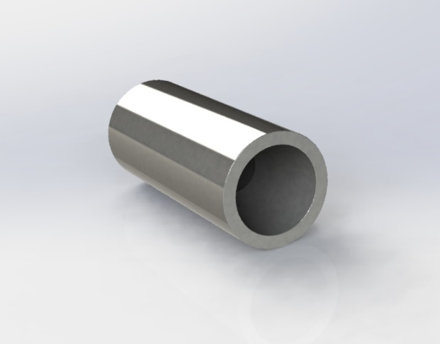  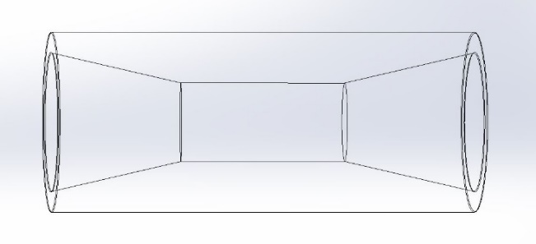
Connecting Rod & Cap | 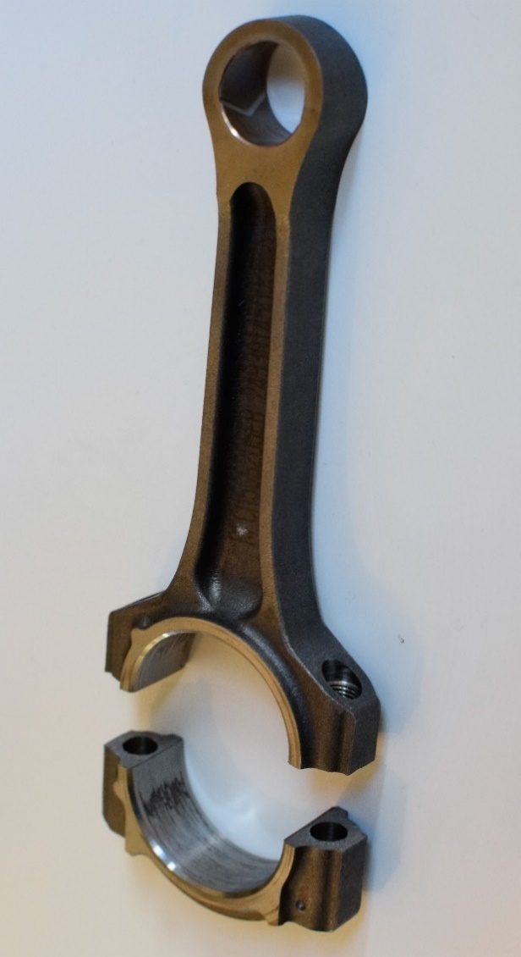 | 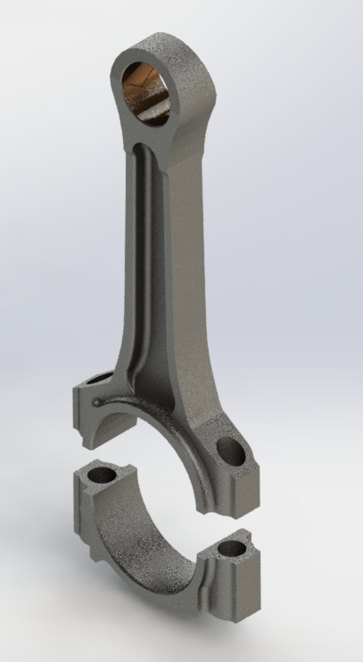
Connecting Rod Bolt | 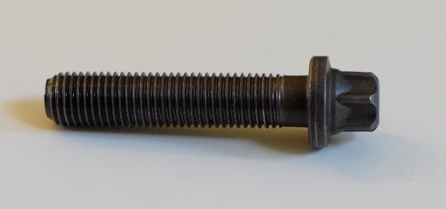 | 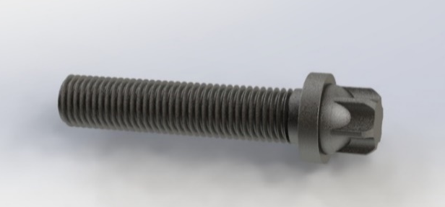
Bearing Shell | 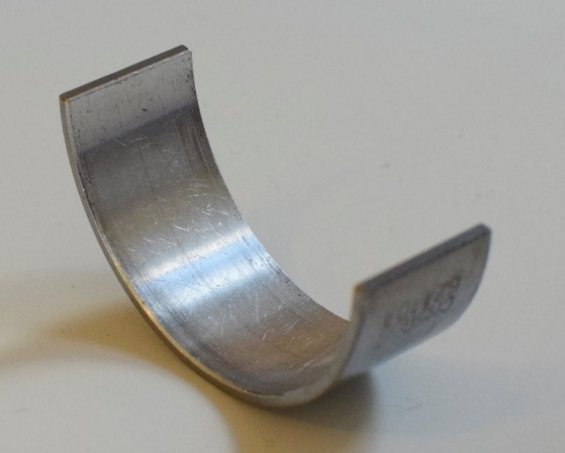 | 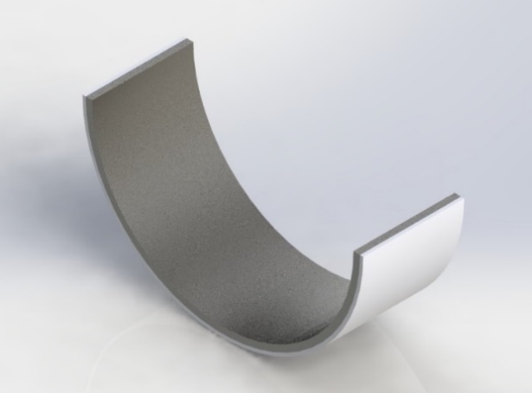
Crankshaft | 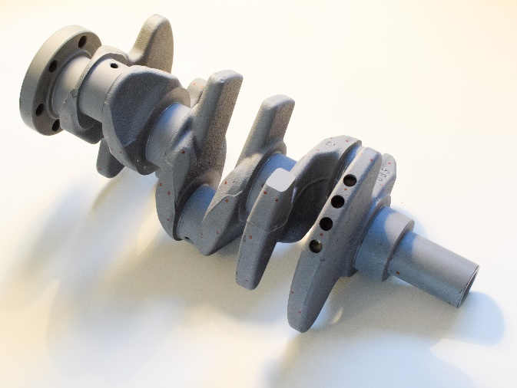 | 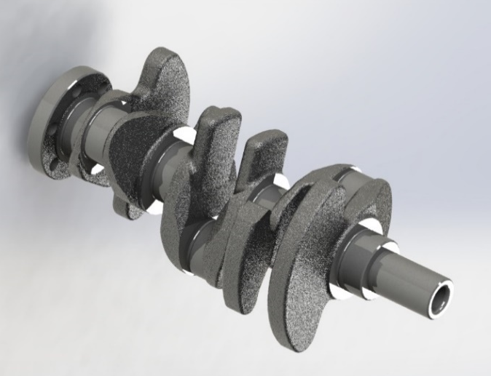

Materials and Properties
The accurate identification of materials for each component plays an important role concerning mass properties and stress simulations. Research was done on each component in order to identify the most appropriate material. These are assumptions as original material specification could not be gathered from manufacturer sources or documentation.
The piston is identified as an EVOTEC design, a unique formation which is ideal in mass reduction within a four-stroke engine. The piston is made out of a cast aluminium-silicon alloy M174+. The material details are displayed in Figure 59 (Mahle GmbH, 2016b). The gudgeon pin is assumed to be made of a Nickel-Chromium alloy (Inconel) 625, due to the high stress operation at high temperature capabilities. The connecting rod from visual inspection is made of a powder forged steel specified by Ford and it has been mentioned to have a UTS of 750 N/mm^2 (McDonald, 2019). An appropriate material designation is 3Cu6C steel alloy (Mahle GmbH, 2016a). Material properties data of the aforementioned are not readily available therefore the properties of a sintered steel with a similar chemical makeup was sourced from (Dietsche and Konrad, 2018). The bearing shells are a multi-material component as previously seen in Figure 19. The material interfacing with the connecting rod is a low carbon steel (AISI 1020) known as the ‘backing’. Roll-bonded to this is an aluminium-tin alloy (7075-O (SS)), which allows the absorption of debris in the oil to avoid scoring and increase bearing life. The bolt material is assumed to AISI 4340 Steel. Lastly, the crankshaft is made of a spheroidal graphite cast iron, specifically assumed to be that of DIN EN-GJS-400-15, material properties were already defined in Solidworks.
The material designations are identified in the table below along with real mass and CAD model mass with applied material. Although mass difference provides an indication of modelling accuracy it is dependent on material density where the real figure is unknown in all cases. Therefore, the component may well be accurately modelled however the material density assigned produces an untrue mass.
Table 4 - 1.0 Ecoboost modelled component materials and masses compared to that of the real engine.
Component | Identified Material | Real Mass (kg) | Solidworks Mass (with applied material) (kg) | Mass Difference (%)
Piston | Aluminium-Silicon Alloy M174+ | 0.2088 | 0.2005 | -3.98
Gudgeon Pin | Nickel-Chromium alloy (Inconel) 625 | 0.0670 | 0.0867 | +29.4
Connecting Rod | 3Cu6C steel alloy | 0.3559 | 0.3158 | -11.27
Connecting Rod Bolt | AISI 4340 Steel, normalized | 0.0177 | 0.0181 | +2.26
Bearing Shell (1/2) | Backing: AISI 1020  Bearing Face: 7075-O(SS) | 0.0110 | 0.0068 | -38.18
Crankshaft | 0.7040 (EN-GJS-400-15) | 6.400 | 6.791 | +5.93

Each material not already defined within Solidworks was added as a custom material file containing the researched material properties, an example can be seen in Figure 60.

Other Considerations

The Oil Film
An important feature not to overlook is the oil film present between the bearings throughout the assembly. In this case however the only benefit would be seen from modelling the crankshaft main bearings. The limitations of processing power inhibit full fluid modelling or accurate modelling of an oil layer however the neglection of this element would produce even further in-accuracies, thus a compromise would be more favourable. The neglect of the oil film would in theory not allow a degree of movement under loading and increase stress experienced in fillets, it would also not show any edge loading if present. The properties of the oil film are similar to a polymer with high stiffness properties (Hu, Zhou and Chen, 2019). The most appropriate material available in the Solidworks materials library is Nylon 6/10.

Initial Design
The design of the in-line twin crankshaft stems from that of the original crankshaft design. The initial design created seen bellow is not balanced to a specification. The counter-mass dimensions featured utilize the maximum tolerated space available and is the main area designed for alteration to achieve the desired balance. The webbing design is closely that of the original in a symmetrical formation efficiently utilising material. The same material is retained.

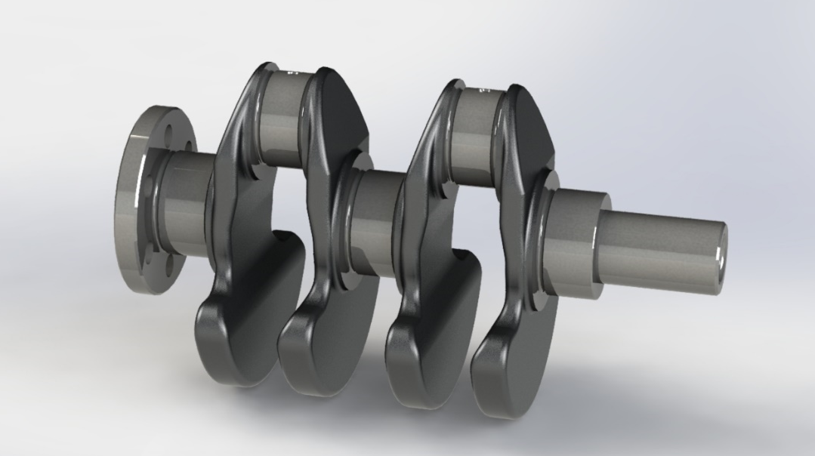
Figure 22 - Initial in-line twin crankshaft design.

The oil galleries are designed in the same manner as the original, a single angled drilling at a 45º angle from TDC (Oil galleries pictured are at 0º TDC, the earliest design). All drillings are chamfered. The outer main bearings centrifugally feed the connecting rod bearings. All three bearings are fed through the engine block. All bearings feature fillets to prevent stress concentrations to the same specification as the original (a radius of 1.5mm). Fore and aft mounting for the ancillaries and flywheel are also predominantly retained although will be altered to suit hybrid generator coupling method.

Under-Balancing Study
It was decided that since the engine will be horizontally mounted it would be most beneficial to adopt an under-balanced crankshaft design as opposed to either a fully balanced system requiring three balance shafts or a first order balanced system requiring a single counter rotating balance shaft. Both options introduce addition friction losses, mass and complexity while under-balancing would remove the rotating unbalances and retain the reciprocating force along the cylinder axis which when mounted horizontally vibrations can be compensated for with compliant engine mounts.
To under-balance the horizontal inline-twin crankshaft design an Excel spreadsheet was developed on the first order balancing principles. Illustrated in Figure 23, the forces present in a inline-twin are broken into three force vectors, a forward vector acting in line with the connecting rod bearing and following the direction of rotation. The second a reverse vector rotating opposite to the first at an equal angle from the cylinder axis. The third is the centrifugal force produced by the mass of the crankshaft and counter mass which is utilised to move the centre of gravity affecting balance.

α
α
Forward Vector
$\left(M_{ROT}+\frac{M_{REC}}{2}\right)Rω^{2}$
Reverse Vector
$\left(\frac{M_{REC}}{2}\right)Rω^{2}$
Centrifugal Force
$M_{CRANKSHAFT} х ω^{2}$
х
Crankshaft
Figure 23 - First order force vectors present within the horizontally mounted crank train assembly.

Under-balancing retains the reciprocating mass vectors and balances only the rotational mass using the counter mass centrifugal force. The centre of gravity (COG) is altered a set distance ‘х’ away from the rotational axis. The distance is found through Equation 8. The rotational and reciprocating masses are defined by Equation 9. The original component masses are used for balancing, therefore within Solidworks all component masses were overridden retaining only the mass distribution qualities specified by the model geometry.
$${х=(M_{ROT}*R)/M}_{CRANKSHAFT } mm$$
$$Crank Throw R \left(mm\right), { M}_{CRANKSHAFT} (kg)$$
Equation 8 - Crankshaft centre of gravity distance for under-balanced assembly.

$$M_{ROT}=\frac{2}{3}Rod+Bearing Shells+ConRod Bolts kg$$
$$M_{REC}=\frac{1}{3}Rod+Piston Assembly+Gudgeon pin kg$$
Equation 9 - Rotational and reciprocating masses.
Initially to achieve the desired COG location the mass of the first crankshaft design were entered into the spreadsheet calculations in order to achieve the COG distance. This proved difficult as alteration in counter-mass changed the crankshaft mass and thus the resultant COG distance. Instead a set of bob weights were modelled and added the crankshaft, pictured in Figure 24. The bob weights only totalled the mass of the rotational components (M_{ROT}). This allowed the counter-mass to be altered to position the COG in the middle of the crankshaft axis of rotation. A benefit to this method is that instead of retaining mass and redistributing it to retain the validity of the equation, mass can be removed and optimized resulting in a lighter overall design. The under-balanced design is 422 grams lighter than a 100% balanced version (which would require the addition of a possible 1kg balance shaft).
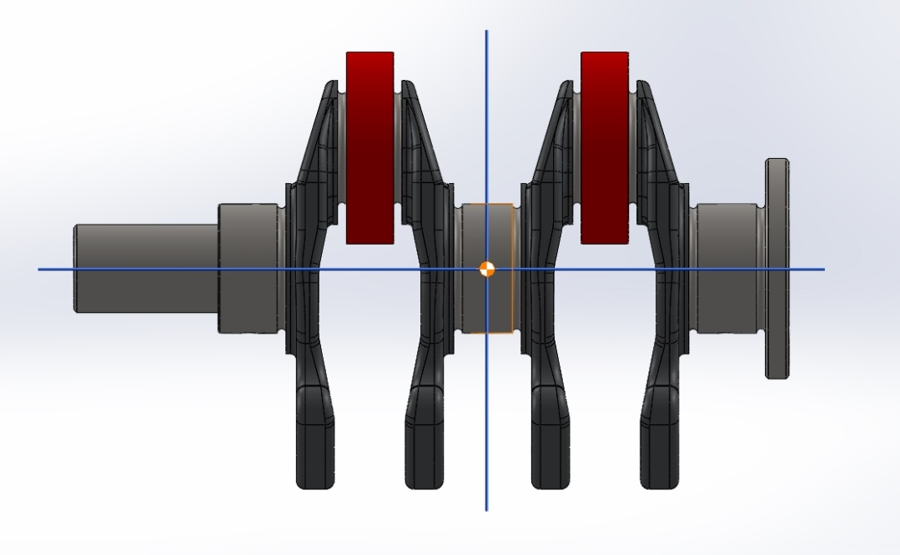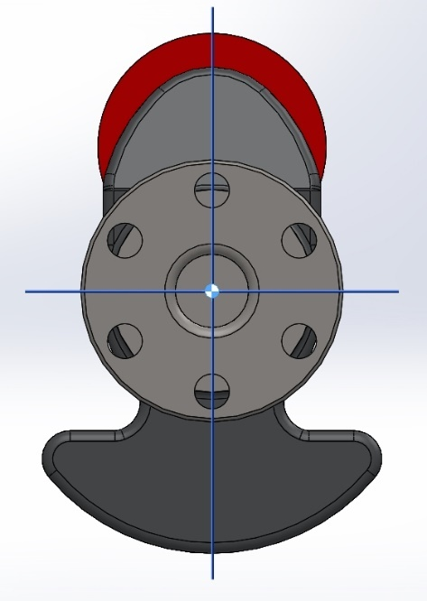
Figure 24 - Under-balanced crankshaft design within Solidworks. The centre of gravity is on the centreline of the rotation axis, when the (red) bob weights are added.

Dynamic Balancing - Motion Simulation
To confirm the validity of the static balance a motion study was conducted within Solidworks. The aim was to measure reaction forces at the main bearing journals. This was achieved through modelling a main journal bore for the crankshaft to rotate within, avoiding the used of restricted axis mating. Instead a it was concentrically mated allowing a sensor to be attached to the mate measuring reaction forces along the Y and Z axis (vertically and horizontally perpendicular to the crankshaft axis of rotation). The bob weights were added to the study totalling that of the mass used in the static study. The crankshaft is spun with a motor to 3000rpm for 4 complete cycles.
The results showcased an insignificant total magnitude of 2.12 N, see Figure 25. The vertical and horizontal reaction forces form a circle when plotted proving the rotating assembly is uniformly balanced.

Figure 25 - Main journal bearing reaction force of under-balanced motion study, only containing bob weights.
The effects of the under-balanced crankshaft were further studied in the complete assembly of the engine. A motion study of the complete assembly with a mock engine block and methods used in the previous study was set up, which can be seen in Figure 26. Again, the engine is motored to 3000rpm and reaction force measured along the vertical and horizontal axis.
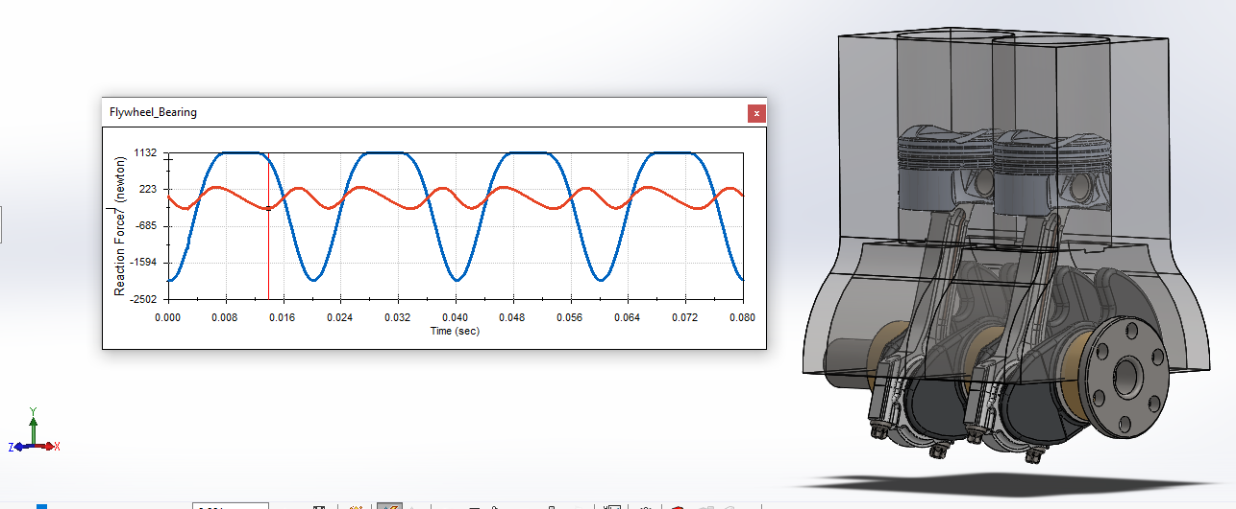
Figure 26 - Motion simulation results of motored engine assembly. Sensor measurements taken at the flywheel main bearing (due to central bearing computational error).
The results of the motion study were positive, showing the highest forces acting along the cylinder axis graphing the Y and Z axis reaction forces. The graph showcased a triangular shape, the same trend illustrated in the Figure 28, which is a polar plot visualizing the reaction forces of various levels of mass added to the counterbalance from investigation by (Heifetz and Marsh, 1984). Studies by (Burkhardt, 1917) further add confidence in the results obtained. A small addition of counterbalance mass (under-balanced) is shown in the data line ‘A’. This supports the findings of the motion study and hence confirming the crankshaft is indeed correctly under-balanced.

Figure 27 - Complete motion study findings of reaction forces plotted in the Y and Z axis. The result of the underbalanced crankshaft is a lower force present in the z axis than that of the Y.

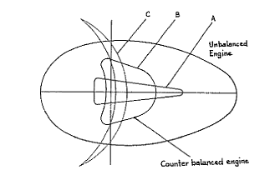
Figure 28 - Polar plot of various counterbalance configurations. (Heifetz and Marsh, 1984)
The final balance study looked at the dynamic balance of the crank assembly under the force of combustion instead of a driving motor. The gas force acting on the piston is gathered from the original engine cylinder pressure data studied in the previous segment. The data range for 3000rpm is selected as a sensible operation engine speed and the pressure data converted into gas force through Equation 10. The data is phased correctly for the firing and non-firing cylinders.

$$Gas Force=Cylinder Pressure*\frac{π}{4}*D^{2} N$$
Equation 10 - Gas Force.

The study method is repeated with the addition of the gas force, as a data set across 720deg, being applied to the top of the piston and set to act along the Y axis. To aid smooth operation the engine is first motored to 3000rpm and then run under gas force, eliminating teething problems. The result of the study can be seen in below.

Figure 29 - Bearing reaction force of under-balanced engine under firing. The transition from motor driven to combustion can be witnessed.

FEA Testing
A finite element analysis of the under-balanced crankshaft design was conducted in order to evaluate the bending stresses of the newly designed webbing and counter-mass geometry. As well as to study the torsional stress properties essential to the torsional vibration excitation within the engine. Although bearing diameters and crank throw are retained it cannot be assumed the same level of stresses will be present within the component as the configuration has completely been altered. Both the hybrid and original crankshaft is tested in order to evaluate the new design. The aim is to achieve similar or lower values of stress and displacement for the assumption of equal longevity to be valid.
The study was carried out using Genesis Design Studio a NASTRAN based finite element solver. A mesh is generated from the Solidworks assembly and exported to the solver; this retains the specified material properties. Component relations, constraints and loads are defined in the solver.

Mesh Quality
Defining the mesh plays and important in solving time and quality of results. The temptation is to use a very fine mesh, <1 mm, to attain maximum accuracy of results. However, this drastically impacts solving time increasing exponentially with each increment and is not required on most of the components. It must also be understood that FEA results are only an approximation albeit an accurate one at times. Initially a 2mm mesh was utilised for the crankshaft and other components however as illustrated in Figure 30 the undercut bearing fillets were oversimplified therefore a mesh size of 1mm was selected satisfying the guidance; at least three elements on fillet (Altiar University, 2019). It must be noted that a later limit in computational power meant mesh size had to be increased and limited to ‘draft quality’ (mid-point nodes are removed).
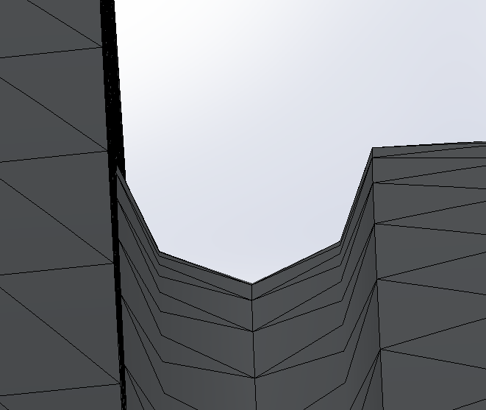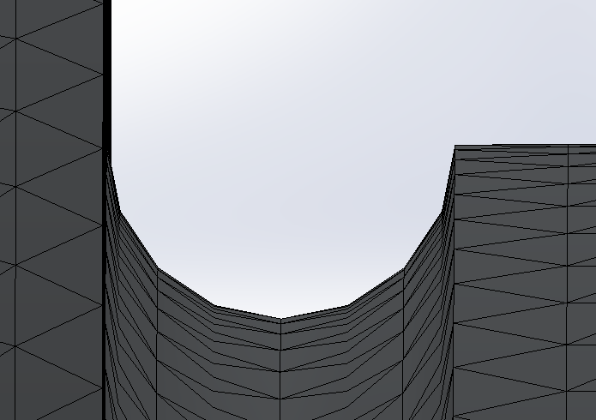
Figure 30 - The effect of mesh size on the crankshaft bearing fillets. Left, 2mm mesh and right 1mm mesh.

Loads and Constraints
Loading is done in two planes for each crankshaft, the first is referred to as in-plane where the connecting rod pins are positioned at TDC. This is would be a worst-case loading condition for bending. For the in-line twin both crankpins are at TDC while for the original crankshaft with pins positioned at 240º of each other only cylinder one is positioned at TDC. In addition to the former tests were conducted with the crankshaft out of plane (90º to TDC) to evaluate the differences in stiffness. Again, cylinder one was used for each test.
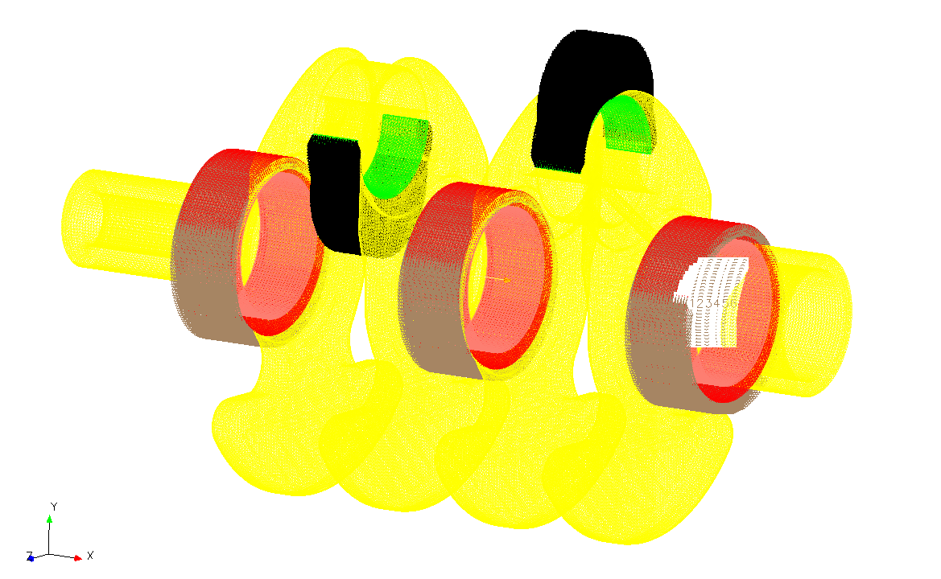
Figure 31 - Constraints and loading setup. Big end bearing shell (green), main bearing ‘holders’ (red), crankshaft (yellow).
Maximum force data was provided by the paper (Engelbrecht, 2019) defining the net force applied to crankshaft under firing and exhaust stroke conditions using combustion data.
The FEA test is set up in the manner illustrated in Figure 31, which is also applicable to the original crankshaft with small variations. The load is applied through the connecting rod bearing shells to simulate real loading surface area, instead of the force being applied through all nodes of the connecting rod pin. The difference in configuration of both crankshafts lead to difficulty in producing a fair loading scenario. Initially a firing as well as exhaust cycle load was applied to the hybrid crankshaft to achieve which is considered to most accurate loading scenario. This however could not be emulated on the original for a limitation in solving power was encountered. To compensate for the difference in testing the hybrid design testing was repeated with only the firing load, an insignificant reduction in nominal stresses of <1% was shown in all instances believed to be due to the difference in force magnitude between compressive and tensile. Therefore, only the first two tests are featured below.
The main bearings were fixed in early testing iterations to simplify processing however this did not allow the degree of freedom offered by the oil film therefore ‘bearing holders’ were developed and a 1mm oil film was implemented. Modelled as a Nylon polymer 6/10 as previously discussed in 1.5.1.4.1. The oil film is a thickness of 0.033 (recommended bearing clearance) but the fine mesh size required could not be achieved with the available computational power.

Hybrid In-line Twin Stress Analysis Results

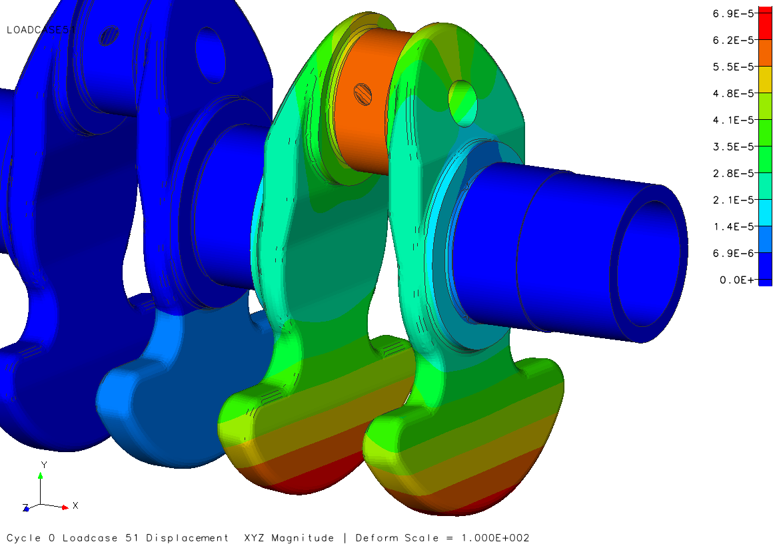
Figure 32 - Hybrid in-line twin in-plane total deformation.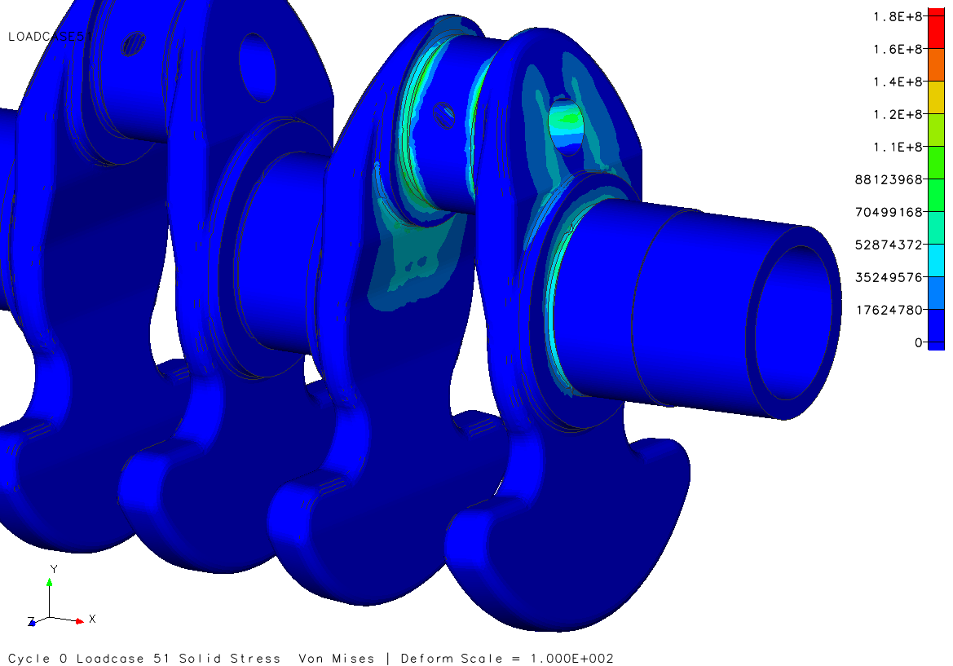
Figure 33 - Hybrid in-line twin in-plane equivalent stress.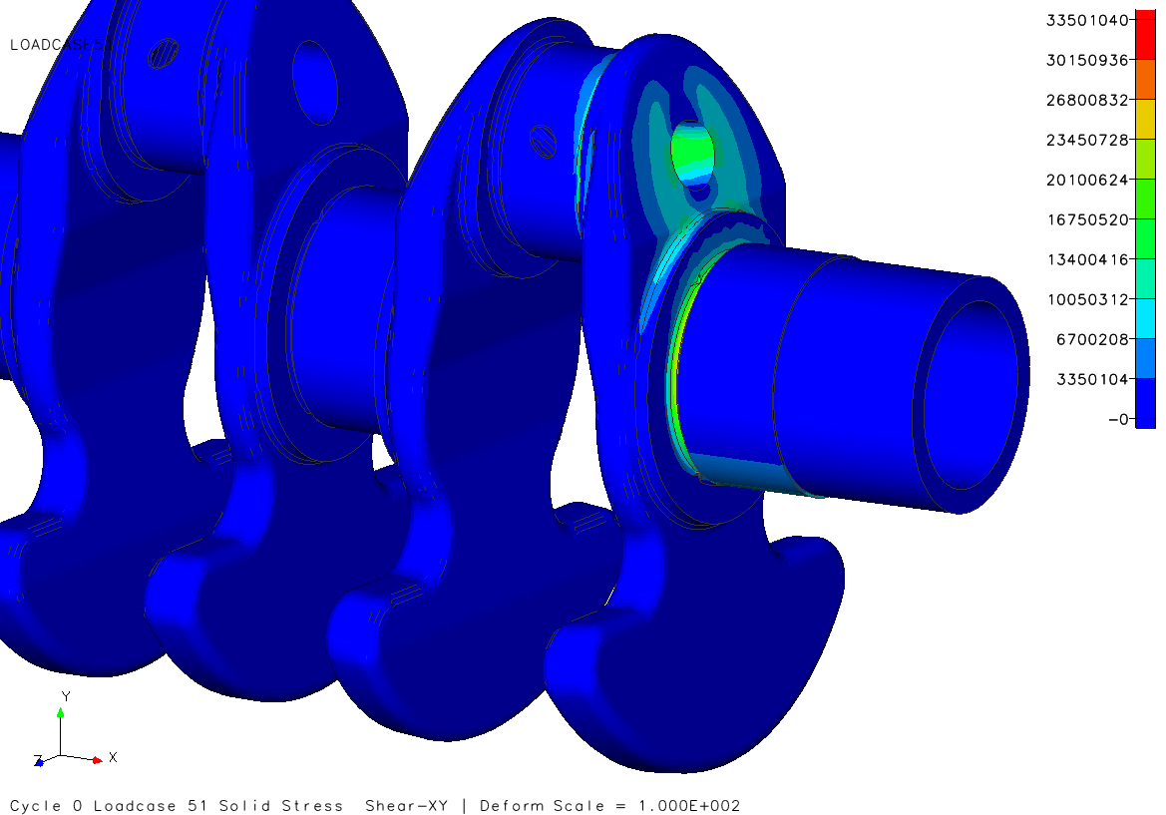
Figure 34 - Hybrid in-line twin in-plane shear stress.
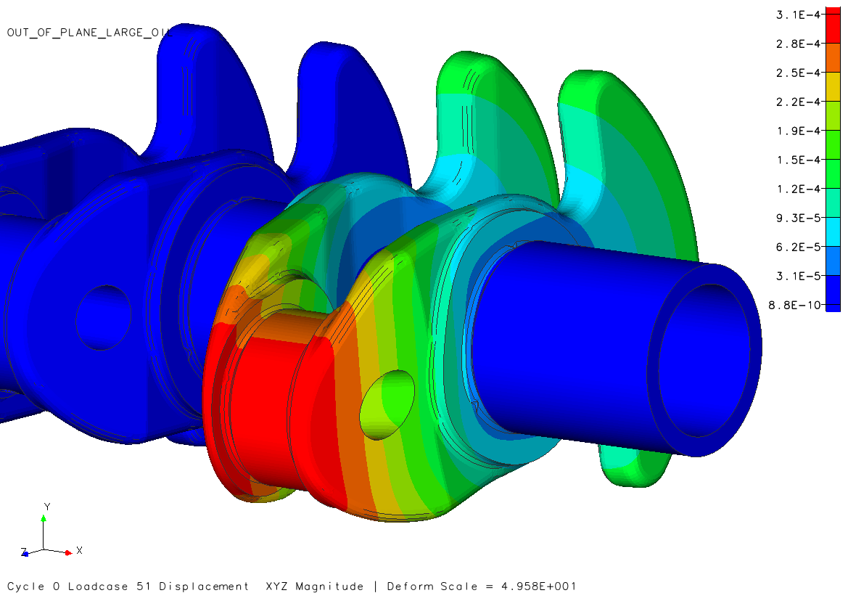
Figure 35 - Hybrid in-line twin out-of-plane total deformation.
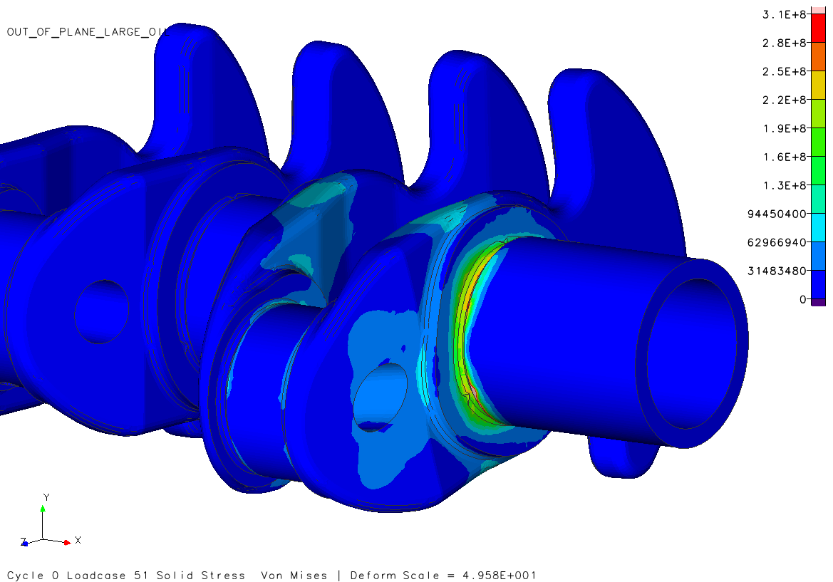
Figure 36 - Hybrid in-line twin out-of-plane equivalent stress.
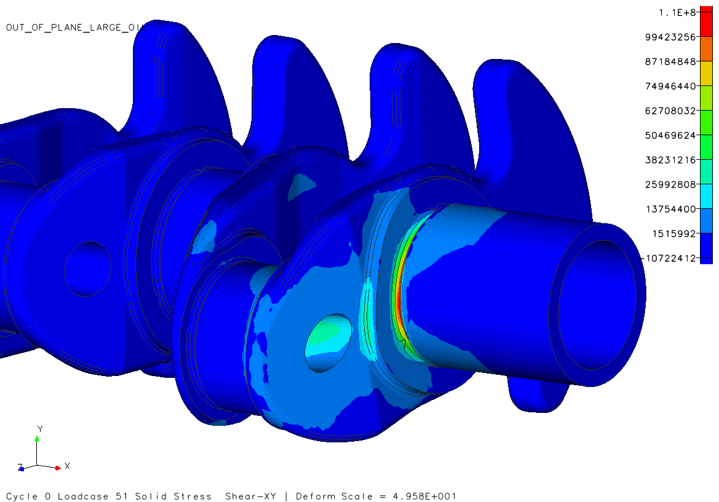
Figure 37 - Hybrid in-line twin out-of-plane shear stress.

Original Crankshaft Stress Analysis Results
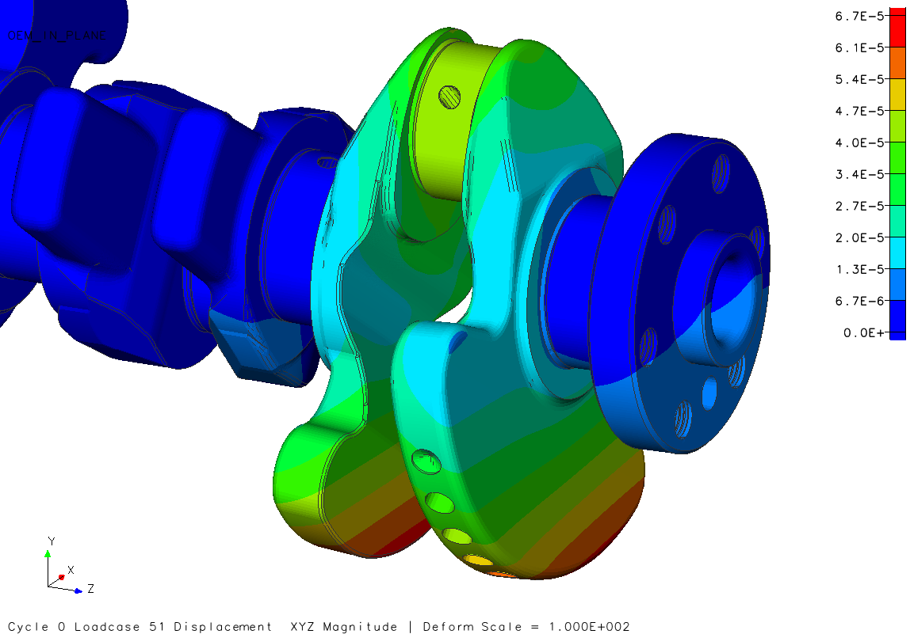
Figure 38 - Original crankshaft in-plane total deformation.
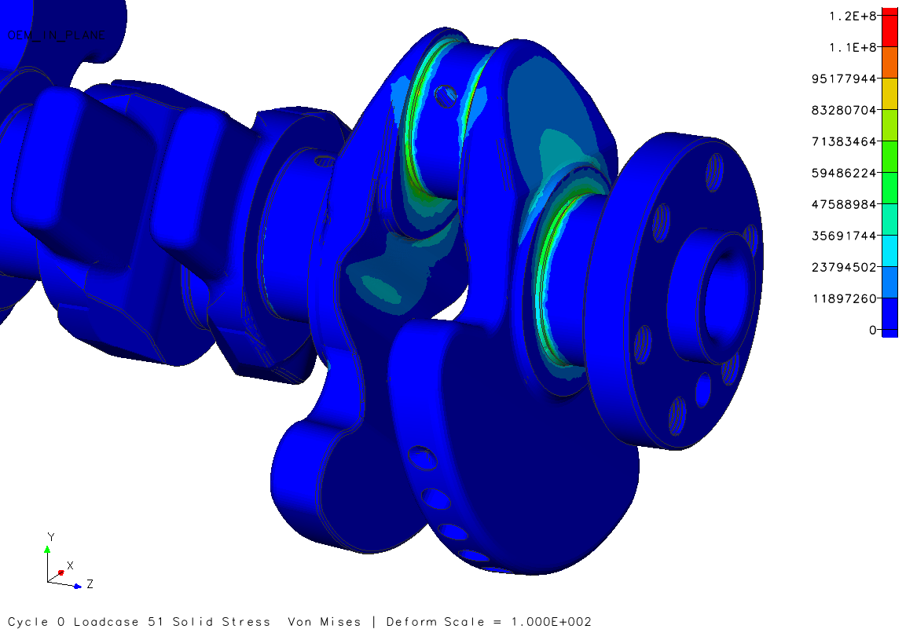
Figure 39 - Original crankshaft in-plane equivalent stress.
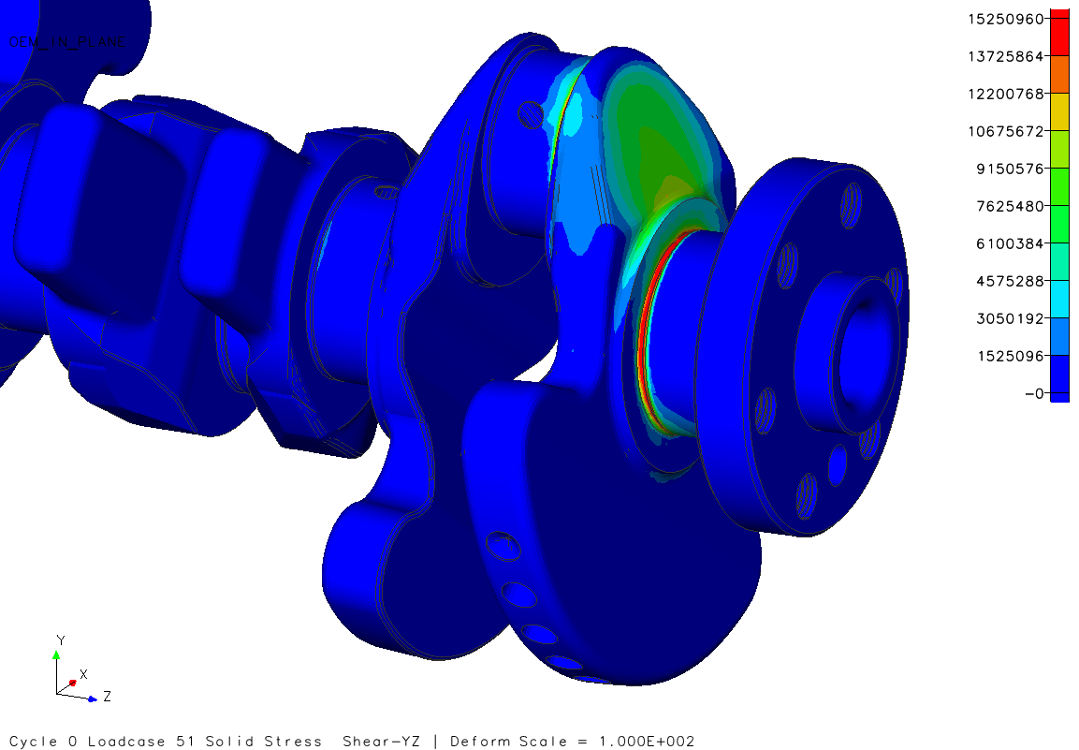
Figure 40 - Original crankshaft in-plane shear stress.
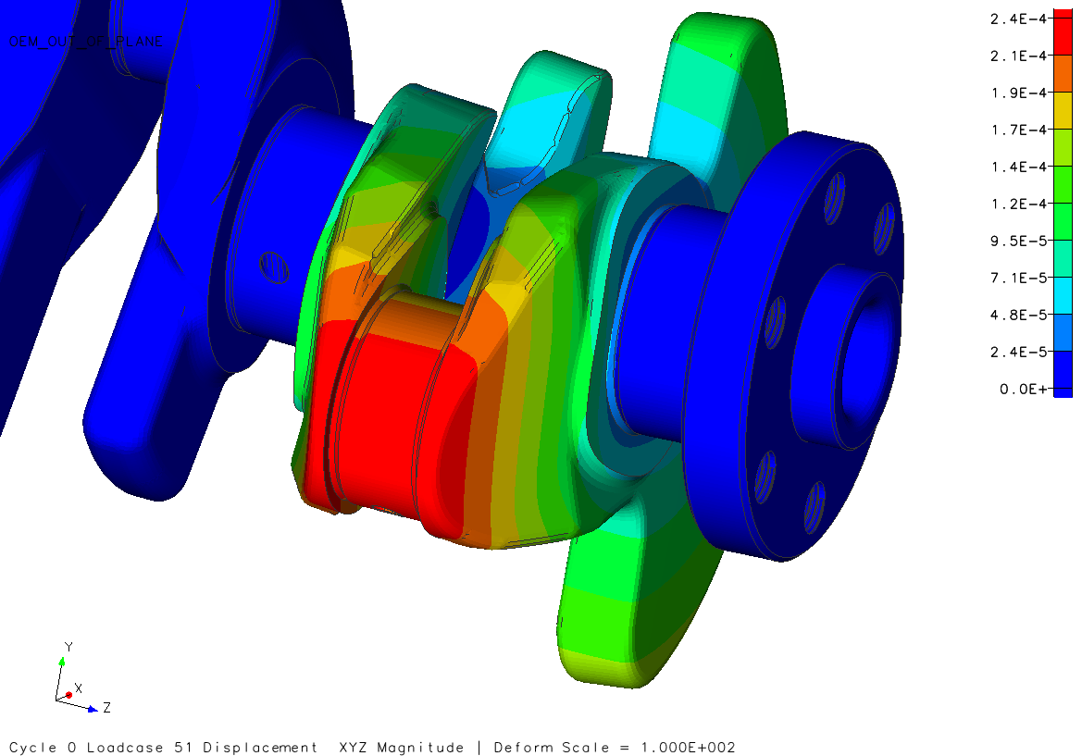
Figure 41 - Original crankshaft out-of-plane total deformation.
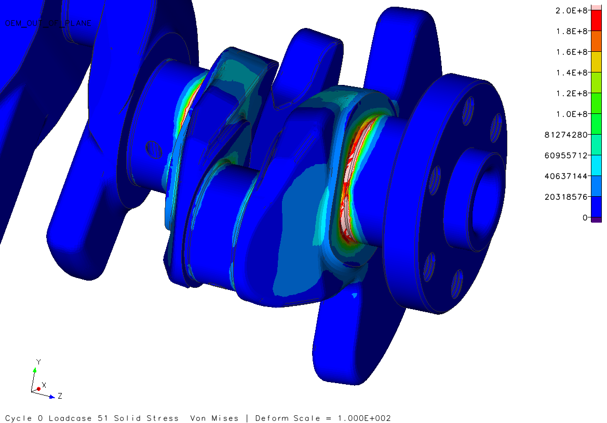
Figure 42 Original crankshaft out-of-plane equivalent stress.
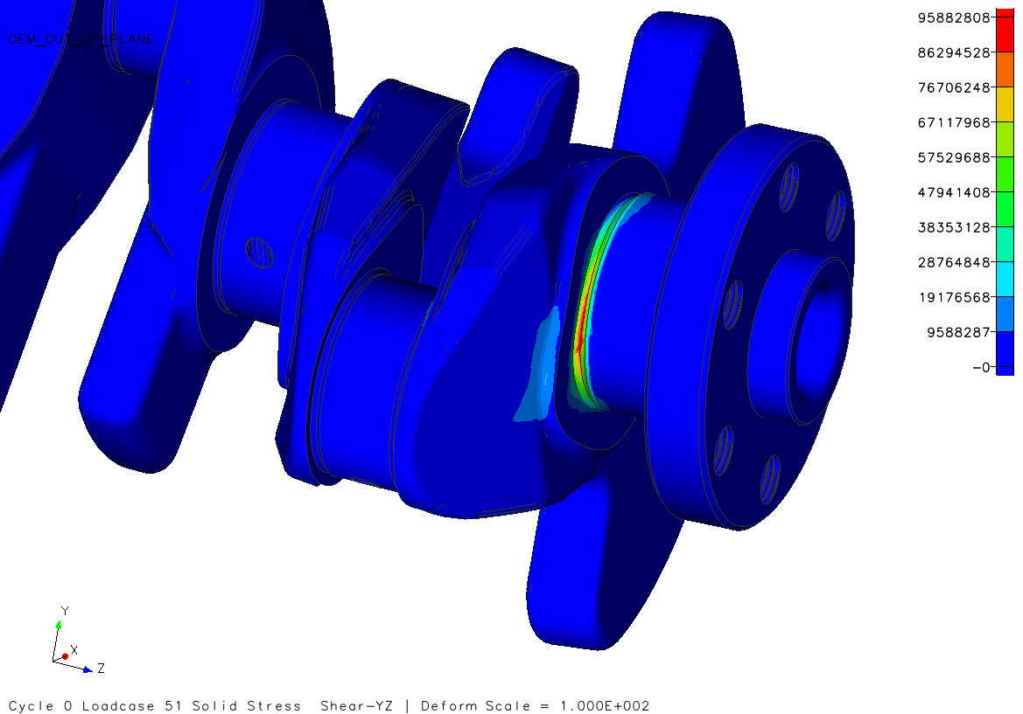
Figure 43 - Original crankshaft out-of-plane shear stress.

Stress Analysis Results Correlation
Tabulated results of the study are showcased below. The findings show a greater amount of deformation in all cases with the new design and are believed to be due to the lightening pin hole. The greatest amount of deformation In-plane were seen at the outer edges of the counter mass, figures were near identical. While out-of-plane deformations are significantly higher and seen solely at the end of connecting rod pin on both crankshafts.
The in-plane equivalent stress faired a great deal better showing a reduction of 168.4 MPa. While out of plane equivalent stress saw an increase of 223.3 MPa over the original. Originally thought of as a large increase which would indicate failure was soon found to be a meshing error where high stress values were concentrated at a single point (Figure 67), the surrounding stress values are in line with that of the original. This is the result of limited processing power.
Lastly, the shear values were similar in-plane to an acceptable amount. Again, out-of-plane values were greater for the new design and are not attributed to mesh error but rather the combination of lightening hole and oil gallery (Figure 68).
Table 5 - FEA analysis results.
Maximum Values | Original Ecoboost Crankshaft |  | Hybrid In-Line Crankshaft
Maximum Values | In-Plane | Out-of-Plane | In-Plane | Out-of-Plane
Total Deformation (mm) | 6.74E-5 | 23.80E-4 | 6.92E-5 | 30.10E-4
Equivalent Stress (MPa) | 237.94 | 406.37 | 176.25 | 629.67
Shear Stress (MPa) | 30.50 | 95.88 | 33.50 | 111.66

Modal Analysis
A modal analysis was of interest and therefore conducted to develop an understanding of the natural frequencies which would excite the crankshaft assembly and cause a resonance. Harmonic frequencies are caused by the combustion process could resonate with the assembly resulting in decreased fatigue life and possible breaking. The engine has a maximum operation speed of 4000 rpm (firing each rotation) resulting in a first order frequency of 67Hz and a second order frequency of 133Hz. The aim is to remain in a frequency range above those values.
The crankshaft will need to test with the rotor attached as this will heavily influence the frequency response similar to the effect a flywheel would normally have. The design of the internal rotor is based on the UQM PowerPhase 75 hybrid electric motor, specified by (Turner et al., 2010). The rotor designed for testing purposes possesses the following properties. Material: DIN Iron EN-GJMW-400-5, mass: 30.00 kg (Total unit mass 41.00kg), moment of Inertia: 0.15 kg/m. It has been designed as one single part to simply the testing procedure and computational loads. The coupling spline has been suppressed (removed) for testing and a RBE2 is used instead to join crankshaft and rotor shaft. The modal analysis is done in Genesis Design Studio using the Lanczos method. Hardware limitations resulted in the finest mesh possible being 2mm draft quality. The results of the study are as follows.

Modal Analysis Results
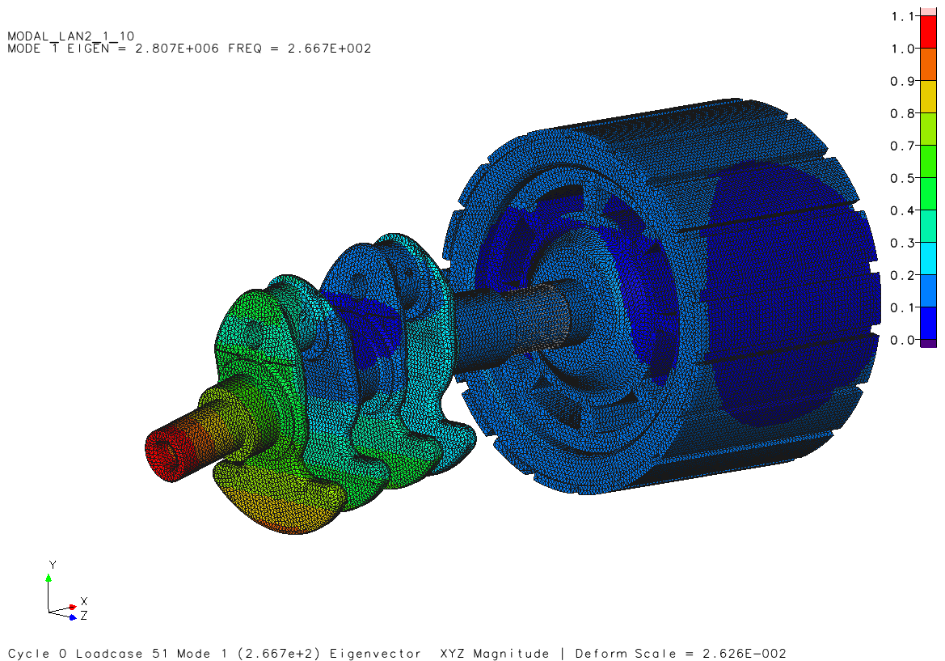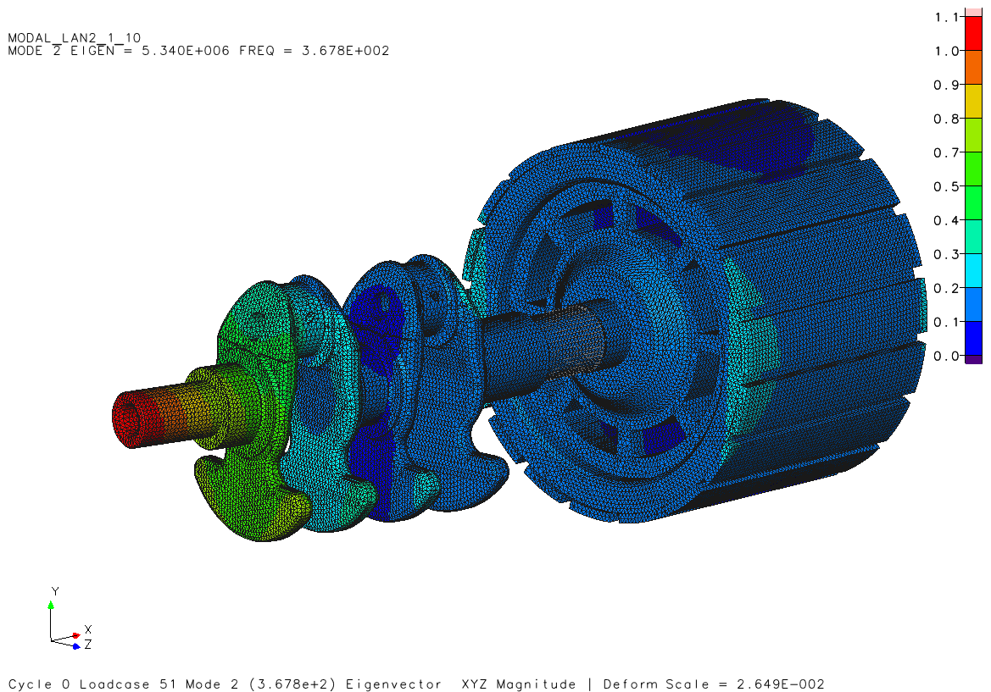
Figure 44 - First and second mode.
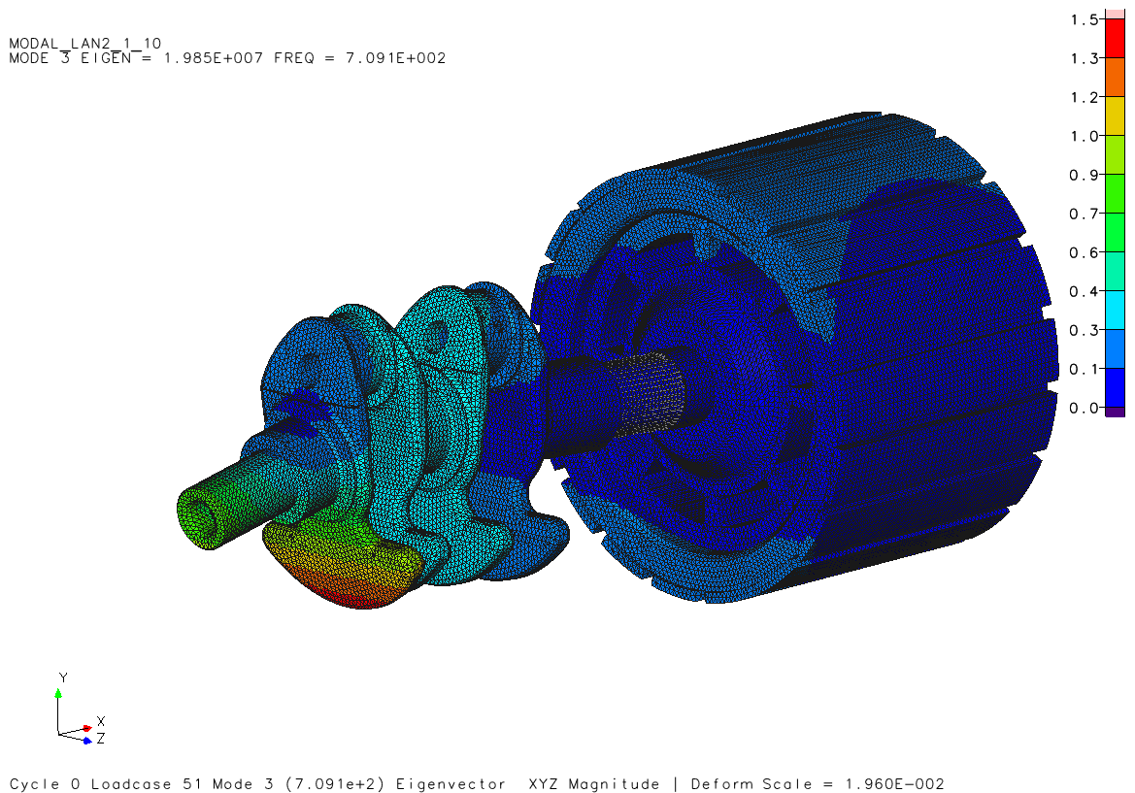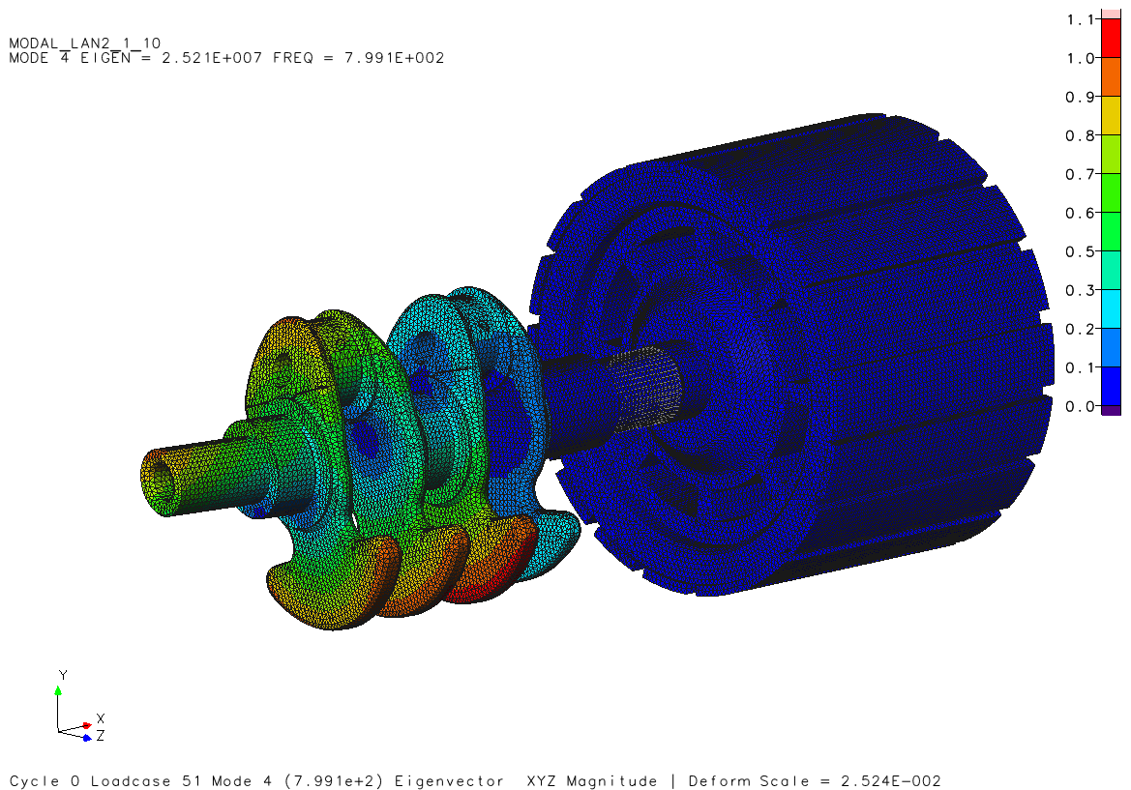
Figure 45 - Third and fourth mode.
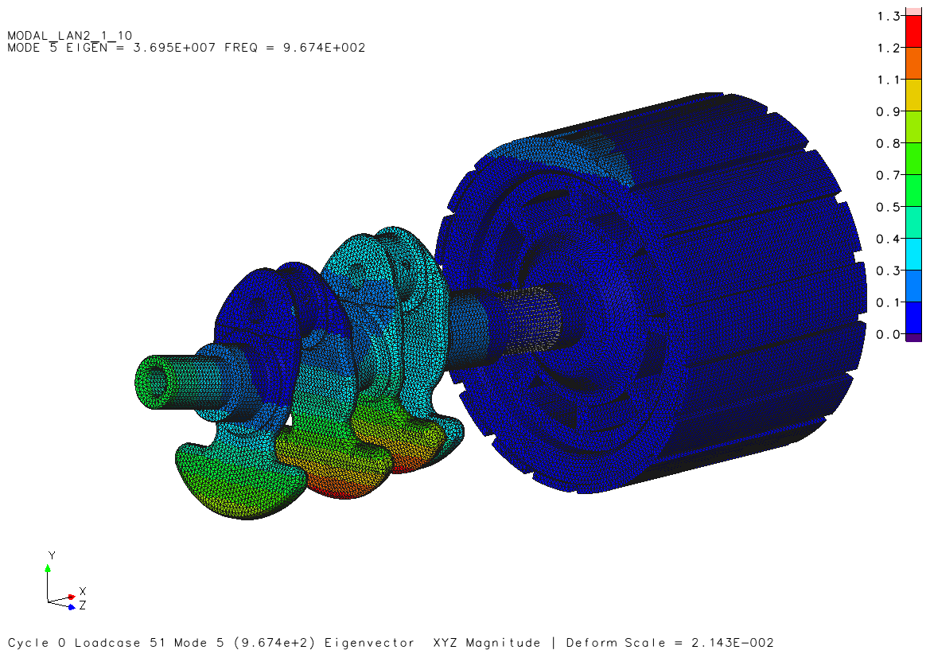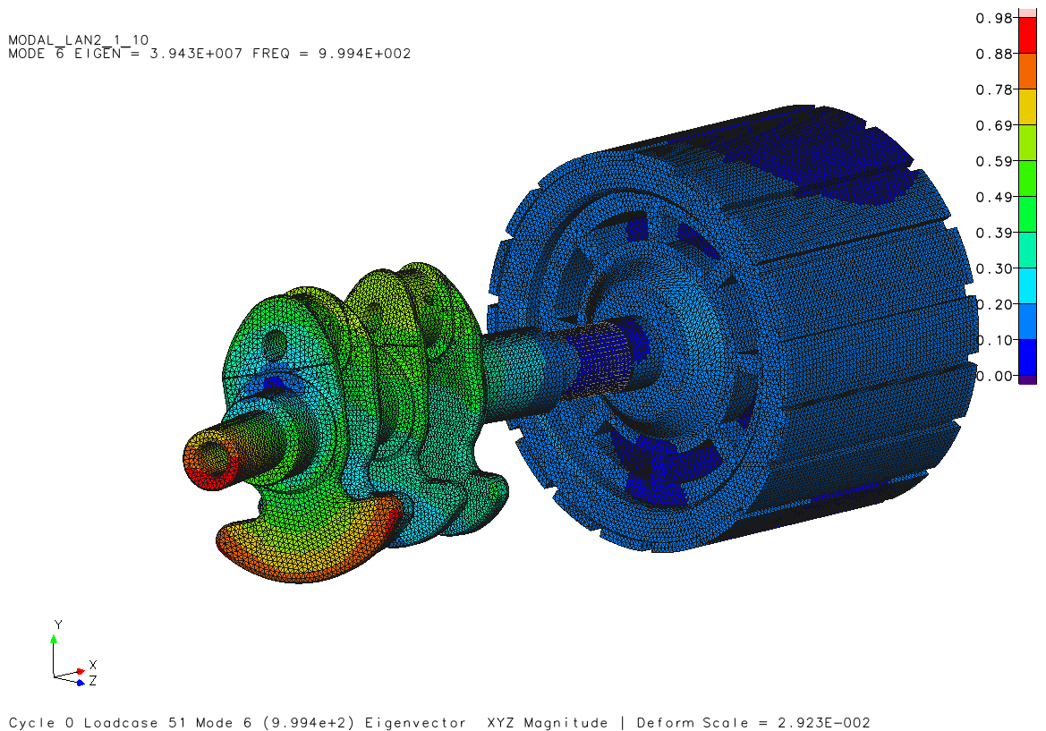
Figure 46 - Fifth and sixth mode.
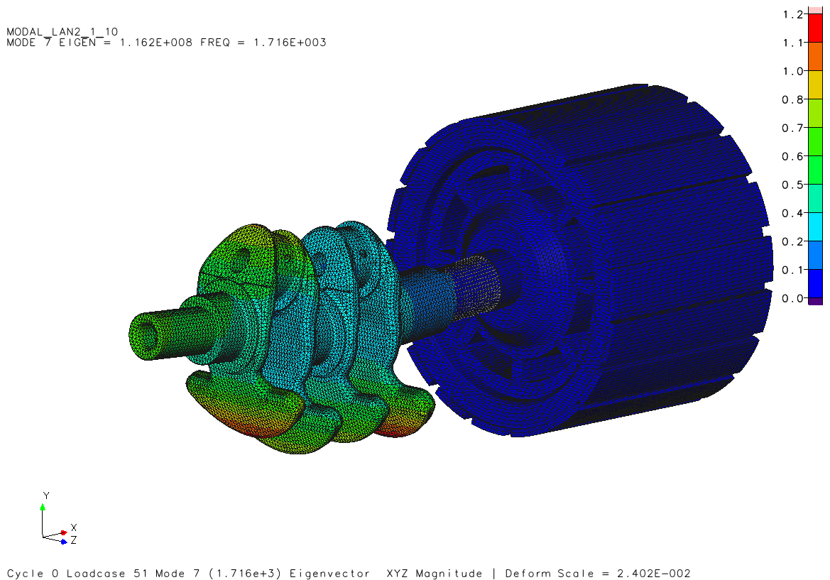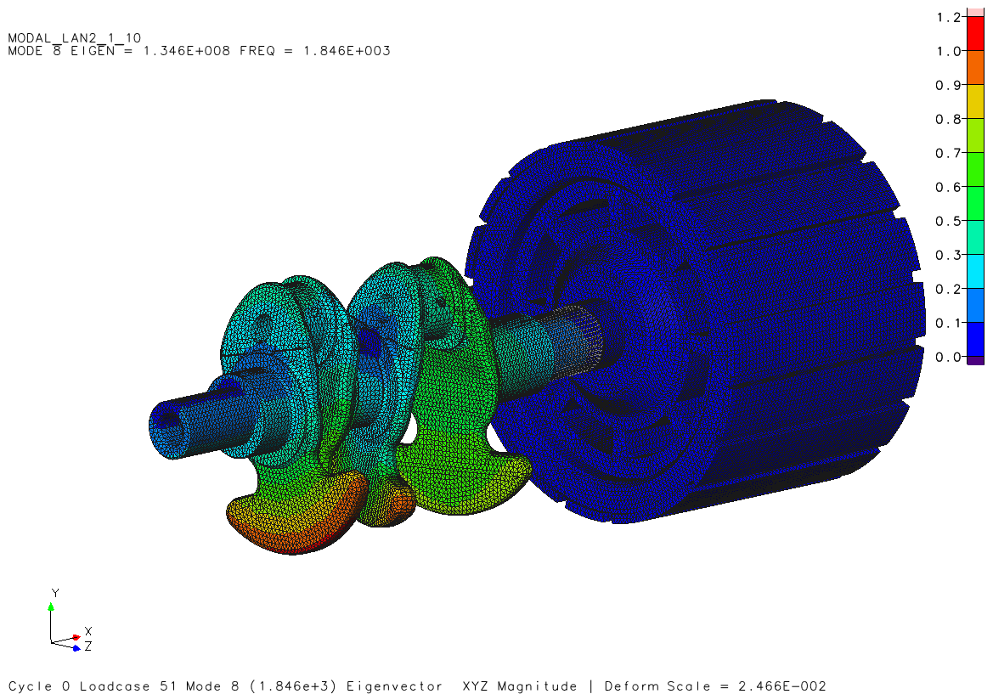
Figure 47 - Seventh and eight mode.
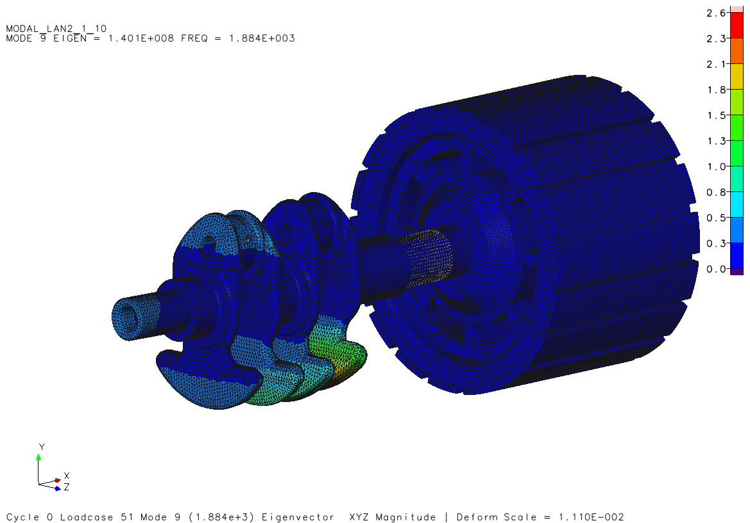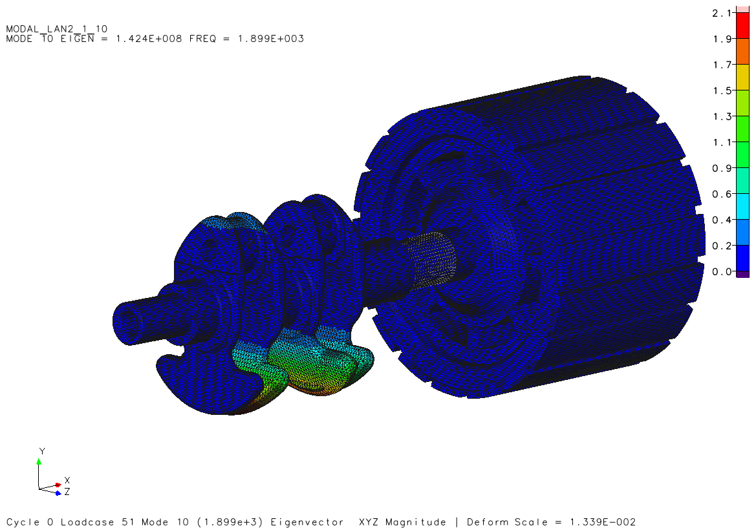
Figure 48 - Ninth and tenth mode.
Table 6 - Inline twin crankshaft and hybrid rotor assembly modal analysis frequency results.
Mode | Frequency (Hz) | Type of Mode
1 | 266.7 | Bending
2 | 367.8 | Bending
3 | 709.1 | Bending
4 | 799.1 | Torsion
5 | 967.4 | Bending
6 | 999.4 | Torsion and Bending
7 | 1716.0 | Bending
8 | 1846.0 | Torsion and bending
9 | 1884.0 | Bending
10 | 1899.0 | bending

The modal analysis results are positive despite the increase in length and mass of the additional rotor. The lowest frequency achieved is 266.7Hz, under bending, which is much higher than the combustion first and second order frequency.

Torsional Vibration Damper Design
Due to the reduction in cylinders and lower operational speeds of the engine there were concerns of a higher rotational irregularity and therefore, to further improve the NVH qualities of the cranktrain assembly a torsional vibration (TV) damper was specified. Mounted at the opposite end to the drive output and consisting of a circular two-part assembly similar to that of a pulley, with a flexible (butyl rubber) element acting as a spring, joining the two together. This connects a power-take-up element (ex. the alternator) to the crankshaft. During torsional vibration, the spring element temporarily absorbs the energy through compression (Dietsche and Konrad, 2018). The TV damper also reduces the magnitude of torsional stress at the static point within the assembly (As torsional twisting occurs at opposite ends of the assembly in opposing directions, along the centre of the assembly is a static point which experiences the greatest torsional stress).
The damper design is featured in Figure 49. Made up of three components before bonding, the first couples to the non-drive output side of the crankshaft. The outer component drives the ancillary belt and the diameter thereof is altered to tune the damper to that of the torsional frequency present in the cranktrain assembly. Both are made of DIN Iron EN-GJMW-400-5. The complaint bonding material is NBR Acrylonitrile-Butadiene Rubber at a thickness of 2mm.

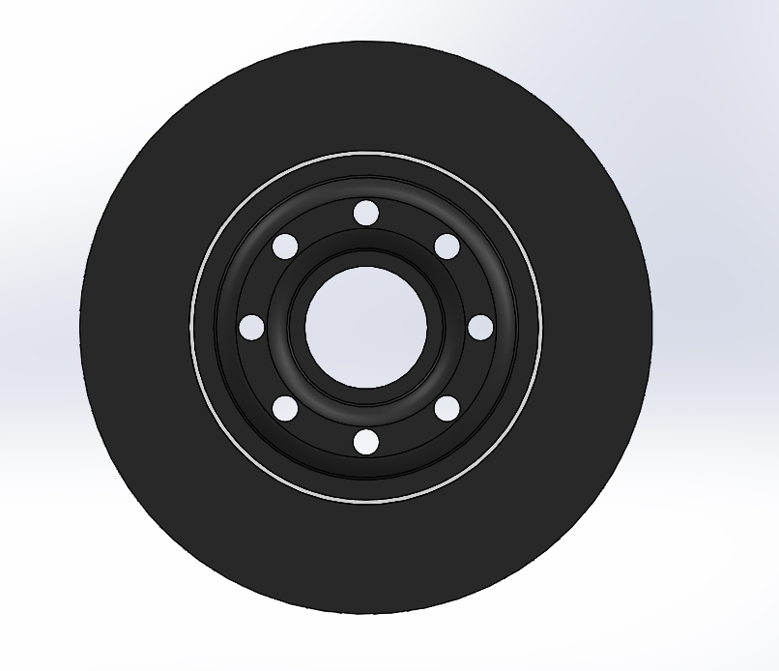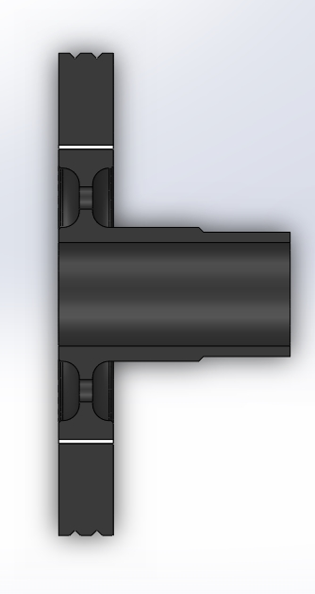
Figure 49 - Designed torsional vibration damper. featuring a butyl rubber coupling.

TV Damper tuning is done in Genisis Design Studio in a similar process to that of the crankshaft and rotor assembly. The mounting surface to the crankshaft is constrained to isolate vibration to the outer element.

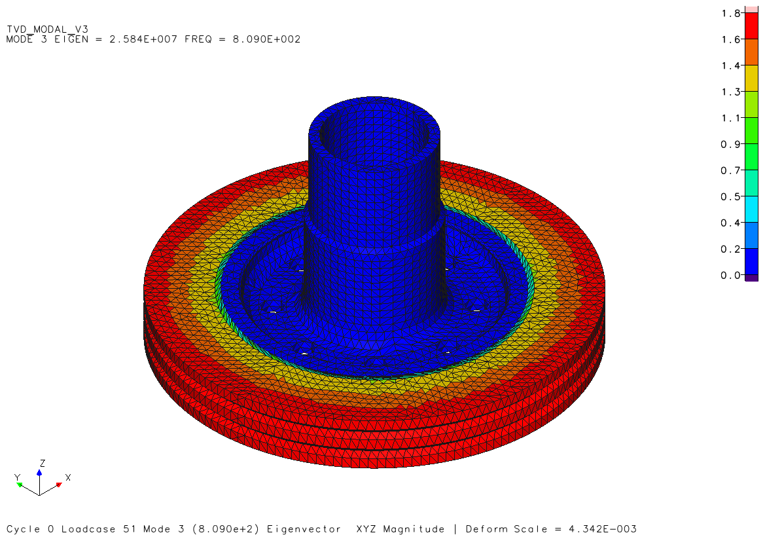
Figure 50 - Modal analysis of TV damper.

Table 7 - Damper tuning process results.
Design Model Version | Outer Diameter (mm) | Frequency (Hz)
1 | 82.0 | 1151.0
2 | 87.0 | 851.7
3 | 88.0 | 809.0
4 | 88.1 | 805.0
5 | 88.2 | 801.0
6 | 88.3 | 797.0
7 | 88.25 | 799.0

Through seven iterations of the total diameter (altered through the outer element) the damper was tuned to the crank train torsional frequency of 799.1Hz, see Table 6. The method proved efficient and the result, while positive, is believed accurate.

Final Design and Considerations
Illustrated bellow, after many iterations from the first concept and through many form of validation from testing the under-balanced crankshaft design has been concluded upon. The addition of the drilled holes in the connecting rod bearing pins lightened the mass above the centreline which allowed a reduction in the counter-mass leading to an overall lighter crankshaft. The flange coupling was replaced with a female spline connection (not modelled) to interface with the existing spline on the UQM PowerPhase 75 generator, specified by (Turner et al., 2010). This is beneficial as splines are well suited for high alternating torque (Schaeffler Technologies GmbH & Co, 2014) and is an effective alternative to the coupling flange. These design alterations led to a final crankshaft mass of 3.88 kg (23.3% lighter than first under-balanced design).
General displacement, equivalent and shear stress results bar that of a meshing error were acceptable. The lightening hole in the con-rod bearing pin is believed to be the cause of higher figures particularly affecting shear stress. The exclusion thereof would not be of detriment and would result in more counter-mass added to compensate, while headroom in the frequency range allow for the mass addition.
The removal of two of the inner counter-mass webs was initially attempted however this led to two excessively large geometries to achieve the desired balance (Figure 69) and was not considered feasible. The oil gallery hole angle relative to TDC have been altered from 45º to 60º (maximum recommended by (Manning, 2012)) to allow greater wall thickness between the con-rod pin hole and oil gallery. FEA result showed no critical stress associated with the oil gallery and lightening hole wall thickness.
Following the results of the modal analysis is was clear under the maximum operational engine speed of 4000rpm with a resulting first and second order excitation of 67Hz and 133Hz respectively it would not resonate the assembly. It is important to consider harmonics of the combustion frequency as the 4th harmonic of the first order frequency excites the first bending mode, although the amplitude naturally decreases the validation of a Fourier series torque ripple analysis would be beneficial.
To remain within the specified limits, it is recommended that the maximum mass of the rotor would be 30kg with the centre of mass 166 mm away from the crankshaft connection end. The maximum moment of inertia of 0.15 kg/m is recommended. The TV damper specification for this assembly are mentioned previously. Headroom is available and naturally tests would be repeated with alterations in components and materials. The method however has been proven to be sound and the final outcome positive.

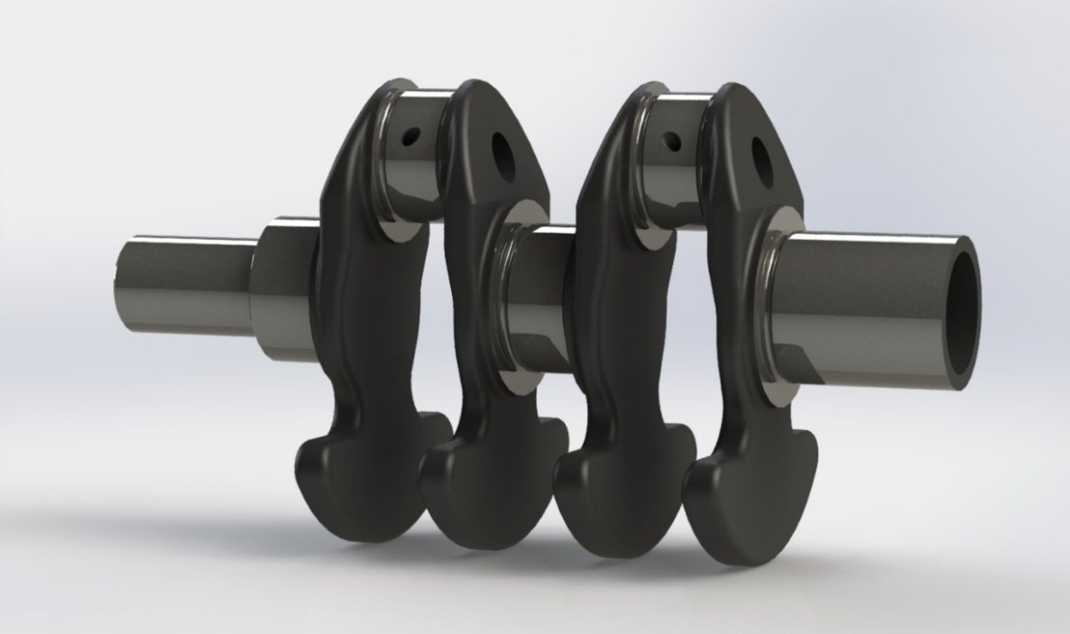
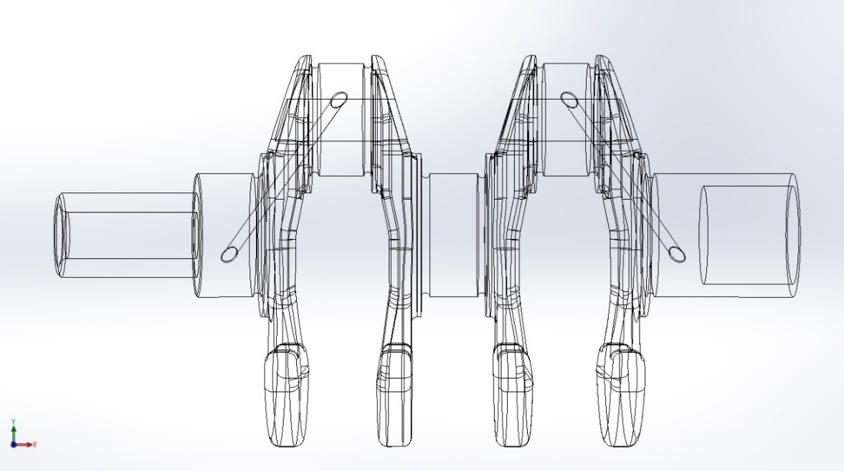
Figure 51 - Final hybrid in-line twin crankshaft design.

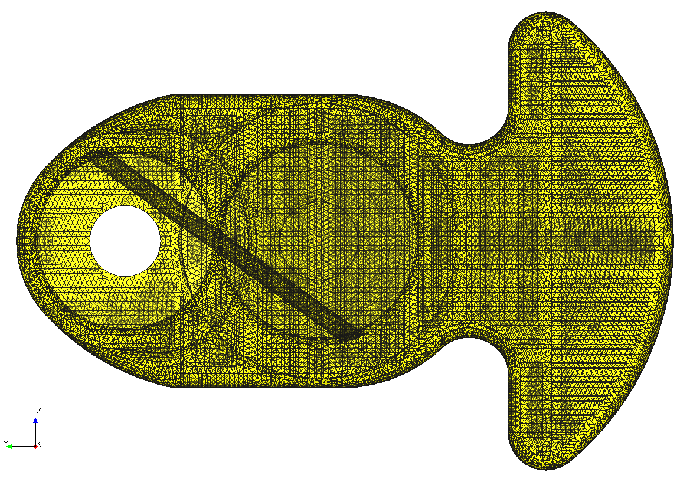
Figure 52 - Visible oil galley of hybrid in-line twin crankshaft.

Conclusion
A cyclic analysis tool with MATLAB has been successfully developed with reasonable output results. The method is based on many assumptions however proved acceptable for the outcome of this paper. The peak pressure-based method, even though simpler, proved much more reliable than a burn-angle based analysis when using a manual SOC and EOC detection method. Noise from non-averaged data allowed for the impact of human error in identification, negatively affecting the validity of the output results. With the peak-pressure method faster burn cycles were successfully identified accompanying higher peak cylinder pressure occurring closer to TDC and a clear trend was identified. Further development is recommended in adding a heat release analysis to the method to add further information less sensitive to polytropic index estimations.
In light of the cyclic findings it is clear that the outcome is very much in agreement with that said by (Daily, 2019), the process is indeed non-linear and chaotic, much more so during cold conditions. However peak pressures can inform the design process in optimizing the loading conditions within testing. A greater understanding of the cyclic occurrence within the Ford 1.0 Ecoboost has been understood, thus the initial outcome has been achieved.
An inherent sense reluctant to things out of balance is an effective method of describing the way design problems in the crankshaft domain is approached. While a 100% balance of all vectors is always the aim, it is feasibility and other factors which call for a compromise. In this case was this was the reasoning behind the decision and development of the underbalanced approach. Added cost and complexity made the use of a first or second order balance shaft assembly inappropriate for the use within a hybrid series range extender engine. Output power requirements to achieve a Vmax of 120km/h were satisfied with a two-cylinder variant of the original engine 1.0l Ecoboost platform and it was decided the even firing properties of an in-line twin was more desirable.
Through the use of Solidworks motion analysis software the reaction force on the crankshaft were measured to evaluate the balancing procedure. An under-balanced design was successfully achieved and validated against early crankshaft studies. The force magnitude remained greatest along the cylinder axis. Modelling of the original crankshaft allowed subsequent stress analysis which proved useful in evaluating the design of the new crankshaft. The design showed similar displacement and stress values to that of the original, although course meshing did produces spots of high stress not coherent with surrounding values. Overall values were acceptable and could be improved with the removal of lightening features.
A modal analysis study of the crankshaft assembly including a generator rotor identified critical resonance frequencies in both bending and torsional mode shapes. The engine speed limitation of 4000rpm ensured none of the harmonics created by combustion occurrences would excite the mode frequencies. Through the identification of the torsional frequency a torsional vibration damper was also specified through the tuning process. The final design outcome of a low NVH crankshaft suit for a hybrid series engine has been achieved.

Recommended Further Work
Throughout the project it became clear at each stage the depth of investigation could be further explored in different avenues. The following is additional work which would be carried out in future developments of the crankshaft or revisions of previous methods.
- Include a heat analysis to the cyclic study.
- Investigate oil gallery and connecting rod bearing pin lightening hole limits in terms of equivalent stress.
- Reduced bearing diameters.
- Greater mesh quality in all studies.
- Investigate engine mount forces through the design of an engine block and mounting hardware.
- A Fourier series torque ripple analysis, to identify subsequent harmonics which may cause resonance within the assembly.
- Investigate the implementation of a smaller spline coupling outer diameter with a 45˚ step down from the main bearing to relieve stress concentrations.

Pandemic Impact
Due to the unforeseen circumstances imposed by the COVID-19 pandemic, the project and its outcomes have been negatively affected. Despite this a satisfactory outcome has been achieved which is not lacking in quality or validity and has not fallen short of the expectations of the author. That being said, the area which has been most hindered was the computational requirements for detailed processing during the finite element studies and modal analysis. Many of the studies had to be simplified particularly with regards to the mesh sizing as large draft quality meshes had to be used and which limited factors such as meshing of the oil film to 0.03mm thickness. Meshes smaller than 2mm would also cause modal analysis failures due to computer memory limitations. Final plans of 3D printing the finalized crankshaft were not viable as manufacturing facilities had been closed and whilst not detrimental to the outcome of the project, it was a milestone within the project. Trailing situations and delays in the timings were also a product of the current situation. However, the outcome and subsequent conclusion remains positive and complete in its entirety.

References
Altiar University (2019) ‘Practical Aspects of Finite Element Simulation, A Study Guide’, Altair University, (5th Edition).
Amann, C. (1985) ‘Cylinder-Pressure Measurement and Its Use in Engine Research’, SAE Technical Papers.
Blair, G. P. (1999) Design and Simulation of Four-Stroke Engines. Warrendale: SAE International.
Brooke, L. (2020) ‘The case for hybrids remain strong’, Automotive Engineering, March, p. 4.
Brunt, M. F. J. and Pond, C. R. (1997) ‘Evaluation of Techniques for Absolute Cylinder Pressure Correction’, SAE Technical Papers, (412). doi: 10.4271/970036.
Burke, A. F. (1992) ‘Hybrid / Electric Vehicle Design Options and Evaluations’.
Burkhardt, O. M. (1917) ‘PROBLEMS OF CRANKSHAFT DESIGN’, in SAE International. doi: 10.4271/170040.
Daily, J. W. (2019) ‘Cycle-To-Cycle Variations: A Chaotic Process?’, SAE Technical Paper Series.
Dietsche, K.-H. and Konrad, R. (2018) Automotive Handbook. 10th Editi. Edited by D. Karl-Heinz. Karlsruhe: Robert Bosch GmbH.
Engelbrecht, C. P. (2019) Ford 1.0 GDI Con-Rod Accelerations, Forces and Displacements. Swansea.
Harkness, J. R. (1968) ‘Methods of balancing single cylinder engines’, SAE Technical Papers. doi: 10.4271/680571.
Hazzard, H. I. (2020) ‘Recreational Vehicle Engines and Their Installation’, pp. 2358–2367.
Heifetz, M. and Marsh, M. (1984) ‘Engine dynamics and balancing’, SAE Technical Papers. doi: 10.4271/840914.
Heywood, J. B. (2018) Internal Combustion Engine Fundamentals. Second Edi. Edited by R. Argentieri. Mc Graw Hill Eduction.
Hu, B., Zhou, C. and Chen, S. (2019) ‘Elastic dynamics modelling and analysis for a valve train including oil film stiffness and dry contact stiffness’, Mechanism and Machine Theory, 131, pp. 33–47. doi: 10.1016/j.mechmachtheory.2018.09.009.
Hubmann, C. et al. (2012) ‘360 ° vs . 270 ° vs . 180 ° : The Difference of Balancing a 2 Cylinder Inline Engine : Design , Simulation , Comparative Measurements’, SAE International. doi: 10.4271/2012-32-0106.
Karaki, N. and Mitani, J. (2010) ‘Balancer of Engine, Engine, and Outboard Motor’. United States.
Mahle GmbH (2016a) Cylinder components. 2nd Editio. Edited by Mahle GmbH. Stuttgart: Springer Nature.
Mahle GmbH (2016b) Pistons and engine testing. 2nd Editio. Edited by Mahle GmbH. Wiesbaden: Springer Fachmedien Wiesbaden. doi: 10.1007/978-3-658-09941-1.
Manning, J. (Ricardo) (2012) Internal Combustion Engine Design. Shoreham-by-Sea: Ricardo Uk Limited.
McDonald, M. (2019) ‘Advanced Engine Design Lecture’.
Morishita, M. and Kushiyama, T. (1997) ‘An improved method of determining the TDC position in a PV-diagram (First Report)’, SAE Technical Paper, (412). doi: 10.4271/980625.
Neo, G. H. and Collings, N. (1997) ‘Pressure Data Analysis of Formula One Racing Engines’, SAE Technical Papers, (412). doi: 10.4271/970061.
Okano, S. et al. (2002) ‘Development of two-cylinder liquid-cooled utility gasoline engine models with twin balancer shafts’, SAE Technical Papers, pp. 1–8.
Pischinger, M. et al. (2012) ‘A low NVH range-extender application with a small V-2 engine - Based on a new vibration compensation system’, SAE Technical Papers, 4. doi: 10.4271/2012-32-0081.
Tang, H. et al. (2014) ‘Behaviours of a GDI gasoline engine during start’, SAE Technical Papers, 1(MiL). doi: 10.4271/2014-01-1374.
Turner, J. et al. (2010) The Lotus range extender engine, SAE Technical Papers. doi: 10.4271/2010-01-2208.
UQM (2020) PowerPhase® 75. Available at: https://www.uqm.com.
Zal, P. (2020) Horsepower/Torque Curve for 2016 Fiat 500 TwinAir Turbo 85 (man. 5) (model for Europe ). Detailed engine characteristics. Available at: https://www.automobile-catalog.com/curve/2016/2182325/fiat_500_twinair_turbo_85.html (Accessed: 27 February 2020).

Appendix
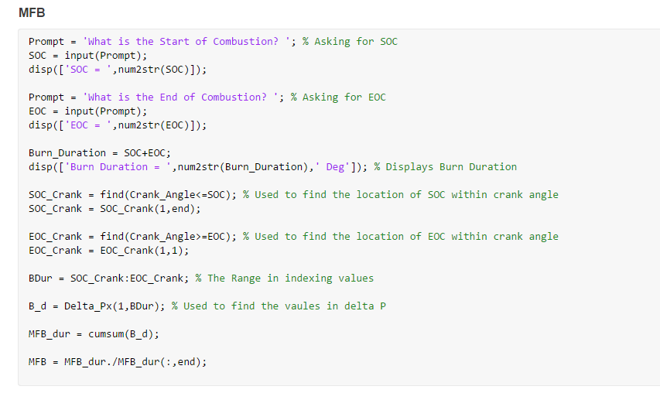
Figure 53 - Mass fraction burnt MATLAB script.
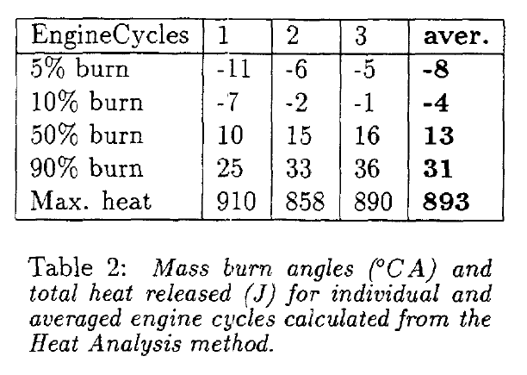
Figure 54 - Formula one engine burn angle variations. (Neo and Collings, 1997)
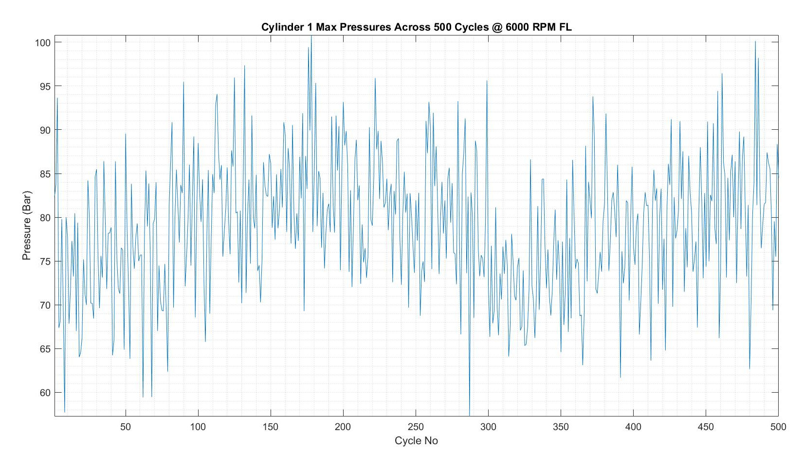
Figure 55 - Maximum pressure of 500 cycles plotted, showcasing the range of fluctuations from cyclic variations.
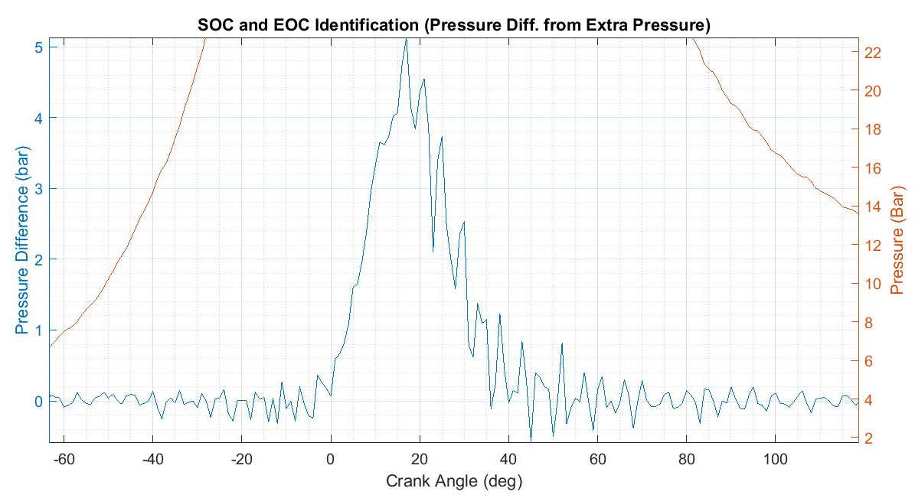
Figure 56 - Evidence of data error and variation from non-averaged data. This causes problems when identifying SOC and EOC.

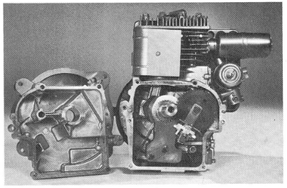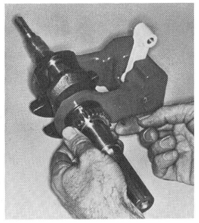
Figure 57 - 7hp Briggs and Stratton Synchro-balanced engine utilizing a counterbalance mass to balance the engine. (Harkness, 1968)

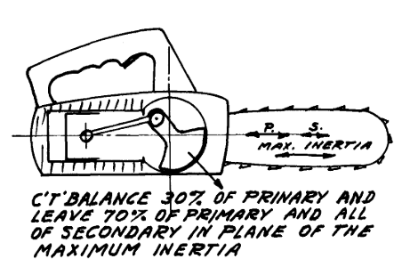
Figure 58 - 30% counter balance utilized for chainsaw use. (Hazzard, 2020)
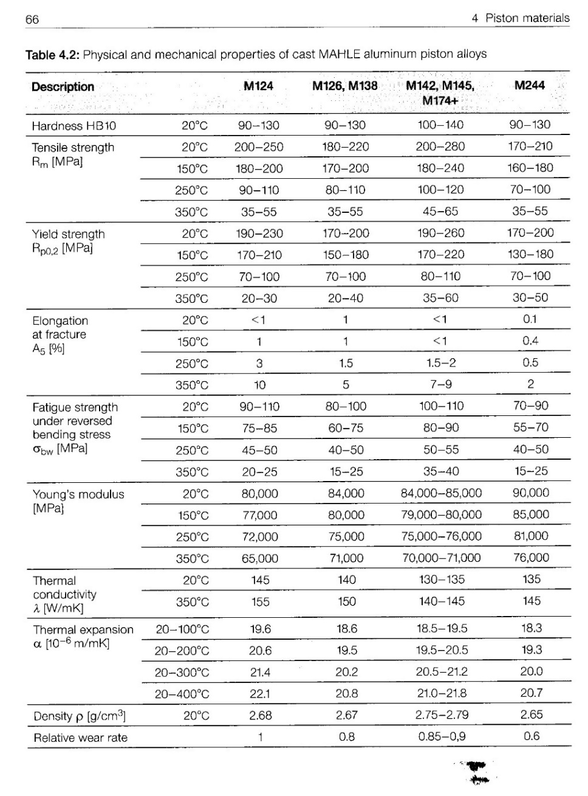
Figure 59 - Common piston material, aluminium alloy specification table.

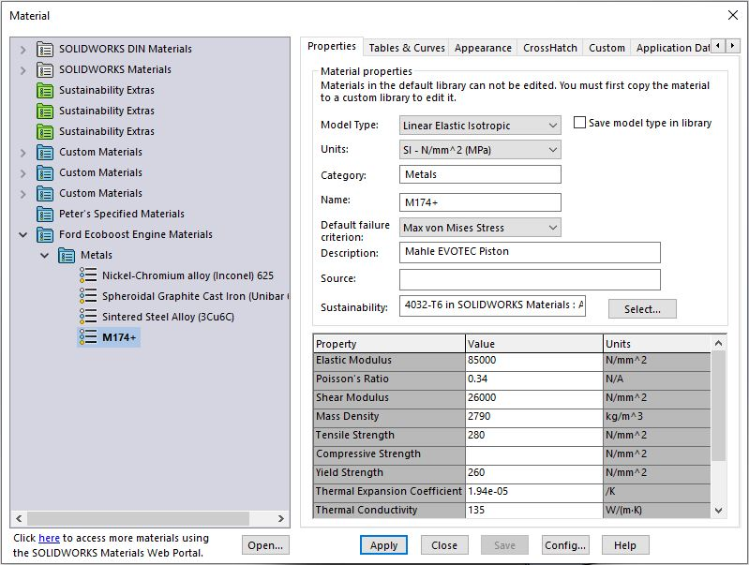
Figure 60 - Solidworks Custom material entries for accurate FEA analysis.
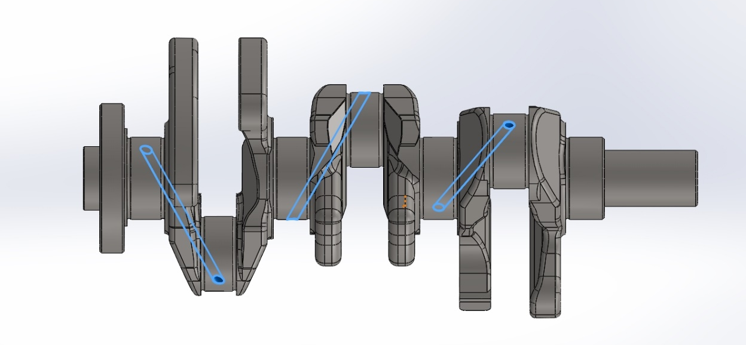
Figure 61 - Original oil galleries modelled.
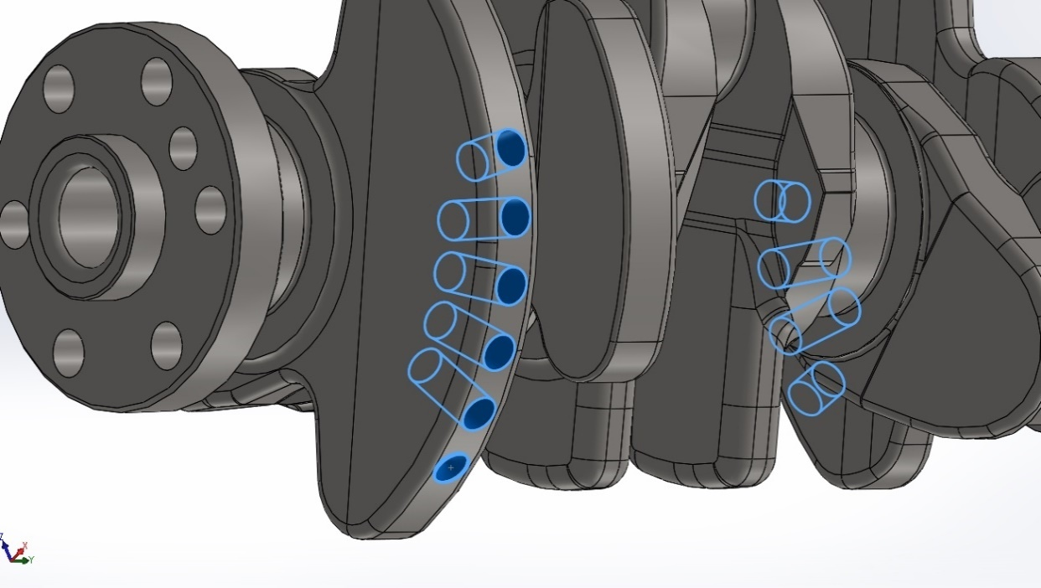
Figure 62 - Original balancing drilled holes modelled.

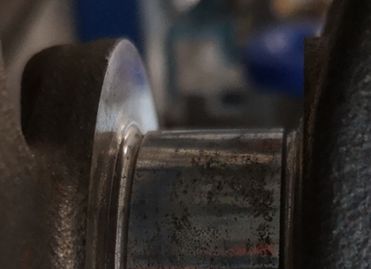
Figure 63 - Original crankshaft fillets.

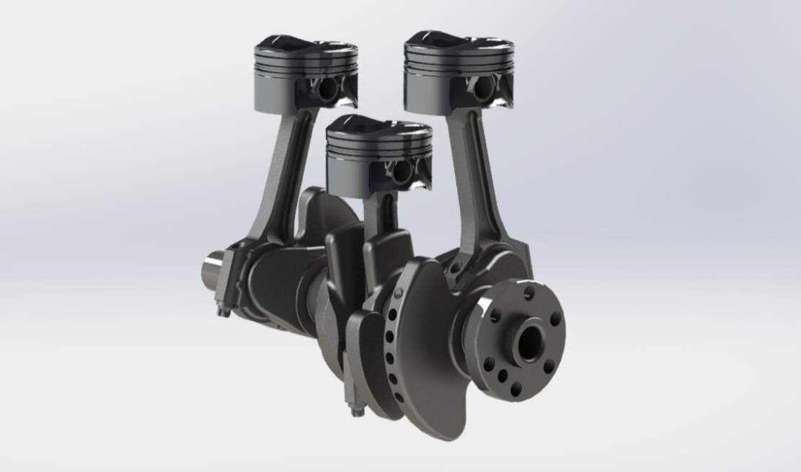
Figure 64 - Ford 1.0L Ecoboost complete modelled cranktrain.

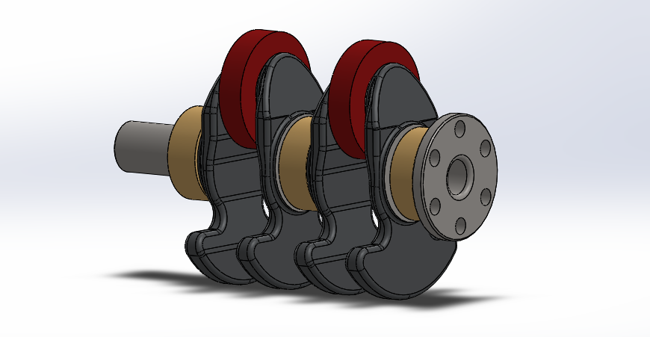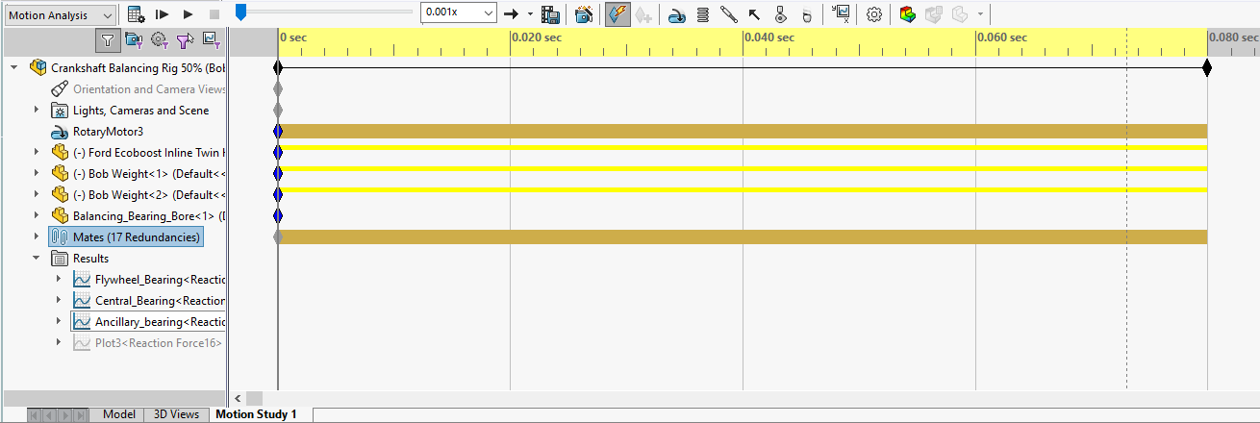
Figure 65 - Under-balance motion study within Solidworks.

Figure 66 - Motion study reaction force magnitude result for the under-balanced bob weight study.

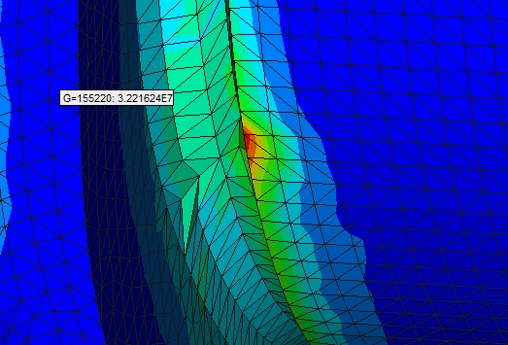
Figure 67 - Mesh error showing a point of abnormal high stress, which could be solved by finer meshing.

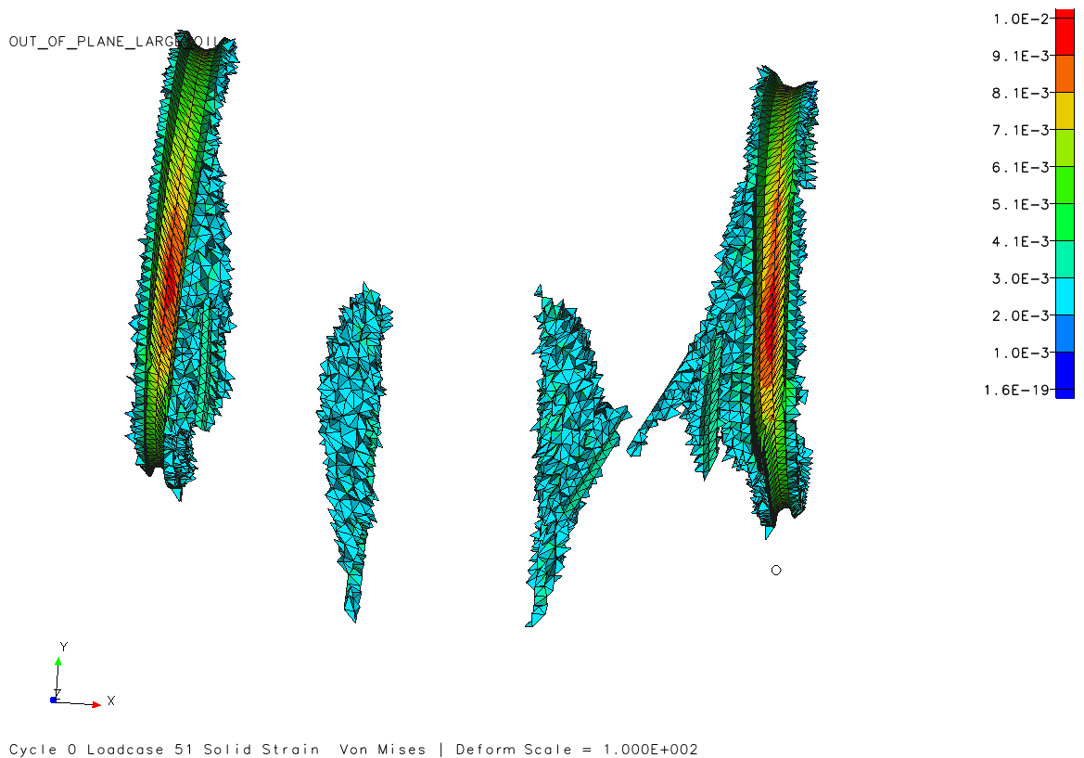
Figure 68 - Hybrid crankshaft out-of-plane shear XY result, focusing on the areas of higher stress. Higher shear values over the original is attributed to the increased deformation caused by the lightening hole through the connecting rod pin.

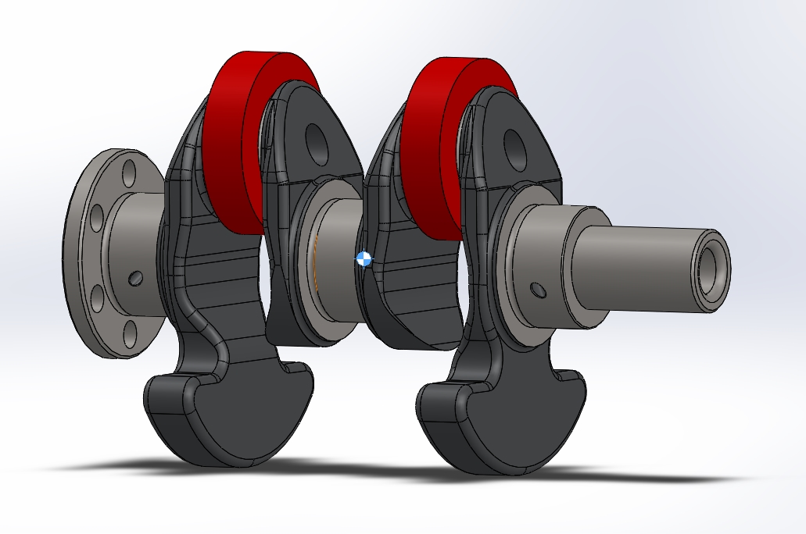
Figure 69 - Underbalanced design with only two counter-masses, the end mass was deemed too substantial and would negatively add to torsional vibration therefore the design was abandoned.

