Introduction:
The purpose of this chapter is to analyse my results which I have collected from my quantitative and qualitive research from interviewing participants and carrying out an independent survey from police officers, in relation to resilience in South Wales Police. The survey was open to South Wales Police officers and I received 27 responses, 92.6% being response officers. The interviews were 6 open questions asked to willing participants to have used support services from South Wales Police.
This section will also show trends and any themes from my results which I obtained from my research and will analyse the findings. In doing so, it will assist in answering the following research objectives.
- Evaluate frontline officers’ mental wellbeing in South Wales police.
- Measure the effectiveness of the support for frontline officers in South Wales Police.
- Evaluating if the support received from South Wales police has built resilience to assist in dealing with future traumatic incidents?
- Explore why some frontline officers may not want to receive additional support?

Theme 1:
This theme relates to officers attending a traumatic incident and being offered support once having attended a traumatic incident. These results are from question 4 and question 6 of the survey, which is being evidenced as figure 1.
Figure 1.
Table showing a theme from officers attending a traumatic incident to being offered support.
 | Have you attended an incident that is either physically, emotion or mentally traumatic? | Have you been offered any support in your career (TRiM, CareFirst, Ect)
Yes | 92.6% | 92.6%
no | 7.4% | 7.4%

Analysing theme 1 shows that 92.6% of South Wales Police officers have attended an incident that was traumatic in their service and that those 92.6% of South Wales Police officers have been offered support. This indicates that South Wales Police does recognise what a traumatic incident is and the need to offer support to those officers.

Figure 2.
2) A Pie chart measuring the effectiveness of support provided by South Wales Police.

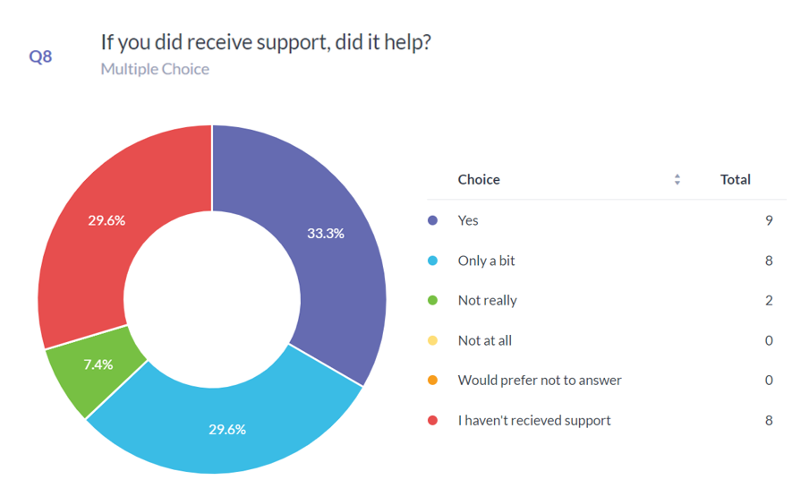
Figure 2, which relates to question 8 of the survey shows that not only does South Wales Police recognise and offer support but that the support is effective. The above pie chart shows that by adding all the positive experiences from police officer’s results equals to 62.9%, with only 7.4% stating that the support that they received was negative. Analysing this result shows that the officers who did receive support from South Wales Police was helpful with once they have attended a traumatic incident.

Theme 2:
This theme relates to the effectiveness of the support from South Wales Police and if the support has built resilience.

Figure 3.
A pie chart measuring if South Wales Police officers struggled to attend a similar traumatic incident.

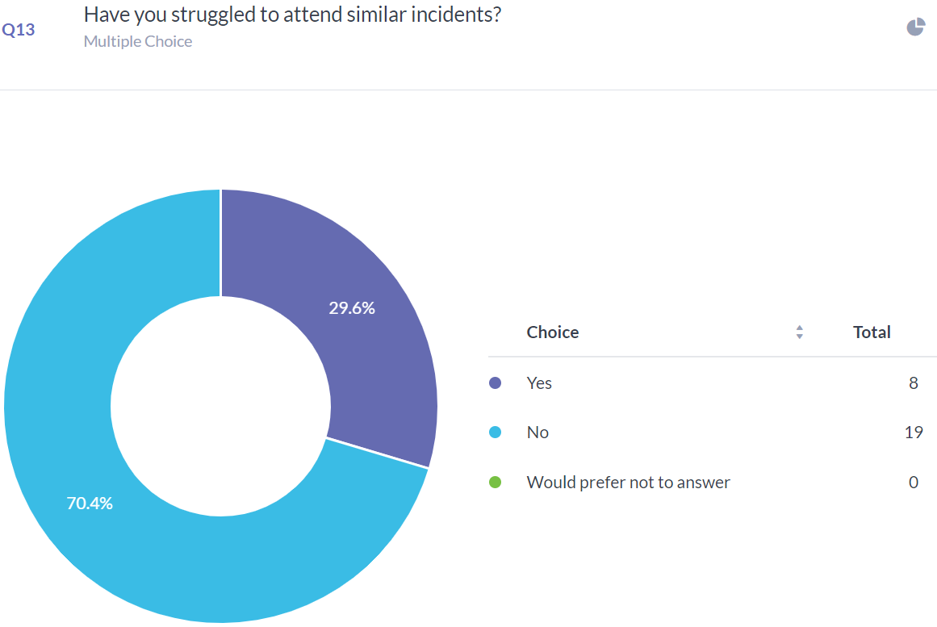
Figure 4:
A pie chart measuring if South Wales Police assist in building resilience.

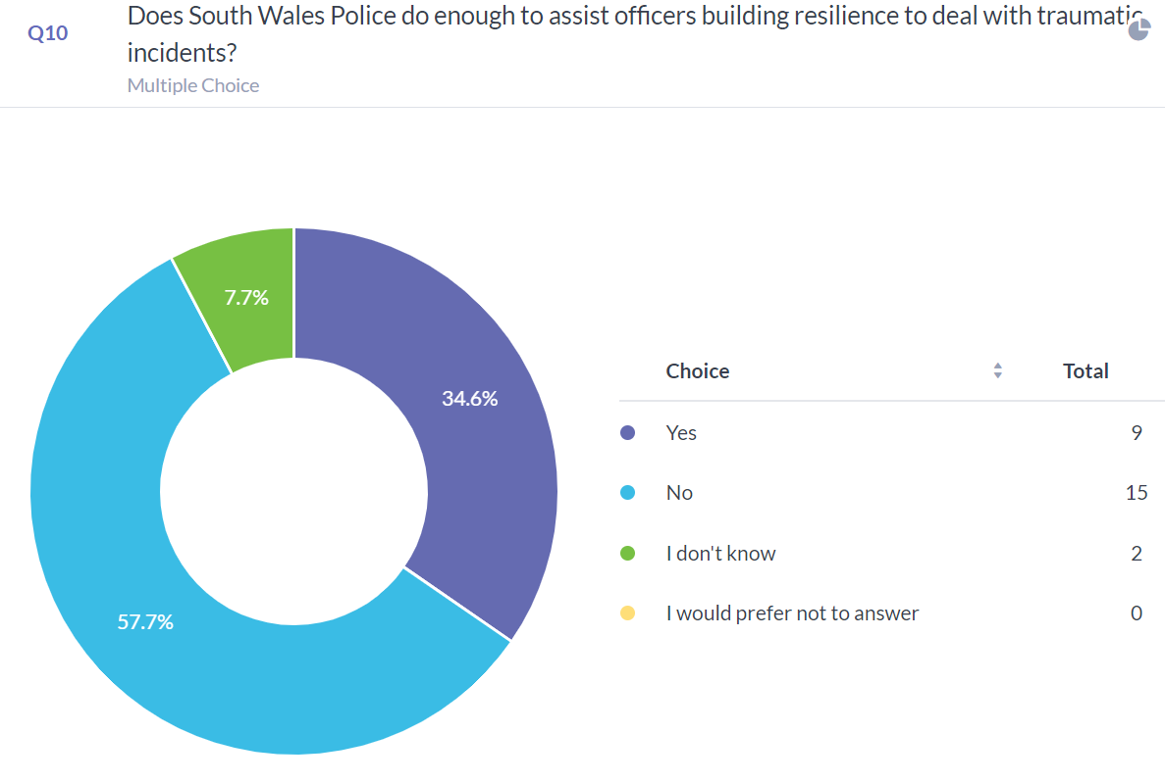
By comparing figure 2 and 3 a theme is found that the support officers receive was helpful and that they do not struggle to attend a similar traumatic incident. This shows that they support helps officers build resilience, however there contrasting evidence from figure 4. Analysing figure 4 show that 57.7% of officers believe that South Wales Police service does not do enough to build resilience for attending traumatic incidents.
Theme 3:
This theme relates to barriers in place that may prevent police officers from receiving support from South Wales Police service.

Figure 5.
A pie chart to measure if South Wales Police officers feel receiving support will have a negative effect.
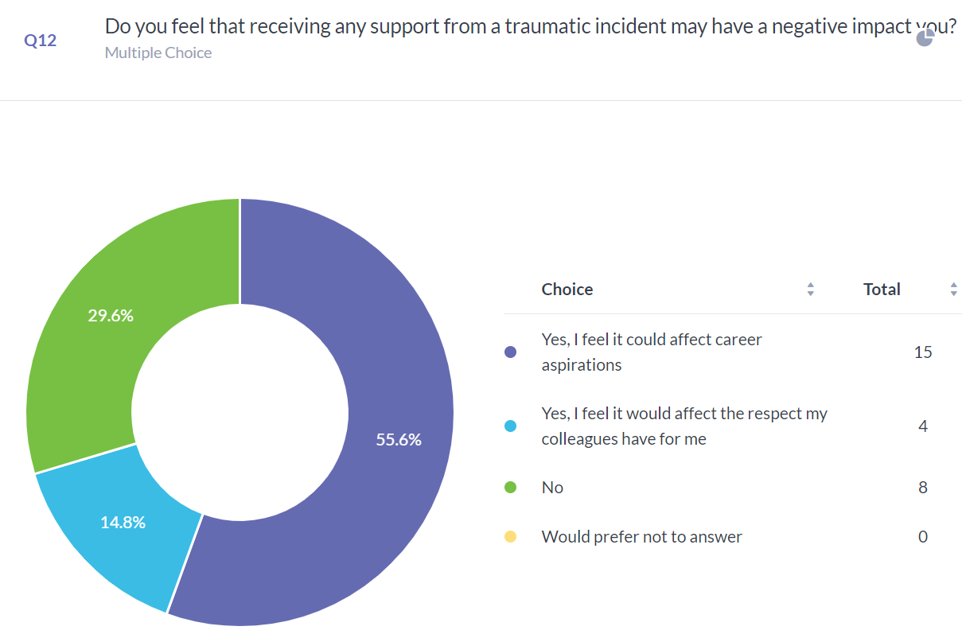

Question 12 of the survey was in relation to barriers in place to prevent police officers from asking for support and asked the Percipients if they felt receiving support for attending a traumatic incident may produce a negative impact, it was found that 55.6% of participants that it would affect their career aspirations and 14.8% felt it would affect the respect from colleagues, equalling a total of 70.4%. 70.4% of the participants felt that receiving support may produce a negative impact on them. Analysing this trend. As there is an overwhelming percentage of officers believing they may be treated negatively, this indicates that there is a stigma that follows attending a traumatic incident or job stress regarding mental health and associated mental health illness. The stigmas are organisational and environmental factors in the workplace culture acting as a barrier to prevent officers from receiving or asking support.

Interviewing participants.
Theme 4:

Five Participants who has received support were asked question in relation their experience in asking for support in South Wales Police and if that support built resilience. The interview contained 6 open end questions, however the participants preferred to answer some questions with yes or no. I have summarised the participants responses and placed into a table.

Figure 6.

Analysing the figure 6, there is a trend that the participants felt that the support was offered by South Wales Police was quick with most occurring the day of the incident. This again evidences that South Wales Police recognises what a traumatic incident is and the requirement to support police officers having delt with one. There is also a trend that most participants felts that the support they received was beneficial with TRiM being mostly used to conduct a risk assessment. However, one participant felt that even though they had taken the support, it felt as though it was a tick box exercise conducted by South Wales Police and that their personal individual needs were not met.

In conclusion I have established four themes from my research conducted by use of surveys and interviews. My themes evidence that South Wales Police service recognises a traumatic incident and offers support to those who attend. That support issued does build resilience however in contrast officers believe that the police service doesn’t do enough to build their resilience. That there are stigmas from receiving support and that officers believe that the support my negatively affect them and that TRiM is the most used service and has a positive effect as they can attend a similar traumatic incident.

Word count 1007.

