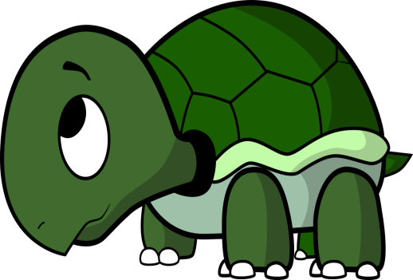
THE TURTLE (withdrawing). Turtles withdraw into their shells to avoid conflicts. They give up their personal goals and relationships. They stay away from the issues over which the conflict is taking place and from the people they are in conflict with. Turtles believe it is hopeless to try and resolve conflicts. They feel helpless. They believe it is easier to withdraw (physically and psychologically) from a conflict than to face it.

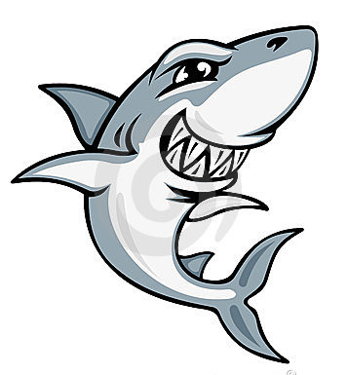
THE SHARK (Forcing). Sharks try to overpower opponents by forcing them to accept their solution to the conflict. Their goals are highly important to them and the relationship is of minor importance. They seek to achieve their goals at all costs. They are not concerned with the needs of other people. They do not care if other people like or accept them . Sharks assume that conflicts are settled by one person winning and one person losing. They want to be the winner. Winning gives sharks a sense of pride and achievement. Losing gives them a sense of weakness, inadequacy and failure. They try to win by attacking, overpowering, overwhelming and intimidating other people


THE TEDDY BEAR (Smoothing). To teddy bears, the relationship is of great importance, while their own goals are of little importance. Teddy bears want to be accepted and liked by other people. They think that conflict should be avoided in favour of harmony and believe that conflicts cannot be discussed without damaging relationships. They are afraid that if the conflict continues, someone will get hurt and that would ruin the relationship. They give up their goals to preserve the relationship. Teddy bears say “I’ll give up my goals and let you have what you want, in order for you to like me.” Teddy bears try and smooth over the conflict in fear of harming the relationship.

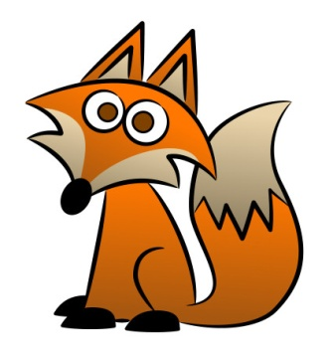
THE FOX (Compromising). Foxes are moderately concerned with their own goals and about their relationship with other people. Foxes seek a compromise, They give up part of their goals and persuade the other person in a conflict to give up part of their goals. They seek a solution to conflicts where both sides gain something – the middle ground between two extreme positions. They are willing to sacrifice part of their goals and relationships in order to find agreement for the common good.

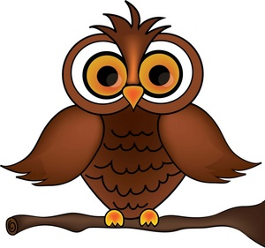
THE OWL (Confronting). Owls value their own goals and relationships. They view conflicts as problems to be solved and seek a solution that achieves both their own goals and the goals of the other person in the conflict. Owls see conflicts as improving relationships by reducing tension between two people. They try to begin a discussion that identifies the conflict as a problem. By seeking solutions that satisfy both themselves and the other person, owls maintain the relationship. Owls are not satisfied until a solution is found that achieves their own goals and the other person’s goals, and they are not satisfied until the tensions and negative feelings have been fully resolved.

