A Database solution for Coastal Tourism Management System in Wales, UK

Types of Users
External
External users would be:
Tourists, this role is for anyone who is looking to buy an available package from one of the many options provided by the business owners associated with the CTMS.
Business owners, is fairly self explanatory as it represents the local businesses that have partnered with the CTMS to advertise and sell their product/service packages to tourists.
Internal
Internal users would be:
Database admins, who’s job is to maintain the functionality and capacity of the database for its continual usage.
Customer care, their role is to help guide the tourists through the system as well as to help with any queries about facilitating payment as well as travel.
Product managers, they define and validate the packages that finally make it on to the CTMS package board as well as reevaluating the performance of existing packages.

Types of departments that require access

Sales/marketing: will need to be able to look at the reviews as well as be able to see the sales data so that they can track how effective their approaches have been and how they can extend them to build brand loyalty.

Database administration: have access to be able to correct any faulty data as well as maintain the functionality of the databases storage and retrieval processes through maintenance.

Finance : is required so that they can accurately track the revenue of the packages sold then using the data to make sure the company is turning a profit. As well as providing useful information for the company to make decisions with later.

Customer care: in order to stay in touch with what customers are saying they will need access to be able to read their reviews as well as potentially follow up with questions and possible reimbursement where data T&C’s apply.

Entity relationship Diagram

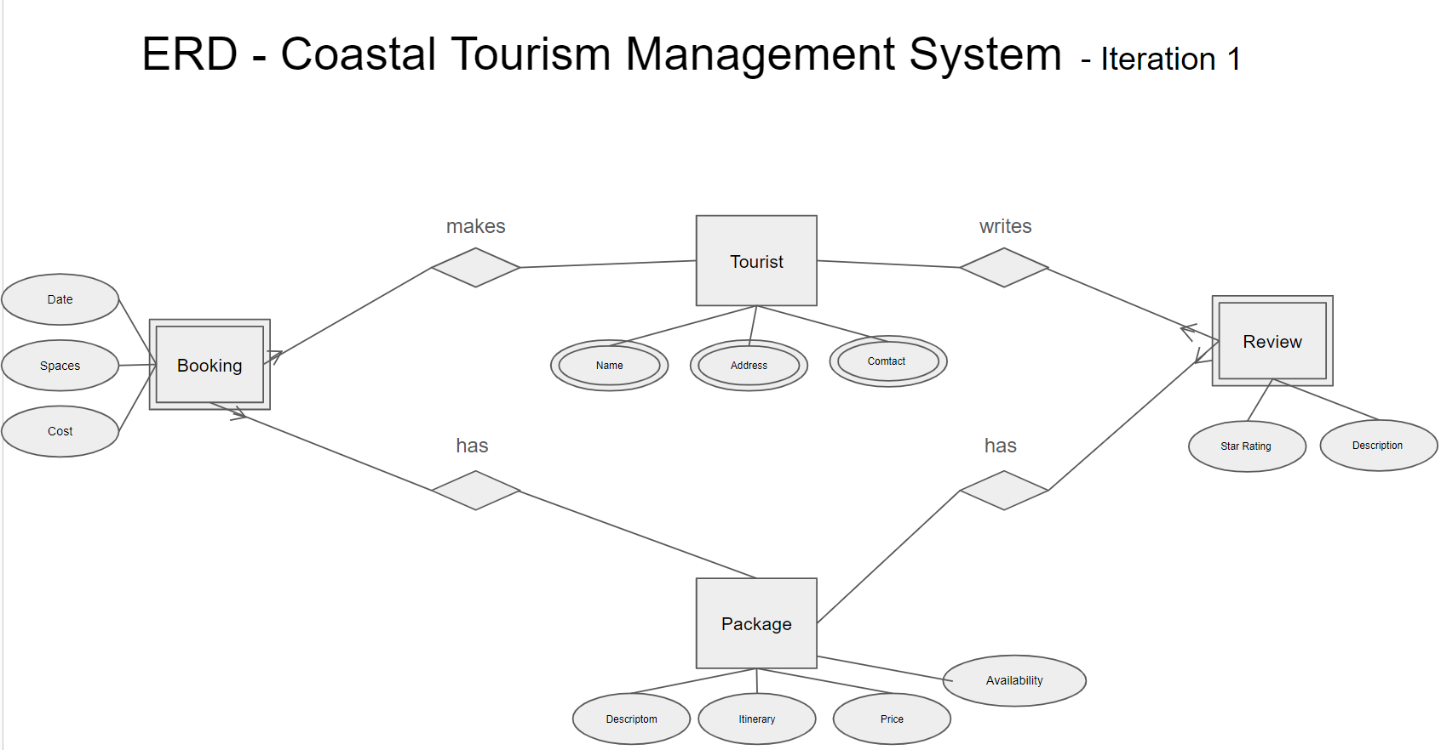
This is the first iteration of the entity relationships when initially putting together an idea of how they will interact. The main entities selected are the tourists themselves, reviews, packages and bookings. These were chosen as the initial walk through was that tourists will need to enter their data/contact to make a booking with its specific details, where a package is selected upon which the tourist can write a review.

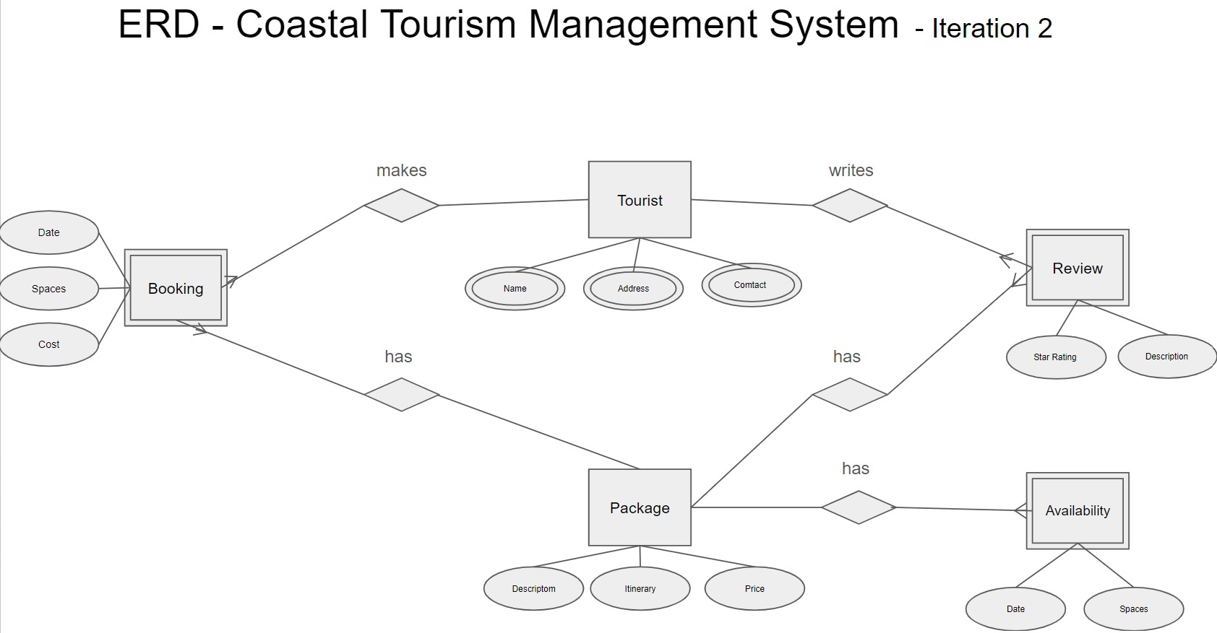
In the second iteration I believed that it was necessary to expand on the relationship of the package and its related availability as there are many available for each package. This is moving it from 2nd normal form to 3rd normal form as the relationship to it is one to many.

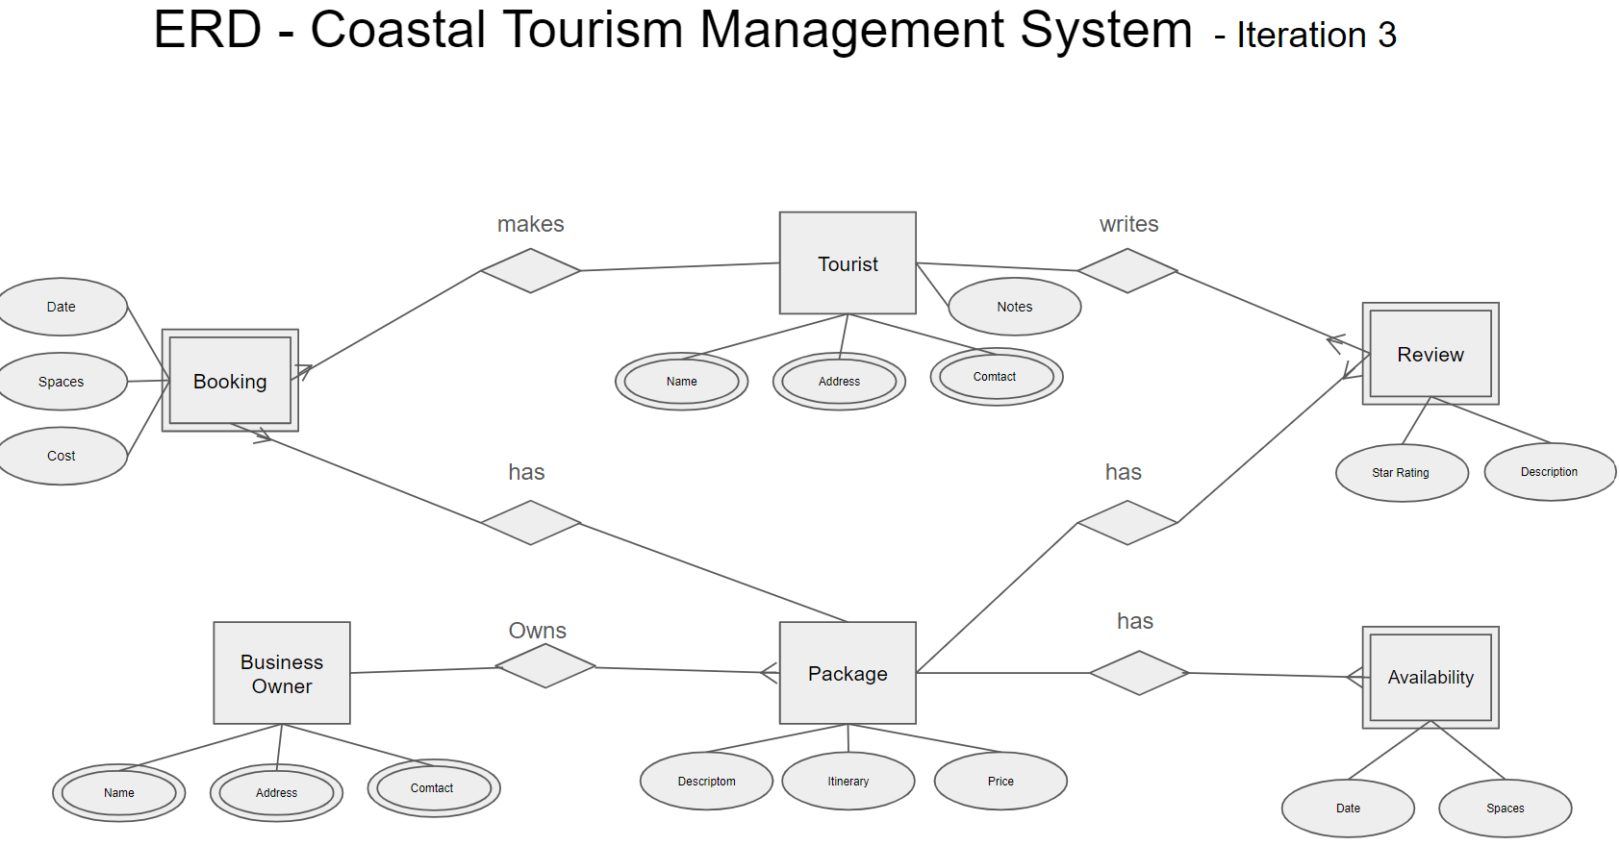
In the final iteration of the entity relationship diagram the conclusion was that business owners were necessary to be added. They have a need to be able to modify their packages as well as being able to contact them. along with their one to many relationship needing to be represented.(below you will find the schema which goe into further detail over the entities and their attributes).

Entity Descriptions
Tourist Entity – An individual or company who wishes to book a package with Coastal Getaways
Tourist | Description
Title | Shows their status and profession.
First Name | Is their legal first name.
Last Name | Is their legal last name.
Address_1 | Is their primary Address.
Address 2 | Is for further address detail e.g flat number.
Town | Is the town they reside in.
County | Is the county they reside in.
Post Code | Is their postcode they reside in.
Country | Is the country they live in.
Email | Is the email address they can be contacted at
Phone | Is the phone number they can be reached from
Notes | If there is any specific need for the customer to be looked over by customer care.
Tourist ID | Is a unique identifier for a specific tourist.

Review – Is feedback of what the tourists thought of the package that they had booked. Mainly on whether they enjoyed it and possible improvements if they did not.
Review | Description
Star rating | Is the rating a tourist would give on a specified scale
Review description | Is the detailed experience of what they thought of their package.

Booking – Is an agreed date that a tourist will have access to a specific package.
Booking | Description
Booking spaces | Is how many spaces a tourist has requested
Booking cost | Is the final price of the booking
Booking date | Is the confirmed date that the event will take place

Business owner – A business that has partnered their packages to be booked with Coastal getaways.
Business owner | Description
Business contact name | Is the name of the Business.
Business address | Is the primary address of the business.
Business phone number | Is the phone number the business is reached from.
Business Email | Is the email address the business can be reached at.

Package – is a venue with a pre planned itinerary that is sold to a tourist.
Package | Description
Package ID | Is a unique identifier for a package.
Package Name | Is the name given by the business providing the package.
Package description | Is a detailed description about the venue and activities.
Package Itinerary | Is a shorthand version of the venue's activities with timestamps.
Package Price | Is the price per space a package will cost.

Availability – is the dates and capacity that a tourist can book a package.
Availability | Description
Date | Is the date a package is available.
Spaces | Is the number of attendees a package can accommodate.

Database Schema
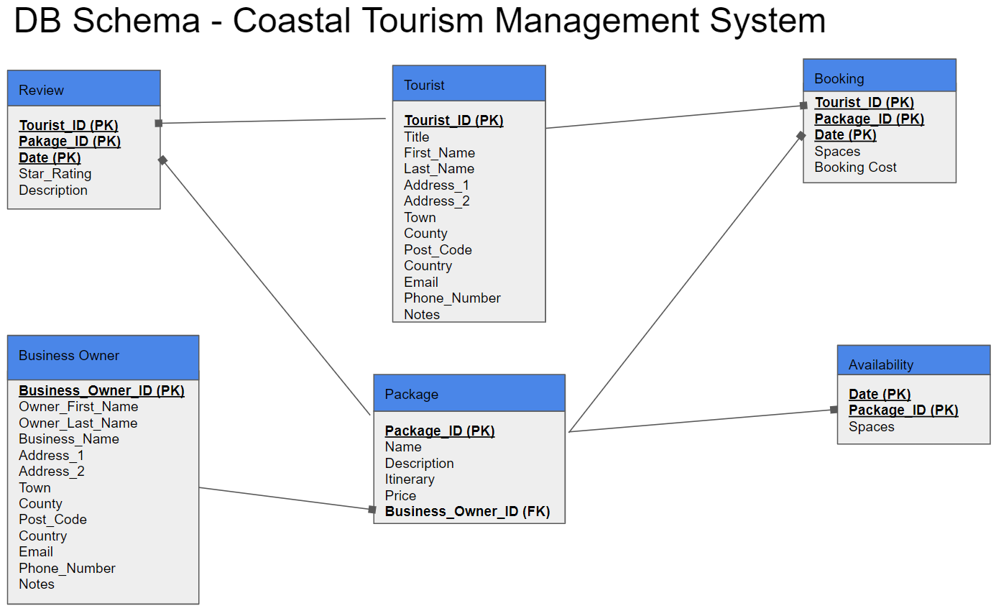

Availability Entity
Key | Attribute | Format | Size | Validation
PK | Date | Date | 8 | dd/mm/yyyy
PK | Package_ID | Number (Floating Decimal) | 8 | System generated
 | Spaces | Long Integer | 4 | number

Booking Entity
Key | Attribute | Format | Size | Validation
PK | Tourist_ID | Number (Floating Decimal) | 8 | System generated
PK | Package_ID | Number (Floating Decimal) | 8 | System generated
PK | Date | Date | 8 | dd/mm/yyyy
 | Spaces | Long Integer | 4 | number
 | Booking Cost | Currency | 8 | Calculated field

Business Entity
Key | Attribute | Format | Size | Validation
PK | Business_Owner_ID | Long Integer | 4 | System generated
 | Owner_First_Name | Short Text | 20 | Alphanumeric
 | Owner_Last_Name | Short Text | 20 | Alphanumeric
 | Business_Name | Short Text | 30 | Alphanumeric
 | Address_1 | Short Text | 20 | Alphanumeric
 | Address_2 | Short Text | 20 | Alphanumeric
 | Town | Short Text | 20 | Alphanumeric
 | County | Short Text | 20 | Alphanumeric
 | Post_Code | Short Text | 10 | Alphanumeric (AA99 9AA)
 | Country | Short Text | 20 | “Wales”,”England”,”Scotland”,”Ireland”,”Other”
 | Email | Short Text | 30 | Alphanumeric
 | Phone_Number | Short Text | 20 | +99 9999999999
 | Notes | Short Text | 255 | Alphanumeric

Package Entity
Key | Attribute | Format | Size | Validation
PK | Package_ID | Long Integer | 4 | System generated
 | Name | Short Text | 30 | Alphanumeric
 | Description | Short Text | 255 | Alphanumeric
 | Itinerary | Short Text | 255 | Alphanumeric
 | Price | Currency | 8 | Calculated field
FK | Business_Owner_ID | Number (Floating Decimal) | 8 | (foreign key from Business owner)

Review Entity
Key | Attribute | Format | Size | Validation
PK | Tourist_ID | Long Integer | 4 | Unique system generated
 | Pakage_ID | Long Integer | 4 | “Mr”, “Mrs”, “Miss”, “Master”, “Other”
 | Date | Date With Time | 8 | Alphanumeric
 | Star_Rating | Short Text | 10 | Alphanumeric
 | Description | Long Text | - | Alphanumeric

Tourist Entity
Key | Attribute | Format | Size | Validation
PK | Tourist_ID | Long Integer | 4 | number
 | Title | Short Text | 6 | “Mr”, “Mrs”, “Miss”, “Master”, “Other”
 | First_Name | Short Text | 20 | Alphanumeric
 | Last_Name | Short Text | 20 | Alphanumeric
 | Address_1 | Short Text | 30 | Alphanumeric
 | Address_2 | Short Text | 30 | Alphanumeric
 | Town | Short Text | 20 | Alphanumeric
 | County | Short Text | 20 | Alphanumeric
 | Post_Code | Short Text | 10 | Alphanumeric (AA99 9AA)
 | Country | Short Text | 20 | “Wales”,”England”,”Scotland”,”Ireland”,”Other”
 | Email | Short Text | 40 | Alphanumeric
 | Phone_Number | Short Text | 20 | +99 9999999999
 | Notes | Short Text | 255 | Alphanumeric

The importance of Microsoft access implementation in Coastal getaways
Coastal tourism is quite an administration intensive system as many of the customers will be traveling long distances in order to reach their destinations, so every part of the booking must be reliably orchestrated and cataloged. So any mishaps would display quite poorly for the company. [1]A key benefit to using access compared to traditional non digital record keeping systems is that the information is centralized so that all sources are uptodate. Is more efficient than having to chase down different branches and departments for said data.
[2] When it comes to record keeping, standardization is incredibly important as it allows for the quick search and cross comparison of data. This goal is assisted greatly as Access is primarily built to help automate these processes along with making validation of such data a simple intuitive process.[3]One of the many useful inbuilt features with in the software is that Coastal management can vastly improve its efficiency and readiness as report are developed automatically with the right queries. This allows for the heads of departments to have quick access to business performance snapshots allowing for greater more effective strategic decisions at the higher level.

Challenges and benefits of transitioning from manual data management to a computerized system
One of the potential challenges that could cause an issue is digitizing the data or simply re-entering it into the new centralized system. [3] One of the key advantages to digital systems like Access is that they are cross compatible with other microsoft office platforms like excel so data can be easily imported or exported between the two.
Another potential issue is that different branches and departments could potentially be running on different operating systems which can cause some issues when centralizing a data management system that works for all environments like mac ios vs windows.[2] Thanks to Access this won't be an issues as it functions on both systems, this is a major benefit as Coastal getaways potentially won't have to retro fit any of their offices or work stations. Which is both a massive time and cost saving move.
Depending on the extensivity of the record that Coastal getaways is looking to manage that could minimize the amount of viable software solutions available to them. [4] For example a solution most might go to initially would be excel however under larger data sets excel will struggle with managing and keeping track unlike access. And if manipulation of data is required access can easily export said data to excel.
In conclusion bringing Coastal getaways systems into modernity is a vast improvement to both their efficiency, reliability and business strategy. However there are many ways to go about solving this and some solutions perform better than others which is why i’d recommend Microsoft Access for their data set.

References:

[1] Excelhelp.com .[Online]
https://www.excelhelp.com/3-ways-microsoft-access-adds-efficiency/
(Visited 07/01/2024)

[2] Access Experts software solutions .[Online]
https://accessexperts.com/blog/2021/08/03/7-ways-microsoft-access-can-help-businesses/
(Visited 07/01/2024)

[3] Indeed .[Online]
https://ca.indeed.com/career-advice/career-development/microsoft-access-benefits
(visited 07/01/2024)

[4]SoftKey.uk .[online]
https://softkeys.uk/blogs/blog/what-is-the-difference-between-excel-and-access
(visited 07/01/2024)

Screenshots(proof) of Access Database link: https://drive.google.com/file/d/1M5mpp5-iLA7gUSI-TYIxknfMam-bP94A/view?usp=sharing



