Creating Infographics D4X00004 - Data Analysis and Visualization

- Claire West

Joel Hunt - HUN11802466

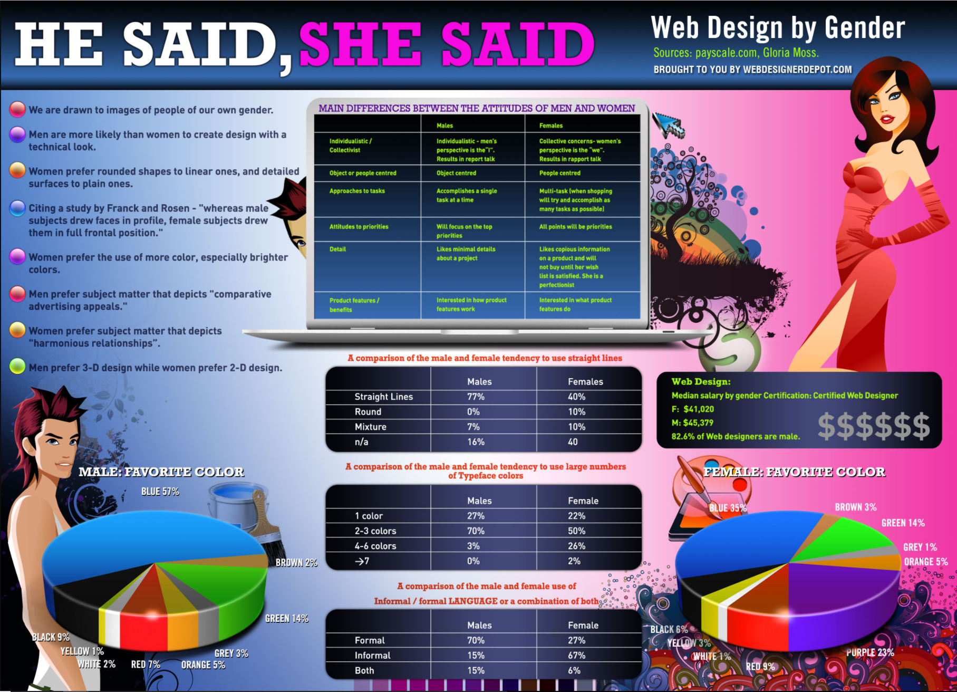

Introduction

This piece will analyze the data visualization effectiveness in the ‘HE SAID, SHE SAID’ poster above.

Color

There are over 30 colors on this document, varying in tones. Most of these colors are sporadically placed throughout the poster with little relevance to the content, or information, that the poster is trying to portray.

As the content theme is based on Web design, the choice to create a poster which stands out with color is understandable. Color, in posters can be a powerful tool, and welding color correctly can make even the most complex of graphs easy to comprehend. However, the use of too much color can hinder the contents message and distract the reader. (1)

Highlighted below is an example of where the location and execution of colors could serve to overload or confuse the reader rendering the visualized data less effective in its display.

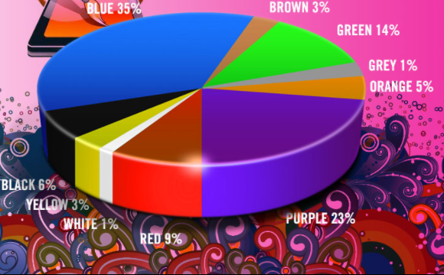

The Pie charts themselves are segmented, displaying the specified colors that the data is portraying. The addition of more color surrounding the chart obstructs the text and detracts from the color of the chart.

The main two colors that make the background are largely Blue and Pink. This appears to intentionally represent the male and female sections of the poster. This theme could invoke a dangerously stereotypical representation. The choice of the color pink to represent females becomes even more redundant when considering that the Pie chart that displays the Female favorite color, does not even include the color pink within it. Couple this with the un-realistic caricatures of the male and female, reduces the credibility of the poster.

Text

Labeling and the use of text is essential for most Data Visualization. It allows viewers to quickly absorb the information, whilst also providing focus points, legends or captions. (2)

“Words and pictures belong together. Viewers need the help that words can provide”
Edward Tufte

For this poster however, the text has a less harmonious relationship with the data. The font size in the poster is relatively small, rendering the majority of the information difficult to read. As well as being difficult to read, the body of text throughout the poster envelopes most of its space. Where there is a mass of text providing information, there could have been a graph depicting the same information, which would be easier to view. There is also a lack of consistency with the texts color and Font, neither titles or content have a uniform tone. This can lead to confusion reading the document. The role of Text in Data Visualization is to provide more information or emphasize a point. There are several fonts being utilized in the poster and again, this just increases the difficulty in readability.

Graphs

Data Visualization was created to convey data in a faster and easier way. It identifies key areas and can pinpoint information in a more efficient way than a large list of numbers. When Data Visualization is used correctly then regardless of how difficult the initial data is to read then it makes the readability of large data sets effortless, the reader is able to focus on main points with ease (3).

Within this poster it is difficult to ascertain the main focal points. Amongst the mass of text there are a few tables and two Pie charts. The main issue with the tables is that the text font size and color are not appropriate for viewers to read the content, it is too small and the light green color can be difficult to read.

The amount of redundant data-ink within this poster is vast. Edward Tufte introduced the concept of Data-ink, and it is the core of the graphic. Data-ink is the ink on the graph that represents data. Tufte’s view was that in displaying data, the user should remove all or most non-data-ink and redundant data-ink. This creates a more effective graphical design. (4)

"Data-ink is the non-erasable core of the graphic”
- Edward tufte

This poster has not followed such laws however. Its use of background color for each section of the tables is unnecessary when there is already ample color in the poster. Pie charts are generally used to display percentage data and so in this case are used correctly, although some percentages do not appear completely accurate. As shown in the pie chart above 5% only looks to be about double of the 1% segment.

The pie charts are displayed in a 3d format. Creating 3d graphics, especially pie charts, are strongly discouraged as it creates an optical effect that makes it harder for the reader to compare the different categories.(5)

“Avoid design elements that detract from the message you are trying to convey such as 3D effects and exploding slices.” - Leicester University

Pie chart segments are often arranged clockwise in order of magnitude. Creating a pie chart in this fashion allows the reader to view and compare numerous pie charts. It also gives pie charts a uniform design. This poster does not adhere to that.

Graphics that do not provide information can be frequently used. This can detract from the objective of displaying data. The images of the of the male and female are applied to the poster to represent the theme of the data, but the choice of images could be a concern. Neither image represents the sex accurately and it sets the theme of the poster on an unethical path.

The temptation can sometimes be to create a stylish, colorful and over the top visualization, but it is important to remember that the data should always be the priority. Ensuring that nothing distracts from this is vital. Everything displayed should support or direct the reader towards the data. (6)

“Every single pixel should testify directly to the content.” - Edward Tufte

Cognition

When designing data visualization, it is important not to overload the reader with too much information. He said, she said overloads the reader in many ways. Firstly there is the use of too much colour, and secondly the amount of textual data to read is colossal. There is a considerable amount of information to take in and very little visual stimulant for the brain to absorb.

Improvements

With regards to improving this document, less would be better. Most of the textual data could be modified into graphs, making for a more effective display to get the point across faster.(7)

“Graphics reveal data. Indeed graphics can be more precise and revealing than conventional statistical computations.” - Edward Tufte

The palette should use more neutral colors so that it does not interfere with the message. The bullet points listing differences between the sexes should be a universal color so it represents a list as opposed to separate entities.

Graphical Excellence is key to displaying any form of data. Tufte lists the key components to regard as; utilizing clarity, precision and efficiency(8). These components are not present within this poster and as such the data is poorly revealed.

Reference Bibliography

- A carefully selected color palette helps you to harness the pre-attentive processing powers of the human brain, and makes insight clearer and easier to find. A badly chosen color palette obscures the information your users need to understand, and makes your graph visualization less effective and harder to use. https://cambridge-intelligence.com/choosing-colors-for-your-data-visualization/
- Edward Tufte,.The Visual Display of Quantitative Information Second Edition. 2001
- Stephen Few. Show me the numbers. 2004
- Edward Tufte. The Visual Display of Quantitative Information Second Edition. 2001
- Leicester University - Pie Charts. https://www2.le.ac.uk/offices/ld/resources/numerical-data/pie-charts
- Edward Tufte. The Visual Display of Quantitative Information, Second Edition. 2001
- “Graphics reveal data. Indeed graphics can be more precise and revealing than conventional statistical computations.”. Edward Tufte. The Visual Display of Quantitative Information, Second Edition. 2001
- Edward Tufte. The Visual Display of Quantitative Information Second Edition. 2001

