HPHP 4018 – Exploring the Humanities
– Representing Greeks, Romans and “Others” in Portrait Art

In this workshop we will examine how individuals (gods, heroes, rulers and “ordinary” people) were represented in portraiture. Such images were often used to convey ideals and qualities, not only based on a youthful aesthetic ideal, but also reflecting important social values. We will look at a broad gamut of material from the Archaic period down to the Roman Imperial period. I have uploaded a PowerPoint with the images we will be looking at during the workshop on Moodle. You should have a look through these images and think about the questions set below. I have suggested some modern scholarship which would be useful to read.

Questions:
- What would you want yourself to look like in a painting or portrait that was being produced for you?
  - Would you want it to be realistic?
  - Would you want it to put yourself in the best possible light?
  - Would you want anything to be exaggerated?
  - How much would the context or purposes of the image affect your choices?
- What is your reaction to the different types of portraits?
  - Do you find them particularly attractive? Which ones?
  - Would you wish for yourself to be represented in any of these ways?
  - Why do you think many elite Romans chose to be represented in Veristic form – what qualities may they have been trying to emphasis?
  - Why would these qualities have been important in the context of particular social and political circumstances (these changed over time and in different regions of the Mediterranean world)?
- What might Pompey have been trying to achieve (if this image is in fact of him) on the Glyptotek bust?
  - Do you find it aesthetically pleasing?
  - Can the image still be seen as versitic?
- Why do you think Augustus chose to move away from verism and adopt the Augustan “Classicising” style?
  - What underlying social and political context may have influenced this change?
  - What practical and propagandist purposes may have been served by adopting a consistent Classicising style?
  - Who is Augustus accompanied by on the Prima Porta statue, what is the significance?
  - What is the importance of the symbolism of Augustus armour on the Prima Porta statue?
- Does the bust of Livia look distinct to you in any particular way?
  - How might the social and political position of women in Rome have affected the style of portraits that were produced?
- What is your reaction to the statue of Claudius and do you find anything particularly odd?
  - Might different parts of the statue be conveying different qualities?
  - What reason may Claudius have had from moving away from the Classicising style?

Modern Scholarship (optional read):
Smith, R. R. R. 1981: ‘Greeks, Foreigners and Roman Republican Portraits’, JRS 71: 24-38.

Archaic Greek Portraiture
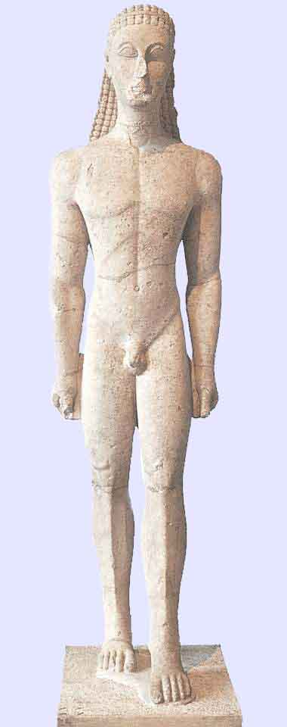
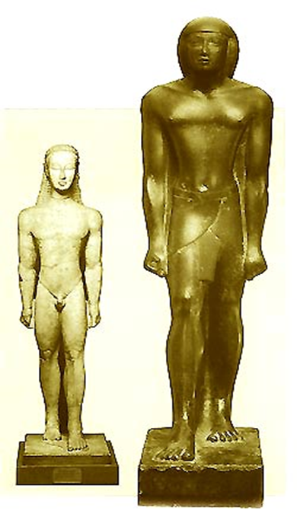

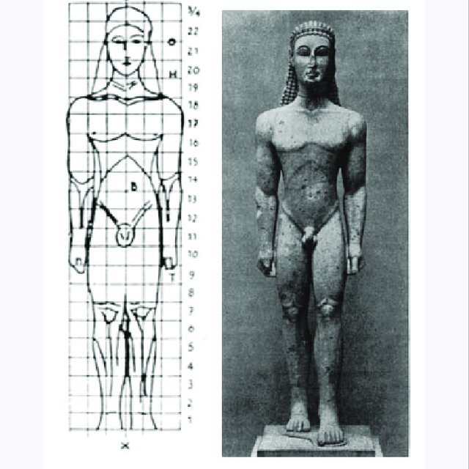
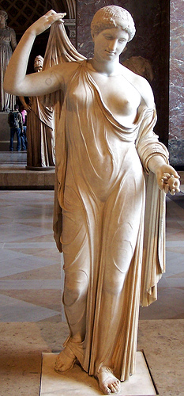
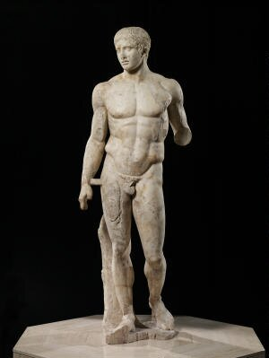
Classical Greek portraiture

Hellenistic Sculpture
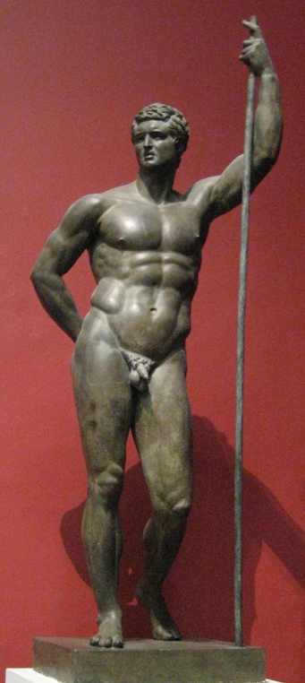
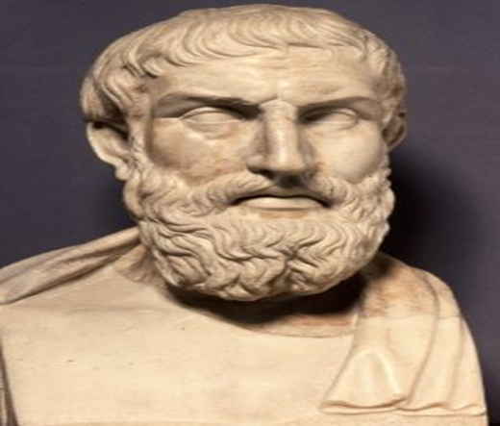

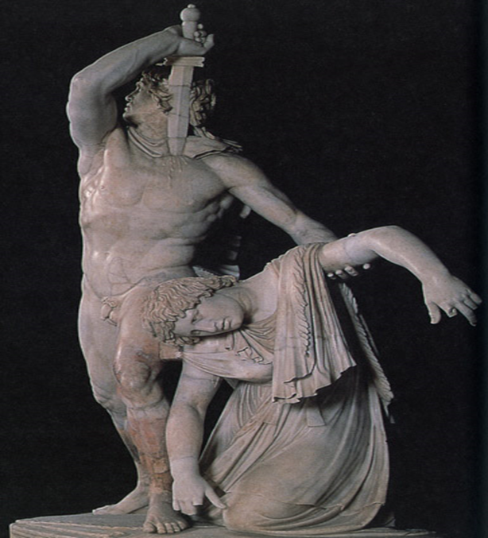

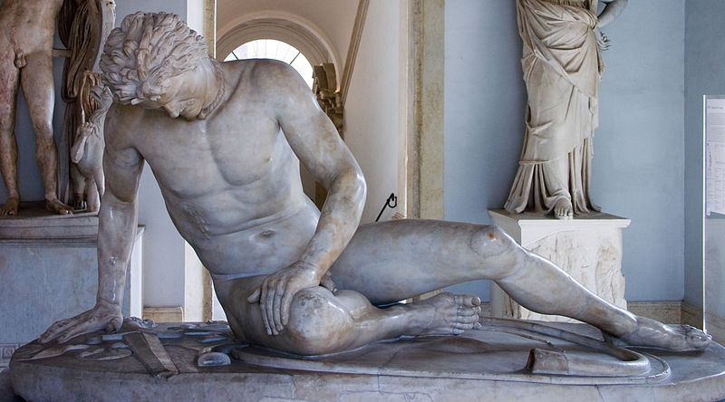

Roman Veristic Art
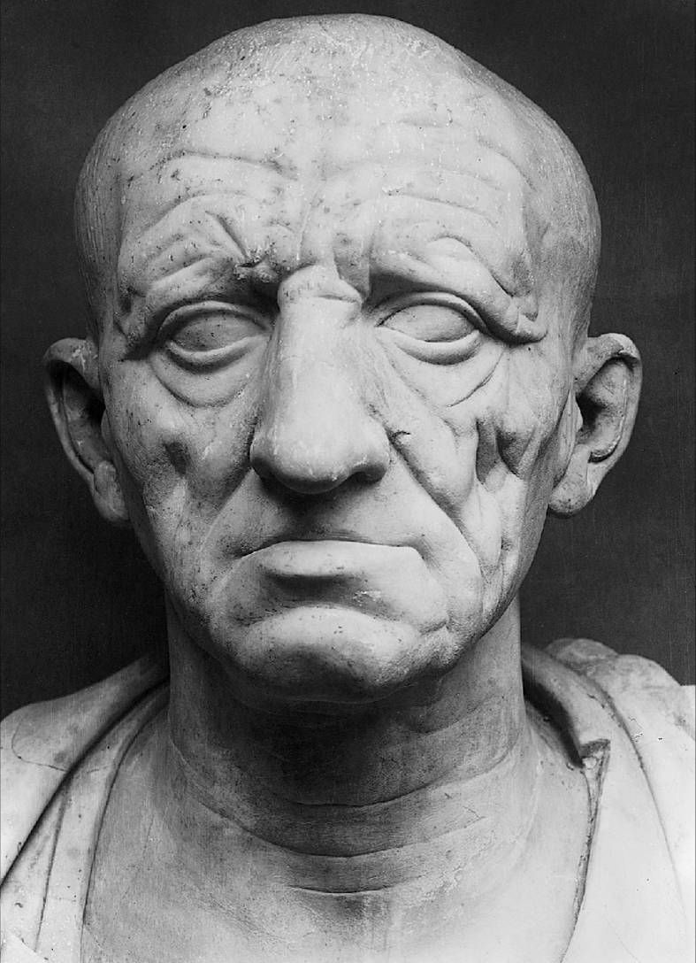

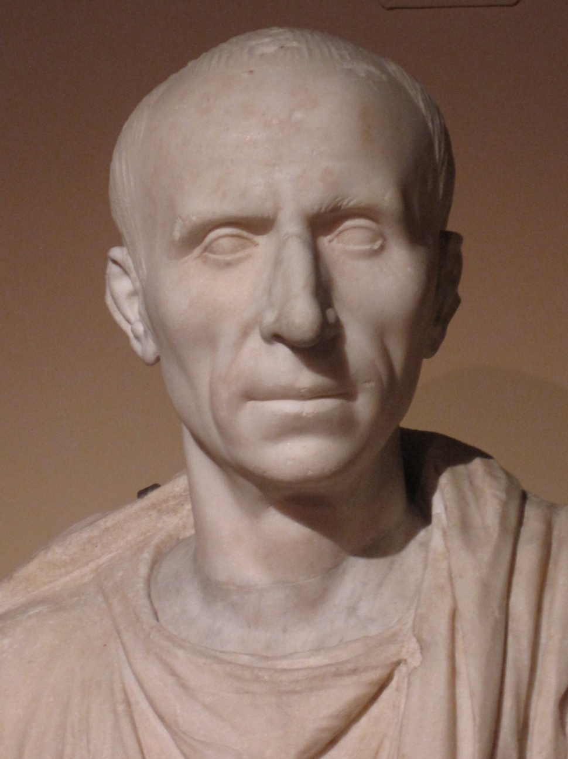
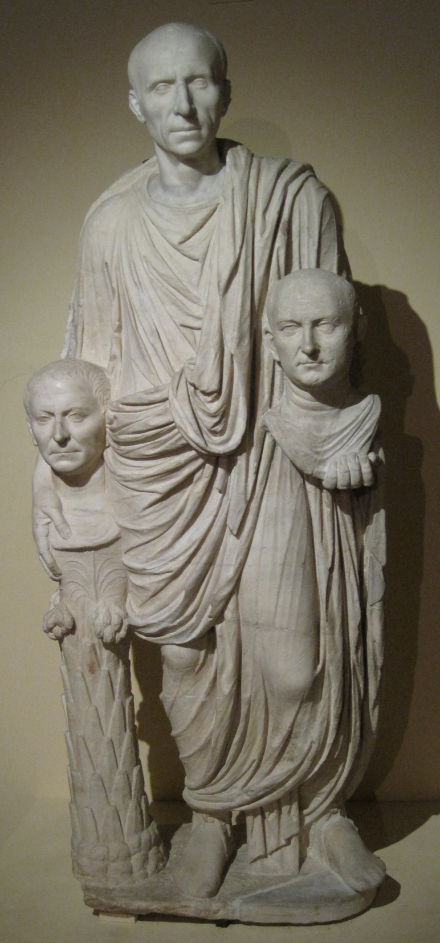

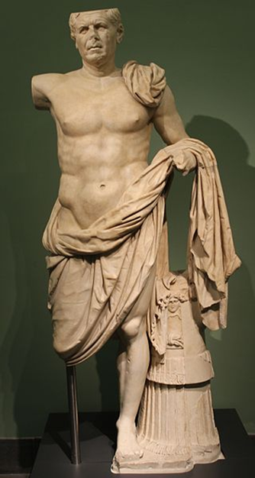
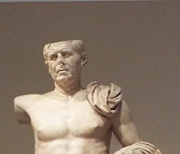

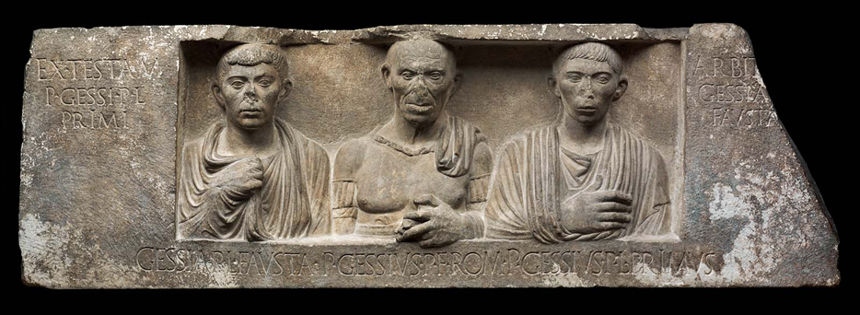
Veristic style among liberti
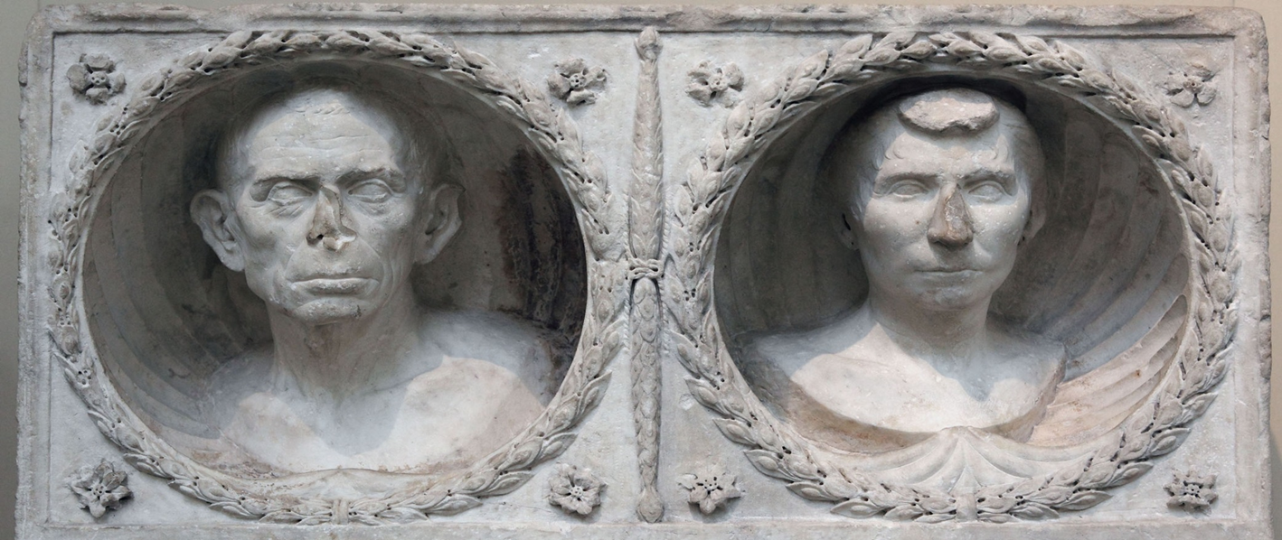
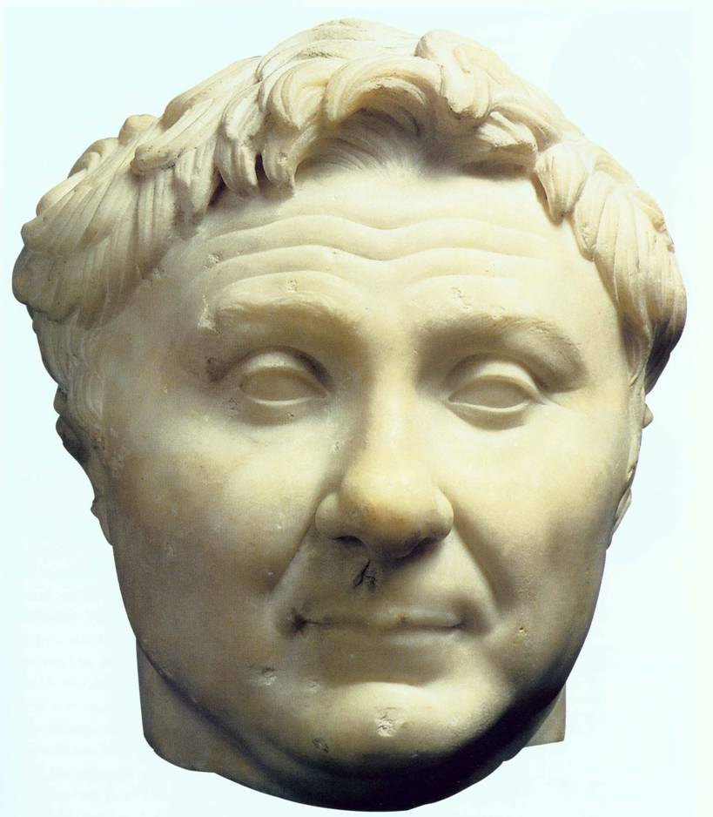

Augustan Classicizing portraiture

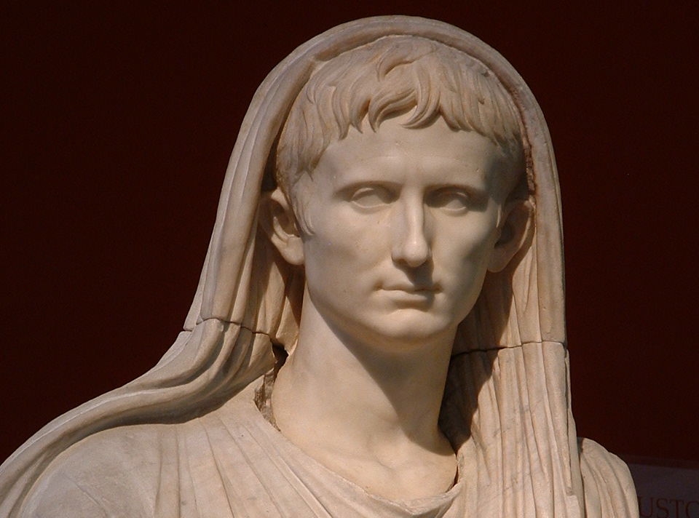
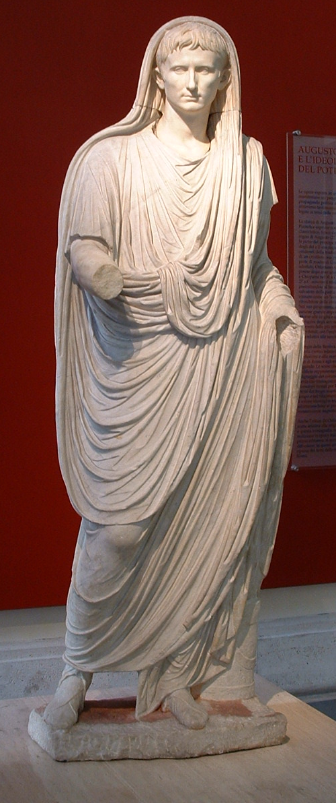

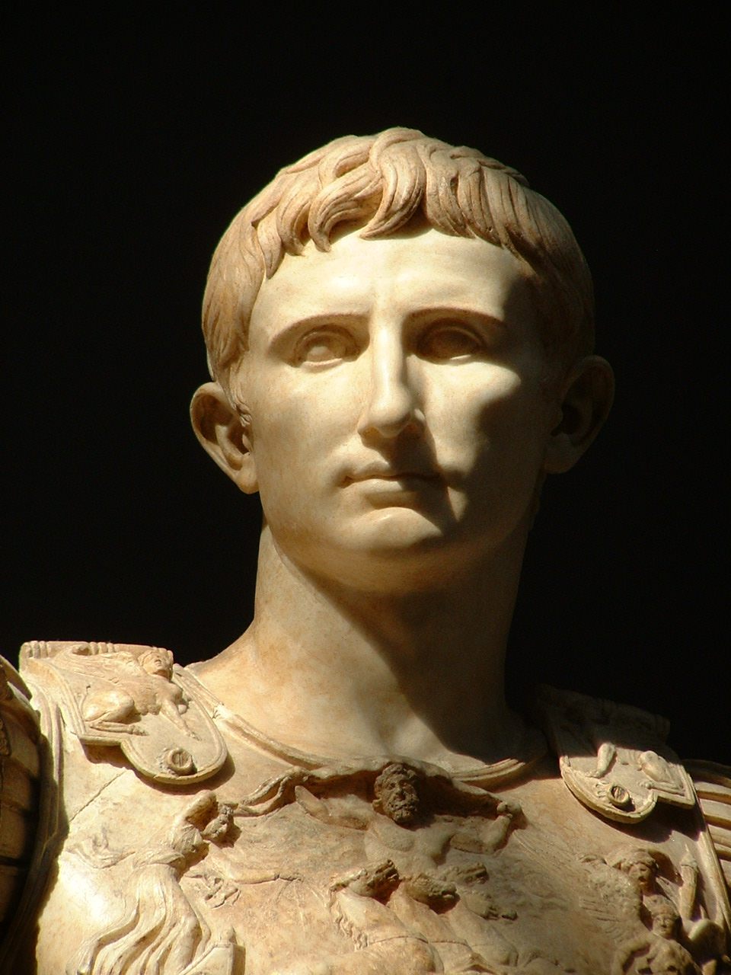
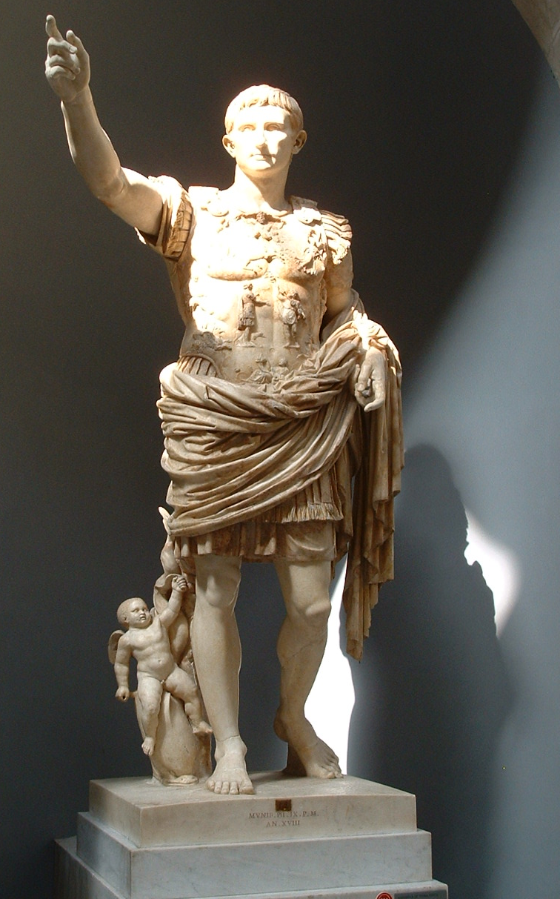

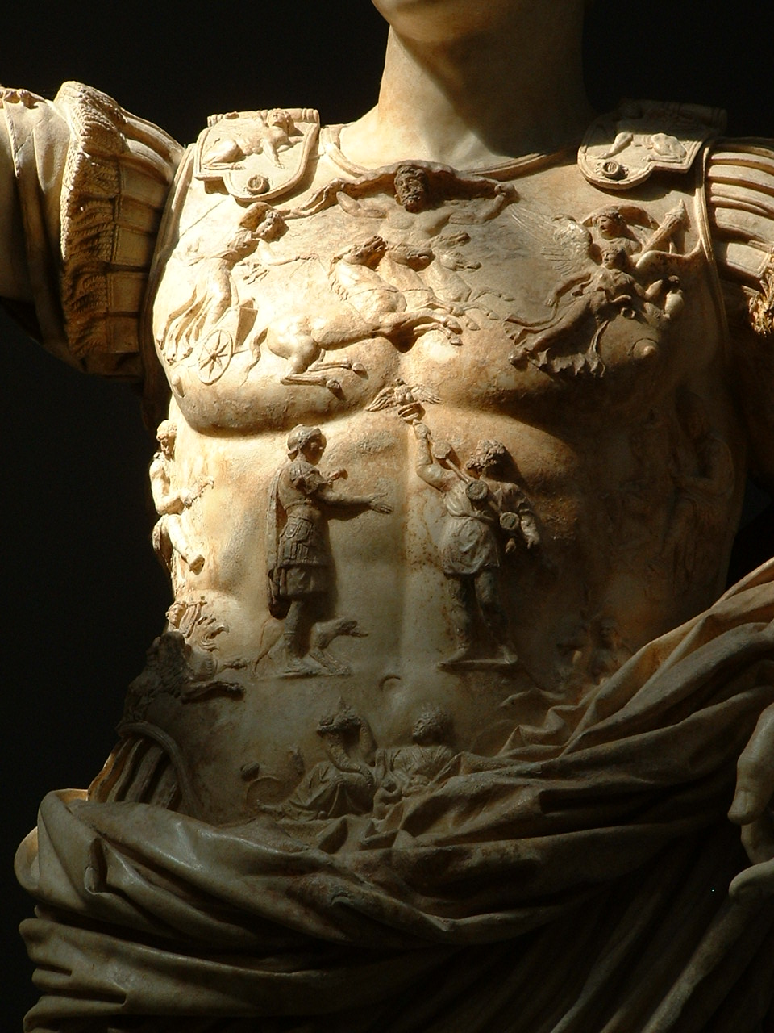
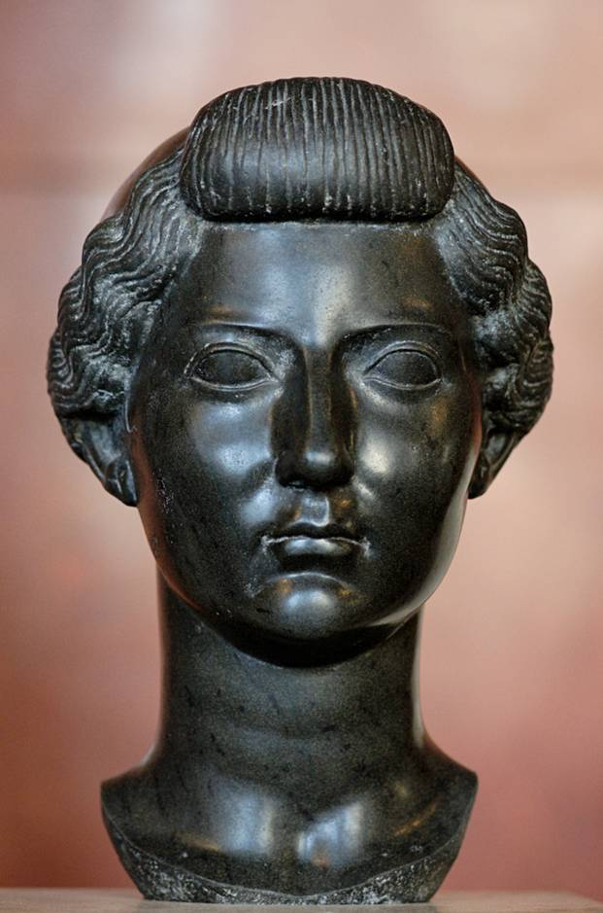

Later Julio-Claudian and Flavian emperors


